TECHM
Backtest

Pre-market
no info from OI
NIFTY-IT
but the daily candle shows negativity with volume increase
current_range=1.89
min_next_day_%=1.00
avg_nxt_day_%=1.79
55%
-----------------------------------------------
if the price openend below1337.35 for a 10K account we can enter with 10 stocks
then we can shift theSL to 1343.25 and then to min_next_day_%
In-trade
Max we can positon for a 10K account is 37
->we first enter with 20 as the price opened below HVN of past 2 days
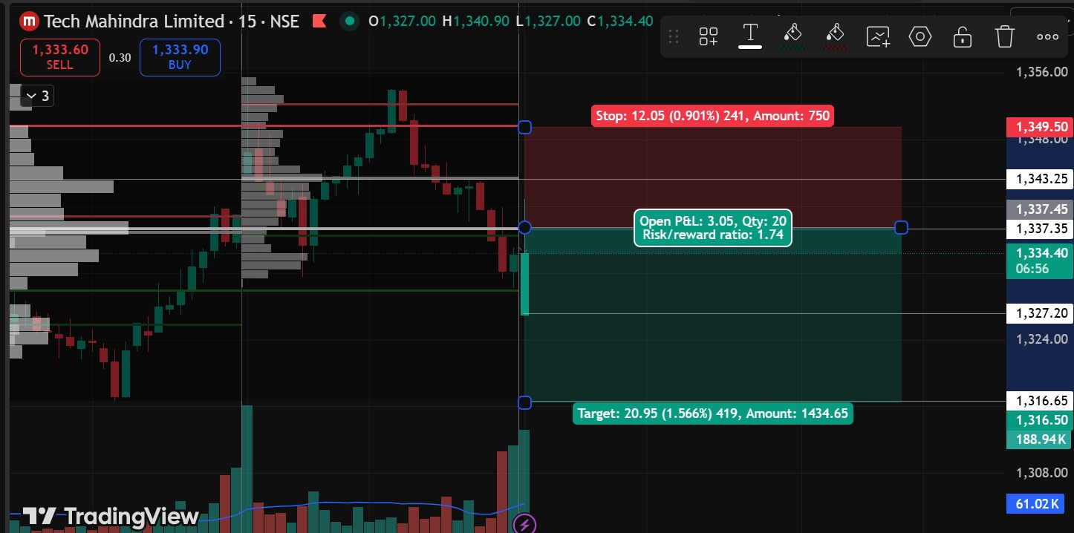

When we see rejection we entered another 20

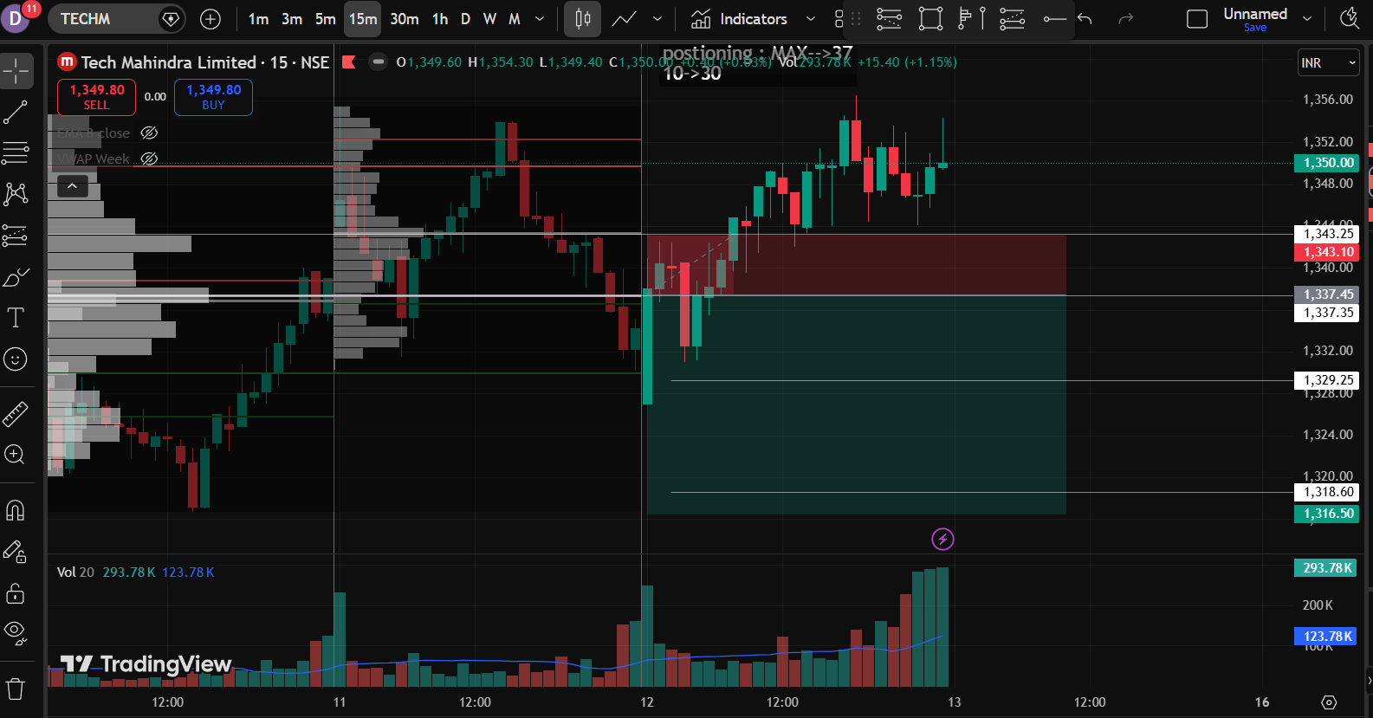

We actually oversee the OI change PUT OI increased with decrease on CALL OI
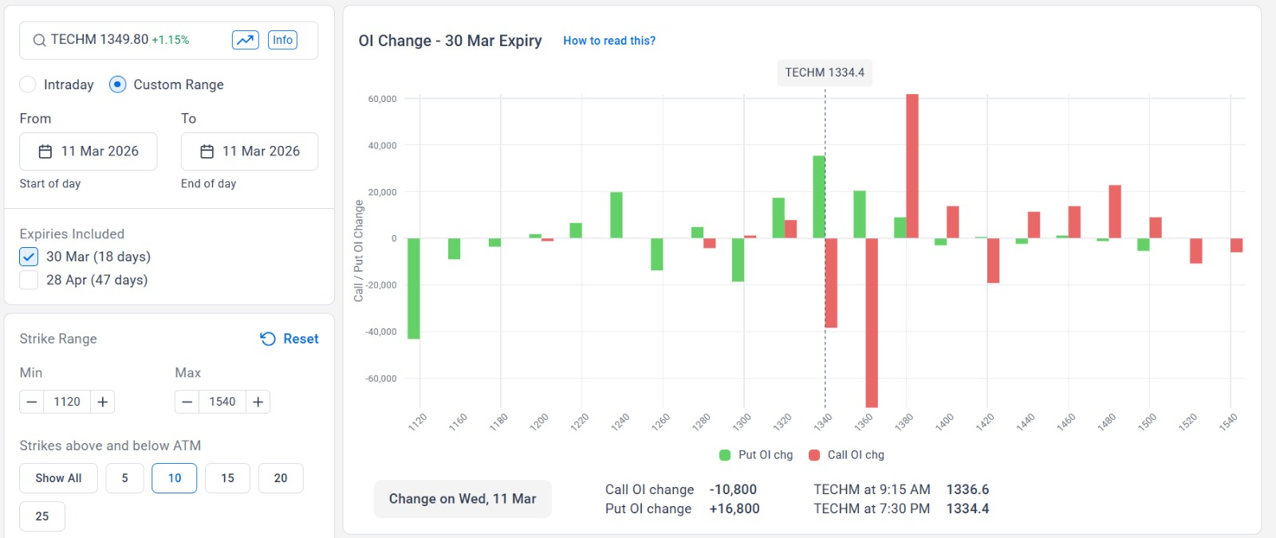

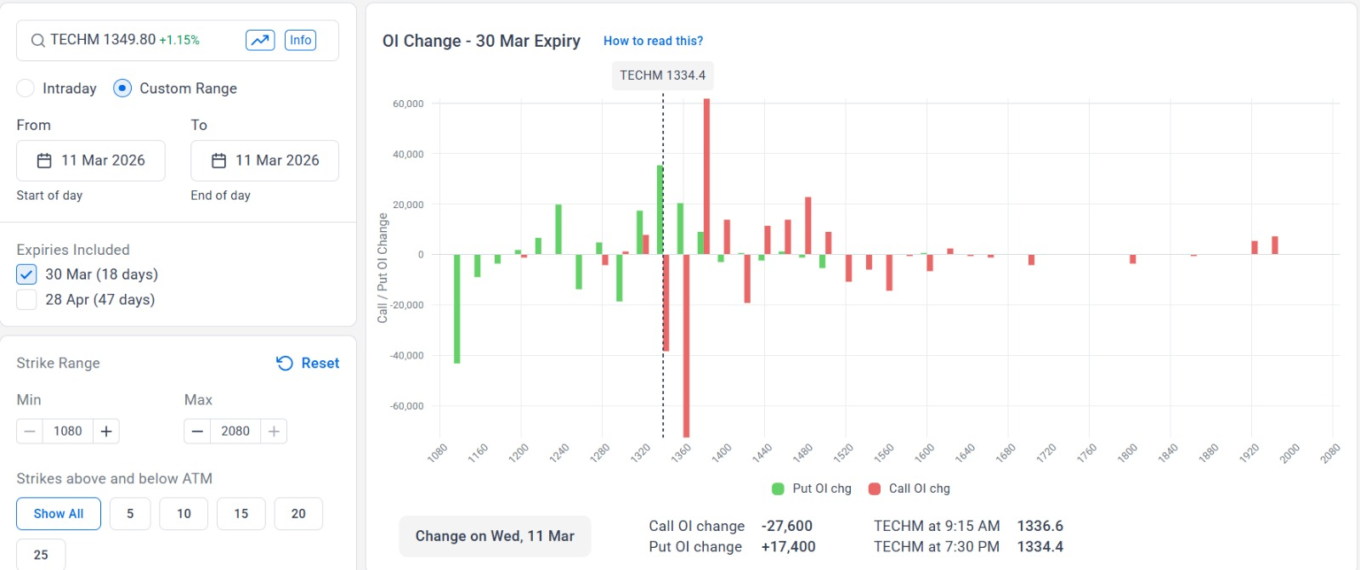

The price moved higher and ended higher
->Also the a rating agency Nuvama says it is bullish on IT stocks

