TECHM
Backtest

Pre-market
no info from OI
NIFTY-IT
but the daily candle shows negativity with volume increase
current_range=1.89
min_next_day_%=1.00
avg_nxt_day_%=1.79
55%
-------------------------------------------------
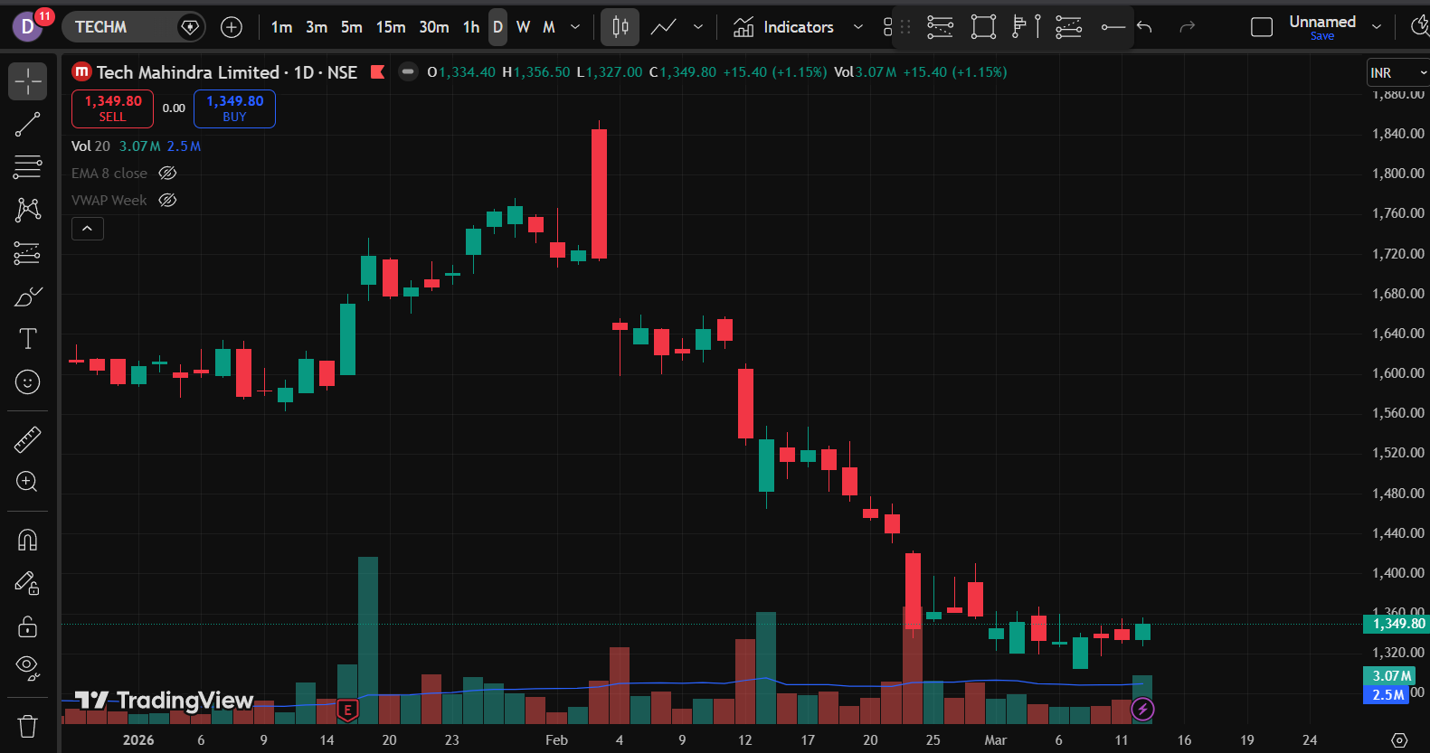

CALL OI has increased rapidly
OPEN INTREST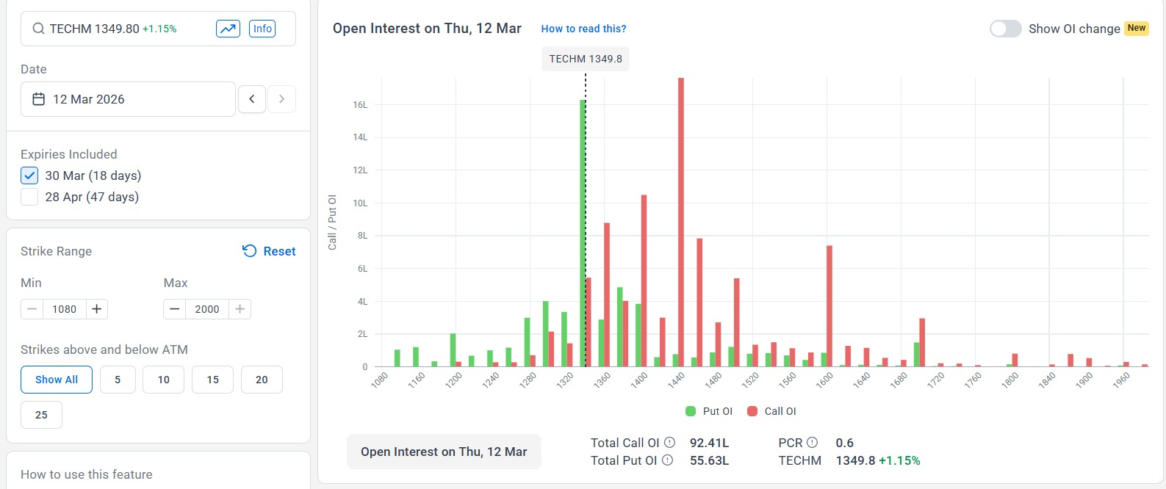
OI 10
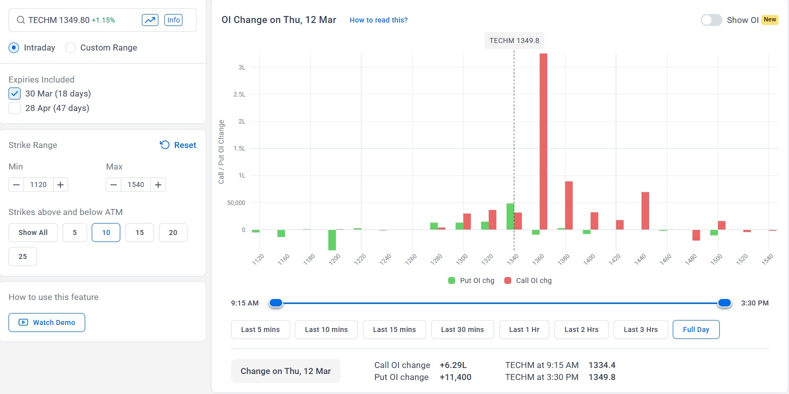
OI ALL
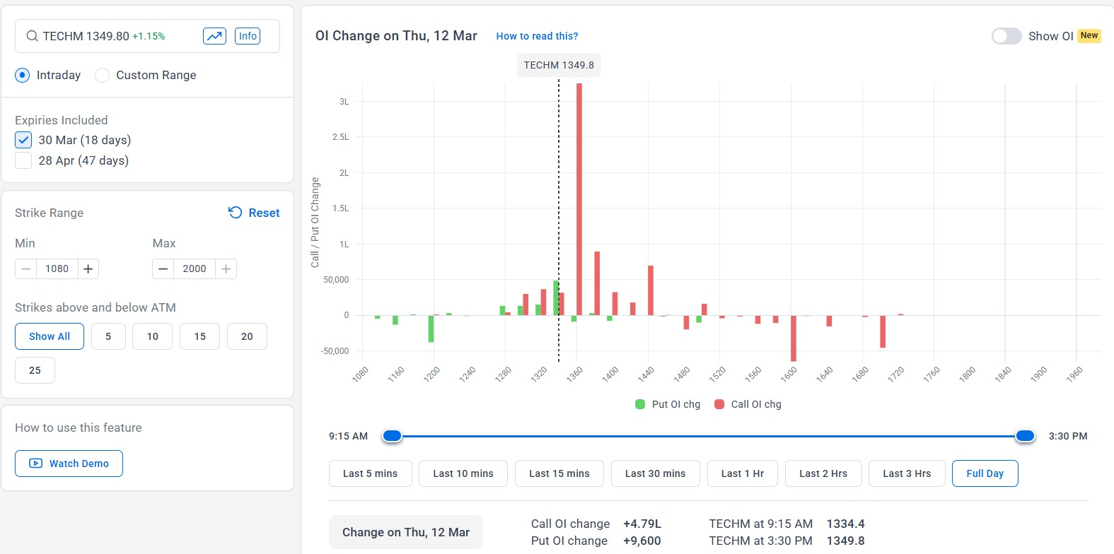

This shows a kind of negativity
->but the daily candle closed higher with high volume
Volume also shifted higher
------looking for longs but based on OI change
-----_> short of the first 15 min candle closes below them HVN i.e 1348.75

Intrade
->in the premarket it shows a gapdow and both CNXIT and Nifty 50 are down
->OI positions seems workedout
I expected the price should come to the 2 days HVN as it gapdown

- Weekily VVAP an act as a secondary watch level
