Bio-diesel quality characterization towards bio-jet fuel production using infrared spectroscopy and an interpretable machine learning framework

Chao Chenª, Rui Liangª, Yadong Geª, Ruodong Wang^{c}, Yanhui Men^{f}, Junyu Tao^{b}, Beibei Yan^{a,d,}*, Zhanjun Chengª, Xuebin Lvª, Guanyi Chen^{c,e}
ª School of Environmental Science and Engineering, Tianjin University, Tianjin 300350, China
^{b} National & Local Joint Engineering Research Center of Biomass Resource Utilization, College of Environmental Science and Engineering, Nankai University, Tianjin 300350, China
^{c} School of Mechanical Engineering, Tianjin University of Commerce, Tianjin 300134, China
^{d} Tianjin Key Lab of Biomass Wastes Utilization/Tianjin Engineering Research Center of Bio Gas/Oil Technology, Tianjin 300072, China
^{e} School of Science, Tibet University, Lhasa 850012, China
^{f} Qingdao Spring Water-treatment Co., Ltd., China

* Corresponding author: Beibei Yan, Email address: yanbeibei@tju.edu.cn

Table of Contents

Fig. S1. The overall research logic of the study. 3
Fig. S2. Schematic of the two-stage classification–regression strategy used in this study. 4
Fig. S3. Model Training Interface. 5
Fig. S4. Prediction and Testing Interface. 7
Table S1. Comparison of biodiesel model performance with and without descriptor identification based on infrared spectroscopy. 8
Table S2. Cross-indicator comparison of SHAP-ranked infrared features and biodiesel chemical relevance. 10
Table S3. Summary of input spectral descriptors and output biodiesel indicators used for model construction. 11

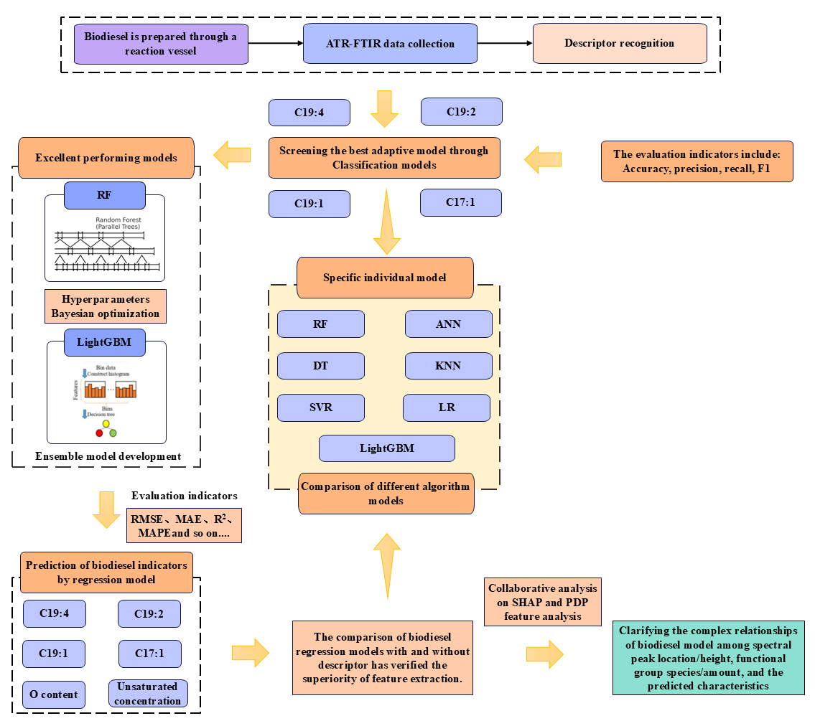

Fig. S1. The overall research logic of the study.
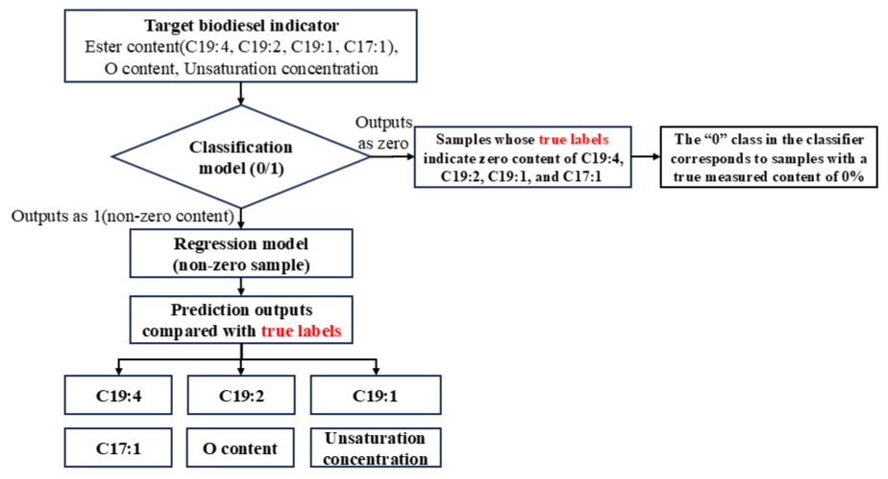

Fig. S2. Schematic of the two-stage classification–regression strategy used in this study.
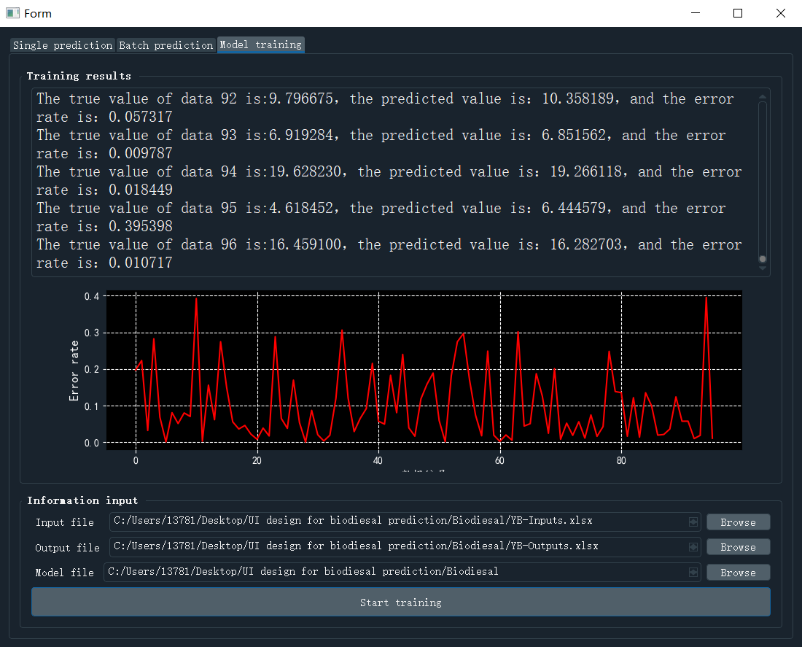

Fig. S3. Model Training Interface.

This Fig. S3 interface supports the construction, training, and performance monitoring of machine learning models, primarily targeting the research and model development stages. Users first load training data via the file input module, including input feature files (ATR-FTIR spectra or their extracted descriptors) and corresponding output label files (real index values ​​obtained through experimental methods such as GC-MS). After confirming the data path and model save location, the training process can be started with a single click.
During model training, the interface outputs real-time comparisons between the predicted results and the true values ​​for each round or batch of samples, and simultaneously calculates the corresponding error indices. These results are dynamically updated in text format, allowing users to intuitively track the model's fit performance on different samples. Simultaneously, the visualization window below displays the error trend with sample number or training progress in line form, reflecting the model's stability and convergence characteristics during the training phase.
This training interface supports iterative optimization and saving of the model: After training, the model parameters and structure are serialized and saved as independent .pkl model files, ready for subsequent independent testing.

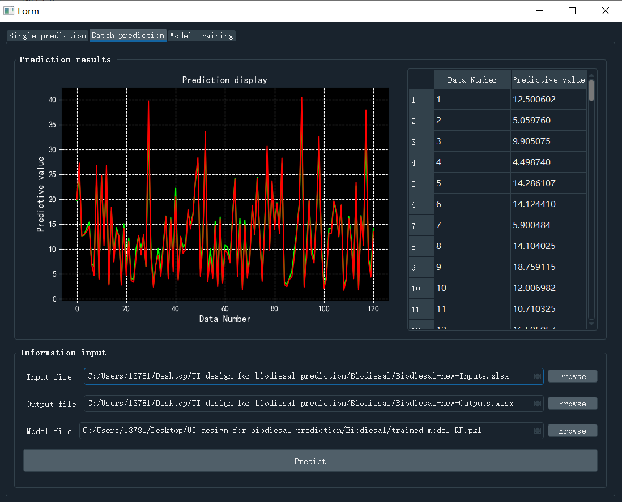

Fig. S4. Prediction and Testing Interface.

After model training is completed and saved, the prediction interface is used for rapid evaluation and result display on independent test sets or new sample data. Users load the trained model file and input new spectral data or feature files in this interface. This test data remains independent throughout the modeling process and is used only for verifying the model's generalization performance or for prediction in practical application scenarios. Prediction results are presented in two ways. In the visualization window on the left, the model output is displayed as a line graph, where the red curve represents the model's predicted value, and the green curve represents the actual experimental value of the corresponding sample.
This comparison method can intuitively reflect the model's prediction deviation, trend consistency, and overall fitting quality at different sample points. The table area on the right lists the sample number and its prediction result in numerical form, facilitating quantitative analysis, result export, and further processing.

Table S1. Comparison of biodiesel model performance with and without descriptor identification based on infrared spectroscopy.

 | Data descriptor identification  (this study) |  |  |  | Without descriptor identification
C19:4 | Valid set |  | Test set |  | Valid set |  | Test set
Algorithm | MRE(%) | R² | MRE(%) | R² | Algorithm | MRE(%) | R² | MRE(%)
ANN | 7.18 | 0.87 | 10.11 | 0.85 | 26.00 | 0.76 | 25.51 | 0.72
DT | 11.39 | 0.84 | 12.84 | 0.84 | 18.85 | 0.84 | 24.26 | 0.68
KNN | 8.04 | 0.95 | 18.10 | 0.82 | 19.53 | 0.86 | 21.88 | 0.81
LightGBM | 6.55 | 0.94 | 14.31 | 0.85 | 12.30 | 0.88 | 19.43 | 0.79
LR | 21.66 | 0.78 | 19.34 | 0.78 | 37.89 | 0.70 | 22.91 | 0.75
RF | 9.81 | 0.98 | 7.44 | 0.91 | 14.82 | 0.82 | 12.97 | 0.89
SVR | 7.20 | 0.95 | 15.23 | 0.86 | 24.85 | 0.72 | 25.58 | 0.73
Ensemble | 4.78 | 0.92 | 3.84 | 0.95
C19:2 | Valid set |  |  |  | Test set
Algorithm | MRE(%) |  | R² |  | MRE(%) |  | R²
ANN | 5.42 | 0.90 | 10.00 | 0.89 | 21.28 | 0.75 | 18.90 | 0.80
DT | 14.42 | 0.85 | 10.68 | 0.91 | 12.80 | 0.86 | 13.79 | 0.89
KNN | 9.79 | 0.87 | 16.43 | 0.85 | 14.74 | 0.82 | 17.27 | 0.78
LightGBM | 5.96 | 0.89 | 9.56 | 0.95 | 8.00 | 0.91 | 17.27 | 0.75
LR | 3.24 | 0.94 | 18.84 | 0.85 | 20.85 | 0.76 | 17.88 | 0.76
RF | 5.12 | 0.92 | 6.89 | 0.97 | 11.63 | 0.83 | 7.44 | 0.89
SVR | 6.67 | 0.86 | 17.11 | 0.82 | 18.59 | 0.79 | 17.70 | 0.79
Ensemble | 5.96 | 0.89 | 6.62 | 0.97
C19:1 | Valid set |  |  |  | Test set
Algorithm | MRE(%) |  | R² |  | MRE(%) |  | R²
ANN | 17.85 | 0.85 | 16.22 | 0.86 | 36.84 | 0.71 | 26.54 | 0.73
DT | 18.85 | 0.84 | 19.94 | 0.84 | 17.35 | 0.83 | 24.26 | 0.76
KNN | 19.53 | 0.85 | 21.65 | 0.82 | 31.66 | 0.70 | 18.53 | 0.71
LightGBM | 3.54 | 0.99 | 12.66 | 0.91 | 7.86 | 0.92 | 16.36 | 0.87
LR | 21.66 | 0.83 | 19.34 | 0.84 | 21.39 | 0.77 | 17.28 | 0.82
RF | 17.97 | 0.84 | 14.30 | 0.90 | 24.91 | 0.76 | 28.71 | 0.74
SVR | 24.85 | 0.75 | 17.59 | 0.86 | 31.84 | 0.73 | 25.58 | 0.78
Ensemble | 3.54 | 0.98 | 7.04 | 0.94
C17:1 | Valid set |  |  |  | Test set
Algorithm | MRE(%) |  | R² |  | MRE(%) |  | R²
ANN | 5.57 | 0.95 | 9.82 | 0.86 | 26.18 | 0.89 | 22.75 | 0.87
DT | 9.47 | 0.88 | 8.68 | 0.87 | 12.19 | 0.78 | 9.76 | 0.66
KNN | 11.79 | 0.89 | 7.85 | 0.92 | 11.35 | 0.68 | 8.62 | 0.52
LightGBM | 6.24 | 0.99 | 5.84 | 0.95 | 17.51 | 0.86 | 10.89 | 0.83
LR | 14.09 | 0.85 | 7.30 | 0.94 | 14.28 | 0.80 | 18.97 | 0.46
RF | 7.92 | 0.94 | 6.22 | 0.95 | 11.80 | 0.88 | 5.35 | 0.72
SVR | 15.40 | 0.89 | 7.57 | 0.90 | 16.82 | 0.81 | 6.41 | 0.78
Ensemble | 5.96 | 0.99 | 6.62 | 0.94
O content | Valid set |  |  |  | Test set
Algorithm | MRE(%) |  | R² |  | MRE(%) |  | R²
ANN | 7.18 | 0.77 | 10.11 | 0.75 | 22.95 | 0.89 | 26.91 | 0.75
DT | 18.85 | 0.94 | 24.26 | 0.84 | 15.80 | 0.95 | 15.27 | 0.87
KNN | 19.53 | 0.94 | 21.88 | 0.86 | 20.80 | 0.77 | 17.92 | 0.82
LightGBM | 8.89 | 0.87 | 9.17 | 0.92 | 17.00 | 0.82 | 17.94 | 0.84
LR | 21.65 | 0.93 | 19.34 | 0.90 | 12.45 | 0.87 | 30.32 | 0.66
RF | 13.41 | 0.87 | 10.43 | 0.90 | 20.53 | 0.68 | 23.99 | 0.72
SVR | 24.85 | 0.95 | 25.58 | 0.86 | 18.72 | 0.69 | 24.96 | 0.72
Ensemble | 9.11 | 0.87 | 8.75 | 0.92
Unsaturated concentration | Valid set |  |  |  | Test set
Algorithm | MRE(%) |  | R² |  | MRE(%) |  | R²
ANN | 5.54 | 0.97 | 13.97 | 0.88 | 18.63 | 0.79 | 20.75 | 0.72
DT | 7.05 | 0.93 | 15.91 | 0.76 | 18.77 | 0.72 | 14.48 | 0.80
KNN | 8.12 | 0.89 | 8.01 | 0.89 | 20.11 | 0.72 | 10.07 | 0.90
LightGBM | 7.22 | 0.93 | 9.34 | 0.85 | 21.74 | 0.80 | 10.64 | 0.89
LR | 6.33 | 0.94 | 7.54 | 0.87 | 16.54 | 0.78 | 9.53 | 0.85
RF | 5.61 | 0.91 | 5.33 | 0.93 | 19.35 | 0.80 | 18.72 | 0.74
SVR | 7.78 | 0.92 | 7.72 | 0.90 | 20.09 | 0.76 | 11.41 | 0.90
Ensemble | 5.26 | 0.93 | 8.91 | 0.95

Table S2. Cross-indicator comparison of SHAP-ranked infrared features and biodiesel chemical relevance.
Indicator | Top SHAP-ranked wavenumbers (cm⁻¹) | Functional group / vibration | Chemical implication supported by FTIR–biodiesel chemistry
C19:4 | 720, 3007 | 720: Methylene rocking (–CH₂–); 3007: Olefinic =C–H stretching | Indicates strong sensitivity to highly polyunsaturated long-chain FAMEs, where multiple C=C functionalities enhance the olefinic =C–H stretching response (3007 cm⁻¹), while the methylene rocking band at 720 cm⁻¹ reflects concomitant changes in long-chain packing and conformational ordering induced by high unsaturation.
C19:2 | 1363, 3007 | 1363: CH₃ symmetric bending; 3007: Olefinic =C–H stretching | Reflects the combined influence of di-unsaturation and alkyl-chain deformation, with olefinic =C–H stretching (3007 cm⁻¹) capturing the presence of C=C sites and CH₃ symmetric bending (1363 cm⁻¹) responding to saturation-dependent variations in terminal and side-chain environments characteristic of co-varies with unsaturation-related alkyl-chain environment changes
C19:1 | 3318, 881 | 3318: O–H stretching (non-FAME intrinsic); 881: Olefinic C=H out-of-plane deformation (configuration-dependent) | Suggests sensitivity to mono-unsaturated FAME microenvironments, where the olefinic C–H out-of-plane deformation at 881 cm⁻¹ acts as an auxiliary fingerprint descriptor sensitive to local C=C microenvironment, while the O–H stretching band at 3318 cm⁻¹ reflects extrinsic polarity or mild oxidation effects that co-vary with mono-unsaturated FAME abundance rather than intrinsic ester structure.
C17:1 | 1233, 720 | 1233: Ester C–O stretching (asymmetric); 720: Methylene rocking (–CH₂–) | Highlights chain-length- and conformation-related effects in mono-unsaturated FAMEs, where asymmetric ester C–O stretching (1233 cm⁻¹) reflects ester backbone environment and methylene rocking (720 cm⁻¹) captures packing and conformational differences between shorter-chain (C17) and longer-chain FAME homologues.
O content | 1741, 1363 | 1741: Ester carbonyl (C=O) stretchin; 1363：CH₃ symmetric bending | Demonstrates that oxygen-content variation is primarily anchored by oxygenated ester framework (co-varying with GC–MS–derived O content) the ester carbonyl framework, with the strong C=O stretching band at 1741 cm⁻¹ anchoring ester abundance, while CH₃ symmetric bending (1363 cm⁻¹) provides secondary modulation through alkyl-chain environment effects rather than direct oxygen quantification.
Unsaturated concentration | 720, 1363 | 720: Methylene rocking (–CH₂–); 1363: CH₃ symmetric bending | Indicates that overall unsaturation is indirectly captured through unsaturation-induced perturbations in alkyl-chain packing and deformation, as reflected by methylene rocking (720 cm⁻¹) and CH₃ symmetric bending (1363 cm⁻¹), rather than relying solely on direct olefinic stretching bands.

Table S3. Summary of input spectral descriptors and output biodiesel indicators used for model construction.
(More detail: GitHub (https://github.com/Diligent007/ATR-FTIR-combined-with-interpretable-ML-biodiesel-monitoring-for-bio-jet-fuel-production)
530.14 | 720.048 | 881.036 | 1020.334 | 1080.102 | 1157.222 | 1233.378 | 1363.036 | 1458.472 | 1741.406 | 2852.3 | 2923.228 | 3007.183 | 3318.395 | C19:4 | C19:2 | C17:1 | C19:1 | Unsaturated concentration | O Content
peak height (a.u.) |  |  |  |  |  |  |  |  |  |  |  |  |  | m % | m % | m % | m % | (mol/L) | (wt%)
0.026029 | 0.068177 | 0.022083 | 0.041222 | 0.0212 | 0.065681 | 0.052318 | 0.036453 | 0.054747 | 0.163142 | 0.08233 | 0.123291 | 0.016542 | 0.002594 | 40.72441 | 0 | 28.01895 | 9.50518 | 199.57192 | 10.92699
0.160593 | 0.139415 | 0.063766 | 0.46261 | 0.077775 | 0.051571 | 0.056531 | 0.069381 | 0.088668 | 0.041845 | 0.076622 | 0.112706 | 0.05128 | 0.144247 | 28.2388 | 0 | 20.60826 | 0 | 194.94088 | 4.172503
0.13845 | 0.117175 | 0.03311 | 0.534756 | 0.036735 | 0.02419 | 0.02072 | 0.034744 | 0.058814 | 0.008909 | 0.044231 | 0.075229 | 0.033892 | 0.125579 | 35.49919 | 0 | 25.49304 | 8.8253 | 186.64248 | 10.46061
0.042011 | 0.087283 | 0.030993 | 0.050177 | 0.06561 | 0.148143 | 0.072758 | 0.041769 | 0.068217 | 0.198441 | 0.118065 | 0.171735 | 0.017626 | -0.00034 | 23.90128 | 0 | 18.04132 | 0 | 158.74692 | 2.952691
0.011772 | 0.053074 | 0.017249 | 0.010634 | 0.008075 | 0.060811 | 0.040385 | 0.023899 | 0.037142 | 0.145539 | 0.057056 | 0.080281 | 0.008653 | -0.02628 | 29.49227 | 0 | 21.36315 | 7.41554 | 142.1192 | 7.882255
0.199123 | 0.142212 | 0.050145 | 0.589507 | 0.084504 | 0.030319 | 0.044593 | 0.062484 | 0.080787 | 0.007327 | 0.059815 | 0.093849 | 0.040322 | 0.170266 | 33.62768 | 0 | 23.94005 | 8.20128 | 162.27117 | 8.959077
0.127671 | 0.168779 | 0.104089 | 0.113195 | 0.107014 | 0.165598 | 0.122541 | 0.094846 | 0.114717 | 0.229435 | 0.150021 | 0.194368 | 0.045164 | 0.033224 | 0 | 0 | 36.77542 | 9.16807 | 166.36568 | 11.26842
-0.05936 | -0.00492 | -0.09403 | -0.01894 | -0.07787 | 0.064384 | 0.038584 | 0.003298 | 0.017308 | 0.173959 | 0.059838 | 0.089049 | -0.00217 | -0.08538 | 0 | 0 | 0 | 17.29841 | 137.8273 | 11.19553
0.208388 | 0.150517 | 0.05697 | 0.566239 | 0.079088 | 0.03251 | 0.043589 | 0.060176 | 0.078341 | 0.009574 | 0.056065 | 0.091037 | 0.035624 | 0.155766 | 0 | 19.87129 | 24.17886 | 5.68354 | 227.27322 | 10.97544
0.029886 | 0.054601 | -0.00901 | 0.054309 | -0.00364 | 0.05211 | 0.039412 | 0.02458 | 0.037389 | 0.113919 | 0.058361 | 0.086326 | 0.010727 | -0.00266 | 0 | 19.03096 | 26.54657 | 5.45613 | 215.89084 | 11.11844
0.142912 | 0.10749 | 0.034321 | 0.492769 | 0.054234 | 0.014865 | 0.027658 | 0.041593 | 0.055788 | -0.01415 | 0.022901 | 0.036534 | 0.021302 | 0.113689 | 0 | 21.96857 | 27.52444 | 9.05749 | 190.05749 | 0.972616
0.205464 | 0.158421 | 0.063683 | 0.428644 | 0.043526 | 0.036128 | 0.03126 | 0.044193 | 0.061457 | 0.016508 | 0.041809 | 0.067688 | 0.038194 | 0.12297 | 0 | 0 | 0 | 82.3001 | 123.29419 | 10.75107
0.057676 | 0.101087 | 0.041243 | 0.057562 | 0.078515 | 0.163992 | 0.080675 | 0.047762 | 0.075118 | 0.21571 | 0.129188 | 0.186072 | 0.023141 | 0.002505 | 0 | 17.23275 | 20.07265 | 3.89377 | 186.41361 | 9.63629
0.119527 | 0.095252 | 0.022477 | 0.527251 | 0.017793 | -0.00391 | -0.00058 | 0.019344 | 0.040274 | -0.03998 | 0.011668 | 0.034192 | 0.02502 | 0.121754 | 36.59399 | 0 | 0 | 14.65478 | 207.1874 | 11.34514
0.002819 | 0.021944 | 0.004065 | -0.00146 | 0.028204 | 0.068971 | 0.012406 | -0.00061 | 0.007443 | 0.043367 | 0.02308 | 0.036016 | -0.00595 | -0.01674 | 0 | 0 | 0 | 16.57815 | 125.44056 | 11.49754
0.061244 | 0.122551 | 0.047428 | 0.058546 | 0.083215 | 0.171506 | 0.081139 | 0.046204 | 0.075599 | 0.230121 | 0.123156 | 0.172207 | 0.026506 | 0.002203 | 43.24102 | 21.32868 | 20.45064 | 5.84136 | 212.55791 | 10.93533
0.028912 | 0.08929 | 0.025642 | 0.039633 | 0.06175 | 0.149621 | 0.069985 | 0.037592 | 0.066969 | 0.211602 | 0.122862 | 0.179357 | 0.022682 | -0.00215 | 42.44939 | 22.80353 | 22.91861 | 5.43376 | 219.00094 | 10.96858
0.163328 | 0.131231 | 0.054372 | 0.400059 | 0.042578 | 0.030256 | 0.028529 | 0.041771 | 0.058732 | 0.007751 | 0.038451 | 0.060123 | 0.03779 | 0.124706 | 38.02474 | 23.97442 | 24.74482 | 9.14582 | 203.62997 | 11.07119
-0.04765 | 0.019615 | -0.03803 | -0.0235 | -0.00049 | 0.079091 | 0.007077 | -0.01857 | 0.009232 | 0.145814 | 0.063664 | 0.110881 | -0.0091 | -0.02911 | 0 | 22.59027 | 23.45372 | 5.48253 | 196.83908 | 10.26313
0.157136 | 0.135541 | 0.052005 | 0.608483 | 0.050703 | 0.035666 | 0.032367 | 0.048328 | 0.074061 | 0.012353 | 0.052599 | 0.086139 | 0.045195 | 0.147609 | 36.76329 | 23.50125 | 26.65474 | 9.07071 | 203.13596 | 11.36348
0.013722 | 0.085503 | 0.014127 | 0.029146 | 0.054747 | 0.151459 | 0.061843 | 0.027869 | 0.059615 | 0.223309 | 0.117066 | 0.1727 | 0.01763 | -0.00896 | 36.85252 | 23.53749 | 25.88226 | 9.67668 | 205.76286 | 8.771118
0.132419 | 0.117257 | 0.034941 | 0.620733 | 0.037029 | 0.022562 | 0.020237 | 0.036707 | 0.063239 | 0.001932 | 0.044415 | 0.077438 | 0.038651 | 0.140654 | 30.07051 | 20.91181 | 21.24412 | 7.68582 | 184.93428 | 9.599097
0.088817 | 0.126878 | 0.077512 | 0.088545 | 0.080629 | 0.134651 | 0.102624 | 0.080354 | 0.098359 | 0.213143 | 0.129045 | 0.176256 | 0.042801 | 0.023843 | 23.58969 | 0 | 0 | 16.74002 | 179.38726 | 9.866823
0.168139 | 0.121376 | 0.038754 | 0.507787 | 0.060541 | 0.028519 | 0.035309 | 0.047498 | 0.065029 | 0.018592 | 0.053032 | 0.086461 | 0.032514 | 0.133305 | 0 | 20.95214 | 21.01172 | 4.54589 | 200.66595 | 10.20177
0.196511 | 0.152842 | 0.053486 | 0.544486 | 0.0424 | 0.030169 | 0.026367 | 0.042031 | 0.063911 | 0.009744 | 0.047286 | 0.076487 | 0.04385 | 0.149455 | 0 | 0 | 0 | 0 | 155.8077 | 1.677425
0.034506 | 0.088658 | 0.023873 | 0.03123 | 0.056775 | 0.143804 | 0.058156 | 0.026323 | 0.051368 | 0.189622 | 0.09464 | 0.137266 | 0.008296 | -0.02844 | 0 | 21.50667 | 24.9937 | 8.54906 | 187.23643 | 10.3601
-0.03859 | -0.00385 | -0.07883 | -0.00525 | -0.04749 | 0.083915 | 0.033466 | 0.003267 | 0.012552 | 0.129972 | 0.048048 | 0.069719 | -0.00022 | -0.05339 | 0 | 0 | 0 | 0 | 172.71409 | 1.415486
0.330121 | 0.242913 | 0.088341 | 0.34262 | 0.048943 | 0.036912 | 0.035143 | 0.047812 | 0.059946 | 0.018417 | 0.043883 | 0.062924 | 0.059538 | 0.215779 | 24.27029 | 0 | 43.17363 | 18.46381 | 154.45488 | 11.2367
0.04928 | 0.103553 | 0.045434 | 0.0618 | 0.083669 | 0.166608 | 0.084122 | 0.050286 | 0.078918 | 0.218028 | 0.137048 | 0.194835 | 0.02311 | 0.002588 | 50.1475 | 0 | 24.60832 | 5.67635 | 216.42415 | 10.91388
0.098895 | 0.131475 | 0.071389 | 0.10531 | 0.074562 | 0.125256 | 0.09266 | 0.070508 | 0.09012 | 0.199477 | 0.120701 | 0.169815 | 0.03543 | 0.015395 | 0 | 0 | 0 | 0 | 584.10405 | 5.347841
0.037823 | 0.012279 | -0.00366 | 0.172699 | -0.00258 | -0.03236 | -0.00327 | 0.011552 | 0.009872 | -0.05105 | -0.01105 | -0.01156 | 0.006478 | 0.041954 | 0 | 0 | 19.66017 | 3.84893 | 152.18963 | 4.730772
0.02407 | 0.073107 | 0.024063 | 0.036858 | 0.025032 | 0.072518 | 0.054854 | 0.039143 | 0.066629 | 0.174702 | 0.100852 | 0.147052 | 0.025531 | 0.003605 | 28.73784 | 0 | 14.62944 | 4.30058 | 110.99074 | 5.407145
0.250798 | 0.177565 | 0.036307 | 0.343501 | 0.003596 | -0.00556 | -0.00686 | 0.008551 | 0.024575 | -0.01645 | 0.015484 | 0.035734 | 0.026721 | 0.17158 | 23.16722 | 0 | 11.01832 | 3.77105 | 106.71085 | 3.928101
0.02872 | 0.086554 | 0.023717 | 0.040096 | 0.06311 | 0.154686 | 0.070111 | 0.037422 | 0.06649 | 0.213682 | 0.122566 | 0.177355 | 0.020604 | -0.00149 | 40.55199 | 0 | 29.53146 | 9.48053 | 185.59501 | 10.05841
0.121557 | 0.104292 | 0.032344 | 0.574244 | 0.034296 | 0.011666 | 0.014229 | 0.031761 | 0.053222 | -0.0283 | 0.019674 | 0.03727 | 0.031258 | 0.12695 | 0 | 0 | 25.17844 | 0 | 224.80996 | 12.01674
0.027766 | 0.057253 | 0.022635 | 0.032335 | 0.034311 | 0.074148 | 0.043474 | 0.026923 | 0.039129 | 0.098651 | 0.058925 | 0.084351 | 0.009636 | 0.001338 | 37.11018 | 0 | 23.17559 | 0 | 249.44595 | 10.3601
0.162216 | 0.09726 | 0.038034 | 0.376275 | 0.040939 | 0.028666 | 0.061278 | 0.093885 | 0.050081 | 0.012266 | 0.026032 | 0.047807 | 0.023478 | 0.080294 | 42.70785 | 0 | 18.85139 | 3.97199 | 202.45481 | 14.19414
0.009775 | 0.083912 | 0.013828 | 0.029229 | 0.055635 | 0.15057 | 0.061637 | 0.027823 | 0.060126 | 0.224444 | 0.118811 | 0.174643 | 0.019997 | -0.00586 | 39.49294 | 0 | 20.1598 | 4.60367 | 194.54073 | 14.53509
-0.03865 | 0.020682 | -0.03183 | -0.0054 | -0.00973 | 0.050596 | 0.011659 | -0.00833 | 0.01575 | 0.118976 | 0.059094 | 0.099821 | -0.00464 | -0.0203 | 0 | 0 | 17.84406 | 0 | 182.33424 | 4.04373
0.044173 | 0.098856 | 0.042 | 0.067862 | 0.073457 | 0.142821 | 0.070678 | 0.042237 | 0.065546 | 0.180941 | 0.100305 | 0.140535 | 0.020219 | -0.00607 | 42.52564 | 0 | 0 | 13.93681 | 239.12658 | 10.79846
0.174051 | 0.084762 | 0.01005 | 0.468854 | 0.030709 | 0.00502 | 0.048227 | 0.083446 | 0.042823 | -0.00068 | 0.029498 | 0.059226 | 0.02148 | 0.108574 | 35.47929 | 19.42115 | 32.23085 | 8.4085 | 201.72277 | 10.68415
0.114998 | 0.12077 | 0.057764 | 0.112468 | 0.074825 | 0.12661 | 0.08796 | 0.085059 | 0.081822 | 0.182157 | 0.114275 | 0.168385 | 0.034044 | 0.014556 | 0 | 27.48965 | 21.16803 | 5.7626 | 189.96879 | 13.43967
0.195363 | 0.115757 | 0.043132 | 0.41998 | 0.056139 | 0.032884 | 0.06492 | 0.092617 | 0.060857 | 0.021345 | 0.043314 | 0.071361 | 0.031807 | 0.106955 | 39.24668 | 18.86605 | 22.1623 | 4.84304 | 197.77005 | 13.03526
0.121458 | 0.1292 | 0.065725 | 0.108205 | 0.080395 | 0.132151 | 0.091958 | 0.0865 | 0.085803 | 0.189907 | 0.116957 | 0.168894 | 0.037167 | 0.014539 | 45.63032 | 23.1495 | 22.17085 | 8.20142 | 215.02984 | 11.06213
0.058935 | 0.077339 | 0.030215 | 0.063663 | 0.047692 | 0.091533 | 0.056331 | 0.04915 | 0.053191 | 0.134328 | 0.078914 | 0.119357 | 0.017866 | 0.003346 | 0 | 27.48965 | 0 | 5.7626 | 189.96879 | 13.43967
0.093631 | 0.084926 | 0.032354 | 0.148691 | 0.047674 | 0.061751 | 0.051486 | 0.055708 | 0.048866 | 0.069689 | 0.051697 | 0.079353 | 0.017942 | 0.034548 | 44.53334 | 24.90993 | 21.97393 | 8.1107 | 214.10288 | 11.06059
0.21406 | 0.133491 | 0.067268 | 0.417064 | 0.076272 | 0.050985 | 0.086506 | 0.11992 | 0.079044 | 0.033119 | 0.058528 | 0.087331 | 0.04623 | 0.128635 | 39.24668 | 18.86605 | 22.1623 | 4.84304 | 197.77005 | 13.03526
0.092789 | 0.109168 | 0.05445 | 0.096947 | 0.074489 | 0.122572 | 0.084327 | 0.073975 | 0.081063 | 0.184578 | 0.11444 | 0.161668 | 0.034636 | 0.01659 | 45.63032 | 23.1495 | 22.17085 | 8.20142 | 215.02984 | 11.06213
0.066842 | 0.016565 | -0.00257 | 0.1693 | -0.01733 | -0.01749 | 0.00396 | 0.02973 | -0.00401 | -0.04565 | -0.0247 | -0.02312 | 0.000606 | 0.015356 | 28.32239 | 14.01407 | 23.54436 | 0 | 180.8816857 | 13.20021
0.067662 | 0.107028 | 0.050556 | 0.078225 | 0.083239 | 0.151847 | 0.084294 | 0.066465 | 0.078533 | 0.198299 | 0.119624 | 0.167656 | 0.033017 | 0.010569 | 0 | 18.52058 | 30.10038 | 7.02182 | 202.37067 | 11.55792
0.181959 | 0.117569 | 0.042716 | 0.352987 | 0.035122 | 0.02376 | 0.046898 | 0.072631 | 0.045735 | -0.00187 | 0.02087 | 0.04105 | 0.024516 | 0.096216 | 45.54659 | 31.33301 | 0 | 10.47345 | 242.5412 | 11.02846
0.09263 | 0.026558 | 0.002086 | 0.226332 | 0.002213 | -0.02915 | 0.011216 | 0.048484 | 0.00647 | -0.06902 | -0.0226 | -0.02009 | 0.005355 | 0.044702 | 0 | 14.84875 | 16.38876 | 3.46218 | 193.92358 | 15.17365
0.157358 | 0.096026 | 0.034098 | 0.341665 | 0.050935 | 0.021226 | 0.055123 | 0.085324 | 0.051321 | 0.001656 | 0.030645 | 0.056381 | 0.024146 | 0.099145 | 27.83988 | 35.61243 | 31.56623 | 11.37725 | 121.78712 | 11.34439
0.08244 | 0.111088 | 0.058718 | 0.089634 | 0.071887 | 0.120943 | 0.087611 | 0.076741 | 0.085176 | 0.19691 | 0.122376 | 0.172328 | 0.039766 | 0.019801 | 22.4931 | 43.61925 | 26.97003 | 14.64994 | 168.8888254 | 11.30079
0.041442 | 0.024656 | 0.002031 | 0.073812 | 0.008972 | 0.00767 | 0.015006 | 0.03034 | 0.014219 | 0.004782 | 0.012887 | 0.027893 | 0.005808 | 0.014404 | 0 | 18.10443 | 26.56875 | 6.58724 | 208.82876 | 11.42
0.082523 | 0.102684 | 0.051548 | 0.093594 | 0.072603 | 0.123241 | 0.083013 | 0.078457 | 0.078857 | 0.178063 | 0.114225 | 0.163965 | 0.035247 | 0.014676 | 42.03792 | 24.10355 | 24.09273 | 6.58808 | 211.17629 | 11.06793
0.133659 | 0.104927 | 0.048576 | 0.093012 | 0.067398 | 0.047286 | 0.053178 | 0.062628 | 0.057228 | 0.048381 | 0.055894 | 0.081765 | 0.025487 | 0.090765 | 0 | 13.55606 | 15.07441 | 3.25059 | 182.40369 | 16.5939
0.097976 | 0.111392 | 0.055522 | 0.146361 | 0.077689 | 0.118001 | 0.085553 | 0.083986 | 0.080412 | 0.152457 | 0.107693 | 0.154061 | 0.037756 | 0.032193 | 0 | 23.43511 | 25.53735 | 6.74906 | 208.00056 | 11.05397
0.132424 | 0.07234 | 0.023681 | 0.298615 | 0.031211 | 0.006505 | 0.038508 | 0.070927 | 0.033548 | -0.02544 | 0.006378 | 0.019969 | 0.016534 | 0.075306 | 0 | 14.76381 | 16.59777 | 3.61989 | 187.39833 | 15.61053
0.056445 | 0.086131 | 0.035591 | 0.064493 | 0.055663 | 0.109953 | 0.066198 | 0.054879 | 0.062517 | 0.164493 | 0.095489 | 0.141475 | 0.021787 | 0.000804 | 41.01561 | 24.67359 | 23.67818 | 6.82893 | 209.6101 | 11.15142
0.034972 | 0.053033 | 0.01515 | 0.04198 | 0.023694 | 0.047537 | 0.035074 | 0.033117 | 0.035845 | 0.097559 | 0.05206 | 0.081681 | 0.01259 | 0.0081 | 28.77006 | 0 | 26.83533 | 9.77886 | 191.5074 | 11.07377
0.105785 | 0.038656 | 0.006197 | 0.254922 | 0.011822 | -0.041 | 0.0112 | 0.047727 | 0.013597 | -0.08384 | -0.02248 | -0.02099 | 0.010348 | 0.081955 | 0 | 18.35075 | 21.42491 | 5.51485 | 202.21368 | 13.02035
0.096534 | 0.029062 | 0.002955 | 0.232773 | 0.006836 | -0.02795 | 0.013798 | 0.051858 | 0.009046 | -0.07016 | -0.02023 | -0.01634 | 0.007708 | 0.060959 | 32.64284 | 14.38051 | 17.44639 | 4.76972 | 183.07901 | 15.76545
0.112552 | 0.062894 | 0.015117 | 0.264193 | 0.020167 | 0.001493 | 0.030727 | 0.061898 | 0.030244 | -0.02041 | 0.007322 | 0.022964 | 0.015453 | 0.070796 | 0 | 16.5708 | 19.08823 | 4.66581 | 198.54452 | 14.00503
0.043891 | 0.063469 | 0.022703 | 0.051859 | 0.035059 | 0.084129 | 0.045697 | 0.037216 | 0.035088 | 0.114627 | 0.049698 | 0.068103 | 0.006595 | -0.03295 | 0 | 23.85802 | 25.5119 | 6.96898 | 208.01465 | 13.03847
0.13466 | 0.054924 | 0.008976 | 0.230847 | -0.00609 | -0.00982 | 0.024597 | 0.057125 | 0.003197 | -0.04642 | -0.02677 | -0.02613 | 0.002817 | 0.027565 | 0 | 17.12344 | 22.4405 | 6.07832 | 198.50409 | 13.12116
0.064721 | 0.089977 | 0.038844 | 0.063221 | 0.066384 | 0.1232 | 0.066261 | 0.056077 | 0.060086 | 0.15794 | 0.089724 | 0.13239 | 0.01919 | -0.00136 | 0 | 19.9044 | 25.77998 | 6.6579 | 210.29912 | 11.27474
0.113254 | 0.099397 | 0.045841 | 0.184115 | 0.059113 | 0.077636 | 0.071841 | 0.083144 | 0.067086 | 0.10504 | 0.075808 | 0.114934 | 0.028147 | 0.038318 | 0 | 19.69376 | 26.18464 | 6.64901 | 211.11698 | 11.07126
0.058802 | 0.01975 | -0.00382 | 0.143484 | -0.00234 | -0.0143 | 0.012496 | 0.041333 | 0.008331 | -0.02539 | -0.00734 | 0.003544 | 0.002323 | 0.017373 | 0 | 21.93312 | 26.42964 | 6.62766 | 208.84483 | 11.08469
0.03308 | 0.040306 | 0.008823 | 0.034171 | 0.026882 | 0.063923 | 0.029772 | 0.028425 | 0.025833 | 0.076568 | 0.042033 | 0.065521 | 0.007625 | -0.01136 | 0 | 23.24128 | 25.20867 | 6.87584 | 209.08131 | 11.06798
0.1399531 | 0.06260721 | 0.0160997 | 0.3153218 | 0.02232146 | 0.01817881 | 0.02364713 | 0.05606073 | 0.01793552 | 0.06235865 | 0.01903315 | 0.01567748 | 0.007164432 | 0.06669284 | 0 | 22.13042 | 25.88094 | 6.80996 | 209.51468 | 11.0768

