**Stock Price Prediction Project Design and Innovation**

|  |  |
| --- | --- |
| **Date** | **10-10-2023** |
| **Team ID** | **3892** |
| **Project Name** | **Advanced deep learning techniques like CNN-LSTM or attention mechanisms for improved accuracy in stock prices predicting.** |

**Table of Contents**

|  |  |
| --- | --- |
| 1 | Introduction |
| 2 | Problem Statement |
| 3 | Design and Innovation Strategies |
| 3.1 | Data Collection and Feature Engineering |
| 3.2 | Data Pre-processing |
| 3.3 | Model Selection and Training |
| 3.4 | Continuous Learning |
| 4 | CNN-LSTM Models |
| 5 | Attention Mechanisms |
| 5.1 | Data Preparation |
| 5.2 | Model Architecture |
| 5.3 | Hyperparameter Tuning |
| 5.4 | Training and Evaluation |
| 5.5 | Fine-Tuning and Iteration |
| 5.6 | Deployment |
| 4 | Conclusion |

1.**Introduction:**

In the pursuit of developing a robust predictive model for forecasting stock prices, we recognize the need to continually push the boundaries of innovation and leverage advanced technologies. we aim to explore more sophisticated deep learning techniques, such as Convolutional Neural Networks with Long Short-Term Memory (CNN-LSTM) architectures and attention mechanisms, to achieve superior accuracy in predicting stock prices.

2.**Problem Statement:**

The core problem remains consistent: to create a predictive model that can provide accurate forecasts of stock Prices .We embrace an innovative approach by integrating state-of-the-art deep learning techniques to address the intricacies and volatility of financial markets more effectively.

3.**Design and Innovation Strategies:**

In this phase, we outline our design and innovation strategies to enhance the accuracy and reliability of our predictive model:

3.1. **Data Collection and Feature Engineering:**

- We will continue to gather historical market data from diverse sources, including traditional financial datasets, alternative data sources, and sentiment analysis data from news and social media.

- Feature engineering will be extended to include the extraction of relevant features from textual data through natural language processing (NLP) techniques. Additionally, we will explore techniques for handling unstructured data, such as news articles and social media posts.

3.2. **Data Pre-processing:**

- Data pre-processing methods will be refined to accommodate the increased complexity introduced by new data sources. This may involve advanced data cleaning, text tokenization, and image preprocessing for visual data.

**3.3. Model Selection and Training:**

- We will delve into the utilization of CNN-LSTM architectures, which have demonstrated effectiveness in handling sequential and spatial data. These models have the potential to capture intricate patterns in both time series data and visual data representations.

- Attention mechanisms will be a focal point of our research. By implementing attention mechanisms, we aim to enhance the model's ability to focus on crucial information within the vast dataset, leading to improved prediction accuracy and interpretability.

**3.4. Continuous Learning:**

- We recognize the dynamic nature of financial markets and the importance of adaptability. To address this, we will establish mechanisms for continuous learning and model retraining. Regular updates and retraining will ensure that our models remain aligned with evolving market conditions.

**4. CNN-LSTM Models:**

- Convolutional Neural Networks (CNNs) are commonly used for image recognition but can also be applied to sequential data like time series. They can help capture local patterns and features within the data.

- Long Short-Term Memory (LSTM) networks are well-suited for modeling sequential data and capturing long-term dependencies.

- Combining CNNs and LSTMs in a hybrid model, known as CNN-LSTM, can leverage the strengths of both architectures. CNNs can extract relevant features from the input time series, which can then be fed into an LSTM for temporal modeling.

- This architecture is particularly useful when the spatial and temporal aspects of your stock price data are essential for making accurate predictions.

**5. Attention Mechanisms:**

- Attention mechanisms have proven to be highly effective in various natural language processing tasks and are increasingly being used in time series forecasting.

- They allow the model to focus on specific parts of the input sequence that are most relevant for making predictions. This can help the model capture important patterns and trends in the data.

- You can apply attention mechanisms to your LSTM or CNN-LSTM models to give them the ability to weigh the importance of different time steps or features in the input data dynamically.

**5.1. Data Preparation:**

- Continue to preprocess and clean your historical stock price data.

- Ensure that you have a suitable dataset for training and testing your advanced models.

**5.2. Model Architecture:**

- Experiment with building CNN-LSTM models for stock price prediction. You can define the architecture with convolutional layers followed by LSTM layers.

- Alternatively, you can incorporate attention mechanisms into your existing LSTM or CNN-LSTM architecture to improve the model's ability to focus on relevant information.

**5.3. Hyperparameter Tuning:**

- Perform hyperparameter tuning to optimize the architecture, learning rate, batch size, and other parameters.

- Consider using techniques like grid search or random search to efficiently explore the hyperparameter space.

**5.4. Training and Evaluation**:

- Train your advanced models on the training dataset and validate them on a separate validation dataset.

- Evaluate the models using appropriate metrics such as Mean Absolute Error (MAE), Mean Squared Error (MSE), or Root Mean Squared Error (RMSE).

- Ensure that you compare the performance of your advanced models with the baseline models built.

**5.5. Fine-Tuning and Iteration:**

- Based on the evaluation results, fine-tune your models and iterate on the process to improve their performance.

- You may also consider ensemble methods or combining predictions from multiple models to further enhance accuracy.

**5.6. Deployment:**

- Once you are satisfied with the performance of your advanced models, prepare them for deployment in a real-time or batch prediction system.

Remember that stock price prediction is a complex and noisy task, and no model can provide perfect predictions. However, by exploring advanced deep learning techniques like CNN-LSTM and attention mechanisms, you can aim to improve the accuracy of your predictions and gain valuable insights from your financial data.





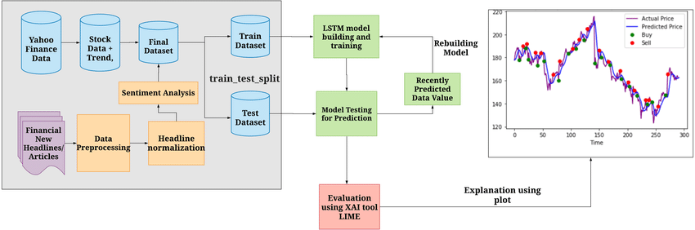



**6.Conclusion:**

By considering advanced deep learning techniques like CNN-LSTM and attention mechanisms, we aim to substantially enhance our predictive capabilities. These innovations will enable us to capture intricate patterns, adapt to changing market dynamics, and empower investors with more accurate insights for informed decision-making and optimized investment strategies.

Our pursuit of excellence in predictive modeling remains unwavering, with the ultimate goal of providing investors with cutting-edge tools to navigate the complex world of financial markets.