MINI END-TO-END APP DEPLOYMENT
Deployment Report
Prepared by: PGSN Intern Program
Docker Hub Repository: dilipdev714
Date: July 18, 2026

Table of Contents

Project Overview

Goal
Take a simple two-tier application (web frontend and database) and deploy it three different ways using previously acquired skills, combining and applying existing knowledge of Docker, Terraform, GitHub Actions, and Kubernetes without introducing new concepts.

Deliverables
- Dockerfile
- Terraform code
- GitHub Actions workflow file
- Kubernetes YAML manifests
- Architecture diagram
- README
- Screenshots

Day 1 — Build & Containerize the App

Recap
Docker basics and Dockerfile fundamentals were reviewed prior to implementation.

Implementation
- A simple sample application was created — a static HTML/Flask page displaying “Hello from PGSN Intern.”
- A Dockerfile was written for the application.
- The Docker image was built and run locally to verify functionality.
- The image was pushed to Docker Hub, consistent with the process used in Week 3, Day 3.
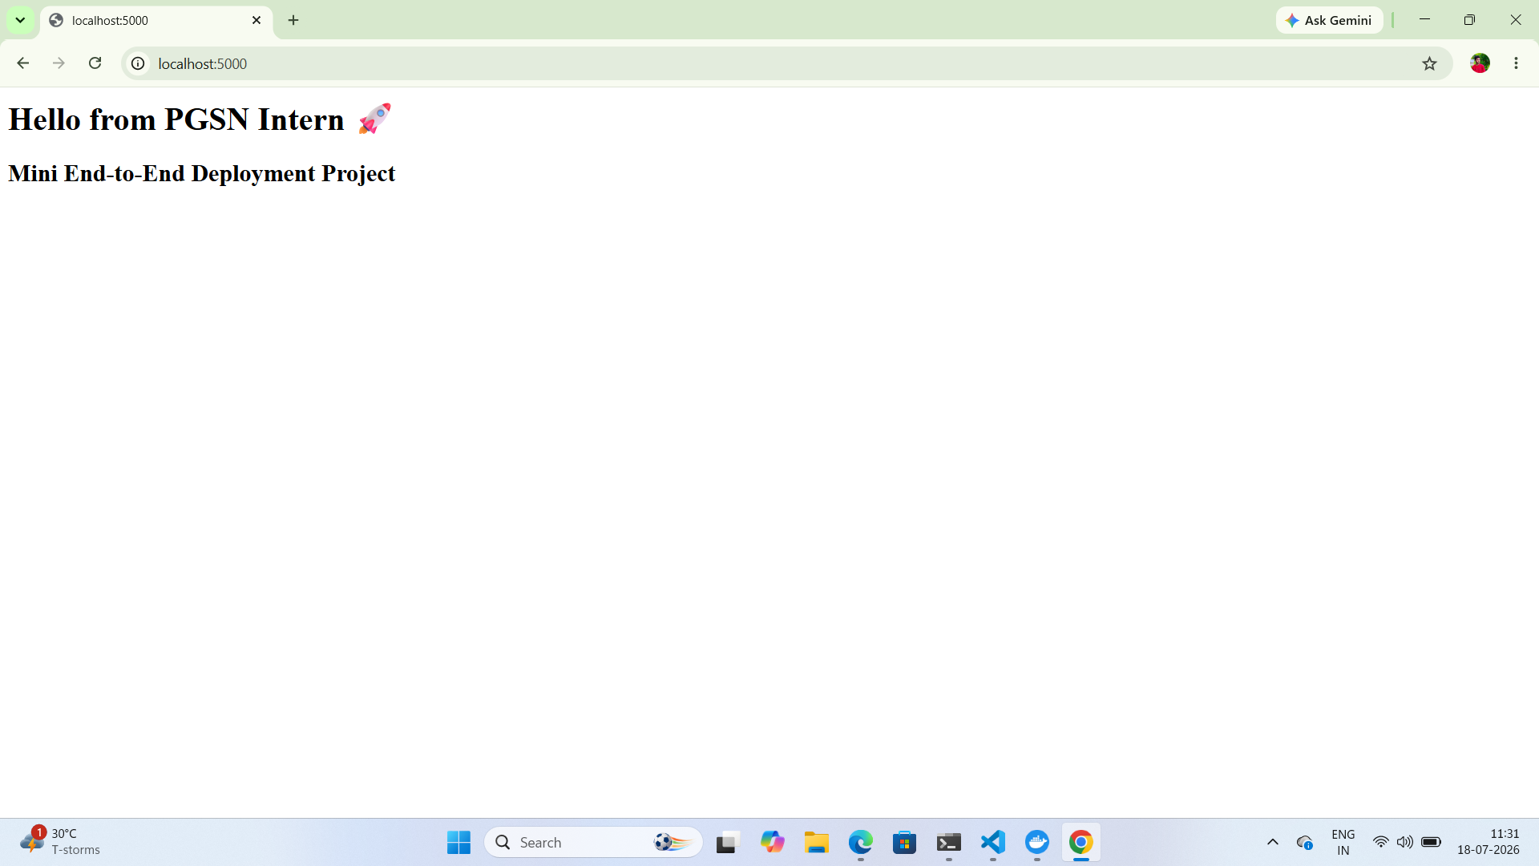
Figure 1: Application Running Locally on localhost:5000
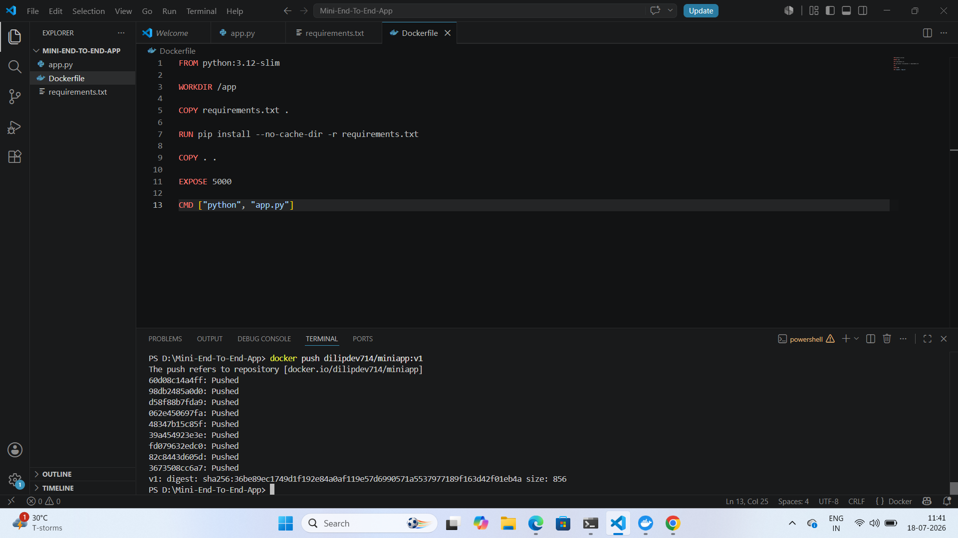
Figure 2: Dockerfile Configuration and Image Push to Docker Hub
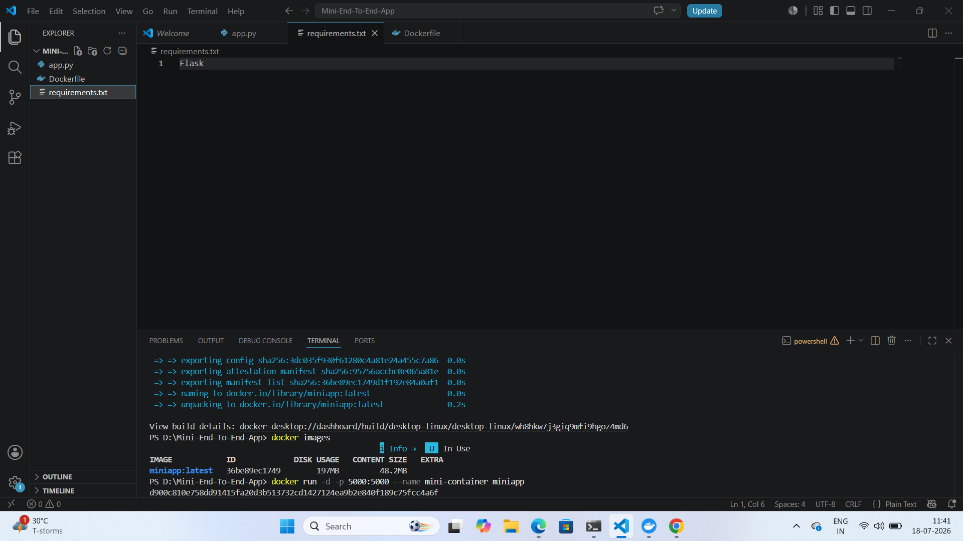
Figure 3: requirements.txt and Local Docker Build / Run Output
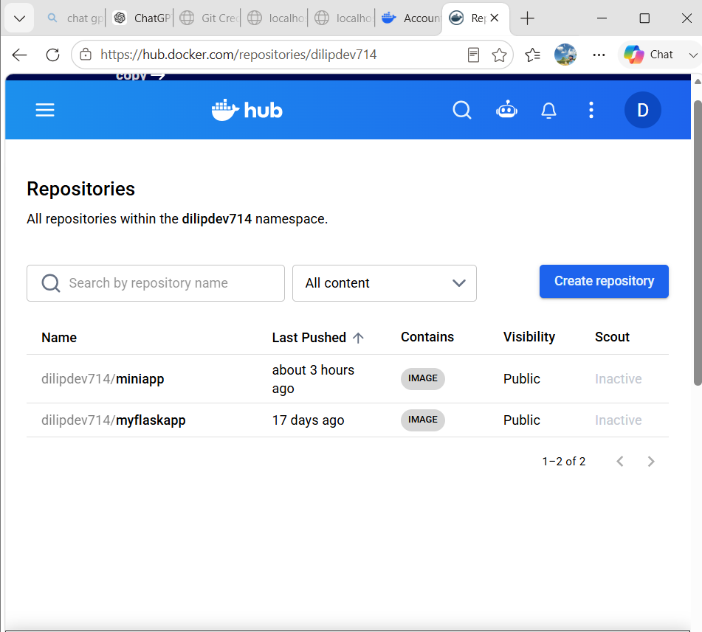
Figure 4: Docker Hub Repository Showing Pushed Image

Day 2 — Deploy on AWS with Terraform

Recap
Terraform resources and variables were reviewed prior to implementation.

Implementation
- The Week 3 Terraform code was reused to launch a single EC2 instance in a public subnet.
- User Data was used to automatically install Docker and pull the image from Docker Hub.
- The EC2 public IP address was output using Terraform outputs.
- The application was verified as reachable in a browser.
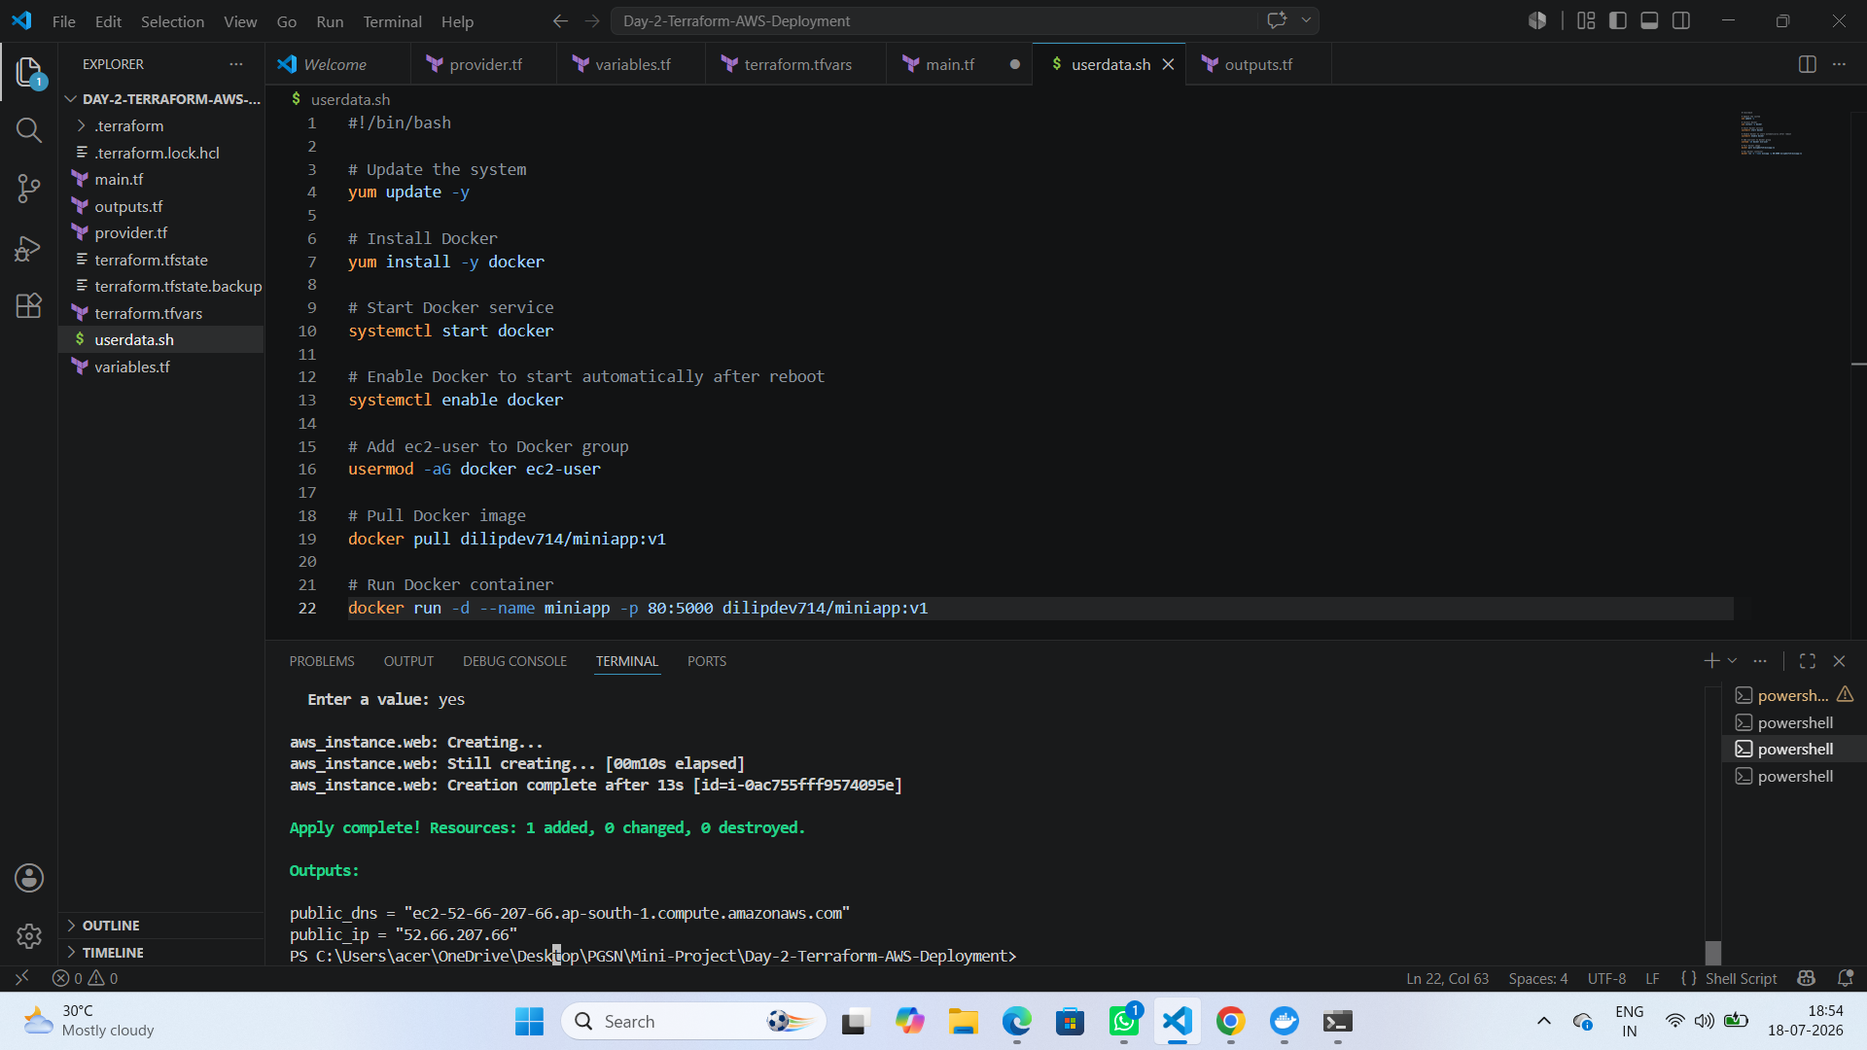
Figure 5: Terraform User Data Script and Apply Output
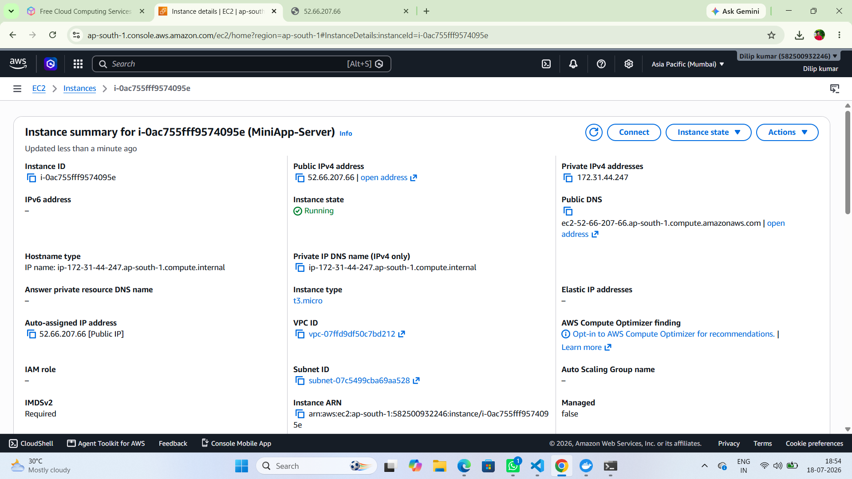
Figure 6: EC2 Instance Summary (MiniApp-Server)
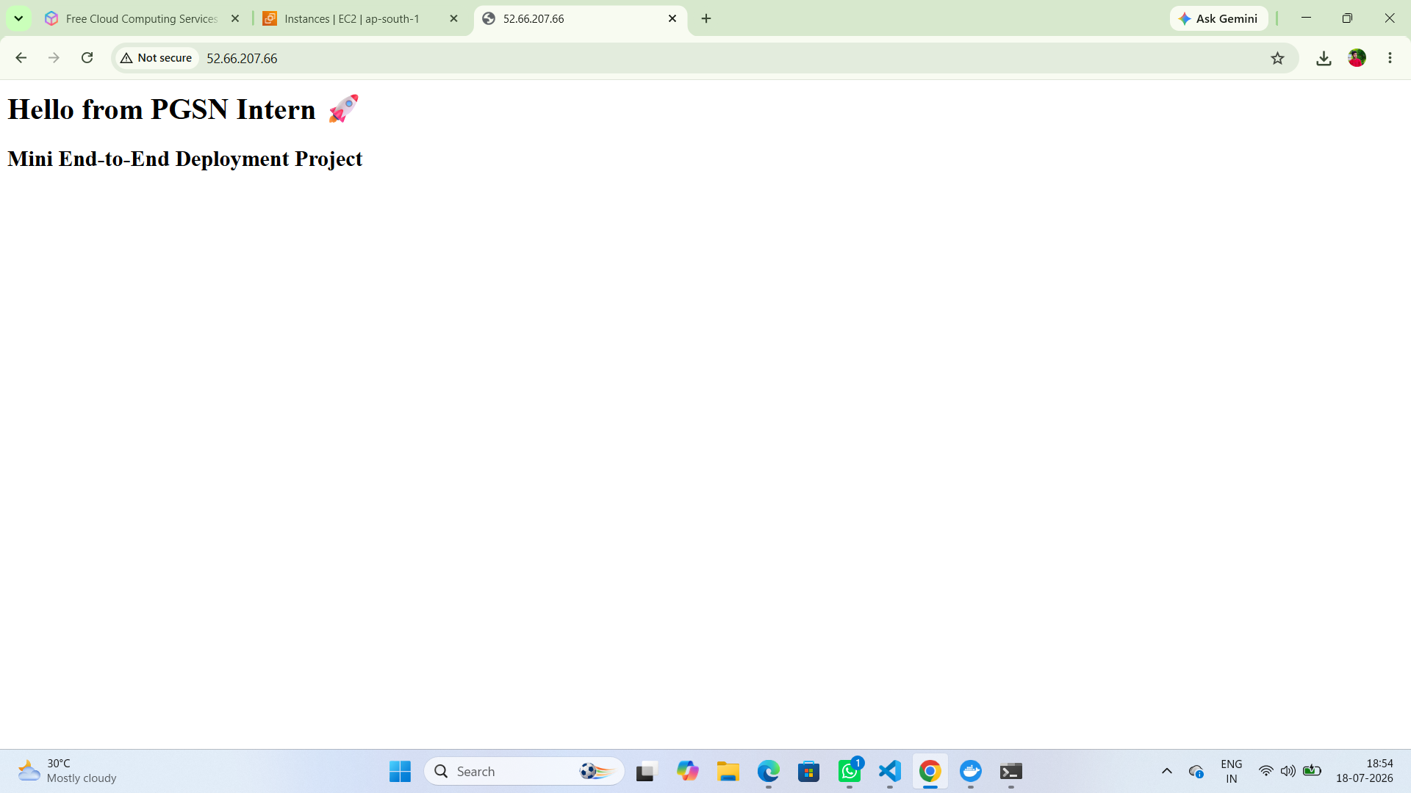
Figure 7: Application Verified via EC2 Public IP Address

Day 3 — Automate with GitHub Actions

Recap
GitHub Actions workflow files were reviewed prior to implementation.

Implementation
- A GitHub Actions workflow was created to build the Docker image on every push and push it to Docker Hub automatically.
- A manual redeploy was triggered on the EC2 instance by pulling the latest image and restarting the container, demonstrating that the automation flow functions correctly.
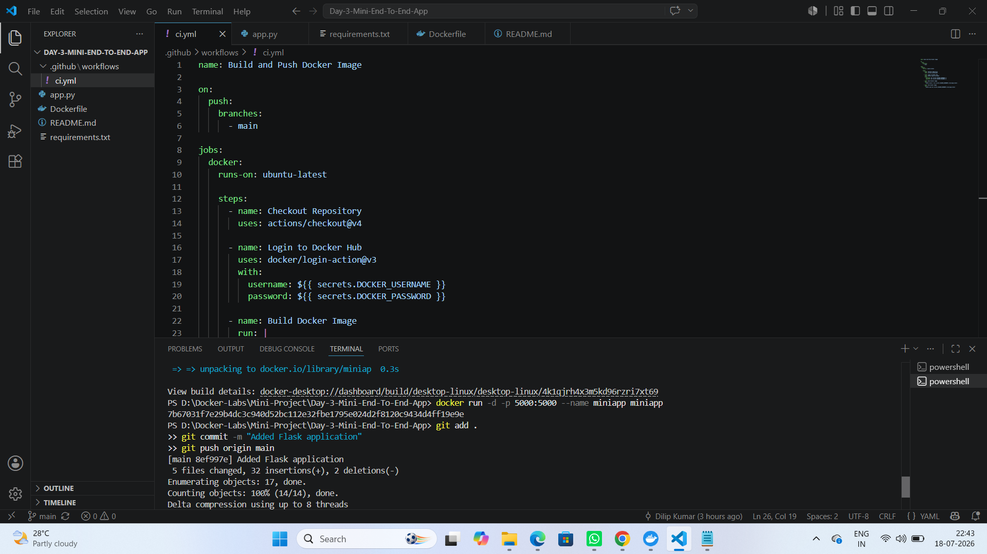
Figure 8: GitHub Actions Workflow File (ci.yml)
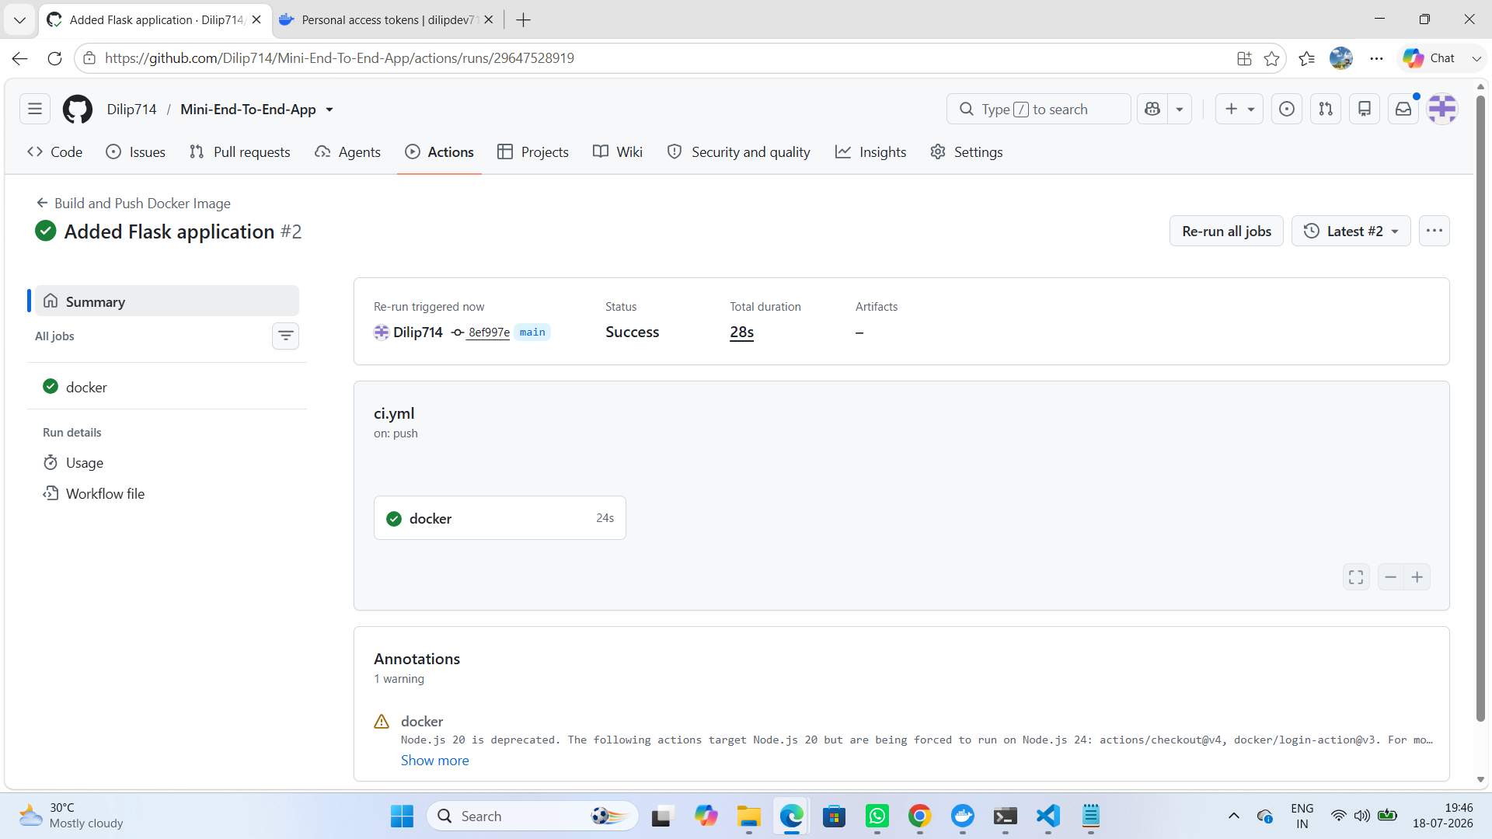
Figure 9: GitHub Actions Workflow Run — Success
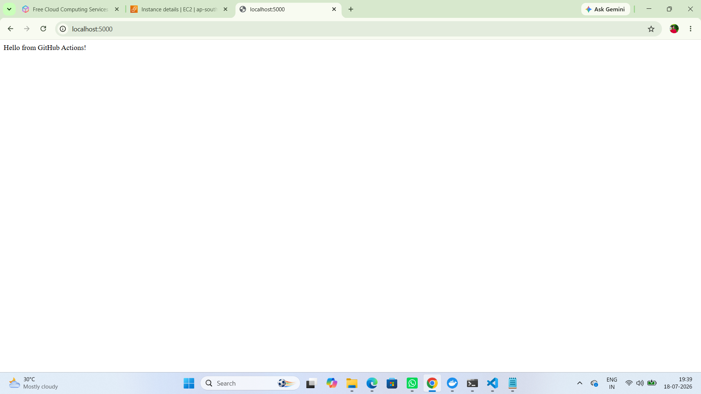
Figure 10: Updated Application Tested Locally After Build
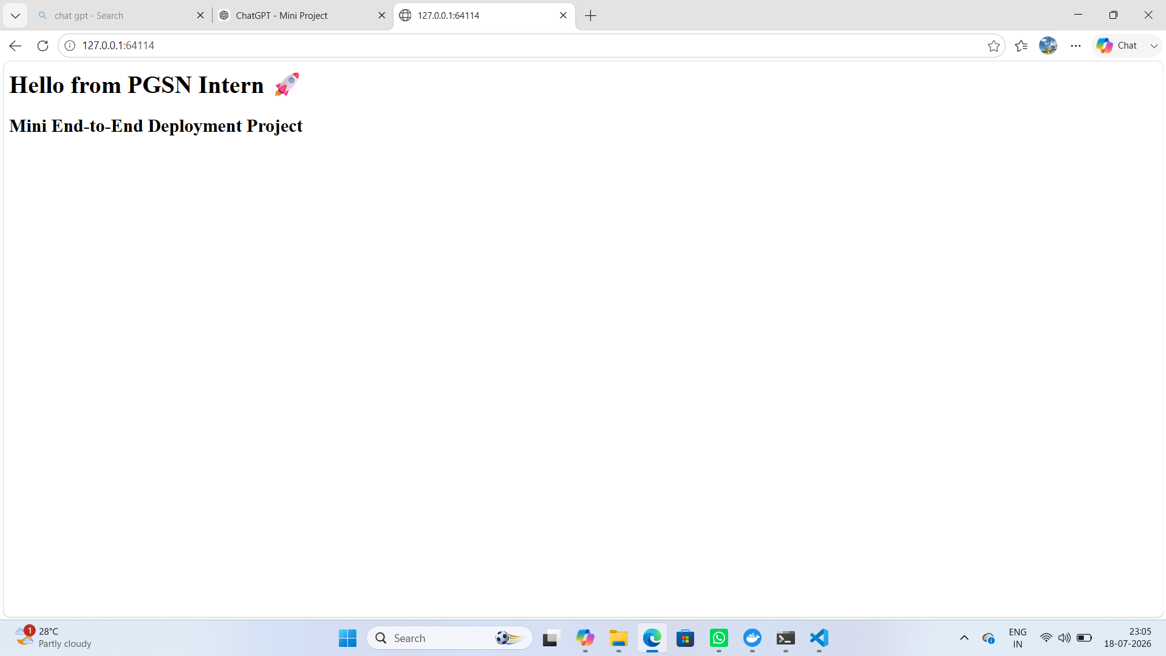
Figure 11: Installing Docker on the EC2 Instance via SSH
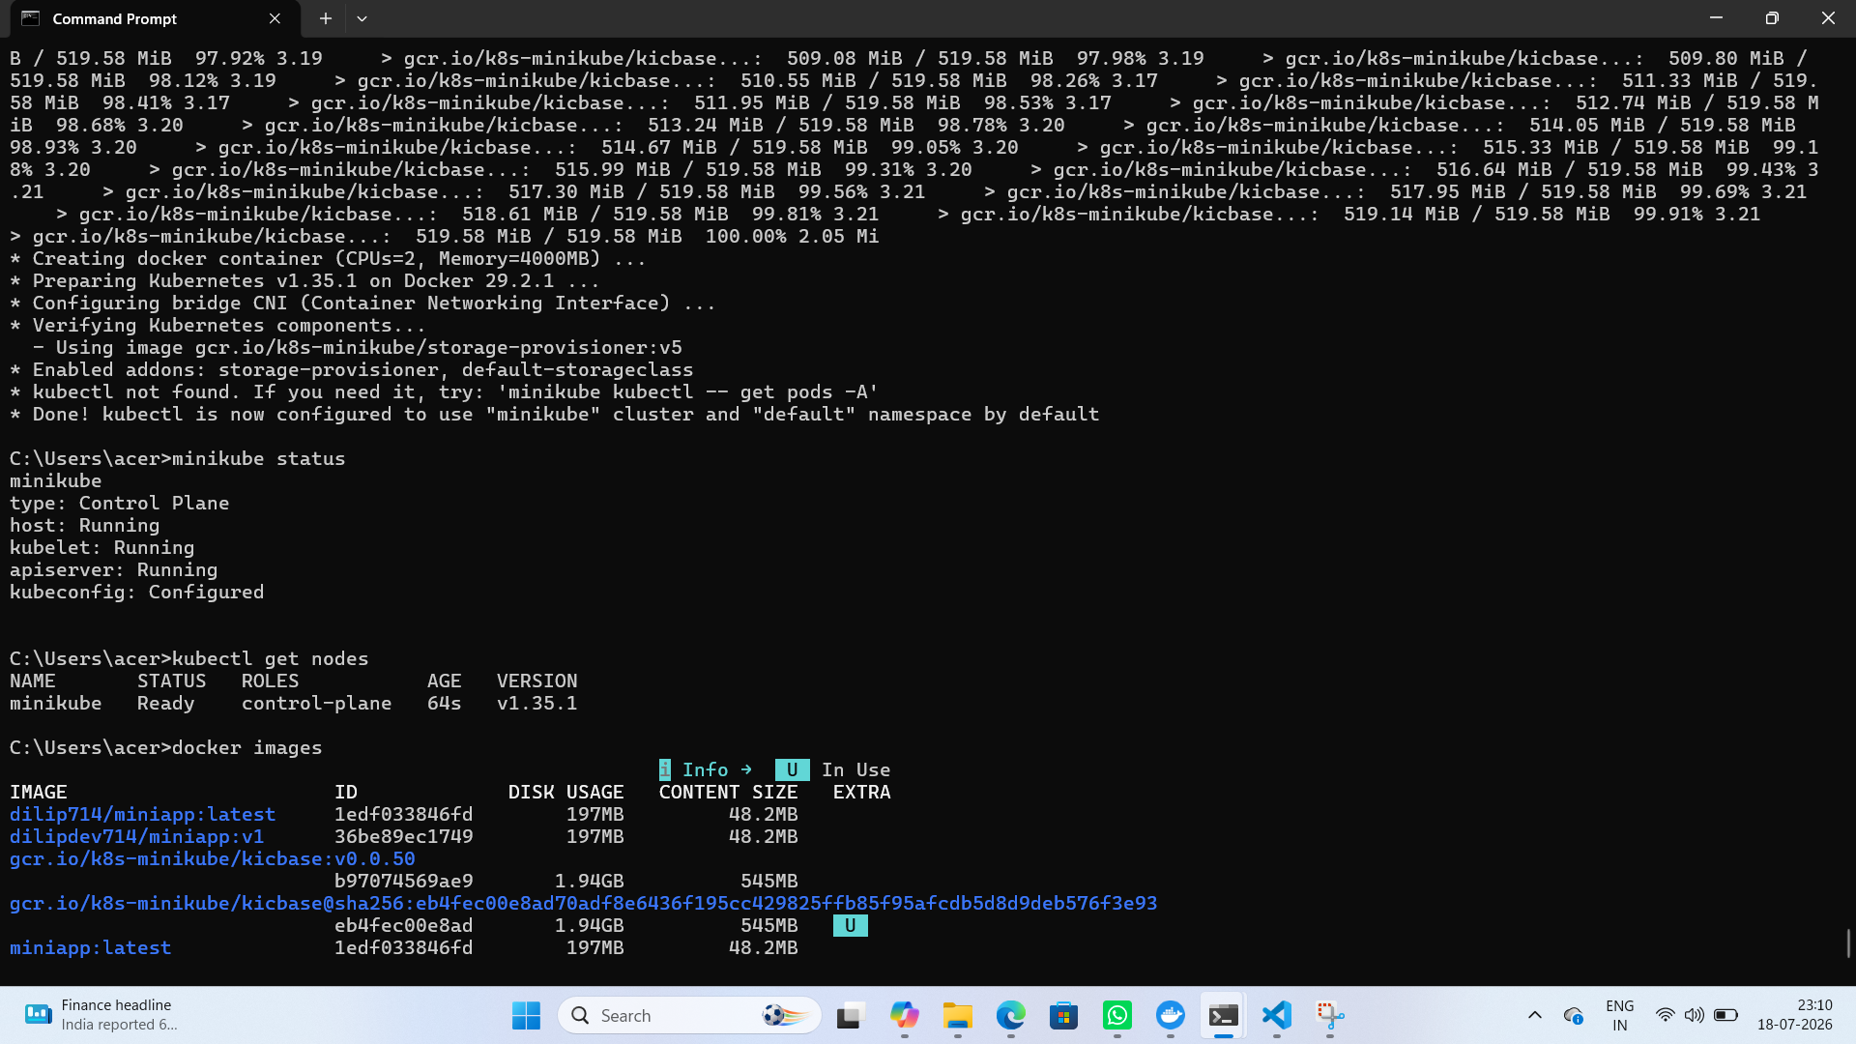
Figure 12: Pulling and Running the Updated Image on EC2
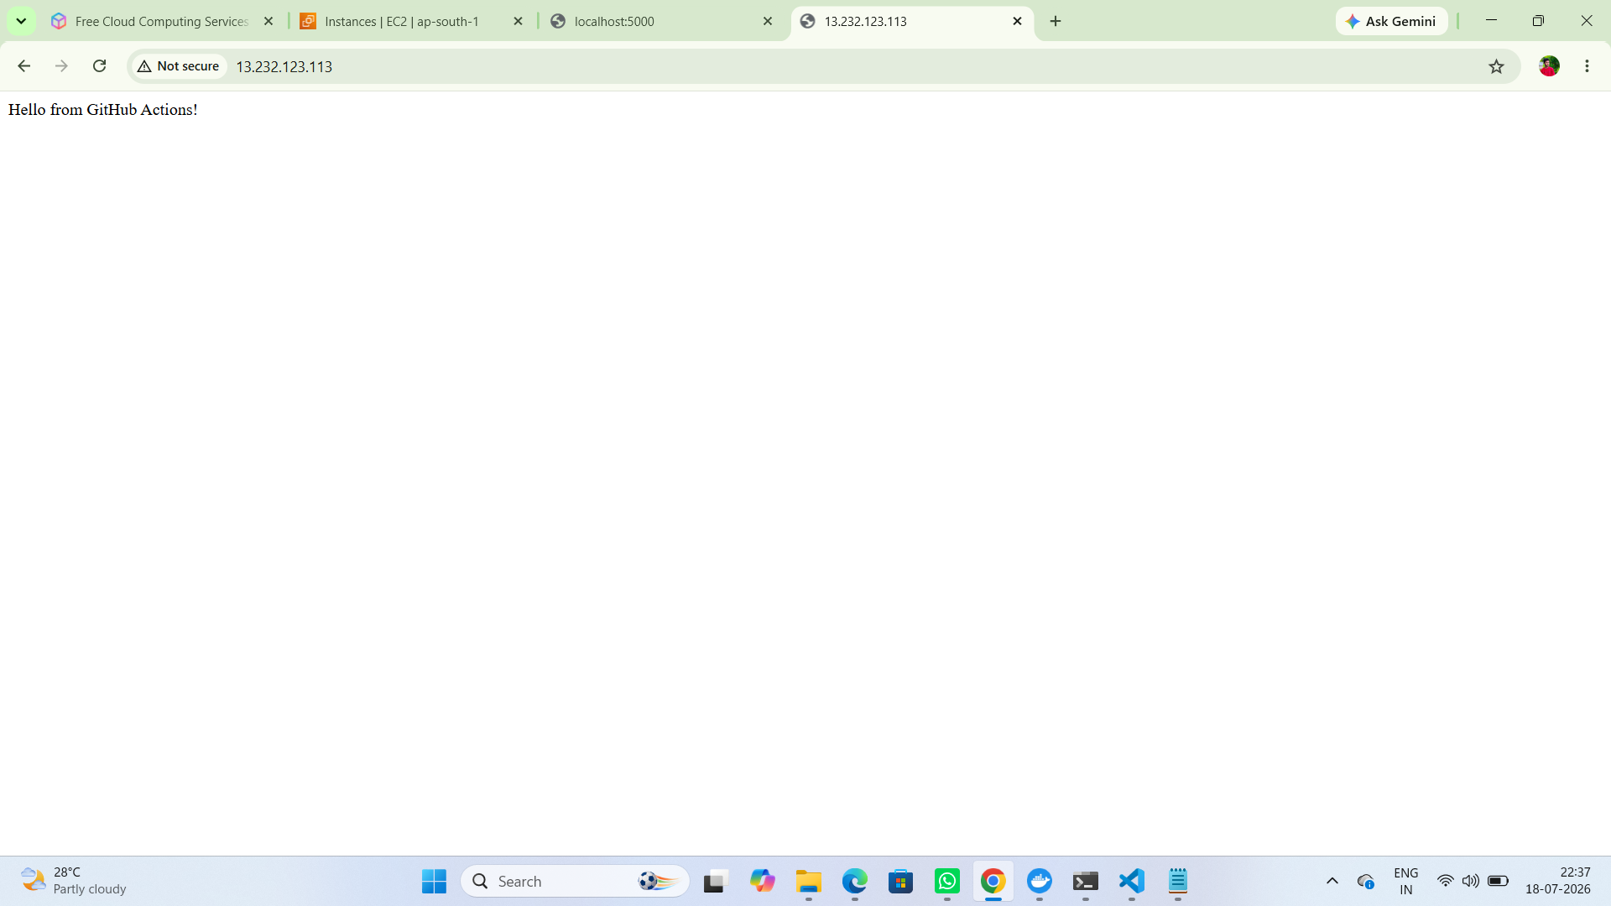
Figure 13: Updated Application Verified via EC2 Public IP
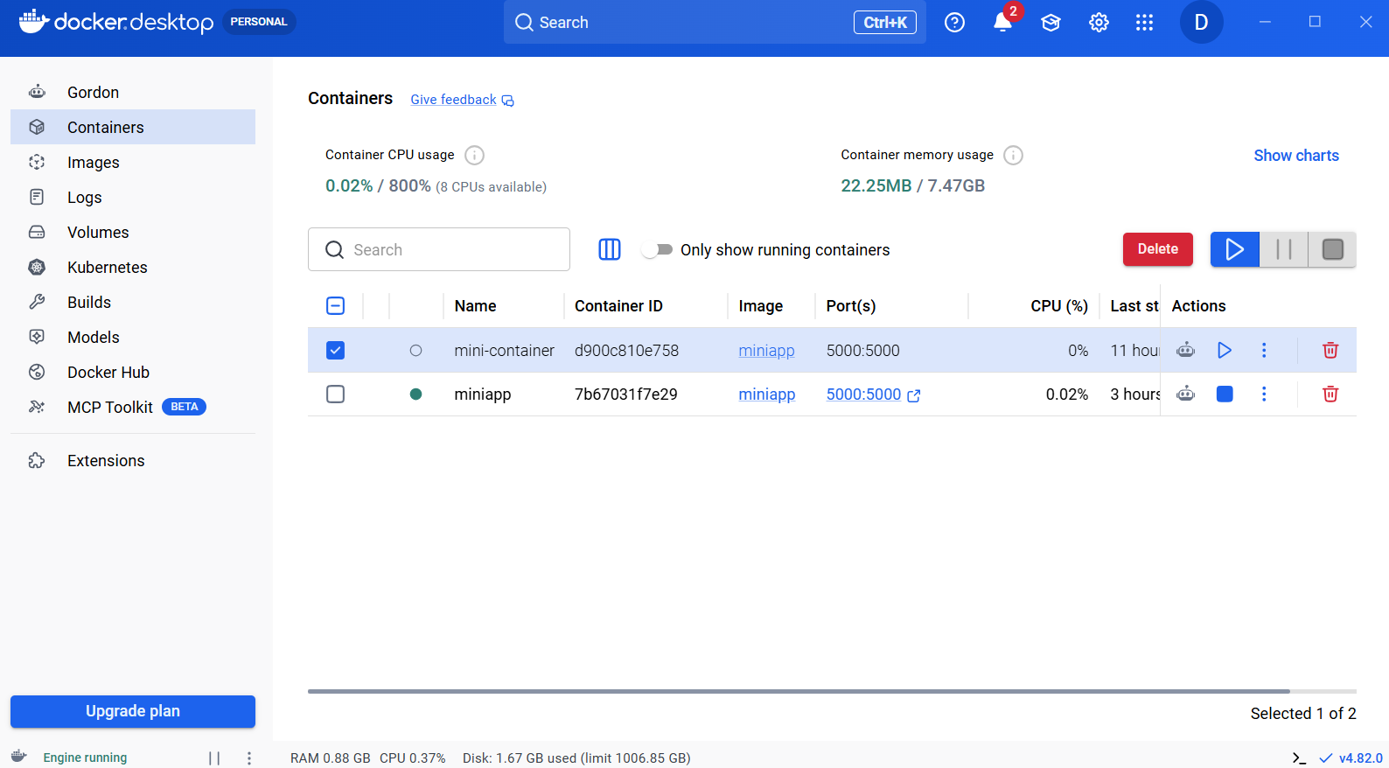
Figure 14: Docker Desktop — Running Containers Overview

Day 4 — Redeploy the Same App on Kubernetes

Recap
Kubernetes Deployments and Services were reviewed prior to implementation.

Implementation
- Using Minikube from the Kubernetes track, a Deployment with two replicas was created for the same Docker image.
- The Deployment was exposed using a NodePort Service.
- The application running on plain EC2 was compared with the application running on Kubernetes, noting the differences in scalability, replica management, and networking.
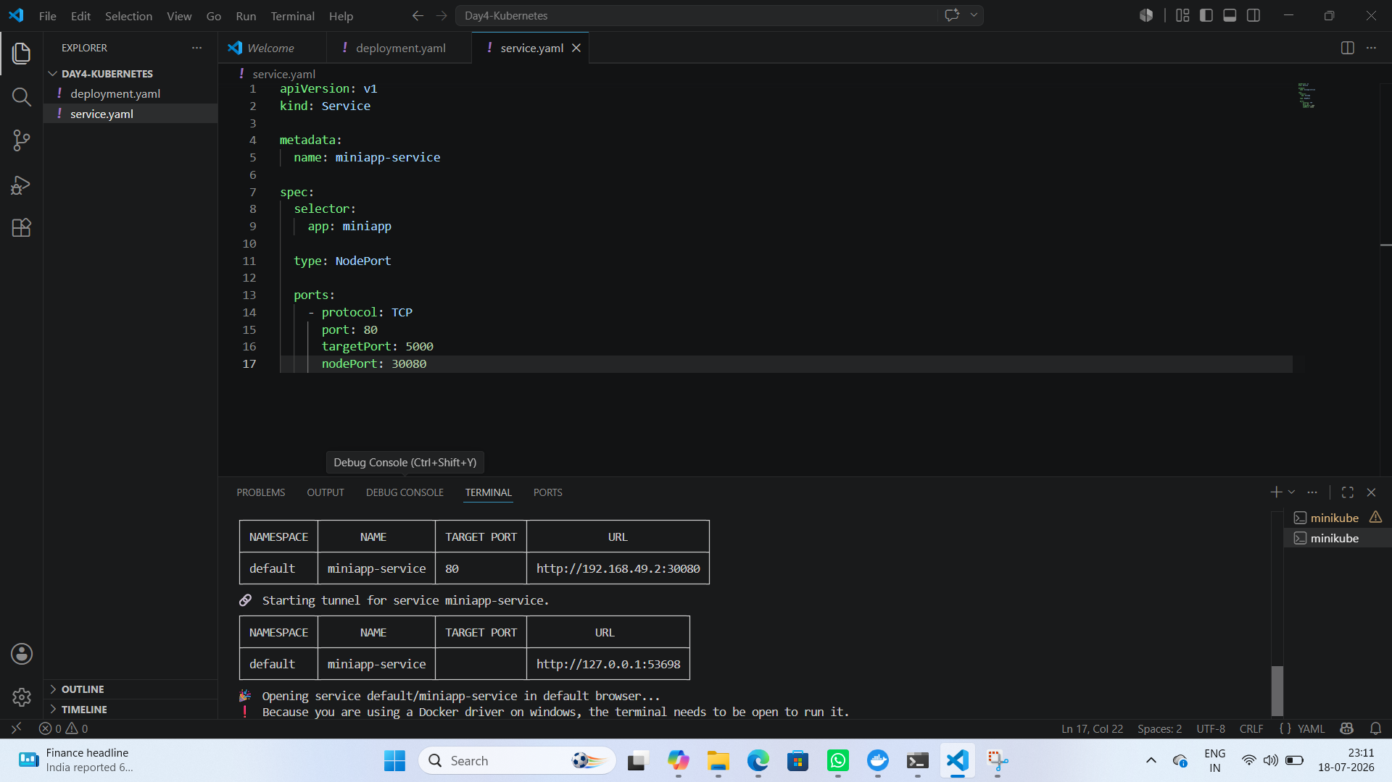
Figure 15: Minikube Cluster Status and Node Verification
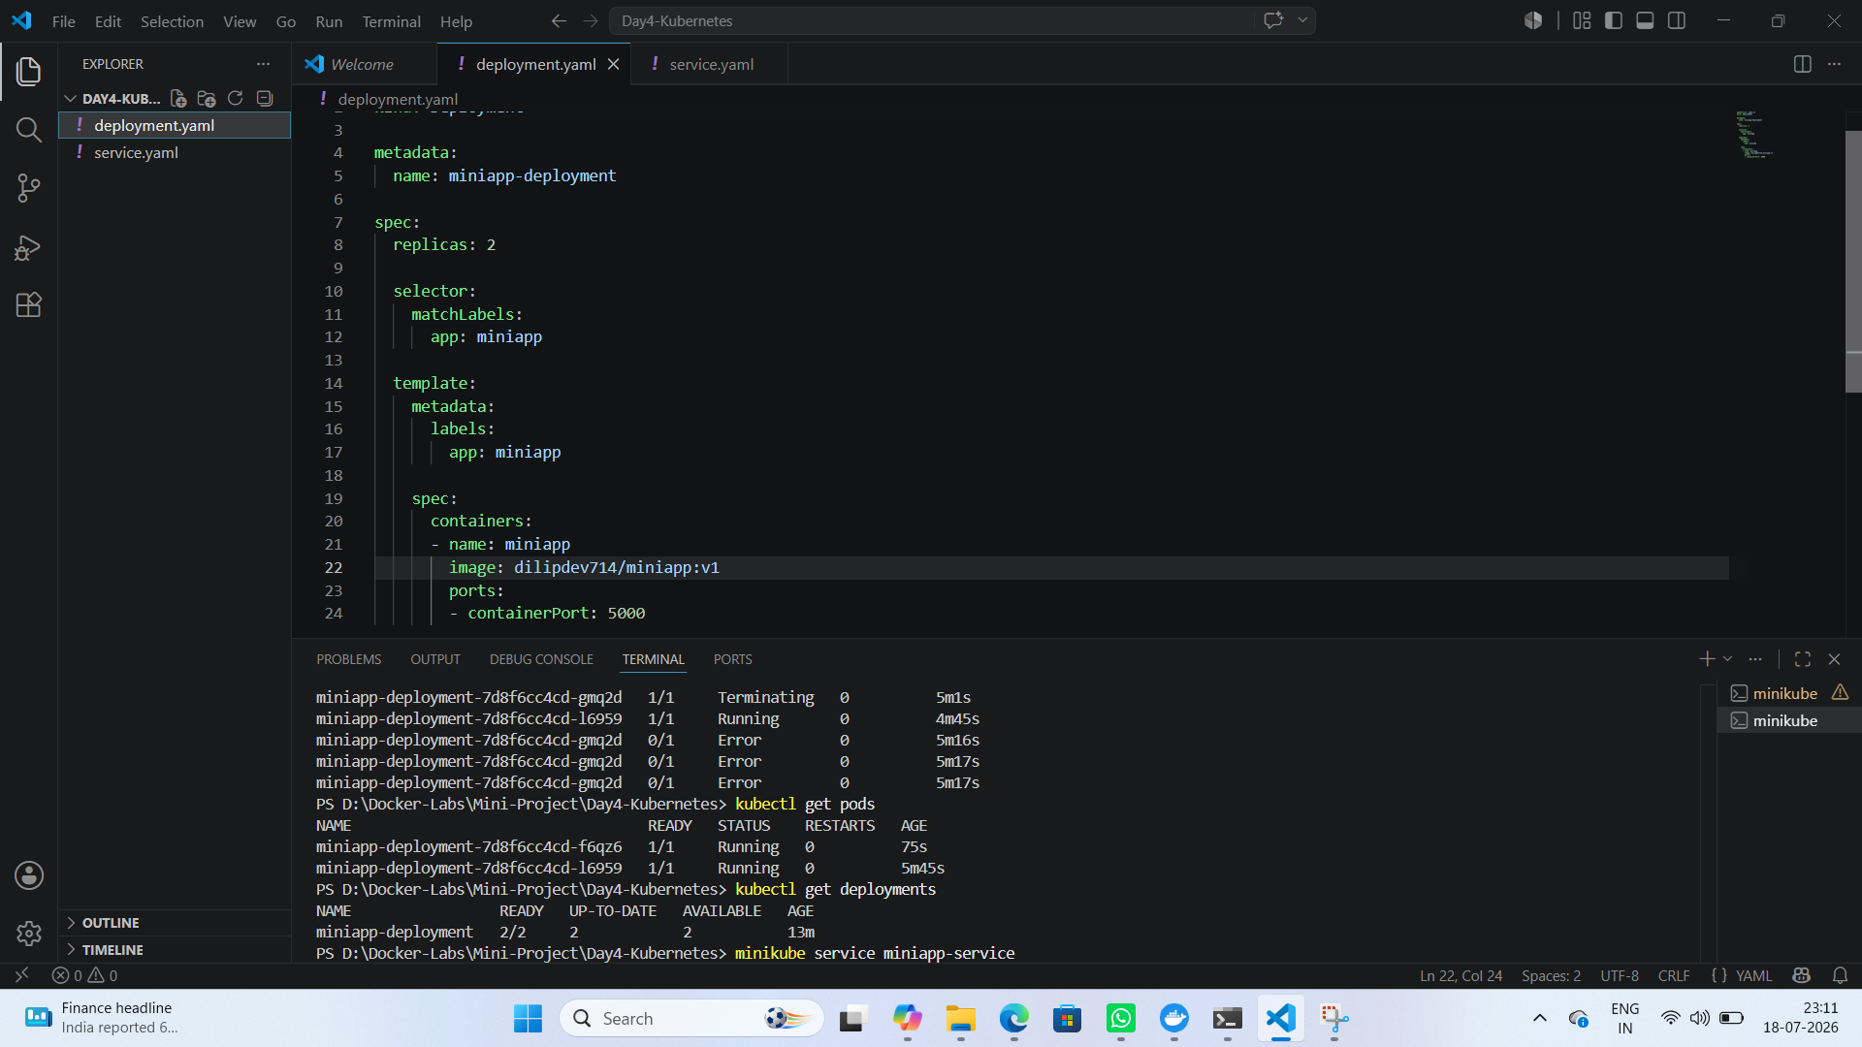
Figure 16: Kubernetes Deployment Manifest and Pod Status
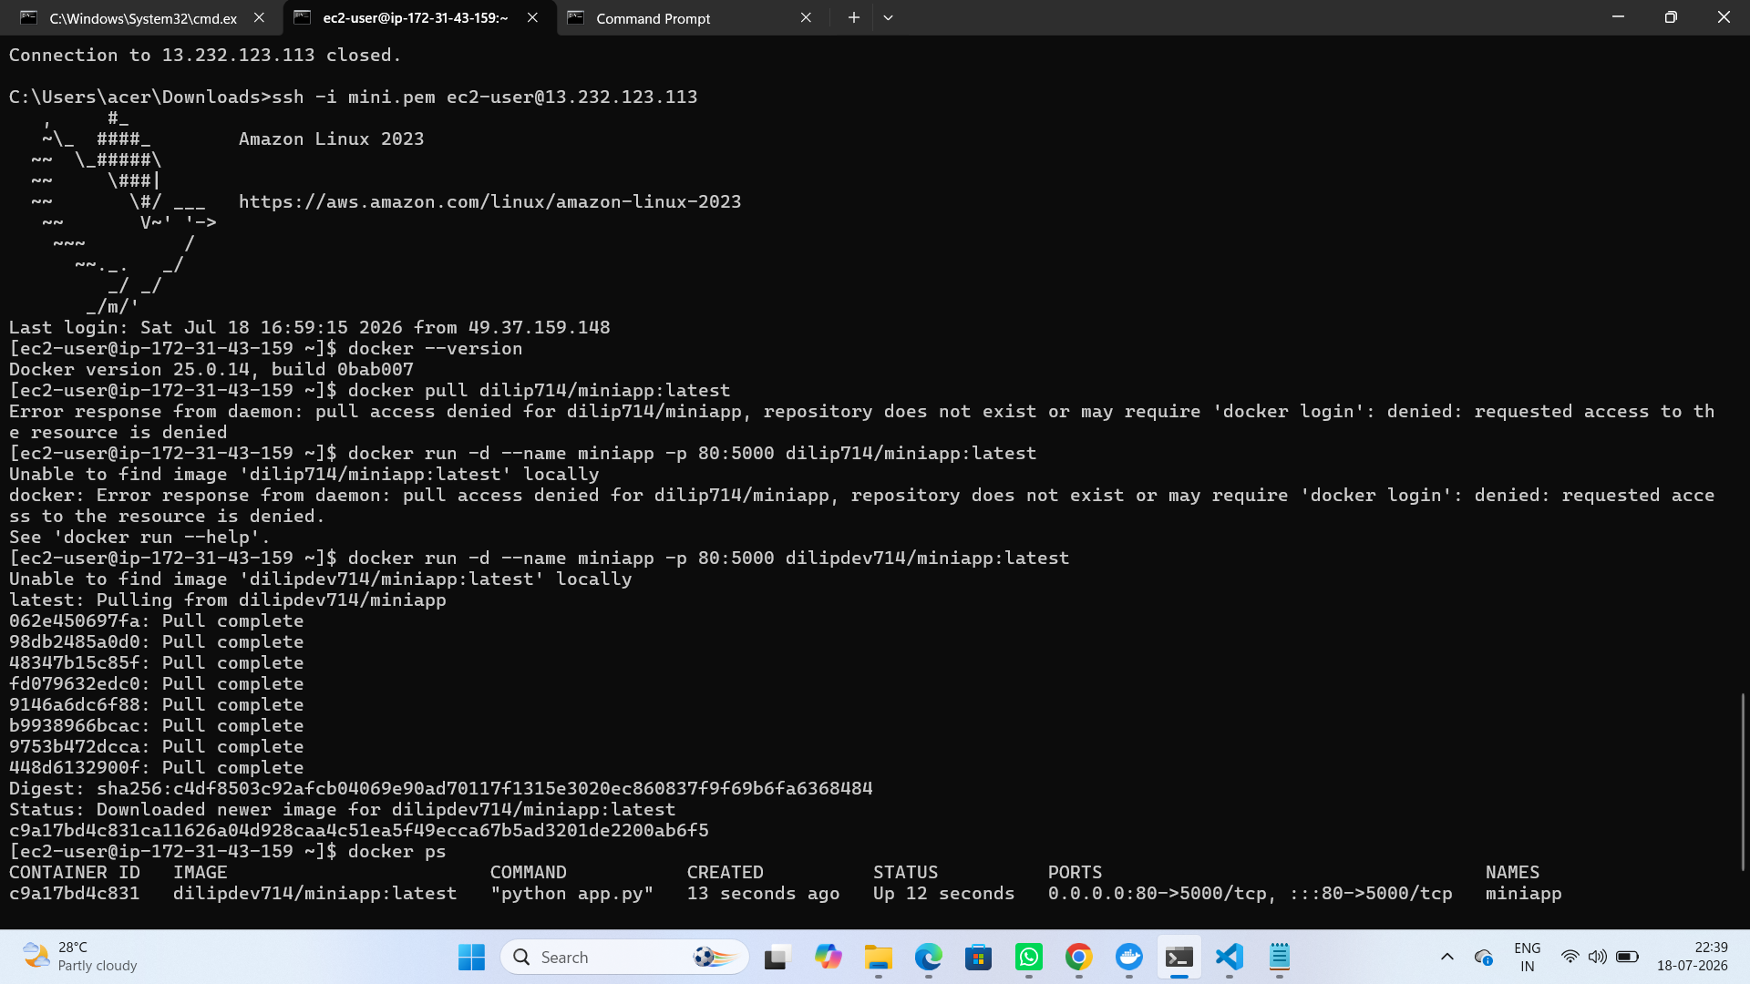
Figure 17: Kubernetes Service Manifest and Minikube Tunnel
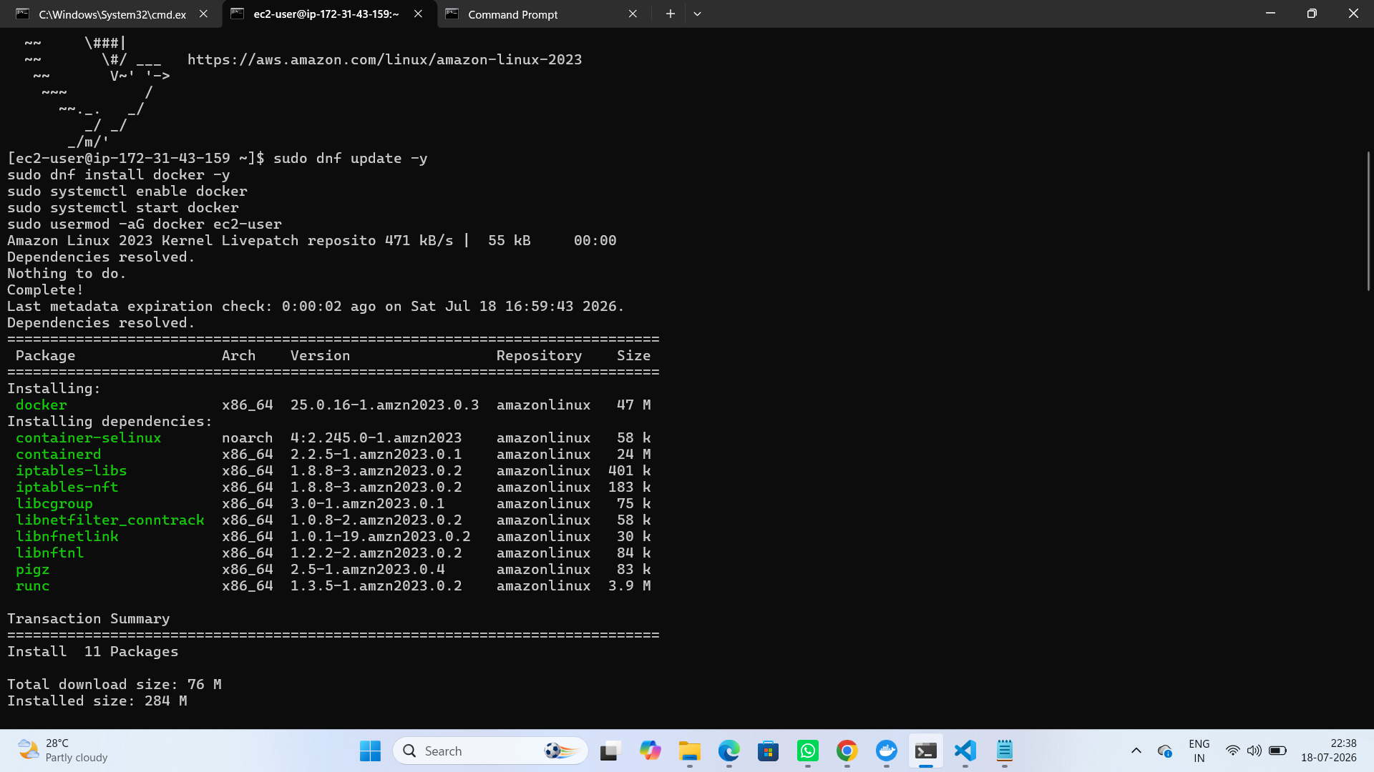
Figure 18: Application Verified via Kubernetes NodePort Service

Comparison: EC2 vs. Kubernetes
- EC2 deployment runs a single container instance manually managed via Docker commands over SSH.
- Kubernetes deployment runs two replicas automatically managed by the Deployment controller, providing built-in redundancy.
- Kubernetes exposes the application through a Service abstraction (NodePort), while the EC2 route relies on direct host port mapping.
- Scaling on Kubernetes requires only a replica count change, whereas scaling on EC2 would require provisioning additional instances.

Day 5 — Documentation & Demo

Implementation
- A simple architecture diagram was prepared showing both deployment paths (EC2 route and Kubernetes route).
- Screenshots demonstrating the application running both ways are included throughout this report (Figures 1–18).
- A five-minute walkthrough presentation was prepared, matching the final seminar presentation format used in Hackathon 1.

Summary
The mini end-to-end project successfully demonstrates deployment of the same containerized application through three complementary paths: a locally built and pushed Docker image, an automated EC2 deployment using Terraform and GitHub Actions, and a Kubernetes deployment using Minikube. Each path reuses concepts already learned, reinforcing the practical integration of Docker, Infrastructure as Code, CI/CD automation, and container orchestration.

