**Steps to run the Data Reconciliation engine rest api :**

1. Make sure Maven and Java is set in the current path
2. Run the command “mvn spring-boot:run”
3. When the tomcat is started, Go to any restapi clients like PostMan,etc.,
4. Hit the request <http://localhost:8080/fileMatcher> with method ‘POST’ and two files as body form-data as in below attachment.

e 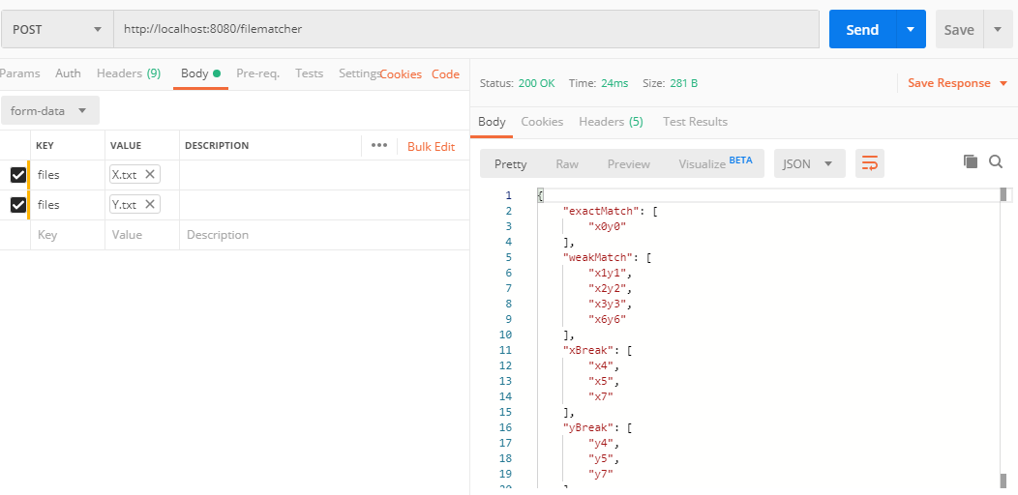

**Assumptions:**

1. The transactions between files has to be checked for each line equality
2. Return type of the api is json