FML

Dilip Kumar

2023-09-10

library(tinytex)  
getwd()

## [1] "C:/Users/user/Downloads/Assignment_1_FML"

setwd("C:/Users/user/Downloads/")  
let<-read.csv("delhi.csv")  
hist(let$year)

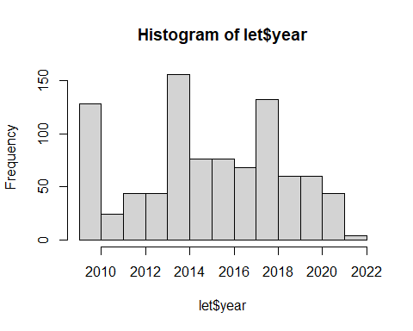

plot(let$year)

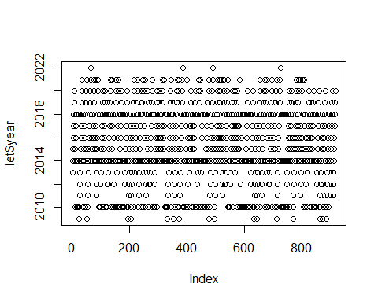

summary(let)

## X country_id country gender_code   
## Min. : 0.0 Min. : 8.0 Length:916 Length:916   
## 1st Qu.:228.8 1st Qu.:250.0 Class :character Class :character   
## Median :457.5 Median :498.0 Mode :character Mode :character   
## Mean :457.5 Mean :477.3   
## 3rd Qu.:686.2 3rd Qu.:724.0   
## Max. :915.0 Max. :860.0   
## gender year amount_local_currency  
## Length:916 Min. :2009 Min. : -46.200   
## Class :character 1st Qu.:2013 1st Qu.: 9.227   
## Mode :character Median :2015 Median : 29.060   
## Mean :2015 Mean : 350.171   
## 3rd Qu.:2018 3rd Qu.: 57.627   
## Max. :2022 Max. :20370.200

summary(let$serial.no)

## Length Class Mode   
## 0 NULL NULL