**README**

**Spring Boot – REST API Implementation**

**Prerequisite/info needed to run this Project:**

* **JDK 1.8** is used for this project. You should have this version or above, installed in your machine.
* **IDE** : This project is built using **Spring Tool Suite IDE** (STS). One can use Eclipse IDE too.
* **Server**: **Tomcat Server** is used. With STS, Tomcat is embedded by default in spring project. For Eclipse, install the Tomcat Server.
* **Database used:** **H2 database** (in-memory database ) is used. In every rerun of the application, the previous data from this database is erased.
* **Dependencies :** These are managed via **Maven** pom.xml file

**Import the Project:**

1. Clone the project from Github:
2. After cloning the project to your local system , you have to import it in Spring Tool Suite IDE.
3. Go to File-> Import-> Select Existing Maven Project-> Browse this cloned project from your local machine ->Finish

**How to Run the application:**

1. Start the Tomcat server.

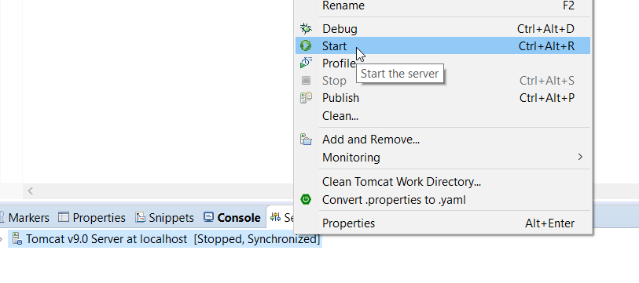

1. Now Run the Application as Spring Boot App: Click on project ->Run As -> Spring Boot App

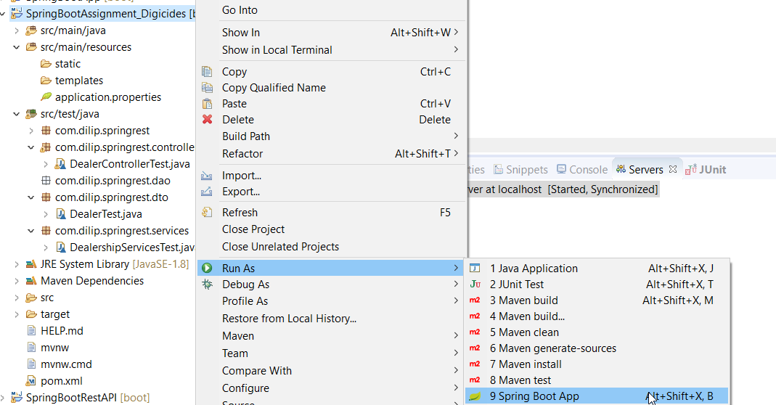

**Note :**

1. In this project **server port** is set to **8085**. If this port is shown as busy, then try to change the port to another one like 8086 or other in application.properties file under src/main/resources/ application.properties )
2. application.properties file also contains the H2 database configurations. These should not be changed and kept as such.

**Calling the APIs:**

1. **Client used**: One can use either **system browser** or **postman** as a client to fire the query/ APIs.
2. **Open the connection to H2 database:**
3. Type the following in your browser:

**localhost:8089/h2-console and Click connect**

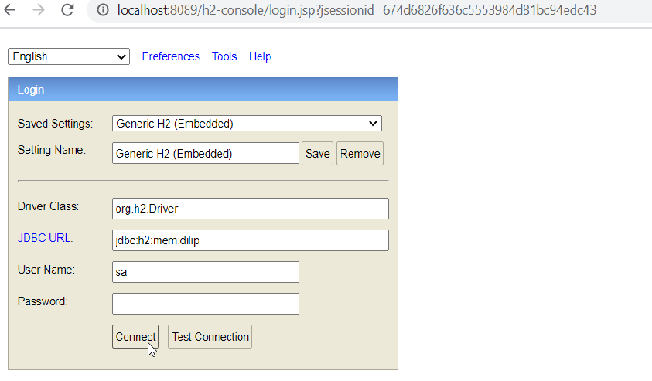

**We can see the DEALER table created there**

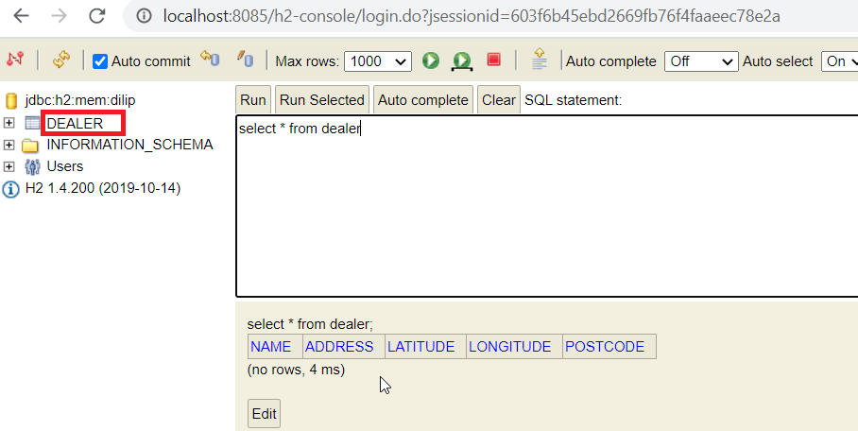

**API 1: Configuring the Dealership Details:**

1. This API adds the dealers information in to the database (H2 database)
2. Call the API as below in browser or postman:

localhost:8085/dealer?name=Dilip&address=Madhapur&postcode=500081

(The API takes 3 query parameters as given in requirements in the assignment.)

1. Check in H2:
2. Fire the query : select * from dealer and Click Run

You will see the new row is added with above values of query parameters alongwith latitude and longitude in database

**Note**: **name** is kept as primary key in the **dealer** table.

Likewise , you can call the API again with different values of 3 parameters.

**API 2:**

**a)Finding the nearest dealership details via postcode**

1. Call the API as below in browser or postman:

localhost:8085/ dealer?postcode=180001

1. This will return/show you the nearest dealer details fetched from H2 database in JSON format.



**b) Finding the nearest dealership details via latitude and longitude**

1. Call the API as below in browser or postman:

localhost:8085/dealers?lat=32.7346834&lon=74.872184

Note: We have used dealers here (In above we used dealer, so type carefully)

2. This will return/show you the nearest dealer details fetched from H2 database in JSON format.



**Junit Test cases:**

Some test cases are also made for testing the API functionality.

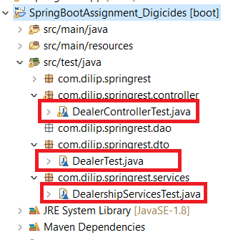

Run the test cases as:

Right click the test case -> Run as -> Junit Test