Auto Comments in Sim

 | A | B | C | D | E | F | G
1 | Auto Commments
2 | Reason | Fields update
3
4 | Launch update | name
5 |  | status
6 |  | PMM
7 |  | launchOwner
8 |  | adPolicy
9 |  | legal
10 |  | releaseManager
11 | task update | approvalStatus
12 |  | status
13 |  | dueDate

Auto comment in SIM working on below reason
- Updating approvalStatus, status, and dueDate fields on Task.
- Updating name and status fields in the launch, and also triggering updates based on changes to the assignee, with assistance from PMM, launchOwner, adPolicy, legal, and releaseManager.
- Triggering updates on task and coretasks refreshes with help of a Lambda function.

Triggering Below Comments
- When a non completed task is restored, Launchpad will reopen SIM with a comment
status resolved and status changedBy launchPad: Launchpad is re-opening this SIM because the task configs updated and this task is applicable to the launch entry.
status resolved and status changed By other/unknown OR status is open: The task configs updated and this task is now applicable to the launch entry.
- When a completed task is restored, Launchpad will add a comment to the SIM.
Launchpad is re-adding this task because the task configs updated and this task is applicable to the launch entry

- When a task approval is revoked by checklist refresh, Launchpad will reopen the SIM.IM with a comment.
status resolved and status changedBy launchPad: This SIM is being Re-opened because the approval status has been marked as non-compliant
status resolved and status changed By other/unknown OR status is open: The approval status has been marked as non-compliant
- When a task's approval is turned on, Launchpad will reopen with a comment.
status resolved and status changedBy launchPad: Launchpad is re-opening this SIM because the task configs updated and this task requires approval to be closed out
status resolved and status changed By other/unknown OR status is open: The task configs updated and this task requires approval to be closed out
- When task is deleted
status is open: Launchpad is resolving this SIM because the task configs updated and this task is no longer applicable to the launch entry
status is resolved: The task configs were updated and this task is no longer applicable to the launch entry
- When task is approved and also completed
status is open: `${userId} marked this task as ${approval status} so this SIM is being closed.
status is resolved: `${userId} marked this task as ${approval status}.

- When task is marked as completed
status is open: ${userId} set task status to ${status} which is closing your SIM.
status is resolved: ${userId} set task status to ${status}.
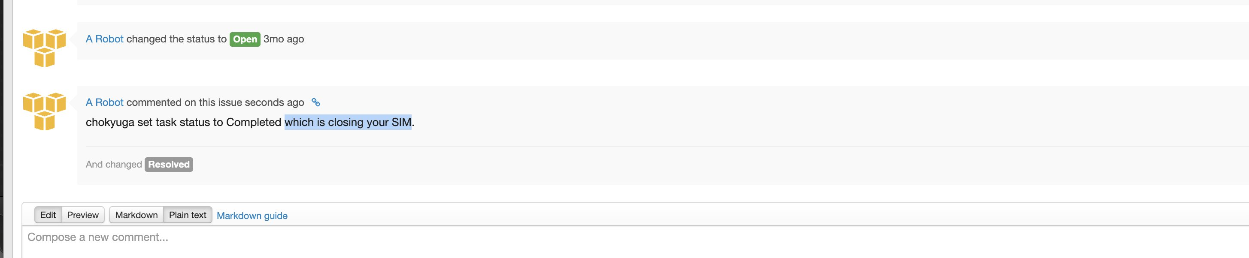
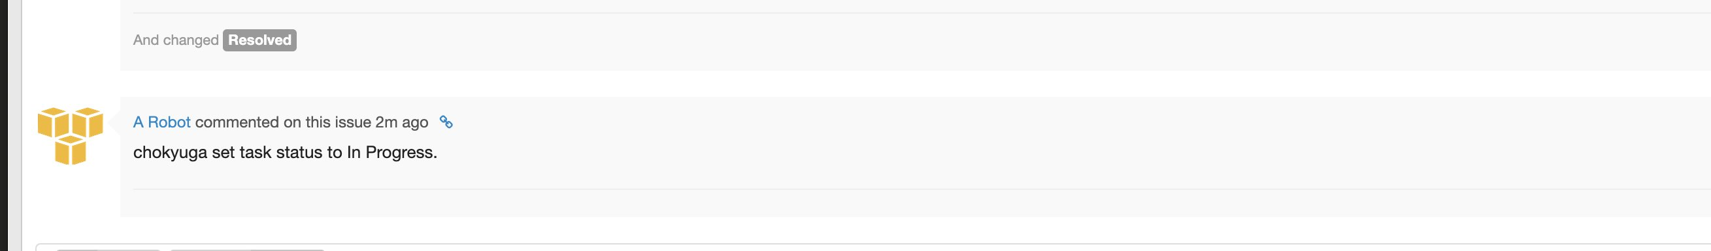
- When task status changed as not applicable
This Launch showed the “Skip for launch” task status was not applicable and rationale provided is ${not applicable reason}

- When task approval is in progress
status resolved and status changedBy launchPad: ${userId} marked this task as ${approval status} so this SIM is being reopened
status resolved and status changed By other/unknown OR status is open: `${userId} marked this task as ${approval status}.

- When task is not completed and status is changed
status resolved and status changedBy launchPad: ${userId} set task status to ${updated status} which is reopening your SIM.
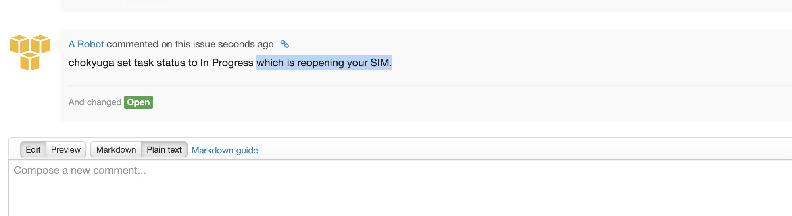
status resolved and status changed By other/unknown OR status is open: ${userId} set task status to ${updated status}.

- when task is completed and approved and need to require re-approval
The phase details for this task have changed so this approval has re-opened. Please reapprove this phase after reviewing the changes.

- when task phase update
This task is now applicable to different phase of your launch. The system has moved this task and replaced the phase details above. You can retrieve old data from the audit tab in your SIM
- when task have same phase and defferent release
Launch owner ${launchOwner} added another ${launchPhase} phase to this launch on ${currentDateTime}. See details below.
Phase: ${launchPhase}
Phase ID: ${phaseVisibleId}
Locales: ${locales}
Access points: ${accessPoints}
Launch date: ${launchDate}
${endDate ? `End date: ${endDate}` : ''}
- when task locale value is changed
Launch owner ${launchOwner} added ${localesAdded} locales to this phase on ${currentDateTime}. Please add these locales to your evaluation of this launch.
- when task locale value is removed
Launch owner ${launchOwner} removed ${localesRemoved} locales to this phase on ${currentDateTime}. Please remove these locales from your evaluation of this launch.
- when task access point added
Launch owner ${launchOwner} added ${accessPointsAdded} access points to this phase on ${currentDateTime}. Please add these access points to your evaluation of this launch.
- when task access point removed
Launch owner ${launchOwner} removed ${accessPointsRemoved} access points to this phase on ${currentDateTime}. Please remove these access points from your evaluation of this launch.
- when task release phase status changed
For this phase, ${launchPhase} phase, Status changed from ${value.old} to ${value.new} on ${currentDateTime} by ${value.userId}.
- when task phase launch date changed
For this phase, ${launchPhase} phase, Launch Date changed from ${convertStringToStandardDate(value.old)} to ${convertStringToStandardDate(value.new)} on ${currentDateTime} by ${value.userId}.
- when task phase launch owner changed
Launch owner for ${launchName} launch has changed from ${value.old} to ${value.new} on ${currentDateTime} by ${value.userId}

- when Launch is set to Inactive Status(Cancelled or Deleted)
status is open: This SIM is being automatically resolved because the launch status has changed to ${launch.status}
status is resolved: The launch status has changed to ${launch.status}

