Industry Project Title | Superstore Profit Analytics
Name of the Company | TCS ION
Name of the Institute | YISU Training Institute
Start Date | End Date | Total Effort (hrs.) | Project Environment | Tools used
29-9-2025 | 10-11-2025 | 90 Hours | Python, Power BI | Python (Pandas, NumPy, Matplotlib, Seaborn), Power BI Desktop

TABLE OF CONTENT
- Title
- Abstract
- Acknowledgements
- Introduction
- Objective and Scope
- Problem Statement
- Hypotheses
- Existing Approaches
- Approach / Methodology - Tools and Technologies used
- Workflow
- Assumptions
- Implementation - Data collection, Processing Steps, Diagrams - Charts, Table
- Solution Design
- Challenges & Opportunities
- Reflections on the project
- Recommendations
- Outcome / Conclusion
- Enhancement Scope
- Link to code and executable file
- Research questions and responses
- References

TITLE
Superstore Profit Analytics
This project focuses on analyzing retail sales data to uncover meaningful insights that help improve profitability and operational efficiency. It uses Python for data cleaning, preprocessing, and exploratory analysis, and Power BI for developing interactive dashboards and visual reports.
The study identifies the top-performing product categories, customer segments, and regions, while also examining the impact of discounting and seasonality on overall profitability. By integrating two analytical tools, the project demonstrates a complete end-to-end business intelligence workflow — from raw data to strategic insights.

ABSTRACT
The Superstore Profit Analytics project is designed to transform raw retail data into actionable business intelligence using modern analytics techniques. The importance of this project lies in addressing a common challenge in the retail sector — large volumes of unorganized sales data that lack structured analysis and visualization.
In this project, Python was used for data acquisition, cleaning, transformation, and feature engineering. Important metrics such as Profit Margin, Order Month, Order Quarter, and Discount Categories were created for detailed analysis. After preprocessing, Power BI was utilized to design dashboards that present clear and interactive views of sales, profits, and customer trends.
The major results indicate that the Technology category generates the highest profit, the Consumer segment drives most sales, and the West region shows the greatest profitability. Moreover, it was observed that discounts above 25% significantly reduce profit margins, and that sales peak in Quarter 4 (October–December) due to seasonal demand.
This combination of Python and Power BI establishes a reliable analytics pipeline for retailers to improve decision-making, plan inventory, and design effective pricing and marketing strategies.

ACKNOWLEDGEMENTS
I would like to express my sincere gratitude to YISU Training Institute and TCS iON for providing me with the valuable opportunity to work on the project titled “Superstore Profit Analytics.”
This project has been an integral part of the Placement Success Program for Graduate Engineer Trainee in Information Technology (GET-IT), and it has given me the practical experience of applying data analytics and visualization techniques to a real-world business scenario.
I am extremely thankful to my mentors and trainers at YISU for their continuous support, guidance, and encouragement throughout the training and project period. Their mentorship helped me gain a deeper understanding of Python, Power BI, data preprocessing, and business intelligence concepts.
I would also like to thank TCS ION for structuring such a comprehensive learning program that bridges the gap between academic knowledge and industry expectations. The entire journey of this project has enhanced my analytical thinking, technical proficiency, and problem-solving skills, which will be valuable in my professional career.
Lastly, I wish to extend my gratitude to my family and peers for their constant motivation and encouragement throughout the duration of this project. Their support played a key role in helping me stay consistent and complete this work successfully.

INTRODUCTION
Retail businesses generate vast amounts of transactional data every day, covering sales, profit, discounts, and customer details. However, this data often remains underutilized because it is not properly analyzed or visualized. The Superstore Profit Analytics project addresses this issue by applying data analytics and business intelligence (BI) techniques to extract useful insights from retail sales data.
The term analytics refers to the systematic computational analysis of data to discover meaningful patterns and trends. Profit analytics specifically focuses on studying sales and profit data to understand which products, customers, and regions contribute the most to business success. Business Intelligence (BI), through platforms like Power BI, helps organizations present complex data visually, making it easier for decision-makers to act.
This project combines the strengths of Python (for data cleaning and statistical analysis) and Power BI (for dashboard creation and visualization) to analyze the Global Superstore dataset. The dataset contains details such as order dates, product categories, sales amounts, profit values, discounts, customer segments, and regional information.
By analyzing these factors, the project aims to answer key business questions such as:
- Which products and categories are most profitable?
- Which customer segment contributes most to revenue?
- How do discounts affect profit?
- Are there seasonal sales patterns?
- Which regions or states perform best?
Through this comprehensive analysis, the project demonstrates how data-driven insights can optimize marketing strategies, improve logistics, and support informed decision-making within the retail domain.

OBJECTIVE AND SCOPE
Objective
The primary objective of the project “Superstore Profit Analytics” is to perform a detailed profit analysis using modern data analytics techniques and tools. The aim is to identify the factors that drive profitability, understand customer behavior, and uncover patterns that influence business outcomes.
In a competitive retail environment, organizations collect vast amounts of data through daily operations such as sales transactions, product orders, and shipping. However, without structured analysis, this data remains unused and fails to deliver meaningful insights. This project focuses on transforming raw retail data into actionable business intelligence by leveraging Python for data processing and Power BI for visualization.
The ultimate goal of this project is to design and implement a data-driven analytical system that helps business decision-makers evaluate performance, identify profitable segments, and optimize strategies for higher returns.
By examining key business parameters like sales, profit, discount, category performance, and customer segmentation, the project provides clear and quantifiable insights into profitability trends.
Additionally, this project emphasizes the importance of data accuracy, visualization, and interpretability. It demonstrates how a combination of analytical programming and business intelligence tools can turn complex datasets into clear, strategic insights that help organizations improve operational efficiency, profitability, and customer understanding.
Specific Goals
The project is structured around several measurable objectives to ensure a systematic approach to profit analysis and visualization:
- To clean, preprocess, and transform raw data using Python:
The dataset contains records related to orders, sales, and profits from a superstore. The first step focuses on preparing this data by removing missing values, correcting inconsistencies, renaming columns for clarity, and converting data types. The process ensures that only accurate and relevant data is used for analysis.
- To conduct exploratory data analysis (EDA) to discover profit-related patterns:
Using Python libraries such as Pandas, Matplotlib, and Seaborn, exploratory data analysis is conducted to uncover trends in sales, discounts, and profit. This helps identify which product categories, regions, or customer segments contribute most to profitability and which areas need improvement.
- To develop interactive dashboards in Power BI for profit visualization:
The cleaned and transformed data is then imported into Microsoft Power BI, where multiple visuals such as KPI cards, line charts, bar graphs, maps, and treemaps are used to represent profit insights. These dashboards allow users to filter data dynamically by region, category, or time period to understand performance at a granular level.
- To validate the analysis across both Python and Power BI platforms:
Analytical values such as total profit, category-wise profit share, and discount effects are cross-verified between Python results and Power BI visuals to ensure consistency and correctness.
- To derive insights and formulate recommendations:
Based on the findings, the project provides actionable business recommendations — such as which product categories yield maximum returns, how discounts impact margins, and how customer segmentation affects overall profit. These insights support evidence-based decision-making.
By achieving these goals, the project not only fulfills its analytical purpose but also contributes to the understanding of how profitability analytics can guide long-term business strategy.
Scope
The scope of Superstore Profit Analytics covers the complete workflow of descriptive analytics — from data acquisition to business insight generation. The project is confined to analyzing existing retail data and identifying profitability trends rather than predicting future outcomes.
The key elements within the project’s scope include:
- Data Understanding and Preparation:
The dataset used contains transaction-level details such as sales, profit, discount, region, and customer information. The project focuses on ensuring the dataset is structured and standardized for accurate analysis.
- Data Cleaning and Transformation:
The data undergoes preprocessing using Python to remove duplicates, fill missing values, and generate new calculated metrics like profit margin and order quarter.
- Exploratory Data Analysis:
Detailed exploration is performed to identify profit behavior across time periods, customer segments, and product categories. The analysis also highlights relationships between discounts and profitability.
- Dashboard Development and Visualization:
Power BI is used to visualize all critical findings. Dashboards are interactive, allowing users to apply filters and view performance dynamically. Key profit indicators are displayed through charts, cards, and maps to enhance decision-making clarity.
- Business Insights and Recommendations:
The insights drawn from this project are designed to assist business managers in optimizing pricing strategies, discount policies, and regional sales distribution. It aims to make profit management data-driven rather than intuitive.

PROBLEM STATEMENT
In today’s competitive retail environment, organizations generate an enormous amount of data daily from various business activities — including customer orders, product information, pricing, discounts, and shipping details. This data, when analyzed effectively, can reveal valuable insights about customer behavior, product performance, and profitability.
However, despite the abundance of such rich data, many retail companies still lack the necessary analytical systems and data management frameworks to convert this data into meaningful and actionable business intelligence.
The central problem this project addresses is:
“How can data analytics be used to transform retail sales data into meaningful insights that drive performance and profitability?”
While most retail organizations collect detailed transactional data, the major challenge lies in understanding and interpreting it to make strategic decisions. The gap between data collection and insight generation often leads to missed opportunities and inefficient business processes.
Key Issues Faced by Retail Businesses:
- Inconsistent Data Entry and Formatting Errors:
Data gathered from multiple sources — such as online and offline systems — often contains inconsistencies, errors, or missing entries. Without proper preprocessing, this can lead to inaccurate analysis and unreliable conclusions.
- Limited Ability to Visualize Data Trends Interactively:
Many organizations still rely on static reports that do not allow real-time filtering or dynamic trend exploration. This restricts decision-makers from quickly identifying changes in sales performance or emerging trends.
- Difficulty in Understanding the Effect of Discounts and Shipping Methods on Profits:
Discounts and shipping modes significantly influence profitability, but in many businesses, these relationships are not analyzed systematically. Over-discounting or inefficient logistics can reduce profit margins, and without analytics, these problems often go unnoticed.
- Absence of Centralized Performance Dashboards for Monitoring KPIs:
Key Performance Indicators (KPIs) such as profit margin, sales growth, and customer segment contribution are often tracked manually. The absence of automated dashboards results in fragmented insights and delays in decision-making.

HYPOTHESES
The Superstore Profit Analytics project is designed to explore key business questions by formulating the following hypotheses:
- The Technology category generates the highest total sales and profit compared to Furniture and Office Supplies.
(Tested by comparing category-wise sales and profit in both Python and Power BI dashboards.)
- The Consumer segment contributes the largest share of overall sales, while the Corporate segment yields higher profit per order.
(Validated using segment-wise sales and profit analysis.)
- Sales and profits show a seasonal increase during Quarter 4 (October–December) due to higher consumer spending.
(Confirmed through time-series visualization of monthly and quarterly sales trends.)
- Discounts greater than 25 % lead to reduced profit margins, negatively impacting total profitability.
(Analyzed using discount bins and profit margin comparison charts.)
- The West region, particularly California and Washington, is the most profitable region in terms of total sales and average profit per order.
(Verified through regional and geospatial analysis in Power BI.)

EXISTING APPROACHES
The evolution of data analytics in retail has been significant. Traditionally, most organizations relied on manual methods like Excel spreadsheets for analysis. Over time, the need for automation, scalability, and real-time decision-making led to the adoption of more advanced analytical frameworks and visualization tools.
Traditional Retail Analysis
Historically, data analysis in retail was conducted using basic tools such as Microsoft Excel or other spreadsheet-based systems.
While these methods were effective for small datasets, they presented several limitations as the data volume grew:
- Manual effort: Analysts had to perform repetitive calculations, creating high chances of error.
- Limited scalability: Excel cannot efficiently process large datasets, leading to performance slowdowns.
- Static reporting: Charts and summaries generated in Excel are static and lack interactivity.
- Time-consuming process: Generating insights requires multiple steps and manual updates, leading to delayed reporting.
Consequently, while Excel and similar tools provided foundational analytical capabilities, they could not meet the demands of real-time data analysis and visualization in modern business environments.
Modern Analytics Framework
With technological advancement, retail analytics has shifted towards automated and intelligent systems. Modern tools combine data preprocessing, analysis, and visualization in a seamless pipeline.
- Python-based Analysis:
Python offers advanced data handling capabilities through libraries like Pandas and NumPy, which simplify large-scale data manipulation and transformation. Its visualization libraries — Matplotlib and Seaborn — provide flexibility in analyzing sales, profit, and discount patterns through high-quality plots and graphs.
- Power BI for Visualization:
Microsoft Power BI allows users to create interactive dashboards with real-time filters and dynamic visuals. It offers features such as KPI tracking, drill-down charts, slicers, and geo-mapping, enabling decision-makers to interpret complex business data easily.
By combining Python for analytical processing and Power BI for visualization, organizations can implement a complete end-to-end business intelligence solution. Python handles the technical aspects of data cleaning and computation, while Power BI translates these findings into meaningful visual narratives for stakeholders.
Why the Combined Approach Works
The integration of Python and Power BI brings together the strengths of both programming and visualization. This dual-layered approach ensures that the analytics process is both technically accurate and business-friendly.
It provides the scalability of coding with the interpretability of visual dashboards, making it ideal for solving real-world business problems such as profitability analysis.

APPROACH / METHODOLOGY – TOOLS AND TECHNOLOGIES USED
To achieve the project objectives, a systematic analytical methodology was adopted. This methodology ensures a logical flow from data collection to insight presentation and is divided into several well-defined stages.
Methodological Framework
The overall approach followed in the Superstore Profit Analytics project can be represented as a structured, sequential process:
- Data Acquisition:
The dataset was obtained from the Kaggle Sample Superstore dataset. It contains details about customer orders, categories, sales, discounts, profits, and shipping details.
- Data Cleaning:
Data quality is ensured by handling missing, duplicate, or invalid entries. Irrelevant columns are removed, and textual inconsistencies (such as spacing and case sensitivity) are standardized.
- Data Transformation:
New analytical fields are generated to enhance data interpretability. These include:
  - Profit Margin (Profit ÷ Sales)
  - Discount Bin (categorization of discount ranges)
  - Order Quarter, Month, and Year for time-based trend analysis
- Exploratory Data Analysis (EDA):
Visual analysis is conducted in Python using Matplotlib and Seaborn to identify relationships between key metrics such as sales, profit, discounts, and product categories. This helps uncover patterns and anomalies in the dataset.
- Visualization and Dashboarding:
Cleaned data is imported into Microsoft Power BI, where multiple visuals are created.
The dashboards include line charts for sales trends, bar charts for profit by category, maps for regional analysis, and KPIs for key metrics.
- Validation and Insight Derivation:
Results from Python-based EDA and Power BI dashboards are compared to ensure consistency. Final insights are summarized into recommendations for business improvement.
Tools Used
Tool | Description
Python | Used for data cleaning, manipulation, and feature engineering.
Pandas, NumPy | Libraries for handling large datasets efficiently.
Matplotlib, Seaborn | Data visualization and statistical plotting.
Microsoft Power BI | Business intelligence tool for visual dashboards.
Microsoft Excel | Source format and reference validation.

Software Environment
- Operating System: Windows 10/11
- IDE: Jupyter Notebook
- BI Platform: Power BI Desktop
- Python Version: 3.11+

WORKFLOW
The workflow of the project “Superstore Profit Analytics” outlines the complete sequence of steps followed from collecting the dataset to analyzing, visualizing, and validating insights.
A structured workflow ensures clarity, consistency, and accuracy throughout the entire analytical process.
This project followed a systematic, step-by-step workflow to maintain data integrity and ensure reliable results. The workflow was divided into six major phases:
Phase 1: Data Acquisition
The first stage of the workflow involved collecting and importing the dataset for analysis.
The dataset used in this project was the Sample Superstore Dataset obtained from Kaggle, which contains around 9,994 records and 21 attributes.
The dataset provides comprehensive retail business information, including:
- Sales and Profit values per transaction
- Discounts applied to different orders
- Product details such as Category and Sub-Category
- Geographic Regions and States
- Customer Segments and Shipping Details
The dataset was imported into Python using the Pandas library, which allowed for efficient handling and manipulation of tabular data.
Python’s data analysis capabilities made it possible to explore, process, and clean the dataset effectively before visualization.
Objective:
To gather and load the dataset into a Python environment, establishing the foundation for further analysis.
Outcome:
A structured dataset successfully imported into Python and made ready for the data cleaning phase.
Phase 2: Data Cleaning
After acquiring the dataset, the next crucial step was data cleaning, which aimed to remove any inconsistencies, errors, or missing entries.
In real-world datasets, raw data often contains imperfections that can lead to inaccurate or misleading insights if not handled properly.
The following key operations were performed in this phase:
- Removal of duplicate entries:
Duplicate records were identified and removed using the drop_duplicates() function to avoid counting the same transaction multiple times.
- Handling of missing values:
Missing data in essential columns like Sales, Profit, and Quantity were removed using the dropna() function to maintain accuracy.
- Standardization of column names:
Column names were standardized by replacing spaces with underscores and ensuring uniform capitalization (for example, Order Date → Order_Date).
- Conversion of dates:
The Order_Date and Ship_Date fields were converted into datetime objects. This enabled easier extraction of time-based insights like sales by month, quarter, or year.
This cleaning process ensured the dataset was reliable, consistent, and free from redundant or incomplete information.
Objective:
To improve the dataset’s quality and accuracy for subsequent transformation and analysis.
Outcome:
A clean, well-structured dataset prepared for analysis, with consistent formatting and no missing or duplicate entries.
Phase 3: Data Transformation
Following data cleaning, the next phase focused on data transformation, which involved creating new calculated features to enhance the analytical capability of the dataset.
This process, also known as feature engineering, allowed deeper insights into profit trends and performance metrics.
The major transformations performed include:
- Profit Margin:
A new column was created using the formula Profit / Sales to evaluate how efficiently sales are converted into profit.
- Order Time Periods:
The Order_Date column was further broken down into Order_Month, Order_Quarter, and Order_Year using Python’s datetime functions. This enabled detailed time-series analysis.
- Discount Bins:
Discounts were categorized into bins using pd.cut() to analyze how different discount levels (0–10%, 11–25%, 26% and above) affect profitability.
These derived fields enriched the dataset by adding meaningful dimensions to the analysis.
Objective:
To transform the data into a format that supports analytical exploration and visualization.
Outcome:
A feature-enhanced dataset containing new calculated columns ready for exploratory data analysis.

Phase 4: Exploratory Data Analysis (EDA)
The Exploratory Data Analysis (EDA) phase was crucial in understanding the dataset’s structure, identifying trends, and uncovering relationships among key variables such as sales, profit, and discounts.
EDA helps detect hidden patterns, outliers, and anomalies before creating visual dashboards.
Using Matplotlib and Seaborn, several visual analyses were performed, including:
- Sales and Profit Distribution:
Histograms were used to study how sales and profit values were spread across transactions. This helped detect outliers and data skewness.
- Profit vs. Sales Relationship:
Scatter plots revealed how profit changes with increasing sales. It showed that certain categories like Technology consistently produced higher profit margins.
- Profitability by Category and Segment:
Bar charts and boxplots were created to understand which product categories and customer segments contributed most to the company’s overall profit.
- Impact of Discounts on Profit:
Visual analysis showed that higher discount rates (above 25%) negatively affected profit margins, emphasizing the need for balanced pricing strategies.
Objective:
To explore and visualize key business metrics and understand the underlying trends within the dataset.
Outcome:
Comprehensive insights were derived regarding category performance, regional differences, and discount impact, laying the groundwork for dashboard visualization.
Phase 5: Visualization
The cleaned and analyzed dataset was then imported into Microsoft Power BI for creating interactive and visually rich dashboards.
Power BI was used to present the analytical results in a way that is both accessible and visually understandable to business users.
The visualization phase focused on presenting insights through various interactive charts, including:
- KPI Cards: Displaying overall Sales, Profit, and Average Profit Margin.
- Line Charts: Showing profit and sales trends across months and quarters.
- Bar Charts: Comparing profits across product categories and sub-categories.
- Treemaps: Highlighting the contribution of different product sub-categories to total profit.
- Maps: Displaying regional sales and profit performance across different states.
- Waterfall Charts: Demonstrating how discount levels influence total profit.
Each visual element was connected through filters and slicers such as Year, Segment, and Region to make the dashboard interactive and user-friendly.
Objective:
To visually communicate key analytical findings and create an intuitive, interactive dashboard for decision-making.
Outcome:
A complete Power BI dashboard that allows users to explore sales and profit insights dynamically and make informed business decisions.
Phase 6: Validation and Documentation
The final phase involved validating the analytical results and documenting the complete process.
Validation ensures that the numbers and trends observed in Power BI match the calculations and insights derived from Python analysis.
The following checks were performed:
- Total sales and total profit figures were cross-verified between Python and Power BI.
- Profit margin calculations were checked for accuracy.
- Category and segment-level analyses were compared across both tools.
After validation, the entire project workflow, results, and insights were documented in this report, ensuring transparency and reproducibility.
Objective:
To confirm analytical accuracy and compile all findings into a final structured report.
Outcome:
A verified and well-documented analytical workflow demonstrating the end-to-end process of converting raw data into actionable business insights.
Summary of the Workflow
The Superstore Profit Analytics workflow can be summarized as a structured sequence of interrelated steps that connect data collection with actionable insights:
Dataset Collection → Data Cleaning → Data Transformation → Exploratory Data Analysis → Visualization → Validation & Documentation
This process ensures that every stage contributes meaningfully to the final objective — delivering a reliable, accurate, and insightful profit analytics solution using Python and Power BI.

ASSUMPTIONS
To ensure analytical consistency and maintain focus on the project objectives, several assumptions were made during the Superstore Profit Analytics study. These assumptions define the boundaries and working conditions under which the data was analyzed and interpreted.
- The dataset accurately represents historical sales data:
It is assumed that the Global Superstore dataset obtained from Kaggle provides a realistic and complete record of past transactions, without significant data loss or corruption.
- Discounts apply directly to total order value:
All discount percentages are considered to be applied at the order level rather than item-wise. The effect of discounts on total profit was analyzed based on this assumption.
- External market factors are ignored:
Factors such as inflation, changing market conditions, marketing campaigns, and economic fluctuations are not included in the analysis. The focus remains solely on internal business data.
- All financial values are in USD:
Since the dataset uses U.S. dollars as the standard currency, all monetary calculations, visualizations, and KPIs are represented in USD without currency conversion.
- Dates and regions are valid and consistent:
It is assumed that the Order Date and Ship Date fields are correctly recorded and that the Region and State values are accurate and standardized across all entries.

IMPLEMENTATION – DATA COLLECTION, PROCESSING STEPS, DIAGRAMS, CHARTS, TABLES
Data Collection
Data was obtained from the publicly available Superstore dataset. It includes sales transactions from multiple regions and product categories, providing a real-world view of retail operations.
Processing Steps
import pandas as pd
df = pd.read_excel(‘SPA CLEANED DATASET.csv’)
df.dropna(subset=['Sales', 'Profit'], inplace=True)
df.drop_duplicates(inplace=True)
df['Order_Date'] = pd.to_datetime(df['Order_Date'])
df['Profit_Margin'] = df['Profit'] / df['Sales']
df['Order_Quarter'] = df['Order_Date'].dt.to_period('Q').astype(str)
df['Discount_Bin'] = pd.cut(df['Discount'], bins=[0,0.1,0.25,1], labels=['0-10%','11-25%','26%+'])
df.to_excel('cleaned_superstore.xlsx', index=False)
Data Visualization in Python
1. Histogram – Sales Distribution
The histogram represents the distribution of sales values across all orders. The plot shows that most orders have low sales values, while a smaller number of transactions involve higher amounts, resulting in a right-skewed distribution.
This indicates that smaller orders are more frequent, which is common in retail businesses. It also highlights that a few large transactions contribute significantly to total sales, emphasizing the need to focus on high-value customers or bulk buyers.
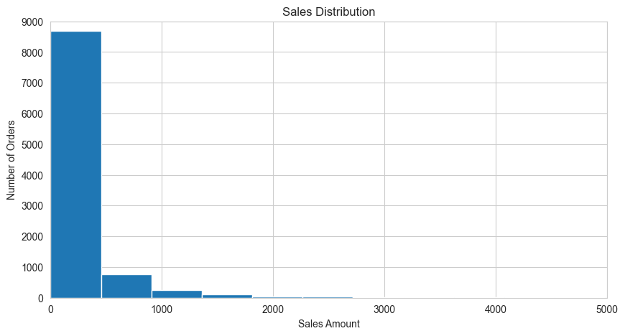
2. Histogram – Profit Distribution
This histogram displays the distribution of profit across transactions. The plot shows a wide variation, with a large number of orders yielding low or moderate profits and a few resulting in higher profits.
There are also some negative profit values, representing losses, possibly caused by excessive discounts or shipping costs. This visualization helps identify the overall profitability structure of the superstore and highlights the uneven distribution of profits.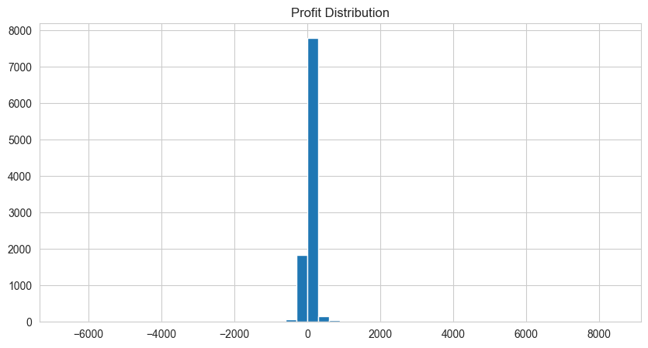
3. Bar Chart – Orders per Category
This bar chart shows the number of orders received for each product category: Furniture, Office Supplies, and Technology.
From the visualization, Office Supplies appears to have the highest number of orders, followed by Technology and Furniture.
However, while Office Supplies generates more sales volume, Technology contributes more profit, showing that high sales volume doesn’t always equate to high profitability.
This insight helps the business prioritize categories based on both order count and profit margin.
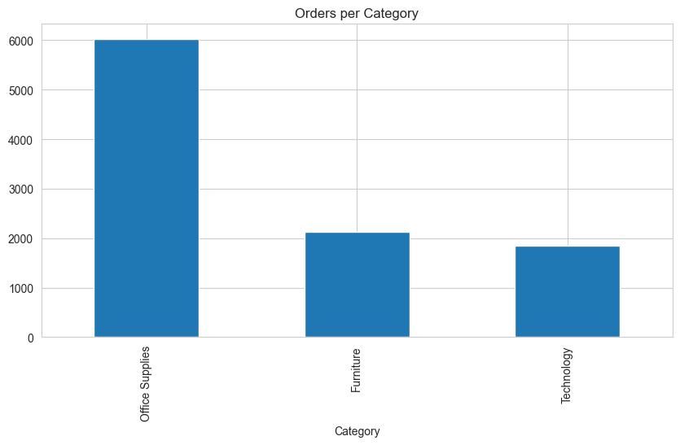
4. Scatter Plot – Sales vs Profit
The scatter plot visualizes the relationship between sales and profit, with each point representing an order.
A generally positive correlation can be observed — as sales increase, profit tends to rise as well. However, there are several outliers, especially at high discount levels, showing orders with large sales but little or no profit.
The hue by category further shows that Technology and Office Supplies clusters are more profitable, whereas Furniture exhibits more loss-making transactions.
This visualization clearly identifies profit-driving and loss-prone areas within the business.
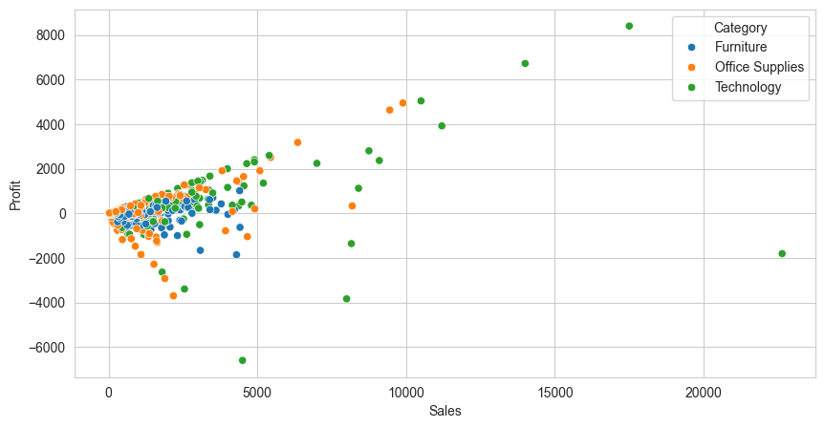
5. Box Plot – Profit by Segment
The box plot compares the profit distribution across customer segments — Consumer, Corporate, and Home Office.
It shows that Corporate customers generally yield higher profit margins, while the Consumer segment has wider variability, indicating diverse purchasing behavior.
Outliers reveal instances of unusually high or low profits, often influenced by product type or discount strategy.This insight helps understand which customer segment contributes most effectively to profitability.
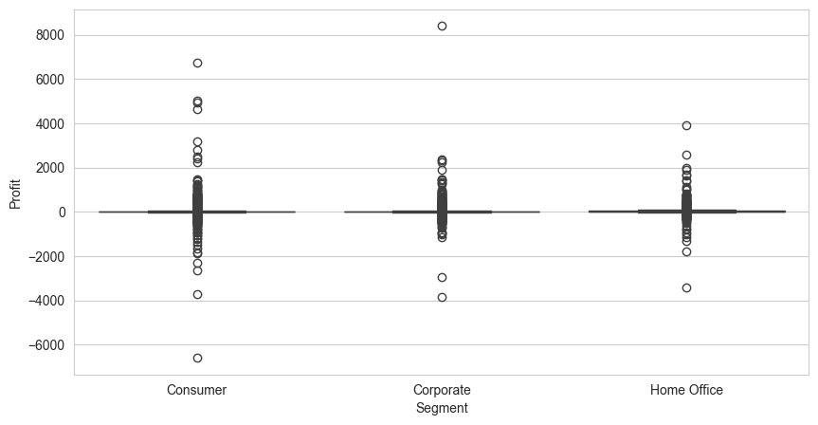
6. Line Chart – Monthly Sales and Profit Trends
The line chart illustrates monthly sales and profit trends over time.
It shows a steady increase in both sales and profit during Q4 (October–December), suggesting seasonal spikes during the year-end period.
This trend indicates that the superstore experiences its highest performance in the last quarter, possibly due to festive shopping seasons and promotional campaigns.
Such time-based insights help management plan inventory, marketing, and staffing more efficiently during peak months.
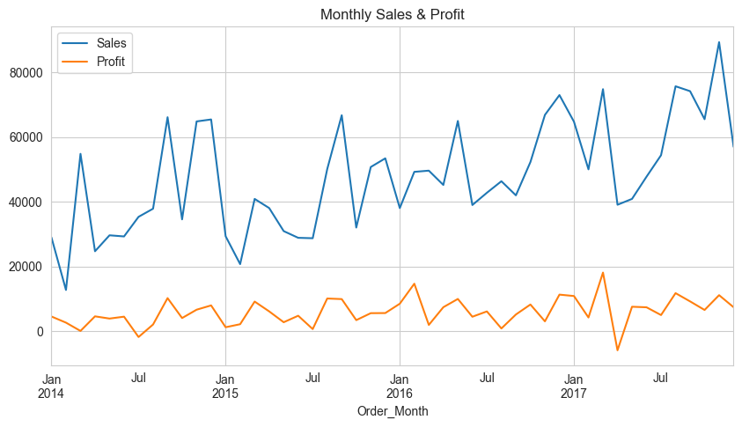
Dashboard Design in Power BI
Two interactive dashboards were created:
Dashboard 1: Sales Overview
The first dashboard provides a high-level summary of overall business performance, focusing on sales, profit, and customer metrics.
It offers management a quick and clear understanding of the company’s financial health and operational distribution.
Key Components:
- KPI Cards:
The KPI section displays essential performance metrics — Total Sales, Total Profit, Number of Orders, and Profit Margin.
These indicators serve as quick visual cues for evaluating the company’s performance and comparing it against previous periods.
- Line Chart – Sales vs. Profit Over Time:
This chart displays the relationship between Sales and Profit across different months or quarters.
The lines for both metrics move in similar directions, confirming a positive correlation.
A noticeable upward trend can be observed during Q4 (October to December), indicating strong end-of-year sales momentum.
- Bar Chart – Category-wise Comparison:
The bar chart compares Sales and Profit across the three main product categories: Furniture, Office Supplies, and Technology.
From this chart, Technology emerges as the highest revenue and profit generator, whereas Furniture shows lower profitability, often due to higher discounts and shipping costs.
- Map – Sales by Region:
A filled geographic map illustrates how sales are distributed across regions and states.
The darker shades indicate higher sales volumes, with the West and East regions performing significantly better than the South.
This visual helps management pinpoint profitable regions and identify areas needing improvement.
- Table – Top 10 Customers:
The table lists the top 10 customers based on sales and profit contribution.
This component allows businesses to recognize and focus on their most valuable clients, reinforcing customer relationship strategies.
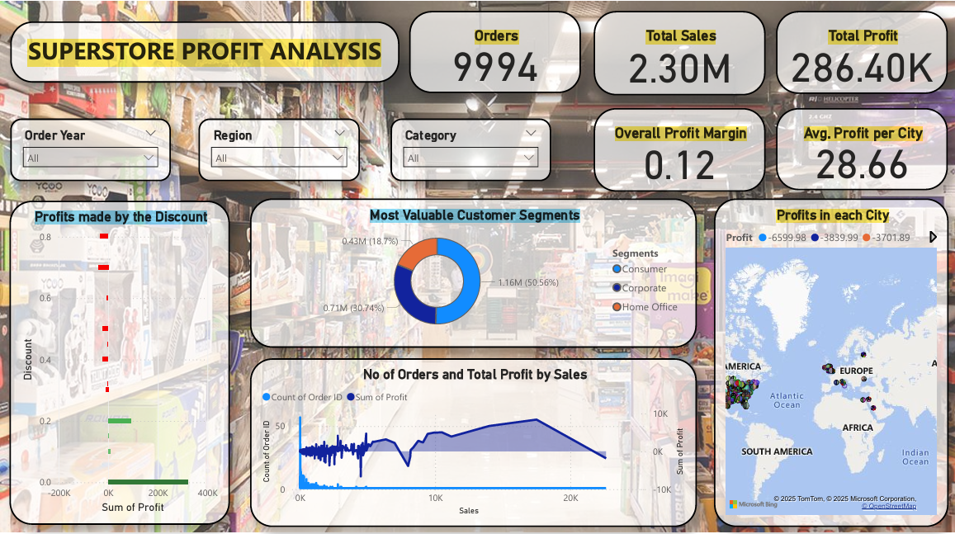

Dashboard 2: Analytical Deep Dive
The second dashboard, titled “Analytical Deep Dive,” focuses on advanced insights related to profit drivers, discount impact, and customer segmentation.
It provides a more detailed analytical view of business performance beyond just sales figures.
Key Components:
- Waterfall Chart – Discount Effect on Profit:
This chart visually demonstrates how different discount levels impact total profit.
Each bar represents a change (positive or negative) in profit as discount percentages increase.
The chart reveals that higher discounts (above 25%) significantly reduce profit margins, emphasizing the need for controlled discount strategies.
- Treemap – Profit Contribution by Segment:
The treemap shows how different customer segments — Consumer, Corporate, and Home Office — contribute to overall profit.
The Consumer segment holds the largest area, indicating it contributes the most to sales, whereas the Corporate segment achieves higher profit margins per order.
This helps the business tailor marketing and pricing strategies according to each segment’s behavior.
- Donut Chart – Segment-wise Sales:
The donut chart provides a visual breakdown of sales share by segment.
It shows that the Consumer segment accounts for more than half of total sales, highlighting it as the most active customer base.
However, analyzing this in conjunction with profit data provides a clearer picture of segment efficiency.
- Pie Chart – Orders by Shipping Mode:
This visualization presents the distribution of orders among different shipping modes — Standard Class, Second Class, First Class, and Same Day.
The chart reveals that Standard Class dominates in order count but often results in longer delivery times, while First Class has fewer but higher-value orders.
This insight can help optimize logistics strategies and improve customer satisfaction.
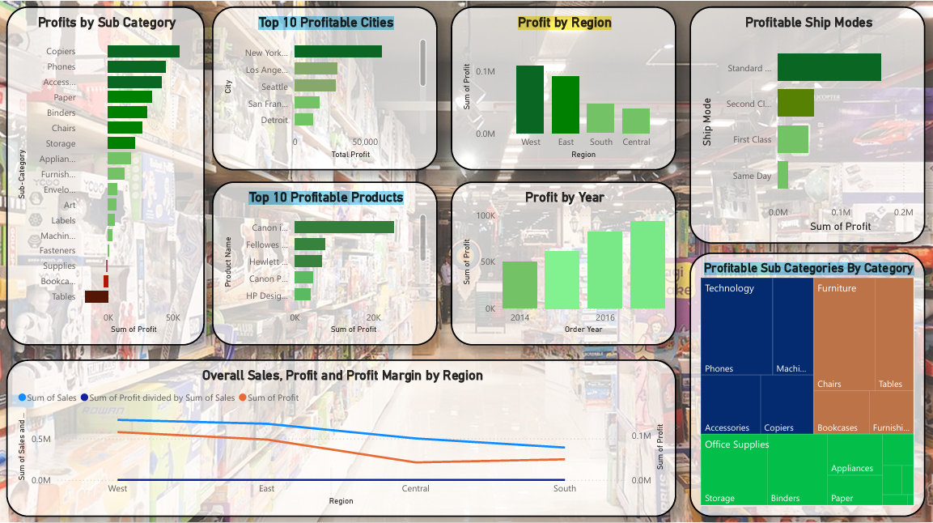

SOLUTION DESIGN
The solution for the Superstore Profit Analytics project integrates two complementary technologies — Python and Power BI — to create a complete analytical workflow. This design ensures both accuracy in data analysis and clarity in visualization.
- Python Layer
The Python layer is responsible for data preparation and KPI calculation.
It handles the import, cleaning, and transformation of raw data using libraries such as Pandas and NumPy.
Key operations include removing duplicates, handling missing values, creating calculated columns like Profit Margin, and grouping discounts into bins.
Python outputs a cleaned dataset in Excel format, ready for visualization.
- Power BI Layer
The Power BI layer focuses on data visualization and reporting.
The transformed dataset is imported into Power BI to create interactive dashboards that display insights such as total sales, profit, customer performance, and discount impacts.
This layer allows decision-makers to apply filters, explore trends, and interpret results easily through visuals like bar charts, line graphs, maps, and treemaps.
- Data Flow
The overall data flow of the system is as follows:
Dataset → Python (Cleaning & Transformation) → Excel → Power BI (Visualization & Reporting)
This structure ensures that data is first processed for accuracy and then visually represented for clarity.
Design Highlights
The solution emphasizes three core principles:
- Automation: Repeatable process for future datasets.
- Clarity: Clean visuals and organized metrics for quick understanding.
- Scalability: Easily extendable to larger datasets or new KPIs.
In summary, the dual approach of Python and Power BI provides analytical precision, reliability, and interactivity — making the solution both technically efficient and business-friendly.

CHALLENGES & OPPORTUNITIES
CHALLENGES
During the development of the Superstore Profit Analytics project, several challenges were encountered that required careful attention and problem-solving. These challenges primarily arose during data preparation, visualization, and result validation phases.
- Dealing with inconsistent time formats:
The dataset contained irregular date formats for Order Date and Ship Date, which initially caused issues in extracting time-based insights such as months and quarters. Consistent formatting was achieved through proper datetime conversion in Python.
- Ensuring correct data type conversions:
Converting numerical and categorical columns to appropriate data types was essential for accurate computation and visualization. Errors in type assignments occasionally led to incorrect aggregations.
- Designing optimal Power BI visuals for readability:
Selecting the right chart types and arranging visuals for clarity posed a challenge. The design had to balance visual appeal with ease of interpretation for users unfamiliar with analytical tools.
- Handling outliers affecting statistical accuracy:
Certain transactions displayed unusually high or negative profit values due to excessive discounts. These outliers had to be identified and analyzed carefully to prevent skewed results.
Opportunities
While this project successfully delivers a complete descriptive analytics solution, several opportunities exist for further enhancement and innovation.
- Extend analysis into predictive forecasting:
Future versions of the project can integrate machine learning techniques to forecast sales and profit trends, providing proactive decision support.
- Automate dashboards using Power BI Service:
The existing dashboards can be published to Power BI Service for automated data refresh and online accessibility, enabling real-time monitoring of key business metrics.
- Incorporate AI-based customer segmentation:
Integrating AI-driven clustering methods such as K-Means can provide deeper insights into customer behavior, allowing for targeted marketing and personalized offers.

REFLECTIONS ON THE PROJECT
The Superstore Profit Analytics project has been a valuable learning experience that allowed me to apply theoretical concepts of data analytics to a practical, real-world business dataset. It bridged the gap between academic understanding and practical implementation by involving multiple stages — from data cleaning and transformation to visualization and insight generation.
Working on this project gave me hands-on experience in handling the entire data lifecycle — including acquisition, preprocessing, exploration, and visualization. I learned how crucial it is to ensure data accuracy and consistency, as even minor errors in raw data can significantly impact final analytical outcomes. The process of data cleaning using Python deepened my understanding of how reliable data forms the foundation of all meaningful insights.
Developing dashboards in Power BI helped me understand the importance of visualization and effective storytelling in analytics. I discovered that presenting data visually not only makes it easier for decision-makers to interpret but also highlights trends and patterns that might remain hidden in raw numbers.
This project also emphasized the importance of collaboration between technical analysis and business interpretation. Translating technical findings into clear business insights required balancing accuracy with simplicity — a skill that is essential for any data professional.
Overall, the project enhanced my ability to combine analytical thinking with visualization design and taught me the value of data-driven communication. It was an enriching experience that strengthened both my technical proficiency and my understanding of how analytics can influence strategic business decisions.

RECOMMENDATIONS
Based on the insights and findings from the Superstore Profit Analytics project, several recommendations can be made to improve overall business performance, profitability, and operational efficiency. These recommendations focus on optimizing product strategy, customer targeting, pricing, and supply chain management.
- Promote the Technology category due to high profitability:
Analysis indicates that the Technology category consistently generates the highest profit margins and contributes significantly to total revenue. It is recommended that marketing and promotional efforts focus more on this category to leverage its profitability potential and expand market share.
- Focus on the Consumer segment for revenue growth:
The Consumer segment represents the largest portion of total sales. Targeted campaigns, personalized offers, and loyalty programs for this segment can help maintain customer retention and further increase revenue. However, maintaining competitive pricing will be crucial to balance sales volume with profit margins.
- Restrict discounts above 25% to avoid losses:
The analysis of discount trends revealed that excessive discounts—particularly above 25%—negatively impact profitability. Implementing discount limits or data-driven promotional strategies can prevent unnecessary revenue loss while maintaining customer satisfaction.
- Strengthen logistics in the South region:
Regional analysis showed that the South region underperforms compared to others. Improving supply chain efficiency, optimizing shipping routes, and reducing delivery times in this region can enhance customer satisfaction and overall regional profitability.
- Optimize stock levels before Q4 seasonal peaks:
The line chart trend identified a consistent surge in sales during Quarter 4 (October–December). Preparing adequate inventory in advance, along with well-timed marketing campaigns, can help the business meet increased seasonal demand and maximize profit during the peak period.
OUTCOME / CONCLUSION
The Superstore Profit Analytics project successfully achieved all its defined objectives by transforming raw, unstructured retail data into actionable business insights. The project demonstrated how a combination of Python and Power BI can be used to build a complete analytics pipeline — from data cleaning and transformation to visualization and decision support.
Outcomes:
The key outcomes of the project are as follows:
- Cleaned and transformed dataset using Python:
The raw dataset was refined by handling missing values, standardizing formats, and generating new analytical fields such as Profit Margin, Order Quarter, and Discount Bins.
- Developed interactive Power BI dashboards:
Multiple dashboards were designed to visually represent key metrics like sales, profit, category performance, and discount impact, allowing users to explore insights dynamically.
- Validated accuracy between both tools:
The results obtained from Python analysis were cross-verified with Power BI visuals to ensure data consistency and analytical correctness.
- Identified top-performing products and regions:
The analysis revealed that the Technology category and West region were the strongest contributors to profit, while high discounts in Furniture products negatively impacted margins.
Conclusion:
The integration of Python and Power BI enabled the development of an end-to-end data analytics workflow that combines technical precision with business understanding.
Python provided a robust foundation for data processing and analysis, while Power BI transformed analytical results into clear, interactive visual stories for decision-makers.
This project proves that even small or medium-scale retail businesses can harness the power of data analytics to improve efficiency, identify opportunities, and make informed, strategic decisions. By using the right tools and methodologies, data can move beyond numbers — becoming a reliable guide for organizational growth and profitability.

ENHANCEMENT SCOPE
While the Superstore Profit Analytics project successfully delivers a comprehensive descriptive analytics solution, there is significant potential to expand its capabilities in the future. The current implementation focuses primarily on analyzing historical data and providing visual insights. However, several enhancements can be introduced to make the system more dynamic, predictive, and intelligent.
Future Improvements
- Implementing forecasting models for predictive analytics:
Integrating machine learning techniques such as time series forecasting (ARIMA or Prophet models) can help predict future sales and profit trends. This would allow the business to make proactive, data-driven decisions rather than reactive ones.
- Automating data updates in Power BI through scheduled Python scripts:
Automating the data pipeline would eliminate manual intervention by scheduling Python scripts to refresh and export the cleaned dataset at regular intervals. This ensures that dashboards always display the most up-to-date information.
- Expanding the dataset to include global or multi-year trends:
Including data from multiple years or additional regions can help identify long-term performance patterns and seasonal variations. This would make the analysis more comprehensive and improve business forecasting accuracy.
- Performing sentiment analysis using customer feedback data:
Incorporating unstructured data, such as customer reviews and feedback, and applying Natural Language Processing (NLP) techniques could provide deeper insights into customer satisfaction, preferences, and product perception.
- Deploying the dashboard to Power BI Cloud Service for accessibility:
Publishing the dashboards on Power BI Service would enable online accessibility, automated refresh scheduling, and secure sharing with stakeholders. This would enhance collaboration and make analytics available across devices.

LINK TO CODE AND EXECUTABLE FILE
Python Code File:
https://colab.research.google.com/drive/1xd-d7pWje5Autx2rvKuYUFrGqVQR8w9c?usp=drive_link
Cleaned Dataset:
https://drive.google.com/file/d/1boVQPOs5YFrdgV5X5UTKTwiGWJ_uuJ_4/view?usp=sharing
Power BI File:
https://drive.google.com/file/d/1AeCGbCS_iBMjkZh8FcfIUyfO9TDIKzRS/view?usp=drive_link

RESEARCH QUESTIONS AND RESPONSES
This section highlights the critical business questions defined by TCS ION as part of the project brief.
Each question was explored through analytical methods using Python and Power BI to uncover meaningful business insights.
Research Question | Analytical Response
What are our best-selling and most profitable product categories and sub-categories? | The Technology category and its sub-categories like Copiers, Phones and Accessories show the highest sales and profit margins.
Who are our most valuable customer segments? | The Consumer segment contributes the largest share of sales, while the House office segment provides the highest profit per order.
What are the sales trends over time (e.g., monthly, quarterly)? Is there any seasonality? | Sales and profit trends show a steady increase towards Q4 (October–December) each year, indicating seasonal buying behaviour.
Which regions or cities are the most profitable? | The West region is the most profitable, with California and Washington being top-performing states.
How do discounts impact overall profitability? | Discounts above 25% lead to reduced profit margins, highlighting the need for balanced discount strategies.

Summary:
Through these research questions, the project successfully identified key factors driving profitability including category performance, regional strength, customer segmentation, and discount impact.
The insights derived support data-driven business decisions that can enhance profitability and strategic planning.
REFERENCES
- Kaggle – Global Superstore Dataset
Source of the dataset used for analysis in this project. The dataset provided sales, profit, discount, and regional data that formed the basis for all Python analysis and Power BI visualizations.
URL: https://www.kaggle.com/datasets
- Python Software Foundation. (2024). Python Language Documentation.
Python was used as the core programming language for data preprocessing, transformation, and analysis. Its official documentation served as a reference for implementing data handling logic.
URL: https://www.python.org/doc/
- Pandas Library – Data Analysis in Python.
Pandas was extensively used for cleaning, transforming, and aggregating the dataset. Official documentation was referred to for operations like grouping, filtering, and handling missing data.
URL: https://pandas.pydata.org/docs/
- NumPy – Numerical Computing Library.
Used alongside Pandas for efficient numerical computations and supporting data transformations within the Python layer.
URL: https://numpy.org/doc/
- Matplotlib and Seaborn – Data Visualization in Python.
These libraries were used to generate exploratory visualizations such as histograms, scatter plots, and line charts during the EDA phase.
URL: https://matplotlib.org/stable/contents.html URL: https://seaborn.pydata.org/
- Microsoft Power BI Documentation.
Used for building interactive dashboards and visual summaries. Power BI’s official documentation helped in designing visuals such as bar charts, maps, tree maps, and waterfall charts.
URL: https://learn.microsoft.com/en-us/power-bi/

