PROJECTS

**Title: MALE Fashion - Revolutionizing Retail Stock Tracking and Management**

In the fast-paced world of fashion retail, efficient stock tracking and management are pivotal for success. Recognizing this need, the MALE Fashion project emerges as a Java-based solution aimed at transforming the way retailers handle their inventory. This comprehensive system encompasses CRUD operations (Create, Read, Update, Delete) on products, along with robust reporting functionalities for monitoring stock levels and analyzing sales trends.

**Overview:** MALE Fashion stands as a testament to innovation in retail technology. Built on the Java and J2EE stack, the system leverages the power of modern web technologies, including Basic HTML, CSS, and JavaScript, to provide a seamless and user-friendly experience. The incorporation of JSP (JavaServer Pages) and Servlet further enhances the dynamic nature of the web application, making it responsive and interactive.

**Technology Stack:**

* Java and J2EE: The backbone of the project, Java ensures the robustness and reliability of the system. J2EE (Java 2 Platform, Enterprise Edition) extends Java's capabilities to cater to enterprise-level applications, making it an ideal choice for a retail management system.
* Web Technologies (HTML, CSS, JavaScript): The project employs basic HTML for structuring web content, CSS for styling, and JavaScript for client-side interactivity. This ensures a modern and visually appealing user interface.
* Database (SQLYog): Efficient data management is achieved through the use of SQLYog, a powerful database management tool. The relational database stores critical information related to products, sales, and stock levels, enabling seamless data retrieval and manipulation.
* JSP & Servlet: JavaServer Pages (JSP) and Servlets play a crucial role in rendering dynamic web pages and handling server-side logic. They contribute to the project's scalability and maintainability.
* Payment Integration (RazorPay): To facilitate online transactions, MALE Fashion integrates RazorPay, a secure and efficient payment gateway. This feature ensures a smooth and secure payment process for customers engaging in online shopping.

**Functionality:** MALE Fashion is not just a stock tracking system; it's a complete retail management solution. Users can perform CRUD operations on products, allowing for easy addition, modification, and deletion of items in the inventory. The system also generates detailed reports on stock levels and sales, providing valuable insights for business decision-making.

**Synopsis:** The MALE Fashion website serves as a virtual storefront for customers, offering a convenient and intuitive platform for online shopping. The sleek and responsive design, coupled with the seamless integration of payment processing through RazorPay, ensures a hassle-free shopping experience.

**Customer** **Functionality**

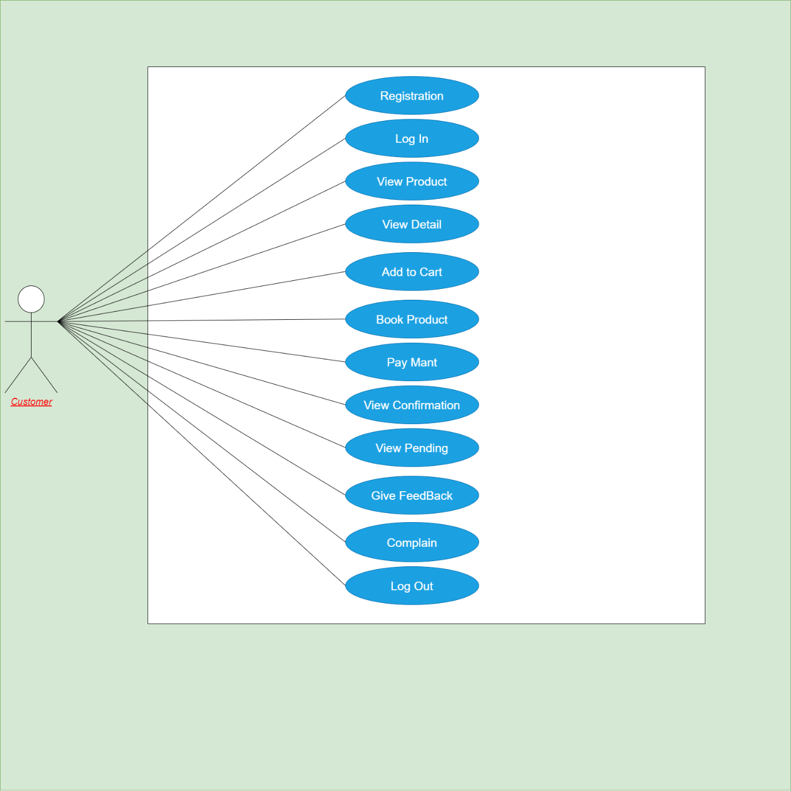

**Customer Registration :**

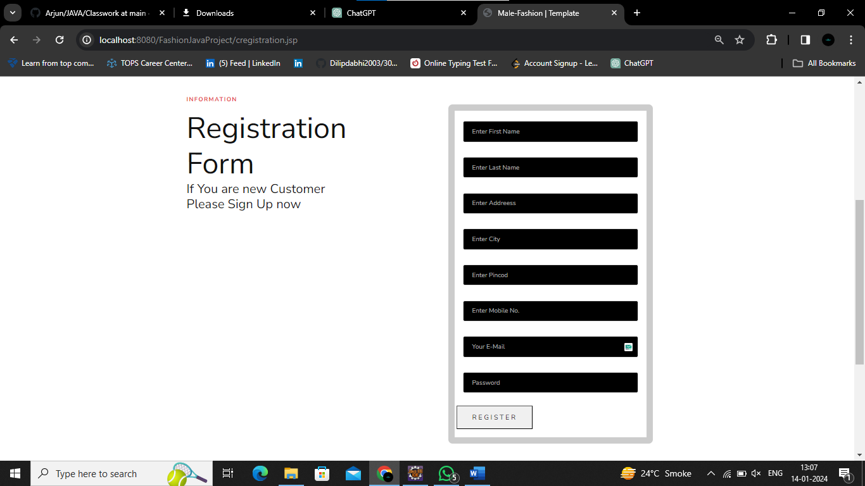

**Customer Login:**

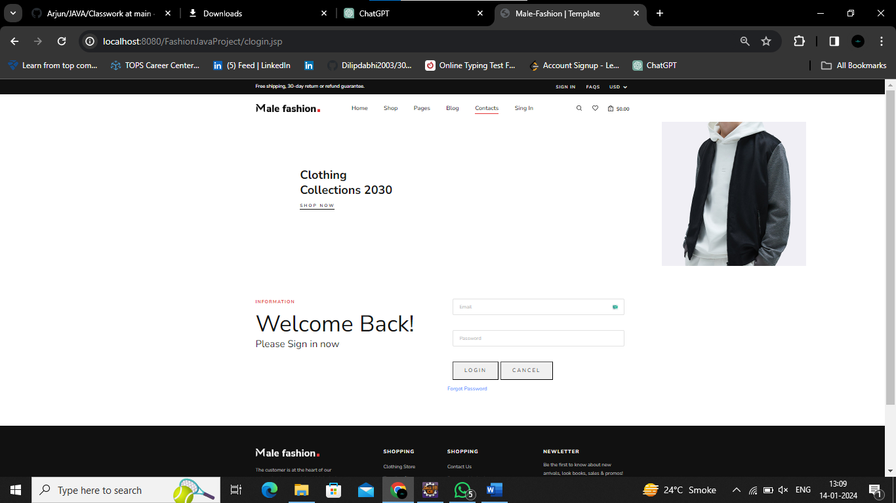

**Forgot Password:**

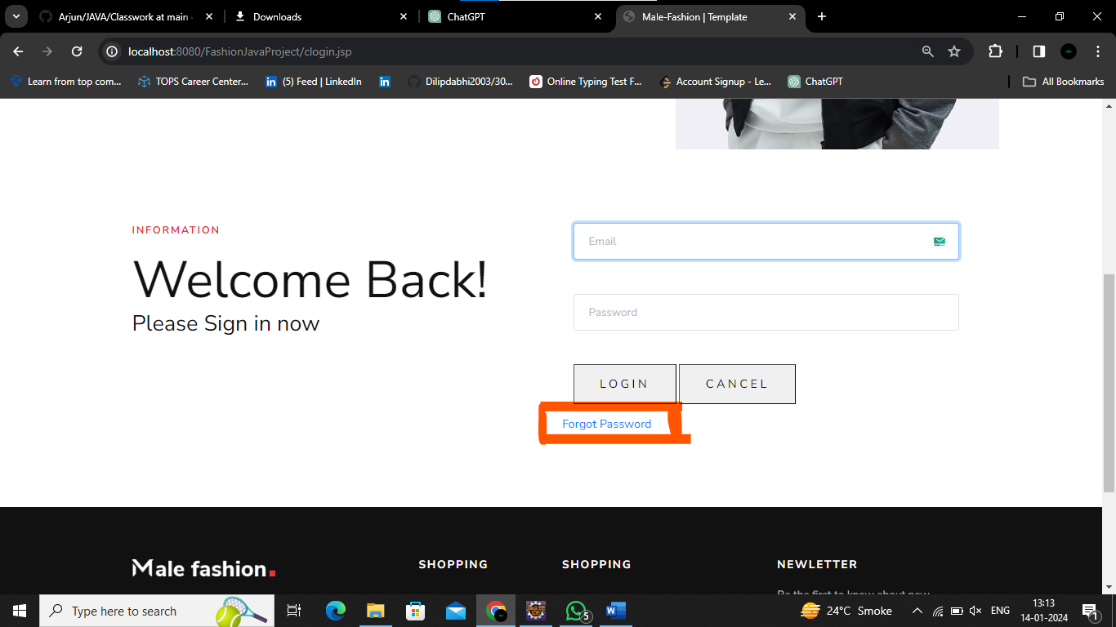

MALE Fashion's password retrieval prioritizes security:

1. Initiate process with email verification.
2. Confirm registered email existence in customer data.
3. Generate a secure One-Time Password (OTP).
4. Deliver OTP to registered email.
5. User undergoes secure OTP verification.
6. Access secure password reset interface.
7. Confidentiality assured at each step.
8. Clear user instructions for a seamless experience. This multi-step process ensures the legitimacy of requests and reinforces MALE Fashion's commitment to user security.

**After updating your password, effortlessly resume your shopping experience by being redirected to the homepage on MALE Fashion**

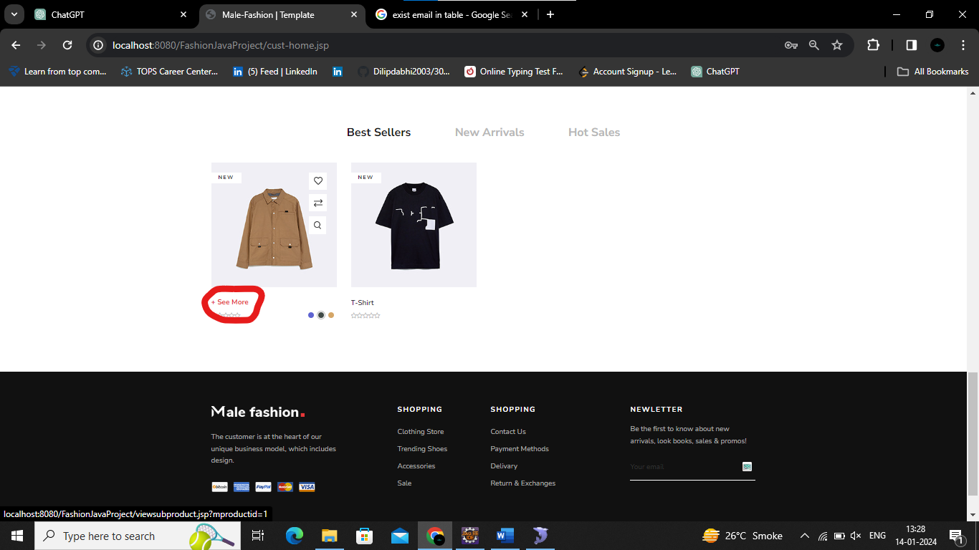

After click see more customer see Sub Product:

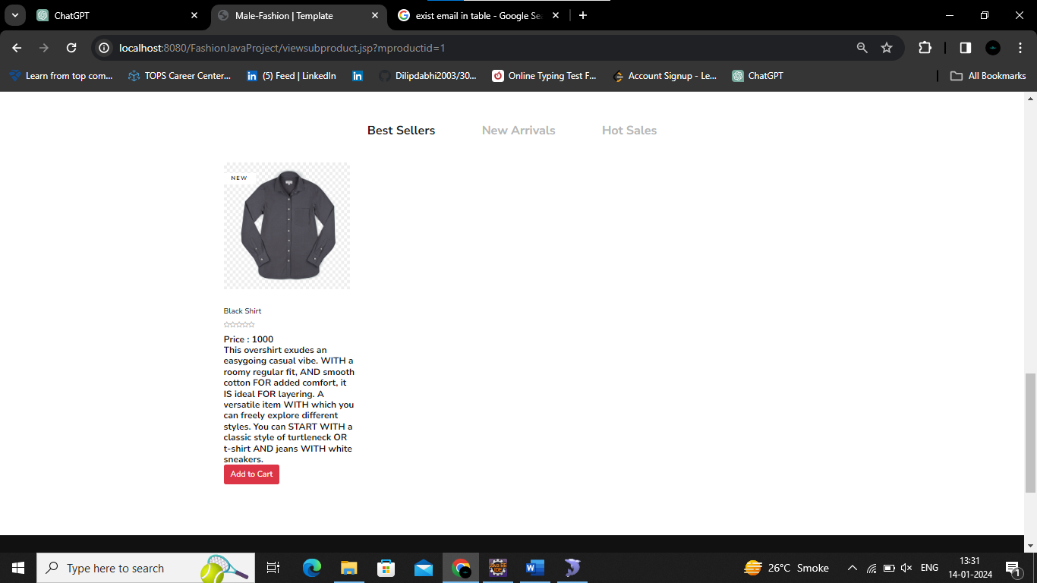

Now Customer Want Purchasing Sub Product click on Add to Cart Button :

After click on this Button Customer redirect on cart page :

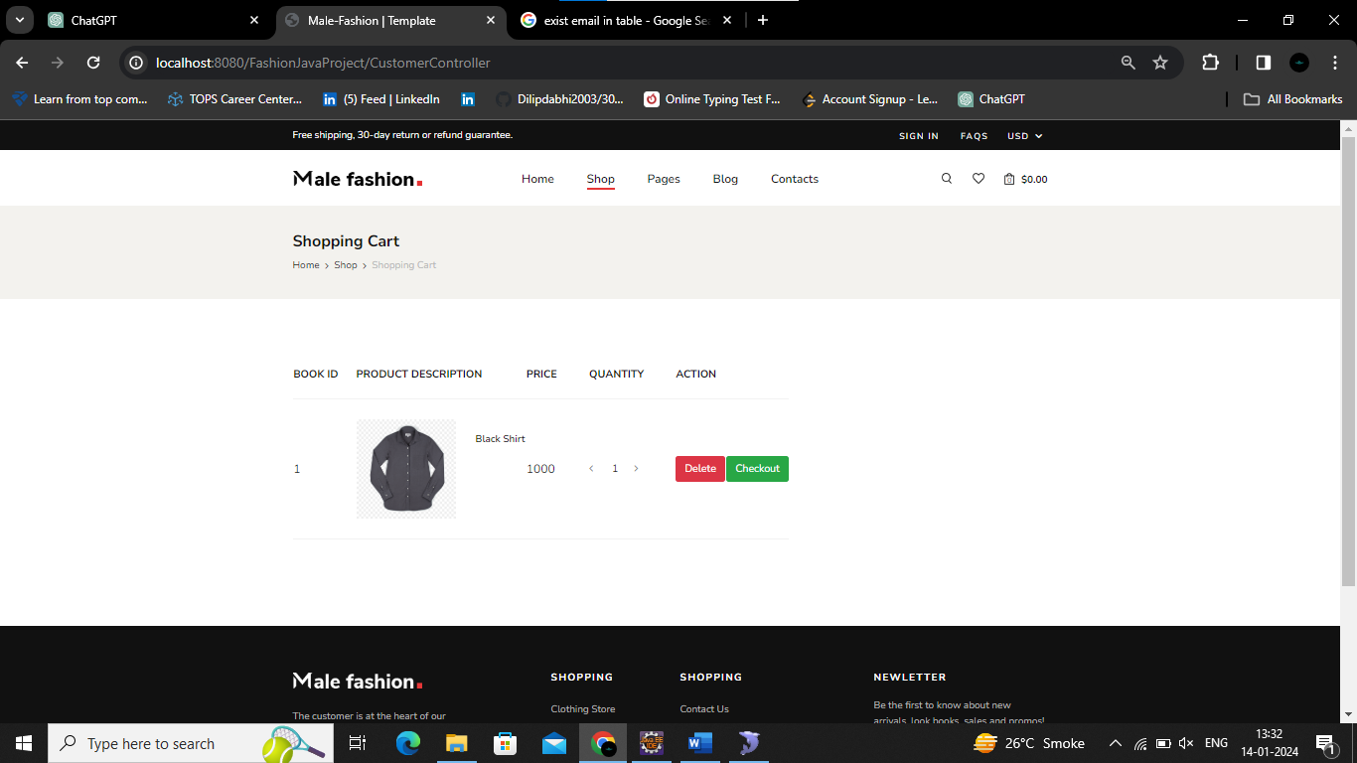

If Customer want more Quantity so customer also add this things. And for book this items customer click on Checkout button.

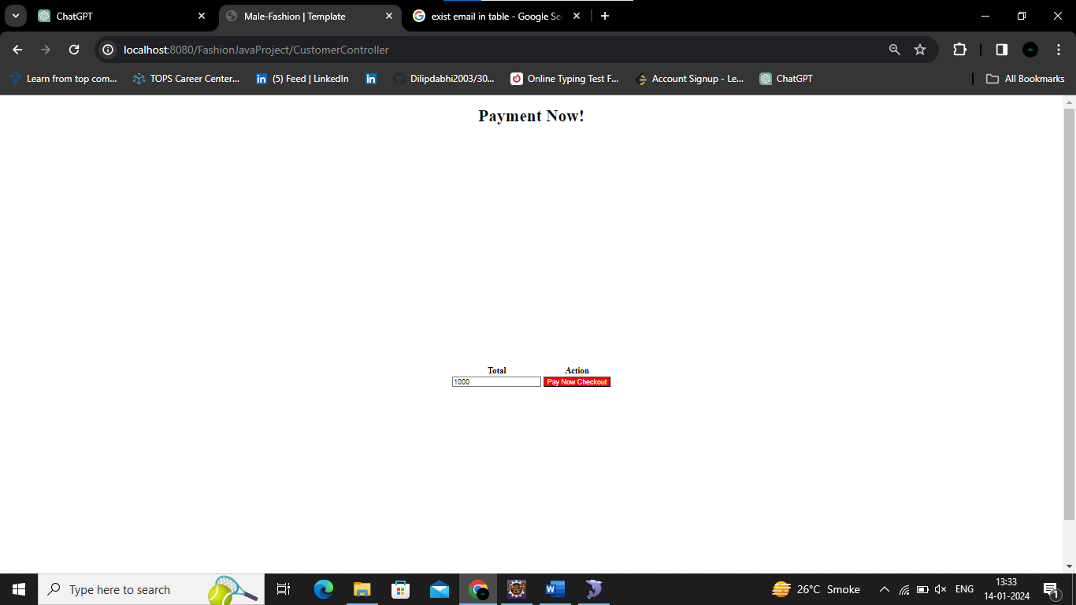

Now customer see total price of item and click on payment

Button and doing online payment using razor pay.

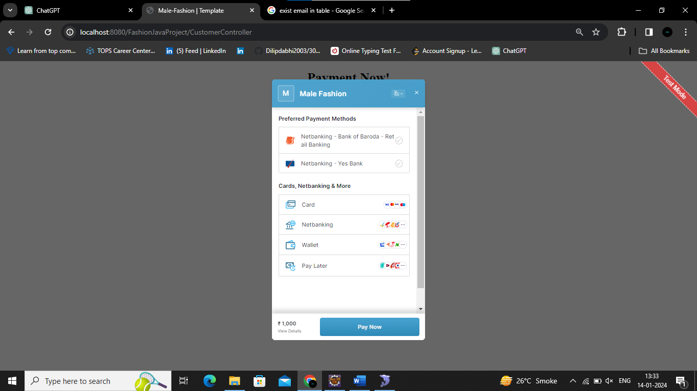

**Upon successful payment, customers are seamlessly redirected to the review page, providing an opportunity to share their perspectives on both the website and the purchased products.**

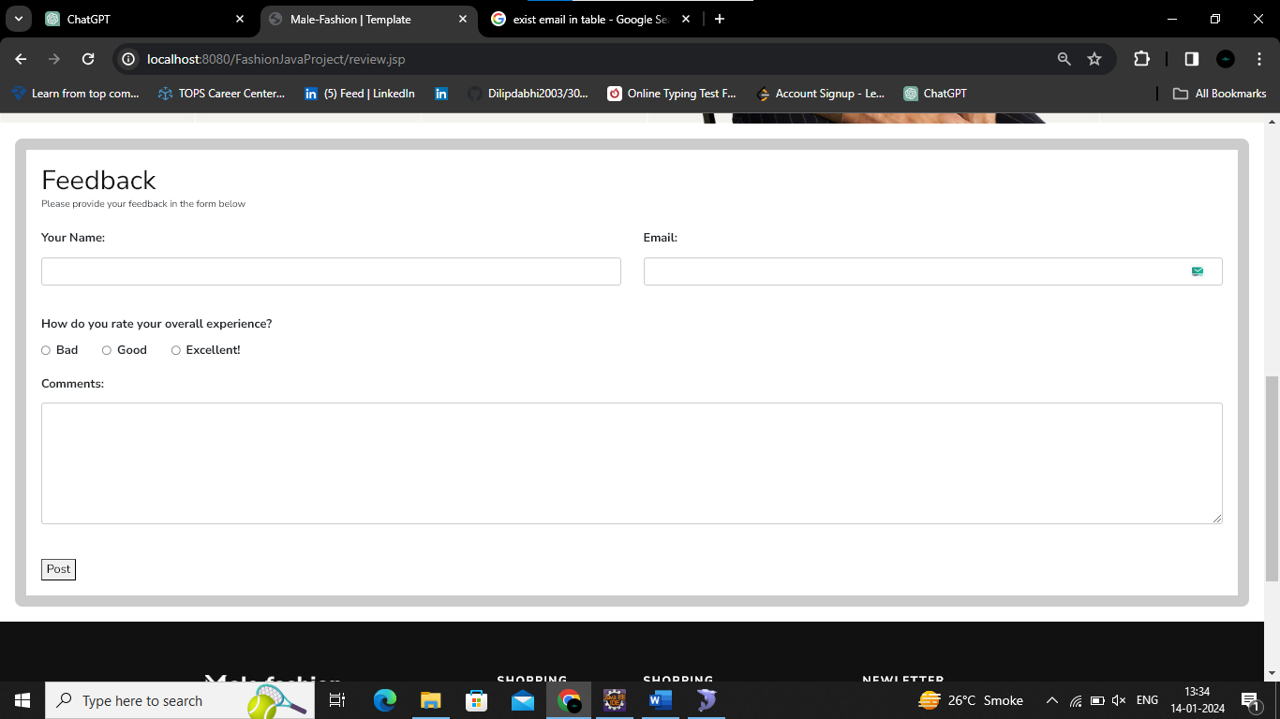

**Admin** **Functionality**

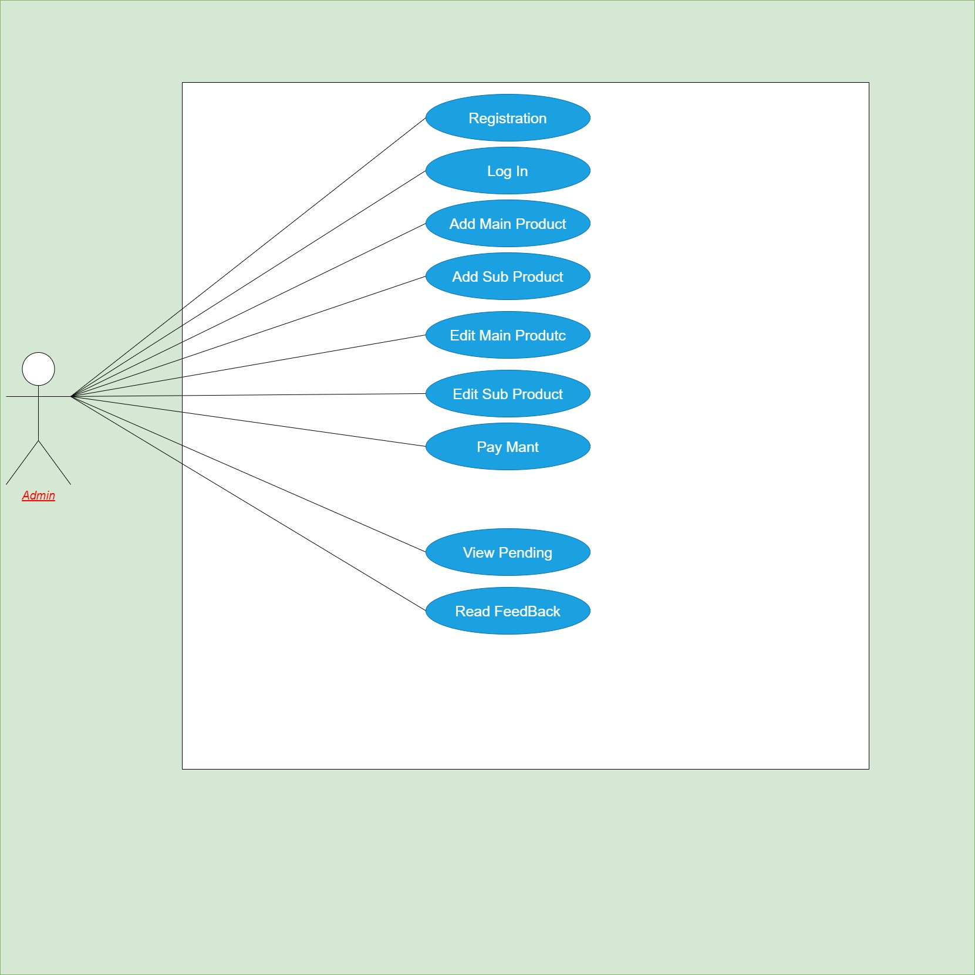

Admin Penal:

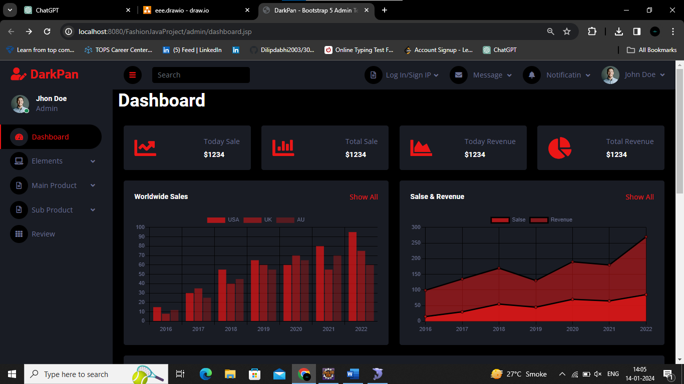

Now You Can see all Feature are There:

**Add Main Product:**

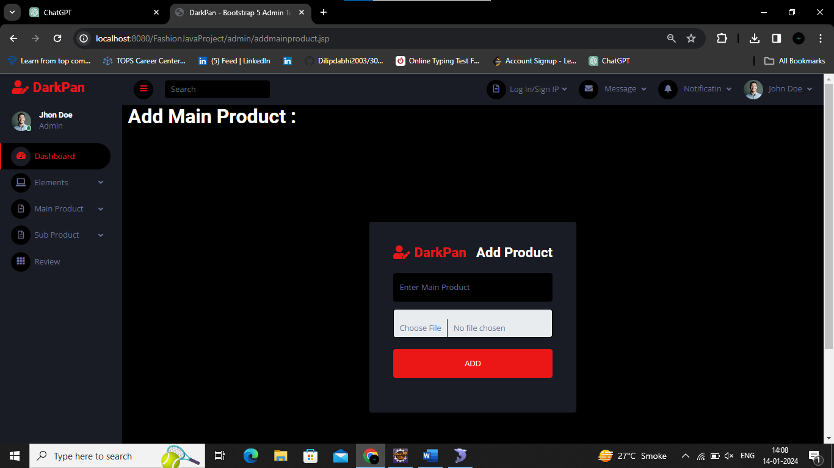

if Admin add Main product that product display on Male Fashion Home Section.

**Add Sub-Product:**

After add Main Product admin add Sub Product that display on Male Fashion Sub Product Section

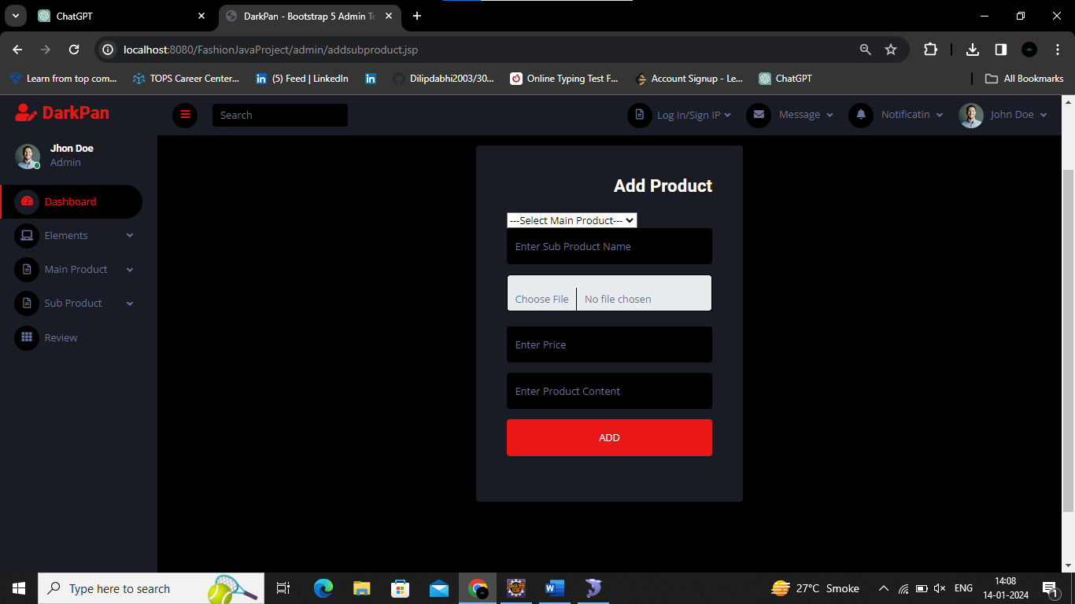

**View Main Product:**

Click on view Main Product Admin see all Main Product on Table Product.

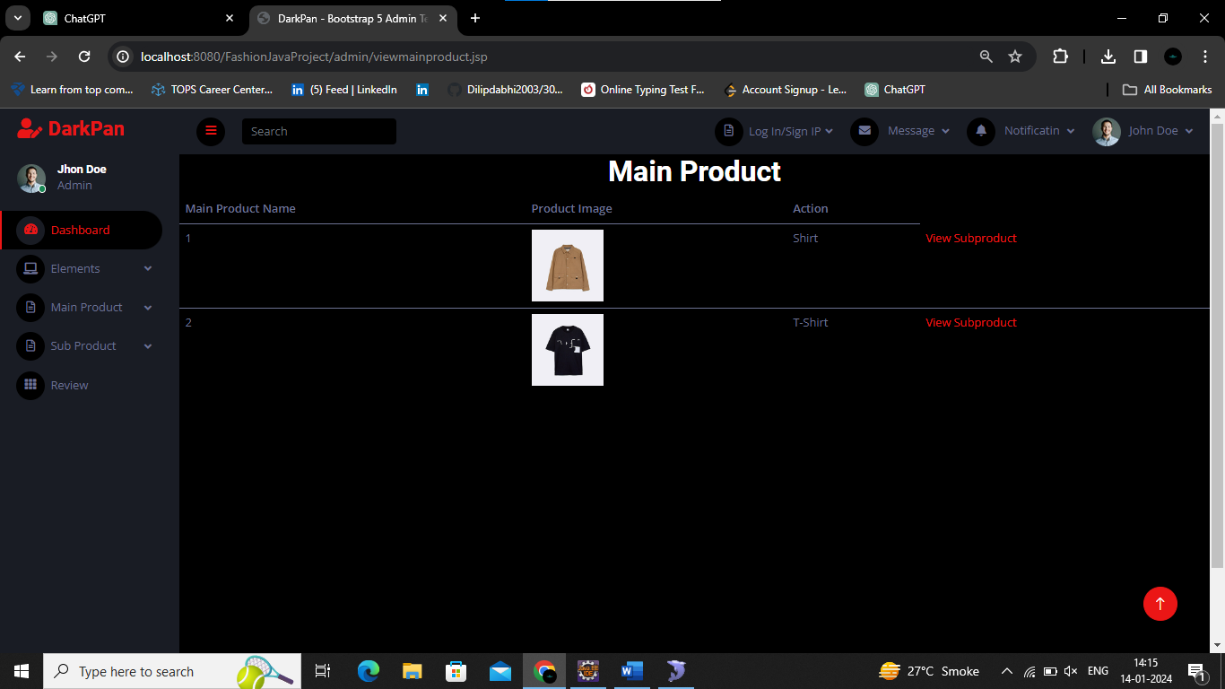

**View Sub Product:**

After Click on view Subproduct button admin see all subproduct

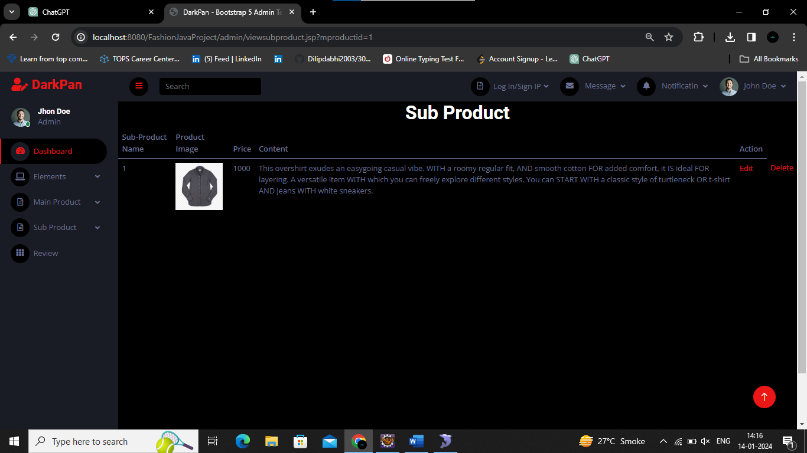

So You can see Now Admin have Edit or Delete option.

**View Review:**

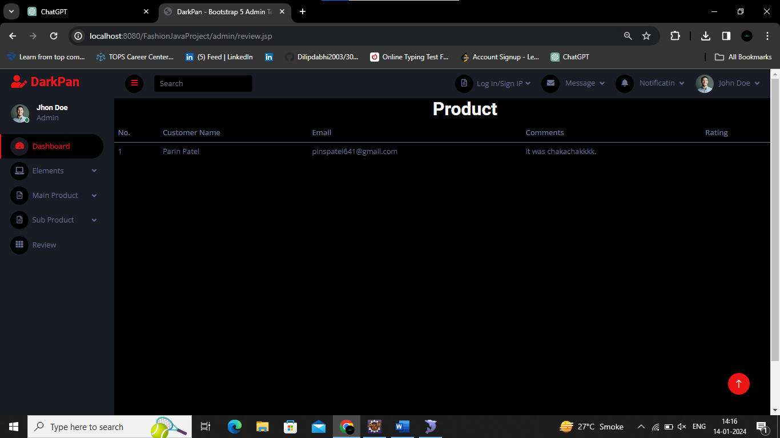

**Conclusion:**

In the dynamic landscape of retail, staying ahead requires embracing technology. MALE Fashion not only addresses the fundamental need for efficient stock tracking and management but also goes beyond by providing a feature-rich, user-friendly interface for customers. With its Java-based architecture and integrated technologies, MALE Fashion represents a paradigm shift in how retailers can leverage digital solutions to streamline their operations and enhance the customer shopping experience. As the retail industry continues to evolve, MALE Fashion stands as a testament to the power of innovation and technology in shaping its future.