Table of Contents

TMS Pro — Complete Workflow Guide (All Scenarios)
Transport Management System covering booking → LR → trip → delivery → billing → accounting → HR → payroll.

1. System Actors & Entry Points

Diagram: flowchart 01
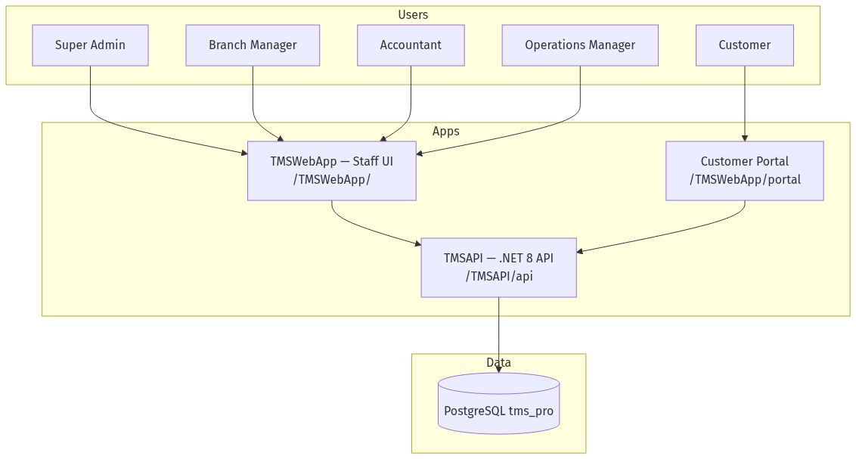
flowchart 01
Actor | Login | Default access
Super Admin | /login → admin / admin123 | All branches, all modules
Branch Manager | /login | Own branch data only
Accountant | /login | Accounting, reports, payroll
Operations | /login | Bookings, LR, fleet, GPS, trips
Customer | /portal/login | Track shipments, invoices, POD

2. Authentication Workflows

2.1 Staff Login

Diagram: flowchart 02
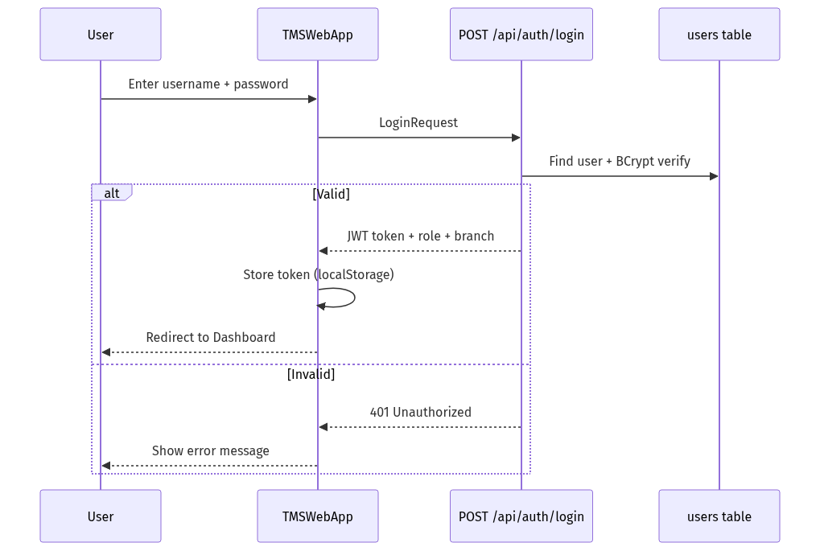
flowchart 02

2.2 Customer Portal Login

Diagram: flowchart 03
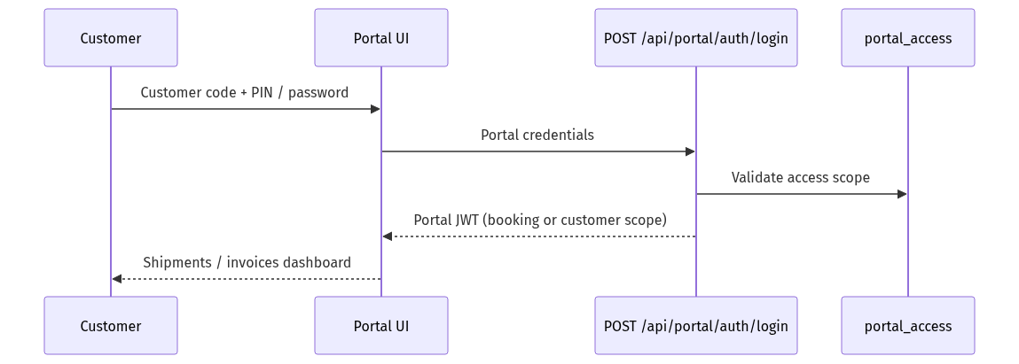
flowchart 03

2.3 Public Tracking (no login)

Diagram: flowchart 04
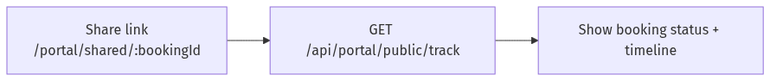
flowchart 04

3. Core Transport Workflow (End-to-End)
Primary business path from enquiry to payment.

Diagram: flowchart 05
flowchart TD
A[Master Data Setup] --> B[Create Booking]
B --> C{Assign Vehicle<br/>& Driver?}
C -->|Yes| D[Update Booking Status]
C -->|No| D
D --> E[Generate LR<br/>Lorry Receipt]
E --> F[Create / Assign Trip]
F --> G[GPS Tracking<br/>optional]
G --> H[Delivery + ePOD<br/>OTP proof]
H --> I[Update Payment Status<br/>Paid / To Pay / Balance]
I --> J[Record Expenses]
J --> K[Accounting Vouchers<br/>Receipt / Sales]
K --> L[Reports & GST]
subgraph Master["A — Master Data (one-time)"]
A1[Customers]
A2[Vendors]
A3[Vehicles]
A4[Drivers]
A5[Branches]
end
A --> Master

3.1 Booking Scenario
Step | UI Path | API | Status flow
1 | Bookings → Add New | POST /api/bookings | Pending
2 | Booking Details → Edit | PUT /api/bookings/{id} | Confirmed / In Transit
3 | Assign vehicle/driver | Same | Assigned
4 | Complete delivery | Same | Delivered / Closed

3.2 LR (Lorry Receipt) Scenario
Step | UI Path | API
1 | LR Management → Generate LR | POST /api/lr/generate
2 | LR List → View / Print | GET /api/lr
3 | Print LR format | Frontend print component

3.3 Trip & Operations Scenario
Step | UI Path | API
1 | Operations → Trips | GET/POST /api/trips
2 | Add stops, assign vehicle | Trip workflow
3 | Operations → Route Optimizer | POST /api/routing/optimize
4 | Operations → Shipments | GET/POST /api/shipments

3.4 ePOD Scenario

Diagram: flowchart 06
sequenceDiagram
participant D as Driver / Ops
participant UI as ePOD Page
participant API as /api/pod
participant C as Customer
D->>UI: Select booking / LR
UI->>API: Request OTP
API-->>C: SMS / notification (if configured)
C->>D: Share OTP
D->>UI: Enter OTP + delivery notes
UI->>API: Confirm POD
API-->>UI: Delivery confirmed

4. Fleet & GPS Workflows

4.1 Live GPS Tracking

Diagram: flowchart 07
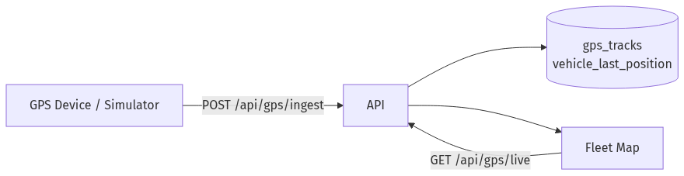
flowchart 07

4.2 Geofence Alerts

Diagram: flowchart 08
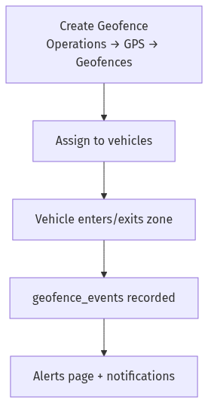
flowchart 08

4.3 Predictive Maintenance
Step | Action
1 | npm run maintenance:install — DB schema
2 | Maintenance page — schedules per vehicle
3 | Record service / breakdown
4 | Alerts when due odometer/date reached

5. HR Workflow (All Scenarios)

Diagram: flowchart 09
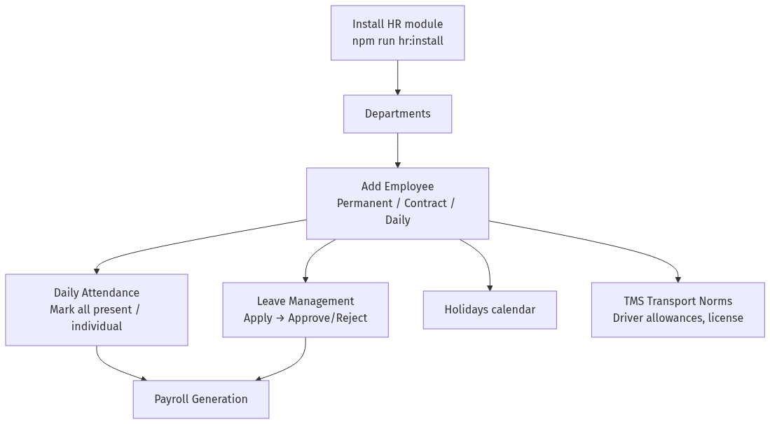
flowchart 09
Scenario | UI | API
New employee | HR → Employees → Add | POST /api/hr/employees
Edit driver with fleet fields | Employee form (TMS section) | sp_hr_save_employee
Mark attendance | HR → Attendance | GET/POST /api/hr/attendance
Bulk present | Mark All Active Present | POST /api/hr/attendance/bulk
Apply leave | HR → Leave → Apply | POST /api/hr/leaves
Approve leave | Pending list → Approve | POST /api/hr/leaves/{id}/approve

6. Payroll Workflow (All Scenarios)

Diagram: flowchart 10
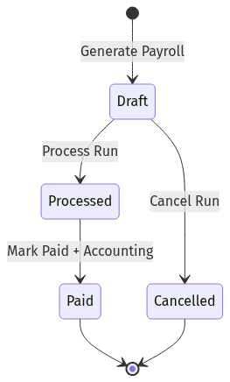
flowchart 10
Step | UI | API | Notes
1 Configure | Payroll → Settings | GET/PUT /api/payroll/settings | PF, ESI, trip bonus, etc.
2 Generate | Payroll → Generate | POST /api/payroll/generate | Month + year
3 Review | Payroll Runs → Details | GET /api/payroll/runs/{id}/entries | Per-employee breakdown
4 Process | Process button | POST /api/payroll/runs/{id}/process | Locks calculations
5 Pay | Mark Paid | POST /api/payroll/runs/{id}/pay | Posts accounting voucher
6 Payslip | Payslips → Print | GET /api/payroll/payslips/{id} | PDF/print
7 Register | Salary Register | GET /api/payroll/salary-register | Export/report
Employment types in payroll calculation: - Permanent — full monthly salary, PF, ESI, insurance - Contract — contract amount, reduced allowances - Daily — daily wage × attendance days

7. Accounting Workflow

Diagram: flowchart 11
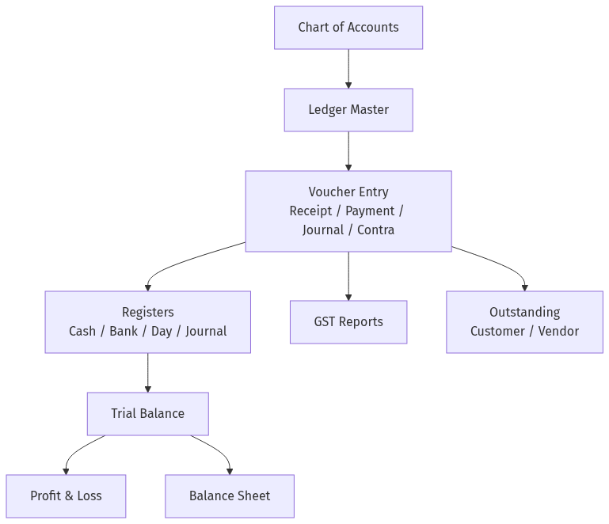
flowchart 11
Voucher type | Use case
Receipt | Customer freight payment
Payment | Vendor / driver / expense payment
Journal | Adjustments, payroll accrual
Contra | Cash ↔ Bank transfer
Sales | Freight invoice posting
Purchase | Vendor bills
Payroll integration: Mark Paid on payroll run auto-creates accounting voucher.

8. Expense Workflow

Diagram: flowchart 12
flowchart 12

9. Customer Portal Workflow

Diagram: flowchart 13
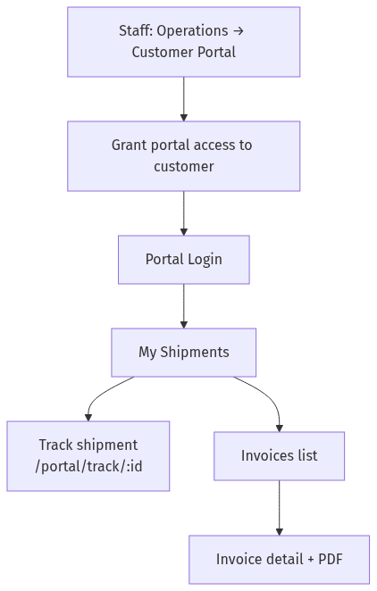
flowchart 13

10. Notifications Workflow

Diagram: flowchart 14
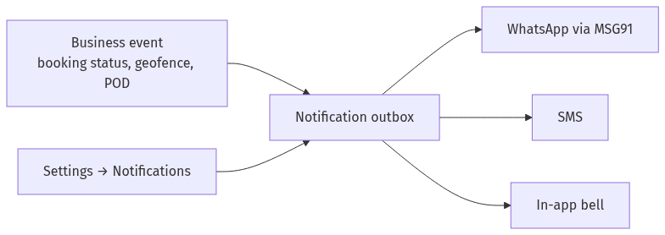
flowchart 14

11. Multi-Branch Scenario

Diagram: flowchart 15
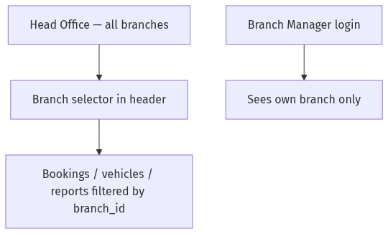
flowchart 15
Install: npm run branches:install

12. Reports Workflow
Report | Path | Data source
Trip report | /reports/trips | trips + bookings
Vehicle utilization | /reports/vehicles | vehicles + GPS
Driver performance | /reports/drivers | drivers + trips
Income / expense | /reports/income, /reports/expenses | accounting
Cash flow | /reports/cash-flow | vouchers
Dashboard analytics | / (Dashboard tabs) | aggregated KPIs

13. Deployment & Install Scenarios

Diagram: flowchart 16
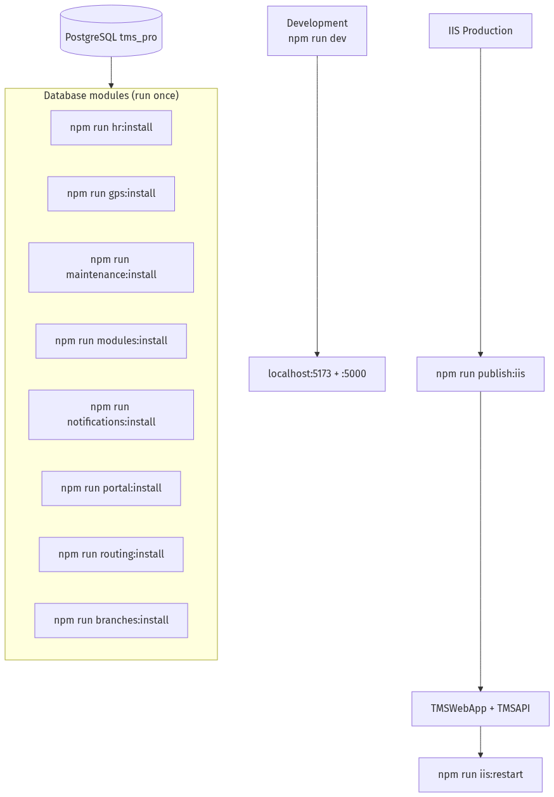
flowchart 16

Environment variables (Production)
Variable | Purpose
TMS_CONNECTION_STRING | PostgreSQL connection
TMS_JWT_KEY | JWT signing (32+ chars)
ASPNETCORE_ENVIRONMENT | Production
PGPASSWORD / TMS_PG_PASSWORD | For install scripts

14. Typical Day-in-Life Scenarios

Scenario A — New freight booking (Operations)
- Login → Dashboard
- Customers (verify exists) → Bookings → New Booking
- Fill consignor, consignee, route, freight, payment type
- Save → Generate LR → Print for driver
- Operations → Trips → assign vehicle
- Fleet map → monitor movement
- ePOD on delivery → update payment status

Scenario B — Month-end payroll (HR + Accounts)
- HR → Attendance → mark month / bulk present
- HR → Leave → approve pending requests
- Payroll → Settings → verify PF/ESI rates
- Payroll → Generate → select month/year
- Review run → Process → Mark Paid
- Accounting → verify voucher posted
- Payslips → distribute to employees

Scenario C — Customer tracks shipment
- Staff grants portal access (Settings → Portal Users)
- Customer logs in at /portal/login
- Views shipment list → opens track page
- Optional: receives SMS on status change

Scenario D — Vehicle maintenance due
- Maintenance page → view due schedules
- Record service when completed
- Update odometer on vehicle master
- Dashboard alerts if overdue

15. API Health Check
GET /TMSAPI/api/health
→ { "status": "healthy", "service": "TMS Pro API", "database": "connected" }

16. Module Dependency Map

Diagram: flowchart 17
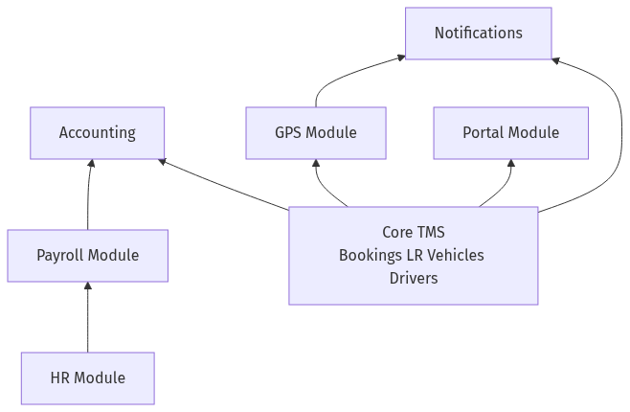
flowchart 17

Generated for TMS Pro — Enterprise Transport Management · India Powered by Codeestack

