TMS Pro — System Workflow Document
Transport Management System | Version 1.1 | 23 June 2026
Includes flowchart diagrams & module map

1. Introduction
TMS Pro is an enterprise Transport Management System for logistics and transport companies. It covers booking, LR generation, fleet management, expenses, accounting, and reporting — all connected through a React frontend, .NET 8 API, and PostgreSQL database.
This document includes visual flowcharts for architecture, authentication, business processes, accounting, installation, data flow, and UI module navigation.

2. System Architecture
Three-tier architecture with JWT-secured REST API between the React UI and PostgreSQL database.
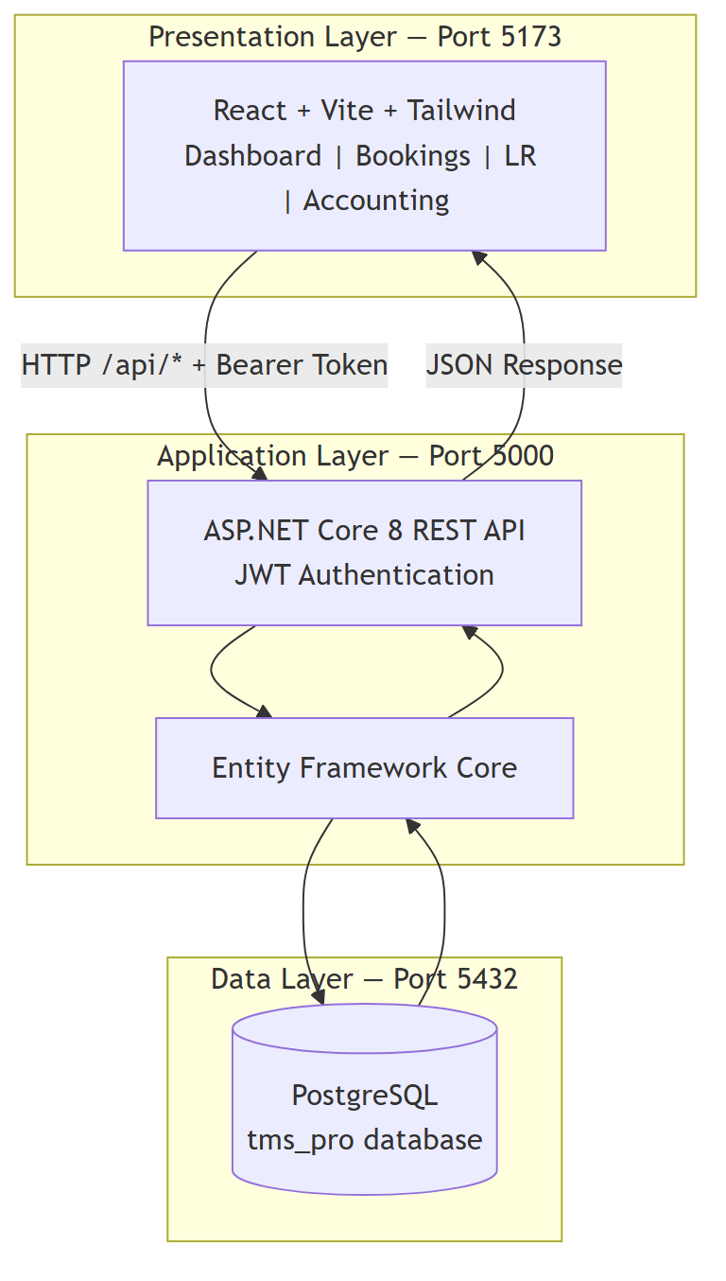
Figure: System Architecture — React → .NET API → PostgreSQL
- Presentation Layer: React 19 + Vite + Tailwind CSS (Port 5173)
- Application Layer: ASP.NET Core 8 REST API (Port 5000)
- Data Layer: PostgreSQL tms_pro database (Port 5432)

3. Authentication Workflow
All protected routes require a valid JWT bearer token. Session expires on 401 response.
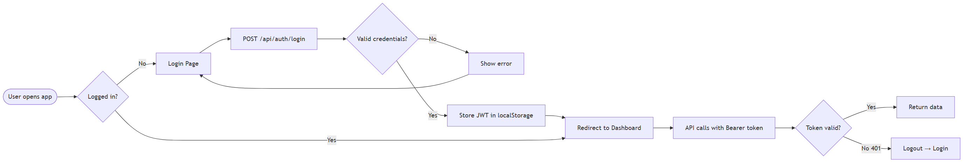
Figure: Authentication & JWT Token Flow
- User opens http://localhost:5173 → redirected to /login if no token.
- POST /api/auth/login with username & password.
- Backend validates BCrypt hash → returns JWT stored in localStorage.
- All API calls include Authorization: Bearer {token}.

4. Application UI Module Map
Navigation structure showing how modules connect from the Dashboard sidebar.
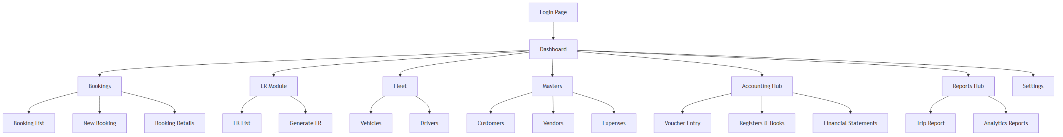
Figure: TMS Pro UI Module Navigation Map

5. Master Data Setup
Configure these records before daily operations:
- Settings → Company profile, GSTIN, financial year
- Customers, Vendors, Vehicles, Drivers
- Accounting → Ledger Master (Cash, Bank, Income, Expense accounts)

6. Core Business Workflow
End-to-end transport operations from booking creation through payment collection.
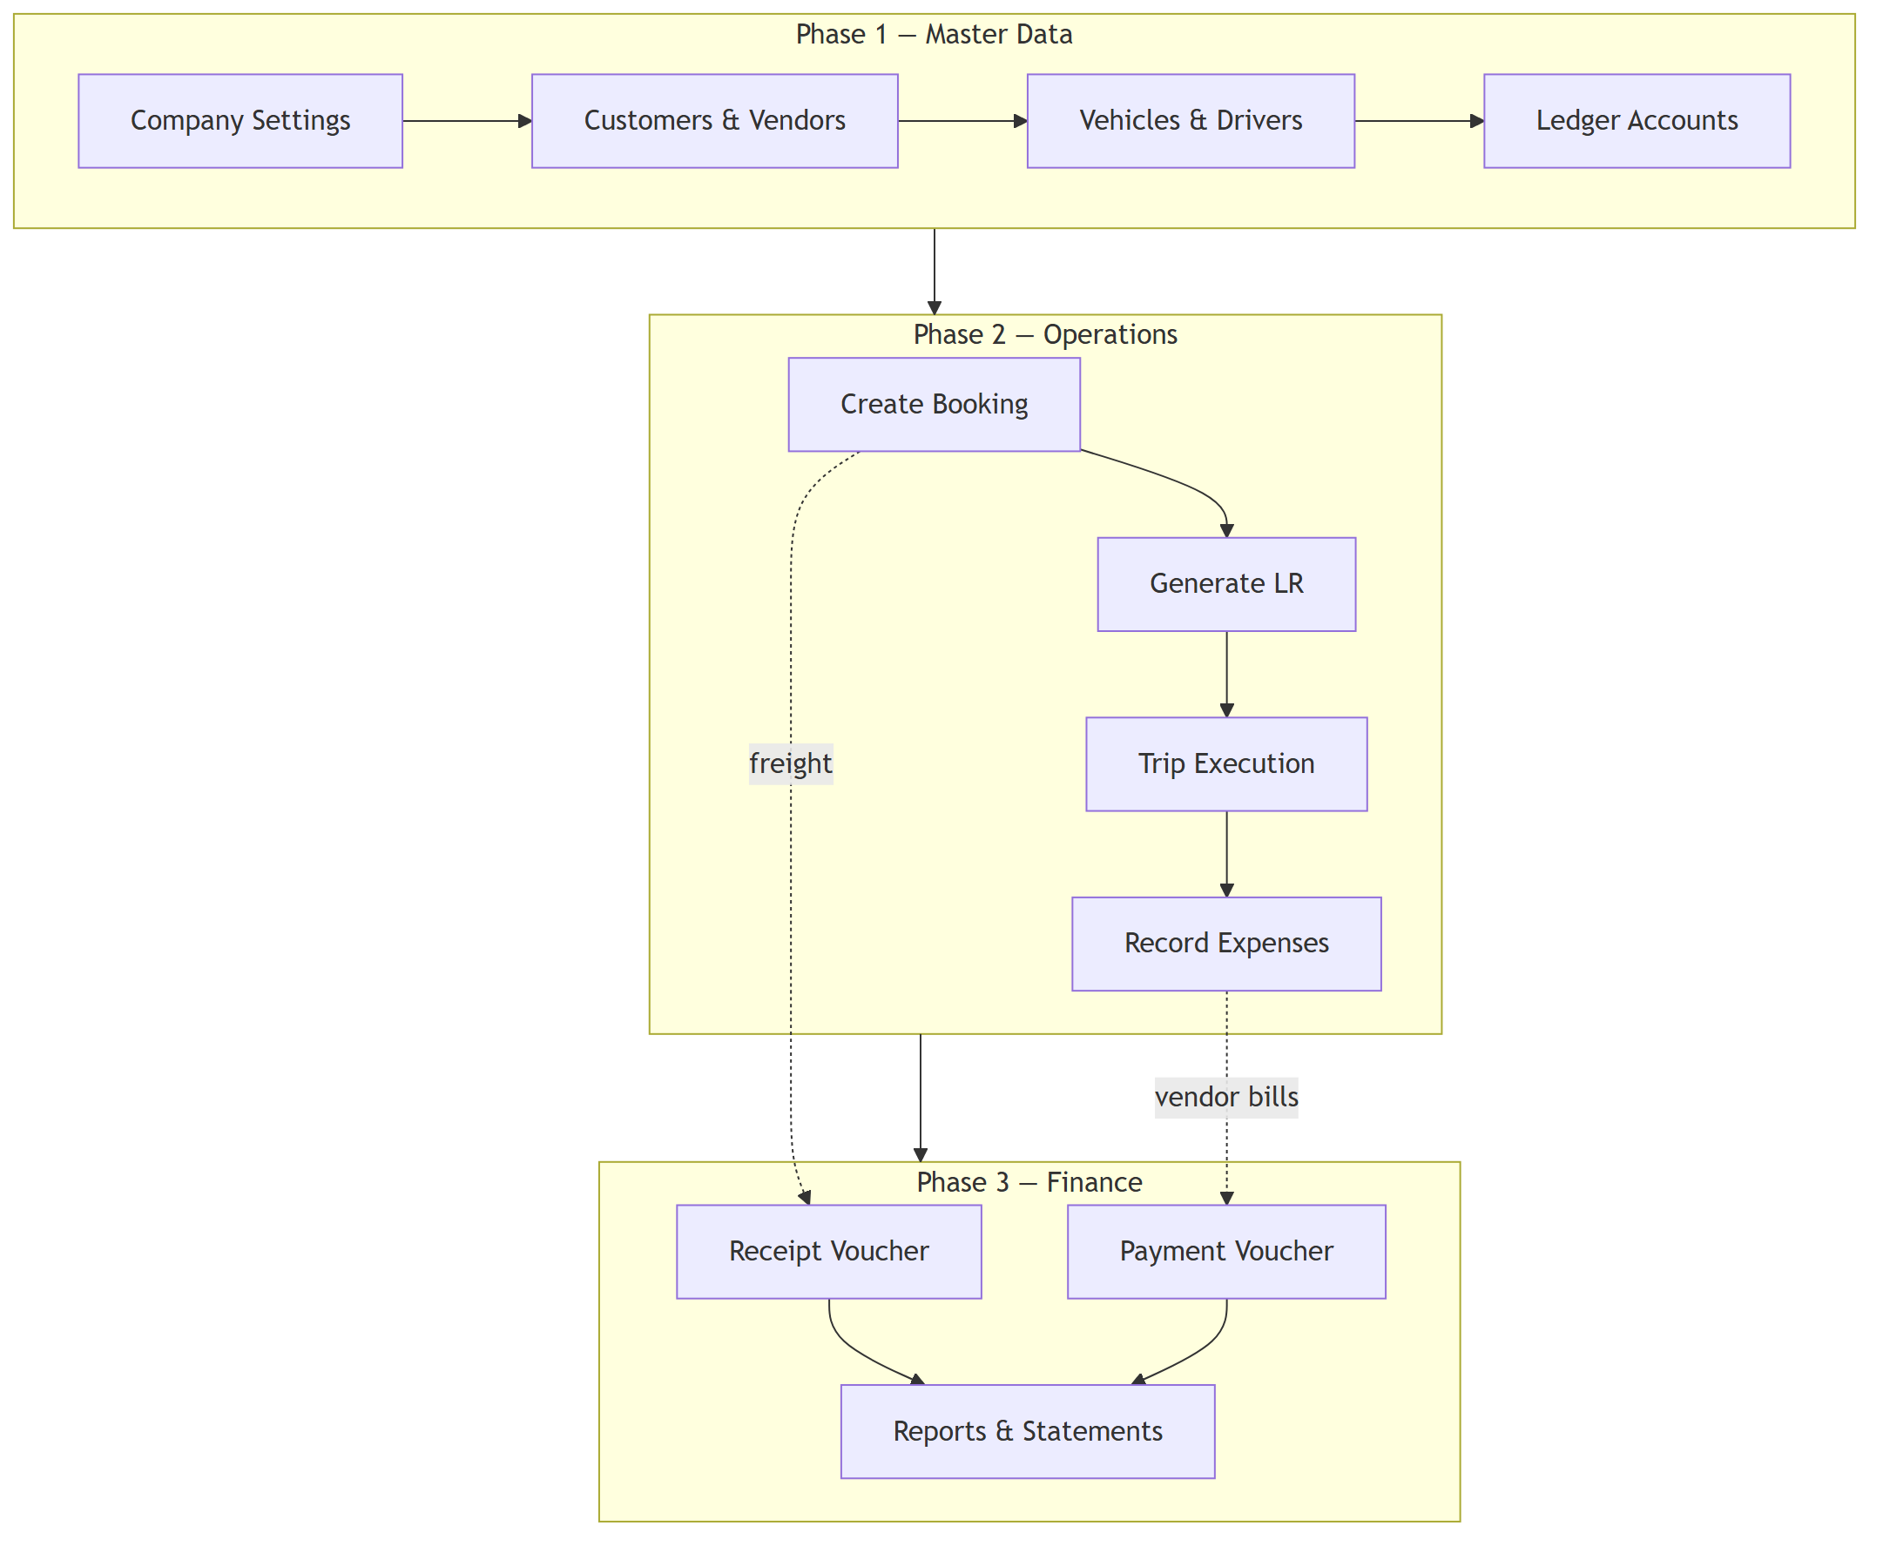
Figure: Business Process — Setup → Operations → Finance

6.1 Create Booking
- Bookings → Add New: customer, route, vehicle, driver, freight, payment status.

6.2 Generate LR
- LR → Generate: consignor/consignee, charges, GST, advance → auto LR number.

6.3 Trip & Expenses
- Update booking status through trip lifecycle; record fuel, toll, maintenance expenses.

6.4 Payment Collection
- Accounting → Receipt Voucher when customer pays freight balance.

7. Accounting Workflow
Double-entry accounting with vouchers flowing into registers and financial statements.
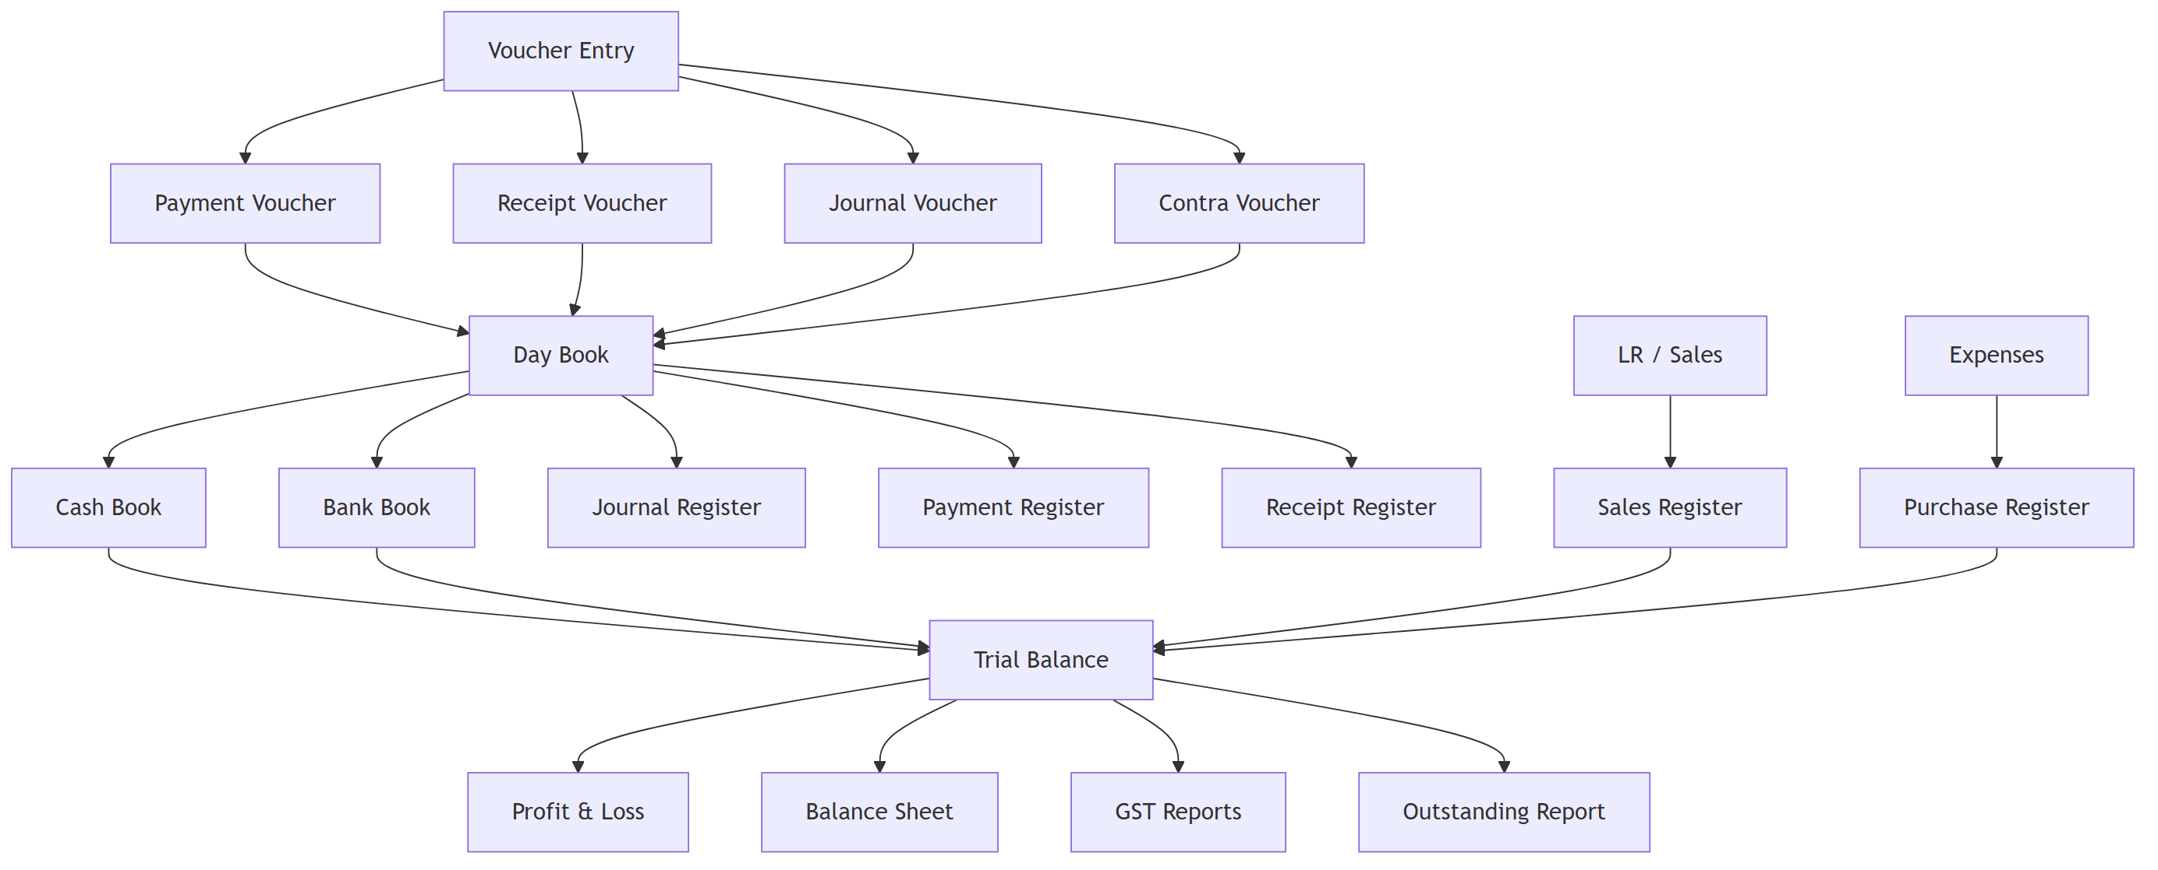
Figure: Accounting Flow — Vouchers → Registers → Financial Statements
- Payment / Receipt / Journal / Contra vouchers
- Cash Book, Bank Book, Day Book, all registers
- Trial Balance → P&L → Balance Sheet → GST → Outstanding

8. End-to-End Data Flow
How operational data feeds reports and accounting modules.
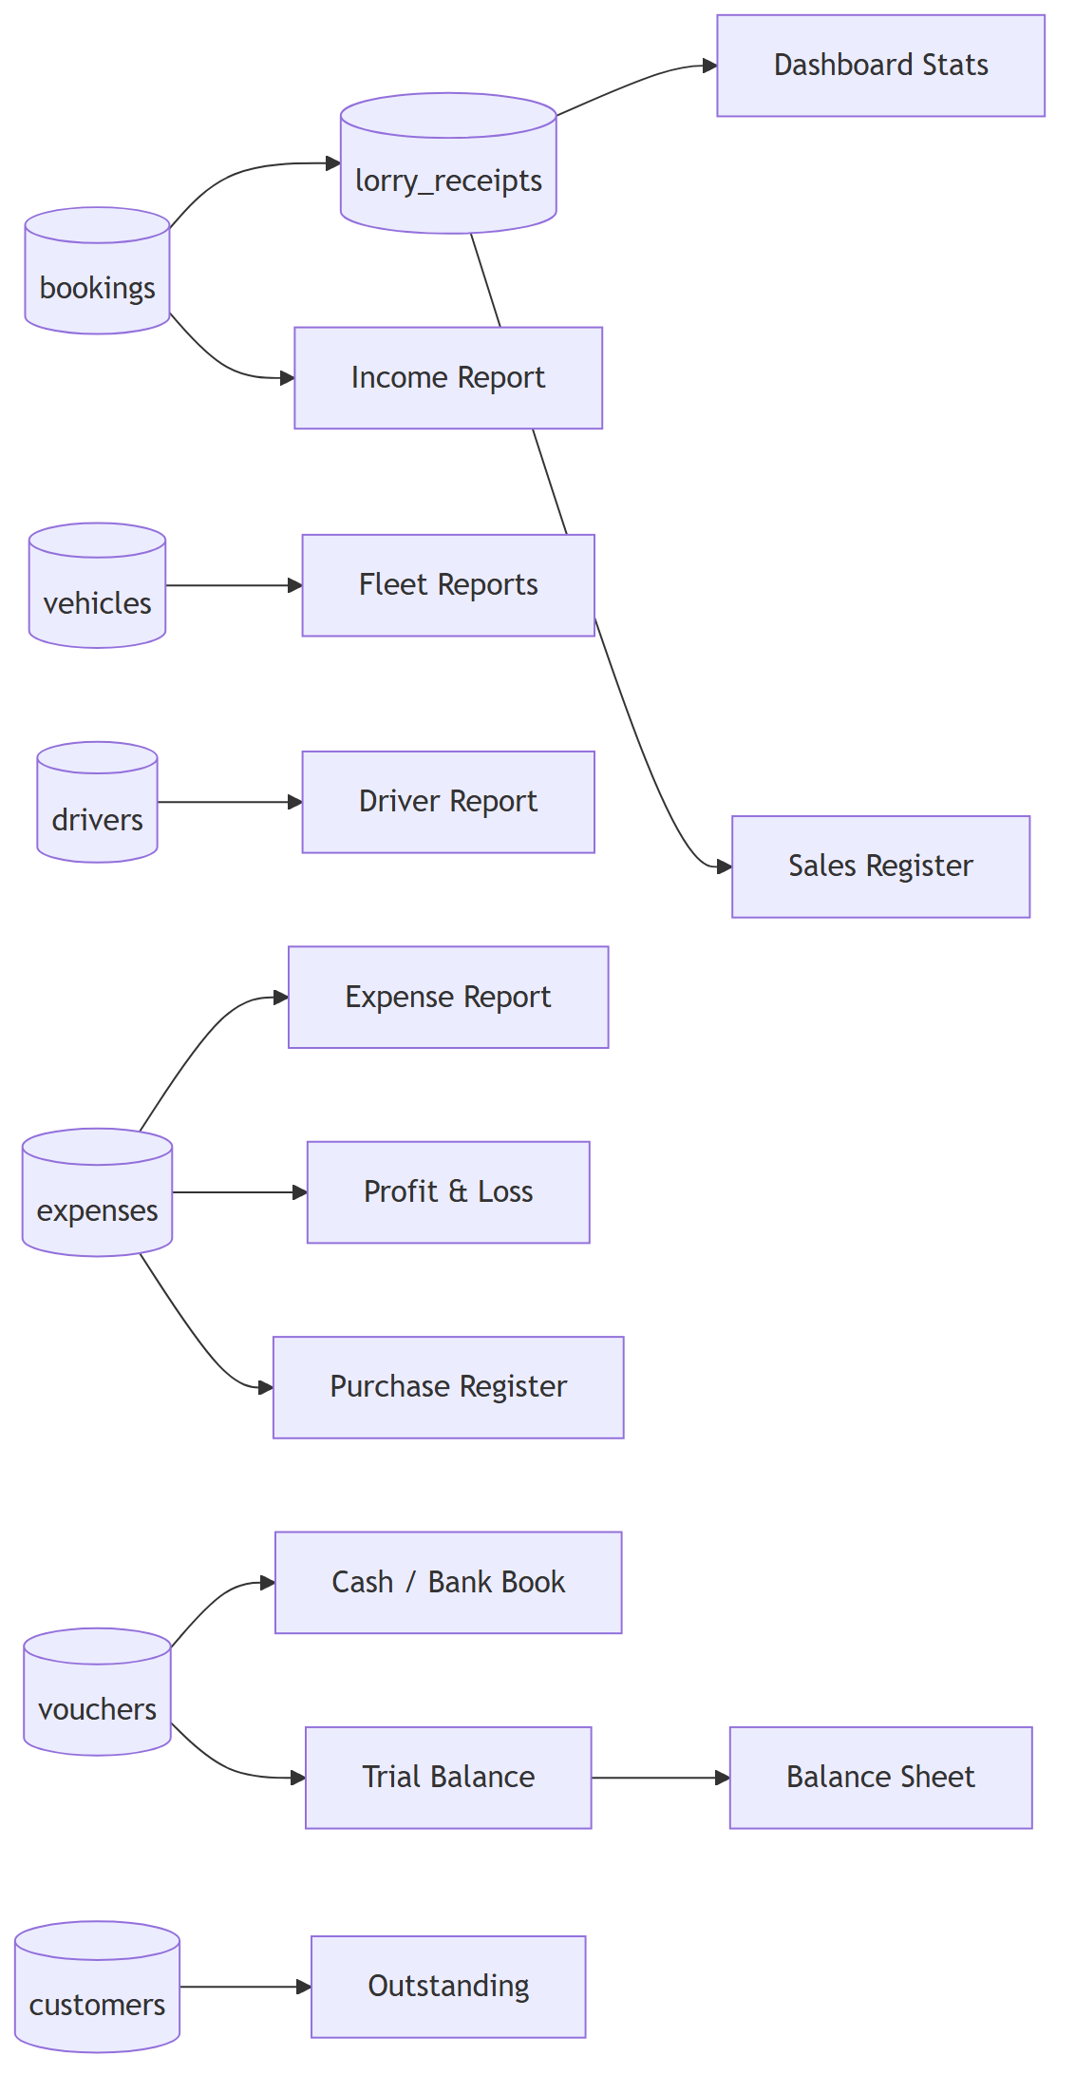
Figure: Database Tables → Reports & Accounting Outputs

9. Dashboard & Reporting
- Dashboard: 11 KPI cards, 14 analytics charts, alerts panel
- Reports Hub: trips, vehicles, drivers, income, expenses, cash flow
- Accounting Hub: 21 screens for books, registers, and statements

10. Installation Workflow
Step-by-step setup for local development environment.
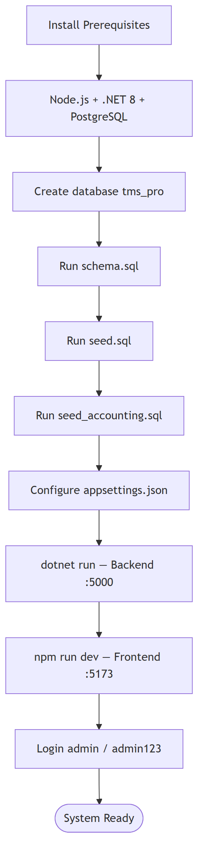
Figure: Installation & Deployment Steps

10.1 Database
- CREATE DATABASE tms_pro;
- Run schema.sql → seed.sql → seed_accounting.sql

10.2 Application
- Configure appsettings.json connection string
- dotnet run (backend :5000) + npm run dev (frontend :5173)
- Login: admin / admin123

11. User Roles
Role | Access | Modules
Super Admin | Full access | All + Settings
Accountant | Accounting | Accounting, Reports, Vouchers
Operations Manager | Operations | Bookings, LR, Fleet, Expenses
Driver Coordinator | Fleet | Drivers, Vehicles, LR
Viewer | Read-only | Dashboard, Reports

12. API Module Reference
Module | Endpoints
Auth | POST /api/auth/login, GET /api/auth/me
Operations | /api/bookings, /api/lr
Fleet & Masters | /api/vehicles, /api/drivers, /api/customers, /api/vendors, /api/expenses
Dashboard | /api/dashboard/stats, charts, alerts
Reports | /api/reports/*
Accounting | /api/accounting/*
Settings | GET/PUT /api/settings
— End of Document —

