./



Version Number:

Team Members :

Team No:

Module: Model Based System Engineering

|  |  |  |  |  |  |
| --- | --- | --- | --- | --- | --- |
| **Ver.Rel. No.** | **Release Date** | **Prepared. By** | **Reviewed By** | **Approved By** | **Remarks/Revision Details** |
|  |  |  |  |  |  |
|  |  |  |  |  |  |
|  |  |  |  |  |  |
|  |  |  |  |  |  |
|  |  |  |  |  |  |

**Document History**

Table of Contents

1.0 INTRODUCTION :…………………………………………………………………….3

2.0 REQUIREMENTS……………………………………………………………………..3

2.1 SWOT ANALYSIS…………………………………………………………………..3

2.2 COMPONENTS USED IN FIRE ALARM………………………………………..4

2.3 4W'S AND 1H……………………………………………………………………….5

2.4 TABLE OF REQUIREMENTS.........................................................................5

3.0 ARCHITECTURE………………………………………………………………………..6

4.0 SIMULATION…………………………………………………………………………….7

# GAS DETECTING SENSOR

# 1.0 Introduction:

# In this project we are going to create a gas detecting sensor by using ATMEGA32 Gas sensor MQ-2 is used here with ATmega32 microcontroller to detect gas presence and display the level of the gas on LCD. MQ-2 gas sensor can detect LPG, smoke and hydrogen gas, butane, CO2, alcohol etc… so you can use it in many projects. Here we will simply display the level of LPG gas and Smoke in PPM(Parts Per Million) on LCD.

**2.0 Requirements:**

**2.1 SWOT ANALYSIS:**

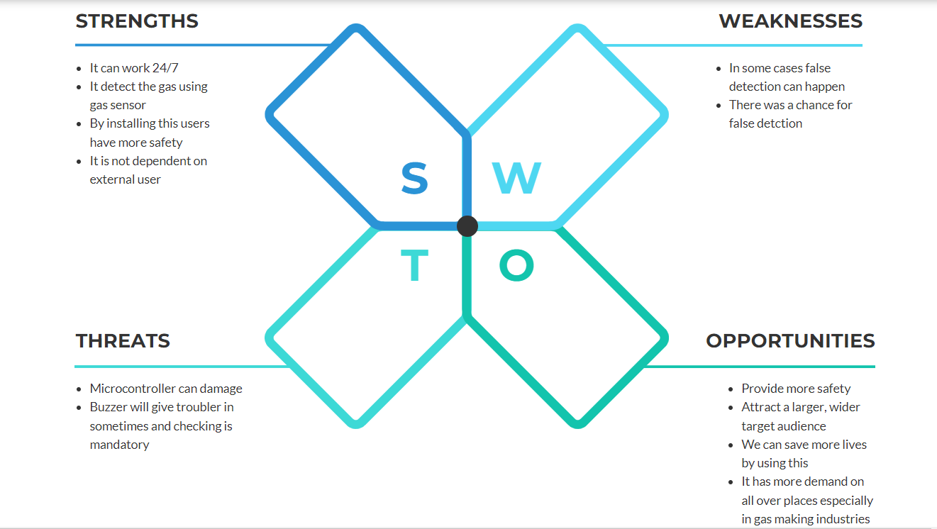

**2.2 Components used in gas Detecting sensor:**

MQ-2 Gas sensor module

Lcd(16*2)

ATMEGA32

Power supply

Ground

Buzzer

**MQ-2 Gas sensor module:**

The MQ-2 module contains the MQ-2 gas sensor, some chip that performs signal conditioning, resistors, potentiometer for adjusting the sensitivity. The MQ-2 gas sensor itself contains gas sensitive conductive Tin Dioxide (SnO2) layer whose conductivity increases, that is, resistivity decreases when the gas concentration near it increases. This increase in conductivity or decrease in resistivity is translated into output voltage via the voltage divider that is formed by the internal SnO2 and the potentiometer.

**Power supply:**

It is used to give the power supply to the circuit.

**Lcd(16*2):**

Lcd(16*2) it is used for output source it shows the percentage of the gas present and

leakage of gas in places.

**ATMEGA32:**

It is used to control the all circuit and send commands and operate.

**Buzzer:**

* Buzzre is used to make sound and it is a output to the circuite button.
* It is used to set and reset button.

**2.3 4WS & 1H**

**Where:**

Gas sensor system is use this in real time environments like hospitals, schools and shopping malls etc..

**When:**

Gas sensor is activated when the gas is leak in and the lcd screen and buzzer activate automaticallythrought micro controller atmega8.

**What:**

Gas sensor system using microcontroller Atmega8 and gas sensor, here gas sensor play a vital role.

**Why:**

Gas sensor system is use this in real time environments like hospitals schools and shopping malls they are usedHow:Gas sensor is independent device it not dependent on external user it work on micro controller.

**2.4 Table of requirements**

|  |  |
| --- | --- |
| **HLR** | **HIGH LEVEL REQUIREMENTS** |
| **HLR-1** | It work when gas is detected. |
| **HLR-2** | Buzzer will start work when gas is detects. |
| **HLR-3** | We need to reset buzzer after work done. |
| **HLR-4** | Fire alarm need to work perfectly. |

|  |  |
| --- | --- |
| **LLR- ID** | **LOW LEVEL REQUIREEMENTS** |
| LLR-1 | Gas sensor is needed |
| LLR-2 | Lcd screen and buzzer is need and connects to microcontroller |
| LLR-3 | Reset button is need to install. |
| LLR-4 | Microcontroller need to install. |

**3.0 ARCHITECTURE:**

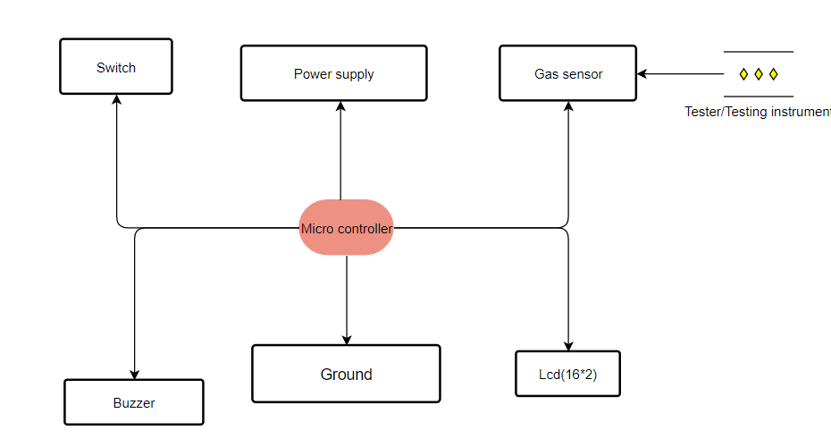

**4.0 SIMULATION:**