**Microsoft Power Platform**

It’s built around 3 primary solutions:

* **PowerApps**for building custom applications
* **Power BI** for analytics and reporting
* **Microsoft Flow** for business processes and workflows

What is Common Data Service?

Common Data Service is the storage service for any data held within Power Platform. More importantly, for users of online versions of Microsoft Dynamics 365, the Common Data Service already holds all of your data. This makes Power Platform the optimal solution for working with your data for the purposes mentioned above.

**Power Apps:**

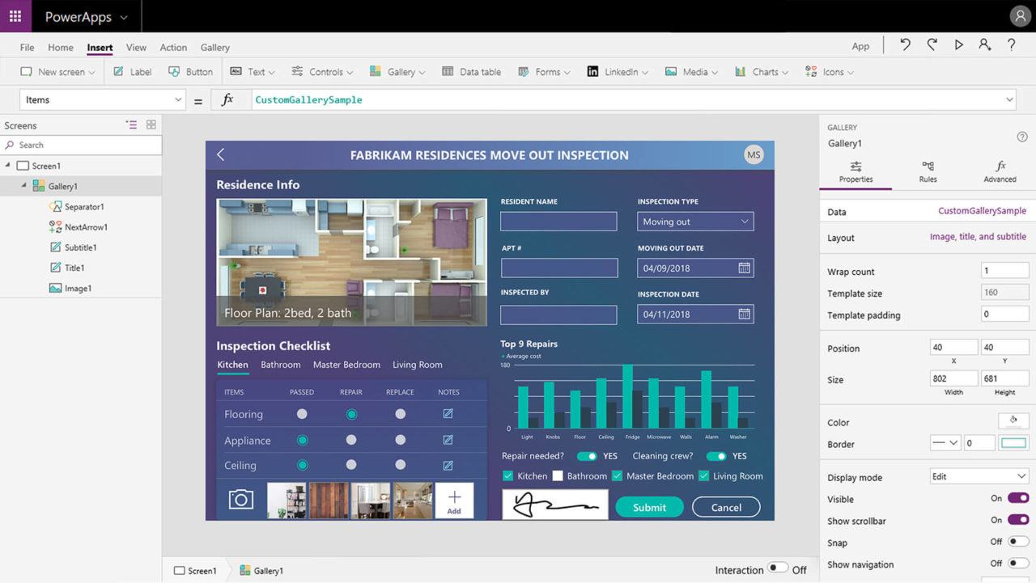

### What is a PowerApp?

A PowerApp can be a mobile phone or tablet application (published on iOS, Android, and Windows application stores) or a browser-based application (published as a web site).

Microsoft categorise PowerApps into 3 different types when building them:

* **Model-driven Apps** – start with the data source(s), and bring in the design afterwards (most useful for Dynamics 365 data sources)
* **Canvas Apps** – start by designing the look and feel of the app, and connect to data source(s) as you go (most useful for other data sources)
* **Portals** – for creating web portals, allowing customers, employees, partners, or wider communities to interact with you via a dedicated application

What can I use PowerApps for?

The capability of PowerApps shouldn’t be underestimated, and the use cases are endless.

Here are a few ideas for apps that you could create:

* A customer portal, linked to Dynamics 365, that allows customers to view knowledge articles, and submit and track support cases.
* An employee expenses app, allowing your employees to enter details of any expenses they’ve incurred, and attach photographs of receipts or invoices.
* A one-off events competition entry app, allowing attendees to enter competitions at your exhibition stand, with an opt-in form for your marketing list.
* A product showcase, allowing customers who visit your premises to browse the products that you offer.

These are just a few simple examples, but more complex solutions are possible. For example, Autoglass use PowerApps for various purposes, the most noteworthy being that their mobile technicians can now view and complete the jobs to which they’re assigned, and the back-office system is automatically updated with their progress.

Their app even has an augmented reality interface allowing the correct windscreen to be selected by overlaying on top of a live image of the vehicle, in the case of needing a replacement.

### Can I really build my own apps?

According to Microsoft, PowerApps allows anyone to create their own apps due to the drag-and-drop interface it provides.

In reality, although this is technically true due to templates that can be used out of the box, there’s actually quite a learning curve for those who want to customise or build their own apps.

Our recommendation is to err on the side of caution with this.

Unless you’re a developer, you should ideally work with your Microsoft partner to plan, design, and build anything but the simplest applications.

That shouldn’t stop you from giving it a go though, and the built-in guided learning courses within the PowerApps website are a good starting point.

What data sources can PowerApps be integrated with?

There are far too many to mention here. Some of the more popular data connectors include:

* Common Data Service (already used for Dynamics 365 online instances)
* SQL Server
* SharePoint/OneDrive
* Microsoft Office applications (Excel, Outlook etc.)
* Dropbox

Microsoft categorise data connectors as either Standard and Premium, so it’s worth checking what you have access to based on your licensing scenario

**PowerBI**

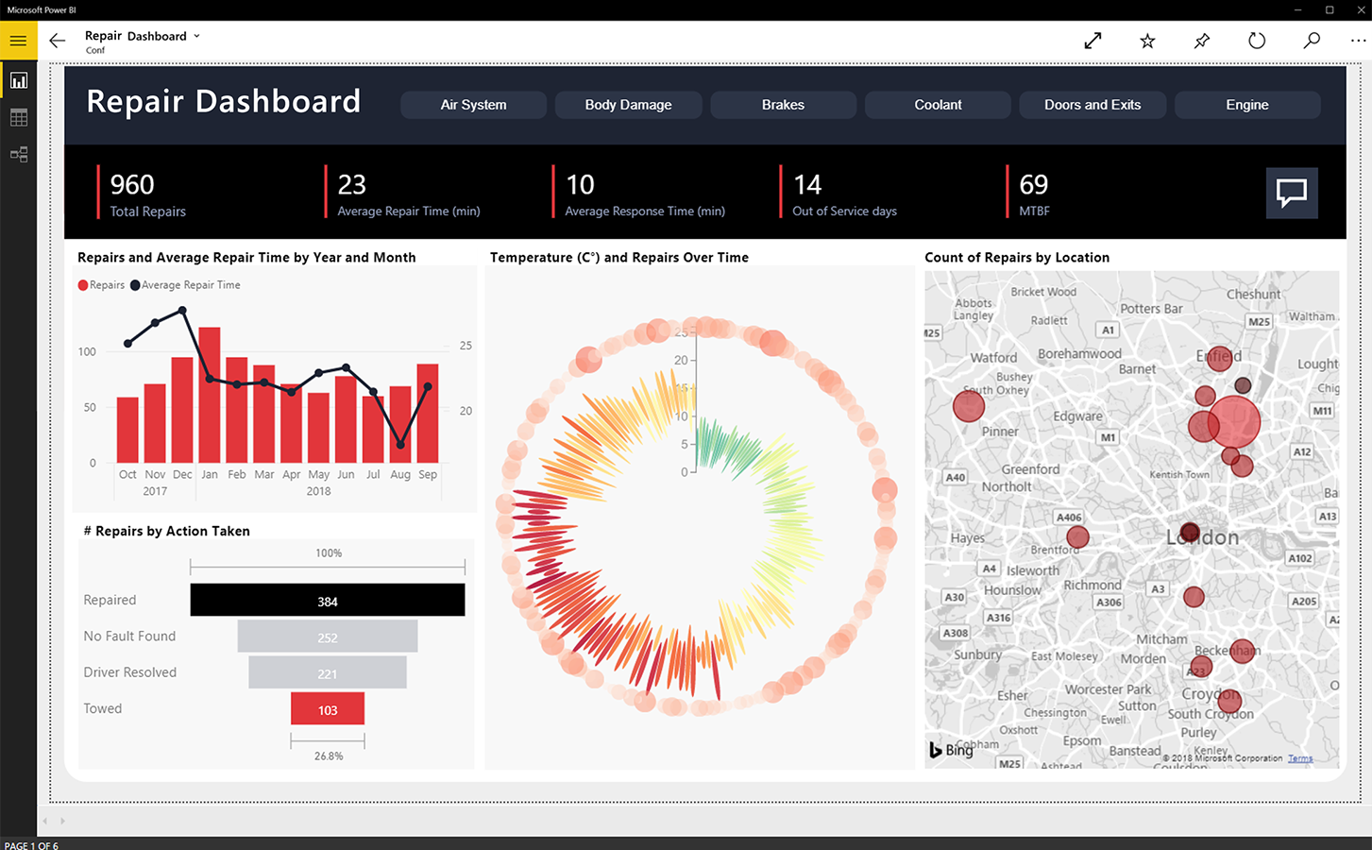

What is Power BI?

Power BI is a business intelligence solution, designed to give visual representations of your data for insights into your organisation’s performance. You may already be familiar with the concept of dashboards and KPIs; Power BI is Microsoft’s take on this.

What can I use Power BI for?

The most obvious purpose of Power BI is to use it to create dashboards to represent your organisation’s performance. However, there are lots of methods available for depicting your data:

* You could have a screen within your offices, demonstrating performance of each team against their monthly targets.
* Departmental managers could have access to dashboards demonstrating their own team’s individual performances, rather than having to manually compile metrics.
* Directors can have a dashboard to review during the month, and another to show at board meetings.

It’s important that we don’t consider Power BI to just be static representations of data, though. They’re a dynamic solution that allow you to explore the data further and to investigate anomalies by drilling down into the data, without having to switch between your various business applications to do so.

Further to this, you can embed various other assets into Power BI. For example, if you want to embed a PowerPoint slideshow to include additional information when presenting to the board, it’s easy to do so. You can also extract data out of Power BI into an Excel spreadsheet, and then pivot or manipulate the data as needed.

We also can’t miss out the collaborative nature of Power BI. If you’re reviewing a dashboard and notice an anomaly, you can ask questions of your colleagues through the Power BI application itself (e.g. “@Paul, please investigate low sales in March” would lead to Paul getting a notification linked directly to the corresponding chart). If your organisation uses Microsoft Teams, you can even embed Power BI charts into your chats or teams.

**Microsoft Flow**

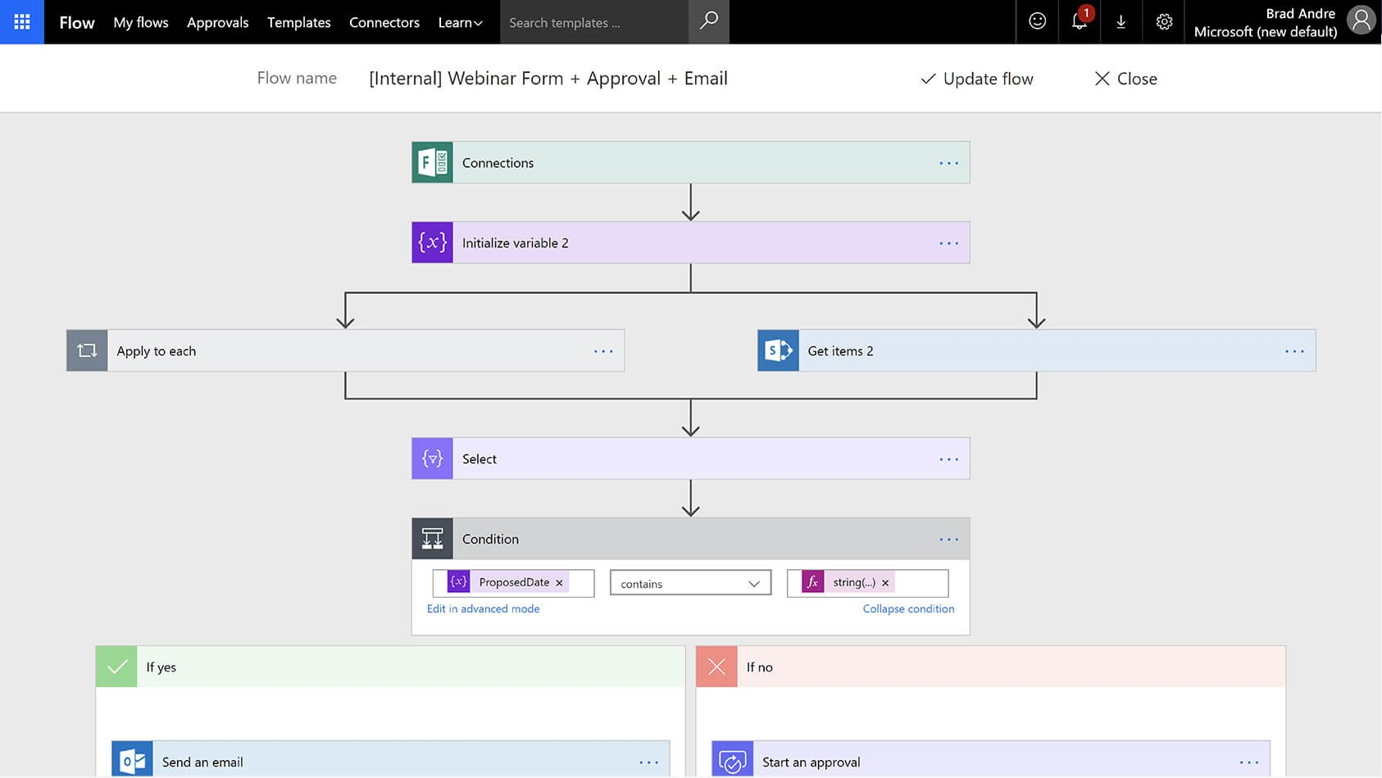

What is a Flow?

A Flow is a series of steps that automate a function or task that is performed by the user.

* Automated Tasks
* Scheduled Tasks
* A triggered action such as a button click
* A business process

Each of these utilise the Common Data Service, but there is a host of third-party connectors which allow users to connect to applications outside of this. If there is no existing endpoint connector for your desired application, a custom one can be created with the correct knowledge.

Flow uses the if then this argument whereby the trigger action causes the ‘if’ statement to be questioned. If that statement returns true the next step in the branch of the flow is processed, triggering the ‘this’ part of the argument.

What can I use Flow for?

Flows are a starting point that utilise drag-and-drop functionality for its connectors, and includes intelligent business sense that narrows down connector options based off of the selected arguments. This can be overruled by the creator enabling flows to be many and varied in their application and use.

For example:

* Whenever an email containing an attachment is sent to a user, automatically organise the document into a SharePoint folder structure.
* Introduce an approval procedure to an employee expenses PowerApp.
* Post new Outlook tasks to a Trello board.
* Saving tweets with specific hashtags to a SharePoint document for targeted marketing purposes.