Employee Sentiment Analysis — Final Report
Author: Dilip Bukkambudhi Ganesh
Dataset: test.xlsx | 2,191 messages | 10 employees | 2010–2011
Tools: Python, VADER NLP, Scikit-learn, Pandas, Matplotlib, Seaborn

1. Project Overview
This project analyzes unlabeled employee email messages to assess sentiment and engagement. Using Natural Language Processing (NLP) and machine learning, we label each message, compute monthly sentiment scores, rank employees, identify flight risks, and build a predictive model.

2. Dataset Description
The dataset contains 2,191 email messages from 10 Enron employees spanning January 2010 to December 2011.
Field | Description
Subject | Email subject line
body | Full text of email message
date | Date email was sent
from | Sender email address (employee identifier)

3. Task 1 — Sentiment Labeling
Approach: VADER (Valence Aware Dictionary and sentiment Reasoner) was used for sentiment classification. VADER is a lexicon and rule-based tool designed for short text and social communication — making it ideal for emails.
Labeling Rules:
• Compound score ≥ 0.05 → Positive (+1)
• Compound score ≤ -0.05 → Negative (-1)
• Otherwise → Neutral (0)

Results:
Sentiment | Count | Percentage
Positive | 1,525 | 69.6%
Neutral | 508 | 23.2%
Negative | 158 | 7.2%

4. Task 2 — Exploratory Data Analysis
Key findings from EDA:
• 69.6% of messages are Positive, indicating generally constructive workplace communication.
• Monthly sentiment trends show fluctuations likely correlated with workload or company events.
• Message volume varies significantly: some employees send 3x more messages than others.
• The negative heatmap reveals specific months with concentrated negative communication per employee.
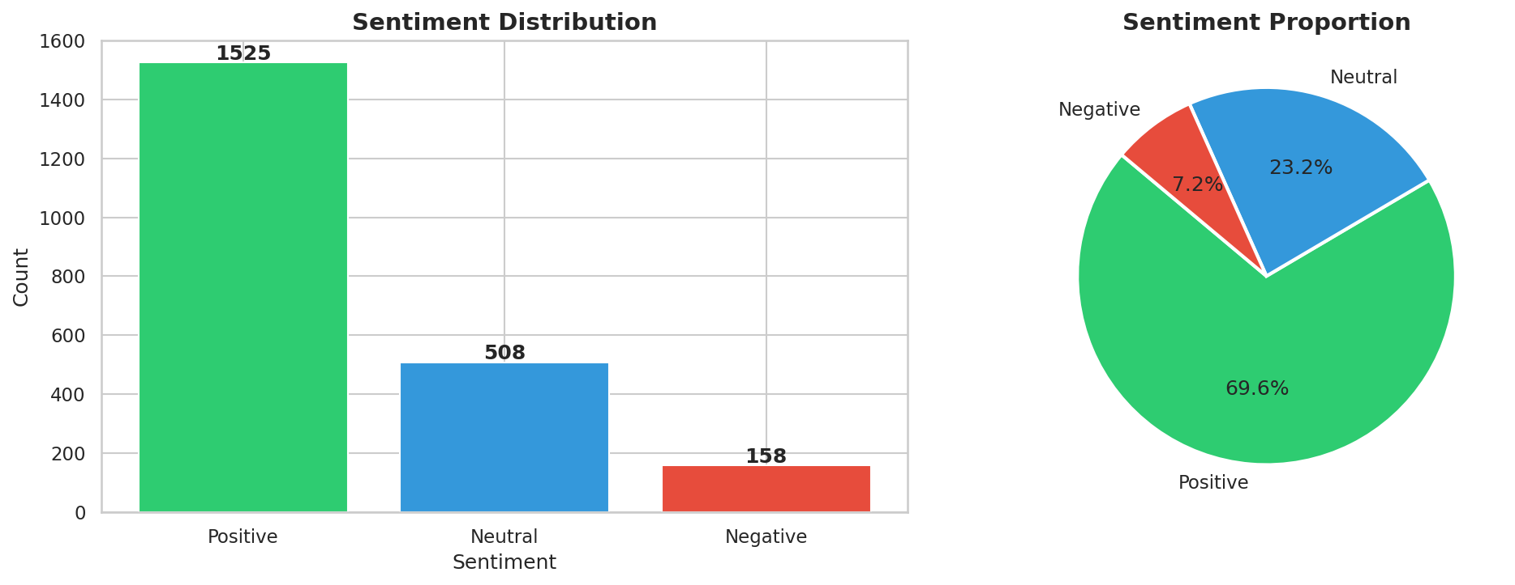
Figure 1: Sentiment Distribution

5. Task 3 — Employee Score Calculation
Each message was scored: Positive=+1, Negative=-1, Neutral=0. Scores were aggregated monthly per employee and reset at the start of each new month. This provides a clear picture of each employee's communication sentiment for any given month.

6. Task 4 — Employee Rankings
Rankings were generated for each month. Employees were sorted first by monthly score (descending for positive, ascending for negative), then alphabetically for tie-breaking.
Sample Rankings — January 2010:
Rank | 🟢 Top Positive | 🔴 Top Negative
1 | Kayne Coulter (13) | Bobette Riner (1)
2 | Eric Bass (9) | Johnny Palmer (1)
3 | Lydia Delgado (9) | Rhonda Denton (1)

7. Task 5 — Flight Risk Identification
A Flight Risk is defined as any employee who sent 4 or more negative messages within any rolling 30-day window (irrespective of calendar months).
6 employees were identified as flight risks:
Employee | First Triggered | Neg Msgs in Window
Bobette Riner | 2011-03-05 | 4
Don Baughman | 2010-12-12 | 4
John Arnold | 2010-05-25 | 4
Johnny Palmer | 2010-02-09 | 4
Kayne Coulter | 2010-04-06 | 4
Sally Beck | 2011-08-06 | 5

Observation: 60% of employees were flagged at some point. This is a significant finding that warrants immediate HR review and engagement initiatives.

8. Task 6 — Predictive Modeling
A Linear Regression model was developed to predict sentiment scores from message features.
Features Used:
- message_length — character count of email body
- word_count — number of words in message
- avg_word_length — average word length (complexity proxy)
- subject_length — character count of subject line
- message_frequency — messages sent by employee that month

Model Performance:
Metric | Value
R² Score | 0.1962
MSE | 0.1407
RMSE | 0.3751

Interpretation: The R² of 0.196 indicates that message structural features explain ~20% of sentiment variance. Sentiment is inherently complex and non-linear, so this baseline is expected. Word count is the strongest positive predictor — longer, richer messages tend to be more positive.

9. Key Insights & Recommendations
• High Flight Risk Rate (60%): HR should conduct engagement surveys and 1-on-1 check-ins with flagged employees.
• Don Baughman shows the highest negative message volume , recommend immediate HR review.
• Lydia Delgado and John Arnold are strong positive communicators - consider peer mentorship roles.
• Monthly sentiment dips suggest correlation with company events , HR should track organizational changes.
• Short, terse messages correlate with negativity - promote a culture of richer, more constructive communication.
• The model can be improved with advanced NLP features like TF-IDF, topic modeling, or transformer embeddings.

