Date: 11 October 2023
Team ID: 329
PROJECT ID: Proj_227277_Team_1
NAME: Dilipvijayakumar T

Create a Chat bot in python

PHASE 2 – INNOVATION

Consider exploring advanced techniques like pre-trained language models (e.g., GPT - 3) and deep learning models (e.g., DNN) for creating a best chat bot.

DEEP LEARNING

Deep learning is a subset of machine learning, which is essentially a neural network with three or more layers. These neural networks attempt to simulate the behavior of the human brain—albeit far from matching its ability—allowing it to “learn” from large amounts of data. While a neural network with a single layer can still make approximate predictions, additional hidden layers can help to optimize and refine for accuracy.
In traditional machine learning algorithms, features are manually extracted from the input data and fed into the algorithm. However, in deep learning, the algorithm automatically learns the features from the data. This is particularly advantageous for tasks involving unstructured data like images, audio, and text.
As we are going to create a chat bot, it going to contain lot of text so we will use deep learning

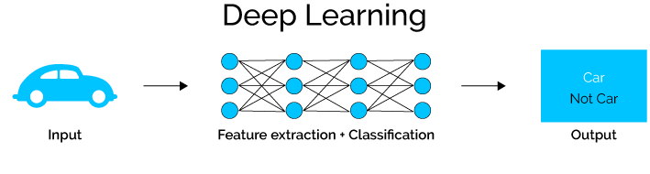

pre-trained language model

A pre-trained model refers to a model or a saved network created by someone else and trained on a large dataset to solve a similar problem.

AI teams can use a pre-trained model as a starting point, instead of building a model from scratch

Once the pre-training phase is complete, the model can be fine-tuned for specific applications. Fine-tuning refines the model's understanding, making it adaptable to tasks such as translation, sentiment analysis, and chatbots. These models serve as versatile foundations for natural language processing tasks. Notable examples like GPT (Generative Pre-trained Transformer) and BERT (Bidirectional Encoder Representations from Transformers) have revolutionized the field, setting new benchmarks in language understanding and generation. The pre-trained approach ensures that the model is well-equipped to handle real-world applications, making it a fundamental advancement in the realm of artificial intelligence.

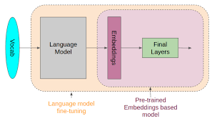

INNOVATION
Innovation phase focuses on enhancing the existing ML model design and
incorporating advanced techniques for creating a better chat bot.

pre-trained language model:

GPT-3, or Generative Pre-trained Transformer 3, is a cutting-edge language processing AI model developed by OpenAI. It belongs to the transformer architecture, capable of generating human-like text by predicting the next word in a sentence. GPT-3 is pre-trained on a vast dataset, making it highly versatile for various natural language tasks, including translation, conversation, and content creation. With its immense scale of 175 billion parameters, GPT-3 represents one of the most powerful and sophisticated language models in existence.

STEP BY STEP INSTRUCTIONS TO INCORPORATE GPT-3 IN THE PROJECT:

1. Obtain Access to OpenAI API
2. Understand GPT-3 Capabilities
3. Structure Conversations
4. Formulate System and User Messages
5. Send Requests to the API
6. Test and Iterate
7. Handle Errors and Edge Cases
8. Integrate into Your Project
9. Monitor and Refine

Use GPT-3 for Chatbot When:
- Versatility: GPT-3 offers remarkable versatility due to its pre-trained nature. It can handle a wide array of conversational topics without the need for extensive domain-specific training, making it suitable for general-purpose or multi-domain chatbots.
- Natural Language Generation: If your chatbot requires generating human-like responses and engaging in diverse conversations, GPT-3 excels at natural language generation, producing coherent and contextually relevant text.
- Quick Prototyping: GPT-3 allows for rapid prototyping and experimentation. You can quickly integrate it into your chatbot application without the time-consuming process of training a custom DNN from scratch.

Deep learning model:

The chatbot uses a Deep Neural Network (DNN) to understand what users are saying. It figures out important words from what users type and changes them into their basic form (like changing 'going' to 'go'). This is called stemming. Then, it turns these words into numbers because neural networks can only understand numbers. This process is called One-Hot Encoding

Once all the words are turned into numbers, the chatbot uses a tool called 'TFlearn' to create a neural network. It teaches this network with lots of examples so it can understand what users mean. After this training, the chatbot can pick appropriate responses based on what users ask

STEP BY STEP INSTRUCTIONS TO INCORPORATE DNN IN THE PROJECT:

1. Get dataset from Kaggle: https://www.kaggle.com/datasets/grafstor/simple-dialogs-for-chatbot
2. Choose a Deep Learning Framework
3. Design the DNN Architecture
4. Preprocess Data for the Network
5. Create and Compile the DNN Mode
6. Split Data into Training and Testing Sets
7. Train the DNN Model
8. Evaluate and Fine-Tune
9. Deployment and Monitoring

Use DNN for Chatbot When:
- Customization: If you require a highly specialized chatbot tailored to specific domains or industries, a DNN allows you to design a model optimized for the unique requirements of your chatbot.
- Control Over Training: DNNs give you granular control over the training process. You can fine-tune and iterate on your model, ensuring it aligns perfectly with your chatbot's objectives and user interactions.
- Data Efficiency: If you have a substantial dataset specific to your chatbot's purpose, training a DNN can leverage this data effectively, leading to a chatbot that understands and responds contextually to user queries within the defined domain.

In summary, chatbot needs to handle specific, domain-focused interactions and you have a substantial dataset, a customized DNN might be the better choice. However, if you need a versatile chatbot capable of handling diverse conversations and you want to minimize development time, GPT-3 offers a powerful and efficient solution.

My chatbot project involves a domain-specific dataset
kaggle = https://www.kaggle.com/datasets/grafstor/simple-dialogs-for-chatbot, such as the one you've provided from Kaggle, a DNN allows you to leverage this specific knowledge effectively. By training a DNN on this dataset, you can create a chatbot that is finely tuned to understand and respond to conversations within the context of the dataset's domain. This domain-specific knowledge can result in more accurate and relevant responses, catering specifically to the topics and conversations present in your dataset. GPT-3, being a general-purpose model, might not utilize the nuances of your dataset as efficiently as a custom-trained DNN can, making DNNs a preferable choice when domain-specific expertise is crucial for your chatbot application.

