
Dilkaran Dhaliwal
500971670
Supervisor’s Name: Tamer Abdou
CIND 820
Date: July 28, 2025
Final Results and Project Report
Table of Contents

Research Questions and Contribution Section....................................................................3

Literature Review and Integration..........................................................................................4

Methodology and Study Design Section...............................................................................5

Model Evaluation Section.......................................................................................................7

Findings and Interpretation Section.....................................................................................11

Limitations and Ethical Considerations Section................................................................13

Future Work and Recommendations Section.....................................................................14

Research Questions and Contribution Section

This research project focuses on post-secondary education and the graduation rates compared to the dropout rate. I wanted to look at the factors that may lead to a student dropping out of their university program. From the data set that was selected, I constructed 3 research questions that I believe could help shine a light on what factors lead to a student dropping out. One of the research questions was whether there was a significant impact on dropouts for students taking daytime classes compared to evening classes. Daytime courses are offered at a higher rate than evening classes, so by looking at this attribute, we may be able to see if universities should allow students more evening course options. The second research question wanted to look at the age of admission and is that impacted the dropout rate. This could help universities look at the age of their student body and if certain students are at higher risk of dropping out compared to others. The third research question would be looking at the parents of the students and their education level. Parents have an influence on how their children handle their education. If a more educated family puts emphasis on completing their children's education, this might motivate a student to continue instead of dropping out. These factors seem like they would have an impact on a student's probability of dropping out of university, so my research wanted to look at them and compare them to the other factors that the dataset has available.

Compared to other research, I wanted to look at some attributes that may be overlooked by others. Universities want their students to succeed, so by identifying certain attributes that contribute to a student's success or failure, universities can provide better support. Attributes like evening courses and daytime courses are not focused on as much. The same goes for the education level of a student's parent. These are factors that may not seem important at first glance, but I want to look at them more thoroughly to be certain. If these factors are important, then it give universities a better understanding of their students and what support they might need. The student body changes every year, and universities need to keep adapting to these changes. That is why research on these students needs to be continuous, as the needs of one-year students could be drastically different from new students attending in a few years.

Literature Review and Integration

Studies into higher education are plentiful and for good reason. The successful education of a population benefits everyone. Research is needed so that universities can get a better understanding of their student population and how to support them. A study performed by Matti Vaarma and Hongxiu Li looked at student dropout rates in Finnish higher education. Through different predictive models, they found that accumulated credits, the Moodle activity count and the number of failed courses were some of the most important features when it came to predicting if a student would drop out of their university program (Vaarma, Li 2024). When looking at my own research, I also created predictive models to predict the dropout rate of students in higher education. When looking at the features and which ones were significant, I also saw that the grades of a student were accurate at predicting if a student was going to drop out of university. This is a conclusion that is fairly common in education studies. A student's grades are the most concrete in predicting their chances of success. Higher grades lead to a better success rate. The Finnish study also noted that accumulated credit affected their predictions. This is common in my own findings as well as the more credits a student has successfully completed shows the they are successfully on their way to completing their education. Fewer completed credits mean that a student is farther from graduating. A student with fewer credits remaining to complete has a higher chance of completing their education compared to someone who has completed many fewer. My research comes to similar conclusions as the Finnish study. Even though my data comes from Portuguese students, this shows that the success of students in higher education are similar around the globe. Another study by the Higher Education Quality Council of Ontario looked at University completion rates and the labour market outcomes of those who did not graduate. They found that non-completion rates were higher for men, domestic students and those who received federal financial aid (Colyar, Chatoor, Deakin 2023). My study did not find a particularly strong correlation between the gender of the student and their graduation rate. My study had a higher female population than male. 2868 female to 1556 male students. The Ontario study had a higher male population than female. The similarities of the two studies are that I also found that student debt does impact the students' chances of success in university. Also, students who receive scholarships are also more likely to graduate than those who do not. This could also be related to the findings noted earlier about higher students' grades improving their chances of graduating. The scholarships do tend to go to students who show a great level of academic success. This only better their odds of graduating.

Methodology and Study Design Section

The dataset being used for this study is from a Portuguese university. The target attribute being assessed is whether the student graduated, dropped out or is currently enrolled. The data contains 36 features and 4424 instances, with each instance consisting of 1 student. Modifications to the headers of each column were made to ensure there were no spaces. Any spaces were replaced with an underscore( _ ). It was found that the data did not consist of any missing values. In our target attribute, there consisted of 2209 graduate, 1421 dropout and 794 enrolled. We removed all enrolled students as they would not have been useful in our analysis. Our research is focused on graduated and dropped out students. A student who is currenyl enrolled could finish their studies or they could dropout. They are unknown, so they are removed as they may alter the results of our study. Our target column was considered an object, so we converted the target attribute into numbers. 1 represents graduate while 2 represents dropout. The attributes of GDP and inflation rate were removed as they consisted of negative values that would cause issues with our models and training. Then for feature selection the Chi Square test was used, and the p-values were found for each independent variable. A significance level of 0.05 was used to see what variables were significant. 6 variables were found to not be significant, those being Daytime/evening_attendance, Fathers_qualification, Educational_special_needs, International, Mothers_occupation, and Unemployment_rate. Those attributes were removed from the dataset. Then I split the data, which consisted of 80% training and 20% testing data. For balancing the data set Synthetic Minority Oversampling Technique (SMOTE) was used. The two models that i decided upon were the decision tree and the Naive Bayes models. The reasoning for choosing these models comes from previous research done on education. Anaile Rabelo and Luis Zarate found 62 articles related to the problem of student dropouts. Out of these articles, they noted the machine learning techniques that were most used. In the table below, it can be seen that the most used techniques are Decision Tree and Naive Bayes (Rabelo & Zárate, 2025).

Techniques | Quantity | Percentage (%)
Decision tree | 35 | 19.9
Naïve Bayes | 30 | 17.0
K-nearest neighbours | 17 | 9.7
Logistic regression | 17 | 9.7
Random forest | 17 | 9.7
Neural networks | 16 | 9.1
Support vector machine | 15 | 8.5
Rules | 8 | 4.5
Gradient boosting machine | 5 | 2.8
Fuzzy | 3 | 1.7
Others | 13 | 7.4
Total | 176 | 100

To evaluate the model Matthews Correlation Coefficient (MCC) was used as well as a classification report which included the confusion matrix, precision, recall, and f1-score. The confusion matrix was also visualized to get a better understanding. Another decision tree and naive bayes models were created after, but this time they were made with only Daytime/evening_attendance, Age_at_enrollment, Mothers_qualification, and Fathers_qualification as the independent variables. These were the attributes that I wanted to have a better look at when it comes to predicting the students' dropout chances, and by making prediction models with only these attributes, I could compare them to the previous models to see how they compare.

Model Evaluation Section

I will be evaluating 4 models that were made for this study: 2 decision trees and 2 naive bayes models. The first decision tree and Naive Bayes model use most of the independent variables, while the second decision tree and Naive Bayes models only uses 4 variables. I wanted to compare the results of the models to see if the 4 variables have a good chance at predicting a student's dropout chances.

Decision tree #1:
Independent variable: Application_mode Course Curricular_units_2nd_sem_(approved) Curricular_units_2nd_sem_(grade) Curricular_units_1st_sem_(approved) Curricular_units_1st_sem_(grade) Age_at_enrollment Previous_qualification Scholarship_holder Debtor Gender Curricular_units_2nd_sem_(without_evaluations) Mothers_qualification Curricular_units_2nd_sem_(evaluations) Admission_grade Curricular_units_2nd_sem_(enrolled) Curricular_units_1st_sem_(enrolled) Tuition_fees_up_to_date Curricular_units_1st_sem_(without_evaluations) Curricular_units_2nd_sem_(credited) Curricular_units_1st_sem_(credited) Previous_qualification_(grade) Application_order Curricular_units_1st_sem_(evaluations) Displaced Nationality Marital_status Fathers_occupation "Daytime/evening_attendance"
Dependent variable: Target

The Matthews Correlation Coefficient (MCC) for the Decision Tree is: 0.6961433327085691

precision recall f1-score support

0 0.77 0.84 0.81 254
1 0.91 0.87 0.89 472

accuracy 0.86 726
macro avg 0.84 0.85 0.85 726
weighted avg 0.86 0.86 0.86 726

Confusion Matrix
[[214 40]
[ 63 409]]
TP: 409 , FP: 40 , TN: 214 , FN: 63

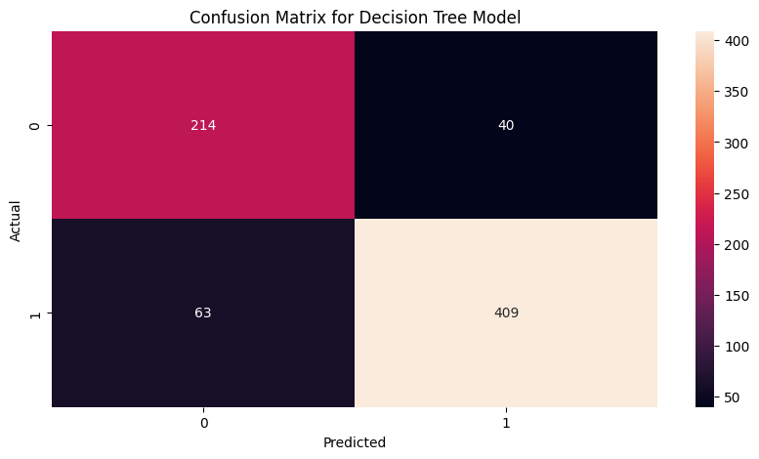

Naive Bayes Model #1

Independent variable: Application_mode Course Curricular_units_2nd_sem_(approved) Curricular_units_2nd_sem_(grade) Curricular_units_1st_sem_(approved) Curricular_units_1st_sem_(grade) Age_at_enrollment Previous_qualification Scholarship_holder Debtor Gender Curricular_units_2nd_sem_(without_evaluations) Mothers_qualification Curricular_units_2nd_sem_(evaluations) Admission_grade Curricular_units_2nd_sem_(enrolled) Curricular_units_1st_sem_(enrolled) Tuition_fees_up_to_date Curricular_units_1st_sem_(without_evaluations) Curricular_units_2nd_sem_(credited) Curricular_units_1st_sem_(credited) Previous_qualification_(grade) Application_order Curricular_units_1st_sem_(evaluations) Displaced Nationality Marital_status Fathers_occupation "Daytime/evening_attendance"

Dependent variable: Target

The MCC for the Naive Bayes Model is: 0.5889738426485639

precision recall f1-score support

0 0.73 0.74 0.73 254
1 0.86 0.85 0.86 472

accuracy 0.81 726
macro avg 0.79 0.80 0.79 726
weighted avg 0.81 0.81 0.81 726

Confusion Matrix
[[187 67]
[ 69 403]]
TP: 403 , FP: 67 , TN: 187 , FN: 69

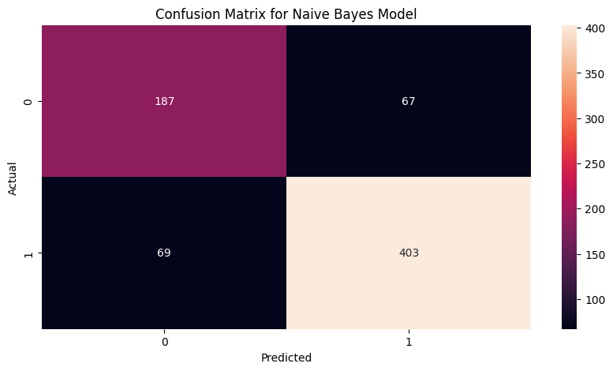
Decision Tree #2
Independent Variables: Daytime/evening_attendance, Age_at_enrollment, Mothers_qualification, Fathers_qualification

Dependent variable: Target

The MCC for the Second Decision Tree is: 0.2510588378537341

precision recall f1-score support

0 0.50 0.54 0.52 254
1 0.74 0.71 0.73 472

accuracy 0.65 726
macro avg 0.62 0.63 0.62 726
weighted avg 0.66 0.65 0.66 726

Confusion Matrix
[[138 116]
[136 336]]
TP: 336 , FP: 116 , TN: 138 , FN: 136

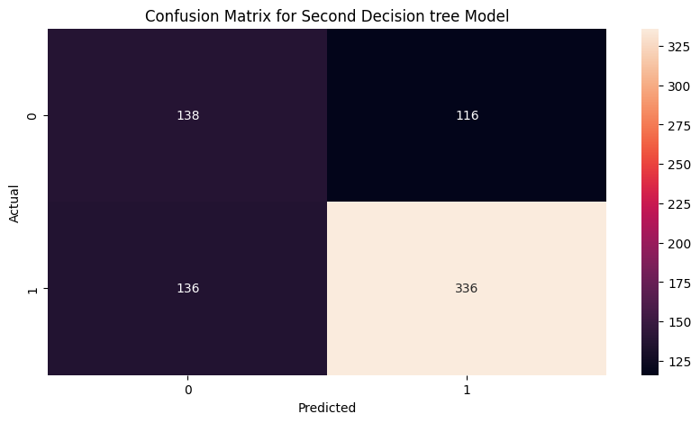

Naive Bayes Model #2
Independent Variables: Daytime/evening_attendance, Age_at_enrollment, Mothers_qualification, Fathers_qualification

Dependent variable: Target

The MCC for the Second Naive Bayes Model is: 0.09391458711655302

precision recall f1-score support

0 0.40 0.52 0.45 254
1 0.69 0.58 0.63 472

accuracy 0.56 726
macro avg 0.54 0.55 0.54 726
weighted avg 0.59 0.56 0.57 726

Confusion Matrix
[[132 122]
[199 273]]
TP: 273 , FP: 122 , TN: 132 , FN: 199

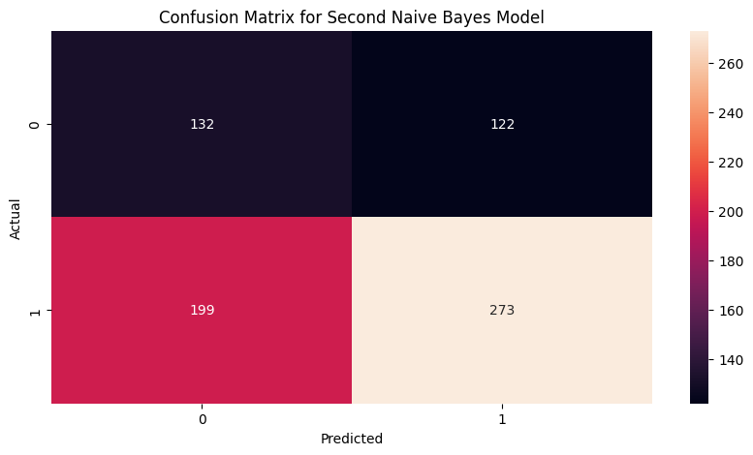

To run the code, the execution takes about 3 minutes. However, a vast majority of this time comes from running the profile report. When there is no profile report, it takes a few seconds to fully execute. The data set only consists of 4424 instances with 36 features, so it can be run on a local machine without difficulty. The resource usage is very low.
Findings and Interpretation Section

The findings from my models came as a bit of a surprise to me. When I was conducting feature selection using Chi square, 6 features were not significant. Of the 6 features, 2 were features I believed to have an impact on the target outcome. Those 2 features being daytime/evening attendance and fathers' qualification. The daytime or evening courses feature was just out of the significance range. This could have been attributed to the fact that a large percentage of courses are in the daytime, and not enough courses are set in the evening for it to be significant. This partially answers one of my research questions, as daytime or evening courses do not have a significant impact on a student's dropout or graduation chances. More research may be needed into the topic of daytime and evening course choices. The other feature that was not seen as significant was the father's education. What surprised me here was that the father's education was not seen as significant, but the mother's education had the 13th highest p-value, which meant that it was significant to the target attribute. This answers one of the research questions, where i wanted to see if one parent's education had more of an impact on a student's success than the other. In this case, the mother's education seems to be of more importance to a student's graduation chances than the father's. Upon further investigation, I noticed that the dataset consisted of 2868 female and 1556 male participants. This could lead to the assumption that, due to the data having more female than male students, the mother’s education may be something that the female students use as motivation to graduate from higher education. This is my assumption, and further research may be needed into a mother's influence on female student academics. Something else that caught my eye was that another variable that was deemed to be not significant was the mother's occupation. Once the decision tree model was created with the remaining variables, it came out with an accuracy of 86%. This is a good result as it is accurate enough to predict a student's graduation or dropout rate. The first Naive Bayes model came to a similar result with an accuracy of 81%. Once these 2 models were complete, I created 2 more models, but this time I reduced the independent variables to just 4: Daytime/evening_attendance, Age_at_enrollment, Mothers_qualification, and Fathers_qualification. These 4 variables were the ones that I wanted to see if they could accurately predict whether a student would graduate or drop out of university. The second decision tree had an accuracy of 65% while the second naive Bayes model had an accuracy of 56%. This shows a drastic decrease in accuracy from the first pair of models. If we take a closer look at the second decision tree, it shows that there is a large number of false positives and false negatives. There are more false positives than false negatives, which means that the decision tree model is predicting that students will drop out when they will actually graduate. This is similar to the results in the Naive Bayes model. A large number of false positives and false negatives are giving the model bad accuracy metrics. These false positive predictions are giving the models a low precision; the decision tree has 0.50, while the naive bayes performed even worse at 0.40 precision. This shows that my previous assumptions are incorrect. Daytime/evening attendance, Age_at_enrollment, Mothers_qualification, and Fathers_qualification can not accurately predict if a student is going to graduate or drop out of university. However age of enrollment and the mother's qualification do seem to be significant to the target, so if they can be used with more significant features, they can create accurate models like the initial pair of models. This study has shown that more research is needed into the education of a child's parents and how that can impact their academic success. Universities could provide more information to the parents of potential students about how their university will benefit their children and how they can help their children transition into university life. If the parents are not familiar with higher education, it may be difficult for them to guide their children into university. Providing more information for the parents may help with student retention in the long term.

Limitations and Ethical Considerations Section

Limitations of this study are that the 4424 instances may not be enough to create a highly accurate model. More student data may need to be collected to accurately predict student dropout chances. This data only consists of students in a Portuguese university. This may not translate to university students in North America. Portugal has a culture of caring about their education as they have invested heavily in their public schooling system. In 2014, 5.1% of its gross domestic product (GDP) was devoted to financing pre-primary, primary and secondary education. This is 1 percentage point higher than its southern European peers in Italy and Spain (Liebowitz, David, David, et al). The data being collected comes from voluntary information that university students provide to the institution, so there may not be an accurate reflection of the whole student body. Other privacy issues may arise as universities may need to create profiles for their students that collect this personal information about their parents and other aspects of a student's life that the students may not be comfortable sharing.

Future Work and Recommendations Section

Future work may include looking at the correlation between male and female students and the impact that fathers and mothers have on their academics. Could a father's educational background or occupation impact male students more them female students? Would a mother’s education or occupation impact female students' academics more than male students? Looking at universities that provide more evening courses to see if there is a connection between the time a course is taken and the success rate. Potentially comparing these results to students in other countries to see if the factors can stay consistently significant or if they change region by region.

GitHub: https://github.com/Dilkarand/CIND820-Big-Data-Analytics-Project

References

Colyar, J., Chatoor, K., & Deakin, J. (2023). Linking postsecondary non-completion rates and
labour market outcomes. Higher Education Quality Council of Ontario. https://heqco.ca/wp-content/uploads/2023/11/Linking-Postsecondary-Non-completion-Rates-and-Labour-Market-Outcomes-in-Ontario-FINAL.pdf

Liebowitz, D., González, P., Hooge, E., & Lima, G. (2018). OECD reviews of school resources: Portugal 2018. In OECD Reviews of School Resources. OECD Publishing. https://doi.org/10.1787/9789264308411-en

OECD (2023), PISA 2022 Results (Volume I and II) - Country Notes: Portugal, OECD
Publishing, https://www.oecd.org/en/publications/pisa-2022-results-volume-i-and-ii-country-notes_ed6fbcc5-en/portugal_777942d5-en.html

Rabelo, A. M., & Zárate, L. E. (2025). A model for predicting dropout of higher education students. Data Science and Management, 8(1), 72–85. https://doi.org/10.1016/j.dsm.2024.07.001

Realinho, V., Vieira Martins, M., Machado, J., & Baptista, L. (2021). Predict Students' Dropout and Academic Success [Dataset]. UCI Machine Learning Repository. https://doi.org/10.24432/C5MC89.

Vaarma, M., & Li, H. (2024). Predicting student dropouts with machine learning: An empirical study in Finnish higher education. Technology in Society, 76, 102474. https://doi.org/10.1016/j.techsoc.2024.102474

