Task 2: Web Application Security Basics
Cybersecurity Internship Task Report | Student: Dilkhush Panchal

1. Objective
Understand common web vulnerabilities—Cross-Site Scripting (XSS) and SQL Injection—and recommend safe mitigations. Scope is limited to an authorized demo/local lab. No public or third-party website was tested.

2. Tools and Environment
• Browser and a local/demo application such as DVWA or OWASP Juice Shop
• Burp Suite Community Edition, if installed, to observe requests
• The figures in this report are simulated examples, not live test evidence.

3. Vulnerability Concepts
XSS can occur when untrusted input is returned to a page without appropriate output encoding. In a lab, a harmless test string can help check whether the application treats input as text or interprets it as HTML/JavaScript.
SQL Injection can occur when user input is combined unsafely into database queries. In an authorized lab, review unexpected database errors or response changes. A single changed response is not enough to confirm a vulnerability.

4. Illustrative Request and Observation
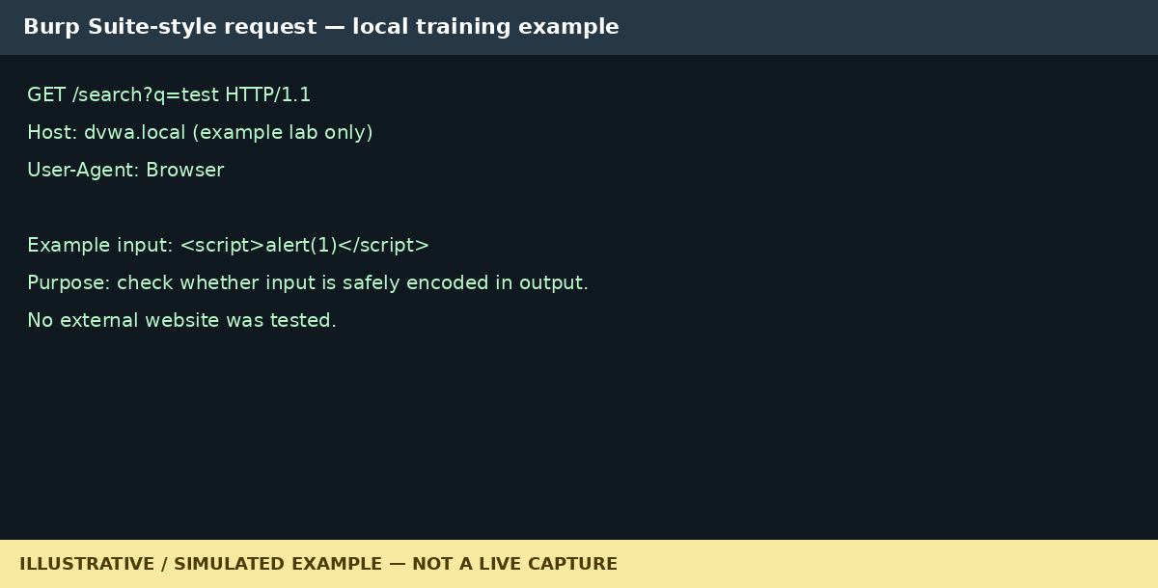
Figure 1. Simulated Burp-style request. This is an illustration, not a screenshot of a real Burp session.
Review how a demo application handles search input. If user input appears in returned HTML without safe encoding, XSS may be possible. This report does not claim that a real application was tested or that a vulnerability was confirmed.

5. SQL Injection Review Approach
Use only a deliberately vulnerable local training application and follow its guided exercise. Do not test systems without explicit permission. Document the environment, steps, observed response, and verification results.

6. Mitigation Recommendations
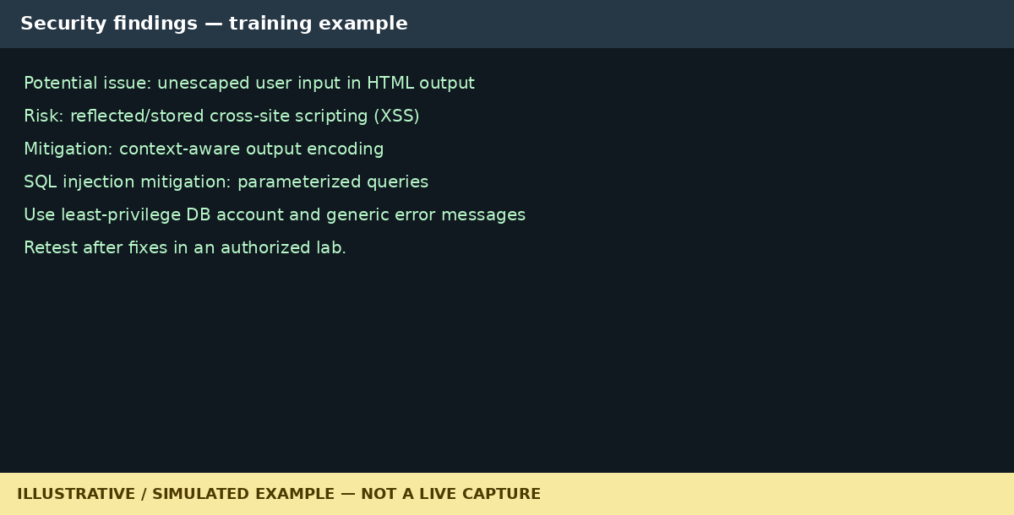
Figure 2. Simulated summary of potential findings and controls.
- Use context-aware output encoding for user data inserted into HTML, attributes, JavaScript, or URLs.
- Use parameterized queries/prepared statements instead of building SQL through string concatenation.
- Validate input server-side as an additional control; validation does not replace output encoding or parameterized queries.
- Use least-privilege database accounts and avoid exposing detailed database errors.
- Retest fixes only in the authorized lab and record genuine evidence.

7. Conclusion
This report summarizes safe review concepts for XSS and SQL Injection and gives mitigation recommendations. Figures are clearly labelled simulated examples. If the evaluator requires actual screenshots, replace these figures with genuine screenshots from your own authorized local lab before submission.

8. References
• OWASP XSS Prevention Cheat Sheet: https://cheatsheetseries.owasp.org/cheatsheets/Cross_Site_Scripting_Prevention_Cheat_Sheet.html
• OWASP SQL Injection Prevention Cheat Sheet: https://cheatsheetseries.owasp.org/cheatsheets/SQL_Injection_Prevention_Cheat_Sheet.html
• PortSwigger Web Security Academy: https://portswigger.net/web-security

