**When is adaptive sampling optimal for monitoring rapidly changing ecosystems?**

Short title: Adaptive survey sampling

Lewis A.K. Barnett*, National Oceanic and Atmospheric Administration, Alaska Fisheries Science Center Seattle, United States; lewis.barnett@noaa.gov

Dylan Fournier, Program on the Environment, University of Washington, Seattle, United States

**Abstract**

Under what conditions is adaptive sampling optimal for monitoring rapidly changing ecosystems? This is the fundamental question facing observational science in ecosystems experiencing rapid climate change, such as the Arctic. Given what fishery-independent monitoring has observed over the prior 40 years, the demersal community of the US Arctic is changing greatly among years, in terms of the spatial distribution of abundances of many species. The eastern Bering Sea and Chukchi Sea hold the boundary between the two dominant fish communities, the Arctic (small-bodied, low productivity) and sub-Arctic (large-bodied, high productivity). When a biogeographic boundary varies greatly in its location among years, it can be difficult to ensure that all stocks maintain their spatial availability to a survey.  Thus, to effectively monitor the demersal fish community in the US Arctic and other rapidly changing ecosystems, we aim to quantify the potential advantages and pitfalls of adaptive sampling. Specifically, we aim to identify when adaptive sampling performs better than traditional sampling approaches for estimating stock abundance, across a range of simulated species distributions driven by an environmental gradient that varies in strength (here assumed to represent temperature). To represent the indicator used to determine when to allocate samples poleward over a North-South environmental gradient, we simulated from a linear model predicting the areal extent of the summer cold pool (bottom waters 2℃) in the eastern Bering Sea as a function of the mean sea ice extent in the prior March. We found that most sampling designs obtained more accurate abundance estimates when spatial autocorrelation was high, dispersion of observations low, with a weak environmental gradient. Adaptive stratified sampling was most accurate, even when cold pool was simulated from sea ice with realistic observation error. These results indicate that adaptive sampling can improve estimation of marine population abundance across a fluctuating environmental gradient.

Keywords: Ecology;Fisheries Oceanography;Fisheries/Habitat;Marine;Survey Methods

**Introduction**

Modern resource management depends critically on monitoring data of high quality, quantity, and representativeness to support decision-making tools. The quality of the monitoring data can be evaluated by the bias and precision of population estimates derived from these data, and may vary over time as ecosystems respond to global change. As species’ spatial distributions shift with climate change, the proportion of their abundance within a given survey domain will cause bias due to this change in the spatial availability of the species to the monitoring program. Indeed, populations are shifting across political boundaries and, in some cases, into novel habitats entirely. Jurisdictional matters aside, it is not yet clear whether and how monitoring efforts should adapt to such changes in species distributions. Historically, a central paradigm of ecological monitoring was maintaining consistency of methods over all else to best preserve the continuity of a time series. However, this approach can lead to reductions in accuracy of population estimates due to changing spatial availability. An alternative approach that introduces flexibility in the spatial allocation of observations may improve accuracy of population estimates, particularly if this reallocation can be adequately informed by early ecological or environmental indicators.

How would an ideal survey monitor a rapidly changing ecosystem, given that there is rarely enough money or time to represent all areas within a species range with consistent sampling methods each year? Perhaps you could retain a core spatial domain that is sampled every survey, with extensions to other areas when conditions dictate that changes in spatial distributions are likely to shift to those zones? How do you decide when to trigger these changes? Or do you only retain a core survey domain and acknowledge that this may not be representative of the true resource state in all years? ….

Adaptive sampling is typically considered to be a framework by which future sampling is directed according to the most recent prior observation of the target variable (cite adaptive sampling book?). However, in cases where additional information about animal distribution or environmental conditions is available prior to the start of a survey, one can imagine a new form of adaptive sampling where the sampling design is modified given external information prior to any observations occurring in the current survey year. By extending the concept of adaptive sampling to include environmental observations or predictions made before a survey as the trigger for changing spatial allocation of samples, we can evaluate the potential efficiency gains of this environmentally informed dynamic sample allocation relative to traditional static survey designs where sampling densities over space are constant over time.

Monitoring in marine fisheries is primarily conducted by fishery-independent surveys (hereafter surveys) that record information on population density and structure (e.g., length and age composition). Resources for these surveys are limited and decreasing, while demands are greater as species ranges extend into unsampled areas, placing an emphasis on designing highly efficient surveys that are robust to ecosystem change.

These issues are particularly acute in polar regions, like the Arctic where entire communities are shifting distributions north and south across thermal barriers between Boreal and Arctic marine biomes. Reductions in Artic sea ice are driving this via changes in the extent of cold demersal waters derived from ice melt. For example, in the eastern Bering Sea, the cold pool changed like this and we observed distribution changes like this…

As spring sea ice extent best correlates with summer cold pool extent in the Bering Sea (Kearney et al. ), we asked whether spring sea ice could be a good early indicator for determining how far north to extend survey efforts the following summer. Does this improve accuracy of abundance estimates relative to these other scenarios…?

Marine resource management depends on monitoring data of high quality and quantity to support tools for modeling resource dynamics and predicting how they are influenced by human uses. While variation in operating budgets and access (e.g., complications of COVID-19) often constrain the quantity of such monitoring observations, yet the quality of these limited observations can be increased by improvements in survey efficiency. We suggest the funding of simulation studies designed to improve the value of information from surveys, particularly as it relates to integration with resource assessment models such as stock assessments. One approach to achieving such improvements could be through more extensive spatial analyses, e.g., using spatial models that explicitly account for spatial dependence between observations to improve precision and accuracy of data products such as fish abundance indices. Furthermore, such approaches could use existing data to redesign surveys in areas already monitored in addition to informing the design of expanded survey areas or new surveys altogether. This would help improve the robustness of survey results as species distributions change in response to climate change. Finally, these model-informed survey designs could allow for better integration with next-generation methods of population estimation, such as model-based estimates of annual abundance and size or age composition.

…. Need for monitoring programs to consider decision-rules so common in rest of fisheries (tie in to Bolser/Thorson ms)

Presentation flow:

In the fishery-independent monitoring world, we face the key challenges of surveying ecosystems where climate change is influencing productivity and species distributions, in the face of ever-present challenges such as weather, breakdowns, and budgets. So, we need pathways to determining how to design flexible surveys that can improve survey efficiency while reducing risk of bias due to changes in catchability as stocks shift in and out of survey boundaries.

One way to approach these challenging survey objectives is by considering the ways that we can leverage flexibility through sample allocation. The extent to which this is possible depends on your sampling design and allocation method. For example, of these common randomized designs, simple random sampling is the least flexible given that we cannot feasibly sample additional random stations that may be far away from where we are in the progression of a cruise. Stratified random sampling proportional to stratum area at least narrows the range of locations of a new station with in a stratum, so it is more logistically flexible while still providing design-unbiased estimates. At the most flexible end of this spectrum, perhaps adaptive stratified random sampling could be the most efficient as well, given the capacity to shift effort among strata based on prior information or predictions of environmental conditions.

The rate of warming of the earth’s surface is greatest in the Arctic where I work, causing loss of sea ice that weakens and shifts the thermal gradient between arctic and subarctic marine communities poleward. The Bering Sea is particularly challenging to sample because demersal community structure is driven largely by inter-annual fluctuation in bottom temperatures resulting from sea ice melt. In the past, the cold water mass, or “cold pool” was larger and extended further south than in more recent years. Cold Pool Extent Index is featured prominently in stock and ecosystem assessments, because it not only tracks the overall warmth but also the spatial distribution of animals. In response to recent heat waves, we have observed more movement of subarctic species like cod and Pollock further into the arctic. So we became interested in whether adaptively allocating more samples north or south given environmental projections as an indicator for adaptively sampling further north, either within the EBS and NBS, or across the bering strait into the Chukchi Sea.

**Methods**

We simulated variation in sea ice and cold pool extent by fitting a linear model to predict summer cold pool extent. Cold pool extent was calculated by interpolation of the bottom temperature observations from the AFSC bottom trawl survey (Rohan et al. 2022). Given that Kearney et al. (Kearney et al. 2021) have demonstrated that summer bottom temperatures over the Bering Sea shelf are best predicted by sea ice extent in March, we regressed the March mean sea ice cover (from daily 5km resolution satellite data accessed from the [NOAA ERDDAP server; NOAA Coral Reef Watch](https://pae-paha.pacioos.hawaii.edu/erddap/griddap/dhw_5km.graph?CRW_SEAICE) 2018) on cold pool extent for each year from 1985 to 2023 (except 2020 when the COVID-19 pandemic prevented a bottom trawl survey). From this fitted linear model, we simulated many replicates of combinations of cold pool area, given the estimated observation error.

We simulated the effect of variation in cold pool size on the true population spatial distribution in a simplified context by creating a square grid with a smooth gradient of temperature increasing from north to south. Using this as a coviariate of fish population density, simulated with varying direction and magnitude of effect of temperature on population density. We then sampled these simulated fish densities over space given each sampling method.

We examined the performance of these surveys across a range of differences in species distribution. We simulated population density distributions under weak, moderate, or strong environmental gradients and a spectrum of spatial correlation ranges representing the patch size of the species distribution (Fig. 3). Finally, we also wondered whether and how the best survey would differ given different data properties, in other words, changing the probability of observing high responses or 0s (Fig. 4).

Because we expected that the focal designs which have the possibility of sampling any location in the spatial domain would perform much better than cases where only one stratum is sampled. Hence we broke out these kind of naïve and incomplete sampling cases where a large portion of the stock is outside the focal survey area to examine separately for context, but also as a bit of a straw man.

**Methods/Results**

We simulated variation in sea ice and cold pool extent by fitting a linear model to predict summer cold pool by the prior spring’s sea ice cover, which explains about 60% of the variation (Fig. 1A). From this fitted linear model, we simulated many replicates of combinations of cold pool area, given the estimated observation error, giving us a wide range of realistic outcomes given conditions observed in the last 40 years (Fig. 1B).

We simulated the effect of variation in cold pool size on the true population spatial distribution in a simplified context by creating a square grid with a smooth gradient of temperature increasing from north to south (Fig. 2). Using this as a coviariate of fish population density, simulated with varying direction and magnitude of effect of temperature on population density. We then sampled these simulated fish densities over space given each sampling method. We examined the performance of these surveys across a range of differences in species distribution. We simulated population density distributions under weak, moderate, or strong environmental gradients and a spectrum of spatial correlation ranges representing the patch size of the species distribution (Fig. 3). Finally, we also wondered whether and how the best survey would differ given different data properties, in other words, changing the probability of observing high responses or 0s (Fig. 4).

Because we expected that the focal designs which have the possibility of sampling any location in the spatial domain would perform much better than cases where only one stratum is sampled. Hence we broke out these kind of naïve and incomplete sampling cases where a large portion of the stock is outside the focal survey area to examine separately for context, but also as a bit of a straw man. Survey accuracy increased with X, decreased with y……. (Figs 5-7)….

Uncertainty increases with strength of env gradient (Fig. 5A). Adaptive is best when env gradient is strong and in known direction.

Uncertainty increases with spatial range, then declines or plateaus (Fig. 6A). Adaptive is best when spatial range is small or large.

Uncertainty increases with dispersion (Fig. 7A). Adaptive and proportional have equal accuracy.

For every variable, under the naïve sampling scenario it was always more accurate to extrapolate than assume you are sampling the whole population (Figs 5-7B). Furthermore, the value of each variable had little effect on this distinction, with the exception of the strength of env gradient, where there were greater differences in accuracy between naïve approaches when the gradient was weak or negative.

**Discussion**

Need for objective system to determine when to expand survey area, this is one example of how to fill that need. Otherwise, the subjective process of gathering input from all to come to consensus is too slow to respond and may be misguided.

…

Given the potential for adaptive sampling to improve fishery-independent and other surveys, there is a need to explore other environmental data that could be used as a trigger for sampling. For example, phenology (e.g., timing of spring transition or sea ice melt), other environmental and climate indices, ROMs model projections, and eDNA…

**Acknowledgements**

We thank the University of Washington, Program on the Environment, Capstone Initiative for supporting DF. We also thank Jim Thorson, and ….. for discussions that shaped the conception of the study.

**Figures**

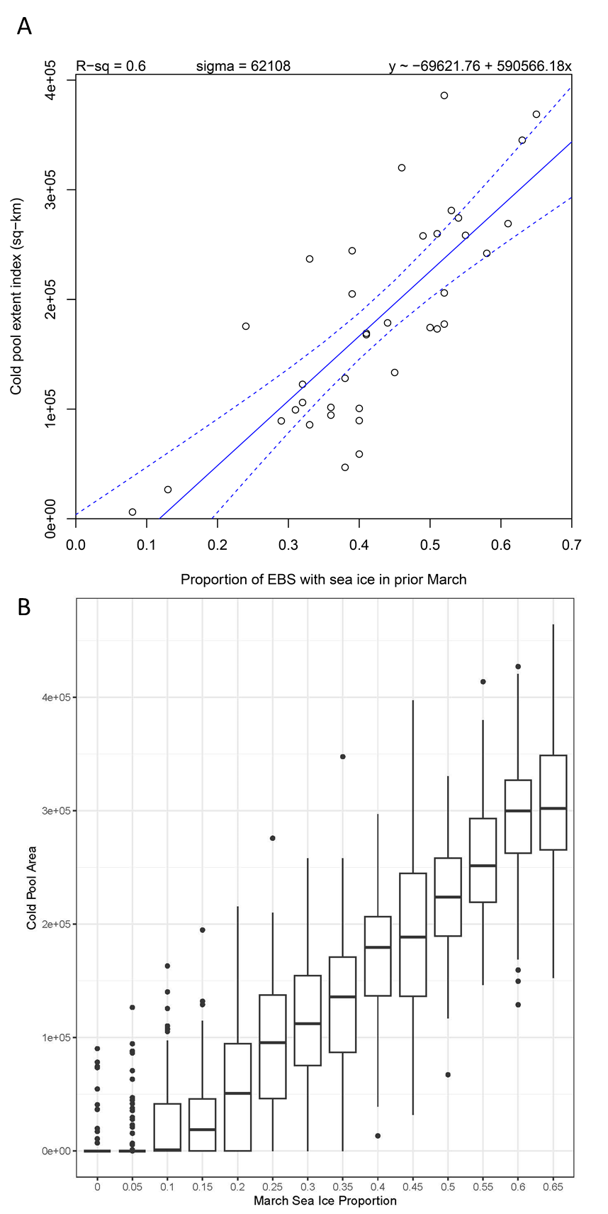

**Figure 1.** We simulated variation in sea ice and cold pool extent by fitting a linear model to predict summer cold pool by the prior spring’s sea ice cover, which explains about 60% of the variation (A). From this fitted linear model, we simulated many replicates of combinations of cold pool area, given the estimated observation error, giving us a wide range of realistic outcomes given conditions observed in the last 40 years (B).

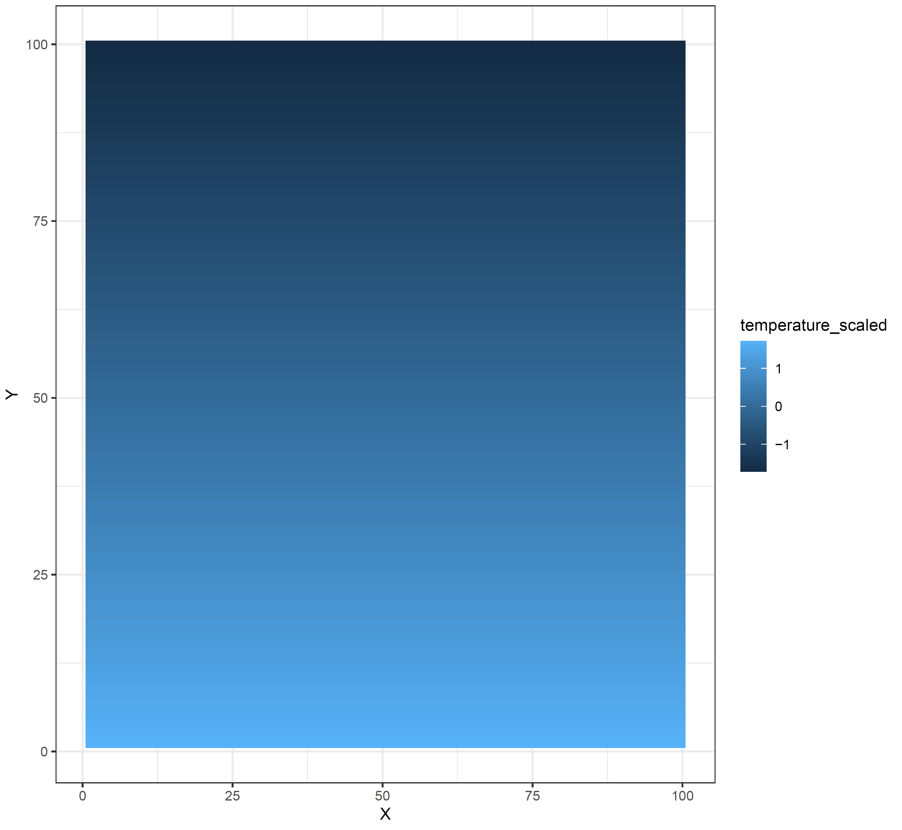

**Figure 2.** We simulated the effect of variation in cold pool size on the true population spatial distribution in a simplified context by creating a square grid with a smooth gradient of temperature increasing from north to south. This was used as a coviariate of fish population density, simulated with varying direction and magnitude of effect of temperature on population density.

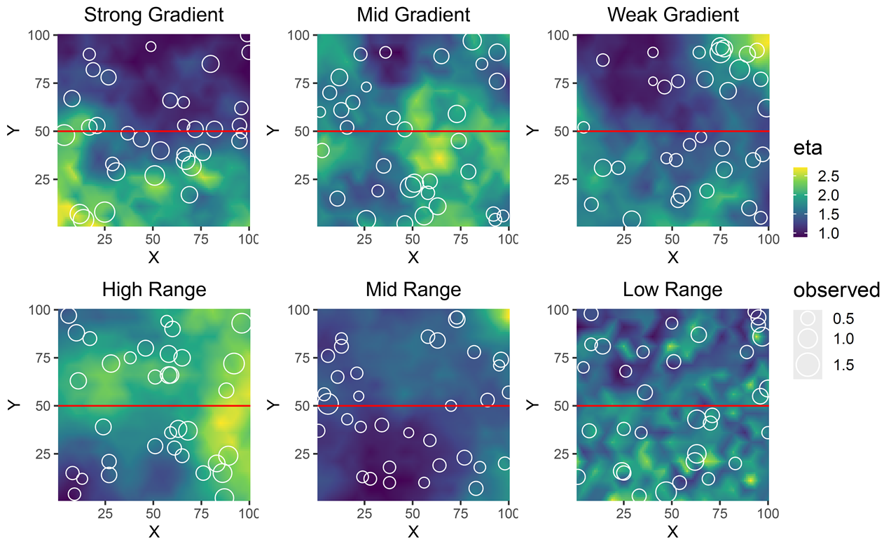

**Figure 3.** Representative examples of simulated fish densities over space given each sampling method, where the red line represents the stratum boundary for stratified sampling methods, with examples of observations here in the white circles. We examined the performance of these surveys across a range of differences in species distribution, namely when simulating population density distributions under weak, moderate, or strong environmental gradients (top row) and a spectrum of spatial correlation ranges representing the patch size of the species distribution (bottom row).

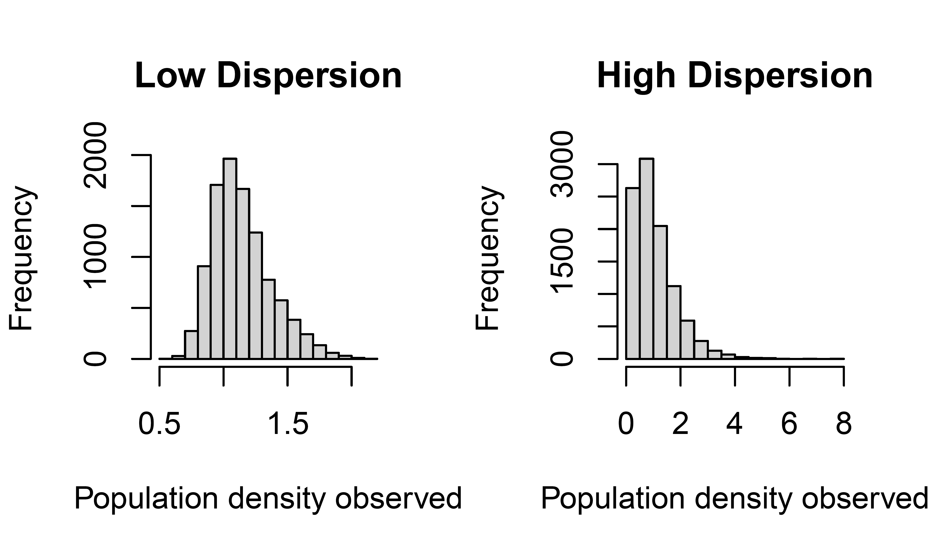

**Figure 4.** Representative examples of the statistical distribution of simulated fish densities given low and high dispersion parameters.

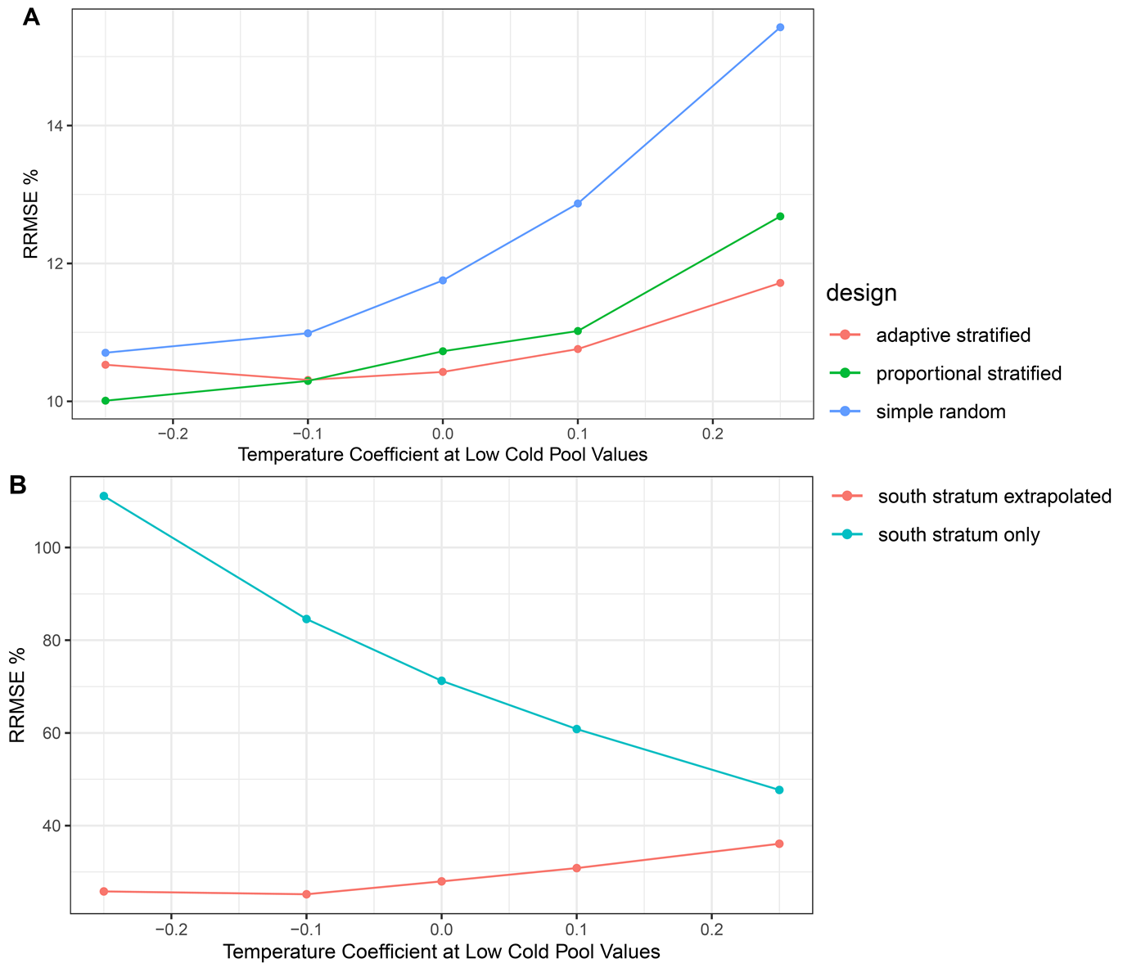

**Figure 5.** Changes in accuracy (Relative Root Mean Square Error, RMSE) with the slope of the relationship between fish population density and temperature (i.e., the north-sound gradient of fish density). Responses are shown separately for (A) designs that sample the full domain and (B) designs that only sample the south stratum only (and either assume that this constitutes the whole population—“south stratum only”—or extrapolate the south stratum density to the full domain to estimate population size—“south stratum extrapolated”).

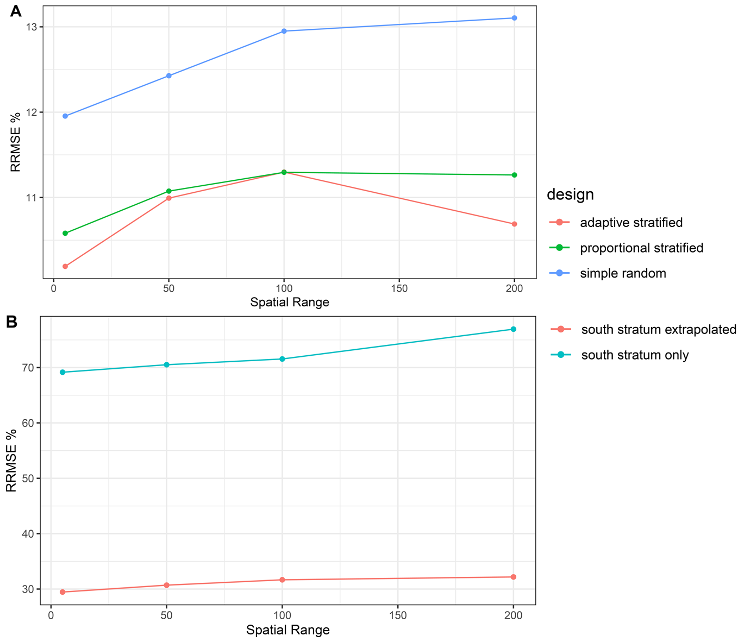

**Figure 6.** Changes in accuracy (Relative Root Mean Square Error, RMSE) with the spatial range of autocorrelation in fish density (a measure of patchiness in species distribution). Responses are shown separately for (A) designs that sample the full domain and (B) designs that only sample the south stratum only (and either assume that this constitutes the whole population—“south stratum only”—or extrapolate the south stratum density to the full domain to estimate population size—“south stratum extrapolated”).

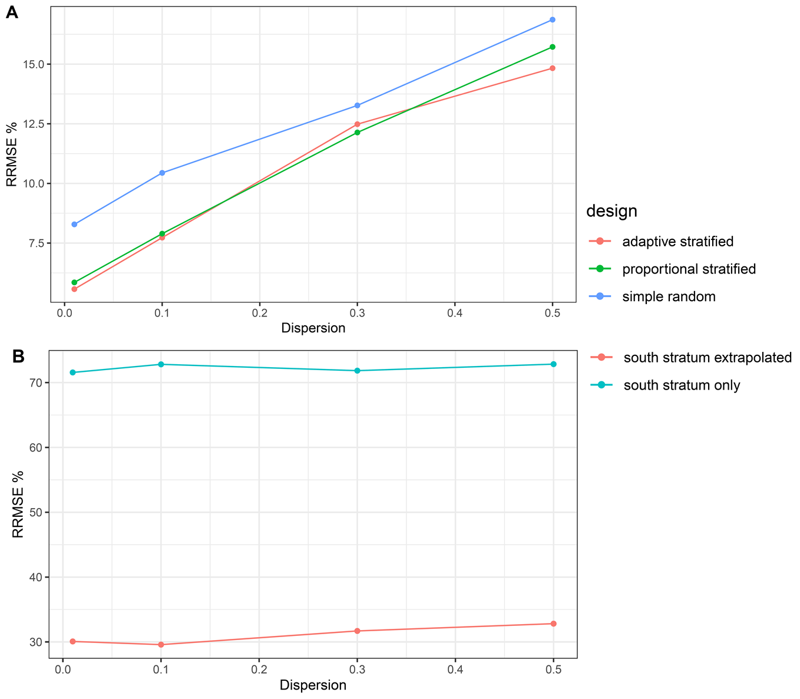

**Figure 7.** Changes in accuracy (Relative Root Mean Square Error, RMSE) with the degree of dispersion of fish density (i.e., the skewness in observations). Responses are shown separately for (A) designs that sample the full domain and (B) designs that only sample the south stratum only (and either assume that this constitutes the whole population—“south stratum only”—or extrapolate the south stratum density to the full domain to estimate population size—“south stratum extrapolated”).