DEAD WEIGHT BRAKES

Different types of dead weight brake systems
The floating shoe-type brake system
Brake posts struts and bass plates
Brake quadrant plates pins and bushes
Tie rods, tie rods ends and turnbuckles
Brake lever arm and dead weights
Brake post and lining
Brake engines
INTRODUCTION

This is the first module on dead weight-type brake systems and components. As we are living in the days of electronics and modern technology, we must remember that some of the inventions of the past are still in our midst, and are still working on the shaft. One of these units is a winder with dead weight-type brakes. These units must still be maintained and kept in a good and safe condition.
Just about the whole brake system is operated mechanically and, what makes it even more interesting, is to see how this is done. Therefore I would recommend you to visit one of these winders before you even attempt to study this module.

The following aspects will be covered in this module:

Different types of dead weight brake systems.
The floating shoe-type brake system (suspended post brake).
Brake posts, struts and base plates.

Brake post strut construction
Brake post strut maintenance

Brake quadrant plates, pins and bushes.
Tie rods, tie rods, tie rod ends and turnbuckles.
Brake lever arm and dead weights.
Brake post and lining
Brake engines.

DIFFERENT TYPES OF DEAD WEIGHT BRAKE SYSTEMS

The brake most commonly used on winding engines is the block-type, in which two blocks, each suspended at an angle of about 90 °, are pressed against the periphery of the brake drum by a dead weight acting through a system of levers and rods.
Pressurized oil or compressed air is used for releasing the brake. Should the supply fail, the brake is applied by a dead weight.
There are many different types and designs of dead weight brake systems. Some are shown in Fig. F.C.9 – 5(1).1.1. These different types of brake systems each have their own advantages and disadvantages.
Superior to the other arrangements is the floating shoe-type or, as it is better known, the suspended post brake. The advantages, disadvantages and operation of this type of brake system will be dealt with in more detail throughout this module.

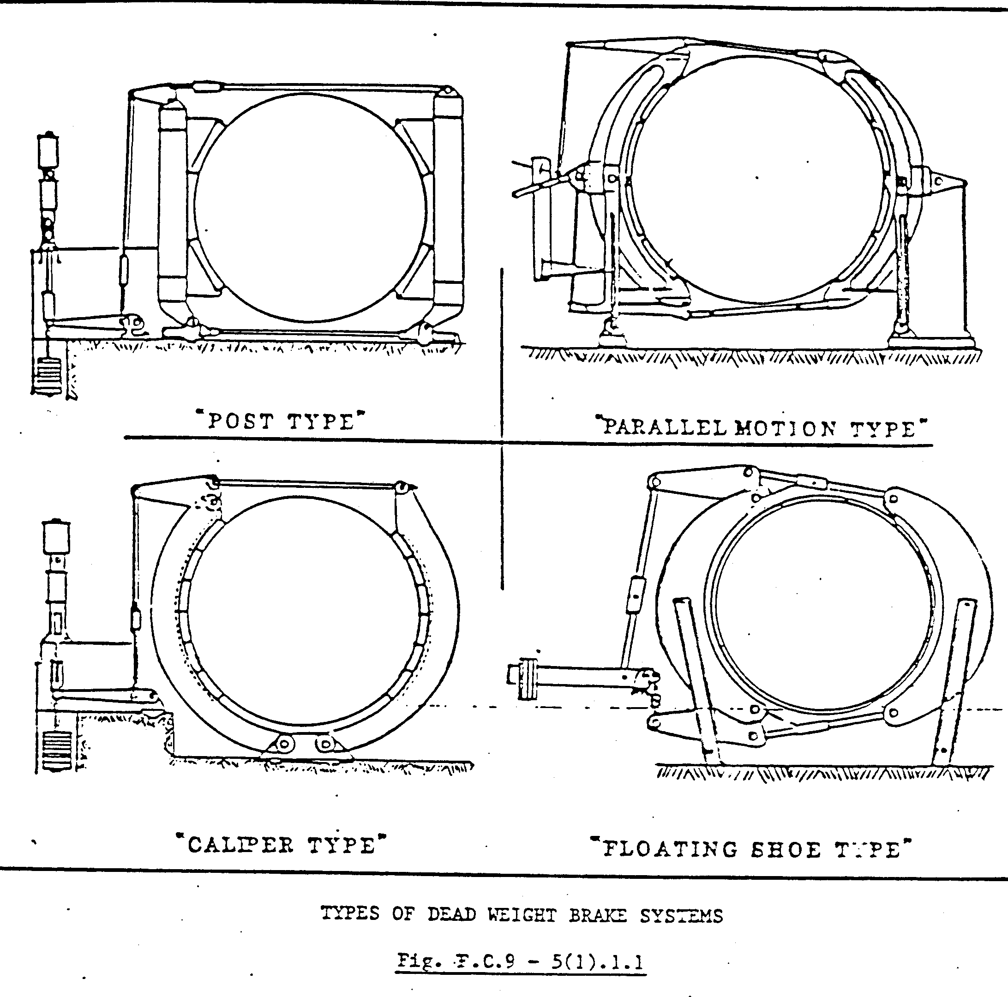
THE FLOATING SHOE-TYPE BRAKE SYSTEM (SUSPENDED POST BRAKE)

As we now know that the floating shoe-type brake is the system which is most commonly used (as far as dead weight types are concerned) n the mining industry, we will only concentrate on this type of brake system which is illustrated in Fig. F.C.9 – 5(1).1.2. STUDY THIS ILLUSTRATION, as we will deal with each item separately.

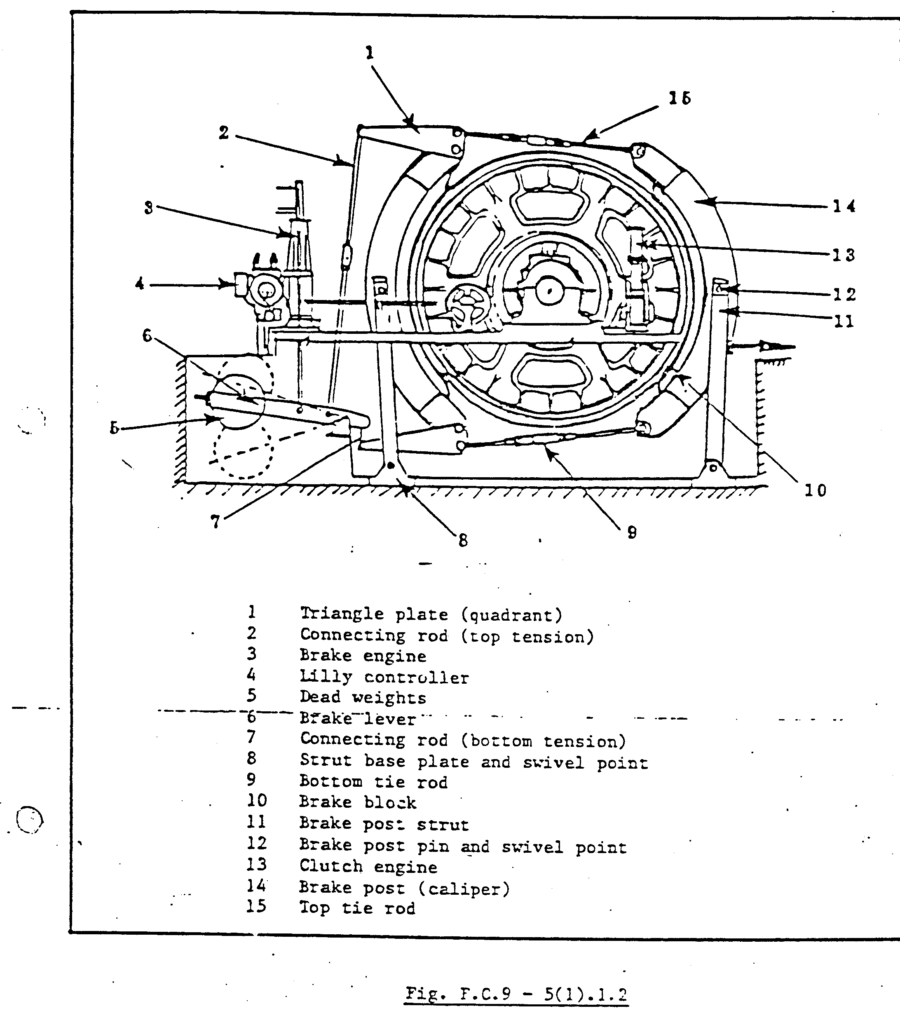
Fig. F.C.9 – 5(1).1.2 illustrates the curved brake post (14) (caliper) which are carried at or about the horizontal centre line (12) on struts (11) slightly inclined to the vertical and separately hinged at the lower end (8).
The brake posts (calipers) carry the brake wooden blocks (10), which in turn can be used with or without brake lining. The different types of brake blocks and lining will be dealt with in more detail later in this module.
Connected to the back brake post two triangle plates (1), top and bottom, which are in turn coupled through a series of the rods (2) and (7) to a dead weight brake lever (6).
A brake engine (3) is also coupled to the brake lever as shown in Fig. F.C.9 – 5(1).1.2. In some cases, this engine is fitted at the bottom of the brake lever and then, instead of pulling the weight up to lift the brakes, pushes it with the same result.
Two tie rods (15 and 9) top and bottom are used to couple the back and front brake posts. These tie rods are also used to adjust the brakes to the correct clearance between the brake lining and the race when the brakes are released. More details on tie rods will be given later in this module.
A clutch engine (13) is used to engage or disengage the clutch gear, enabling the winder to be clutched for any specific point in the shaft.

Fig. F.C.9 – 5 (1).1.2 also shows a “Lilly controller” (4). For the purpose of this module, we will only refer to the “Lilly” as far as it concerns the braking system. The operation, construction and purpose of this unit is dealt with in module F.C.9 – 16.

If you study Fig. F.C. 9 – 5(1).1.2 you will only observe one side of a double-drum winder. NOW STUDY FIG.F.C.9 – 5(1).1.3 and you will have a bird’s eye view of a double-drum winder with a floating-type brake system. The illustration also shows a gearbox (17) with two AC motors (18). Now, as far as the brake system is concerned, there is hardly any difference between an AC or DC winder.

One of the main differences is that, in the case of a DC winder or ‘Ward Leonard”, a mechanical cam or cam gear is used to retard the winder automatically when it enters the retardation area (+ 10 turns from surface in most cases). An AC winder is retarded manually by the Winding Engine Driver by applying reverse current or dynamic braking.
Although some of the items illustrated in Fig. F.C.9 – 5(1).1.3 are not directly related to the brake system as such, it will give you a clear picture and bring all the components into perspective. At this stage, I will suggest that you make a visit to the winder with a “floating shoe-type brake system” (AC or DC) before you carry on with this module, and may I suggest that you ask the person responsible for the winder to show you each part as indicated in Figures F.C.9 – 5(1).1.2 and F.C.9 – 5(1).1.3.

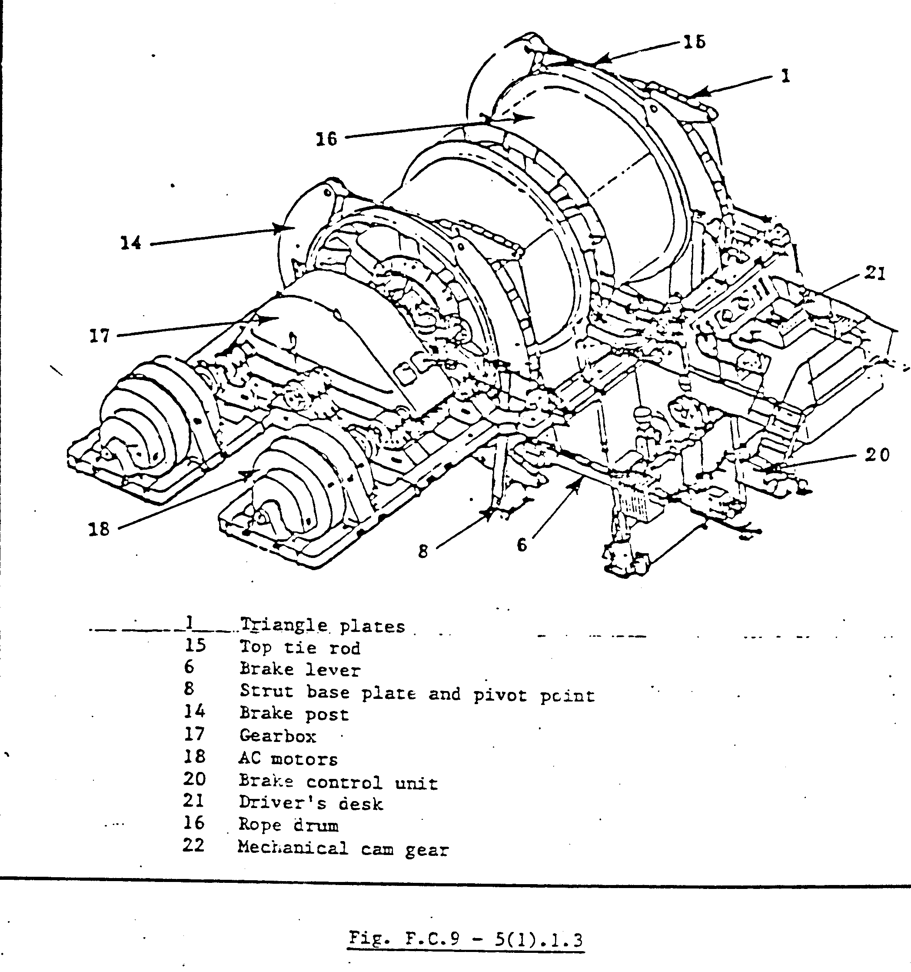

BRAKE POSTS, STRUTS AND BASE PLATES

When one looks at the brake post struts (11), illustrated in Fig. F.C.9 - 5(1).1.4, one might think that these struts are just two channels, supporting the brake posts. Indeed this is what these supports are supposed to do, but on a closer examination of the brake system, you will notice what a vital function these struts perform when the brakes must be applied during normal or emergency conditions.

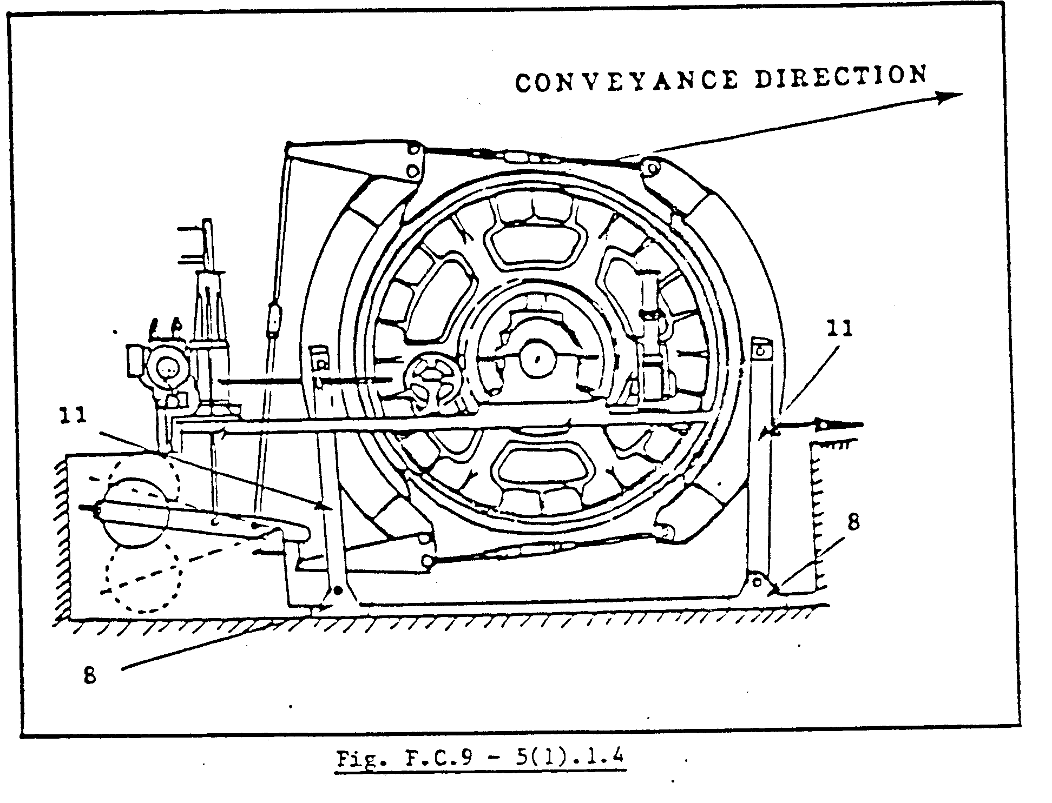

Let us, for example, take a winder with a fully loaded conveyance traveling down the shaft at full speed (+ 15 m/s) and for some reason the brakes must be applied under emergency conditions, for example a complete power failure. By examination you will see that :
The conveyance will tend to accelerate due to its own momentum and the force of gravity.
When the brakes are applied the hoist drum will tend to pull the whole brake system in the same direction of its rotation.
The front strut will be under extreme compression (in the case of the overlay drum) while the back strut (11) will be illustrated in Fig. F.C.9 – 5 (1).1.4, away from the foundation.

Now, realizing how important these struts are to the brake system, let us have a closer look at their construction and the maintenance required.

BRAKE POST STRUT CONSTRUCTION

The brake post struts (11), shown in Fig. F.C.9 – 5(1).1.5 are usually made from channel iron, strengthened by flat bar strips (23) which are usually welded onto the struts. The design and shape varies, depending on the make and model of the specific winder.

BRAKE POST STRUT MAINTENANCE

The struts must be visually examined for cracks at least once a day and special attention must be given to the areas where there are welded joints when checking for cracks.
Check for any distortion of the shape of the strut, for example it is bent or twisted?
The base plate pin, foundation bolts, etc. must be checked for secureness.
The base plate pin and brake post swivel point pin (12) is made of a special type of material, according to AAC specification and these pins must be NDT tested as per your mine standard.

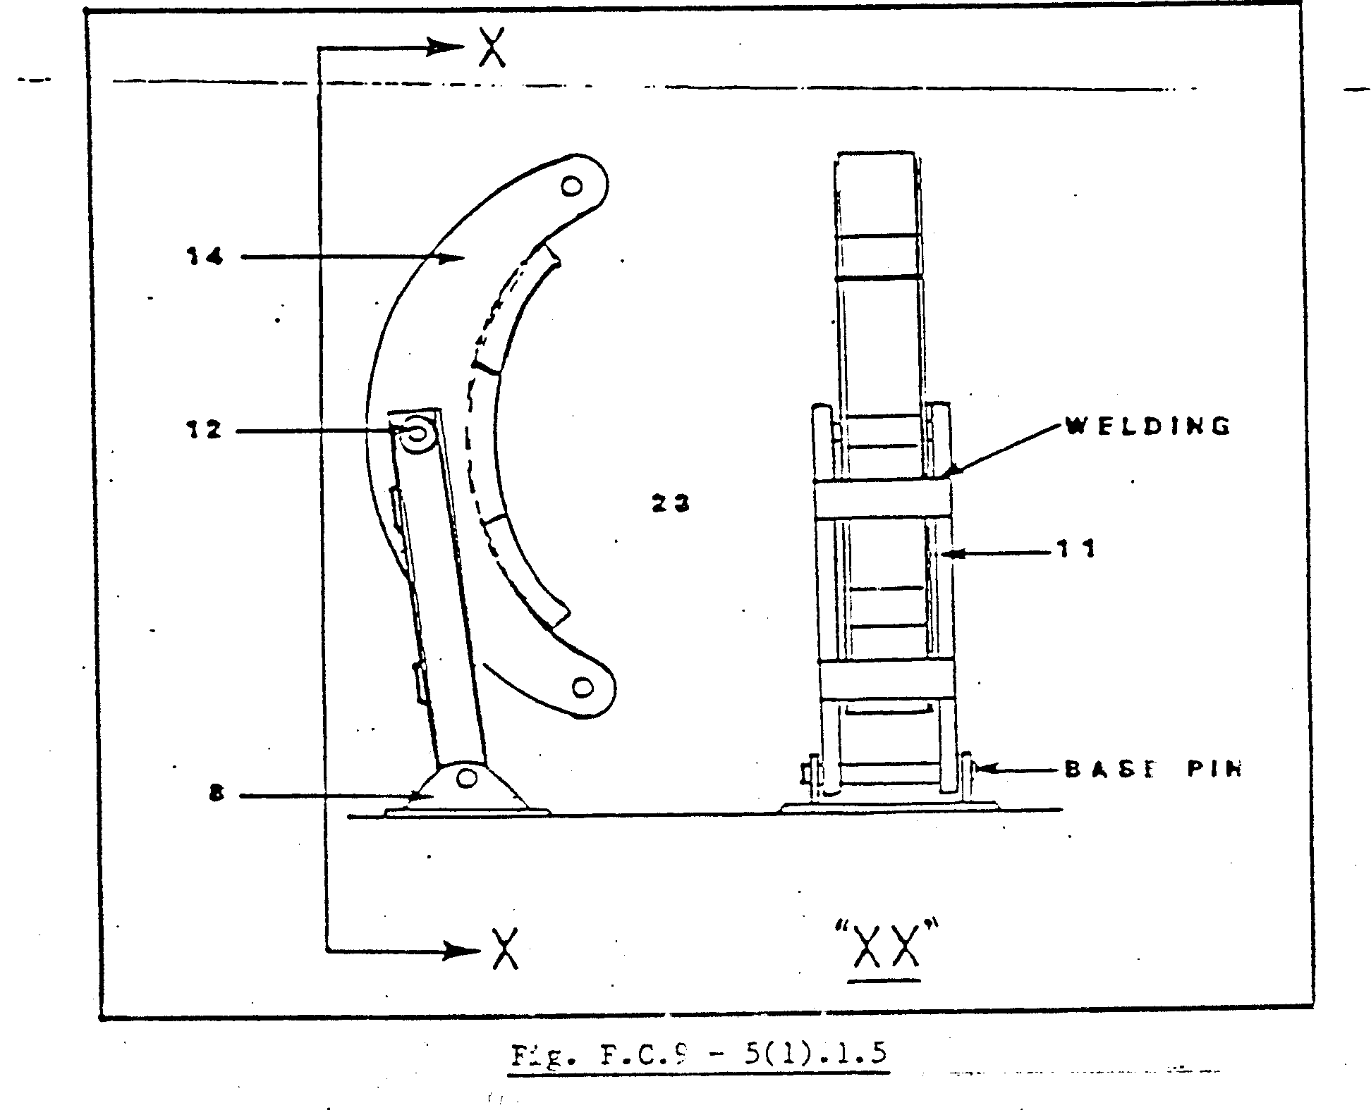

BRAKE QUADRANT PLATES, PINS AND BUSHES

The floating shoe-type brake system always has two sets of quadrant plates. See Fig. F.C.9 – 5(1).1.6. These quadrant plates are fitted to the back brake post (14), top and bottom, with pins (x). The top and bottom tie rods are also fitted to the quadrant plates, which in turn are connected to the front brake posts.

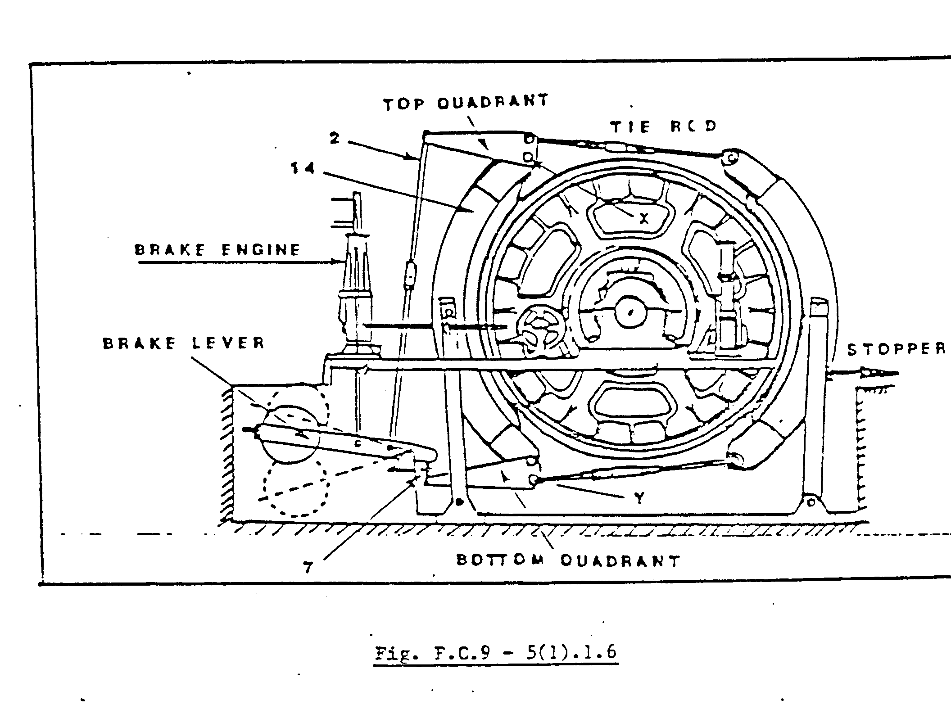

Let us now see what is the function of these quadrant plates. First of all you will notice what the rear-end of the quadrant plates are connected to a long and short connecting rod (2 and 7), which in turn are connected to the brake lever arm.
When the brake engine, which is actuated from the Driver’s lever through a series of valves, lifts the brake lever arm, the quadrant plates hinge about points (X) pushing the top and bottom tie rods forward, releasing the front brake up to a pre-set mechanical stop. Prevented from any further travel on the front brake post, the brake engine lifts the brake lever arm to release the brakes fully. The quadrant plates now start to pivot about point (Y), releasing the back brake post.
From the description in paragraph 28, you will see that the brake quadrants are continuously lifted and lowered to release and apply the brakes. Due to this continuous movement, the pins and bushes must be kept well lubricated to prevent seizure or shearing. Any excessive lubrication must be removed to prevent accidental contact with the brake race just below.
The quadrant plates and pins are made out of special types of material as per AAC specifications and must be NDT tested as per your mine standards.

TIE RODS, TIE ROD ENDS AND TURNBUCKLES

The two designs of the rods shown in Fig. F.C.9 – 5(1).1.7 are of the most commonly used on the “floating shoe-type” brake system. They both perform the same, that is to connect both brake posts with each other and to transfer the braking effort exerted by the brake lever arm to the brake post. The clearance between the brake path and the lining is also determined by the rod setting.

The top tie rod, illustrated in Fig. F.C.9 – 5(1).1.7, has a single turnbuckle in the middle and the bottom illustration shows a tie rod with two separate turnbuckles. Whether the single or double turnbuckle type is used, the threads on the one end are always left – and the other end right-hand threaded. The brakes can therefore be adjusted without removing the tie rod.

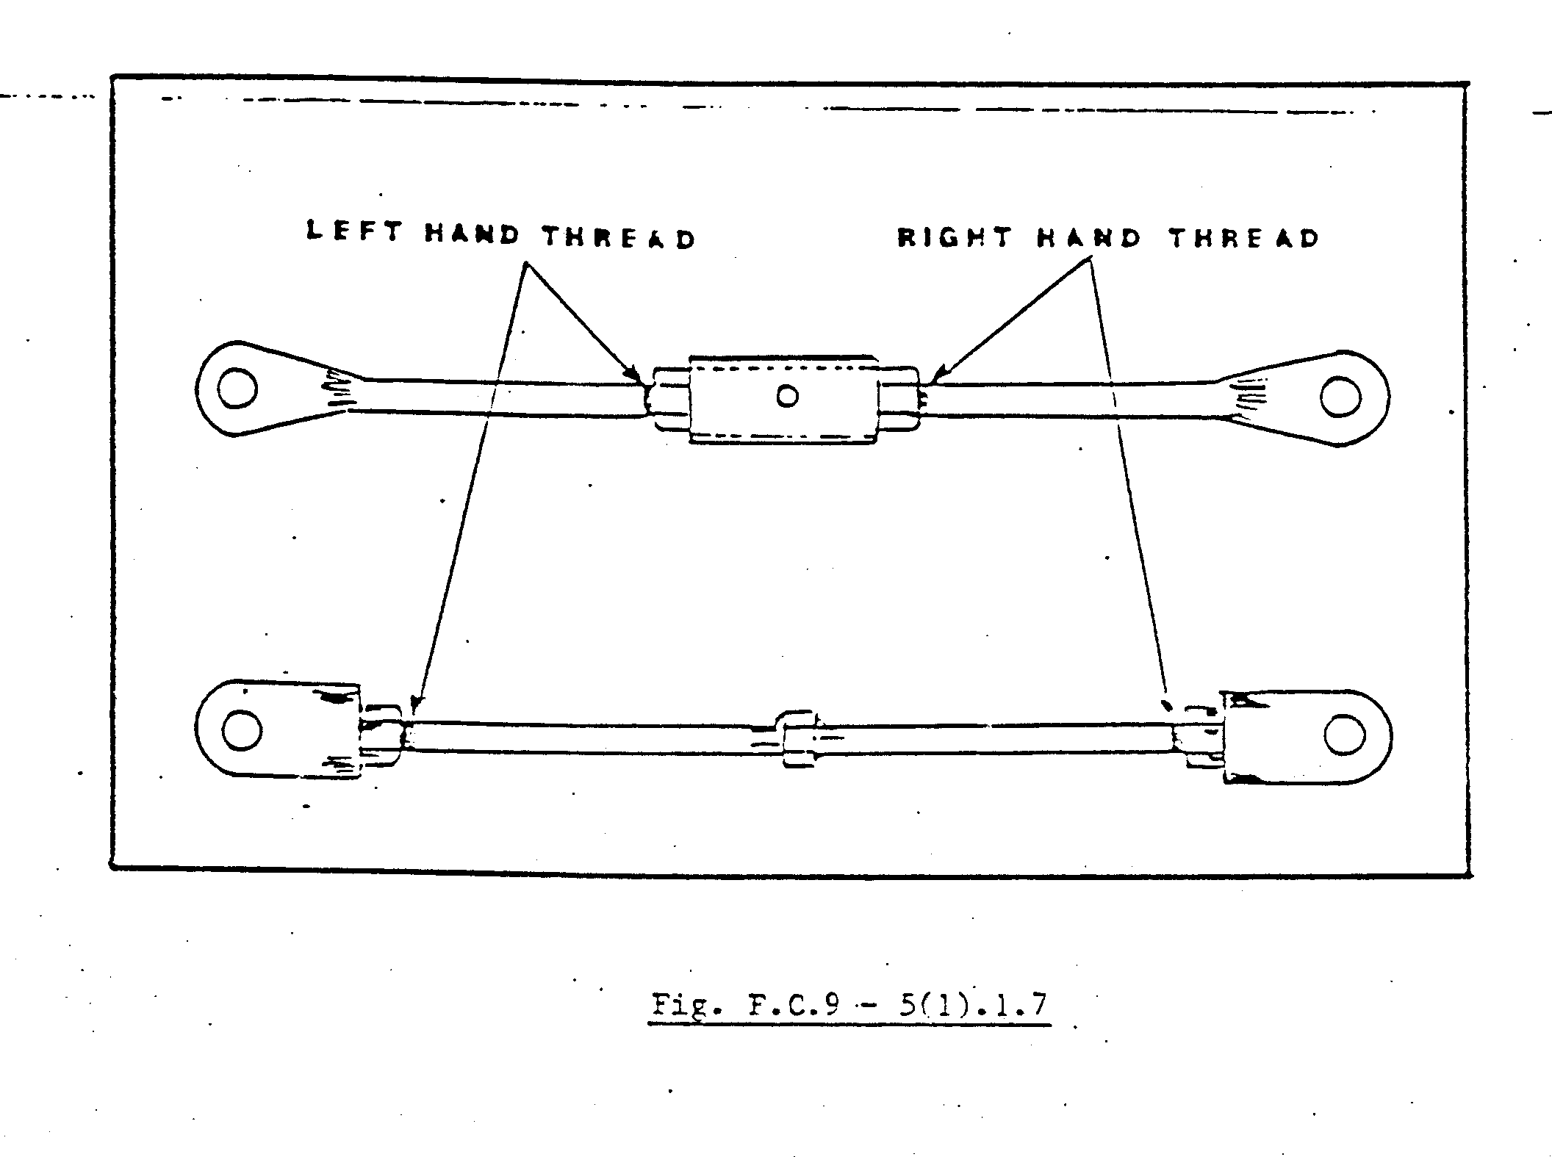
Provision is usually made on the tie rod to use a correct spanner to adjust or turn the tie rod. Pipe wrenches must never be used on these or any tie rod as this method will leave permanent marks on the rod, which could complicate an NDT examination.
Tie rods must be visually examined at least once a week and special attention must be given to stress areas such as changes of section and threaded sections. The tie rods must be kept clean and should never be painted. A thin layer of oil can be used occasionally to protect the rods from rust.
When the brakes are operated, check whether there is any bending moments on t he tie rod which could be caused by insufficient lubrication on the pins, bushes and sides of the quadrant plates. You must remember that the continuous bending of the tie rod could cause a major brake failure.
When tie rods are manufactured, special type of material is used. These materials must be in accordance with the AAC material specification for brake components. Tie rods must be NDT tested periodically as per your mine standards.

BRAKE LEVER ARM AND DEAD WEIGHTS

A machine is a device where force is applied at one end in order to obtain force at another point. Machines normally make work easier. The force is usually called the “effort” and the force overcome by the applied effort is called the load. The effort overcomes the load as soon as their moments are equal.
A lever, which consists of a rigid bar that can be swiveled at a fixed point, is one of the simplest of machines. The fixed point about which the lever rotates, is called the fulcrum or turning point. See Fig. F.C.9 – 5(1).1.8.

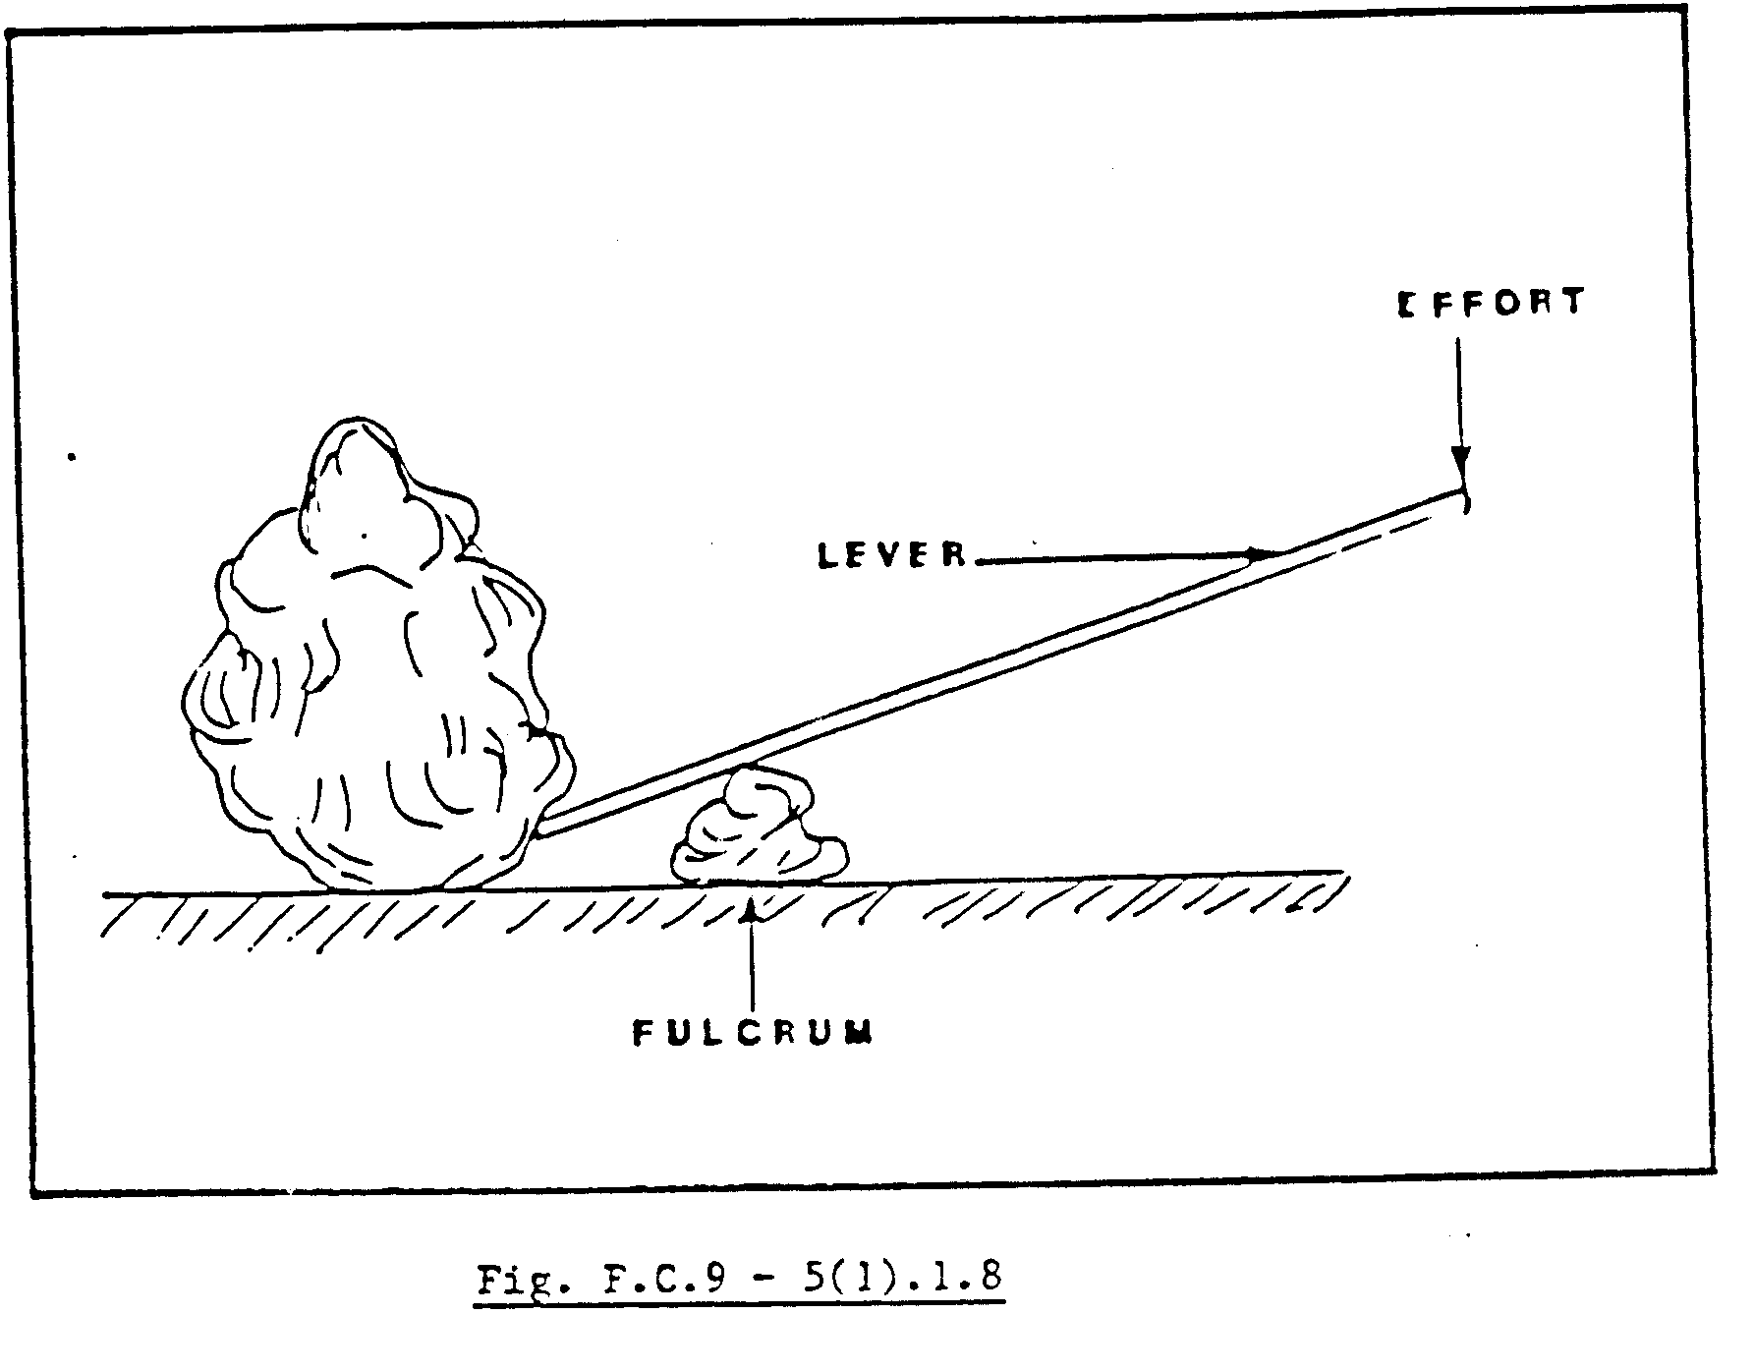

Assume that a rock can be partially lifted by applying a force to the one end of a lever as shown in Fig. F.C.9 – 5(1).1.8. If the same force is applied closer to the fulcrum, the rock appears to be heavier because it does not move; a greater force will now be needed to lift the rock. The above description is one of the most basic fundamental principles of a dead weight brake and now that you know this, we can have a closer look at the brake arm lever and dead weight, as illustrated in Fig.F.C.9 – 5(1).1.9.
From Fig. F.C.9 – 5(1).1.9 we see that the brake arm lever (6) is connected to a fixed point (fulcrum point) about which the lever pivots. Connected to the brake arm lever are the two connecting rods (2 and 7) and the brake engine rods. Mounted on the back of the brake arm lever is the dead weight (5), which is usually adjustable (23). The dead weight is the force, which must be applied to hold or stop the winder under all conditions.

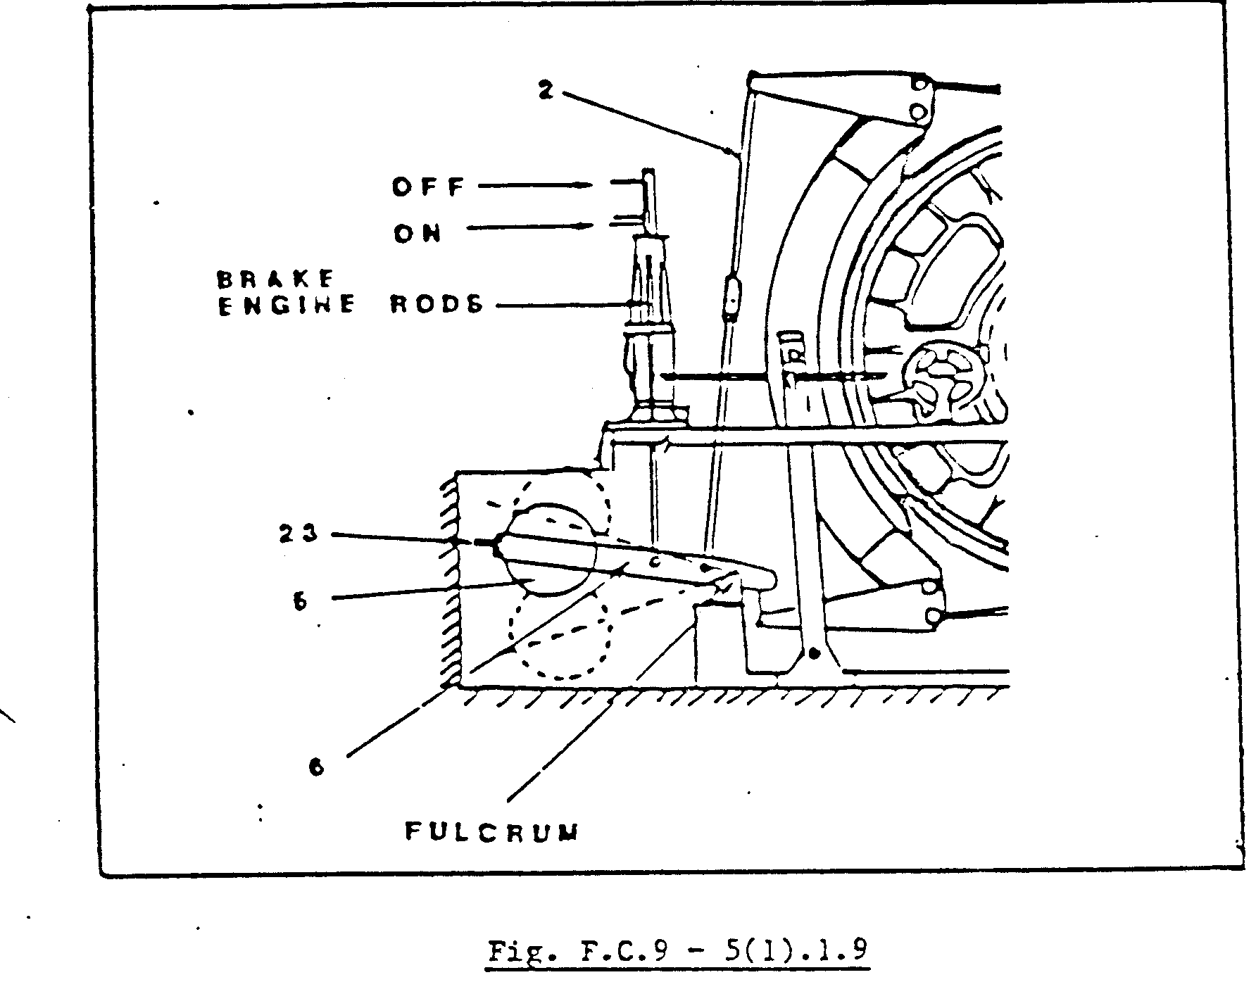
Once these weights are set at the correct position, they must not be tampered with, for this could lead to a malfunction of the brake system. Let us take for example the lever and rock in Fig. F.C.9 – 5(1).1.8. The moment you move the point of application of the force closer to the fulcrum point, a greater force (more weights) will be required to stop or hold the winder under the same conditions as before. Moving it to the opposite side (away from the fulcrum), a stage might be reached where the brake engine will not be able to lift the lever to release the brakes.
The locking pins and nuts on the brake arm lever must be visually checked at least once a day for irregularities. The fulcrum pin, as well as the two connecting rod pins, must be lubricated regularly. These pins are also made out of a special type of steel according to AAC specification and must be NDT tested as per your mine standards.
The use of a brake arm lever and weights necessitates the provision of a pit in the foundation of the winder. This pit must never be used as a storage area and must be kept clear at all times to ensure the free and safe operation of the brake system. This area must also be screened off to prevent persons from entering while the brakes are being operated.

BRAKE POST AND LINING

To most sophisticated and modern techniques employed on winders today, like controlled braking, NDT tests and dynamic brake tests, will be of little or no use if the brake post and linings were not able to pass all this effort over onto the brake drum.
Although there are many different types and grades of frictional material available on the market, for example wood, woven cotton base and woven asbestos base lining, no specific type will be dealt with in this module due to the fact that the lining may vary between the different winders with the same brake system.
Fig. F.C.9 – 5(1).1.10 illustrate a typical “floating shoe-type” brake post with wooden brake blocks and brake lining. Wooden brake blocks, consisting of selected oak, poplar or basswood are usually used to act as a backing for the specific brake lining.
These blocks are usually mounted against the brake post by means of + 40 mm diameter drilled holes in the block, as shown in Fig. F.C.9 – 5(1).1.10 and a hexagon or round bar (brake block nut) with two threaded holes is then forced through the blocks and is bolted onto the brake post with bolts from the back. These bolts must be checked regularly for secureness due to the fact that there is usually a relative amount of vibration present on the “floating shoe-type” brake system. The brake lining is fitted onto the wooden blocks by means of large heavy-duty countersunk brass screws or wooden pegs as illustrated in Fig. F.C.9 – 5(1).1.10. Once the brake posts, tie rods and other equipment are back in position on the winder, the lining must be lapped in to ensure a perfect contact area with no high or low spots.

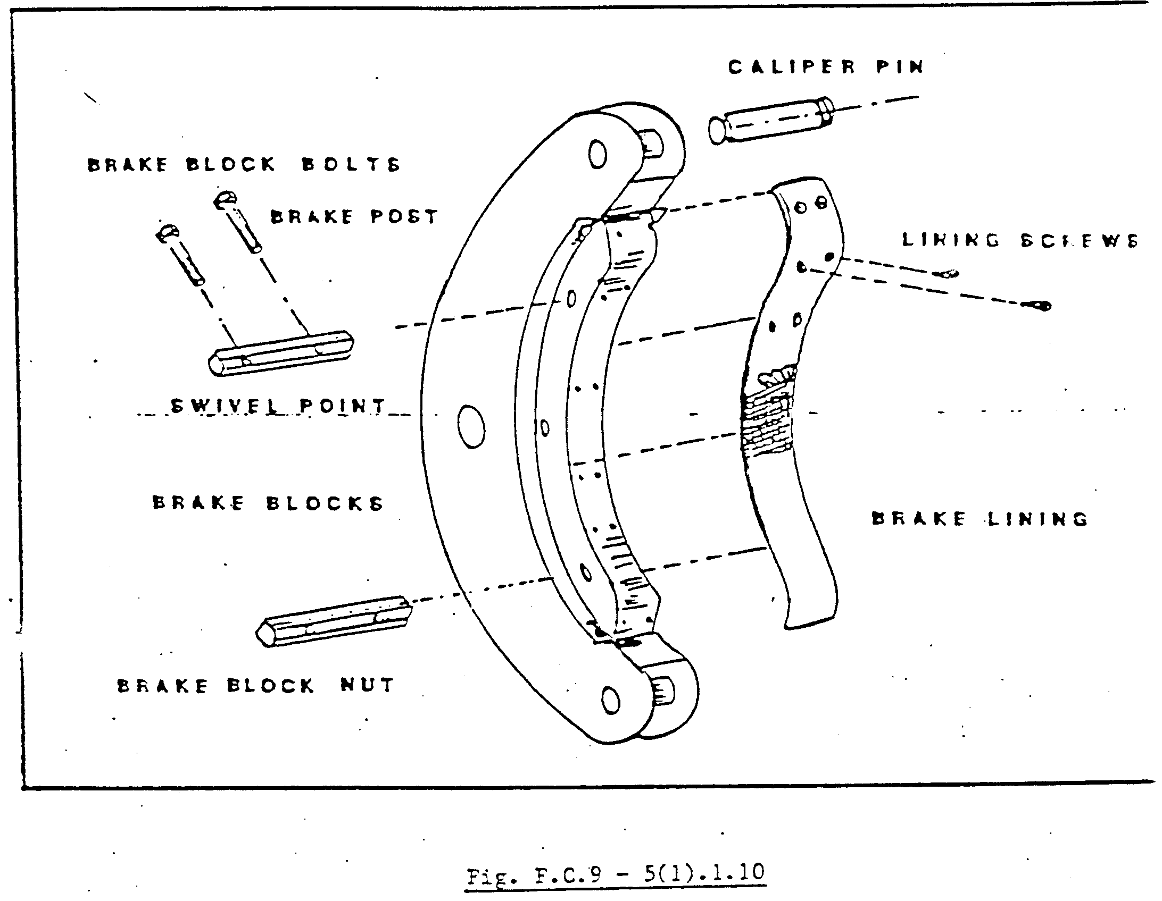
Although there are many different methods used when lapping the brake lining, we will only discuss one. You must ensure that the necessary safety precautions were taken prior to the start of operation, and that at least one brake is in good working order and capable of holding the conveyances as is laid down in the Mines and Works Act and Regulations No. 16.74.1. The brake components must now be correctly adjusted, i.e. top and bottom clearance equal on both calipers. The brake clearance must be at least twice that of the normal working clearance. The reason for this is to ensure that the emery paper clears the lining when the job is started.

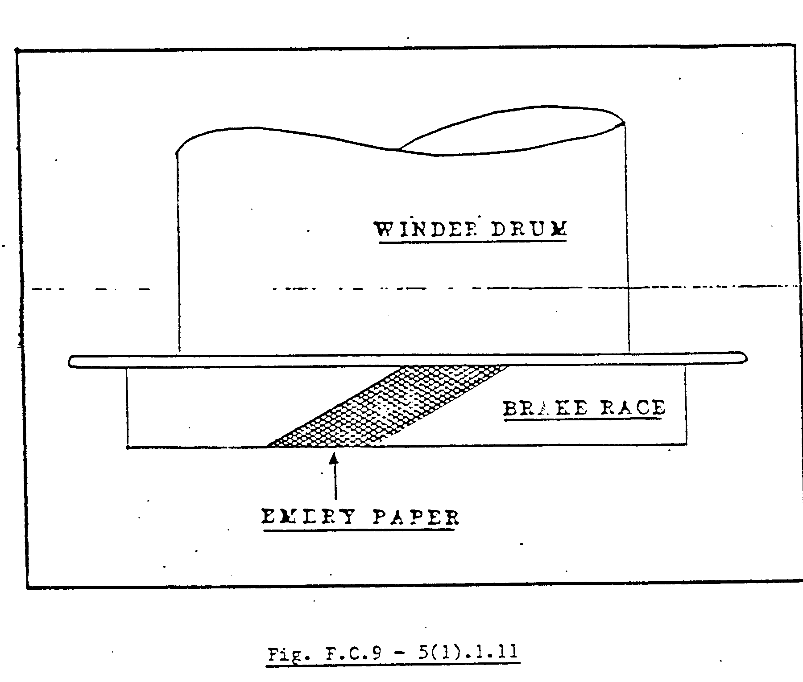
The emery paper must be cut at an angle of + 30 ° - 45 ° as shown in Fig. F.C.9 – 5(1).1.11. The emery cloth must cover the full width of the brake race. It is always advisable to have a few extra pieces of emery paper available as spares. The paper must be bonded to a well prepared, clean, oil- and dirt-free area on the brake race.

With the Driver’s clutch lever in the mid position on the brake which is to be lapped in, a chain block, or any other lifting equipment capable of raising the brake arm lever and dead weight, must now be coupled to a safe lifting point such as an overhead crane.
With this lifting arrangement, you will now be able to raise or lower the dead weight, which in turn will enable you to apply or release the brake slowly.
With the specific brake fully released, emery paper in position, and all persons clear and in safe positions, the Winding Engine Driver can now release the other operational brake and slowly drive the winder up or down in the shaft.
With the emery paper now rotating, the brake, which is to be lapped, can now be applied slowly by lowering the dead weight with the lifting equipment. The emery paper must be cleaned continuously with compressed air to prevent any clogging. Respirators must be worn at all times by all persons present. These respirators will protect all concerned from inhaling the asbestos dust, which will be present in the air.
When the lining is completely lapped in with no high spots evident, the emery paper must now be removed and the entire brake race be cleaned with paint thinners or other cleaning fluid as lay down by your mine standards.
When all the components are cleaned properly and the excessive dust removed from the brake lining, the brakes must be re-adjusted to the correct brake clearance and brake strokes. The brakes must be checked for the correct holding power and a dynamic test should be done before the winder is to be put back into service.
The brake lining and race must be kept clear of water or grease at all times. Products such as resin or soda ash should never be used to improve the braking effort. If the holding power is insufficient it should be brought to the attention of the responsible Engineer and recorded in the Driver’s and Machinery Logbook immediately.

BRAKE ENGINES

As you already know, there are two types of brake engines used on the “floating shoe-type” brake system, namely the type that pushes, shown in Fig. F.C.9 – 5(1).1.12, and the type that pulls, illustrated in Fig. F.C.9 – 5(1).1.13. Both operate the brake arm levers to release the brakes on the winder. Although they are physically different, the basic principle of operation is exactly the same.
For the purpose of this module, we will only discuss the brake engine illustrated in Fig. F.C.9 – 5(1).1.13.

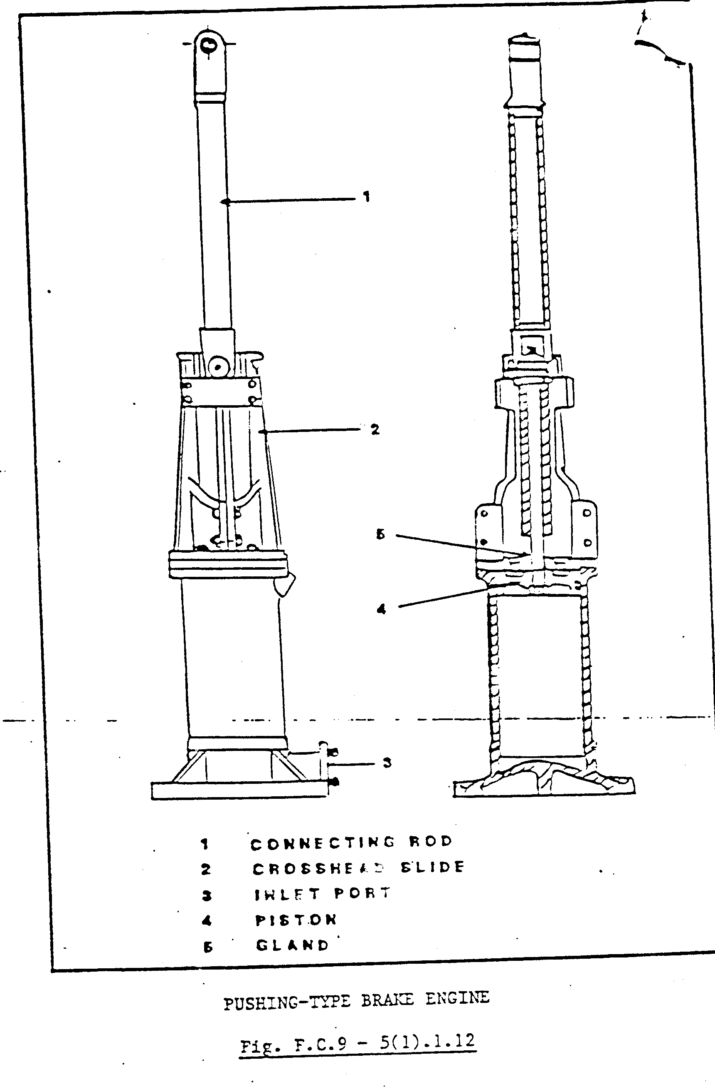
Oil-operated brake engines, arranged to draw their supply from an accumulator fed by a motor-driven pump, are mostly used in the mining industry. They are less complicated mechanically and are found to work more smoothly than air-operated engines. A section through an oil-operated pull-type engine is shown in Fig. F.C.9 – 5(1).1.12.
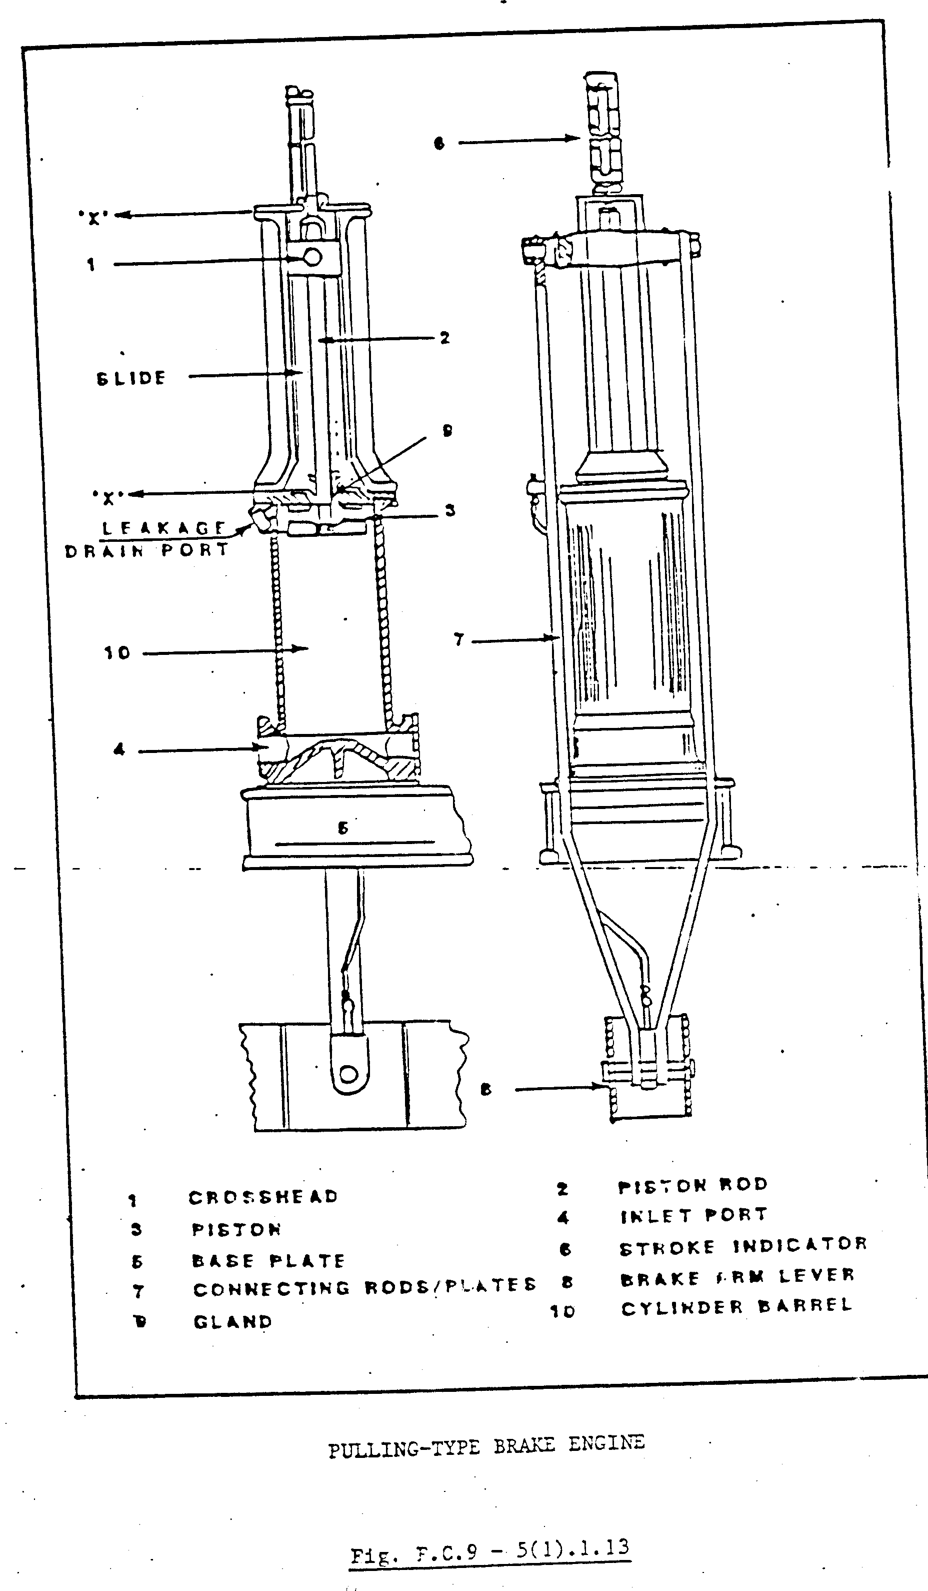
Oil is forced through the inlet port (4) into the brake engine via the driver control and other valves fitted in the hydraulic system, to release the brakes of the winder. As more oil is admitted into the cylinder barrel (10), the piston (3) will continue to move up to its full stroke position. The cylinder stroke is usually indicated on the stroke indicator (6). Fitted to the cylinder piston are a piston rod (2) and a crosshead (1), which travels in a slide mounted on the top of the cylinder, which travels in a slide mounted on the top of the cylinder barrel. From the crosshead is suspended two rods or flat bars (7), which carry the brake arm lever (8) and dead weights. The piston rod gland (9) can be fitted with an ordinary lip seal or, as in some cases, with gland packing. The gland packing-type is usually adjustable and should never be tensioned to a limit where the brake engine travel will be obstructed.
Although the brake engine requires very little maintenance, there are still a few places, which must be checked and cleaned to ensure that the engine will continue to operate in a safe and reliable manner. The following are some of these areas :

The slide area, which is open to dust and dirt, must be cleaned and lubricated regularly.

The gland or seal must be checked for wear and any excessive leakage must be corrected.

The crosshead bolts and brake arm lever pins must be kept well lubricated and locked.

The pipe from the leakage drain port should be disconnected yearly at the reservoir and, with the brakes in the off position, you will be able to determine the condition of the piston rings. If any oil flows continuously through this port, the cylinder barrel should be honed and the piston rings changed.

The standard brake stroke must be permanently marked on the indicator and should be checked daily. Any change in the brake stroke must be investigated immediately for incorrect brake adjustment or excessive brake wear.

In the event of the brake rubbing, heat will build up due to friction, causing the winder drum (brake race) to expand and lessen the brake stroke. In these circumstances the brakes must not be adjusted bur first be allowed to cool down.

Brake wear alarm and brake wear trip switches are usually fitted on or below the brake engine where any brake movement can be detected. These limit switches must be set in conjunction with the Winder Electrician. The switches must be set in such a way that the slightest brake wear can be detected and must at least be checked manually once every week.

