COUPLINGS

Tyre Coupling

Construction of the tyre coupling.

Installation and alignment of tyre couplings.

Bibby Coupling

Construction of the tyre coupling.

Installation and alignment of the Bibby coupling.

Gear couplings
Construction
Application

Rubber disc coupling
Construction

TYRE AND BIBBY COUPLINGS

INTRODUCTION

Most industrial machinery is subject to shock loads in varying degrees. These loads induce high stresses, which shorten the life of the machine. By interdicting tensional softness in the form of a coupling, which will provide a cushion against these destructive shock loading, will protect the machine, motor, bearings and shafts. Tyre couplings are mainly used on pumps, mills, crushers and conveyors and can accommodate slight angular and parallel misalignment. Tyre couplings will also absorb shock loading and end float. Bibby couplings are used on thickener rake arm traction drivers, fans, roll grizzlies and conveyors. Bibby couplings withstand a high starting torque and also resist high impaction.
Proper maintenance and inspections on Tyre and Bibby couplings can only be executed when you are familiar with the different components and alignment procedures.

To set machinery in motion, power must be transmitted from the driving to the driven machine. There are many methods to couple two machines, but in this module we will only discuss the gear and rubber disc coupling. The gear coupling is generally used on high-speed applications such as compressors, blowers and refrigeration plants. Gear couplings normally operate at speeds up to 12 000 r/min. Rubber disc couplings are more generally used on pumps, winches and vibrating screens.
Efficient maintenance and inspections on couplings is possible if you are familiar with the components and alignment procedures.

TYRE COUPLINGS

Tyre couplings have no moving or rubbing parts. They are made with either cast iron or steel flanges, with rubber or neoprene tires. The more commonly used tyre couplings are provided with taper lock bushes, but couplings with tapered or parallel bores are also available for special applications.

CONSTRUCTION OF THE TYRE COUPLING

Fig. 1 illustrates the Tyre coupling and components.
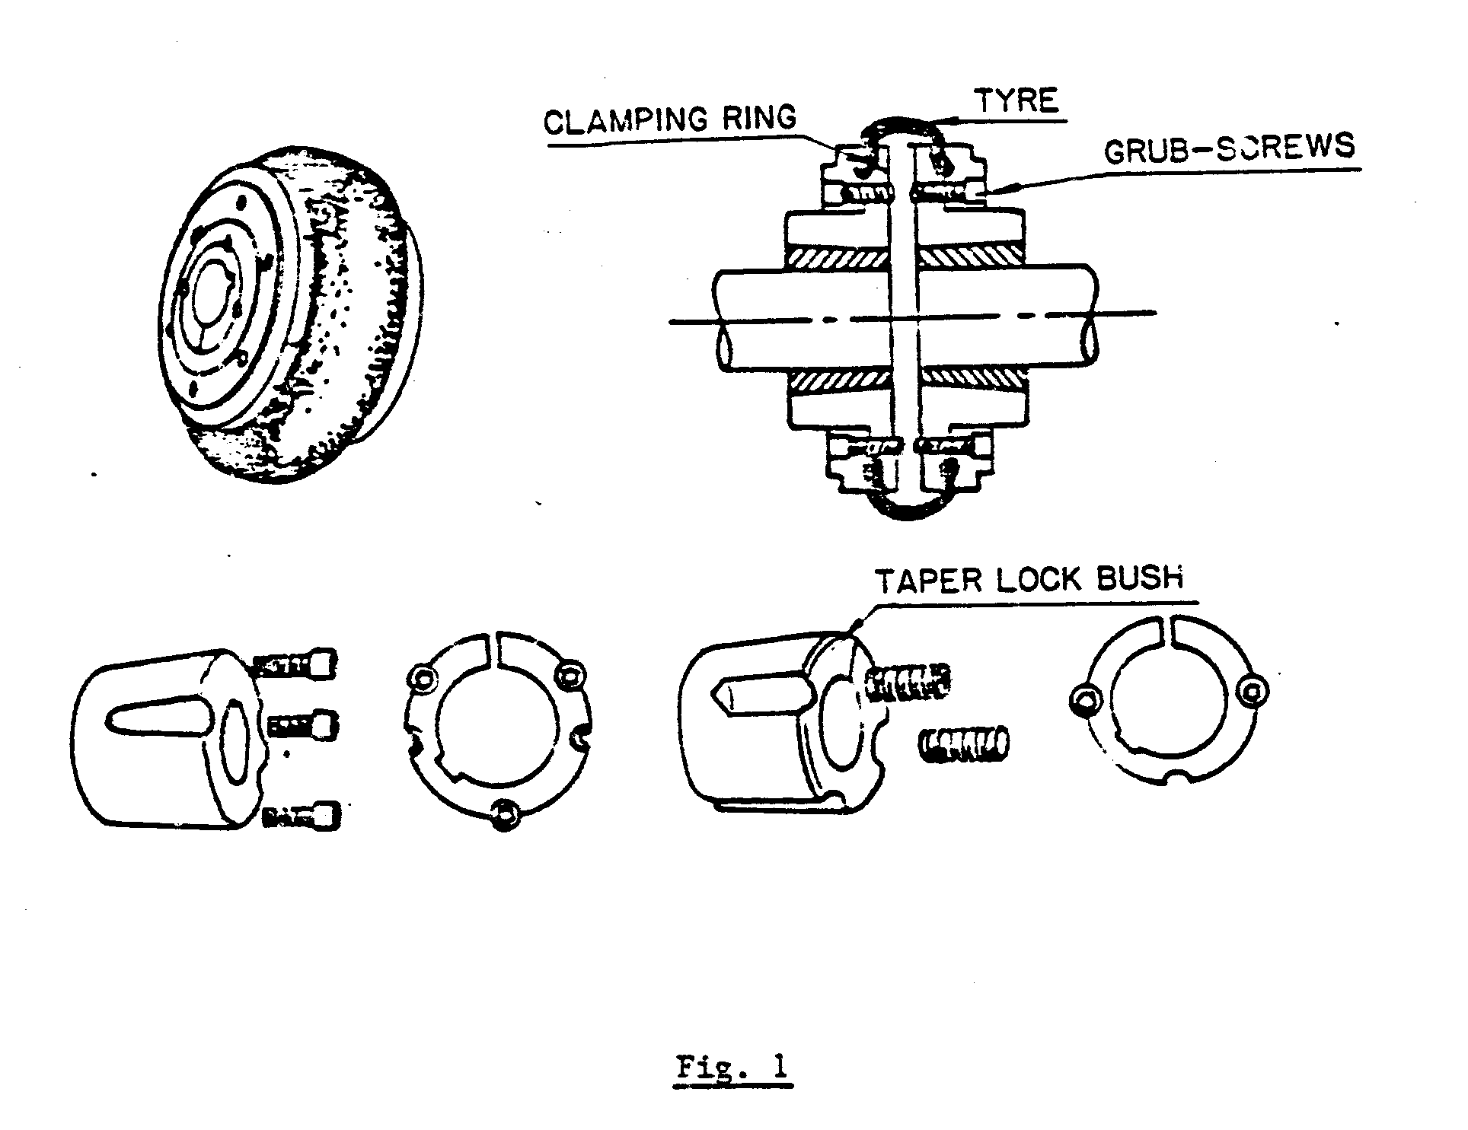
The Tyre beading is held between the flanges and clamping rings by tightening the cap screws. The cap screws are normally countersunk in the flanges to provide a smooth finish without protruding parts. With the Tyre in position, there is no metal-to-metal contact between the shafts of the driven and driving machine.

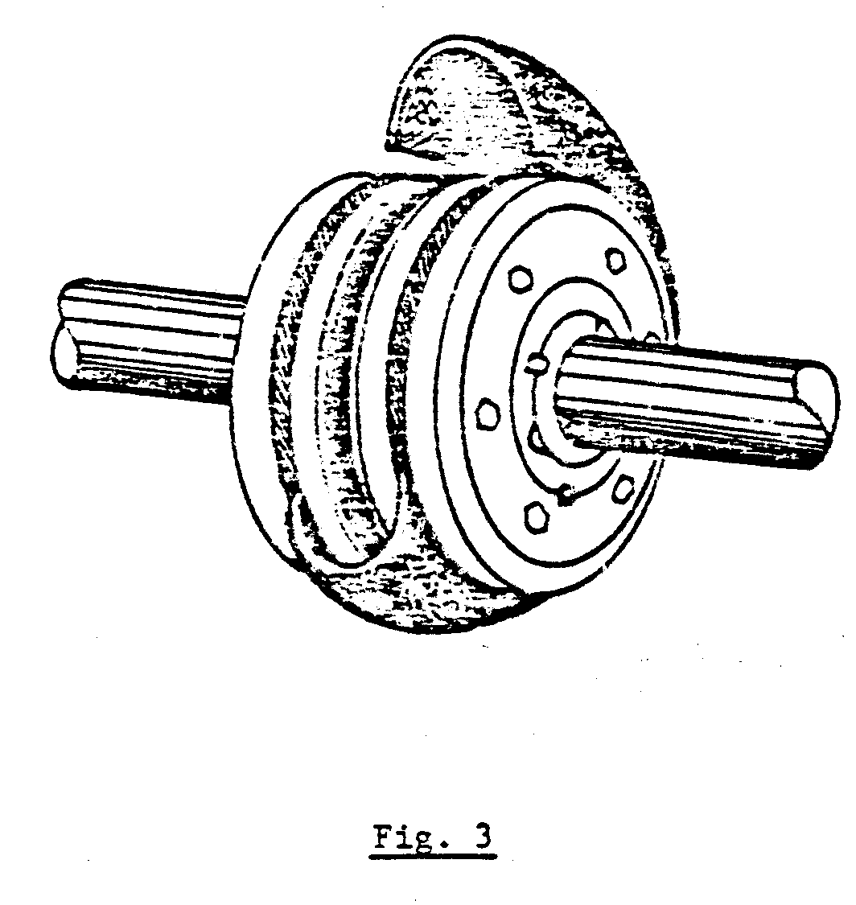
BIBBY COUPLINGS

Bibby couplings can accommodate slight, angular, parallel and axial misalignment, and are used for their shock absorbing and high starting torque resistance ability. Fig. 4 illustrates four different types of Bibby couplings.

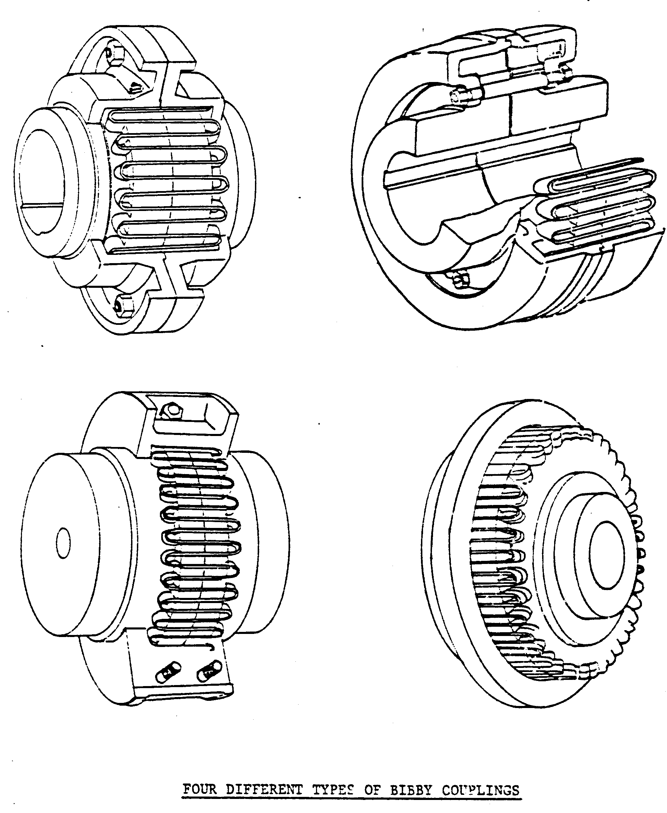
CONSTRUCTION OF BIBBY COUPLINGS

The principle of the Bibby coupling is to connect two grooved discs or hubs, one on the driven shafts, with a grid spring. The grooves are cut axially across the circumference of the hub or disc. The specially designed spring runs through the grooves to form a series of resilient bridges, which can be seen in Fig. 4.
The hubs or discs are shrunk or keyed to the driving and driven shafts. When assembled, the coupling is totally enclosed in a cover filled with oil or grease. The cover plates are fitted with felt seals to keep the lubricant in and the dirt out. Fig. 5 is an exploded view of the Bibby coupling.

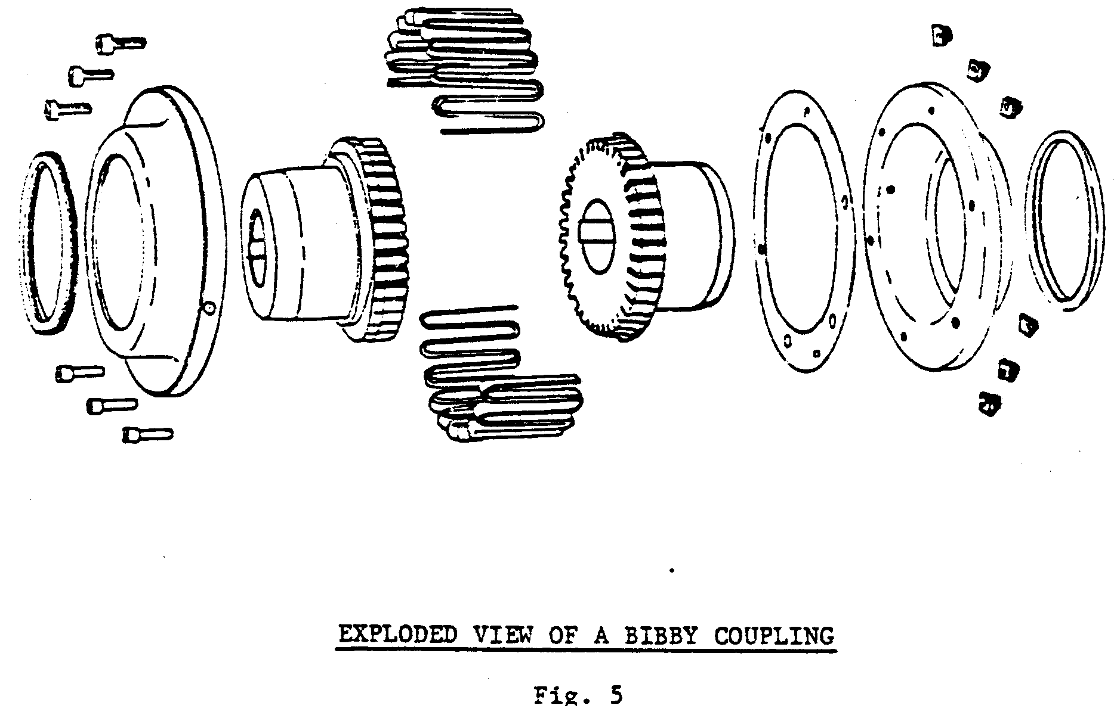

GEAR COUPLINGS

CONSTRUCTION

The coupling consists of two hubs with external gear teeth, which fit over the shafts, and two flanged coupling sleeves with internal gear teeth. The coupling sleeves also have seals, which fit over the hub and are bolted together with a gasket in between.
Clearance on the gear teeth compensates for slight shaft misalignment. The sliding effect on the geared teeth permits a nominal amount of slide for thermal expansion of one or both shafts and free end float. The coupling hubs are normally shrunk to the shafts. Fig. 1 illustrates the gear coupling.

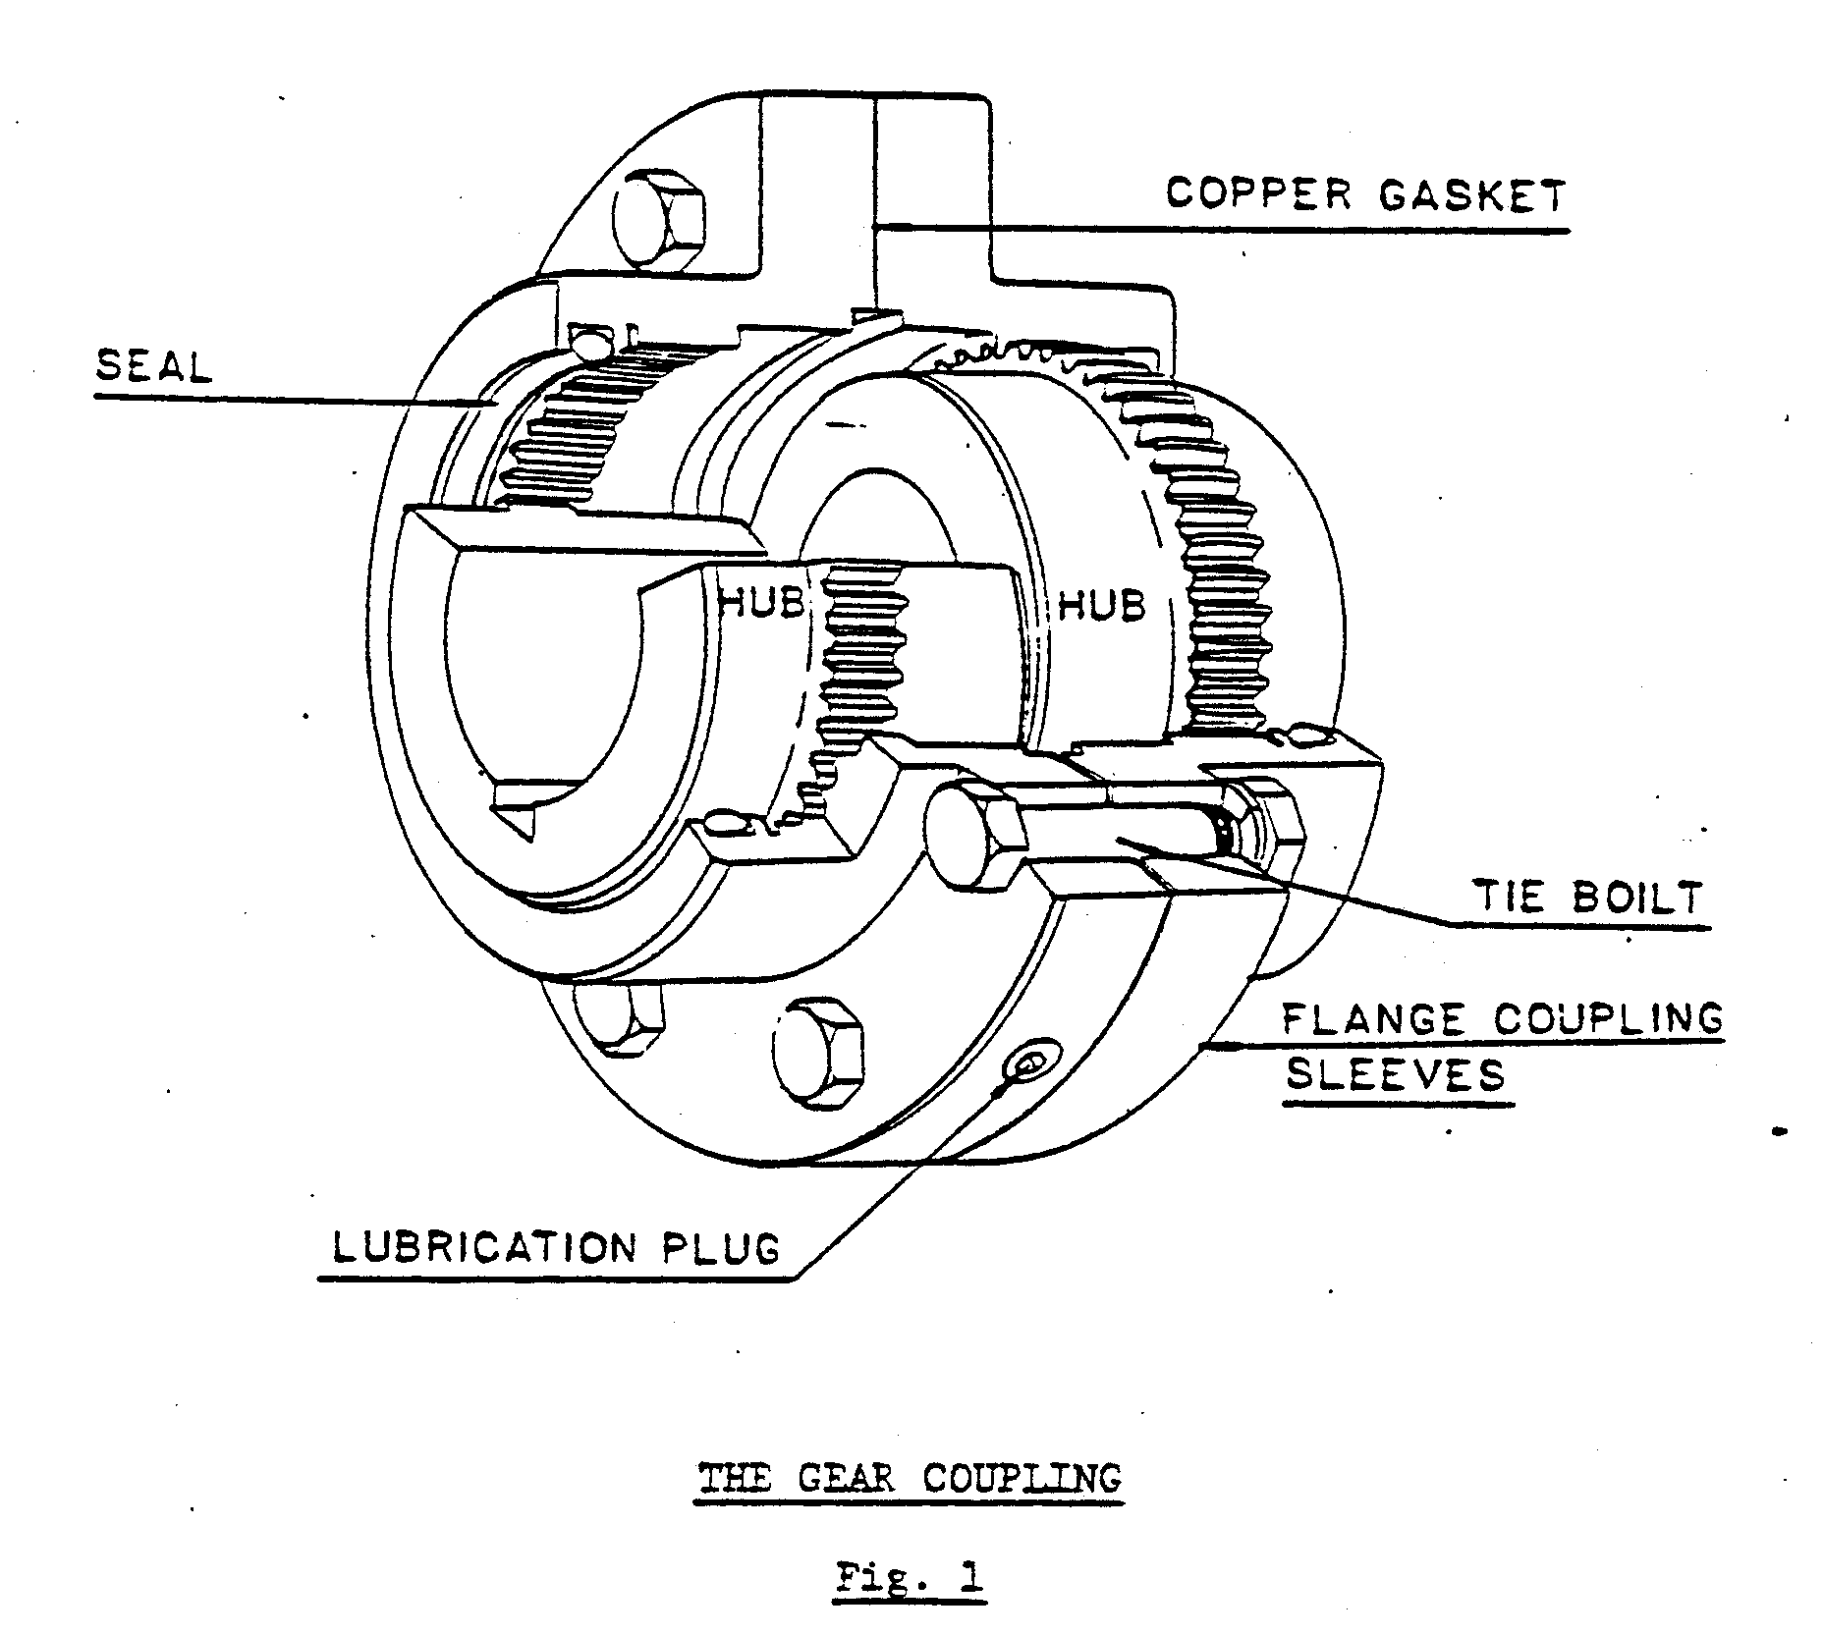
Lubricant, according to A.A.C. specifications, must be added to the coupling. The amount of lubricant required for gear couplings vary, depending on the size.

APPLICATION

Gear couplings are designed to connect two shaft ends directly, either vertically or horizontally. They are also used on drive requiring positive braking and holding of loads. Most parts of the gear coupling are interchangeable.

RUBBER DISC COUPLINGS

CONSTRUCTION

The rubber disc coupling is of robust construction and can withstand slight misalignment, shock loads, vibration and a minimum amount of end float.
The rubber disc coupling consists of two half couplings, pins and a rubber disc. The pins are equally spaced on the two half coupling faces. The amount of pins varies, depending on the application of the coupling. The molded rubber disc fits between the two half couplings with the pins from each coupling through the holes in the rubber disc. The disc allows for a small amount of misalignment. Fig. 4 illustrates the disc coupling.

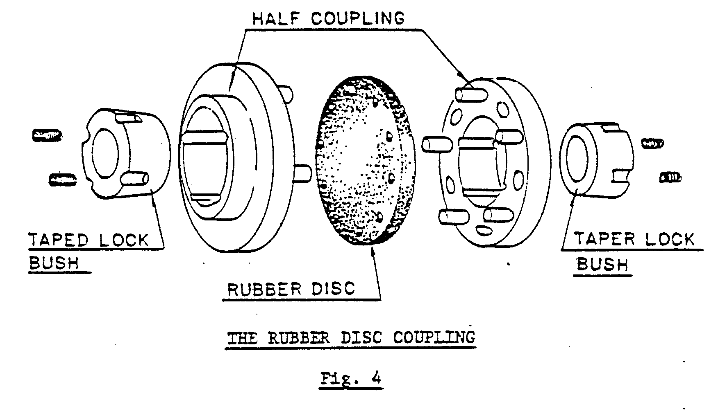
The coupling halves are keyed to the driving and driven shafts, normally by one of the following three methods:

- A tapered or bighead key.
- Rectangular key.
- A taper locking bush.

