EXP.2. Numerical Simulation and Performance Analysis of Microwave Transmission Lines and Two-Port Networks Using Scattering Parameters

A.

Code:
clear; clc; close all;

% Given parameters
Z0 = 50; % Port reference impedance (ohms)
Zc = 50; % Line characteristic impedance (ohms) L = 50e-3; % Line length (m)
f = linspace(8e9,12e9,1001);
f0 = 10e9; % Operating frequency (Hz) c = 299792458; % Speed of light (m/s)
% Ideal lossless transmission line beta = 2*pi*f/c;
gamma = 1i*beta;

% ABCD parameters
A = cosh(gamma*L);
B = Zc.*sinh(gamma*L);
C = sinh(gamma*L)./Zc;
D = A;

% ABCD-to-S parameter conversion den = A + B/Z0 + C*Z0 + D;
S11 = (A + B/Z0 - C*Z0 - D)./den;
S21 = 2./den;
S12 = 2.*(A.*D - B.*C)./den;
S22 = (-A + B/Z0 - C*Z0 + D)./den;

% Find the frequency index nearest to 10 GHz [~,idx] = min(abs(f-f0));
% Calculate results at 10 GHz
RL_dB = -20*log10(max(abs(S11(idx)),eps)); IL_dB = -20*log10(abs(S21(idx)));
efficiency = abs(S21(idx))^2*100;

fprintf('Results at %.2f GHz\n',f(idx)/1e9);
fprintf('S11 = %.4f %+.4fj\n',real(S11(idx)),imag(S11(idx))); fprintf('S12 = %.4f %+.4fj\n',real(S12(idx)),imag(S12(idx))); fprintf('S21 = %.4f %+.4fj\n',real(S21(idx)),imag(S21(idx))); fprintf('S22 = %.4f %+.4fj\n',real(S22(idx)),imag(S22(idx))); fprintf('Return loss = %.2f dB\n',RL_dB);
fprintf('Insertion loss = %.2f dB\n',IL_dB);
fprintf('Transmission efficiency = %.2f %%\n',efficiency);

% Plot S-parameter magnitudes figure;
plot(f/1e9,20*log10(max(abs(S11),eps)),'LineWidth',1.5); hold on;
plot(f/1e9,20*log10(abs(S21)),'LineWidth',1.5); plot(f/1e9,20*log10(abs(S12)),'--','LineWidth',1.5);
plot(f/1e9,20*log10(max(abs(S22),eps)),'--','LineWidth',1.5); grid on;
xlabel('Frequency (GHz)'); ylabel('Magnitude (dB)');
title('S-Parameters of a 50 \Omega Transmission Line'); legend('S11','S21','S12','S22','Location','best');

Output:

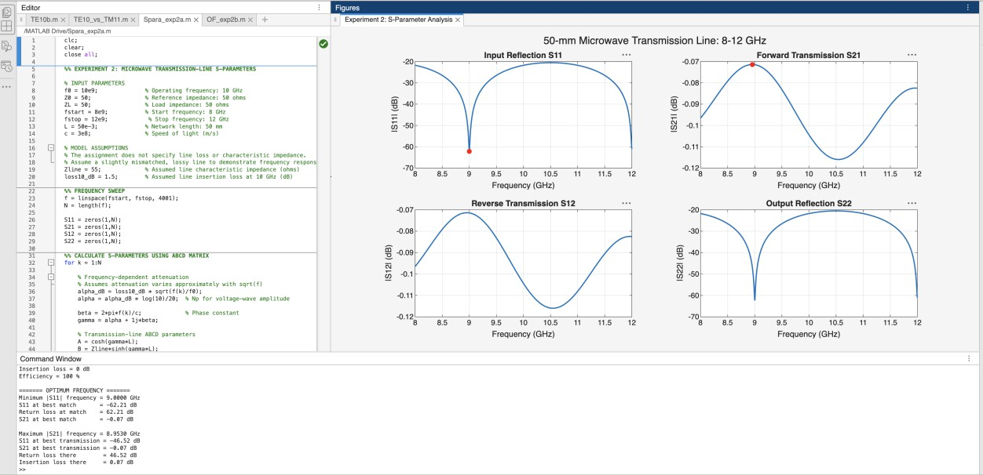
B.

code:

% Find minimum |S11| and maximum |S21| [~,idxMinS11] = min(abs(S11));
[~,idxMaxS21] = max(abs(S21));

% Report the frequency for each optimum fprintf('\nPart B: Optimum Frequency\n');
fprintf('Frequency of minimum |S11| = %.6f GHz\n', ... f(idxMinS11)/1e9);
fprintf('S11 at this frequency = %.6f %+.6Ƞ\n', ... real(S11(idxMinS11)),imag(S11(idxMinS11)));
fprintf('Return loss there = %.3f dB\n', ...
-20*log10(max(abs(S11(idxMinS11)),eps)));

fprintf('\nFrequency of maximum |S21| = %.6f GHz\n', ... f(idxMaxS21)/1e9);
fprintf('S21 at this frequency = %.6f %+.6Ƞ\n', ... real(S21(idxMaxS21)),imag(S21(idxMaxS21)));
fprintf('Insertion loss there = %.3f dB\n', ...
-20*log10(abs(S21(idxMaxS21))));

% Compare with the values at 10 GHz fprintf('\nComparison with 10 GHz:\n');
fprintf('At 10 GHz: |S11| = %.6g, |S21| = %.6g\n', ... abs(S11(idx)),abs(S21(idx)));
fprintf('At optimum: |S11| = %.6g, |S21| = %.6g\n', ... abs(S11(idxMinS11)),abs(S21(idxMaxS21)));

Output:
