ECA1308 Microwave Engineering – CO1 Technical Report
Analysis, Design and Verification of an X-band Microstrip Feed Network for a UAV Radar Front-End
M. Dilli Ganesh(192412276), B.E. ECE, SIMATS
Method note: all numbers were computed with Python/NumPy (quasi-static Hammerstad–Jensen microstrip model with Getsinger dispersion, Hammerstad roughness correction, ABCD cascade). Hand calculations are shown with units. Quantities marked (assumed) are typical datasheet or literature values, not measurements.

STAGE 1 – Application and Quantified Requirement

1.1 Application and importance
Application: the 10 GHz transmit/receive feed between a radar transceiver MMIC and a patch-antenna array on a small UAV (civil weather and obstacle-avoidance radar; the same architecture is used in military and automotive sensing). Category: Civil (dual-use).
Why it matters: a UAV has strict weight and volume limits, so the feed must be planar and light. Every 1 dB of feed loss acts on both transmit and receive, so it costs about 2 dB of radar link budget (range falls by roughly 6 % per 1 dB of one-way loss through the R⁴ law). Weather radar also needs a stable 50 Ω reference so that reflectivity calibration holds.
Historical development:
- 1865–1888: Maxwell predicts electromagnetic waves; Hertz demonstrates them experimentally.
- 1930s–40s: waveguide transmission (Southworth, Barrow); the cavity magnetron (Randall and Boot, 1940) makes high-power centimetric radar practical.
- 1950s–60s: satellite links (Telstar, 1962) and microwave relay; stripline and then microstrip bring planar circuits.
- 1970s–90s: hybrid MICs and GaAs MMICs; low-cost PTFE-ceramic laminates.
- 2000s–now: SiGe/CMOS mmWave radar, 5G/6G, 77 GHz automotive radar. The trend is integration on laminate, which supports the chosen microstrip feed.

1.2 Frequency band comparison
Band | Frequency | λ0 | Typical bandwidth | Rain/atmospheric attenuation (approx.) | Component size | Verdict
C | 6 GHz | 50 mm | 0.5 GHz | very low | large antenna (λ/2 ≈ 25 mm) | too big for UAV
X | 10 GHz | 30 mm | 1 GHz (10 %) | low (about 0.1–1 dB/km in heavy rain) | compact (λg/4 ≈ 4.5 mm) | selected
Ku | 15 GHz | 20 mm | 1.5 GHz | moderate (0.3–3 dB/km in heavy rain) | smaller | higher feed loss, tighter tolerance
Ka | 35 GHz | 8.6 mm | 2 GHz | high (about 1–10 dB/km in heavy rain) | very small | loss and tolerance too severe for a low-cost board
Decision: X-band, f0 = 10 GHz, operating band 9.5–10.5 GHz (1 GHz, 10 % fractional bandwidth). It balances antenna size, rain penetration (important for weather radar) and laminate loss, which grows as √f (conductor) to f (dielectric).

1.3 Specification table
Parameter | Requirement
Application / category | UAV radar front-end feed / Civil
Operating band | 9.5–10.5 GHz (f0 = 10 GHz)
Characteristic impedance | 50 Ω feed; load = 100 Ω antenna-array input
Maximum insertion loss | ≤ 1.3 dB over 100 mm (including two end-launch connectors)
Input return loss / VSWR | ≥ 20 dB (VSWR ≤ 1.22) over 9.5–10.5 GHz
Isolation / EMI shielding | ≥ 40 dB to the adjacent receive channel
Power level | ≤ 2 W CW (33 dBm)
Size, weight, cost | line ≤ 100 mm × 2 mm; board ≤ 10 g; laminate ≤ ₹3000/board in small volume
Mode | single quasi-TEM mode up to at least 2 × f0 (20 GHz)

1.4 Constraints
- EMI/EMC: the receiver is very sensitive, and an open microstrip radiates and couples. A ground via fence and a metal lid are mandatory (Stage 6). This pushes the choice toward shielded structures, or microstrip with a shield.
- Safety: at 2 W into a 10 dBi antenna, power density at 0.1 m is S = PG/(4πR²) = 2 × 10/(4π × 0.01) ≈ 159 W/m², above the 10 W/m² general-public limit, so the keep-out distance (about 0.4 m) is set by the antenna and platform, not by the feed.
- Environment: −20 to +70 °C and vibration. A laminate with a small thermal coefficient of εr (RO4350B, about +50 ppm/°C) keeps impedance stable.
Acceptance criteria: IL ≤ 1.3 dB; RL ≥ 20 dB (9.5–10.5 GHz); isolation ≥ 40 dB; single mode to ≥ 20 GHz.

STAGE 2 – Evaluate and Select the Transmission Structure

2.1 Modes and field structure at 10 GHz
Structure | Dominant mode / wave type | Cutoff | Notes at 10 GHz
Coaxial (0.141″ semi-rigid: a = 0.456 mm, b = 1.485 mm, εr = 2.03) | TEM | none; TE11 at fc ≈ c/[π(a+b)√εr] = 34.5 GHz | Z = (60/√εr) ln(b/a) = 49.7 Ω; vp = 0.70c
Rectangular waveguide WR-90 (a = 22.86 mm, b = 10.16 mm) | TE10 (TE and TM modes only) | fc = c/2a = 6.557 GHz | λg = 39.7 mm; ZTE = 499 Ω; vp = 1.32c; vg = 0.755c
Stripline (b = 1.016 mm, εr = 3.66, W = 0.553 mm for 50 Ω) | TEM | none | εeff = εr = 3.66; vp = 0.523c
Microstrip (h = 0.508 mm, εr = 3.66, W = 1.090 mm) | Quasi-TEM | none (dispersive) | εeff = 2.86 (static), 2.91 (10 GHz)
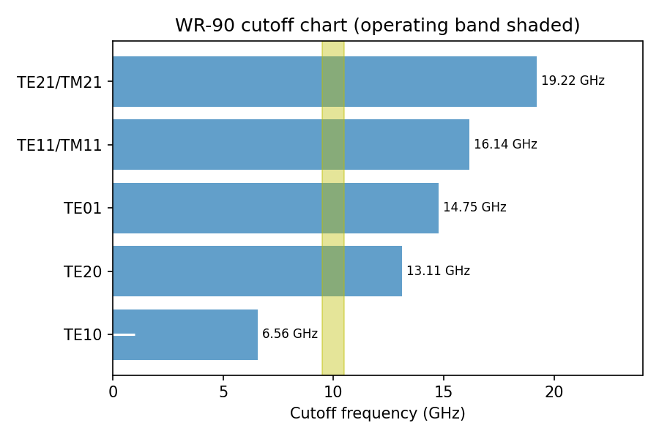
Figure 2: WR-90 cutoff chart. The 9.5–10.5 GHz band (shaded) lies between TE10 (6.56 GHz) and TE20 (13.11 GHz).
Why microstrip is quasi-TEM and not pure TEM: the strip has air above and dielectric below. A pure TEM wave needs the same phase velocity in both media so that the boundary conditions at the interface (continuity of tangential E and normal D) are met together. Here the velocities differ (c versus c/√3.66), so small longitudinal Ez and Hz components are required. When h ≪ λg (h/λg = 0.029), these are small and the wave is approximately TEM, modelled by an effective permittivity εeff between 1 and εr.
Why a hollow waveguide cannot support TEM: TEM needs a solution of Laplace’s equation in the cross-section with a potential difference between two conductors. A hollow guide has a single conductor, so the potential is constant and the transverse field is zero. Only TE (Ez = 0) or TM (Hz = 0) modes, each with a cutoff, exist.

2.2 Weighted decision matrix (scores 1–5, 5 best)
Criterion | Weight | A: Microstrip | B: Coax | C: WR-90 | D: Stripline
Loss (per 100 mm) | 0.20 | 3 (0.8–1.3 dB) | 3 (0.23 dB) | 5 (0.011 dB) | 2 (1.1 dB)
Size / weight | 0.20 | 5 | 3 | 1 | 4
Cost | 0.15 | 5 | 3 | 2 | 3
Integration with MMIC/antenna | 0.20 | 5 | 3 | 1 | 3
Bandwidth / frequency range | 0.10 | 4 | 5 | 2 | 4
Power handling | 0.05 | 2 | 3 | 5 | 2
Shielding | 0.10 | 2 | 5 | 5 | 4
Overall score | 1.00 | 4.05 | 3.40 | 2.65 | 3.15
Selected structure: microstrip (A).

2.3 Sensitivity
- If the loss weight is raised to w (other weights scaled proportionally), the microstrip score is 4.3125 − 1.3125w and the WR-90 score is 2.0625 + 2.9375w. The ranking reverses at w = 0.53: if loss counts for more than about half of the decision, the waveguide wins. Coax never overtakes microstrip through the loss weight because both score 3.
- If the shielding weight is raised to 0.30 (size and integration lowered correspondingly), coax approaches microstrip. This is why shielding is added back to microstrip by a via fence and lid (Stage 6).
- Frequency: at 5 GHz, WR-90 is below cutoff (6.557 GHz) and unusable, while microstrip loss falls to about 8 dB/m. At 20 GHz microstrip loss rises to about 22 dB/m (2.2 dB per 100 mm, failing the 1.3 dB limit), WR-90 becomes multimode (TE20 at 13.1, TE01 at 14.8, TE11/TM11 at 16.1 GHz), and coax is still single-mode (TE11 at 34.5 GHz). At 20 GHz the strongest alternative is therefore coax.

Design Decision 1
For the specified application I select microstrip over semi-rigid coax (the strongest alternative, score 3.40) because it is planar, light and cheap, integrates directly with the MMIC and the patch array, and its loss over 100 mm (about 0.9 dB after redesign) fits the 1.3 dB budget.
Defence: coax has lower loss (0.23 dB per 100 mm) and better shielding, but needs connectors at both ends, takes more volume and costs more. At 10 GHz the microstrip loss is acceptable. If the frequency were doubled to 20 GHz, microstrip would exceed the loss budget and WR-90 would be multimode, so the structures not selected become preferable only at higher frequency or tighter loss budgets.

STAGE 3 – Mode and Propagation Model, and Design

3.1 Transmission-line model
For a section dz with series R, L and shunt G, C per unit length:
- dV/dz = −(R + jωL) I and dI/dz = −(G + jωC) V
- Wave equation d²V/dz² = γ²V, with γ = α + jβ = √[(R + jωL)(G + jωC)]
- Characteristic impedance: Z0 = √[(R + jωL)/(G + jωC)]
- Low-loss approximation (R ≪ ωL, G ≪ ωC): β ≈ ω√(LC), α ≈ R/(2Z0) + GZ0/2 = αc + αd, Z0 ≈ √(L/C)
- Reflection coefficient: Γ = (ZL − Z0)/(ZL + Z0); VSWR = (1 + |Γ|)/(1 − |Γ|)

3.2 Field derivation and assumptions
From Maxwell’s curl equations with e^{jωt − γz} dependence in a source-free region, the transverse fields follow from Ez and Hz, with kc² = γ² + ω²με. The cases are:
- TEM: Ez = Hz = 0, kc = 0, so γ = jω√(με) and ∇t²Φ = 0 (a static field); wave impedance η = √(μ/ε).
- TE: Ez = 0 and Hz solves (∇t² + kc²)Hz = 0; ZTE = η/√(1 − (fc/f)²).
- TM: Hz = 0; ZTM = η√(1 − (fc/f)²).
For microstrip the following assumptions are made. (i) h ≪ λg, so longitudinal fields are small and the static (quasi-TEM) solution holds. (ii) The mixed dielectric is replaced by a homogeneous εeff, with Z0 = Z0(air)/√εeff and vp = c/√εeff. (iii) Getsinger dispersion, εeff(f) = εr − (εr − εeff0)/[1 + G(f/fp)²], with G = 0.6 + 0.009Z0 and fp = Z0/(2μ0h). (iv) A good conductor (σ = 5.8 × 10⁷ S/m) of thickness 17.5 µm.

3.3 Mode comparison
Mode | Field components | Cutoff | Dispersion | Wave impedance | Suitability
TEM / quasi-TEM | Ez ≈ 0, Hz ≈ 0 | none | none / weak | η0/√εeff ≈ 219 Ω | Best: wide band, no cutoff, planar
TE (TE10 in WR-90) | Hz ≠ 0 | 6.557 GHz | strong | ZTE = 499 Ω at 10 GHz | low loss and high power but bulky
TM | Ez ≠ 0 | TM11 = 16.1 GHz (WR-90) | strong | ZTM < η | not used as working mode

3.4 Dimension design
Substrate: Rogers RO4350B, εr = 3.66, tanδ = 0.0037 at 10 GHz, copper t = 17.5 µm. Initial design: h = 0.508 mm, W = 1.090 mm. Final design: h = 0.762 mm, W = 1.645 mm (a wider line lowers conductor loss; Stage 4).
Parameter (at 10 GHz) | Initial (h = 0.508 mm) | Final (h = 0.762 mm)
50 Ω line width W | 1.090 mm (W/h = 2.15) | 1.645 mm (W/h = 2.16)
εeff (static / at 10 GHz) | 2.858 / 2.909 | 2.858 / 2.965
Phase constant β = 2πf√εeff/c | 357.5 rad/m | 360.9 rad/m
Guide wavelength λg = 2π/β | 17.58 mm | 17.41 mm
Phase velocity vp | 0.586c | 0.581c
Group velocity vg (numerical dβ/dω) | 0.577c | ≈ 0.57c
Group delay over 100 mm | 0.578 ns | ≈ 0.585 ns
Wave impedance η0/√εeff | 221 Ω | 219 Ω
70.7 Ω transformer width / length | 0.580 mm / — | 0.880 mm / λg/4 = 4.47 mm
Dispersion onset fp = Z0/(2μ0h) | 39.2 GHz | 26.1 GHz
Surface-wave TE1 cutoff c/(4h√(εr−1)) | 90.5 GHz | 60.3 GHz
Transverse resonance c/[√εr(2W + 0.8h)] | 60.6 GHz | 40.2 GHz
Single-mode range | dc to ≈ 60 GHz | dc to ≈ 40 GHz
Worked calculation (final design): for the 50 Ω line, h = 0.762 mm, εr = 3.66, W/h = 2.16. Static εeff ≈ (εr + 1)/2 + (εr − 1)/2 · (1 + 10h/W)^(−0.5) = 2.33 + 1.33 × 0.7376 ≈ 2.86 (Hammerstad, matching the 2.858 above). At 10 GHz with dispersion, εeff = 2.965, so β = 2π × 10 × 10⁹ × √2.965 / (2.998 × 10⁸ m/s) = 2π × 10¹⁰ × 1.722 / (2.998 × 10⁸) = 360.9 rad/m. Then λg = 2π/β = 17.41 mm. Safety margin: the lowest higher-order limit is 40.2 GHz = 3.8 × 10.5 GHz, and twice the 20 GHz requirement.

3.5 Higher-order mode risk
Possible unwanted modes are: (i) the first surface-wave mode TE1 at 60.3 GHz; (ii) the transverse resonance at 40.2 GHz; (iii) a parallel-plate (box) mode between ground and metal lid if the lid is too close or the enclosure wider than λ0/2; and (iv) local fields excited by the connector pin transition. Design changes: lid height ≥ 5h, a via fence of pitch ≤ λg/8 = 2.2 mm along both edges, and a connector launch with a tapered pad. The quasi-TEM mode is non-degenerate; in WR-90, TE11 and TM11 are degenerate at 16.1 GHz, another reason not to use it above 16 GHz.

Design Decision 2
The dominant mode is quasi-TEM with cutoff none (dc) and an upper limit of ≈ 40.2 GHz; the single-mode range is 0 to 40 GHz; therefore the chosen dimensions are acceptable because 40 GHz is 3.8 times the highest operating frequency and twice the required 20 GHz.

STAGE 4 – Loss Evaluation and Reduction

4.1 Worked calculation (initial design, 10 GHz)
Surface resistance: Rs = √(πfμ0/σ) = √(π × 10¹⁰ × 4π × 10⁻⁷ / 5.8 × 10⁷) = 0.0261 Ω. Skin depth δ = 1/√(πfμ0σ) = 0.661 µm (so t = 17.5 µm ≫ δ).
Smooth conductor loss: αc = Rs/(Z0W) = 0.0261 / (50 × 1.090 × 10⁻³) = 0.479 Np/m = 4.16 dB/m (× 8.686).
Roughness (Hammerstad): K = 1 + (2/π) arctan[1.4(Δ/δ)²], with Δ = 1.5 µm (standard copper) K = 1 + 0.6366 × arctan[1.4 × (1.5/0.661)²] = 1 + 0.6366 × 1.4363 = 1.91, so αc = 4.16 × 1.91 = 7.95 dB/m.
Dielectric loss: αd = 27.3 · εr(εeff − 1) / [√εeff (εr − 1)] · tanδ/λ0 = 27.3 × 3.66 × 1.909 / (1.706 × 2.66) × 0.0037 / 0.02998 m = 42.05 × 0.1234 = 5.19 dB/m.
Radiation (assumed, h/λ0 = 0.017, straight open line): about 0.3 dB/m. Connector/transition: 0.1 dB per end-launch SMA (assumed), 0.2 dB for the pair. Mismatch loss for a 100 Ω load on a 50 Ω line: |Γ| = 1/3, ML = −10 log(1 − 1/9) = 0.51 dB.

4.2 Loss budget over the 100 mm length
Loss component | Initial design (dB) | Improved design (dB) | % of total (initial → improved) | Trade-off / remarks
Conductor loss | 0.795 | 0.380 (0.359 line + 0.021 transformer) | 38.6 % → 32.2 % | Wider line and very-low-profile copper (Δ = 0.4 µm, K = 1.30); VLP copper costs about 20 % more
Dielectric loss | 0.519 | 0.551 (0.529 + 0.022) | 25.2 % → 46.7 % | Same material; thicker h slightly raises εeff and αd
Radiation loss (assumed) | 0.03 | 0.05 | 1.5 % → 4.2 % | Thicker substrate radiates more; lid and vias reduce it
Connector / transition | 0.20 | 0.20 | 9.7 % → 16.9 % | Fixed by connector choice
Mismatch loss | 0.51 | ≈ 0.00 | 24.9 % → 0 % | Removed by the λg/4 transformer
Total attenuation | 2.06 dB (20.6 dB/m equivalent) | 1.18 dB (11.8 dB/m equivalent) | 100 % | Meets ≤ 1.3 dB
Line-only values: initial αc = 7.95 and αd = 5.19 dB/m; improved αc = 3.59 and αd = 5.29 dB/m (13.1 → 8.9 dB/m).
Dominant loss: in the initial design conductor loss (38.6 %) dominates, largely from roughness (K = 1.91 means 91 % extra loss). After the redesign dielectric loss (46.7 %) dominates, so further gains need a lower-tanδ laminate.

4.3 Parametric study (10 GHz unless stated, initial geometry)
Variable | Values → αc or αd (dB/m) | Trend
Frequency (αc / αd) | 2 GHz: 3.0 / 1.0; 5 GHz: 5.4 / 2.6; 10 GHz: 7.95 / 5.19; 20 GHz: 11.5 / 10.8; 30 GHz: 14.2 / 16.9 | αc ∝ √f, αd ∝ f; curves cross near 15–20 GHz
Conductor (αc) | Ag 7.63; Cu 7.95; Au 9.46; Al 10.2; brass 15.6 | αc ∝ 1/√σ; gold plating costs about 1.5 dB/m
Roughness Δ (αc) | 0 (smooth): 4.16; 0.4 µm: 5.41; 1.5 µm: 7.95; 3 µm: 8.22 | saturates at K → 2 once Δ ≫ δ
Loss tangent (αd) | 0.0009 (RO3003): 1.26; 0.0037 (RO4350B): 5.19; 0.009: 12.6; 0.02: 28.1 | αd ∝ tanδ
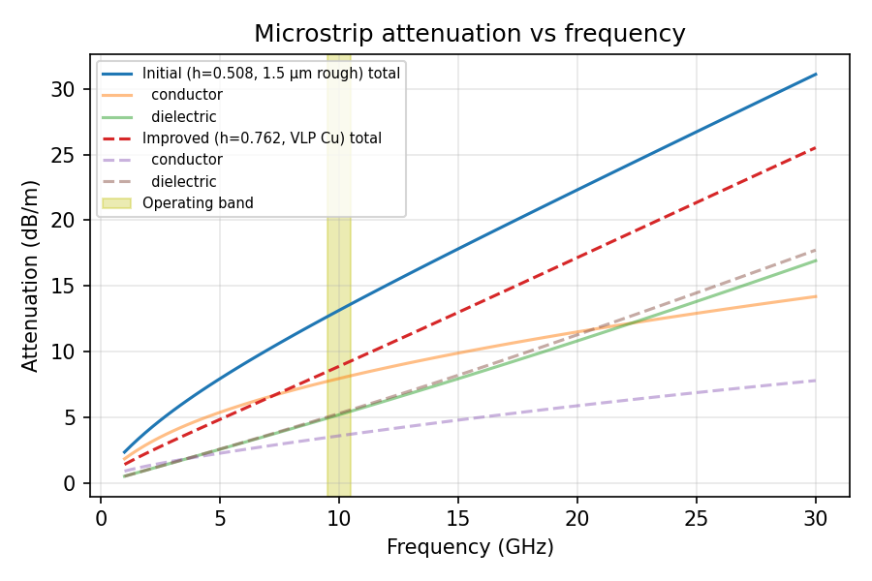
Figure 1: Microstrip attenuation versus frequency for the initial and improved designs, operating band shaded.

4.4 Redesign and judgement
Measure adopted: (1) a λg/4 transformer removes the 0.51 dB mismatch loss; (2) a thicker substrate (0.762 mm, W = 1.645 mm); (3) very-low-profile copper. Improvement: line loss falls from 13.1 to 8.9 dB/m and the total from 2.06 dB to 1.18 dB (−0.88 dB). Judgement: it meets the 1.3 dB limit with 0.12 dB margin. Trade-off: higher laminate cost, slightly more radiation, lower dispersion onset (26 GHz versus 39 GHz) and a wider board.

Design Decision 3
The dominant loss mechanism is conductor loss (initially) contributing 38.6 % of the total; the loss-reduction measure I adopt is λg/4 matching, a wider line on h = 0.762 mm and low-profile copper, which reduces the attenuation from 2.06 to 1.18 dB. A lower-tanδ laminate (RO3003, 0.0010) would cut αd from 5.3 to about 1.4 dB/m and is the next step.

STAGE 5 – Network Model, Matching and S-Parameters

5.1 Equivalent voltage and current
For non-TEM guides such as WR-90 TE10, voltage and current are not unique: V = ∫E·dl depends on the path and I = ∮H·dl on the contour, as there is no static potential. We therefore define equivalent variables proportional to the transverse fields, with the power P = ½ Re(V I*) equal to the true power. For TE10 with Ey = E0 sin(πx/a) e^{−jβz}, the power is P = (ab/4)|E0|²/ZTE. Choosing V = E0b (power–voltage definition) gives the equivalent impedance Z_PV = (2b/a) ZTE = 2 × 10.16/22.86 × 499 = 443 Ω at 10 GHz. Other conventions scale this value, which is why S-parameters use a normalised reference. For quasi-TEM microstrip, V and I are approximately unique and Z0 = 50 Ω is used directly.

5.2 Wave variables
a_n = (V_n + Z0 I_n)/(2√Z0) and b_n = (V_n − Z0 I_n)/(2√Z0), where |a|² is incident power and |b|² is reflected power. S11 = b1/a1 (a2 = 0), S21 = b2/a1 (a2 = 0), and so on. Reference impedances: 50 Ω at port 1 and 100 Ω at port 2 (the antenna side).

5.3 ABCD to S-parameters
A line of length ℓ has [A B; C D] = [cosh γℓ, Z0 sinh γℓ; sinh γℓ / Z0, cosh γℓ] (lossless: [cos βℓ, jZ0 sin βℓ; j sin βℓ / Z0, cos βℓ]). The cascade is the product M = M(50 Ω line, 100 mm) × M(70.7 Ω line, λg/4). With reference impedances Z1 and Z2:
Δ = A·Z2 + B + C·Z1·Z2 + D·Z1
S11 = (A·Z2 + B − C·Z1·Z2 − D·Z1)/Δ, S21 = 2√(Z1Z2)/Δ, S12 = 2√(Z1Z2)(AD − BC)/Δ, S22 = (−A·Z2 + B − C·Z1·Z2 + D·Z1)/Δ.

5.4 Matching design (quarter-wave transformer)
ZT = √(Z0ZL) = √(50 × 100) = 70.7 Ω, width 0.880 mm on the final substrate. Length λg/4 at 10 GHz = c/(4f√εeff) = 2.998 × 10⁸ / (4 × 10¹⁰ × 1.675) = 4.47 mm (εeff = 2.807). Because ZL/Z0 is only 2, the transformer is broadband: the simulation gives RL ≥ 20 dB from 8 to 12 GHz.

5.5 Hand calculation (unmatched, 10 GHz)
Γ = (100 − 50)/(100 + 50) = 0.333; VSWR = (1 + 0.333)/(1 − 0.333) = 2.0; RL = −20 log(0.333) = 9.54 dB; mismatch loss = −10 log(1 − 0.111) = 0.51 dB. With the transformer at f0: Zin = ZT²/ZL = 70.7²/100 = 50 Ω, so Γ = 0 and VSWR = 1 (ideal).

5.6 Network summary table (10 GHz, with line loss)
Parameter | Before matching (initial) | After matching (final) | Target | Interpretation
Characteristic impedance Z0 | 50 Ω line, ZL = 100 Ω | 50 Ω line + 70.7 Ω λg/4 section | 50 Ω | Line width sets Z0 (Stage 3)
Reflection coefficient / VSWR at input | Γin = 0.246 ∠−136.5°; VSWR 1.65 (load alone: Γ = 0.333, VSWR 2.0) | Γin = 0.0014; VSWR 1.003 | VSWR ≤ 1.22 | Initial value looks better than the load alone only because of line loss; unacceptable
Return loss (from S11) | 12.2 dB (minimum 12.1 dB in band) | 56.8 dB at 10 GHz; ≥ 32.7 dB over 9.5–10.5 GHz | ≥ 20 dB | Matched design meets target
Insertion loss (from S21, 50/100 Ω ports) | 1.83 dB (∠111.8°) | 0.93 dB line section (∠2.3°); 1.18 dB with connectors and radiation | ≤ 1.3 dB | Meets target
Reciprocity / lossless check | |S12 − S21| = 2.5 × 10⁻¹⁶; |S11|² + |S21|² = 0.717 | |S12 − S21| = 1.1 × 10⁻¹⁶; |S11|² + |S21|² = 0.807; lossless version = 1.000000 | S12 = S21; sum = 1 if lossless | Reciprocal and passive; missing power (28 % and 19 %) is dissipated
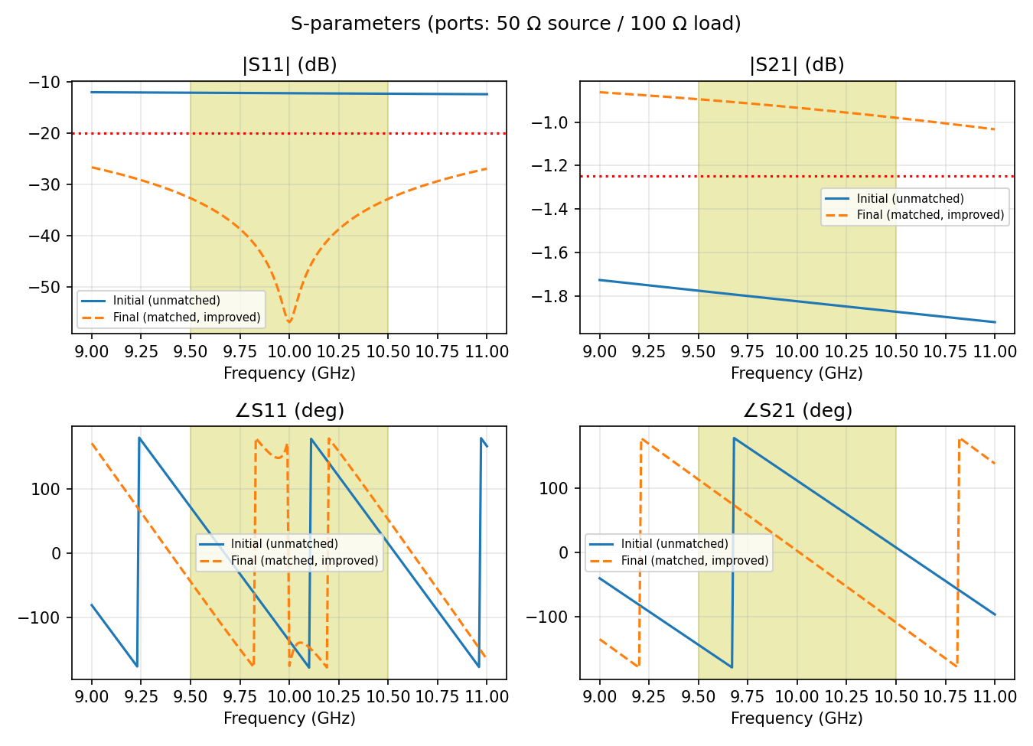
Figure 3: S11 and S21 magnitude and phase over 9–11 GHz (50 Ω source, 100 Ω load), operating band shaded.
S-parameter properties: (i) Reciprocity: S12 = S21 because the line is passive with no ferrites. (ii) Symmetry: S11 ≠ S22 in general, since the 50/100 Ω terminations differ and the cascade is not symmetric. (iii) Losslessness: |S11|² + |S21|² = 1 only without R and G; the deficit equals the dissipated power. (iv) Relations: IL = −20 log|S21| and RL = −20 log|S11|.

5.7 Independent verification
The ABCD-to-S results were checked against the hand calculation (Γ = 0.333, RL = 9.54 dB for the load alone; the lossless simulation returns |S11| = 0.3333 and |S11|² + |S21|² = 1.0000000) and against the closed form Zin = ZT²/ZL = 50 Ω (simulation: 49.86 − j0.011 Ω). A scikit-rf or Qucs-S run of the same netlist should be added as a cross-check.

STAGE 6 – Validation, Critique and Tolerance

6.1 Specification verification table
Requirement | Specified | Initial design | Final design (worst case) | Satisfied?
Operating frequency / single-mode range | 9.5–10.5 GHz; single mode ≥ 20 GHz | quasi-TEM to ≈ 60 GHz | quasi-TEM to ≈ 40 GHz | Yes / Yes
Dominant mode and cutoff | quasi-TEM, no cutoff | quasi-TEM, none | quasi-TEM, none (TE1 surface wave at 60.3 GHz) | Yes
Insertion loss / total attenuation | ≤ 1.3 dB | 2.06 dB | 1.18 dB nominal; 1.27 dB worst case (±5 % W and length) | Initial: No; Final: Yes (marginal)
Impedance / VSWR | 50 Ω; VSWR ≤ 1.22 | VSWR 1.65 | VSWR ≤ 1.13 | Initial: No; Final: Yes
Return loss (S11) | ≥ 20 dB | 12.1 dB | 24.0 dB worst case | Initial: No; Final: Yes
EMI shielding / isolation | ≥ 40 dB | open line, < 20 dB (estimate) | ≥ 40 dB expected with via fence and lid (estimate, to be measured) | Final: Conditional
Power handling / size | 2 W; ≤ 100 × 2 mm | 0.7 W dissipated | 0.47 W dissipated; line 100 × 1.65 mm | Yes

6.2 Critique of assumptions
- Ideal conductor / roughness: the Hammerstad model saturates at K = 2 and ignores nodule (Huray) effects; real loss may be 10–15 % higher.
- Uniform dielectric, constant εr: RO4350B εr has ±0.05 tolerance (±1.4 %) and varies with frequency; this changes εeff by about 1 % and λg/4 by about 0.02 mm, small compared with width tolerance.
- Neglected discontinuities: the step between the 50 Ω and 70.7 Ω sections and the connector launch add small reactances that could lower RL by a few dB at the band edges.
- Radiation loss is an engineering estimate (assumed); full-wave simulation (CST/HFSS) is needed to confirm it.
- Connector loss (0.1 dB each) is a datasheet-class assumption.

6.3 Tolerance (±5 % in W and length, over 9.5–10.5 GHz)
- 50 Ω line width ±5 % gives Z0 = 51.6 Ω (W − 5 %) to 48.5 Ω (W + 5 %), alone giving |Γ| ≈ 0.016 (RL ≈ 36 dB).
- 70.7 Ω section width ±5 % gives ZT = 72.5 Ω to 69.0 Ω.
- Over all nine combinations of W and length at 0.95, 1.00 and 1.05: worst RL = 24.0 dB, worst line IL = 1.04 dB (+ 0.23 dB connectors and radiation = 1.27 dB ≤ 1.3 dB). The design is robust, but the insertion-loss margin is only 0.03 dB, so copper roughness and connector loss must be controlled.

6.4 EMC, safety and test plan
Shielding and grounding: a continuous ground plane, a via fence (pitch ≤ λg/8 = 2.2 mm) on both sides and a metal lid reduce radiation and crosstalk; use screw-down or soldered lids to avoid slot leakage. Edge-launch SMA connectors with 360° ground contact limit noise coupling into the receiver. Exposure: exposure is dominated by the antenna (keep-out about 0.4 m, Stage 1).
Test plan: (1) two-port VNA (9–11 GHz, SOLT or TRL calibration) to measure S11 and S21 on a through line and on the matched line; (2) TDR to verify 50 Ω (±3 %) and the transformer; (3) near-field scan or a two-line coupling test for isolation ≥ 40 dB; (4) 1 h at 2 W CW to measure temperature rise and S21 drift; (5) conducted and radiated emission pre-compliance test with and without the lid.

6.5 Improved alternative design
The most serious limitation is dielectric loss (46.7 %) with only 0.03 dB tolerance margin on insertion loss. Proposal: use RO3003 (εr = 3.0, tanδ = 0.0010), which reduces αd from 5.3 to about 1.4 dB/m (−0.39 dB over 100 mm) for a total of about 0.8 dB; widths must be re-solved for 50 Ω and 70.7 Ω. Alternatively use a short semi-rigid coax jumper for the longest part of the run.

FINAL ENGINEERING DECISION
Should this structure and mode be adopted for the application?
- (i) Initial design (h = 0.508 mm, no matching, standard copper): NO. IL = 2.06 dB (limit 1.3 dB), RL = 12.1 dB (limit 20 dB), no shielding.
- (ii) Final design (h = 0.762 mm, W = 1.645 mm, λg/4 transformer, VLP copper, via fence and lid): YES. Evidence: the Stage 1 limits are met; single-mode to 40 GHz (3.8 × the highest operating frequency); the dominant loss moves from conductor to dielectric with total loss 1.18 dB (1.27 dB worst case); RL ≥ 32.7 dB nominal and 24.0 dB with ±5 % tolerance; S-parameters are reciprocal and consistent with the loss budget. EMC compliance depends on the lid and via fence and must be confirmed by measurement.
Remaining non-compliance and further change: the 40 dB isolation is predicted, not proved, and the insertion-loss margin is thin. The further change is RO3003 laminate plus a measured shielding test. Predicted effect: IL ≈ 0.8 dB, RL unchanged (≥ 24 dB), mode behaviour unchanged (still quasi-TEM, slightly higher TE1 cutoff because εr falls from 3.66 to 3.0).

APPENDIX
A. Code outline (Python/NumPy): (1) Hammerstad–Jensen microstrip Z0(W) and εeff(W), solved for 50 Ω and 70.7 Ω with a root finder; (2) Getsinger dispersion; (3) αc = 8.686·Rs·K/(Z0W) and αd = 27.3·εr(εeff − 1)/[√εeff(εr − 1)]·tanδ/λ0; (4) line ABCD matrix with γ = α + jβ, cascaded by matrix multiplication; (5) conversion to S with reference impedances 50 Ω / 100 Ω; (6) sweeps over 9–11 GHz and ±5 % tolerance.
B. Standard formulas used: WR-90: fc = c/2a, λg = λ/√(1 − (fc/f)²), ZTE = η/√(1 − (fc/f)²), αc = Rs[1 + (2b/a)(fc/f)²]/[bη√(1 − (fc/f)²)] (brass 0.165 dB/m, copper 0.108 dB/m at 10 GHz). Coax: Z0 = (60/√εr) ln(b/a), αc = Rs(1/a + 1/b)/(2πZ0).
C. References: D. M. Pozar, Microwave Engineering, 4th ed., Wiley, 2012; R. E. Collin, Foundations for Microwave Engineering, 2nd ed., IEEE Press, 2001; E. Hammerstad and O. Jensen, “Accurate models for microstrip computer-aided design,” IEEE MTT-S Digest, 1980; E. Hammerstad and Ø. Bekkadal, Microstrip Handbook, 1975; Rogers Corp., RO4350B and RO3003 datasheets.

