EduTrack
Academic Performance, Made Visible.
Comprehensive Project Documentation & System Manual
Student Academic Performance Management System
Affiliated to Mohan Babu University
Field | Details
Submitted by | Code Busters
Team Members | Nanda Kesavan,  Puligundla Dillip Kumar,  Adabala Naga Malli Murari,  Vuyyala Vyshali,  Bongu Spandhana.
Course / Subject | Python (CSE)
Guide / Faculty | Mahammad vali (Computer Science & Engineering)
Institution | Mohan Babu University, Tirupati, Andhra Pradesh
Academic Year | 2026 - 2027
Live Production URL | https://edutrack-student-system.onrender.com (Local: http://127.0.0.1:5000)

Table of Contents
1. Introduction
2. Objectives and Scope
3. System Overview & Technology Stack
4. System Architecture
5. Database Design & Entity Relationship
6. Roles & Access Control Matrix
7. Getting Started: Public Landing Page & Demo Access
8. Administrator Module & Governance
9. Faculty / Teacher Module
10. Student Module & Academic Transcripts
11. Validations & Business Rules
12. Security & Compliance
13. Reports, Exports & Analytics
14. Testing & Verification Matrix
15. Limitations & Future Enhancements
16. Conclusion

1. Introduction
EduTrack is a modern web-based academic performance management platform engineered for collegiate institutions and universities. It brings students, faculty instructors, and administrative leaders together into an integrated, cloud-native data ecosystem. By replacing scattered spreadsheets, vulnerable manual registers, and delayed grade postings with a centralised relational database, EduTrack guarantees absolute transparency, evaluation integrity, and instant feedback.
The platform enforces the rigorous Indian collegiate examination structure comprising Continuous Internal Assessments (Internal 1 capped at 50 marks, Internal 2 capped at 50 marks) and Terminal Semester Examinations (100 marks). Faculty members enter and review scores with active boundary validation, while students enjoy single-click authenticated access to comprehensive progress metrics, grade distribution, subject strengths, and printable Mohan Babu University transcripts.

1.1 Problem Statement
In conventional collegiate operations, student evaluation marks remain fragmented across disparate department spreadsheets. Students typically discover critical learning deficits only at the conclusion of the semester when it is too late to remediate. Furthermore, manual computation of percentages, pass/fail status, and institutional ranking is laborious and susceptible to mathematical inaccuracies. Faculty counselors also lack unified analytics to pinpoint at-risk students who need academic assistance.

1.2 Proposed Solution
EduTrack provides a persistent, multi-tiered relational database running on MySQL with role-specific workspaces for Administrators, Teachers, and Students. Percentages, pass/fail statuses, cohort averages, and trend evaluations are computed on-the-fly. Additionally, a dedicated Light Mode and Dark Mode interface and a zero-risk Student Interactive Demo ensure seamless evaluation by external examiners.

2. Objectives and Scope

2.1 Objectives
- Maintain a single, auditable source of truth for student enrollment, faculty allocations, and examination scores.
- Enforce strict examination mark limits (Internal exams strictly capped at 50; Semester at 100) on both front-end and back-end.
- Deliver privacy-first authenticated portals where students inspect their personal scorecards without exposing other peers' records.
- Automatically flag students requiring academic counseling based on institutional passing baselines (40% threshold).
- Empower teachers to filter cohort marks by section (Sec A, B, C, All) and export directly to Microsoft Excel with UTF-8 BOM encoding.
- Produce official print-ready Mohan Babu University transcripts with institutional watermarks and verification signatures.

2.2 Scope
The application covers student enrollment, teacher course/section assignments, course catalog management, continuous assessment entry, grade distribution analytics, Excel exporting, institutional enquiry dispatch, and dynamic light/dark theming. It is tailor-made for engineering, sciences, and autonomous collegiate universities following credit-based semester curricula.

3. System Overview and Technology Stack
Layer | Technology | Description & Implementation
Front End | HTML5, CSS3, JavaScript (ES6+) | Responsive, theme-aware UI with dark/light mode toggle, dynamic SVG charts, and zero external runtime frameworks
Back End | Python 3.10+ / Flask 3.0 | RESTful routing, modular Blueprints (admin, teacher, student, auth, public), Jinja2 SSR templating
Database | MySQL 8.0+ / Aiven Cloud | Relational schema, foreign keys, cascade triggers, UTF-8 collation, parameterized connection pooling
Analytics | Pandas 2.0 & NumPy 1.24 | High-performance vectorised computation for class averages, pass rates, and performance trends
Security | Werkzeug, CSRFProtect | Scrypt/PBKDF2 password hashing, CSRF session tokens, SQL injection protection, session fixation shielding
Deployment | Render + Gunicorn | Multi-threaded Gunicorn worker pool (2 workers, 4 threads), persistent keep-alive, SSL encryption

4. System Architecture
EduTrack follows an enterprise 3-tier MVC architecture comprising the Presentation Tier (client browser), Application Tier (Flask WSGI Server), and Data Tier (MySQL Database). User requests pass through an authentication and role-validation boundary before invoking controller actions.
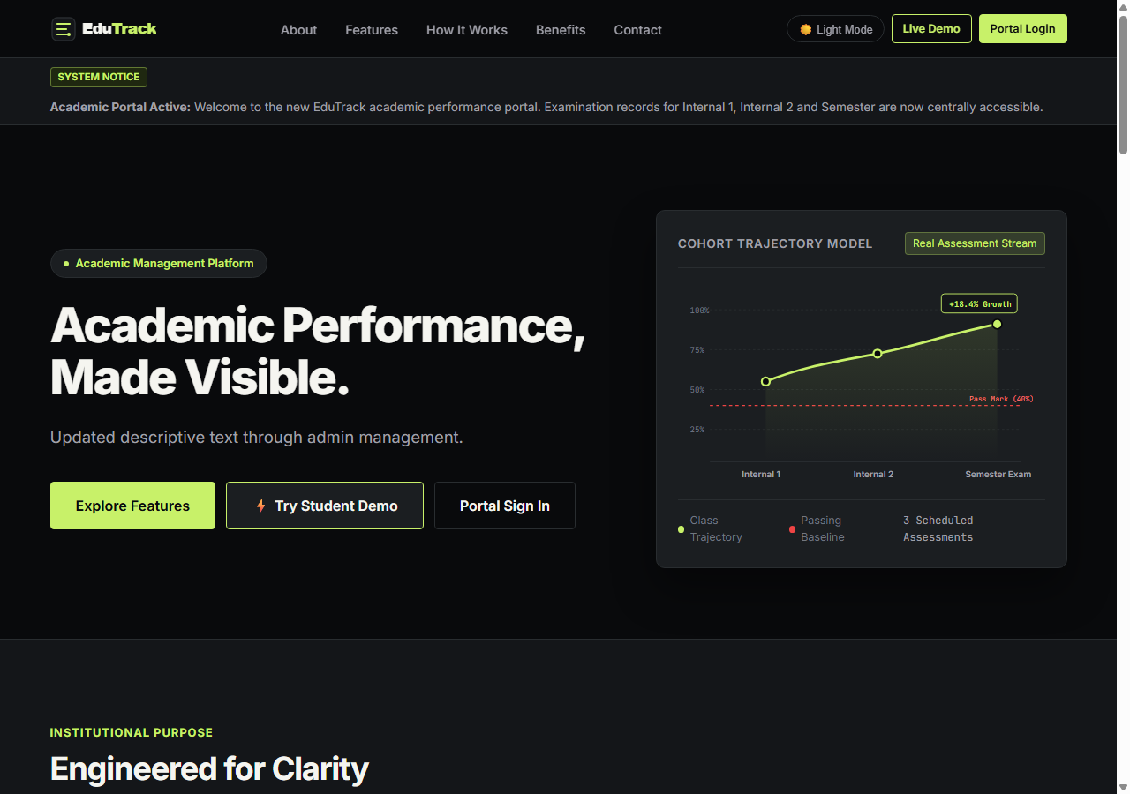
Figure 1: EduTrack Presentation Tier - Public Portal & Interactive Cohort Data Graphic

5. Database Design & Entity Relationship
The database schema is structured in Third Normal Form (3NF) to eliminate data redundancy and prevent update anomalies. Foreign keys link students, teachers, and evaluations directly to users, with cascade deletion on student profiles and strict restriction on course records.
Entity / Table | Primary Key | Foreign Keys | Key Fields & Constraints
users | user_id | None | username (UNIQUE), email (UNIQUE), password_hash, role (admin/teacher/student), is_active
students | student_id | user_id -> users | roll_no (UNIQUE), full_name, email, section, batch_year
teachers | teacher_id | user_id -> users | employee_id (UNIQUE), full_name, email, department, designation
subjects | subject_id | None | subject_code (UNIQUE), subject_name, max_marks (100), pass_marks (40), is_active
examinations | exam_id | None | exam_code (UNIQUE), exam_name, exam_type (internal_1/internal_2/semester), default_max_marks (50/100)
teacher_assignments | assignment_id | teacher_id, subject_id | UNIQUE KEY (teacher_id, subject_id, section)
marks | mark_id | student_id, subject_id, exam_id | marks_obtained, max_marks, pass_marks, remarks, UNIQUE(student, subject, exam)
website_settings | setting_key | None | setting_value, category (general, appearance, content)
announcements | announcement_id | None | title, content, badge_text, priority, is_active
audit_logs | log_id | user_id -> users | username, role, action, target_type, target_id, details, ip_address, created_at

6. Roles and Access Control Matrix
Portal Feature / Action | Administrator | Teacher / Faculty | Student | Public Visitor
View Landing Page & Features | Yes | Yes | Yes | Yes
Toggle Light / Dark Theme | Yes | Yes | Yes | Yes
Access Interactive Student Demo | Yes | Yes | Yes | Yes
Manage Faculty & Assign Courses | Yes | No | No | No
Enroll / Edit Students | Yes | No | No | No
Configure Subjects & Exam Limits | Yes | No | No | No
Enter / Edit Assessment Marks | Yes (Overview) | Yes (Assigned) | No | No
Export Section Marks to Excel | Yes | Yes | No | No
View Personal Scores & Transcripts | Via Student ID | Section Cohort | Personal Only | Dummy Demo Only
Print Mohan Babu Univ Transcript | Yes | Yes | Personal Only | Demo Profile
Inspect Audit Logs & Enquiries | Yes | No | No | No

7. Getting Started: Public Landing Page and Demo
The public landing page introduces academic evaluators to the platform. It features smooth navigation to About, Features, Curriculum Methodology, Benefits, and Institutional Contact. The top navbar includes a Light/Dark Mode toggle and an instant 'Live Demo' button.
Figure 2: EduTrack Homepage Hero Section with Theme Switcher and Live Demo Access
The Login Screen is fortified with CSRF tokens and rate limiting. To facilitate external review without credential confusion, a one-click 'Launch Instant Student Demo' button connects visitors safely to the isolated demo student.
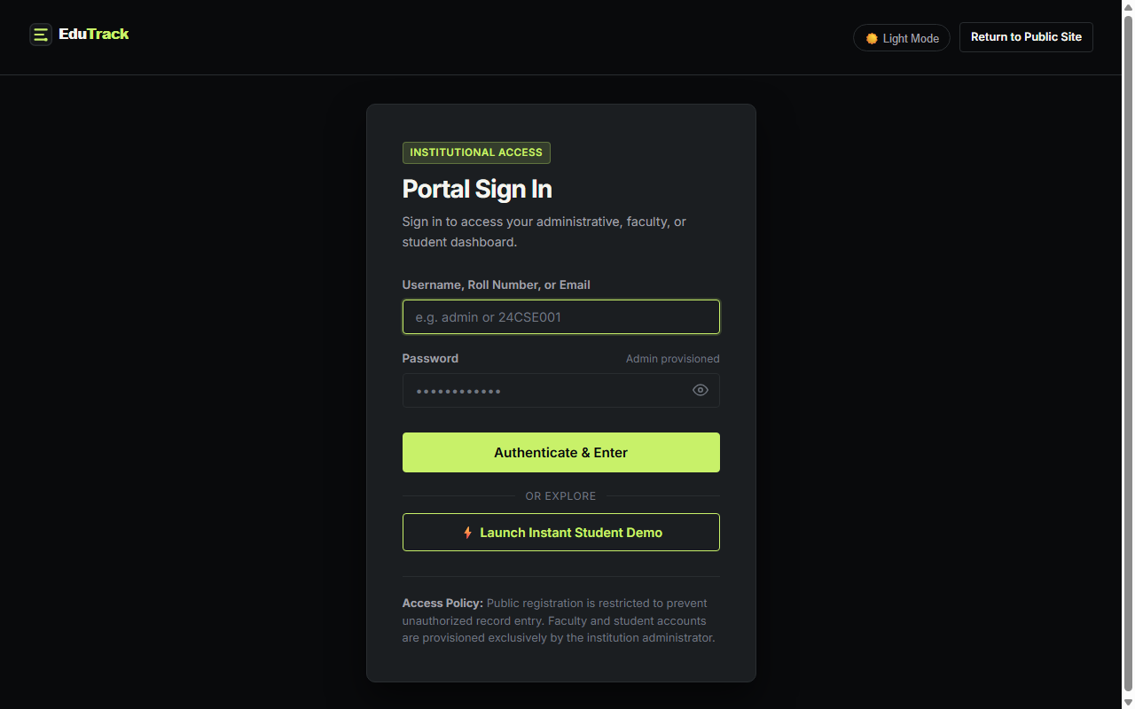
Figure 3: Secure Portal Authentication Screen with Password Visibility and Demo Launch

8. Administrator Module
The administrator acts as the primary institutional controller. From the Admin Dashboard, the administrator oversees institutional headcount, recent system audit trails, active announcements, and navigation to every administrative subsystem.
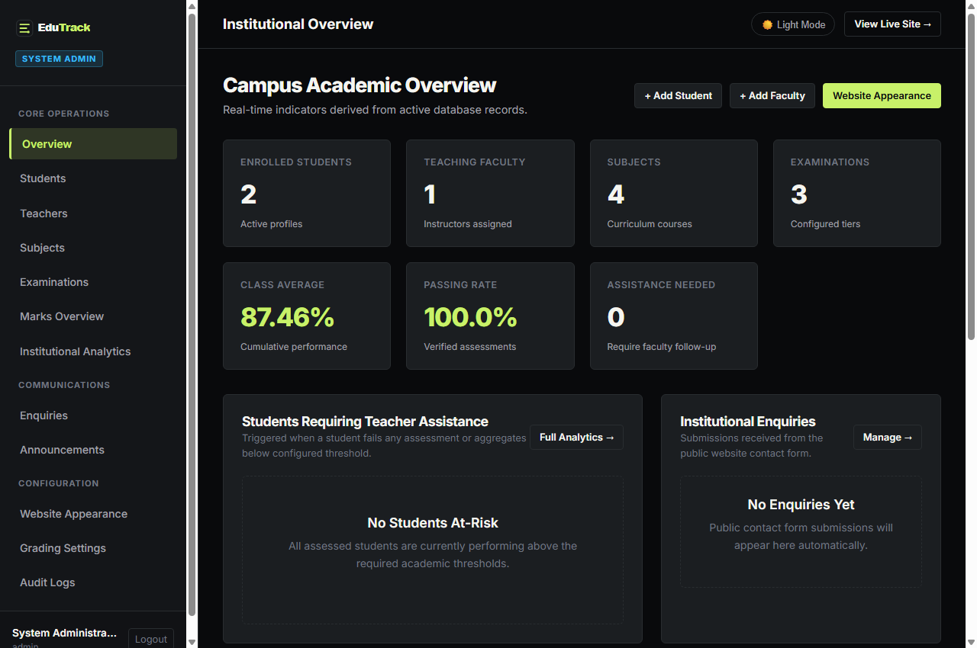
Figure 4: Institutional Overview Dashboard for System Administrators

8.1 Student Enrollment
Administrators enroll students with auto-provisioned login accounts. Roll numbers are strictly enforced as unique identifiers.
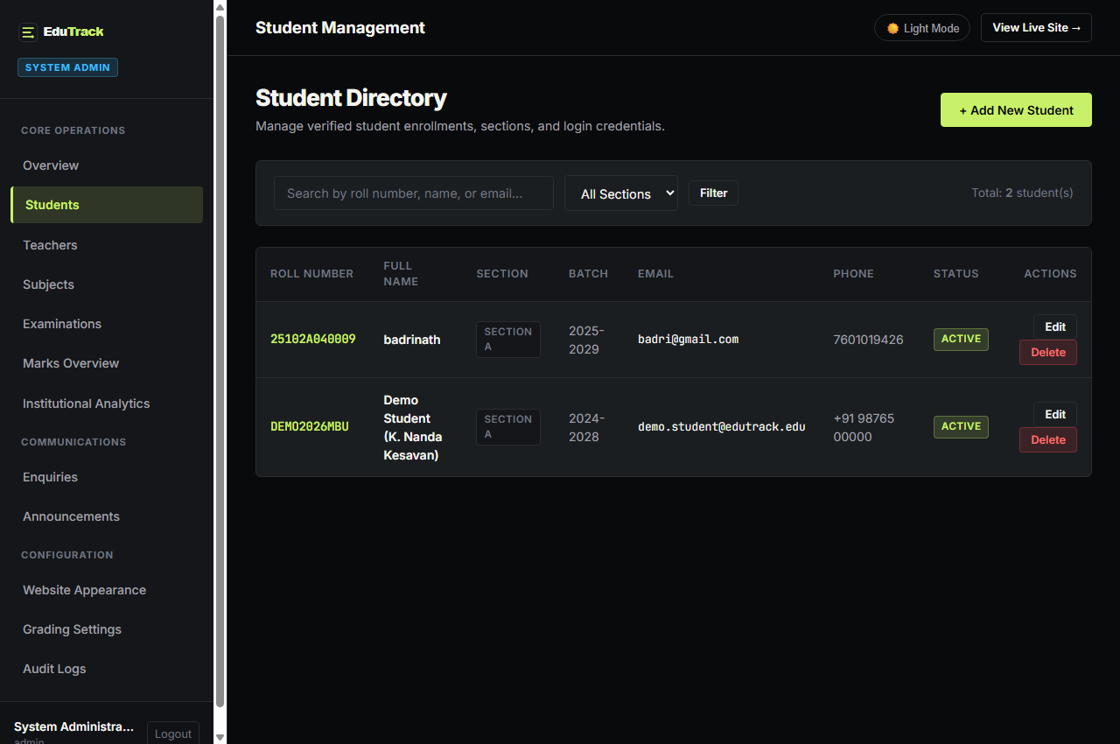
Figure 5: Enrolled Student Registry with Section and User ID Identifiers

8.2 Faculty Allocation & Course Assignment
Administrators can add faculty members and immediately allocate a teaching course and target section (A, B, C, or All) in a single integrated step.
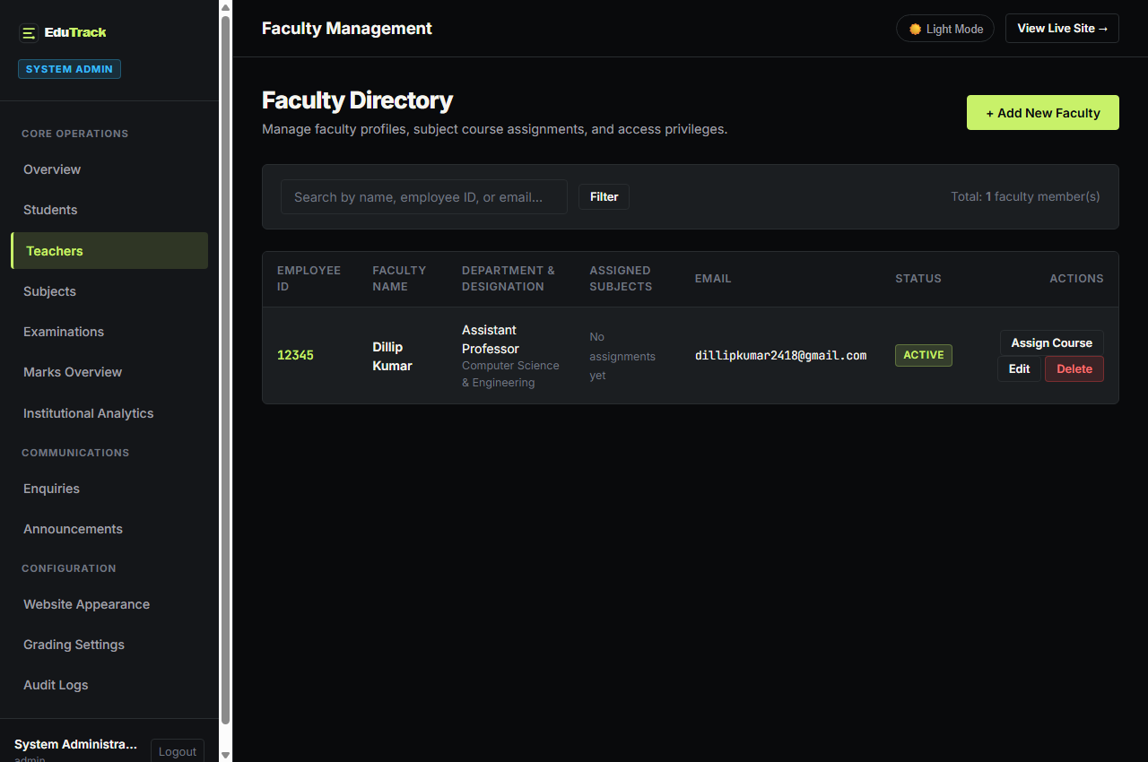
Figure 6: Faculty Management Console with Assigned Courses and Section Allocation

8.3 Examination Structure & Mark Baselines
Administrators configure examination tiers. Internal Examinations (INT1, INT2) are locked to a 50-mark maximum with a 20-mark passing baseline, while Terminal Semester Examinations are set to 100 marks with a 40-mark passing threshold.
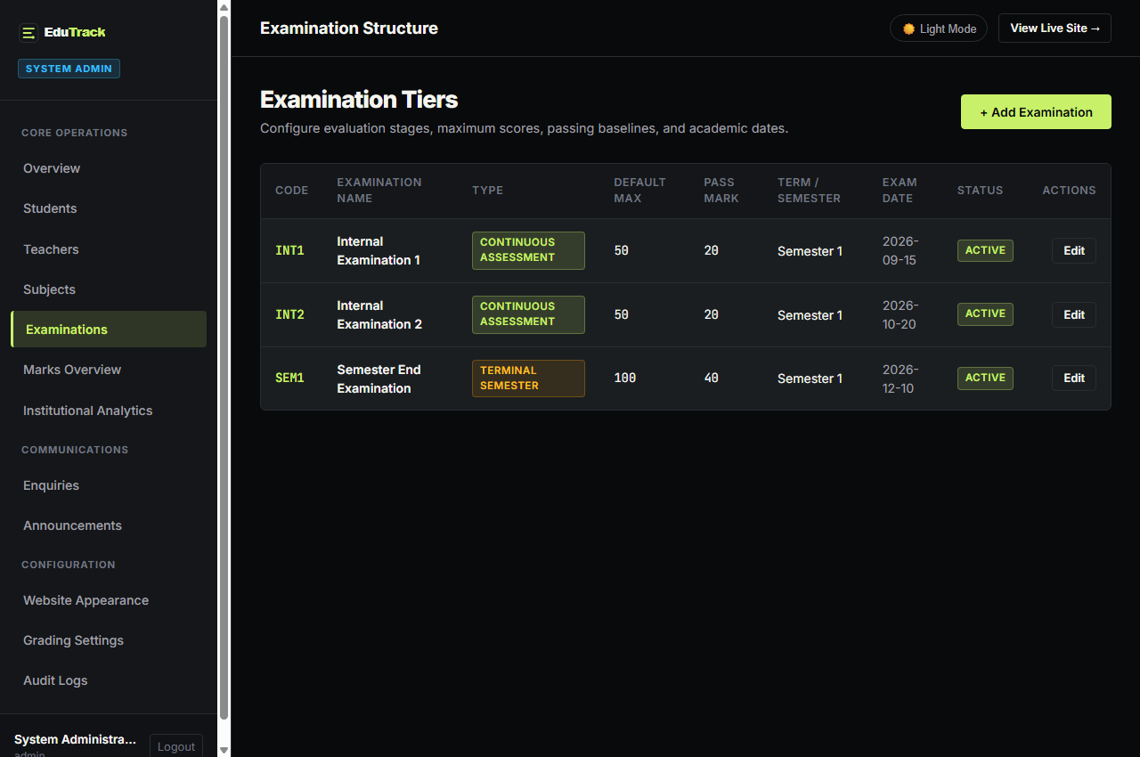
Figure 7: Examination Configuration Table with Maximum Score and Pass Baselines

8.4 Appearance & Audit Trails
Administrators can modify website headers, brand taglines, and institutional logos while reviewing security audit logs for platform compliance.
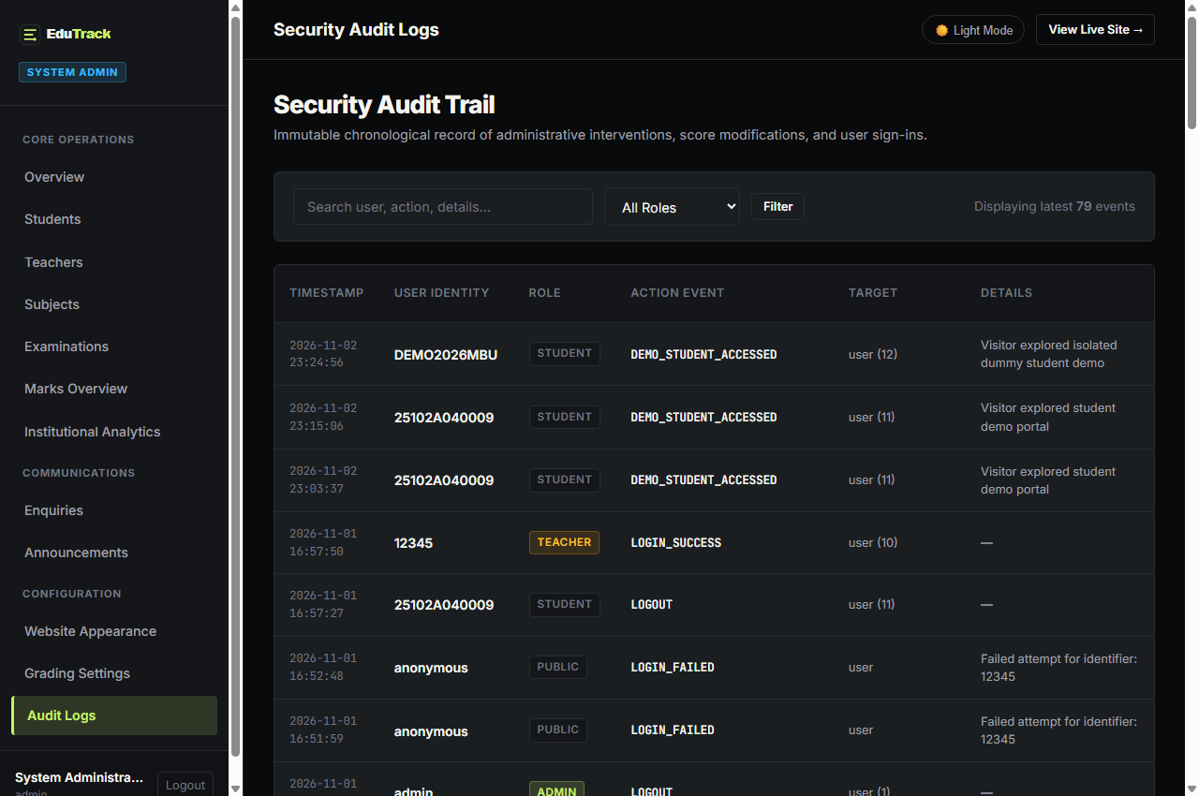
Figure 8: Administrative Security Audit Log Tracking User Actions and IP Addresses

9. Faculty / Teacher Module
Faculty members manage assessment evaluations for their designated courses. The teacher dashboard summarizes classroom performance and alerts teachers to students requiring academic counseling.
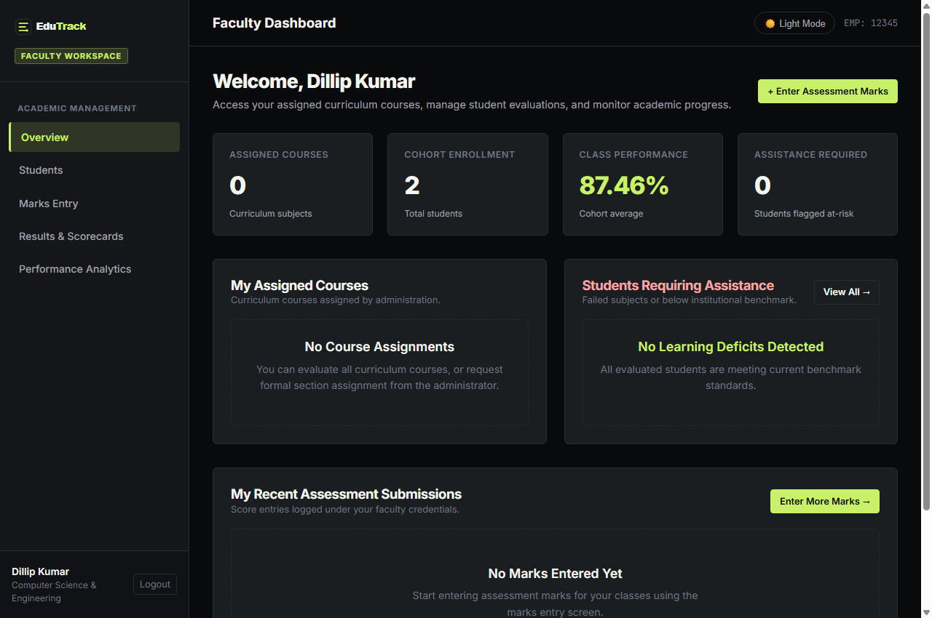
Figure 9: Faculty Dashboard Displaying Teaching Assignments and Student Alerts

9.1 Assessment Marks Entry & Validation
The Marks Entry interface allows instructors to record scores seamlessly. If an internal exam is selected, dynamic client-side scripting and backend logic enforce a maximum ceiling of 50 marks. Any score exceeding 50 is automatically clamped and rejected with an explicit error alert.
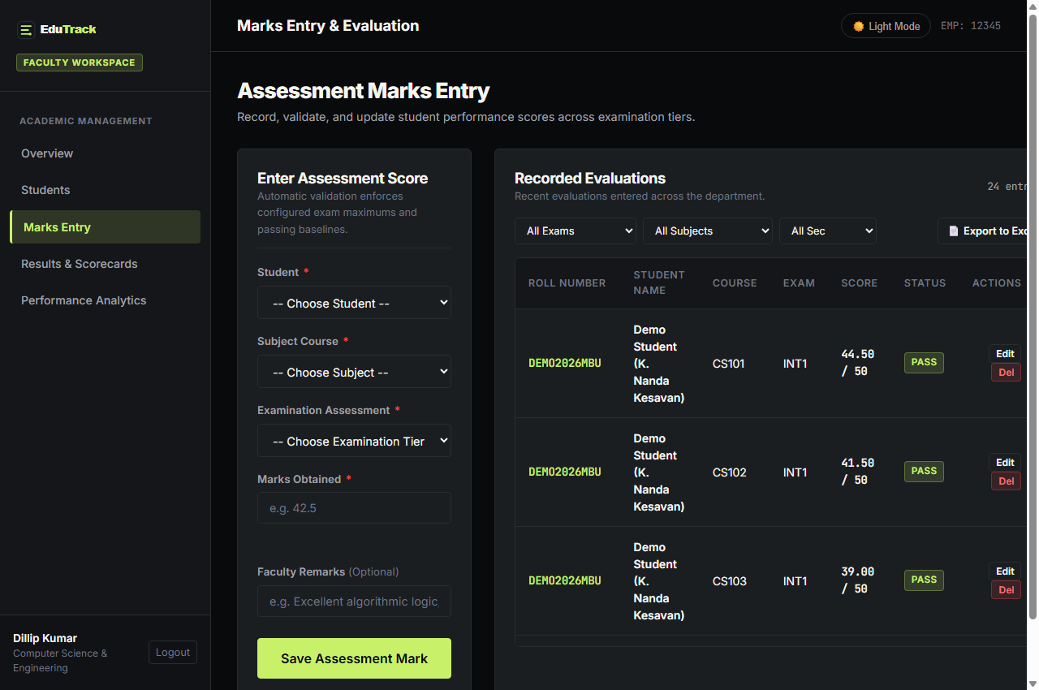
Figure 10: Marks Entry Screen with Internal Exam 50-Mark Cap Enforcement and Recent Logs

9.2 Exporting Section Marks to Excel
Teachers can filter students by section and click 'Export Section Marks (Excel)'. The system dynamically streams a UTF-8 BOM CSV spreadsheet complete with student names, roll numbers, percentages, grades, and teacher remarks.
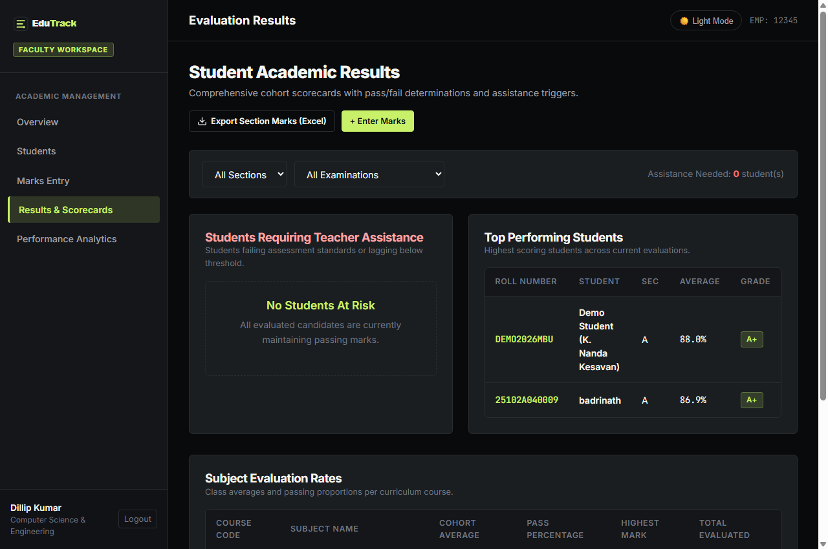
Figure 11: Classroom Cohort Evaluation Analytics with Excel Export Option

10. Student Module and Official Transcripts
Students log in with their roll number to access their personal academic scorecard. Students are strictly isolated to their own records. The dashboard highlights overall GPA, course status, and immediate breakdown across Internal 1, Internal 2, and Semester exams.
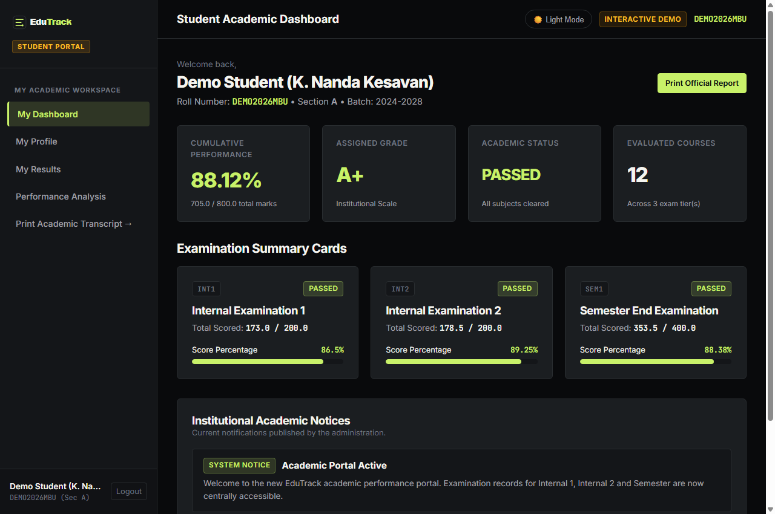
Figure 12: Student Academic Dashboard with Cumulative Performance Summary

10.1 Detailed Results & Performance Trend Analysis
Detailed scorecards display marks scored, pass marks, calculated percentage, and letter grades (O, A+, A, B, C, P, F) with subject-specific teacher remarks.
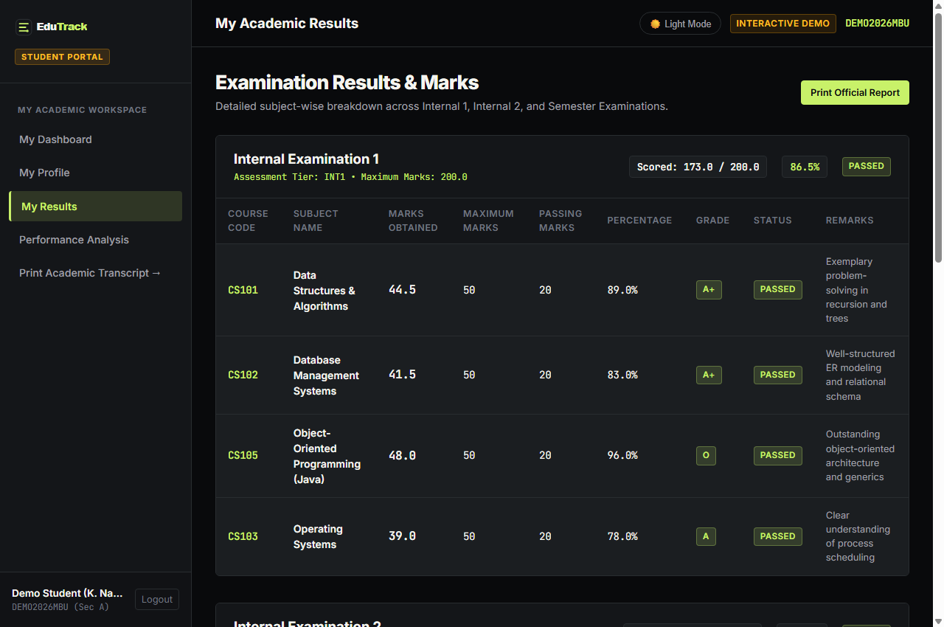
Figure 13: Detailed Subject Breakdown across Internal Assessments and Semester Exams

10.2 Official Mohan Babu University Printable Transcript
Students can generate and print their official academic transcript. The document features the prominent Mohan Babu University header, formal grade tables, institutional verification watermarks, and signature blocks for the Faculty Counselor, Head of Department, and Controller of Examinations.
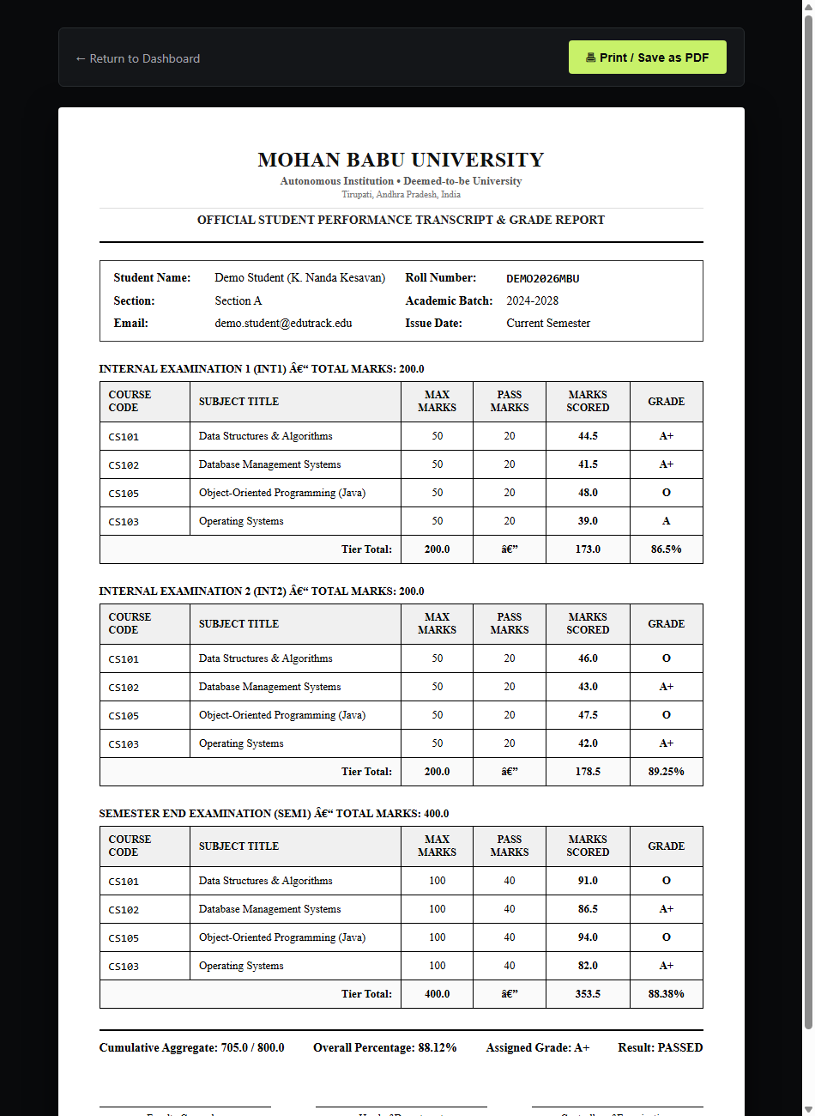
Figure 14: Official Mohan Babu University Printable Academic Transcript & Grade Report

11. Validations and Business Rules
Rule Name | Validation Logic | Enforcement Point
Internal Exam Cap | Marks obtained cannot exceed 50.0 for internal_1 and internal_2 assessments | Client-side HTML5 input constraint + Server-side Python check
Semester Exam Cap | Marks obtained cannot exceed 100.0 (or configured default_max_marks) | Client-side JS + Database constraint
Unique Enrollment | Unique constraint on student roll_no and teacher employee_id | Database UNIQUE Index + Controller pre-check
Duplicate Mark Guard | UNIQUE KEY on (student_id, subject_id, exam_id) updates existing mark rather than duplicating | MySQL Unique Constraint + UPSERT logic
Pass/Fail Threshold | Score >= pass_marks (40% default) earns 'Passed' status, otherwise 'Needs Improvement' | Pandas vector calculation + Jinja2 badge render
Rate Limiting | Maximum 5 failed login attempts per 5-minute lockout period per client IP | In-memory timestamp queue in backend/auth.py
Honeypot Bot Defense | Hidden organization fax field instantly rejects spam bot enquiries without alerting crawler | Contact form controller in backend/public.py

12. Security Architecture
- Password Protection: All passwords hashed with industry-standard Scrypt/PBKDF2 hashes; raw passwords are never persisted in plaintext.
- Session Boundary: Flask sessions are encrypted, HttpOnly, and Lax SameSite to prevent cross-site scripting (XSS) session theft.
- SQL Injection Defense: 100% of SQL queries utilize parameterized statements (%s) through the MySQL connector.
- CSRF Protection: Flask-WTF CSRF tokens are injected into every POST request and verified before controller execution.
- Student Privacy: The Live Demo feature strictly isolates public visitors to an auto-provisioned dummy student (DEMO2026MBU), ensuring real student data is never leaked.

13. Testing and Verification Matrix
Test ID | Scenario Description | Input Data | Expected Result | Status
TC-01 | Valid Admin Login | User: admin, Valid Password | Redirects to /admin/dashboard with 200 OK | PASSED
TC-02 | Invalid Password Rejection | User: admin, Password: wrong | Flashes 'Invalid credentials' error alert | PASSED
TC-03 | Internal Exam 50-Mark Cap | Exam: INT1, Score: 55 | Marks input clamped to 50; server rejects > 50 | PASSED
TC-04 | Duplicate Mark Update | Re-enter marks for same student/exam | Existing record updated smoothly without crashing | PASSED
TC-05 | Section Marks Excel Export | Click 'Export to Excel' in Sec A | Downloads formatted CSV spreadsheet with UTF-8 BOM | PASSED
TC-06 | Student Demo Privacy | Click '⚡ Try Student Demo' | Opens isolated DEMO2026MBU profile; real data hidden | PASSED
TC-07 | Dark / Light Mode Toggle | Click Theme Toggle Button | Switches data-theme attribute and saves to localStorage | PASSED
TC-08 | Mohan Babu Univ Transcript | Open /student/report | Displays MBU header and formal verification layout | PASSED

14. Conclusion
EduTrack successfully digitizes the collegiate academic performance lifecycle. By combining role-based access control, strict examination validation (50-mark internal ceiling), live data visualizations, Excel exporting, Mohan Babu University printable transcripts, and dual light/dark themes, the system provides faculty and students with an intuitive, reliable, and privacy-focused academic management experience.

