**JRAC Installation Guide**

1.Install Python 3.7

2.Create Virtualenv

* Navigate to C:
  + cd C:
* Create a new directory in which to store your virtual environments
  + mkdir virtualenvs
* Navigate to the newly created virtualenvs directory:
  + cd virtualenvs
* Create a new virtual environment
  + python -m venv jrac
* Activate virtual environment
  + Open CMD as a Admin and navigate to scripts folder in jrac then run activate.bat file
* Upgrade Pip
  + python -m pip install --upgrade pip
* Install packages which we noted in the requirements file()
  + Pip install -r requirementstoinstall.txt

3. Install Postgresql 12.0

* Create Database as JRAC
* Schema as jra

4.Check IIS as installed or not

* If not, install IIS refer below link and go to IIS installation (<https://www.mattwoodward.com/2016/07/23/running-a-django-application-on-windows-server-2012-with-iis/>)

5.Open IIS Manager

* Right click on Sites and add new website

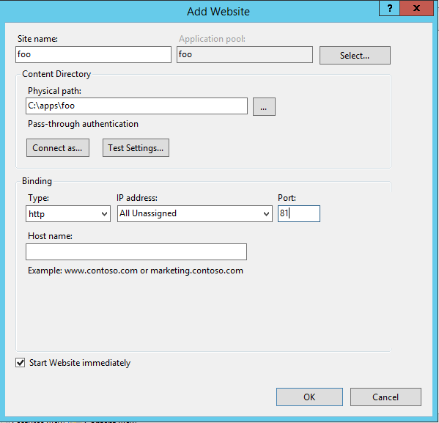

* For the site name enter JRAC
* For the physical path, type the following: folder path
* Enter port 8989 (user defined )
* Click ok.
* Double click on JRAC under sites
* Click on handler mapping
* On the right, under “Actions,” click “Add Module Mapping”
* In the “Request path” box enter an asterisk: *
* select “FastCgi Module”
  + Make sure to select **FastCgi Module**, *NOT* CgiModule
* In the “Executable” box, enter the following:
* C:virtualenvs\jrac\Scripts\python.exe|C:virtualenvs\jrac\Lib\site-packages\wfastcgi.py
* In the “Name” box, enter Django Handler

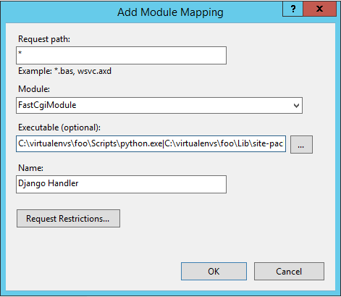

* Click the “Request Restrictions” button and uncheck the “Invoke handler only if request is mapped to:” checkbox
* Click “OK” to close the Request Restrictions dialog
* Click “OK” to close the Add Module Mapping dialog
* Click yes in popup box
* Click on IIS Home (stating INBLR…etc)
* Click on FastCGIsettings
* Double click on Fullpath which is related to us With the Add FastCGI Application dialog box still open, under the “General” section, click on the “Environment Variables” line, then click the gray “…” button that appears next to (Collection) on the right-hand side of the line. This opens the EnvironmentVariables Collection Editor dialog.
* In the EnvironmentVariables Collection Editor dialog, click “Add”
* In the “Name properties” section on the right, click the input box to the right of “Name,” remove the “Name” text that is already in the input box, and enter DJANGO_SETTINGS_MODULE
* Click the input box to the right of “Value” and enter jra.settings
* Click “Add” again and enter the following
  + Name: PYTHONPATH
  + Value: Project path
* Click “Add” again and enter the following:
  + Name: WSGI_HANDLER
  + Value: django.core.wsgi.get_wsgi_application()
* Like below image

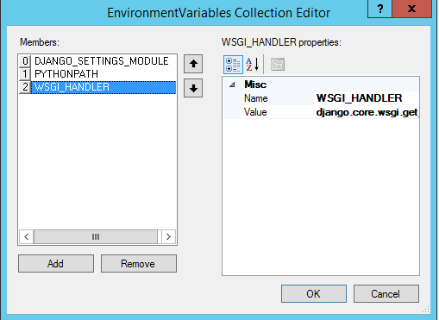

* Open a Command Prompt as Admin
* Activate the application’s virtual environment(If you are closed the previous CMD )
* Navigate to the application’s root directory:
* cd D:\JRA
* Run Django’s collectstatic management command:
  + python manage.py collectstatic
* Django will then tell you the directory into which it’s going to copy the static files, and ask you to confirm since this process overwrites any existing files in the directory. Type yes at this prompt and press Enter.
* The static files will then be copied to the directory indicated bythe STATIC_ROOT setting.
* Add a static Virtual Directory to the IIS Web Site
* Right click on website And Add virtual directory
* In the Add Virtual Directory dialog, enter the following values:
  + Alias: Static
  + Physical path:D:\JRA\jra\static

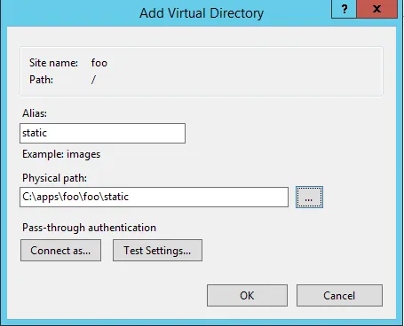

* Click “OK.” You’ll see the static virtual directory appear under the web site.
* Double click on static under website
* Click on “view order list” on right side under Actions
* You’ll now see a list of the handler mappings in the order in which they’re run, with the Django Handler at the top.
* Click on the StaticFile handler at the bottom of the list, then click “Move Up” under “Actions” on the right-hand side.
* Continue to click “Move Up” until the StaticFile handler is at the top of the list of Handler Mappings.
* Restart the server node then navigate url like:
  + <http://localhost:8989>

6. Load Initial Data

* Open CMD with admin
* Navigate to root project folder
* Crate data tables (migrate tables)
  + Python manage.py makemigrations
  + Python manage.py migrate
* Change data in fixtures/initial_data.json as per your jmeter and Java location
* Load data
  + python manage.py loaddata fixtures/initial_data.json