**Advanced Databases – DT354/2**

**Dillon Rochford – C17509063**

**The Ritter Hotel**

The Ritter Hotel is a four-star hotel and restaurant that has recently opened in the city of Dublin. It has a number of hotel rooms including 5 single rooms, 5 twin-single rooms, 10 double rooms, 5 twin-double rooms and 5 king rooms. The single rooms can only take one person, the twin-single, double and king rooms take 2 and the twin-double rooms take up to 4 people. The restaurant can serve up to 50 customers and can take bookings of up to 10 people if there is space available that day.

The hotel room per nightly rates are: 50 euro – single room, 80 euro – twin single room, 90 euro – double room, 150 euro – twin double room, 100 euro – king room. Hotel guests can order food and drinks to their rooms using their room phones and will be brought up by one of the hotel servants. The charge will be added to their bill when they check out. Hotel rooms can be booked either online or by phone. The customer must leave their name, phone number, address, email, room they want and number of nights they are staying.

Likewise, tables can be booked online or by phone and requires a name, phone number, size of group, date of booking and time. A hotel guest can also make a booking in the restaurant by giving the same details.

**Entity Relationship Diagram**

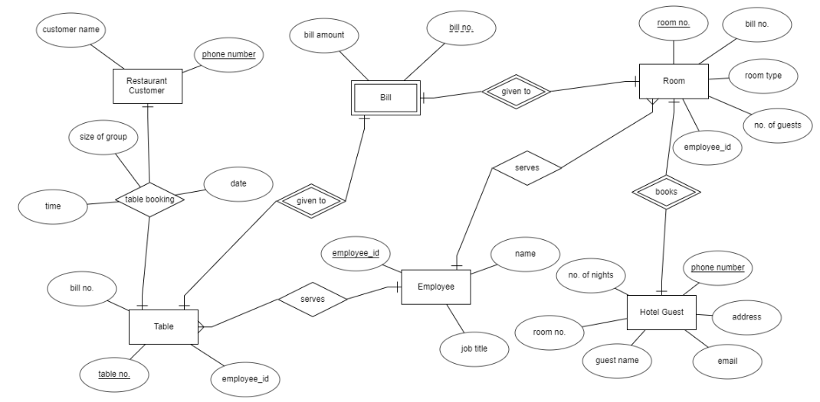

**Relational Model**

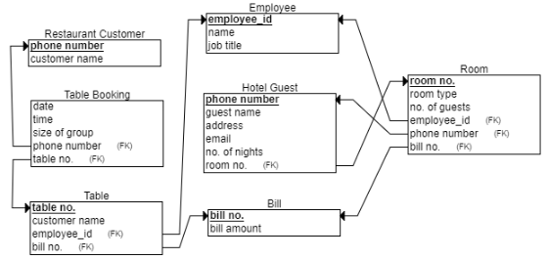

**SQL Scripts**

CurrentDb.Execute ("CREATE TABLE RestaurantCustomer(phoneNumber Long PRIMARY KEY, customerName Text)"

sql = " CREATE TABLE Employee(employeeID Counter PRIMARY KEY, " + _

" name Text, " + _

" jobTitle Text) "

CurrentDb.Execute (sql)

sql = " CREATE TABLE Bill(billNo Short PRIMARY KEY, " + _

" amount Currency ) "

CurrentDb.Execute (sql)

sql = " CREATE TABLE RestaurantTable(tableNo Short PRIMARY KEY, " + _

" employeeID Counter REFERENCES Employee(employeeID), " + _

" billNo Short REFERENCES Bill(billNo)) "

CurrentDb.Execute (sql)

sql = " CREATE TABLE Room(roomNo Short PRIMARY KEY, " + _

" billNo Short REFERENCES Bill(billNo), " + _

" roomType Text, " + _

" noOfGuests Short, " + _

" employeeID Counter REFERENCES Employee(employeeID)) "

CurrentDb.Execute (sql)

sql = " CREATE TABLE HotelGuest( phoneNumber Long PRIMARY KEY," + _

" name Text, " + _

" address Text, " + _

" email Text, " + _

" roomNo Short REFERENCES Room(roomNo), " + _

" noOfNights Short) "

CurrentDb.Execute (sql)

sql = " CREATE TABLE TableBooking( bookDate DateTime, " + _

" bookTime DateTime, " + _

" sizeOfGroup Short, " + _

" phoneNumber Long REFERENCES RestaurantCustomer(phoneNumber), " + _

" tableNo Short REFERENCES RestaurantTable(tableNo) ) "

CurrentDb.Execute (sql)

CurrentDb.Execute ("INSERT INTO RestaurantCustomer VALUES('0871234567', 'Mary Robbins') ")

CurrentDb.Execute ("INSERT INTO RestaurantCustomer VALUES('0862468912', 'Ryan Bader') ")

CurrentDb.Execute ("INSERT INTO RestaurantCustomer VALUES('0851198367', 'Luke Thompson')")

CurrentDb.Execute ("INSERT INTO Employee VALUES('1', 'Brian Rodgers', 'Hotel Servant') ")

CurrentDb.Execute ("INSERT INTO Employee VALUES('2', 'Dylan Conlon', 'Waiter') ")

CurrentDb.Execute ("INSERT INTO Employee VALUES('3', 'Rebecca West', 'Hotel Servant') ")

CurrentDb.Execute ("INSERT INTO Employee VALUES('4', 'David Flynn', 'Hotel Servant') ")

CurrentDb.Execute ("INSERT INTO Employee VALUES('5', 'Hayley Connolly', 'Waiter') ")

CurrentDb.Execute ("INSERT INTO Bill VALUES('1', '250') ")

CurrentDb.Execute ("INSERT INTO Bill VALUES('2', '300') ")

CurrentDb.Execute ("INSERT INTO Bill VALUES('3', '125') ")

CurrentDb.Execute ("INSERT INTO Bill VALUES('4', '276') ")

CurrentDb.Execute ("INSERT INTO Bill VALUES('5', '342') ")

CurrentDb.Execute ("INSERT INTO Bill VALUES('6', '400') ")

CurrentDb.Execute ("INSERT INTO RestaurantTable VALUES('1', '2', '1') ")

CurrentDb.Execute ("INSERT INTO RestaurantTable VALUES('2', '5', '2') ")

CurrentDb.Execute ("INSERT INTO RestaurantTable VALUES('3', '2', '3') ")

CurrentDb.Execute ("INSERT INTO Room VALUES('1', '4', 'Single', '1', '3') ")

CurrentDb.Execute ("INSERT INTO Room VALUES('2', '5', 'Double', '2', '1') ")

CurrentDb.Execute ("INSERT INTO Room VALUES('3', '6', 'Twin Double', '4', '4') ")

CurrentDb.Execute ("INSERT INTO HotelGuest VALUES('0852345552', 'Daniel Cole', '123 Street', 'dan@email', '1', '2') ")

CurrentDb.Execute ("INSERT INTO HotelGuest VALUES('0873452152', 'Bran Stark', '456 Street', 'bran@email', '2', '3') ")

CurrentDb.Execute ("INSERT INTO HotelGuest VALUES('0862345512', 'Steven Muldoon', '789 Street', 'steve@email', '3', '1') ")

CurrentDb.Execute ("INSERT INTO TableBooking VALUES('05/04/2019', '19:45:00', '2', '0871234567', '1') ")

CurrentDb.Execute ("INSERT INTO TableBooking VALUES('05/04/2019', '18:30:00', '4', '0862468912', '2') ")

CurrentDb.Execute ("INSERT INTO TableBooking VALUES('06/04/2019', '20:15:00', '8', '0851198367', '3') ")