Bobcat C.L.A.W.S.

College Lifestyle Affordable Wares Search

An Online Price Grabber for Students

Group Members: Abigail De Rousselle, Dillon Hughes, Dustin Bruce, Garrett Dipalma, Jawad Abu-Gabal, Jess Stevenson, Kevin Garcia, Rayyan Khan, & Rebekah Hardsand

Rewritten 9/21/23

Contents:

1. Background
2. Definitions
3. Scope and Boundaries
   1. Proposed Scope Expansion
4. Requirements
   1. Website
   2. Database
   3. Server
5. Schedule
6. High-Level designs

1. Background

It’s no secret that going to college is expensive, from rising tuition costs and book prices to transportation and necessities. Our team has designed a product to help students with high cost items that they will need throughout their college career. Price comparison for high cost items such as laptops and graphing calculators is a very limited and arduous process including locating, having multiple websites open and some students go as far as to create spreadsheets to try and keep track of all the different stores and prices. Our solution is to create a website to store the various data and help students compare items and price to find the one best suited for their needs. The C.L.A.W.S. website is designed specifically for Texas State University students to compare prices and products in the various stores around San Marcos.

Our goal is to help students make the most informed decision by allowing students to compare reviews, specs, prices, and sales all in one contained location. As Texas State students ourselves we have noticed and been concerned about the rising prices of the tools we need to be successful. We believe that our tool will not only save current students money but also help new students identify products that they will potentially need as they enter college.

2. Definitions

Our server will be using Node.js to host our website built with Angular. We will feature two ways to search for a product, by category or through a search bar. All results can be filtered and sorted to make finding the right product easier for the user. When displaying products that the user may be interested in an overview of the product’s details will be available. When the user chooses a particular product a new page opens giving the user more details, the stores it is available at, the corresponding prices and any known sales. Other product details include name, UPC, a product description, product specific specifications, reviews, images, and manufacturer details. Currently we are focused on gathering information from larger chain stores in the San Marcos area such as Walmart and Target as well as the campus bookstore. We will be using a third party software, Parasehub, to gather the data from their websites and store it in a MYSQL database.

3. Scope and Boundaries

The scope of this project encompasses the development and deployment of a targeted product search and information website. The target of this product search application is college students in San Marcos, TX. The primary objective is to provide these students with an efficient and user-friendly platform for finding products they will need for participation in college studies, including detailed product descriptions, pricing, and relevant discounts. The website will feature two main search methods: category-based navigation and a versatile search bar, ensuring that users can access the desired information seamlessly. The products we have defined as “core” are as follows: Electronics, Appliances, Furniture. Furthermore, users will have the ability to filter and sort search results to refine their product selection. The project will involve the creation of a user interface, backend functionality for data retrieval and storage, integration with external data sources, and the implementation of a secure and responsive website.

This project aims to provide a robust product information platform but we must also acknowledge a boundary and end to our scope. We have decided not to develop a dedicated mobile platform but will instead ensure a responsive and accessible mobile site. We also acknowledge the possibility of not being able access certain data or real-time pricing due to the constraints of the sellers. And finally we have decided against developing an e-commerce system opting instead for redirecting to the external retailer. We felt that attempting an e-commerce may place undue burden not only on ourselves but a potential cost increase for our users.

3.1. Proposed Scope Expansion

The initial scope of our project is focused on delivering core functionality for product search, information, and comparison, however we have identified a few features that we believe would benefit students. These features remain as open possibilities depending on time and access constraints. We would like to include coupon integration possibly through an API from a coupon aggregation site such as Shopkick or coupon.com. We have also considered featuring real-time availability when available to help students who may need their items immediately. Finally we are also considering integration with local businesses to not only help students find the best deals but also to bolster the visibility of these smaller stores. As the project progresses and user feedback is gathered, we remain open to the possibility of integrating these features in subsequent phases. This flexibility allows us to prioritize delivering a working and user-friendly platform initially and then evaluate the feasibility and demand for additional functionalities, ensuring that the project can evolve to meet evolving user needs and market demands.

4. Requirements

These requirements are what we have found to be necessary for the initial completion of our project, encompassing both the needs of the user and for functionality.

4.1. Website

For the user requirements we have decided to focus our target audience on San Marcos college students. We have also decided it is necessary for users to be able to browse through product categories and subcategories such as the electronics to laptops as well as displaying ratings and reviews for a product. We want to be able to display a list of products that match the user's search or a selected category and allow users to sort products based on brand, price, and rating. We are going to provide a detailed view of a selected product and allow users to add products to a comparison list for evaluation. We want to provide a user-friendly interface that provides a list of related products based on user browsing. Finally we want to implement accessibility features for screen readers and keyboard navigation as well as a feedback mechanism for users to report issues.

Our functional requirements include the ability to find products based on price, reviews, and specs. We are also including a search bar and filter functions. We are also implementing a many to many comparison and a one to one comparison for products. For site visibility it should be viewable on laptops, desktop, and mobile maintaining an easy to navigate interface without spending too much time looking around the page. The front-end may also need to handle any issue of unavailable data and maintain a sense of consistency. To meet these requirements we will be using Angular and the related Angular Material and Mobile Angular UI alongside Bootstrap. We will also be using Angular routing and Angular HttpClient.

We have also included some testing requirements to verify that the webpage works across popular browsers. We will also need to test responsiveness on different devices and screen sizes while checking for any rendering issues. Testing will also verify that UI components and features work as expected and evaluate the friendliness of the UI. Testing will also encompass various scenarios and usability issues such as confusing navigation. Testing needs to ensure that error messages are clear, informative and user friendly.

4.2. Database

The database is in charge of storing and organizing the data that is scraped or pulled from API’s. The database must also connect with the server and flow seamlessly to the website. We will be using MySQL as the management and base and will therefore be using SQL queries to give data to the website and Node.js to communicate with the server. Our structure involves using tables for category, subcategories, product, store, and store_location. The Category and Sub_Category tables will be used to assist in the labeling and filtering of the different products. Store and Store_Location will contain the details of the different stores such as name, location, and address. Our main table is the Product table which will hold all of the available data for a product including name, description, images and links.

4.3. Server

The server will be doing most of the heavy lifting for the project including the data scraping and formatting programs as well as hosting the website itself. The main requirements of the scrapper will be to pull product and store information as previously identified and store that data into a JSON file for the data parser. We also expect that the scrapper will work mostly autonomously after initial set up. The data parser will take and re-format the JSON file to normalize the information so that it may easily transfer to the database. Identical products will also be matched inside the parser to help standardize the data shown on the web page. We will be using python, parseHub, and selenium for these programs. The server itself, Provided by Texas State, will be using Node.js and the node package manager to help facilitate communication between the website and the database to best match with the javascript based Angular.

5. Schedule

Our schedule is broken into 3 distinct sections: the build, the prototype, and deployment. We aim to finish the main build by October 12, when we produce a status report. This 6-week section will utilize one week stints, the first 3 focused on groundwork such as installs, webpage framework, and getting the scraper started. The last 3 weeks are used to combine and test the various elements and work on any issues. The prototype section will end on November 9th, on which we will present the prototype, and will be worked on in 2-week sprints to handle any delays from the first section and implement any scope expansions. The last 3 weeks will be focused on deployment, any final bugs, and stress testing our final product which will be deployed on November 30th.

6. High-Level Designs

These images show some of our preliminary designs for various elements of the project.

Sequence Diagram

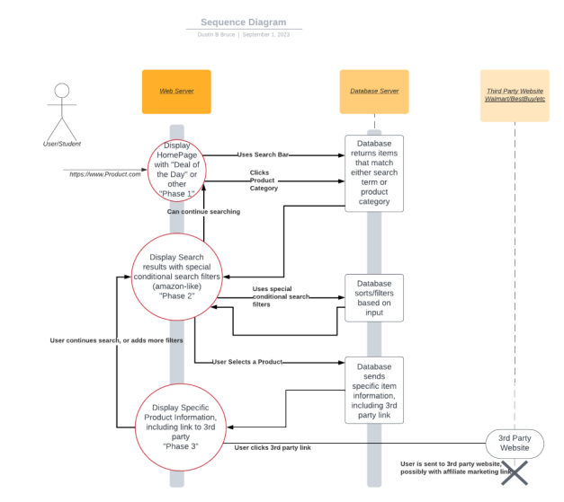

Front End Wireframes

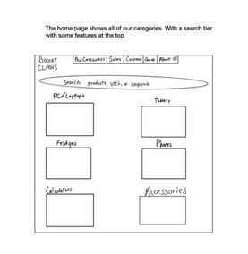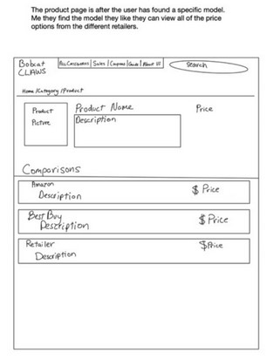

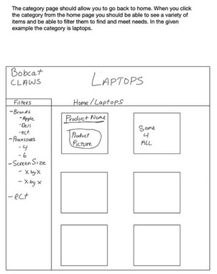

Database Design

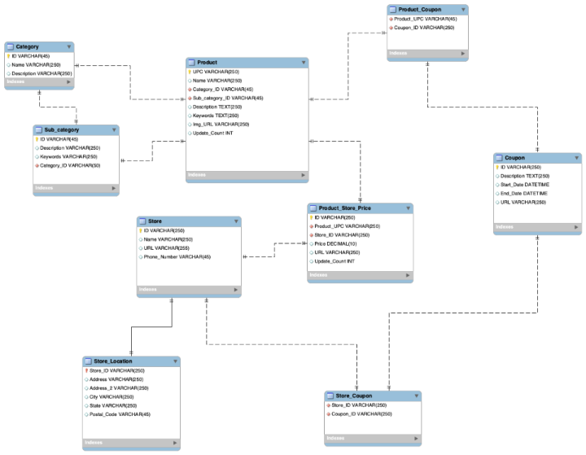

Web Scraping

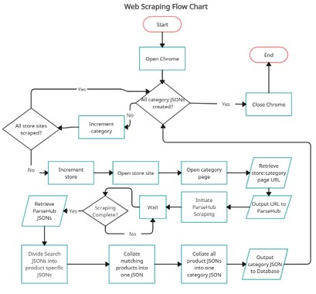

Server Design

