Advanced Telecoms

Assignment 2

Social Media Application D-Book

Patrick Dillon Ryan

17340382



Introduction

The goal of this assignment was to create a social media application. It had to be capable of allowing users to sign in and go into a chatroom where they could talk to people. The chat had to also be encrypted.

Implementation

I decided to build this project in React. I split it into a frontend and backend. The backend was implemented using a node js server. The backend handled the sockets and server/client connection.

The react frontend made it easy to make the app easy to use and made it appealing. The login was handled using Gmail.

I used some public libraries along the way to help, they were

* Bootstrap
* CryptoJs

Encryption

I decided to use AES to encrypt my chat as I felt it was one that could be easy enough to implement. It is a symmetric block cipher that can be used to encrypt and decrypt electronic data. It is one of the most widely used encryption algorithms. It is encrypted and decrypted using a public key.

UML Flow Chart

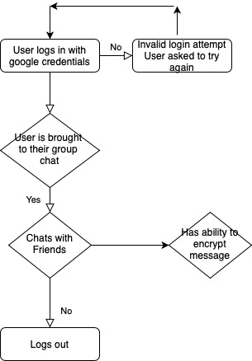

Code

The full working code can be seen in full on my Github. The link to which is here

<https://github.com/DillonRyan/AdvancedTelecoms>

A working demo of the code can be seen by clicking the link below

(If there is a problem viewing the video please let me know [ryanp30@tcd.ie](mailto:ryanp30@tcd.ie))

[patrickdillonryan-finalpresentation.mov](https://drive.google.com/file/d/14jCjhd3JYnuQDGerb67VY3jGdgc07EPc/view?usp=sharing)