Class Kit Vending Machine Conceptual Design

Nidhay Patel

Department of Electrical and Computer Engineering

*Tennessee Technological University Cookeville, United States of America* [*npatel45@tntech.edu*](mailto:npatel45@tntech.edu)

Austin Sigg

Department of Electrical and Computer Engineering

*Tennessee Technological University Cookeville, United States of America* [*aesigg42@tntech.edu*](mailto:aesigg42@tntech.edu)

Dillon Williams Department of Electrical and Computer

Engineering

*Tennessee Technological University Cookeville, United States of America* [*dswilliams42@tntech.edu*](mailto:dswilliams42@tntech.edu)

Ryan Reed

Department of Electrical and Computer Engineering

*Tennessee Technological University Cookeville, United States of America* [*rcreed42@tntech.edu*](mailto:rcreed42@tntech.edu)

Michel Turpeau Department of Electrical and Computer

Engineering

*Tennessee Technological University Cookeville, United States of America* [*mmturpeau42@tntech.edu*](mailto:mmturpeau42@tntech.edu)

1. Introduction

Around fifty devices a day are needed by students each year for their ECE (Electrical and Computer Engineering) courses. The main emphasis of this capstone project is the design and implementation of a vending machine that can loan out devices to students while keeping track of which students have taken the devices. A student can enter their information into the machine, and it will keep track of who has borrowed each device(s). Students will be able to view and choose which gadget to remove with the help of an LED (Light Emitting Diode) equipped drawer system. The purpose of this step in the design process is to complete the following: detail what subsystems must be in place in order for the vending machine to run, how these subsystems will interact with each other, and finally, what constraints each subsystem will have imposed on it and how each constraint can be tested.

1. The machine shall be no taller than the average window height, which is around 2 to 4 feet, and no smaller than 2 feet in height. This allows for easy portability from the office to the student lounge at Brown Hall and vice versa. It should impact the customers and allow the office associates to be able to transport the machine where it is needed. 2. The machine will use ethernet to send data to our customers and be encrypted to avoid others from accessing the students’ information.

3. A Microcomputer shall be used to manage the data acquisition system and allow the proper function of the machine. An SQL (structured query language) database will be programmed into the Microcomputer to hold the student ID (identification) number, name, email, course, and which board has been rented, as required by the customer. 4. The boxes the devices are held inside must be uniquely identifiable according to the department, so each box shall be scanned into the database before a device is taken. This is to prevent the theft of a device by any student and allows the customer to know which is taken. 5. For the same reason, the machine shall have a card reader to ID every student. This way no student can fake the number, even if other information was incorrect.

6. For the entire machine to function after a reset and to remember information for the customer, the machine shall have a form of nonvolatile memory such as MicroSD or an actual separate drive. 7. The machine shall have a series of LED (light emitting diode) indicators so the student knows which drawer and compartment to access when

retrieving the board. 8. Solenoid Locks shall be installed into the drawers and compartments so no single person can easily break through to the devices when the machine is unsupervised. The current plan is for a drawer and compartment to hold for several minutes to allow enough time for a worker to notice the attempt.

The following subsections provide detail on each of the previous requirements and how each shall be completed according to the customer.

1. Background

A question that may arise from the conceptual design is: why use a PLC and a Microcomputer in the vending machine? One reason that a PLC is being considered is due to a PLC being cycle-based. When discussing execution schemes, there are two that can be used: event-driven execution and cycle-based execution. In an event-driven scheme, like a microcomputer, “a run-to-completion step is executed **each time an event is raised**,” while in a cycle-based scheme, like a PLC, “a run-to-completion step is **executed periodically** in regular time intervals,” [1]. The reason this needs to be addressed and specified is to show how a PLC can be useful in our design. Being event-driven, a microcomputer will wait to scan until an input is sent to it. On the other hand, a PLC will constantly check all inputs and sensors on a certain time cycle. It’s important to have a cycle-based execution for the hardware components, such as locks and component sensors, because they are the main security measure against stealing the devices. There is a chance that if this scanning is done by the microcomputer, it could execute at the end of a long command, such as a “for” loop. If this is the case, the hardware scanning could happen minutes after the request was sent. Whereas if a PLC was used, the hardware could be monitored every scan cycle, for example every 200ms. This makes PLCs more reliable in relation to securing the devices and monitoring hardware.

**\*\*\*\*\*\* Mick will discuss why we need to use Ethernet and how we will secure the data\*\*\*\*\*\***

1. Ethical Considerations

During the process of designing this vending machine, every scenario that can occur must be taken into consideration. The vending machine will be plugged into the wall for its power supply. The supply voltage will be 120VAC before it’s sent through the AC/DC converter. It must be certain that the voltage is properly stepped down and converted to DC. The desired voltage is roughly 5V DC; given that “30 volts is generally considered to be a conservative threshold value for dangerous voltage,” a person could be severely injured in the event of incorrect conversion [4]. To counteract this, there will be a system in place to detect if there’s a spike in voltage or current in the AC/DC converter and trip the power supply. This system will most likely be a ground-fault circuit interrupter (GFCI). Having this within the power cord for the vending machine will comply with the National Electric Code (NEC) standard NEC 422.51, which requires vending machines that are powered by cord-and-plug to have a GFCI located near the wall plug [5].

In addition, security must be put in place to prevent student data from being compromised. One security measure is connecting the vending machine’s database to the ECE office’s computer by ethernet. This is because “An Ethernet connection is much more secure than a Wi-Fi connection.

Data on an Ethernet network can only be accessed by physically attaching a device to the network, while data on a Wi-Fi network travel[s] through the air and can be more easily intercepted,” [6]. An Ethernet connection will make it more difficult to steal student information compared to a

Wi-Fi connection since data can only be stolen by attaching a device to either the vending machine or the ECE office’s computers. In using Ethernet as a form of communication, the connection must follow the Institute of Electrical and Electronics Engineers (IEEE) standard IEEE 802.3-2018, which gives a selection of speeds at which an Ethernet connection must work [7].

To work with the Ethernet connection, a form of encryption will be used on the student information before it’s sent out. One option for this is using a cipher of some sort. A cipher is a phrase or string of words that information is shifted by in the alphabet. This will make the received information look jumbled, though it will be deciphered upon retrieval.

Finally, a scenario that must be considered is stealing a device from the vending machine. Given the chance

that the faculty in the ECE office may step out of the office

for a few minutes, there is a chance that someone could attempt to break into the vending machine to steal the devices within. To help prevent this, the vending machine will have locks on both the drawers and the lids of each device. There will also be a sensor system in place to detect if a box is in its compartment. While this will be mainly used for the SQL database, it can be given the purpose of detecting if a device is removed without approval.

1. Block Diagram
2. *Constraints*

The following is the list of constraints that will be imposed on our subsystems:

* + 1. Microcomputer System
       1. The microcomputer will contain a database that is programmed with SQL and another language such as C++ or Java.
    2. PLC
       1. The PLC will interface with the locks and LEDs
       2. The PLC will control the step voltage to the motors.
       3. The PLC will communicate with the microcomputer.
       4. The PLC will receive signals from the sensors in each drawer.
       5. The PLC will have a timer system.
    3. Communication
       1. The machine will have a USB port to transfer information between itself and the drive.
       2. The machine will send a .CSV file to the faculty computer
       3. The machine will have a barcode scanner to send the board number to the microcomputer
       4. The machine will use a card reader to read information off of an Eagle Card and use as a unique ID.
       5. The machine will have a user interface involving a touchscreen to enter certain student information (such as name, email, etc).
    4. Power System
       1. The power system will have a ground fault current interrupter (GFCI) to protect against current surge.
       2. The power system will have an AC/DC converter to send power to the voltage-sensitive components.
       3. The power system will have an emergency stop control.

1. *Raspberry Pi*

To meet the requirement of a Microcomputer to hold the data of the system, a Raspberry Pi will be included to support a database for student information and allow transmission to the customer. A Raspberry Pi is a small computer that can communicate with any input and output gear, such as a monitor, a computer, a mouse, or a keyboard, turning the setup into a packed PC at a reasonable price.

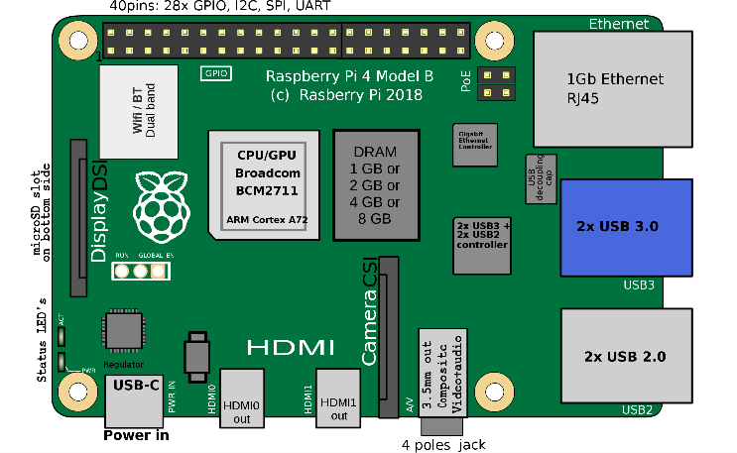

*Figure 1: Layout of Raspberry Pi 4 Model B [8]*

The main characteristics of this product include a powerful 64-bit quad-core processor, dual-display support at resolutions up to 4K via two micro-HDMI (High-Definition Multimedia Interface) ports, hardware video decoding at up to 4Kp60, a maximum of 8GB of RAM (Random Access Memory), dual-band 2.4/5.0 GHz wireless LAN (Local Area Network), Bluetooth 5.0, Gigabit Ethernet, USB 3.0, and PoE (Power over Ethernet) capability (via a separate PoE HAT add-on) [9].

The Raspberry Pi will be mainly used for the following functions:

1. *SQL Database*
   1. *Inventory*

The database will be used to keep a record of the inventory inside the machine and will be able to tell the customer whether a device is loaded or unloaded from a sensor in the PLC system. If loaded, the system will check whether the box is scanned in by the barcode scanner. If unloaded, the system will check whether the box is not scanned. All information will then be recorded and saved in the inventory section of the database.

* 1. Student Information

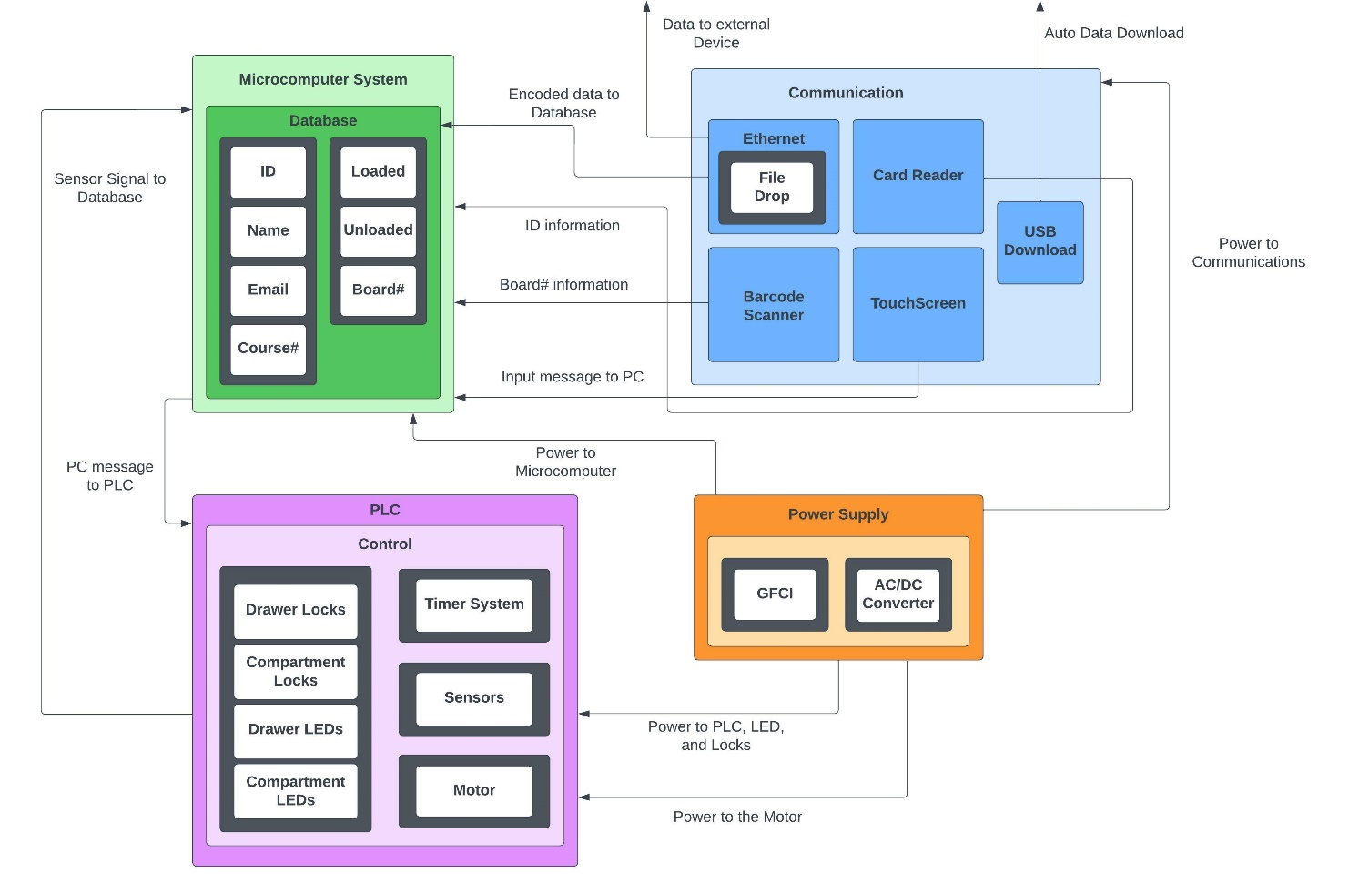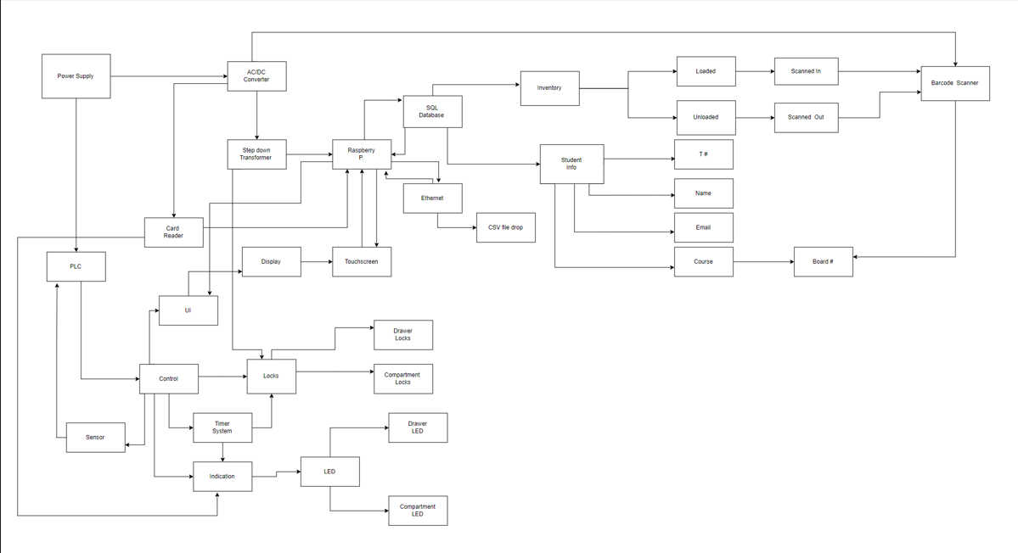

*Figure 2: Block Diagram*

The database will also be used to keep a record of the students who have rented devices for classes and will also be able to send the data to the customer through Ethernet. Under the student portion of the database, the T number will be recorded from the card reader connected to the Microcomputer. The name and email of the student will be taken in by a user interface. A course section will then be chosen from a list of courses held by the database. Once a board is chosen, the barcode will be read by the scanner and logged for use by the customer.

1. *Ethernet*
   1. *File Drop*

The ethernet cord shall be used to send and receive data to and from the customer. If the customer wants to see the database and who has taken items, they can request the file and it will be transmitted. The file will likely be a CSV from Excel that will feed from and to the database. The ethernet cable can be directly connected to the Pi and user PC using an ethernet connector which uses an RJ45 connector, and with the right steps of static IP configuration, one can start transferring data from the Pi.

Input: Encoded message to the database Output: Message signal to the connected device

1. *UI (User Interface)*

The user interface will be connected to the Microcomputer and will allow the user to input their name, email, and which class(s) he or she needs a device for. The information is also relayed through the PLC system.

* 1. *LCD (Liquid Crystal Display)*

For the student to select the needed board an LCD would be used through which student would input their name, and email address, and after verifying the information they will choose the needed board with the help of a touch screen LCD. The needed LCD would most likely be from the same company as our Microcomputer i.e., Raspberry Pi as it would be most compatible. An adapter board that converts power and signal is used to connect the 800 by 480 monitor. There are just two connections needed to the Pi: a ribbon cable connecting to the DSI connector included on every Raspberry Pi, and power coming from the GPIO port. The most recent Raspbian OS will have touchscreen drivers so that users can operate their devices completely without a hardware keyboard or mouse and with 10-finger touch capability and an on-screen keyboard [10].

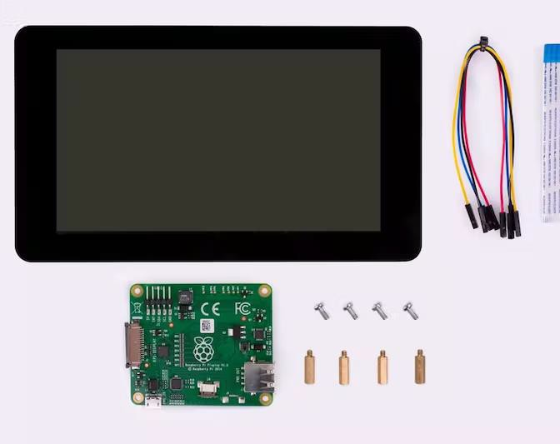

*Figure 3: LCD Screen with Connector and MCU [11]*

Input: Message Signal to Raspberry Pi Output: Raspberry Pi signaling to PLC

1. *Card Reader*

The card reader shall receive a signal from an ID card issued to the student by the college. When the signal is received, the device will send the data to the database through the Microcomputer. The Reader will have an indicator light for a correctly scanned card to notify the student that he/she is good to proceed.

Input: Information from Eagle Card

Output: Create Data and signal to Raspberry Pi

1. *PLC*

To give the vending machine’s hardware reactive functionality, a PLC will be implemented along with its necessary sensors.

* 1. *Control System*
     1. *User Interface (UI)*

The PLC will control the hardware behind the UI used for students to check out their boards. The UI will allow students to enter their names and email. The UI will also interact with our microcomputer to send the student’s information to the database. The functionality will be tested by entering a generic name along with a team member’s email. Once this is done, the database will be checked for the entered information.

Input: Powered by the Microcomputer, controlled by the PLC. The student’s name and email will be entered.

Output: Student information to the Microcomputer to send to the database.

* + 1. *Locks*

The locking system will be solenoid coils energized by the PLC. The PLC will run the student’s course number and board needed through comparison functions to find where it is equal to a board number that isn’t checked out. Once it finds equality, the corresponding locks will become un-energized so the student can grab the board. The functionality will be tested by running a test line in the PLC to see if a lock’s tag correctly updates.

Input: Powered by the vending machine, energized by the PLC.

Output: Locking and unlocking the drawers and compartments containing the devices.

* + - 1. *Drawer Locks*

The first line of defense for the stored objects is the locks for the drawers. Since these are easily accessible, they will require stronger locks than internal locks. They will have to resist forceful entry and external interference. These locks will return to standby (closed) after the item has been removed and the drawer is shut.

* + - 1. *Compartment Locks*

These locks prevent the opening of the separate compartments inside the drawer. Since they are harder to access and in a more compact environment, the locks will not be as strong as the ones holding the drawers shut. These locks will return to standby (closed) after the item has been removed and the compartment is closed.

* + 1. *Indicator*

The vending machine will have an indication system to guide the student to the correct drawer and compartment. When the PLC finds the correct board needed by the student, it will run the board’s tag through compare commands until it finds the corresponding indicator tags. Once the tags are found, they will be energized and un-energized on a timed system.

Input: Voltage from the machine, energized from PLC, set to flash at a certain interval with a timer system.

Output: Drawer and compartment indicators will flash to show where the device is located.

* + - 1. *LEDs*

To assist the user in identifying the location of their required device, there will be LED indicators on both the drawers and

separate compartments. There is a total of 1 LED for each drawer, and 1 LED for each compartment inside of the drawer. When the user is given the location of their rented device, the LED will blink on the drawer that has been unlocked, as will the LED of the specified compartment. LEDs will return to standby after the item has been removed and the drawer has been shut.

* + 1. *Timer System*

The PLC will run the timer system used in tandem with the lock and indication systems. This system will be used to hold the solenoid coils as unlocked for a reasonable duration for the student to grab their device (roughly 15-20 seconds). Once the time has elapsed, the coils will become energized and will lock once the drawer and compartment are closed. The timer system will also set the period of flashing for the indication system. Once the time for the coils has elapsed, the indicators will also stop flashing.

Input: Total duration from PLC, tag update from PLC.

Output: Solenoid coils will be unlocked for a given duration. During this duration, the indicators will flash to show where the device is located.

* + 1. *Sensors*

We need sensors to see which compartments have a device in them to see whether they need to be restocked if empty or to be distributed if there is a device. If there are no sensors then the machine would not know which compartment has a device or not. There are several options as to what kind of sensors we could use, but we are mainly considering two of them.

The first sensor we are considering is a visual Photo Eye light sensor. This sensor emits an infrared signal and captures the signal if reflected. If a device is in between the Photo Eye and the mirror across from it then the Photo Eye will send a signal that the compartment has a device in it. The second option we have considered is using a scale to measure the weight of the bottom of the compartment. If the scale measures no weight, then it will send a signal that there is no device in that compartment.

The biggest factor in which sensor we will choose is the price; Whichever way for sensing is cheaper is probably the route we will take. One possible problem is that the Photo Eye sensors might take up too much room in the compartments. Also, the scales could be impractical if

they need to be recalibrated after being implemented from some extraneous circumstance like if the vending machine is moved.

1. *Power Supply*

A power cord will come from the wall outlet to hook up to the vending machine. This will supply power to the PLC, if it takes AC, and to the AC/DC Converter

*a) AC/DC Converter*

For the Raspberry Pi Microcomputer to be powered the incoming power must be converted to DC and then stepped down with a step-down transformer. The Card Reader and Barcode must be powered with DC as well; whether the voltage needs to be stepped down or not is tentative as of now. Also, the AC/DC converter will convert the power from the supply to power the drawer and compartment solenoid locks to disable.

1. *Barcode Scanner*

To register the individual devices to the machine and properly keep track of the current owner of the device, a barcode scanner will be installed. When loading the devices, the user will first have to scan their barcode, registering them to the indicated compartment. This will tie the device’s ID to the compartment’s location. The next board cannot be loaded until the previous one has been registered and locked. This will allow the database to then tie the rented device to the student, allowing us to keep track of its possession.

Input: ID of the device.

Output: Registering the location of said device.

1. TIMELINE

The attached Gantt chart displays the task to be completed over the course of the project. Each phase contains the label of the tasks, the time allocated, the persons assigned, and the dependencies of another task. Phase 1 is comprised of the design process. Phase 2, pre-construction, is the time between approval and the holiday break. This will be used as the prep time before our official construction phase, completing the work needed to be completed before working on the final product.

Phase 3, the construction phase, is when most of the work will be done and is separated into 3 sub-sections: Programming, Integration, and Physical Build. The programming will be primarily handled by Dillon Williams and Nidhay Patel, while the integration will be overseen by Austin Sigg, Ryan Reed, and Michel Turpeau. The final construction phase will be a collaboration between the ECE team and the ME team.

Phase 4, finalization, will primarily be testing and adjustments, ending with the delivery of the final product.

(The chart is attached on page 6)

1. References
2. “Event-driven vs. cycle-based execution,” *itemis*. [Online] Available: https://www.itemis.com/en/yakindu/state-machine/documentation/user-guide/quick_ref_execution_semantics#quick_ref_execution_semantics. [Accessed: 25-Oct-2022].
3. S. G. Sakshi, “What is SQL & How Does It Work? A guide to structured query language,” *Springboard Blog*, 12-Oct-2022. [Online]. Available: https://[www.springboard.com/blog/data-analytics/what-](http://www.springboard.com/blog/data-analytics/what-) is-sql/. [Accessed: 14-Oct-2022].
4. “Microcomputer,” *Encyclopædia Britannica*. [Online]. Available: https://[www.britannica.com/technology/microcomputer.](http://www.britannica.com/technology/microcomputer) [Accessed: 14-Oct-2022].
5. T. R. Kuphaldt and J. Haughery, “Electrical safety,” *Applied Industrial Electricity*, 01-Jun-2020. [Online]. Available: https://iastate.pressbooks.pub/electriccircuits/chapter/ch apter- 1/#:~:text=In%20industry%2C%2030%20volts%20is,re sistance%20for%20protection%20against%20shock. [Accessed: 14-Oct-2022].
6. ElectricalLicenseRenewal.com, “422.51 vending machines.,” *ElectricalLicenseRenewal.com*. [Online]. Available: https://[www.electricallicenserenewal.com/Electrical-](http://www.electricallicenserenewal.com/Electrical-) Continuing-Education-Courses/NEC- Content.php?sectionID=134.0. [Accessed: 14-Oct- 2022].
7. S. Enterprise, “What is the difference between a WIFI and ethernet connection?,” *Spectrum Enterprise*, 23- Mar-2019. [Online]. Available: https://enterprise.spectrum.com/support/faq/network/wh at-is-the-difference-between-wifi-and-ethernet- connection.html#:~:text=An%20Ethernet%20connectio n%20is%20much,can%20be%20more%20easily%20int ercepted. [Accessed: 14-Oct-2022].
8. “IEEE SA - IEEE Standard for Management Information Base (MIB) definitions for ethernet,” *IEEE Standards Association*. [Online]. Available: https://standards.ieee.org/ieee/802.3.1/5263/. [Accessed: 14-Oct-2022].
9. *RaspberryPi Model 4B*. [image] Available at:

<https://en.wikipedia.org/wiki/Raspberry_Pi> [Accessed 16 October 2022].

1. Raspberry Pi, “Raspberry pi 4 model B specifications,” *Raspberry Pi*. [Online]. Available: https://[www.raspberrypi.com/products/raspberry-pi-4-](http://www.raspberrypi.com/products/raspberry-pi-4-) model-b/specifications/. [Accessed: 16-Oct-2022].
2. Raspberry Pi, “Buy A raspberry pi touch display,” *Raspberry Pi*. [Online]. Available: https://[www.raspberrypi.com/products/raspberry-pi-](http://www.raspberrypi.com/products/raspberry-pi-) touch-display/. [Accessed: 16-Oct-2022].
3. n.d. *Raspberry Pi Touch Display*. [image] Available at:

<https://[www.raspberrypi.com/products/raspberry-pi-](http://www.raspberrypi.com/products/raspberry-pi-) touch-display/> [Accessed 16 October 2022].

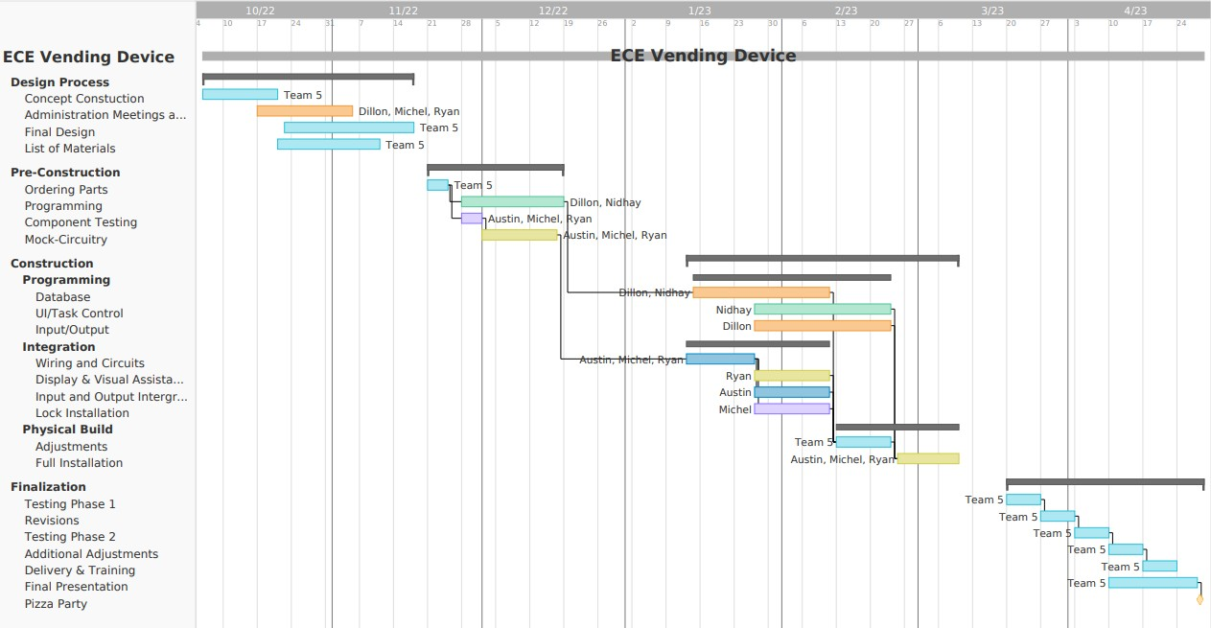*Figure G - Timeline*