Class Kit Vending Machine  
Project Proposal

Nidhay Patel   
Department of Electrical and Computer Engineering  
*Tennessee Technological University*   
*Cookeville, United States of America*  
*npatel45@tntech.edu*

Austin Sigg  
Department of Electrical and Computer Engineering  
*Tennessee Technological University*   
*Cookeville, United States of America*  
*aesigg42@tntech.edu*Dillon Williams  
Department of Electrical and Computer Engineering  
*Tennessee Technological University*   
*Cookeville, United States of America*  
*dswilliams42@tntech.edu*

Ryan Reed  
Department of Electrical and Computer Engineering  
*Tennessee Technological University  
Cookeville, United States of America*  
*rcreed42@tntech.edu*Michel Turpeau  
Department of Electrical and Computer Engineering  
*Tennessee Technological University  
Cookeville, United States of America*  
*mmturpeau42@tntech.edu*

# Introduction

Every year hundreds of students require various devices for their ECE (Electrical and Computer Engineering) classes. These specific devices are provided by the College of Engineering and are rented out to students through the ECE office. Typically, in the first month of a semester, students attempt to check out on average 50 devices in a day from the Office. This capstone project will focus on designing and implementing a vending machine that can distribute devices out to students while recording which students have checked out a device.

The finished product will be a vending machine with the functionality to vend the needed specific devices to students. A student can enter their information into the machine, and the machine will record who has checked out their respective device(s). The machine will use a drawer system that has LEDs which will allow students to see and determine which device is the one they should remove. The student will then take the device and shut the drawer for the next student.

The ECE office will benefit from having this machine because it will reduce traffic in the ECE office. It will also ease the process for the students because they will not have to fill out the paperwork. The vending machine will allow the office to view the data submitted by the students and, as a result of this new vending system, the office associates will not have to fill out paperwork on students as frequently.

The first prototype of the vending machine will have the capability to prevent boards from getting stuck, have a card reader to verify the student’s identity, have a locked drawer to enable associates to restock the machine, and have memory in the event of a fault or power loss: to remember its functionality. Also, the machine will be fitted with a method of communication for the associates to procure student information from it. Security will be implemented to prevent boards from being stolen and to protect the database.

The objective of this capstone project is to make the process of checking out required ECE course devices more efficient by utilizing a vending machine, while also recording all information given by students through a database.

# Formulating the Problem

This section will introduce the background information needed for the project. This includes the constraints of the machine, the specifications of the machine, and the standards we will be bound to while working on the project. A survey of viable solutions to the problem will also be given, so the project can be further improved in the future. (Change)

## Background

The project relies a lot on the background information of the systems in vending machines and on how these systems operate. The project will require knowledge in the areas of controls, programming, embedded, power, databases, and various others.

Vending machines are used throughout many businesses and are a source of convenience for the customers who use them. The needed maintenance on well-made vending machines is also low: saving time and money for the business [1]. A vending machine for the distribution of class kits in the ECE office would be of great convenience to students who could now come by and pick up the device that they need with ease. It would eliminate the need to fill out the paperwork in the office required to obtain a board, and it would allow the office associates to do their own work without worrying about the students. It would also save students time as they won’t have to wait for the associates to help and also wait until the associates manually type in and verify the student information.

Each typical vending machine is developed with a particular product category or vending operation in mind, whether it be for the preservation of frozen goods like ice cream, cold drinks, or carbonated beverages. Frequently, basic operations and signal connections can be set up during production. Examples include pre-set heating temperatures, pre-set mixing patterns, pre-set vending machine actuation patterns, and related processes. This isn't always the case, though; occasionally, adjustments are needed to meet demands placed on a product by its surroundings throughout the operation. A product's price or accessibility can change at any time. Also, there is access to the internal control where price changes might be made, as well as the interior of the cabinet for product filling or replacement. A hinged, locking door has typically been a feature of vending machine construction.[2] In order to provide proper access for both filling the machine and reaching the control mechanism, hinge-able doors may require side clearance, which may be limited in tiny vending spaces or locations with a high density of vending machines.

While the vending device won't be easily accessible to the public, there will still be measures taken for the security of the machine and the devices stored within. To prevent theft and damage, there will be locks in place for each of the drawers and their separate compartments. These locks will have the strength to resist forced entry and the removal of the drawer. Along with securing the separate compartments storing the components.

Unlike the standard vending machine, this requires a way to easily move from place to place. With this new ease of access comes new security risks of theft. There is a technology commonly used by large stores to prevent the theft of their shopping carts. By using a hidden wire and a wireless motor placed into the wheel of the cart, they can demobilize the cart.

Due to the specific structure of vending machines for various products, each vending machine is individually organized, arranged, and operated. Private owners with many product types and specialized vending machines for each product type may require additional training and encounter inefficiencies as a result of equipment differences. Additionally, designing and producing separate vending machines for each unique product category can be fairly expensive.

## Specifications

The class kit vending machine must follow several specifications to achieve the customers’ desired objectives. First, the machine shall have an ethernet port in order to have a secure communication channel with the office workers and to avoid security breaches of student data. Some machines that are connected to the internet are vulnerable to hacking and can sometimes cause issues with other devices [5].

The machine shall be at least 10 inches in length and width to accommodate any device the ECE department places into the machine. Next, the machine shall have an SQL (Structured Query Language) Database to retain the Eagle Card, student ID, class, and board number. As for the boards, they shall be read into the database through a barcode scanner before being taken by the students. The reason is that students cannot be fully trusted to input the device themselves without leaving beforehand. In order to direct a student to the correct device to remove, the machine shall use LED indicators that will show the drawer and section the board is stored in.

Next, the machine shall have nonvolatile memory for storing the program and data in case of power loss. On average, customers and businesses have experienced two hours of power outages per year [3], hence why the machine must remember the data and program installed. To avoid other types of theft, the machine shall have locks that are not easily broken, mainly to hold for several minutes at the least.

## Constraints

The vending machine has several constraints it must adhere to in order to meet the office associate’s desires. First, the machine shall have a barcode reader to read each individual device so students do not either forget to input the number or steal the device. For the same reason, the machine shall also have an installed card reader to scan each student’s eagle card and record the ID of that student.

The machine shall also be the average window height (around two to three feet) to be easily portable between the Brown student lounge and ECE Office as needed.

## Standards

To ensure our team can successfully and safely implement our vending machine, we must understand the standards under which the machine will have to comply. Some of the organizations that impose these standards include, but are not limited to, the Institute of Electrical and Electronics Engineers (or IEEE), and the American National Standards Institute (or ANSI).

One of the most important standards we must hold to comes from the National Electrical Code (or NEC). This standard is the NEC 422.51 and it covers the power connection for vending machines. The standard states that vending machines connected by cord-and-plug “…manufactured or remanufactured on or after January 1, 2005, shall include a ground-fault circuit interrupter [GFCI] as an integral part of the attachment plug or be located within 300 mm (12 in.) of the attachment plug,” [8]. This standard ensures the safety of personnel and equipment near the vending machine, and the vending machine itself, by breaking the power supply circuit in the event of a ground fault leakage current (or GFLC). A ground fault leakage current occurs when “part (and at times all) of the return current in the neutral conductor flows through grounding conduit and conductive parts of the building back to the service entrance,” [9]. When a GFLC occurs, it can cause electronic malfunctions, stray magnetic fields, and voltage differences between grounding points. These risks can be mitigated if we follow NEC 422.51 and include a GFCI near our vending machine’s power plug.

Another standard we much abide by is IEEE’s standard for ethernet, IEEE 802.3-2018. This standard from IEEE states that “Ethernet local area network operation is specified for selected speeds of operation from 1 Mb/s to 400 Gb/s using a common media access control (MAC) specification and management information base (MIB),” [13]. This standard will set upper and lower bounds on the speed of our ethernet communication. Typically, ethernet communication speed is around 8 Mb/s, though this is can depend on the cable quality and the traffic coming through the cable. Because the only traffic traveling through the cable would be the student’s information, and because the information would only be sent when a student checks out a device, the speed of our ethernet communication will be able to abide by IEEE 802.3-2018.

Finally, one more standard we must comply with is IEEE Policy 7.8. This is the Code of Ethics that every electrical and computer engineer must comply with in to conduct any form of professional engineering work. This code of conduct requires that all engineers “uphold to the highest standard of integrity, responsible behavior, and ethical conduct in professional activities,” and “to treat all persons fairly and with respect, to avoid harassment or discrimination, and to avoid injuring others,” [10]. While IEEE Policy 7.8 does not cover anything involving electrical work specifically, it is a crucial standard we much adhere to. Without this policy, there is no guarantee that a project will be ethical or safe for the public. This policy also helps encourage our team members to keep each other accountable for upholding good ethical behavior as we work on our capstone project.

## Survey of Possible Solutions

Because the use of vending machines is such a widespread practice in the modern-day marketplace economy, there are several potential solutions out in the market. One option is the smart vending machine; The smart vending machine would be a reasonable solution to our problem because of its convenience. A smart vending machine implements a touchscreen with digital transactions so as to become a more service-oriented machine [11]. This would help solve the issue of convenience for the ECE office and the student. In a non-smart vending machine, buttons can get jammed and lock up.

Another potential solution to our problem is an elevator vending machine. The general snack vending machines use a coil to keep their products on the shelves, and when a product is requested, the product is dropped down into the collection bin. An elevator vending machine has a platform that raises to the level of the selected product, and the product is pushed onto the platform via a conveyor belt or a gate [12]. The product is then lowered down into the collection bin rather than being dropped. This is another potential solution to our problem because we cannot drop the devices used in the labs; these kits and devices can be very fragile, and even a small fall could severely damage them.

One final solution that could be implemented is an array of lock boxes. The mechanical engineering team that we are collaborating with suggested using a series of lockboxes that could be refilled. When a student wants to check out a specific board, the door of the box with that board would be unlocked for them to take out that device. When the box becomes empty, the staff would refill it. Our team believes that this solution could work, but it would have to be refilled more frequently and would take up a considerable amount of space.

## Summarizing the Problem

The existing solutions for our problem statement do not meet the specifications that we desire--at least not each one on its own. The vending machine for the ECE office should have a customer-friendly interface, such as that of the smart vending machine. Our vending machine should also have a lift and conveyor to safely dispense the kits, similar to that of the elevator vending machine. Given our background information, specifications, and constraints, our vending machine should be able to communicate through ethernet, safely and securely dispense the kits and boards, store and protect the information entered by each student, and reliably restart when there is a power outage. No lone vending machine that is available now can fill all of these specifications, and that is why our project is important to the ECE Department.

# Looking Toward a Solution

This section of the proposal will outline how the team will start crafting a solution based on the current problem. To be able to formulate the solution, the team must determine the critical unknowns of the project. The team will attempt to measure the success of the solution and provide proof of the success through different experiments. The broader impacts, ethics, responsibilities, and scope of the class kit vending machine are considered in the proposed solution to creating the machine.

*A. Systems*

The following diagram in section C relays the proposed layout of the systems within the machine. Some of the systems will include the power, sensors, motors, MCU (Microcontroller Unit), and mechanical system. The mechanical senior design team will design the mechanical system, while the rest of the vending machine’s systems are left up for us to design. The power system will focus on the voltage level of components and the system that will be plugged into the wall. The sensor system will consist of tracking the level of the platform that will vend the devices. The MCU system will consist of the computer PCB and the system to send signals to the motors of the machine.

*B. Critical Unknowns*

The most urgent critical unknown that needs to be addressed is the use of Tennessee Tech Eagle Cards. This is due to several reasons, one of them being that we don’t know exactly what information the Eagle Cards hold.

The Eagle Cards are used with the touch scanners found around campus. Whether it’s to use a meal swipe, unlock a dorm’s entrance, or use the campus printers, the Eagle Card contains some sort of unique identification (or ID) for each student. However, we don’t know what that ID is or how to access it. We have tried using a near-field communication (or NFC) scanner on our Eagle Cards to pull information, but we learned that there is an encryption on the ID.

Because there is some sort of encryption on the Eagle Cards, and they only work on the scanners around campus, we have to ask the Eagle Card Office a few questions. One question we must ask is if we can access the information on the Eagle Cards for the vending machine’s database. If we can’t have some sort of unique ID for each student checking out a board, we cannot successfully implement the lab kit vending machine. Another question we must ask is if we can use a scanner similar to those around campus. The issue that might arise from using the scanner stems from the possibility that the scanner database is not through the school. If it’s not, we must contact the company who controls the database and scanner.

The Eagle Card is the intuitive thing to use for keeping student IDs in our vending machine’s database. But if we can’t access this information, or we can’t use the same scanners as those on campus, we will most likely not be able to implement the vending machine for the ECE department.

## C. Measurements of Success

To measure and evaluate the success of our project we have deduced several tests and evaluations to perform on our vending machine to ascertain that it meets the desired specifications.

In its ideal form, the system would be able to process the user’s inputs and dispense the requested device post-haste. To evaluate this, we will cycle the user inputs in repeatedly and check for the correct distributed item each time. We will compare the distribution speed to that of regular vending machines to make sure.

Since this device will primarily be utilized by consumers, the system must have an intuitive system. To test this, we will sample random ECE students to use our machine, and afterward, we will survey them on the simplicity of obtaining a device from it. Based on these results we will implement the feasible suggestions of these students so as to make to vending machine more intuitive.

The system must also correctly scan and store the device’s bar code information and student information. There will also be testing of the security of the data stored in the database--using "unorthodox" methods to evaluate the difficulty of breaching the system, like through attempting to hack into the system.

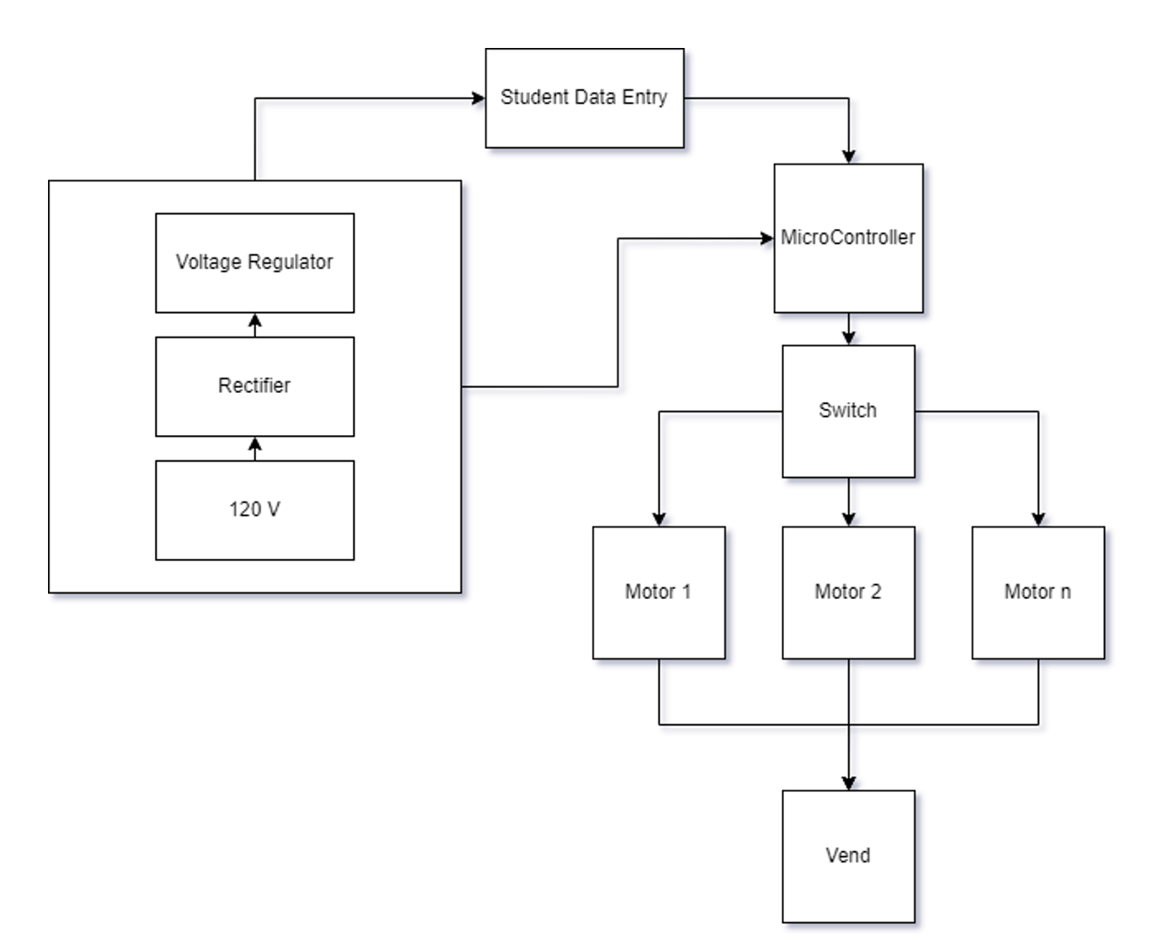

*Figure 2: Formulated Layout of Machine*

## D. Impacts, Ethics, and Responsibility

Normally with design projects, there are certain negative impacts that can arise. The vending machine will influence the jobs of those who work in the ECE department. It will ideally lighten the workload of the administrative associate at the Brown Hall front desk. Although unlikely, our design could displace workers on the Tennessee Tech campus due to the vending machine making the workload easier. The machine will allow students to get a board without interrupting the associate’s work. The only requirement from the associate is to refill the machine when it is low on stock.

The main possible negative impact associated with the vending machine is the risk of loss in assets. If the vending machine is not properly secured, there is a risk of possible theft of Tennessee Tech property.

Another concern is the safety of data held within the system on the machine. If someone were able to hack the database, students’ IDs, names, and emails would be available to steal for any malicious or immoral purpose. Proper precautions must be met to prevent the theft of personal student information.

# Resources

This section of the proposal addresses what resources are available and how they will be used throughout the design process. The team members’ skills and knowledge will be accentuated and discussed to demonstrate how the whole team is a good fit for the project. The proposed budget (Figure 3) and timeline (Figures 4 & 5) are attached below to show how the vending machine can be finished in the amount of time we have to complete the project.

## Personnel and Skills

To complete the design of the machine, our team must have the required technical knowledge. The team is not expected to be able to do the project without any further research or required skills not yet possessed, as not all knowledge will be available at the beginning, but the team is expected to be able to learn any new skills required.

In order to complete the vending machine, skills in databases, programming, power systems, PLC, controls, and microcontrollers are needed.

Dillon Williams and Nidhay Patel, both being Seniors in Computer Engineering, have skills in programming languages such as C++, C, and SQL. These skills are necessary to program the microcontroller and create the database to hold all student information, respectively. They also possess knowledge of microprocessors, which are needed to manage system communications.

Ryan Reed and Michel Turpeau are Electrical Engineering Majors with concentrations in Mechatronics. The concentrations give our team needed knowledge of automation, robotics, and controls. Their concentration and resume in various taken mechanical engineering classes provide a “bridge” between our team and the Mechanical team.

Austin Sigg is an Electrical Engineering major with knowledge of power systems and firsthand experience with wiring machines and programmable logic controllers in the workforce, likewise, Ryan Reed has experience with PLCs and ladder logic too.

With a wide variety of knowledge in programming, power, and ladder logic, our team is well suited to the creation of the vending machine, although there are areas that will require the team to acquire new skills.

## Budget

The budget for the class kit vending machine is subject to change throughout the design process. The suggested budget will function as an outline to prove that the project can be built at a reasonable cost. The project is given an error of fifteen percent in preparation for unexpected costs to set our minimum and maximum total expenditures. The budget for the possible components of the project is detailed in the figure below.

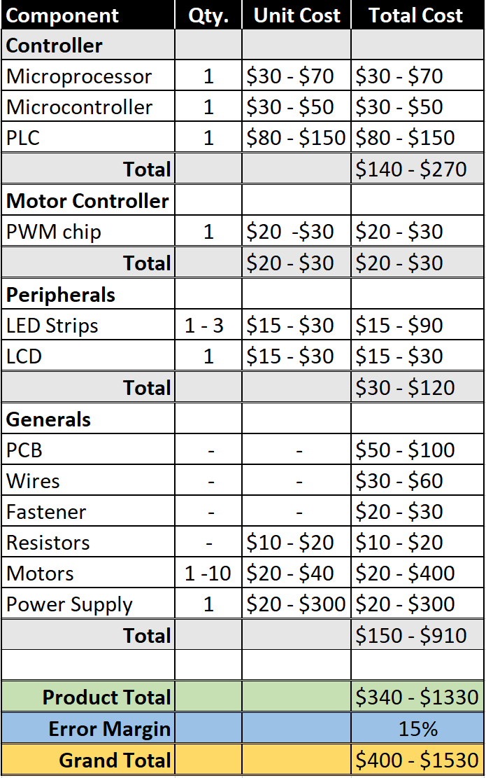

*Figure 3: Cost Breakdown*

## Timeline

The purpose of the project timeline is to lay out the deadlines for the different sections of the design process to help the team stay on track in finishing the vending machine design this semester.

*Figure 5: Tentative Schedule*

Above is the tentative outline for the project’s benchmarks and deadlines. Phase 1 is focused on formulating and discovering possible solutions, ending with our proposal for the project. Phase 2 is the designing process in which there will be research and development of the final product. Phase 3 is the construction of the final build. This is paired with Phase 4, the final testing and adjustment phase, ending with the final presentation.

# Conclusion

Vending machines are a convenient and efficient way to distribute products to meet the demand of those who require them. The purpose of this capstone project is to not only design and create an easier system for students to procure their needed class kit boards and devices, but also to lighten the load off of the employees in the ECE department. The Class Kit Vending Machine will be an efficacious solution to the problem formulated in this project proposal.

# References

1. Elisabeth, “Vending Machines have advantages,” Camelback Vending, 16-Jul-2018. [Online]. Available: https://camelbackvending.com/vending-machines-advantages/#:~:text=Vending%20machines%20are%20convenient%20and%20they%20allow%20your%20employees%20and,are%20in%20the%20right%20location. [Accessed: 23-Sep-2022].
2. https://patents.google.com/patent/US4823570A/en
3. Admin, “Why do vending machines get stuck,” *Vending Business Machine Pro Service*, 15-May-2021. [Online]. Available: https://vendingproservice.com/why-do-vending-machines-get-stuck/. [Accessed: 23-Sep-2022].
4. C. Blomquist and C. Blomquist, “The benefits of offline vs. online vending machines (infographic),” *Parlevel Systems*, 11-Aug-2022. [Online]. Available: https://www.parlevelsystems.com/2018/10/23/online-offline-infographic/#:~:text=Through%20telemetry%2C%20vending%20machines%20can,communicated%20to%20a%20vending%20operator. [Accessed: 23-Sep-2022].
5. Privacy and Security Fanatic By Ms. Smith and M. Smith, “University attacked by its own vending machines, Smart Light Bulbs & 5,000 IOT devices,” *CSO Online*, 12-Feb-2017. [Online]. Available: https://www.csoonline.com/article/3168763/university-attacked-by-its-own-vending-machines-smart-light-bulbs-and-5-000-iot-devices.html. [Accessed: 23-Sep-2022].
6. “NFPA 70®,” *NFPA 70®: National Electrical Code®*. [Online]. Available: https://www.nfpa.org/codes-and-standards/all-codes-and-standards/list-of-codes-and-standards/detail?code=70. [Accessed: 23-Sep-2022].
7. “WIFI vs. Bluetooth: Wireless Electronics Basics: Eagle: Blog,” *Eagle Blog*, 02-Feb-2021. [Online]. Available: https://www.autodesk.com/products/eagle/blog/wifi-vs-bluetooth-wireless-electronics-basics/#eagle-navigation. [Accessed: 23-Sep-2022].
8. ~~“The National Electrical Code (NEC),”~~ *~~Electrical Safety Foundation International~~*~~, 13-Jul-2021. [Online]. Available: https://esfi.org/workplace-safety/industry-codes-regulations/the-national-electrical-code-nec/. [Accessed: 23-Sep-2022].~~
9. “IEEE SA - 2023 National Electrical Safety Code(R) (NESC(R)),” *IEEE Standards Association*. [Online]. Available: https://standards.ieee.org/ieee/C2/10814/. [Accessed: 23-Sep-2022].
10. “IEEE policies.” [Online]. Available: https://www.ieee.org/content/dam/ieee-org/ieee/web/org/about/corporate/ieee-policies.pdf. [Accessed: 23-Sep-2022].
11. “How a smart vending machine works,” *TCN Vending*, 27-Feb-2020. [Online]. Available: https://www.tcnvending.com.au/blog/how-a-smart-vending-machine-works/. [Accessed: 23-Sep-2022].
12. “Elevator vending machine: TCN Vending,” *Elevator Vending Machine | TCN Vending*, 11-Mar-2022. [Online]. Available: https://www.tcnvending.com.au/elevator-vending-machine/. [Accessed: 23-Sep-2022].