Haptics hardwares of interest spreadsheet: Haptics SpreadSheet
ESP32s of interest spreadsheet: ESP32s Of Interest
ESP32s sensors of interest spreadsheet page: ESP32s Of Interest

Cheat Sheet
[ Dillon ]

Types of Haptics:
Exciters/Tactile Transducers
Vibration Motors / vibrotactile
Eccentric Rotating Mass (ERMs)
Linear resonant actuators (LRAs)
Piezoelectric Haptic Actuators
Textbook
Ultrasonic Haptics
Ultraleap Product Overview | Arrow.com
UltraBots: Large-Area Mid-Air Haptics for VR with Robotically Actuated Ultrasound Transducers
Haptics | Ultraleap
STRATOSTM Explore
Electrotactile
Only DIY options exists
A developer made a arduino controller for electro tactiles
...”A 20 year old patent recently expired that has restricted anyone from using lingual electrotactile stimulation for about 95% of its useful applications. With the patent expiring, the time seemed ripe to get this to the maker community...”
Reddit threads discussing how to make one of those arrays
PCB makers:
https://www.pcbway.com/ (They can make flexible PCBs)
Exotics
Haptx (Air pressure)
Universal Music Design met with them, they’re interested and may be able to set up a booth alongside our haptic zoo stuff once the dust settles for them around July 2024~. They’re close to putting a customer product onto the market.

Fluid Reality (Ferrous metals)
Shawn is in the process of contacting this team.

Research
[ Dillon ]

DIY options:
PCB Actuators (<-- Youtube PlayList)
Making Ultra-Thin Flexure Actuators with Magnetic Circuits!
This blows my mind, because those are made at PCBway. Carl Bugeja is a PCB genius!

Textbooks:
Engineering Haptic Devices (Springer Series on Touch and Haptic Systems) (Open access)
Musical Haptics (Open access)
Haptics (The MIT Press Essential Knowledge series)

Research Articles:
Felt Sound: A Shared Musical Experience for the Deaf and Hard of Hearing
The paper the current project is building off, working with Doga Cavdir and Stefania Serafin.
Felt Sound

Super-resolution wearable electrotactile rendering system (!!!)
“Various sensations can be elicited, including vibration, touch, tingling, itching, and pressure through the variation of the waveform, frequency, duration, or location of the stimulation current.“

“While having 25 electrodes per fingertip may be state of the art, the fingertip is capable of resolving touch with far higher spatial acuity. We capitalize on the high reconfigurability of our electrode array to perform stimulation at locations in between physical electrodes, thus achieving super-resolution”

Dillon’s notes:
Fabrication:
PCBway should be able to make this... Possibly even including the silver covering for the exposed solder poking into our flesh. Just need to design a flexible PCB and send it over to them.

Possible alternative approaches...
Electrotactile sheets covering walls and objects? Touch those sheets with your hands to feel the scene being played in a loop on the screen.

Mad scientist idea:
New military weapon shoots lightning bolts | ZDNET
Can the voltage be adjusted to lower levels and still be guided along the ionizing beams? Less wires, less problems!

VHP: Vibrotactile Haptics Platform for On-body Applications
VHP: Vibrotactile Haptics Platform for On-body Applications
Google's Open Source Vibrotactile Haptic Platform Offers Feedback and Sensing in One
Likely built off:
The Haptic Bracelets

Vendors
[ Dillon ]

Haptics + ESP32s:

SparkFun
Very friendly for EXTREMELY fast prototyping! This video below showing why is epic!
Product Showcase: Introduction to MIKROE

Haptics
Vibration | Products - SparkFun Electronics

ESP32s
Microcontrollers - SparkFun Electronics

Haptic controller
SparkFun Qwiic Haptic Driver - DA7280 - ROB-17590
Works with ERMs and LRAs, out of the box works with ERMs only by default.

Guide:
Haptic Motor Driver Hook-Up Guide - SparkFun Learn

Features:
- Flexible Haptic and Vibration Driver for both ERM and LRA type motors
- I²C Controlled Digital Playback Engine
- Audio to Vibe
- PWM input with 0% to 100% Duty-Cycle Control Range
- Hardware Trigger Input
- Built-in Waveform Sequencer and Trigger
Snippets from datasheet:
“The DRV2605L device offers a licensed version of TouchSense 2200 software from Immersion which eliminates the need to design haptic waveforms because the software includes over 100 licensed effects (6 ERM libraries and 1 LRA library) and audio-to-vibe features. These waveforms can be instantly played back through an I2C or can be triggered through a hardware trigger pin. Additionally, the real-time playback mode allows the host processor to bypass the library playback engine and play waveforms directly from the host through the I2C”

TouchSense® System 2000 Series – Haptics for Mass Market Products
“Streamlined Haptic Effects Library allows designers to readily select compelling haptic effects through a single command API that is tailored to a range of user interface elements”

UPDATE: It’s actually only for input feedbacks! They trolled us!
See Slack discussion on this:
https://cymaspace.slack.com/archives/C0584UZR7J4/p1703829024870009

See page 90 https://cdn.sparkfun.com/datasheets/Robotics/drv2605l.pdf
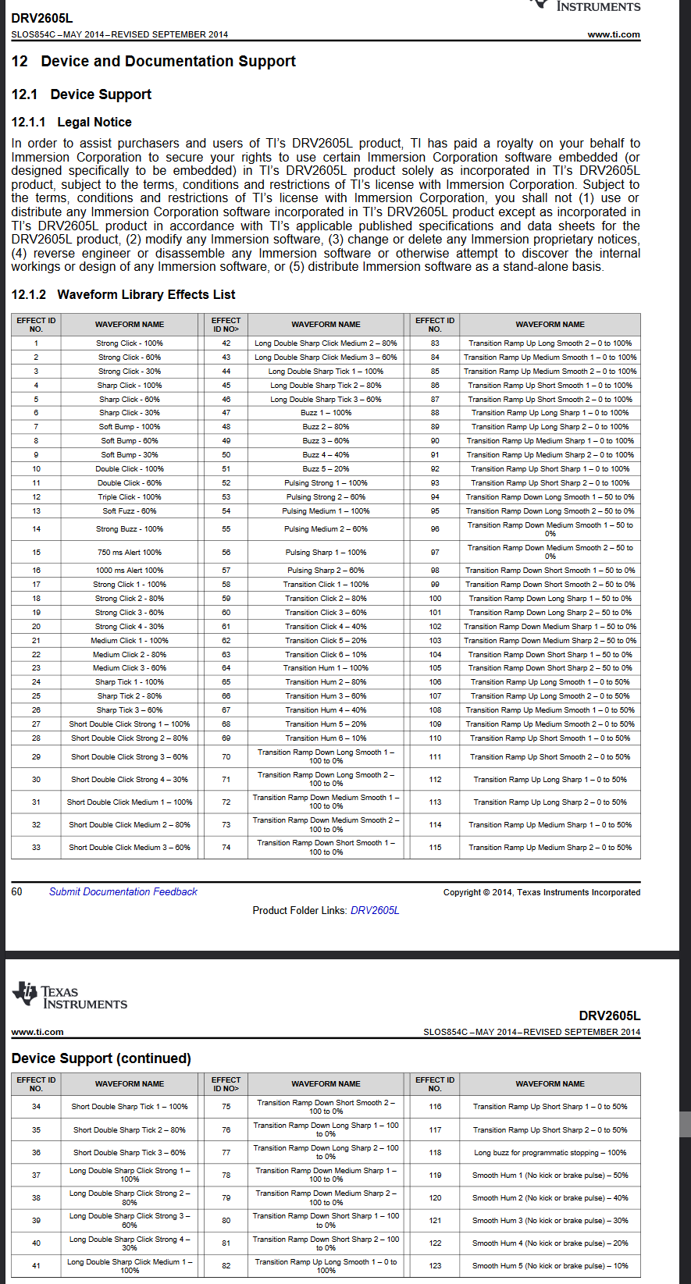

Haptics:
[ Dillon ]

Vybronics

Daytonaudio

Patents
[ Dillon ]

Electrotactile
EP1970877A1 - Electric tactile display - Google Patents - Expiring on 2026-12-07
The research paper, Super-resolution wearable electrotactile rendering system, seems to have solved the conductive gel issue somehow. Much less messy using their approach if their system works.

US7190352B2 - Method and apparatus of electrotactile panel with pointing system - Google Patents - Expired on 2022-10-31

Electrotactile vocoder - Expired on 1992-01-22

