**Dillon Vaughan, Anthony Welter   
Advanced Computer Programming   
Project 5  
User's Manual**   
   
**Setup and Compilation**   
1. The submission includes:

* Server.java
* MusicRequest.java
* InstrumentDB.java
* SimpleDataSource.java
* ClientView.java
* vaughanwelteraUML.jpg
* vaughanwelterUserManual.docx (this file)

2. Running the program. Upon downloading and unzipping the necessary files, import each project folder into Eclipse as an existing Maven project. Click the run button in Eclipse for both the Server.java and ClientView.java file, or right click both files and run as java application, starting with the Server.java file. If the user doesn’t start the server first, user will be prompted with “Unable to connect to server” in the console. Upon proper starting order of the server, then the client, a client window named “Musical Instrument Lookup” will launch and display. User may interact with all features presented within the window. The window contains multiple drop-down boxes to make selections from, like type of instrument, company brand, and the inventory of each item at a particular location. There is also a price box available to enter in a max price limit value, or if user doesn’t want a price limit, they can either enter a zero or leave the price box empty. Anything other than an empty price box, a zero, or positive numeric value will result in an error message being displayed in console upon hitting the “Submit Request” button. The user may then hit the “Submit Request” button to query the desired items selected in the client window, retrieving the data from the database server. Query results will be displayed in a separate “Instrument Information” window. Once the user acknowledges the results by hitting the “OK” button, or exiting the result window hitting the “X” button in the top right corner of the window. The user will be returned and control of the “Musical Instrument Lookup” window will be regained to try any other type of combination query, continuing to follow all instructions and rules described earlier. User may exit or end the client program by using the “X” button in the top right of the client window, but may be relaunched as long as server is still running. Lastly, to stop the server, user must hit the red stop button to the right of the console in Eclipse to terminate the server. No command line arguments are required or checked.

Note: Server.java file must be running first, before running the ClientView.java file.

3. User input: User interaction with the program is required inside the ClientView JavaFX window stage. Window will display three drop down combo boxes, a text box, a submission button, and standard minimize and exit button in top right of window. User can choose not to make changes, and choose to enter a numeric value or leave the price box blank. They could also choose to make any possible combination with drop down combo boxes, and choose to enter a numeric value or not in the price text box. Then the user must hit the “Submit Request,” button to be displayed query results in a dialog box window. In order to request a new query or exit, the user must close the resulting querying dialog box window. All input will take place inside the ClientView window.

4. Output: Output will occur in both the ClientView JavaFX window stage and Server console. Successful start of the server will display “Server is running, waiting for clients to connect...”, in the console window. Then launching the ClientView will display the JavaFX window stage, and present query results upon user pressing the “Submit Request” button.

Successful Run of Server Output:

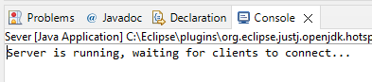

Successful Run of ClientView Output with Server Running:

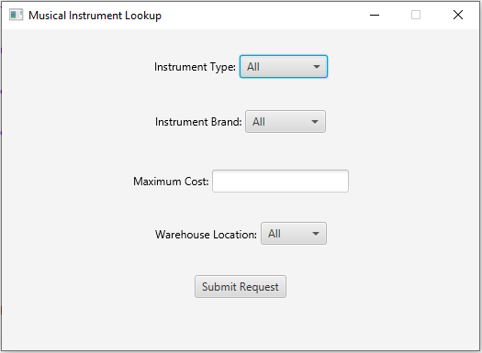

Successful Output of Query Results Pressing Submit Request Button:

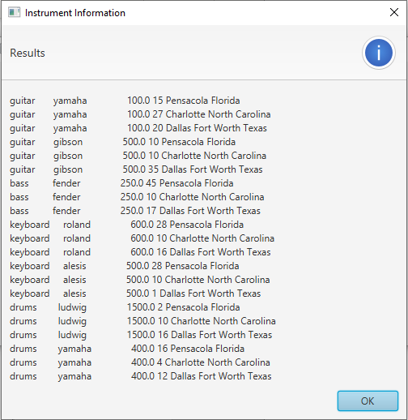

Try/Catch Output:

Server Already Running

Catch Output: Error starting thread.

Failed to Drop Tables

Catch Output: Error, failed to drop tables!

Non-numeric or Negative Value Entered in Maximum Cost Text Box

Catch Output: Invalid entry, leave blank or enter a value zero or greater.

Note: Example output results that appear in “Instrument Information” alert dialog box window will vary. Results displayed depend on user selection in each drop-down combo box, and what value price entered, if any, in Maximum Cost text box.

5. Problems: No problems to report, programs meet all specifications and does what is intended.