Abstract
Drug resistance (DR) remains a global challenge in tuberculosis (TB) control. To develop molecular based diagnostic methods to replace the traditional culture-based diagnostics, there is a need for a thorough understanding of the processes that govern TB drug resistance. The use of whole genome sequencing coupled with statistical and computational methods have shown great potential in unravelling the complexity of the evolution of drug-resistant TB (DR-TB). In this study, we took an innovative approach that sought to determine non-random associations between polymorphic sites in Mycobacterium tuberculosis (Mtb) genomes. Attributable risk statistics were applied to identify epistatic determinants of DR in different clades of Mtb and possible evolutionary pathways of DR development. It was found that different lineages of Mtb exploited different evolutionary trajectories towards multidrug resistance and compensatory evolution to reduce the DR-associated fitness cost. Epistasis of DR acquisition is a new area of research that will aid in better understanding of evolutionary biological processes and allow predicting upcoming multidrug resistant pathogens before a new outbreak strikes humanity.

Introduction
Despite being a disease of antiquity, TB caused by Mycobacterium tuberculosis (Mtb) remains one of the leading killers globally causing twice as many fatalities as HIV/AIDS. According to the latest report by the World Health Organization WHO, TB reclaimed its spot as the global leading cause of death from a single infectious agent following three years in which corona virus disease (COVID-19) had taken the top spot [1]. More than 10 million new cases have been reported annually and the figures have been rising since 2021. Drug susceptible TB is treatable however, drug-resistant TB (DR-TB) has been identified as a cause for concern in global efforts to eradicate TB and has been listed as one of the 24 pathogens on the WHO’s Bacterial Priority Pathogens List [1, 2]. In 2023, an estimated 400 000 people (95% UI 360 000 - 440 000) people developed MDR/RR-TB with an estimated 175 923 people diagnosed and treated for multidrug-resistant or rifampicin resistant TB (MDR/RR-TB). MDR-TB is TB disease caused by strains that have become resistant to both rifampicin (RIF) and isoniazid, two of the most potent first line anti-TB drugs. RR-TB refers to TB disease that is caused by strains that have developed resistance to rifampicin [3]. Extensive drug-resistant TB XDR-TB can also develop when MDR/RR-TB strains develop additional resistance to rifampicin, any fluroquinolone(a class of second-line anti-TB drug) plus at least one of either bedaquiline or linezolid [1]. Pre-XDR-TB is a term that is also used to describe strains resistant to rifampicin and any other fluoroquinolone.

Treatment for patients with MDR-TB and XDR-TB often involves prolonged and costly antibiotic regimens and poor outcomes that result in high rates of mortality and treatment failure [4, 5]. Countries that have a high burden of total cases of TB including DR-TB are often resource-limited. Consequently, the inadequate administration of treatment risks the amplification of resistance to further drugs and may prolong opportunities for infection transmission [6]. Timely diagnosis and correct treatment are of the uttermost importance in turning the tide against TB. DR-TB can be acquired in the course of treatment through the acquisition of chromosomal mutations in anti-TB drug target genes (secondary resistance) or can be transmitted from one infected individual to another (primary resistance) [5, 7]. The development of acquired resistance is common as a result of single nucleotide polymorphisms (SNPs), insertions and deletions [4, 6]. Apart from chromosomal mutations, the intrinsic resistance due to the bacterium’s lipid-rich cell wall and efflux pumps has limited the number of drugs that can treat TB [4, 8]. Rapid molecular diagnostic assays have been developed to tackle the challenge of early diagnosis and treatment. However, the technology behind these assays is often limited to a small number of loci they can interrogate, and thus the number of drugs that can be tested usually is restricted to the first-line drugs. The genetic basis of drug resistance is still poorly understood with recent research suggesting that it’s more complex than previously thought [9]. Whole Genome Sequencing (WGS) technology has proven to be an effective tool in shedding more insights into our understanding of TB [10].Unlike in most bacterial pathogens, horizontal gene transfer does not play a role in the acquisition of DR in Mtb. For this reason, research has mostly focused on identifying multivariate associations between SNPs in the Mtb genome and the resistant phenotype. The use of mathematical methods in together with WGS and other related TB data has also proved to be of importance in exploring associations between variants in the Mtb genome [4, 11-13].

Focusing exclusively on DR associated variants does unravel the full complexity of the evolutionary landscape driving drug resistance in Mtb. Studies have also suggested that the distribution patterns of DR-TB associated mutations in Mtb genomes appear to be lineage specific due to epistasis limitations [14, 15]. Acquisition of a DR associated mutation is expected to impose a bacterial fitness cost. However, several studies have shown that MD-TB strains have minimal or no fitness cost, yet they show high levels of resistance [15-18]. Several DR associated mutations in the following genes: katG, gyrA, rpoB and rpsL render resistance to different antibiotics and are frequently observed in successful DR clinical isolates [15]. On the other hand, a household-based case study done by Salvatore et al. [19] demonstrated that isolates carrying both katG S315T and rpsL R43K mutations were less likely to be found in households with multiple cases, suggesting decreased transmission even though both mutations conferred high-level resistance. Several studies have also identified putative compensatory mutations in rpoA, rpoC and rpoB genes that ameliorate the fitness cost of rifampicin resistance [20, 21]. Work done by Vargas et al. [22] identified 35 additional putatively novel compensatory mutations in rpoC genes from isolates that were rifampicin resistant in Peru. Another study done by Coll et al. [4] identified a pnaB2 mutation that may compensate for pyrazinamide resistance conferred by pncA and mutations in the thyX–hsdS.1 promoter that compensates for para-aminosalicylic acid resistance conferred by mutations in thyA. The stated examples suggest that these strains may have undergone compensatory evolution modulating the fitness of the strains, which either precedes or follows drug resistance acquisition by these strains [23, 24].

Another class of steppingstone mutations that appear to emerge before DR status has been acquired was reported in a study by Cohen et al. [25]. These authors found that mutations in ubiA emerge before ethambutol resistance conferred by mutations in embB. Safi et al. [26] ‘s in vitro studies showed a multistep selection of ubiA, aftA, embB, and embC mutations required to achieve the highest-level of resistance to ethambutol. Another study done by Shea et al. [27] identified low-level resistance conferring mutations in the rpoB gene. Associations between the genetic background and DR-TB have been investigated by several groups [24, 26, 28]. For example, Li et al. [29] reported that substitutions at katG315 and rpoB450 loci conferring isoniazid and rifampicin resistance were more frequent in more transmissible strains of the “modern” Beijing sub-lineages compared to the “ancient” Beijing strains. Additionally, Fenner et al. [30] found that mutations in katG and inhA conferred different levels of INH resistance depending on the lineage of the mutant TB strains. In Lineage 2 mutant strains, substitutions in katG315 were more prevalent and conferred high-level resistance to isoniazid, whereas in the Lineage 1 mutant strains substitutions in inhA conferring low-level resistance to isoniazid were more prevalent.

Materials and methods

Data sourcing

In our initial study, we obtained data for the from the GMTV database [31] , a public repository which provides a comprehensive catalogue of variant call format (VCF) files as well as metadata information on phenotypic drug susceptibility testing (pDST) and lineage classification for each sample. As a follow up study we added an additional 2500 isolates from the “Comprehensive Resistance Prediction for Tuberculosis: an International Consortium” (CRyPTIC) [32] . The new dataset of 5001 Mtb strains were then used to calculate the mutation frequencies for the selected Mtb lineage.

Functional associations between Mtb mutations
We applied the approach described by van Nierkerk et al. [33] which leverages Levin’s attributable risk statistic (R_{a}-statistics) for classifying Mtb strains [34]. The method uses R_{a}-statistics to infer directional epistatic interactions while distinguishing them from genetic drift associations among mutations in Mtb genomes. Statistical inference of attributable risks was performed using Equation 1, while Equation 2 was employed for Fleiss’ standard error estimation [35]. Allele combinations frequencies were represented as P_{AB}, P_{Ab}, P_{aB} and P_{ab}, with N denoting the total number of analysed Mtb strains.
$R_{A→a|b}=\frac{P_{AB}P_{ab}-P_{aB}P_{Ab}}{\left(P_{AB}+P_{aB}\right)\left(P_{aB}+P_{ab}\right)}$ (1)

$StdErr=\sqrt{\frac{P_{Ab}+R_{aA→a|b}\left(P_{AB}+P_{ab}\right)}{N×P_{aB}}}$ (2)

The likelihood and the standard error of the mutation B→b representing the reverse direction A→a were computed using equations 3 and 4, respectively.

$R_{B→b|a}=\frac{P_{AB}P_{ab}-P_{aB}P_{Ab}}{\left(P_{AB}+P_{Ab}\right)\left(P_{Ab}+P_{ab}\right)}$ (3)

$StdErr=\sqrt{\frac{P_{aB}+R_{B→b|a}\left(P_{AB}+P_{ab}\right)}{N×P_{Ab}}}$ (4)

Finally, equation 5 was used to compute the range of confidence values for the derived attributable risks estimate [35].

$\left[1-EXP\left(ln\left(1-R_{a}\right)-1.96×StdErr\right)\right] to \left[1-EXP\left(ln\left(1-R_{a}\right)+1.96×StdErr\right)\right]$ (5)
The co-dependence estimates were then integrated with the pDST metadata collected from the GMTV database together with annotation from ReSeqTB [36].

Phylogenetic drug resistance inference
To validate the results the results obtained from the functional associations inferences for each lineage, we adopted a phylogeny-based approach to tracking the directions of acquisition of DR-associated mutations. Based on the metadata, we created a sub-dataset of 2486 strains which was enriched with MDR-TB and pre-XDR-TB isolates. For a genome to be included in this analysis, it had to be classified under one lineage (no mixed infections), an average coverage >=20, and <10% missing SNPs across all isolates [37]. We generated a SNP alignment by merging the individual VCF files using BCFTOOLs v1.9 [38] while choosing the missing parameter for missing variants. From the merged vcf file, we generated an alignment file in phylip format and used SNPsites to extract an alignment of only variable sites. We inferred a maximum likelihood phylogenetic tree using IQTREE2 v2.1.3 [39] using the following parameters -m GTR+G+ASC -bb 1000 -nt AUTO where GTR is the general time reversible model, G is the rate heterogeneity among sites modelled by the gamma distribution , ASC is ascertainment bias correction since we used only variable sites, -bb is the ultrafast bootstrapping option , and nt allows for multicore processing.

Utilizing the Nextstrain Augur software suite [40], which enables phylogenetic trait mapping and ancestral state reconstruction. We used the tree topology from IQTREE2 to fix the branch lengths by positioning the tips by year of date of isolation using the augur refine command. Using TreeTime [41], the commands output a time resolved tree in newick format and a JSON file with the estimated dates and mutations on each node or branch. We then used augur ancestral command for ancestral sequence reconstruction for each internal node on the tree. The program outputs a VCF file with the reconstructed sequence of all the internal nodes and a JSON file with all the nucleotide mutation data for each node in the tree. We then compiled a tab delimited file of genes that harboured mutations with the highest likelihoods from our functional association analysis as well as known drug target genes. We then downloaded a GFF of Mtb gene annotations from Mycobrowser [42] to use as input for the augur translate command. With this command, the program translates the nucleotide mutations generated by augur ancestral using the gene coordinates in the GFF file as reference points. The output of augur translate is a Json file with identified amino acid mutations for each tip (strain) or internal node. Using custom python scripts, we extracted the identified mutations from the generated Json files while discarding genes with no mutations present.

Using the augur sequence-traits command, we sought to identify mutations that were associated with drug resistance. To do this, we created a tab delimited file in the format specified by the augur documentation. For our analysis, we populated this file with information on well characterized drug resistance associated mutations as well as possible compensatory mutations inferred from our functional association inference modelling. The file contains the gene name, the amino acid site as well as the display information for the mutation. Table 1 below shows an example of how we compiled our file.

Table 1: Structure of input file required by augur sequence traits
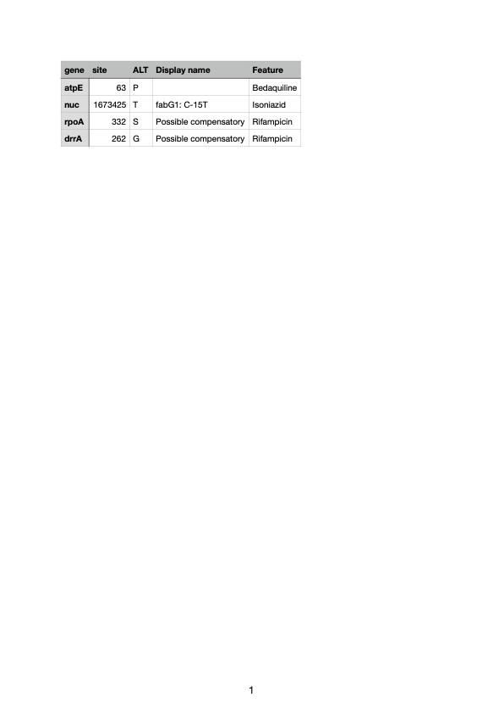

We used the augur export program which consolidates all the metadata information, the inferred time resolved phylogeny and the JSON results file to generate a visualization file. A comprehensive list of all commands ran in this analysis is provided for in the appendices. Finally we integrated our identified mutations with their co-dependency estimates (section 5.3.2) and created drug resistance functional association networks using Cytoscape v3.7.2 [43].

Results

Lineage 1
Lineage 1 strains are generally known to be drug susceptible except for those belonging to sub-lineage 1.2 [31]. Figure 1 shows the inferred paths connecting the DR mutations in strains of this lineage. We identified the pyrG gene as an integral mutation in the early development of drug resistance in our Lineage 1 network. The gene codes for the CTP synthetase , pyrG and has been proposed as a possible drug target for new antitubercular agents. We also identified a mutation at codon 40 of the frdC gene as a possible prerequisite of the acquisition of fluoroquinolone resistance associated gyrA mutations, gyrA A90V and gyrA D94G. The gene frdC is known to affect quinol binding [44].

We also identified the Rv3651 gene in two pathways that lead to the development of MDR-TB . Our co-dependency analysis estimates suggests that mutations in the gene develop early on after the development of low isoniazid resistance as a result of the acquisition of the inhA.G-154A mutation in the promoter region of inhA gene. Mutations in the Rv3651 gene were also linked to pathways that lead to the acquisition of rpoB L430P and embB D354A mutations that are known to be associated with rifampicin and ethambutol resistance respectively. The exact function of Rv3651 is currently unknown, however, structural studies have reviewed that the protein possesses a unique structure that differs from other sensor-effector proteins [45].

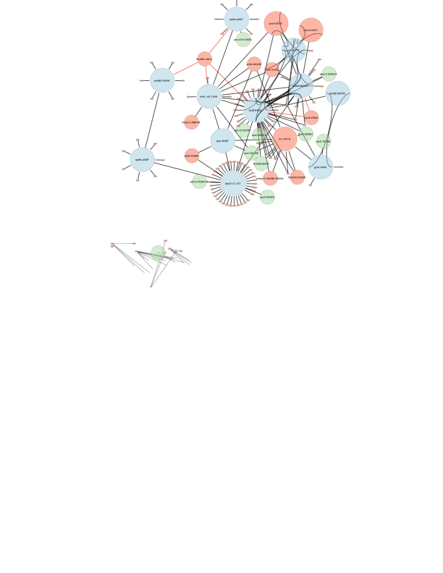
Figure 1:Network of DR-associated mutations inferred from Lineage 1. The well characterised DR mutations are coloured blue while the prerequisite inferred compensatory mutations are highlighted in green. Arrows illustrate relations between prerequisite mutations and the well charecterized DR mutations.

Lineage 2
Certain sublineages of Lineage 2 have been associated with hypervirulence and a propensity to develop MDR-TB. Our analysis for this lineage showed a complex network of mutations co-occurring with known antibiotic resistance mutations (Figure 2). Our analysis identified the acquisition of mutations in the dhaA gene as key in the progression to MDR-TB status. In the development of MDR-TB , we identified different pathways to isoniazid resistance development mainly mutations in the katG gene, inhA and the fabG1 promoter region. The dhaA gene was identified in both different pathways. Previous transcriptomic studies have shown that this gene is upregulated in bacteria living inside macrophages [44].

We also identified the ponA1 gene as a possible link to the complex networks that lead to the development of MDR-TB. In our analyses using Lineage 2 strains, we identified ponA1 mutations in three different MDR-TB networks. The first one was the ponA1:X213L mutation in a pathway linked to low-level isoniazid resistance mutations fabG1G-17T as well as inhA.G-154A mutation in the inhA promoter region. The second one, ponA1:X365H was estimated to have preceded the acquisition of rpoB S450L in an MDR pathway that started with the emergence of fabG1:G-15T mutations conferring low level isoniazid resistance. Lastly, the third mutation, ponA1: X402F was found to have been prerequisite in the acquisition of rpoB:V170F. Our findings agreed with previous studies that link the ponA1 gene to cell wall synthesis mechanisms that alter Mtb fitness during rifampicin therapy [11, 46, 47].

Another key gene identified in the complex network of drug resistance associated mutations in this study was the aspC gene. We found two mutations (aspC:X298S and aspC:X3S) arose before the acquisition of rpoB S450L and rpoB D435V. The gene is known to mediate functioning of the transcriptional regulator Whib7 which plays a role in regulating intrinsic multidrug resistance [48]. In Lineage 2 we also identified the lysX gene as an integral part of the trajectory to multi-drug resistance in TB.

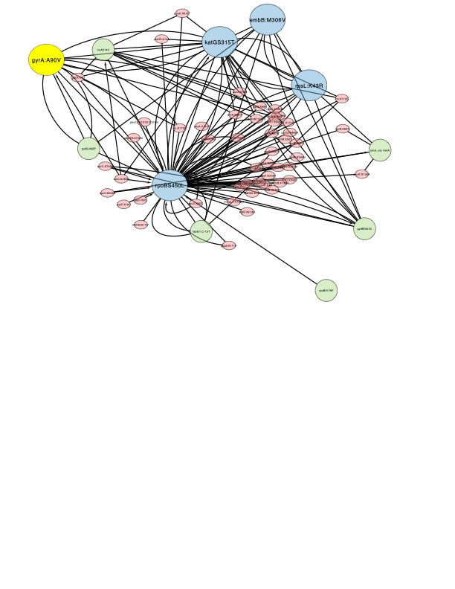
Figure 2: Network of DR-associated mutations inferred from Lineage 2. The well characterised DR mutations are coloured blue while the prerequisite inferred compensatory mutations are highlighted in green. Arrows illustrate relations between prerequisite mutations and the well charecterized DR mutations.

Lineage 4
In Lineage 4 we inferred several mutations that were prerequisites for MDR-TB emergence in different resistance trajectories (Figure 3). In lineage 4.3 we identified one interesting pathway from drug susceptibility leading to the pre-XDR-TB phenotype. In this pathway, the fabG1:X-15C mutation emerges first together with several mutations such as drrA:X262. The fabG1:X -15C mutation is associated with low levels of isoniazid resistance [49] while the XX mutations have been associated with. Several mutations in the rpoB gene then emerge, notably the L452P mutation which is then supported by the D435V mutation. Other mutations outside the RRDR of the rpoB gene a such as X286V, X399A, X827L and I1106T also emerge together with other previously characterized compensatory mutations such as rpoC (G332C, F452C,F452S, D485Y, V883G, V483A, N698S, N698H and Q1125H) [50]. We hypothesize that the acquisition of these mutation confers low level to moderate level rifampicin resistance. As the more mutations accumulate, katG S315T and rpoB S450L emerge leading to full blown MDR-TB and eventually pre-XDR-TB after the acquisition of gyrA A90V. In Lineage 4 we also identified other putative rpoC putative compensatory mutations such as X1017Q, X746V, X734V, X62C, and X861T as possible prerequisites for rifampicin resistance.

We also found mutations in the Rv0147, Rv0893 and Rv3087 genes to be prerequisite for rifampicin resistance. The Rv1047 gene has been suggested as a possible drug target for MDR-TB treatment although no differences were reported when RNA expression profiles of the protein were compared between drug susceptible and MDR-TB isolates [51]. Rv0893 was confirmed to be a sam-dependent MTase, however, very few studies have characterized the enzyme [52].
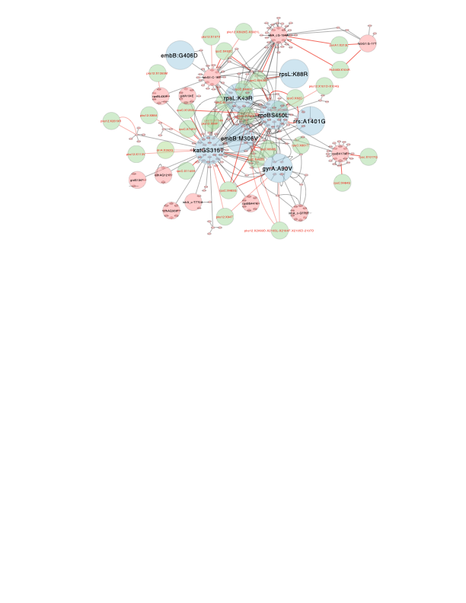
Figure 3: Network of DR-associated mutations inferred from Lineage 4. The well characterised DR mutations are coloured blue while the prerequisite inferred compensatory mutations are highlighted in green. Arrows illustrate relations between prerequisite mutations and the well charecterized DR mutations.

Discussion
The evolution of drug resistance (DR) in Mycobacterium tuberculosis (Mtb) is influenced by factors such as fitness cost, compensatory mutations, and phylogenetic background. Since some of these factors cannot be directly measured experimentally, mathematical modelling and statistical approaches are essential. These tools challenge earlier assumptions, such as the notion that all DR Mtb strains experience fitness disadvantages compared to susceptible strains. Instead, bacterial fitness is now understood to be heterogeneous.

This study combined whole-genome sequencing (WGS) and drug susceptibility testing (DST) data with statistical modelling to investigate genetic epistasis and its role in DR evolution.

We identified epistatic mutations in genes associated with stress response, efflux pumps, lipid metabolism, DNA repair, and cell wall synthesis. For example, mutations in efflux pump genes may enhance tolerance to isoniazid, while loss of katG function leaves Mtb vulnerable to reactive oxygen species (ROS). This vulnerability, coupled with mechanisms like SOS-induced mutagenesis, accelerates the accumulation of resistance mutations. Rifampicin and aminoglycosides (e.g., kanamycin, streptomycin) directly induce this SOS response, potentially explaining the role of rpsL mutations in DR evolution. Moreover, mutations in lipid metabolism genes likely compensate for fitness losses associated with DR.

Using Levin’s attributable risk statistic, we mapped networks of DR-associated mutations and identified evolutionary trajectories of resistance development. Isoniazid resistance often precedes rifampicin resistance, while fluoroquinolone resistance emerges last, consistent with global treatment practices. While these results align with known resistance mechanisms, biases in public genomic datasets, such as overrepresentation of DR strains and incomplete phenotype data, pose limitations. Additionally, the evolutionary pathways of DR can vary by geographic region and treatment practices, further complicating the analysis.

Advances in WGS technologies, including long-read sequencing, are expected to overcome current challenges, particularly in characterizing repetitive regions of the Mtb genome. Such developments will enhance future studies on DR evolution and epistatic networks, enabling earlier prediction of potential DR outbreaks.

1. Organization, W.H., Fourth WHO consultation on the translation of tuberculosis research into global policy guidelines: meeting report, 15 February 2024. 2024: World Health Organization.
2. Organization, W.H., WHO Bacterial Priority Pathogens List, 2024. World Health Organization, 2024.
3. Organization, W.H., WHO consolidated guidelines on tuberculosis. Module 4: treatment-drug-resistant tuberculosis treatment, 2022 update. 2022: World Health Organization.
4. Coll, F., et al., Genome-wide analysis of multi-and extensively drug-resistant Mycobacterium tuberculosis. Nature genetics, 2018. 50(2): p. 307-316.
5. Wang, F., et al., Evolution and transmission patterns of extensively drug-resistant tuberculosis in China. Antimicrobial agents and chemotherapy, 2015. 59(2): p. 818-825.
6. Perdigao, J. and I. Portugal, Genetics and roadblocks of drug resistant tuberculosis. Infection, Genetics and Evolution, 2019. 72: p. 113-130.
7. Casali, N., et al., Evolution and transmission of drug-resistant tuberculosis in a Russian population. Nature genetics, 2014. 46(3): p. 279-286.
8. Gygli, S.M., et al., Antimicrobial resistance in Mycobacterium tuberculosis: mechanistic and evolutionary perspectives. FEMS microbiology reviews, 2017. 41(3): p. 354-373.
9. Zhang, H., et al., Genome sequencing of 161 Mycobacterium tuberculosis isolates from China identifies genes and intergenic regions associated with drug resistance. Nature genetics, 2013. 45(10): p. 1255-1260.
10. Comas, I. and S. Gagneux, The past and future of tuberculosis research. PLoS pathogens, 2009. 5(10): p. e1000600.
11. Farhat, M.R., et al., Genomic analysis identifies targets of convergent positive selection in drug-resistant Mycobacterium tuberculosis. Nature genetics, 2013. 45(10): p. 1183-1189.
12. Walker, T.M., et al., Whole-genome sequencing for prediction of Mycobacterium tuberculosis drug susceptibility and resistance: a retrospective cohort study. The Lancet infectious diseases, 2015. 15(10): p. 1193-1202.
13. Georghiou, S.B., et al., Evaluation of genetic mutations associated with Mycobacterium tuberculosis resistance to amikacin, kanamycin and capreomycin: a systematic review. PloS one, 2012. 7(3): p. e33275.
14. Coscolla, M. and S. Gagneux. Consequences of genomic diversity in Mycobacterium tuberculosis. in Seminars in immunology. 2014. Elsevier.
15. Nguyen, Q.H., et al., Insights into the processes that drive the evolution of drug resistance in Mycobacterium tuberculosis. Evolutionary applications, 2018. 11(9): p. 1498-1511.
16. Coll, F., et al., Rapid determination of anti-tuberculosis drug resistance from whole-genome sequences. Genome medicine, 2015. 7: p. 1-10.
17. Trauner, A., et al., Evolution of drug resistance in tuberculosis: recent progress and implications for diagnosis and therapy. Drugs, 2014. 74: p. 1063-1072.
18. Spies, F.S., et al., Identification of mutations related to streptomycin resistance in clinical isolates of Mycobacterium tuberculosis and possible involvement of efflux mechanism. Antimicrobial agents and chemotherapy, 2008. 52(8): p. 2947-2949.
19. Salvatore, P.P., et al., Fitness costs of drug resistance mutations in multidrug-resistant Mycobacterium tuberculosis: a household-based case-control study. The Journal of infectious diseases, 2016. 213(1): p. 149-155.
20. Huo, F., et al., A 10-year comparative analysis shows that increasing prevalence of rifampin-resistant Mycobacterium tuberculosis in China is associated with the transmission of strains harboring compensatory mutations. Antimicrobial Agents and Chemotherapy, 2018. 62(4): p. 10.1128/aac. 02303-17.
21. Cohen, K.A., et al., Evolution of extensively drug-resistant tuberculosis over four decades: whole genome sequencing and dating analysis of Mycobacterium tuberculosis isolates from KwaZulu-Natal. PLoS medicine, 2015. 12(9): p. e1001880.
22. Vargas, A.P., et al., Determination of potentially novel compensatory mutations in rpoc associated with rifampin resistance and rpob mutations in Mycobacterium tuberculosis Clinical isolates from peru. The International Journal of Mycobacteriology, 2020. 9(2): p. 121-137.
23. Merker, M., et al., Evolutionary history and global spread of the Mycobacterium tuberculosis Beijing lineage. Nature genetics, 2015. 47(3): p. 242-249.
24. Al-Saeedi, M. and S. Al-Hajoj, Diversity and evolution of drug resistance mechanisms in Mycobacterium tuberculosis. Infection and drug resistance, 2017: p. 333-342.
25. Cohen, K.A., et al., Deciphering drug resistance in Mycobacterium tuberculosis using whole-genome sequencing: progress, promise, and challenges. Genome medicine, 2019. 11(1): p. 45.
26. Safi, H., et al., Allelic exchange and mutant selection demonstrate that common clinical embCAB gene mutations only modestly increase resistance to ethambutol in Mycobacterium tuberculosis. Antimicrobial agents and chemotherapy, 2010. 54(1): p. 103-108.
27. Shea, J., et al., Low-level rifampin resistance and rpoB mutations in Mycobacterium tuberculosis: an analysis of whole-genome sequencing and drug susceptibility test data in New York. Journal of clinical microbiology, 2021. 59(4): p. 10.1128/jcm. 01885-20.
28. Gagneux, S., Strain variation in the Mycobacterium tuberculosis complex: its role in biology, epidemiology and control. Vol. 1019. 2017: Springer.
29. Li, Q.-j., et al., Positive epistasis of major low-cost drug resistance mutations rpoB531-TTG and katG315-ACC depends on the phylogenetic background of Mycobacterium tuberculosis strains. International journal of antimicrobial agents, 2017. 49(6): p. 757-762.
30. Fenner, L., et al., Effect of mutation and genetic background on drug resistance in Mycobacterium tuberculosis. Antimicrobial agents and chemotherapy, 2012. 56(6): p. 3047-3053.
31. Chernyaeva, E.N., et al., Genome-wide Mycobacterium tuberculosis variation (GMTV) database: a new tool for integrating sequence variations and epidemiology. BMC genomics, 2014. 15: p. 1-8.
32. Consortium, C., A data compendium associating the genomes of 12,289 Mycobacterium tuberculosis isolates with quantitative resistance phenotypes to 13 antibiotics. PLoS biology, 2022. 20(8): p. e3001721.
33. Van Niekerk, K., et al., Clade-specific distribution of antibiotic resistance mutations in the population of Mycobacterium tuberculosis. Prospects for drug resistance reversion. Basic Biology and Applications of Actinobacteria, 2018: p. 79-98.
34. Fleiss, J.L., B. Levin, and M.C. Paik, Statistical methods for rates and proportions. 2013: john wiley & sons.
35. Muzondiwa, D., Exploring the evolution of drug resistance in Mycobacterium using whole genome sequencing data. 2019: University of Pretoria (South Africa).
36. Schito, M. and D.L. Dolinger, A collaborative approach for “ReSeq-ing” Mycobacterium tuberculosis drug resistance: convergence for drug and diagnostic developers. EBioMedicine, 2015. 2(10): p. 1262-1265.
37. Napier, G., et al., Comparison of in silico predicted Mycobacterium tuberculosis spoligotypes and lineages from whole genome sequencing data. Scientific Reports, 2023. 13(1): p. 11368.
38. Danecek, P., et al., Twelve years of SAMtools and BCFtools. Gigascience, 2021. 10(2): p. giab008.
39. Minh, B.Q., et al., IQ-TREE 2: new models and efficient methods for phylogenetic inference in the genomic era. Molecular biology and evolution, 2020. 37(5): p. 1530-1534.
40. Huddleston, J., et al., Augur: a bioinformatics toolkit for phylogenetic analyses of human pathogens. Journal of open source software, 2021. 6(57).
41. Sagulenko, P., V. Puller, and R.A. Neher, TreeTime: Maximum-likelihood phylodynamic analysis. Virus evolution, 2018. 4(1): p. vex042.
42. Kapopoulou, A., J.M. Lew, and S.T. Cole, The MycoBrowser portal: a comprehensive and manually annotated resource for mycobacterial genomes. Tuberculosis, 2011. 91(1): p. 8-13.
43. Shannon, P., et al., Cytoscape: a software environment for integrated models of biomolecular interaction networks. Genome research, 2003. 13(11): p. 2498-2504.
44. Dash, P., et al., Three-dimensional models of Mycobacterium tuberculosis proteins Rv1555, Rv1554 and their docking analyses with sildenafil, tadalafil, vardenafil drugs, suggest interference with quinol binding likely to affect protein’s function. BMC structural biology, 2018. 18: p. 1-13.
45. Abendroth, J., et al., Mycobacterium tuberculosis Rv3651 is a triple sensor‐domain protein. Protein Science, 2018. 27(2): p. 568-572.
46. Miotto, P., et al., Transcriptional regulation and drug resistance in Mycobacterium tuberculosis. Frontiers in Cellular and Infection Microbiology, 2022. 12: p. 990312.
47. Kieser, K.J., et al., Peptidoglycan synthesis in Mycobacterium tuberculosis is organized into networks with varying drug susceptibility. Proceedings of the National Academy of Sciences, 2015. 112(42): p. 13087-13092.
48. Morris, R.P., et al., Ancestral antibiotic resistance in Mycobacterium tuberculosis. Proceedings of the National Academy of Sciences, 2005. 102(34): p. 12200-12205.
49. Organization, W.H., Catalogue of mutations in Mycobacterium tuberculosis complex and their association with drug resistance. 2023: World Health Organization.
50. De Vos, M., et al., Putative compensatory mutations in the rpoC gene of rifampin-resistant Mycobacterium tuberculosis are associated with ongoing transmission. Antimicrobial agents and chemotherapy, 2013. 57(2): p. 827-832.
51. Tasbiti, A.H., et al., Comparing mRNA expression and protein abundance in MDR Mycobacterium tuberculosis: Novel protein candidates, Rv0443, Rv0379 and Rv0147 as TB potential diagnostic or therapeutic targets. Biotechnology Reports, 2021. 30: p. e00641.
52. Loarer, G., The Approach to Characterizing Three S-Adenosyl-L-Methionine-Dependent Methyltransferases from Mycobacterium tuberculosis. 2018: The University of Toledo.

