ConnectHub: An Offline-First Android Blogging Application
Supporting Documentation
Module: 6CS027 Secure Mobile Application Development
Assessment: Portfolio (coursework artefact and supporting documentation)
Academic year: 2025/2026, Semester 1
Student name: [Student name]
Student ID: [Student ID]

1. Introduction and Objectives
ConnectHub is a native Android application, written in Java with XML layouts, for writing and managing blog posts. Because mobile connectivity is unreliable, the device is the primary store: every post is saved in a local SQLite database, and the internet is needed only when the user chooses to publish. The objectives were to provide complete offline post management, attach photos from the gallery and camera, share posts through Android intents, and publish selected posts to a personal Blogger blog.

2. Requirements and Features
The implemented features are:
- Create, edit, view and delete posts; a list screen with status filters; a detail screen for each post.
- Search across titles and bodies (partial, case-insensitive), listing every match with highlighting.
- Single deletion with confirmation; multi-selection with select-all, clear and bulk deletion.
- SQLite storage, including drafts introduced in schema version 2.
- Photo attachment from the system Photo Picker or the device camera.
- Sharing by email or any compatible app through the standard ACTION_SEND intent.
- Uploading one or several posts to Blogger through the Blogger API v3, plus a clearly labelled Test mode.
Real Blogger publishing is implemented but has not yet been verified, because it requires an OAuth client registered to the signing certificate (Section 6).

3. Software Design
MainActivity hosts five bottom-navigation tabs (Home, Posts, Upload, Gallery, Profile); separate activities provide search, editing, post detail and image preview. Figure 1 shows the principal use cases.
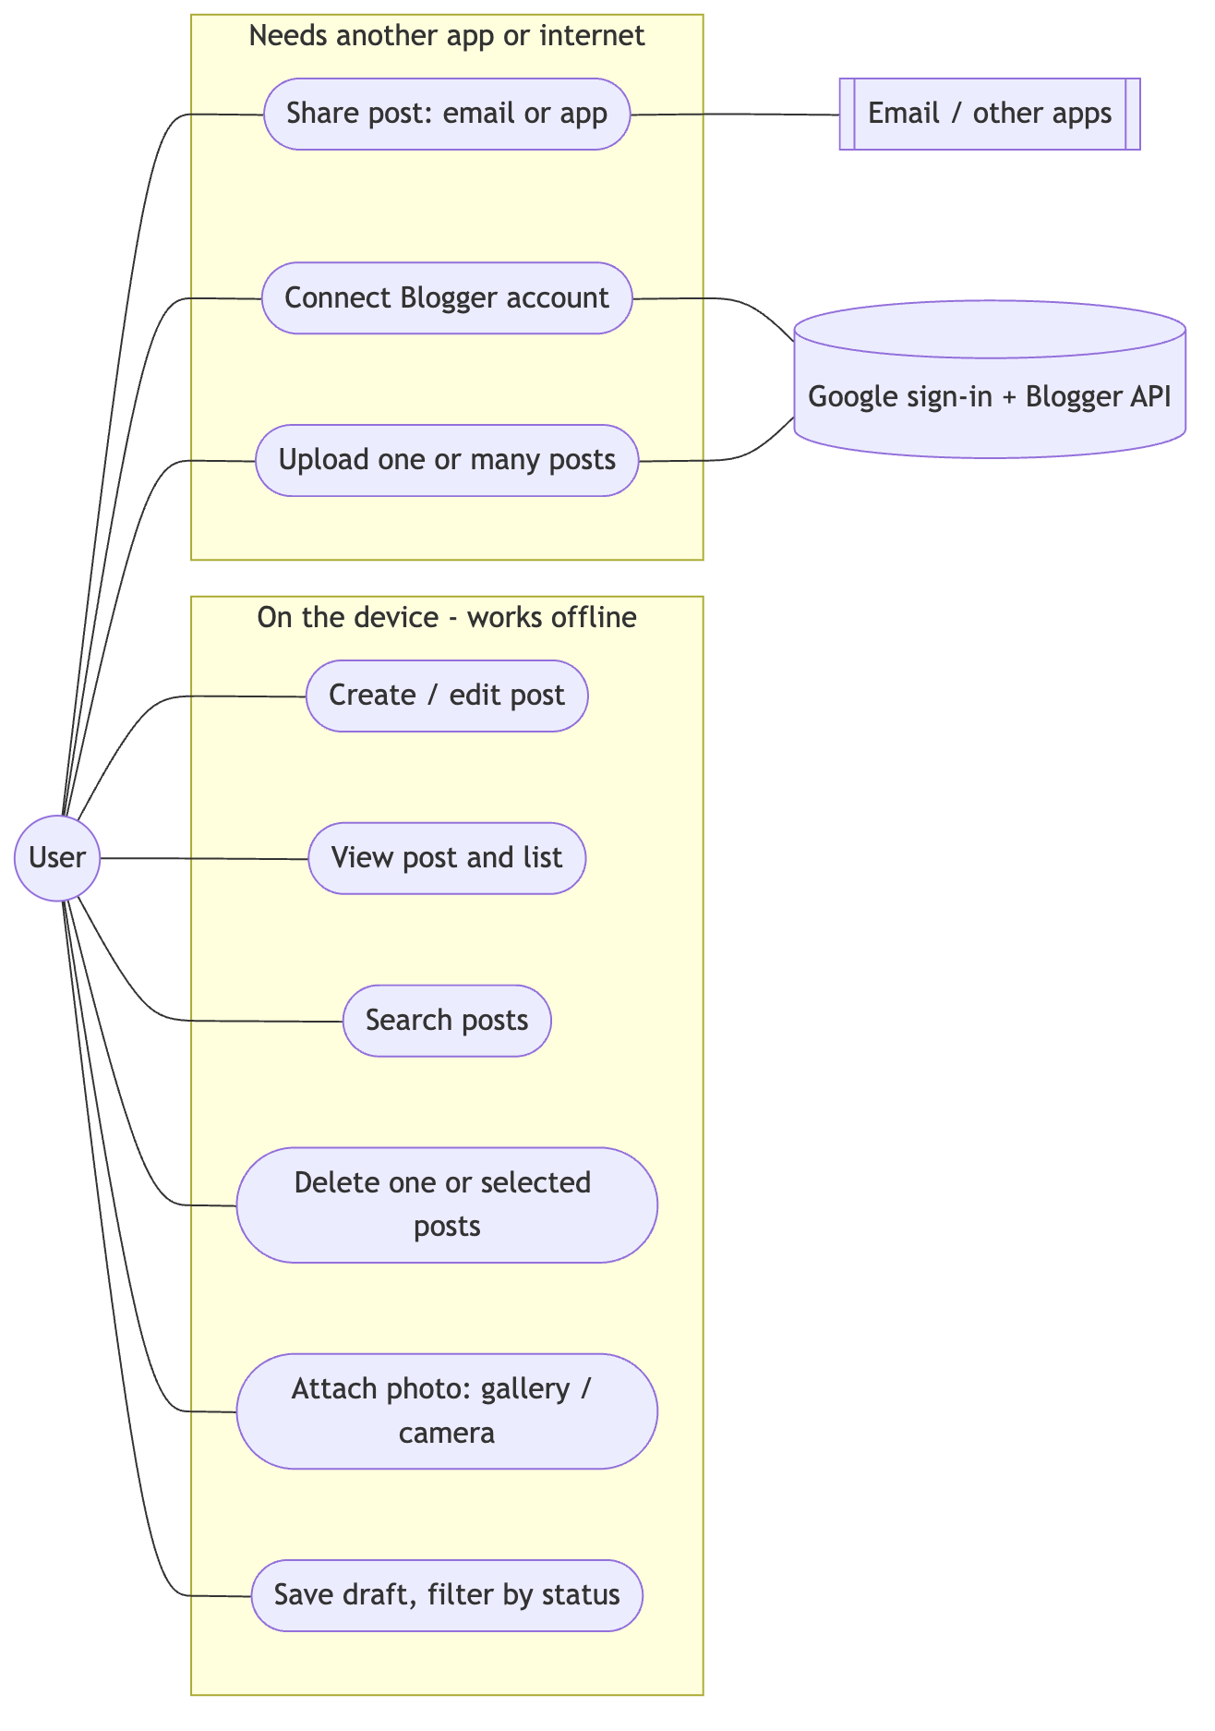
Figure 1. Use-case diagram
The code is layered (Figure 2). Activities and fragments handle presentation only. PostRepository is the only class that executes SQL, through BlogDbHelper (SQLiteOpenHelper). ImageStorage manages photo files and ShareHelper builds share intents. PublishController coordinates confirmation, authorisation and uploads through the PublishService interface, implemented by BloggerPublishService and MockPublishService, so simulated runs can never mark a post as published. Database, file and network work runs on background threads.
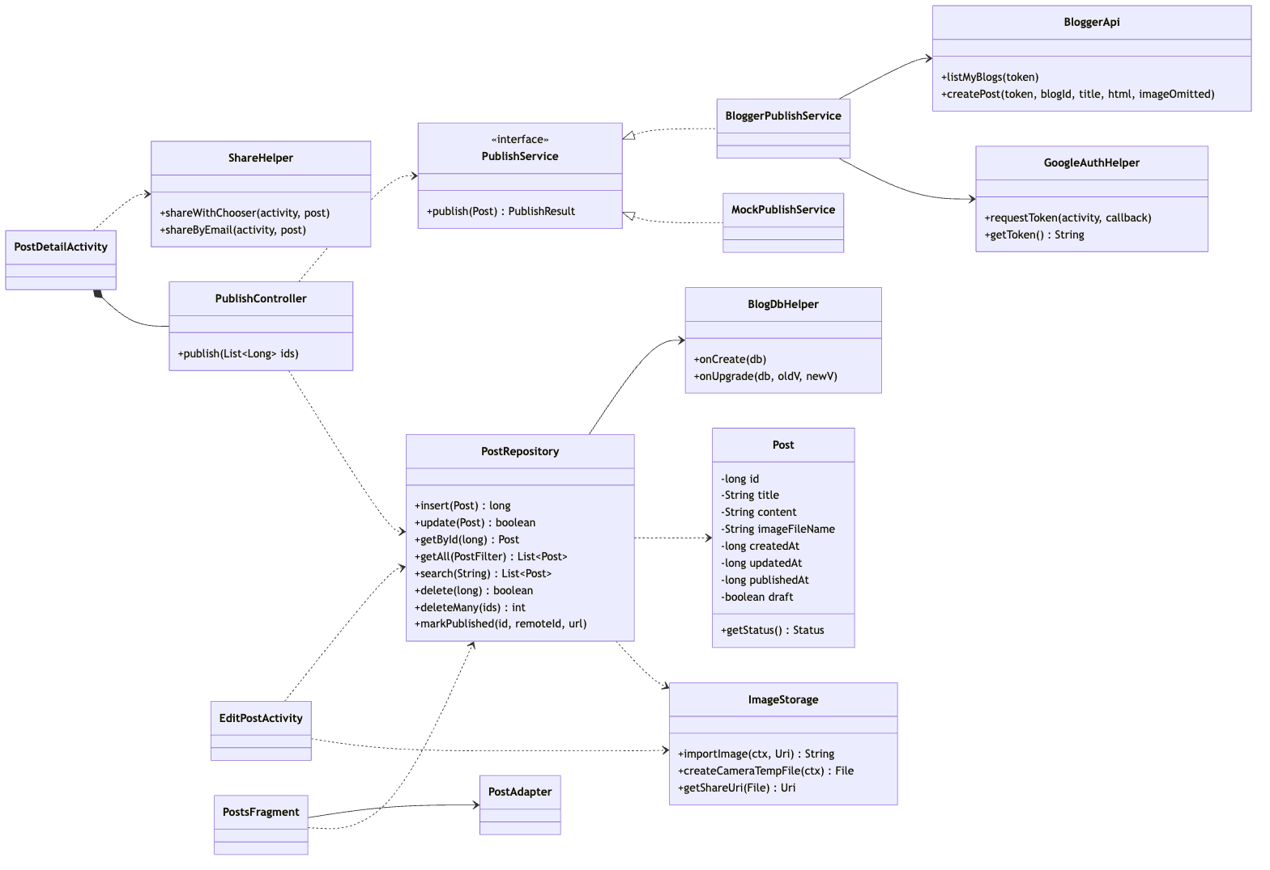
Figure 2. Core class diagram (full diagram in software-design/)

4. Database Design and Persistence
The database blogspace.db contains one table, posts (Figure 3), keyed by an auto-increment _id. Title and content are mandatory TEXT fields; timestamps are stored as epoch milliseconds; remote_post_id, remote_url and published_at record confirmed uploads; is_draft was added in version 2 by onUpgrade, which alters the table rather than dropping it.
Photos are not stored in SQLite. Each selected or captured image is decoded, rotated upright, scaled to at most 2048 px and saved as a JPEG in app-private storage; the table stores only its file name. Records survive restarts because SQLite writes to internal storage. Bulk deletion runs in one transaction, and photo files are removed only after it commits.
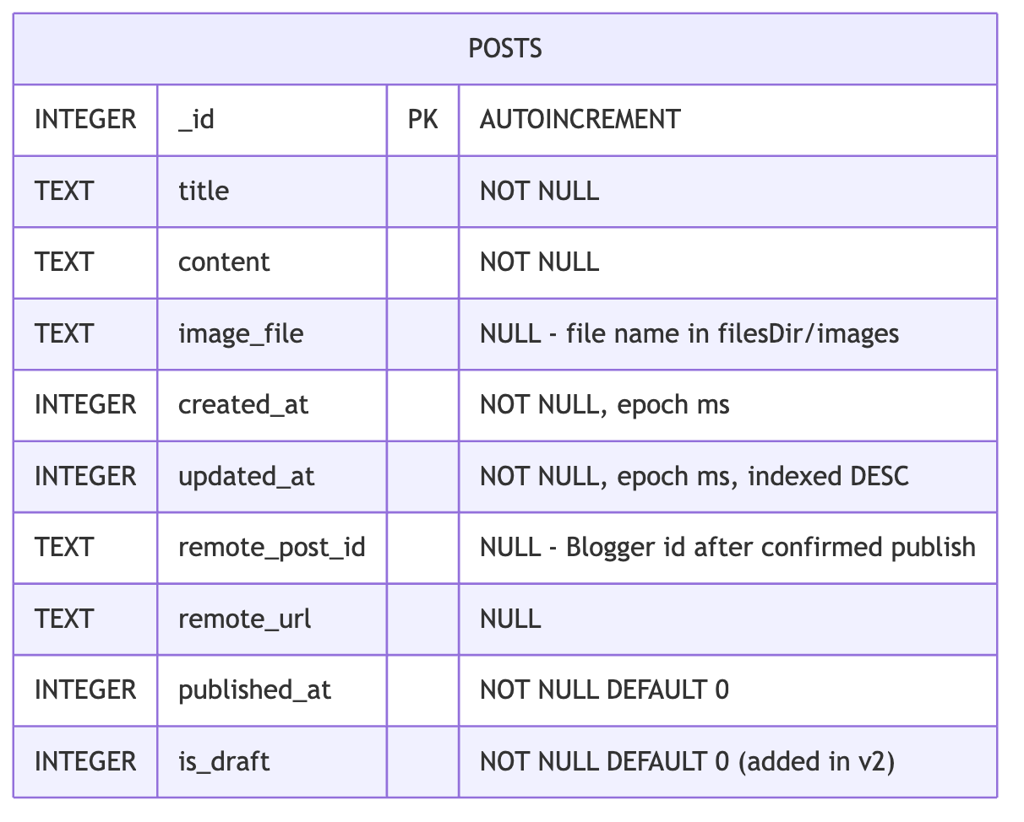
Figure 3. posts table

5. Implementation and Key Decisions
- Validation: titles and bodies are required, trimmed, and limited to 120 and 20,000 characters; drafts need either field.
- Security: all queries use bound parameters and escape LIKE wildcards. No camera or storage permission is requested: the gallery uses the Photo Picker, the camera app writes into a FileProvider URI, and shared photos receive only temporary read grants.
- Publishing: Google Play services AuthorizationClient provides an OAuth 2.0 token; the Android client is identified by package name and SHA-1, so no password or secret is stored. A post is marked Uploaded only after Blogger returns its id.
- Third-party code: AndroidX, Material Components, Google Play services Auth and the Inter typeface (SIL Open Font License).
Three challenges arose. Gallery URIs and temporary camera files are not durable, so images are copied into app storage. The Gallery screen crashed because a grid layout animation is incompatible with RecyclerView; emulator testing exposed this and it was replaced. Target SDK 36 enforces edge-to-edge drawing, handled by applying window-inset padding. Figures 4 and 5 show the resulting screens.
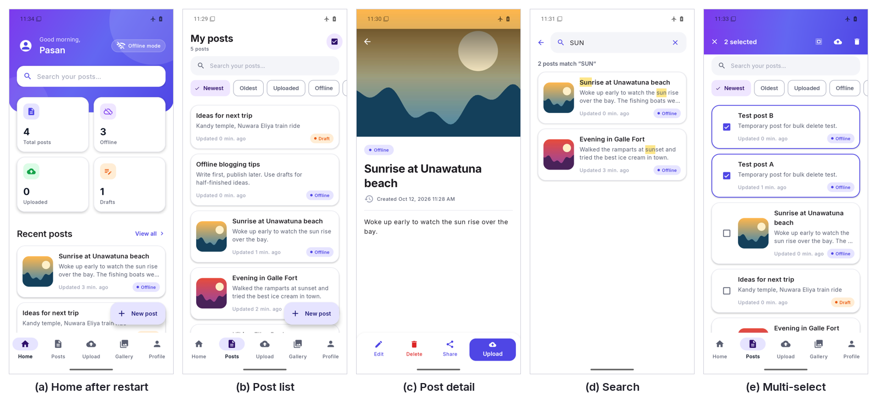
Figure 4. Core screens captured in airplane mode
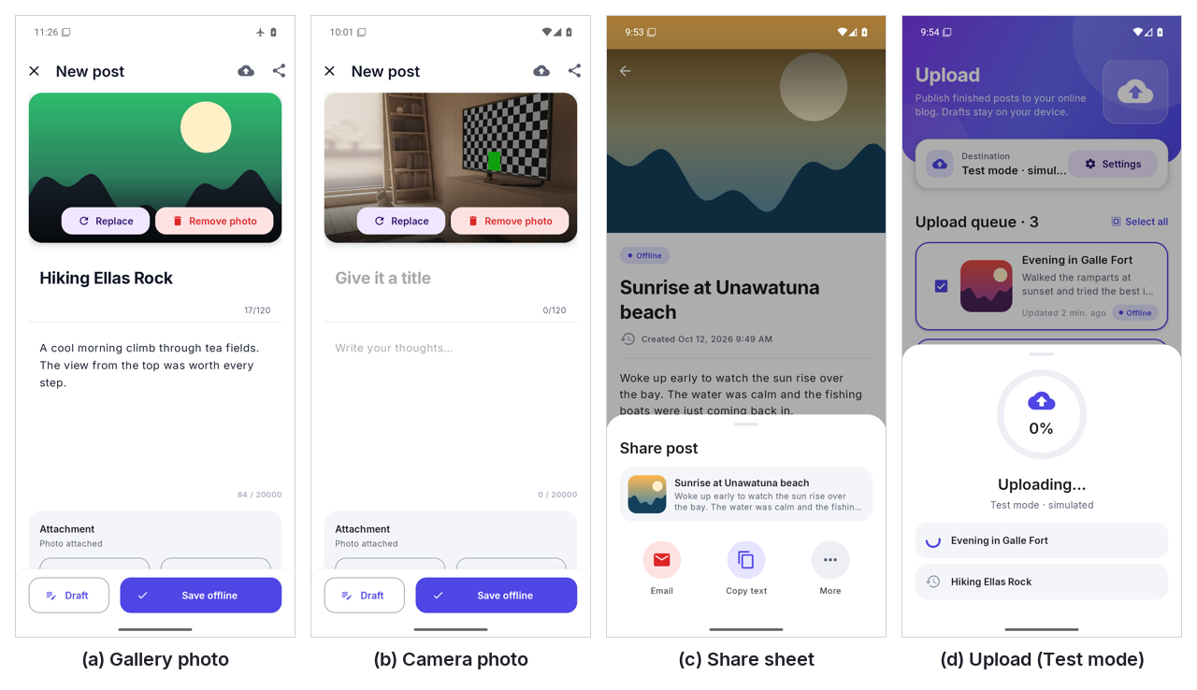
Figure 5. Photo attachment, sharing and upload (Test mode)

6. Testing and Results
Testing combined 24 JVM unit tests and 23 instrumented tests on an Android 16 emulator (all passed) with manual tests performed in airplane mode and recorded as screenshots. Full cases are in test-plan-and-results.md.
Table 1. Testing summary
Area | Evidence | Result
Create, edit, view, delete | Manual (airplane mode); instrumented | Passed
Search, bulk deletion | Manual; instrumented | Passed
Persistence after restart | Force-stop and relaunch; instrumented | Passed
Gallery photos (JPEG, PNG, WebP) | Manual; instrumented | Passed
Camera capture | Emulator virtual camera | Passed (no physical device)
Sharing | Intent contents tested; share sheet opened | Partial: email delivery not checked
Upload flow | Test mode only | Passed (simulated)
Real Blogger publishing | None yet | Not tested
Validation and errors | Manual; unit | Partial: upload-failure path not run

7. Limitations and Future Work
Real publishing depends on one-time Google Cloud configuration and remains unverified. The Blogger API has no media endpoint, so photos are embedded as reduced data URIs; if Blogger rejects one, the post is resent without it. Testing used one emulator profile. Future work includes verifying publishing with a configured account, testing on physical devices and adding database backup.

8. Conclusion
ConnectHub implements offline post management, SQLite persistence, gallery and camera attachments, intent-based sharing and a Blogger publishing workflow. Automated and manual tests confirm the offline features, storage and image handling. Email delivery and real online publishing must still be demonstrated with configured accounts before every criterion can be considered met.

References
Android Developers (n.d.) Save data using SQLite. Available at: https://developer.android.com/training/data-storage/sqlite (Accessed: 12 October 2026).
Android Developers (n.d.) Photo picker. Available at: https://developer.android.com/training/data-storage/shared/photo-picker (Accessed: 12 October 2026).
Android Developers (n.d.) Camera intents. Available at: https://developer.android.com/training/camera/camera-intents (Accessed: 12 October 2026).
Android Developers (n.d.) FileProvider. Available at: https://developer.android.com/reference/androidx/core/content/FileProvider (Accessed: 12 October 2026).
Android Developers (n.d.) Send data to other apps. Available at: https://developer.android.com/training/sharing/send (Accessed: 12 October 2026).
Android Developers (n.d.) Authorize access to Google user data. Available at: https://developer.android.com/identity/authorization (Accessed: 12 October 2026).
Google for Developers (n.d.) Blogger API: Using the API. Available at: https://developers.google.com/blogger/docs/3.0/using (Accessed: 12 October 2026).

