Final Statistical Results

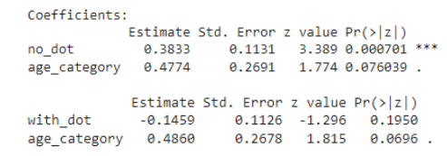

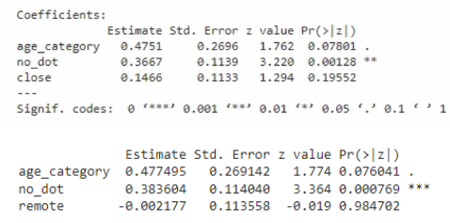

Age - statistically insignificant

No dot - the absence of a dot makes messages more polite

With dot - the presence of a dot does not make messages rude

Social Distance - statistically insignificant