
a^{n}b^{n} , n>0
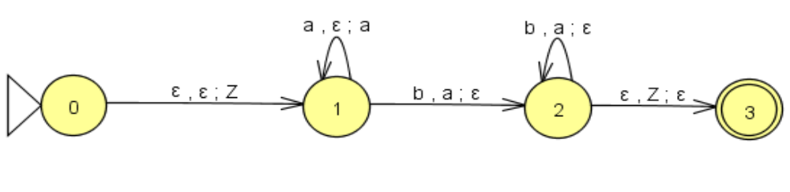
M = (Q, Σ, Z, δ, q₀, z₀, F)
Q={0,1,2,3}
Σ = {a, b}
Z = {‘Z’, a, b}
q₀=0
z₀ = ‘Z’
F = {3}

δ(0,ɛ,ɛ)=(1,’Z’);
δ(1,a,ɛ)=(1,a);
δ(1,b,a)=(2,ɛ);
δ(2,b,a)=(2,ɛ);
δ(2,ɛ,’Z’)=(3,ɛ);

