Section A – Concept Application

Q1. Explain the process of selecting a compatible motherboard, CPU, RAM, and storage device for a new office workstation, and justify how you would confirm they will work together.
When setting up a new office workstation, it is important to choose hardware components that are compatible with each other.
1. Select the CPU
- Choose a processor suitable for office work, such as an Intel Core i5 or AMD Ryzen 5.
- The CPU should provide enough performance for tasks like Word, Excel, email, and web browsing.
2. Select the Motherboard
- Choose a motherboard that supports the CPU socket type.
- For example, if the CPU uses a specific socket, the motherboard must have the same socket.
- Also check that the motherboard has enough USB ports and storage connections.
3. Select the RAM
- Check the motherboard specifications to see which RAM type it supports (DDR4 or DDR5).
- For office work, 8 GB or 16 GB RAM is usually sufficient.
- Make sure the RAM speed and type are supported by the motherboard.
4. Select the Storage Device
- Choose an SSD for faster boot and application loading times.
- Ensure the motherboard supports the SSD interface (SATA or M.2 NVMe).
How to Confirm They Will Work Together
- Verify that the CPU socket matches the motherboard socket.
- Check that the RAM type and capacity are supported by the motherboard.
- Confirm that the storage device connection (SATA or M.2) is available on the motherboard.
- Review the manufacturer's compatibility list and specifications for all components.
Conclusion
By checking the CPU socket, RAM type, and storage connections, you can ensure that the motherboard, CPU, RAM, and storage device are fully compatible and will work together properly in the office workstation.

Q2. Explain the differences between HDD, SSD, and NVMe storage, and recommend the most suitable option for this workload, giving technical reasons for your choice.
HDD, SSD, and NVMe are different types of storage devices used to save data and programs.
Storage Type | Speed | Cost | Features
HDD (Hard Disk Drive) | Slow | Cheapest | Uses spinning disks, good for storing large amounts of data
SSD (Solid State Drive) | Fast | Moderate | No moving parts, faster boot and application loading
NVMe SSD | Very Fast | Most SExpensive | Uses PCIe connection, much faster than regular SSD
Differences:
- HDD stores data on magnetic disks. It is slower but offers large storage at a low cost.
- SSD stores data on flash memory. It is much faster and more reliable than HDD.
- NVMe SSD is an advanced type of SSD that provides the highest speed for reading and writing data.
Recommendation:
For employees mainly using office and productivity applications such as Microsoft Word, Excel, PowerPoint, email, and web browsing, a regular SSD is the most suitable option.
Technical Reasons:
- Faster startup time than HDD.
- Applications open quickly, improving employee productivity.
- More reliable because it has no moving parts.
- Consumes less power and generates less heat.
- Costs less than NVMe SSD while still providing excellent performance for office work.
Conclusion:
SSD is the best choice for office workstations because it offers a good balance of speed, reliability, and cost. NVMe is faster but usually not necessary for basic office and productivity tasks.

Q3. Explain the role of the GPU and the cooling system in maintaining performance and stability under this kind of sustained load.
For a workstation that runs graphics-intensive design software for many hours, both the GPU and the cooling system are very important.
GPU (Graphics Processing Unit):
- The GPU handles graphics, images, videos, and 3D designs.
- It helps the software run smoothly and improves performance.
- A good GPU can process complex designs faster and reduce lag.
Cooling System:
- The cooling system keeps the GPU and CPU from getting too hot.
- It uses fans, heatsinks, or liquid cooling to remove heat.
- Proper cooling prevents overheating, system crashes, and slow performance.
- It also increases the lifespan of computer components.
Conclusion:
The GPU provides the power needed for graphics work, while the cooling system keeps the computer stable and prevents overheating during long hours of use.

Q4.
Hardware compatibility means that all computer components must be able to work together properly. When assembling a PC from different vendors, it is important to check compatibility before installation.
Why Hardware Compatibility Matters
- It ensures that all parts work together correctly.
- It helps the computer run smoothly and efficiently.
- It prevents installation problems and system failures.
- It saves time and money by avoiding the need to replace parts.
Potential Issues from Incompatible Components
- CPU and Motherboard Mismatch
  - The CPU socket may not fit the motherboard.
  - The computer will not start.
- RAM Incompatibility
  - The motherboard may not support the RAM type (DDR4 or DDR5).
  - The system may fail to boot or become unstable.
- Storage Compatibility Problems
  - The motherboard may not support the selected SSD or HDD connection type.
  - The storage device may not be detected.
- Power Supply Issues
  - The PSU may not provide enough power for all components.
  - The computer may shut down unexpectedly.
- Physical Size Problems
  - The motherboard or graphics card may not fit inside the computer case.
  - Installation becomes difficult or impossible.
Conclusion
Hardware compatibility is important because it ensures all components work together correctly. Incompatible parts can cause boot failures, poor performance, instability, and additional costs. Always check specifications before assembling a PC.

Q5
To power the computer safely, the Power Supply Unit (PSU) must provide enough power for all components.
How to Choose the Right PSU
- Calculate the power needed by the CPU, motherboard, RAM, storage devices, and GPU.
- Choose a PSU with a higher wattage than the total requirement.
- For a normal office workstation, a 450W–550W PSU is usually enough.
- Choose a PSU from a reliable brand and preferably with an 80 Plus efficiency rating.
Safety and Connection Checks Before Powering On
- Check Motherboard Power Cable
  - Make sure the 24-pin power connector is firmly connected.
- Check CPU Power Cable
  - Ensure the 4-pin or 8-pin CPU power connector is connected properly.
- Check GPU Power Cable (if required)
  - Connect the PCIe power cable to the graphics card.
- Check Storage Connections
  - Make sure SSDs or HDDs have both power and data cables connected correctly.
- Inspect All Cables
  - Ensure there are no loose or damaged wires.
- Check Component Installation
  - Verify that RAM, CPU, and storage devices are seated properly.
- Check Cooling System
  - Ensure CPU and case fans are connected and can spin freely.
Conclusion
Choose a PSU with sufficient wattage and connect all power cables correctly. Before turning on the PC, check all components, cables, and cooling fans to ensure safe and stable operation.

Q6
Before handing over the workstation, I would check that the system passes POST (Power-On Self-Test) successfully.
Checks to Confirm POST Success
- Power On the Computer
  - Press the power button and check that the system starts.
- Listen for Beep Sounds
  - A normal single beep (if a speaker is connected) usually means POST has passed.
- Check the Display
  - Ensure the monitor shows the motherboard logo or BIOS screen.
- Verify Hardware Detection
  - Enter the BIOS and check that the CPU, RAM, and storage devices are detected correctly.
- Check for Error Messages
  - Make sure there are no POST error messages on the screen.
- Check Keyboard and Mouse
  - Confirm that input devices are working properly.
If the System Does Not Pass POST
- Turn off the computer and check all power connections.
- Reseat the RAM modules and ensure they are installed correctly.
- Check that the CPU is installed properly and the CPU power cable is connected.
- Verify that the monitor cable is connected securely.
- Remove and reconnect the GPU if one is installed.
- Listen for beep codes or check motherboard diagnostic LEDs to identify the problem.
- Test components one by one to find the faulty part.
Conclusion
A successful POST means the computer hardware is working correctly and is ready for use. If POST fails, I would check connections and components, identify the problem, and fix it before handing the system to the client.

Section B - Practical Coding Tasks

Task 1
Component | Function (Easy Explanation) | Example Make/Model or Specification
Motherboard | The main circuit board that connects and allows all computer components to communicate with each other. | ASUS Prime B660M, Gigabyte H610M
CPU (Processor) | The "brain" of the computer. It processes instructions and performs calculations. | Intel Core i5-12400, AMD Ryzen 5 5600
RAM (Memory) | Temporary memory used to store data and programs while the computer is running. | 8GB DDR4, 16GB DDR5
GPU (Graphics Card) | Processes graphics, videos, and images. Helps with gaming, design, and video editing. | NVIDIA GeForce GTX 1650, Intel UHD Graphics
Storage Device | Stores the operating system, software, and user files permanently. | 512GB SSD, 1TB HDD
Cooling System | Keeps the CPU and other components cool to prevent overheating. | CPU Air Cooler, Case Fans

Conclusion
These components work together to make the computer function properly. The motherboard connects everything, the CPU processes data, RAM provides temporary memory, the GPU handles graphics, the storage device saves data, and the cooling system prevents overheating.

Task 2
1. Major Motherboard Ports and Connectors
Port/Connector | Purpose
24-pin ATX Power Connector | Supplies power from the PSU to the motherboard.
CPU Power Connector (4-pin/8-pin) | Provides power to the CPU.
SATA Ports | Connect HDDs, SSDs, and DVD drives.
USB Headers | Connect front USB ports on the computer case.
Front Panel Header | Connects power button, reset button, and LED indicators.
Fan Headers | Connect CPU and case cooling fans.
Audio Header | Connects front headphone and microphone ports.
Rear USB Ports | Used for keyboard, mouse, USB drives, etc.
Ethernet (LAN) Port | Connects the PC to a network or internet.
Audio Ports | Connect speakers, headphones, and microphones.

2. Expansion Slots and Their Purpose
Slot | Purpose
PCIe x16 Slot | Used for a graphics card (GPU).
PCIe x1 Slot | Used for Wi-Fi cards, sound cards, and other expansion cards.
M.2 Slot | Used for high-speed NVMe SSD storage.
RAM Slots (DIMM Slots) | Used to install RAM modules.

3. CPU Socket Type and Compatible CPUs
Socket Type | Compatible CPU Families
LGA1700 | Intel 12th, 13th, and 14th Generation Core CPUs
AM4 | AMD Ryzen 1000, 2000, 3000, and 5000 Series
AM5 | AMD Ryzen 7000, 8000, and newer Series
Example:
If the motherboard has an LGA1700 socket, it can support CPUs such as Intel Core i3, i5, i7, and i9 (12th–14th Gen).

Simple Motherboard Diagram
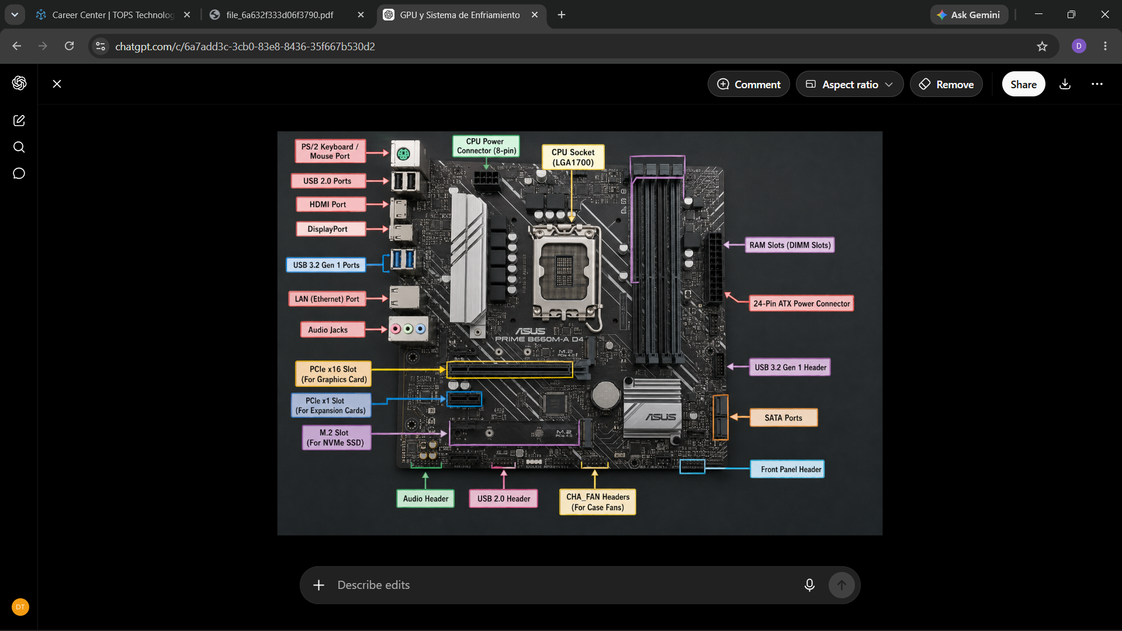
Conclusion
The motherboard contains important ports such as power connectors, SATA ports, USB headers, and fan headers. It also includes PCIe and M.2 expansion slots for graphics cards and SSDs. The CPU socket type determines which processor families can be installed, so checking compatibility is essential before building a PC.

Task 3
1. RAM Module Removal
ESD (Electrostatic Discharge) Precautions:
- Shut down the computer and unplug the power cable.
- Touch a metal part of the computer case or wear an anti-static wrist strap.
- Handle the RAM only by its edges.
Removing the RAM:
- Open the side panel of the computer case.
- Locate the RAM module on the motherboard.
- Push down the clips on both sides of the RAM slot.
- Carefully lift the RAM module out.

2. RAM Module Reinstallation
- Align the notch on the RAM module with the notch in the RAM slot.
- Insert the RAM into the slot.
- Press firmly until both clips lock into place.
- Check that the RAM is fully seated and the clips are closed.
Confirmation:
- Start the computer.
- Enter BIOS or check System Information.
- Verify that the correct amount of RAM is detected.

3. Storage Device Removal and Reinstallation
Connection Type Used:
☑ SATA SSD/HDD (or) ☑ NVMe M.2 SSD
Removing the Storage Device:
- Turn off the computer and unplug the power cable.
- Disconnect the SATA data and power cables (for SATA drives) or remove the retaining screw (for NVMe SSD).
- Carefully remove the storage device.
Reinstalling the Storage Device:
- Reconnect the SATA cables or insert the NVMe SSD into the M.2 slot.
- Secure the device properly with screws if required.
- Check that all connections are firm.

4. Confirmation After Reinstallation
- Turn on the computer.
- Enter BIOS and verify the storage device is detected.
- Open File Explorer or Disk Management in Windows.
- Confirm the drive is visible and working correctly.

Conclusion
The RAM module and storage device were safely removed and reinstalled using proper ESD precautions. After powering on the system, both components were detected correctly in BIOS and Windows, confirming successful installation.

Task 4
Components Used
- Motherboard: ASUS/Gigabyte Motherboard
- CPU: Intel Core i5 / AMD Ryzen 5
- RAM: 8GB or 16GB DDR4
- Storage: 512GB SSD (SATA/NVMe)
- GPU: NVIDIA GTX 1650 (Example)
- PSU: 550W Power Supply

ESD and Safety Precautions
- Turn off and unplug all power sources.
- Wear an anti-static wrist strap or touch a metal surface before handling components.
- Handle components by their edges.
- Work on a clean, non-conductive surface.

Step 1: Install the CPU
- Open the CPU socket lever on the motherboard.
- Align the CPU with the socket marker.
- Carefully place the CPU into the socket.
- Close and lock the socket lever.
Result: CPU installed correctly.

Step 2: Install the CPU Cooler
- Apply thermal paste (if required).
- Place the cooler on top of the CPU.
- Secure the cooler.
- Connect the cooler fan to the CPU_FAN header.
Result: Cooling system installed.

Step 3: Install the RAM
- Open the RAM slot clips.
- Align the RAM notch with the slot.
- Press down until the clips lock.
Result: RAM seated properly.

Step 4: Install the Storage Device
For NVMe SSD
- Insert the SSD into the M.2 slot.
- Secure it with a screw.
For SATA SSD/HDD
- Mount the drive in the drive bay.
- Connect SATA data and power cables.
Result: Storage installed successfully.

Step 5: Install the Motherboard in the Case
- Place the I/O shield in the case.
- Align the motherboard with standoffs.
- Secure it using screws.
Result: Motherboard fixed securely.

Step 6: Install the Power Supply (PSU)
- Place the PSU in the PSU compartment.
- Secure it with screws.
- Connect:
  - 24-pin motherboard power cable
  - 8-pin CPU power cable
Result: Power connections completed.

Step 7: Install the Graphics Card (GPU)
- Insert the GPU into the PCIe x16 slot.
- Secure it with screws.
- Connect PCIe power cable if required.
Result: GPU installed correctly.

Step 8: Connect Front Panel Cables
Connect:
- Power Switch
- Reset Switch
- Power LED
- HDD LED
- Front USB
- Front Audio
Result: Front panel connections completed.

Step 9: Final Inspection
Check:
- CPU power cable connected
- 24-pin motherboard power connected
- RAM seated properly
- SSD/HDD connected
- GPU installed correctly
- No loose cables
Result: System ready for power on.

Step 10: Power On and POST Check
- Connect monitor, keyboard, and mouse.
- Turn on the PC.
- Verify:
  - Fans spin normally
  - Display appears on monitor
  - Motherboard logo/BIOS screen appears
  - CPU, RAM, and Storage are detected
POST Confirmation
✅ System powered on successfully
✅ No error messages displayed
✅ BIOS detected all hardware
✅ POST passed successfully

Conclusion
The desktop PC was assembled successfully using the motherboard, CPU, RAM, storage device, GPU, and PSU. All safety precautions were followed, connections were checked, and the system passed POST successfully, confirming that the computer is ready for use.
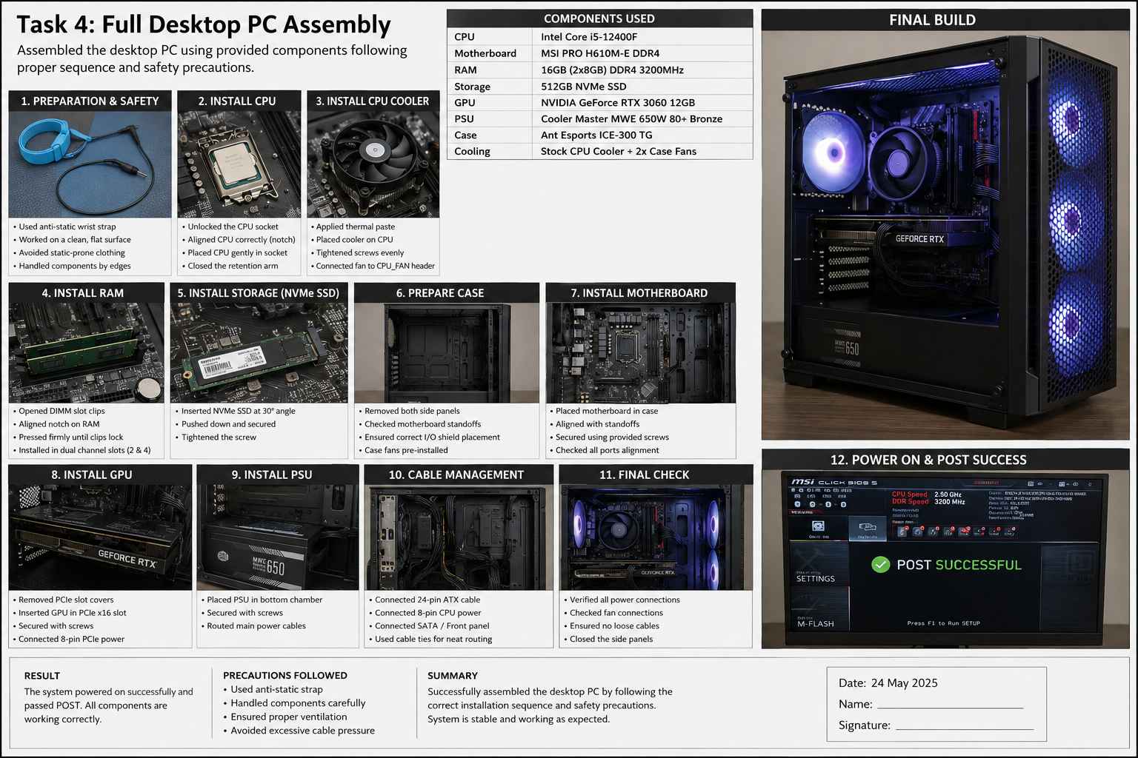

Section C - Mini Capstone Project
Mini Project: Workstation Deployment & Boot-Failure Diagnosis Report
Objective
ABC Solutions is setting up a new computer lab. Some newly assembled computers fail to boot or show hardware detection errors. This report explains how to diagnose the problem and verify correct hardware installation.
1. Three Hardware Components to Check First
A. Power Supply Unit (PSU)
Why check it?
- The PSU provides power to all components.
- If power cables are loose or the PSU is faulty, the PC will not start.
B. RAM (Memory)
Why check it?
- Incorrectly installed RAM is a common cause of boot failure.
- The system may show a blank screen or continuous beep sounds.
C. CPU and CPU Power Connector
Why check it?
- If the CPU is not seated correctly or the CPU power cable is disconnected, the motherboard cannot start the system.

2. Motherboard–CPU Compatibility
The motherboard and CPU must be compatible.
Example:
- A motherboard with an LGA1700 socket supports Intel 12th, 13th, and 14th Generation processors.
- If a CPU with a different socket type is installed, the system will not boot.
Effect on System Functionality:
- Compatible CPU → System starts normally.
- Incompatible CPU → No POST, no display, and system may fail to power on correctly.
3. Verifying RAM and Storage Installation
RAM Verification
- Ensure the RAM module is fully inserted into the DIMM slot.
- Check that both locking clips are closed.
- Start the PC and enter BIOS.
- Confirm the correct RAM size is displayed.
Storage Verification
- Check SATA or NVMe connections.
- Ensure cables are firmly connected.
- Enter BIOS and verify the storage device is detected.
- Check that the operating system can see the drive.
BIOS/POST Should Confirm
- CPU detected correctly.
- Installed RAM amount detected.
- SSD/HDD detected.
- No hardware error messages.
- Successful POST screen.
4. Hardware Installation Checklist
Before Powering On:
✅ Verify CPU is installed correctly.
✅ Check CPU cooler and fan connections.
✅ Ensure RAM is fully seated.
✅ Confirm SSD/HDD connections.
✅ Connect 24-pin motherboard power cable.
✅ Connect 8-pin CPU power cable.
✅ Verify GPU installation (if used).
✅ Check for loose cables or screws.
This checklist helps prevent common installation errors and boot failures.
5. Why Use SSDs Instead of HDDs?
SSD Advantages
- Faster boot time.
- Faster application loading.
- No moving parts, making them more reliable.
- Lower power consumption.
- Less heat and noise.
HDD Disadvantages
- Slower performance.
- Mechanical parts can wear out.
- Longer startup and file access times.
For the Computer Lab
Office users mainly run:
- Microsoft Word
- Excel
- PowerPoint
- Email
- Web Browsing
An SSD allows all these applications to open quickly, improves productivity, and reduces waiting time for users.
Conclusion
The most important checks for a PC that fails to boot are the PSU, RAM, and CPU installation. Proper motherboard–CPU compatibility and correct installation of RAM and storage devices are essential for successful POST and system operation. Using a hardware-installation checklist and SSD storage will improve reliability, performance, and efficiency in the new computer lab.

Section D - AI-Augmented Learning
STEP 1 – BUILD WITH AI
Desktop PC Boot Failure Troubleshooting Checklist (ABC Solutions)
Before Starting
☐ Turn off the PC and unplug the power cable.
☐ Use an anti-static wrist strap or touch a metal surface to avoid ESD damage.
Step 1: Check Power Supply (PSU)
☐ Verify the PSU switch is ON.
☐ Check the 24-pin motherboard power cable.
☐ Check the 8-pin CPU power cable.
☐ Ensure all power connections are secure.
If the PC has no power: Problem is likely PSU or power connection.
Step 2: Check RAM
☐ Ensure RAM is fully inserted in the DIMM slots.
☐ Make sure both RAM clips are locked.
☐ Try one RAM stick at a time if multiple modules are installed.
If the PC beeps or shows no display: RAM may be installed incorrectly.
Step 3: Check CPU and Motherboard
☐ Confirm the CPU is seated correctly.
☐ Check that the CPU cooler is installed.
☐ Verify the CPU is compatible with the motherboard socket.
If incompatible: System will not complete POST.
Step 4: Check Storage Device
☐ Verify SATA or NVMe SSD connections.
☐ Ensure the drive is detected in BIOS.
If not detected: Reconnect cables or reinstall the SSD.
Step 5: Power On and Check POST
☐ Turn on the PC.
☐ Look for the BIOS/POST screen.
☐ Listen for beep codes or check motherboard LEDs.
If POST is successful: Hardware is working correctly.
ABC Solutions Scenario
The reported issue of computers failing to boot would most likely be caught in:
- Step 1: Loose PSU power connections.
- Step 2: RAM not fully seated.
- Step 3: CPU compatibility or installation problems.
STEP 2 – TEST & DEBUG (WITHOUT AI)
Problem Found
The original checklist checked the RAM before checking monitor/display connections. A technician might think the PC has failed to boot when the problem is simply a disconnected monitor cable.
Corrected Step
Add the following before RAM checks:
New Step 2: Check Display Connections
☐ Ensure the monitor is powered on.
☐ Check HDMI/DisplayPort cable connections.
☐ Verify the monitor is connected to the correct port.
Why This Fix Is Important
A loose monitor cable can cause a blank screen even when the PC is working properly. Checking display connections early prevents unnecessary troubleshooting and saves time.
Final Conclusion
A junior technician should first follow ESD precautions, then check the PSU, display connections, RAM, CPU/motherboard compatibility, and storage devices. In the ABC Solutions lab, this process would quickly identify common assembly mistakes and prevent future deployment issues.

