Networking Hardware Assignment

Draw a labeled diagram of a typical home Wi-Fi setup showing a modem, router, switch, access point, and at least two devices (like a laptop and smartphone) connected to the network.
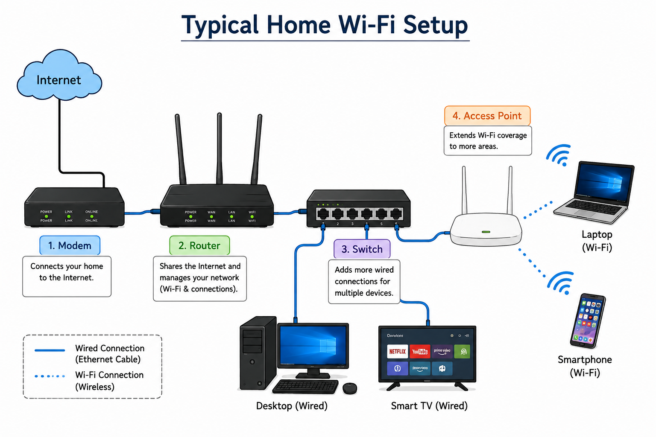
Modem: A modem connects your home or office network to the internet.
Router: A router shares the internet connection with multiple devices.
Switch: A switch connects devices within the same network.
Access Point: An access point provides wireless (Wi‑Fi) connectivity.
Network Cables: These cables connect network devices and transfer data

- List the main function of each networking hardware device: modem, router, switch, access point, and network cable. For each, give a real-life example of where you might see or use it.

Device | Main Function (Easy) | Real-Life Example
Modem | Connects your home or office to the Internet provided by the ISP. | At home, the modem connects your internet service from Airtel, Jio, or BSNL.
Router | Shares the internet with multiple devices and manages the network. | At home, a router lets your laptop, phone, and TV use the same internet connection.
Switch | Connects multiple wired devices in a network. | In an office, a switch connects many computers to the same network.
Access Point (AP) | Extends or provides Wi-Fi coverage. | In a school, mall, or large house to give Wi-Fi in areas where the router signal is weak.
Network Cable (Ethernet Cable) | Transfers data between networking devices through a wired connection. | Used to connect a router to a PC, switch, or smart TV.

Take photos or find images online (with source links) of at least three types of network cables (such as Ethernet, coaxial, fiber optic) and write one line describing where each is commonly used.
Cable Type | Image | Common Use
Ethernet Cable (RJ45) | 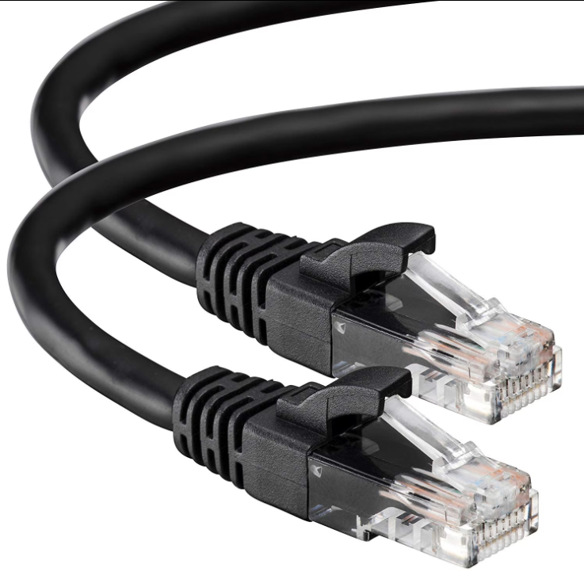 | Used to connect computers, routers, switches, and smart TVs in homes and offices.
Coaxial Cable | 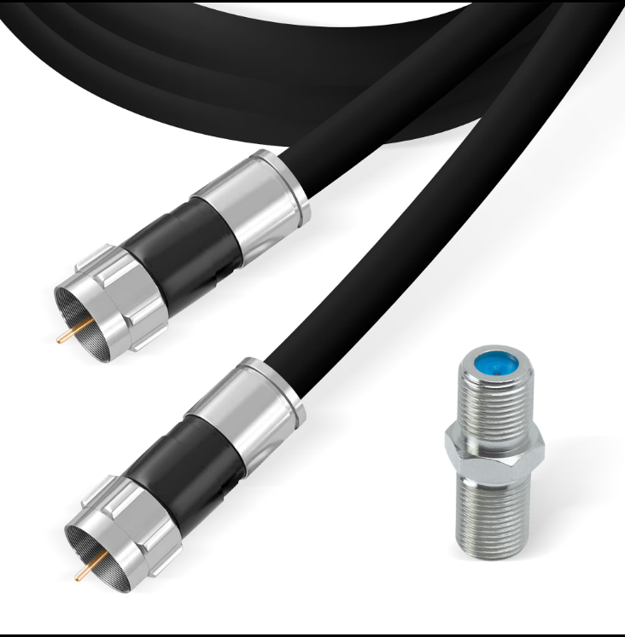 | Commonly used for cable TV connections, cable internet, and connecting a modem to the ISP line.
Fiber Optic Cable | 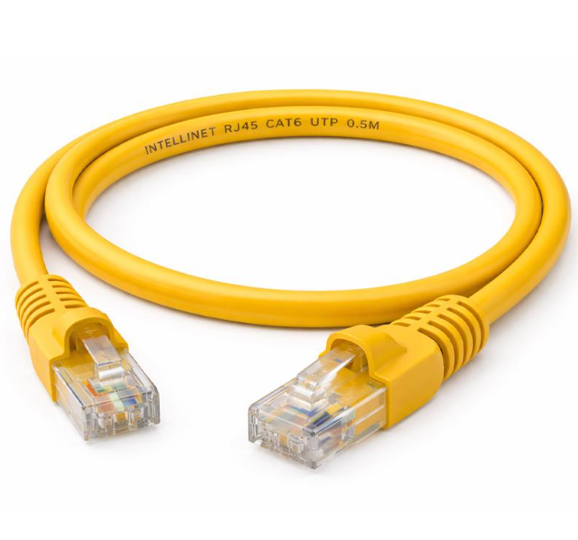 | Used by internet providers and large networks to transmit data at very high speeds over long distances.
Image Sources
- Ethernet Cable: Walmart Ethernet Cable Image
- Coaxial Cable: Walmart RG6 Coaxial Cable Image
- Ethernet (RJ45) Cable Image: Intellinet RJ45 Cat6 Cable Image
One-line summary:
- Ethernet → Connects network devices in a LAN.
- Coaxial → Used for TV and cable internet connections.
- Fiber Optic → Used for high-speed internet and long-distance communication.

Create a comparison table listing at least four differences between a router and a switch, including their main use, typical location, and how they handle data.
Feature | Router | Switch
Main Use | Connects a network to the Internet. | Connects devices within the same network.
Typical Location | Home or office internet setup. | Office, school, or computer lab.
How Data is Handled | Uses IP addresses to send data. | Uses MAC addresses to send data.
Wireless Support | Usually provides Wi-Fi. | Usually provides only wired connections.

