Router and Switch Theory Assignment

Draw a labelled diagram of a typical home WiFi router and a network switch, clearly marking at least 3 different ports (such as WAN, LAN, Console) and the location of status LEDs.
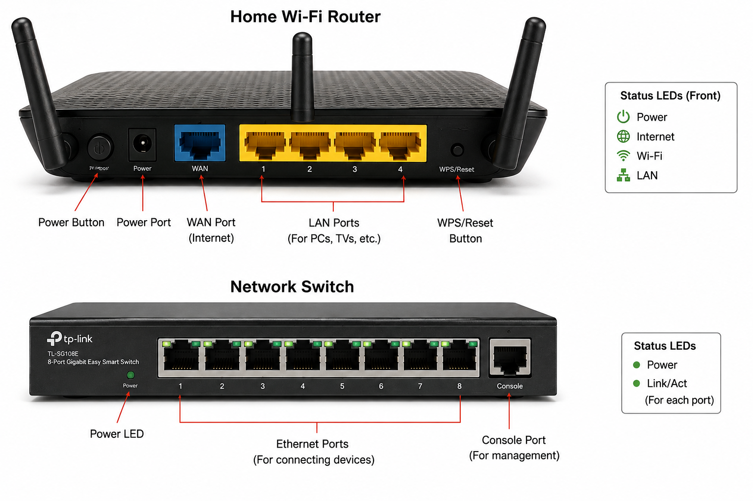

List 3 key differences between routers and switches in terms of their main functions and how they handle network traffic.<br><br><em><strong>Hint:</strong> Think about how each device deals with IP addresses, MAC addresses, and the types of networks they connect.</em>

Feature | Router | Switch
Main Function | Connects different networks (such as a home network to the Internet). | Connects devices within the same network.
Address Used | Uses IP Addresses to send data between networks. | Uses MAC Addresses to send data to the correct device.
Network Traffic Handling | Routes data between different networks and chooses the best path. | Forwards data directly to the destination device within the local network.

Take a real or virtual image of a router and a switch (from your home, lab, or Google Images), and identify the following on each: Power port, at least 2 Ethernet ports, and any LED indicators. Annotate the image or describe their position and purpose.
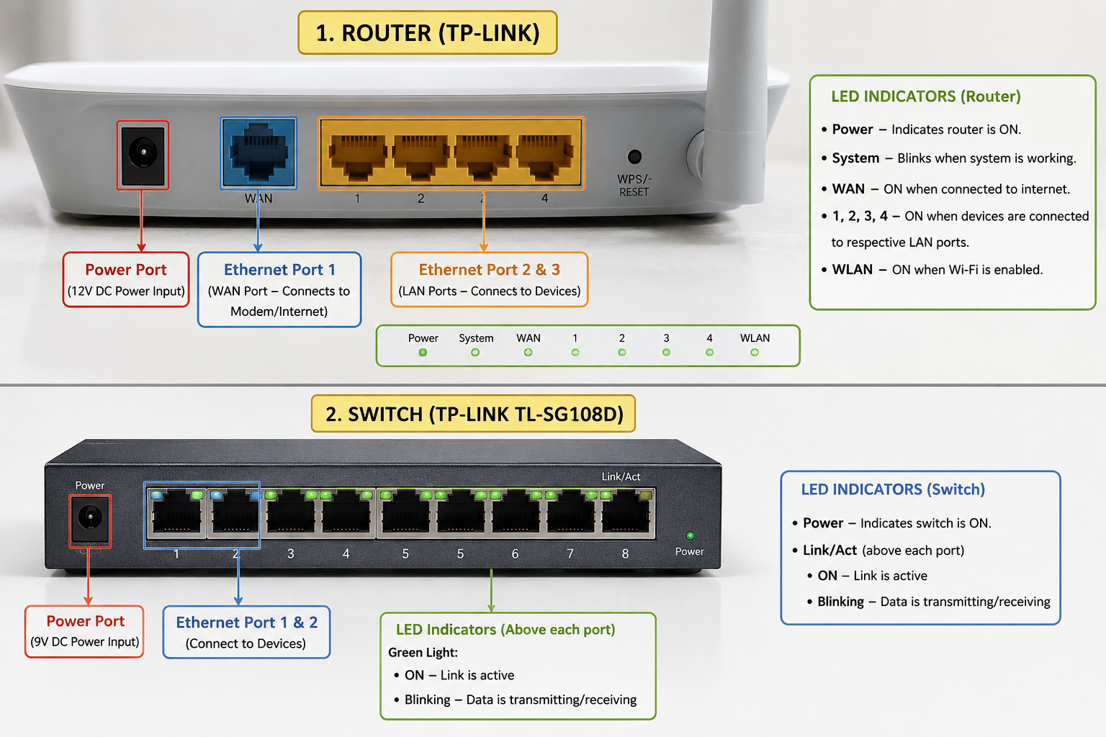

Imagine you are setting up a small gaming café network for IPL streaming and multiplayer matches. Write a short scenario explaining which device (router or switch) you would connect first to the ISP line, and how you would connect 8 gaming PCs to the network. Justify your choices.

I am setting up a small gaming café for IPL streaming and multiplayer games.First, I would connect the Router to the ISP internet line because the router provides internet access and assigns IP addresses to all devices.Next, I would connect a Switch to one of the router's LAN ports. Then, I would connect all 8 gaming PCs to the switch using Ethernet cables.
Why this setup?
- Router → Connects the café to the Internet.
- Switch → Provides enough ports to connect all 8 PCs.
- Ethernet cables → Give fast and stable connections for gaming and streaming.
- This setup reduces lag and ensures smooth IPL streaming and multiplayer matches.

