Wi‑Fi Router Configuration Assignment

Log in to your home Wi-Fi router's admin panel using its default IP address (usually 192.168.0.1 or 192.168.1.1) and take a screenshot of the login page.
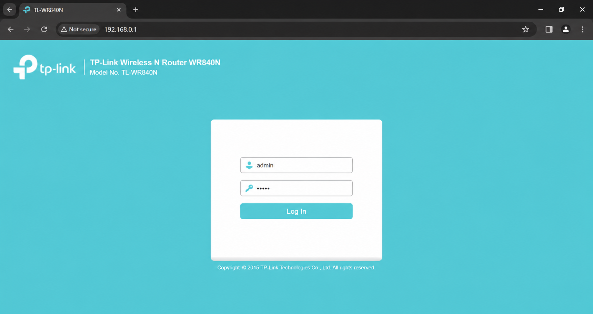

Find and note down the current IP address, subnet mask, and default gateway assigned to your laptop or mobile device when connected to your Wi-Fi network.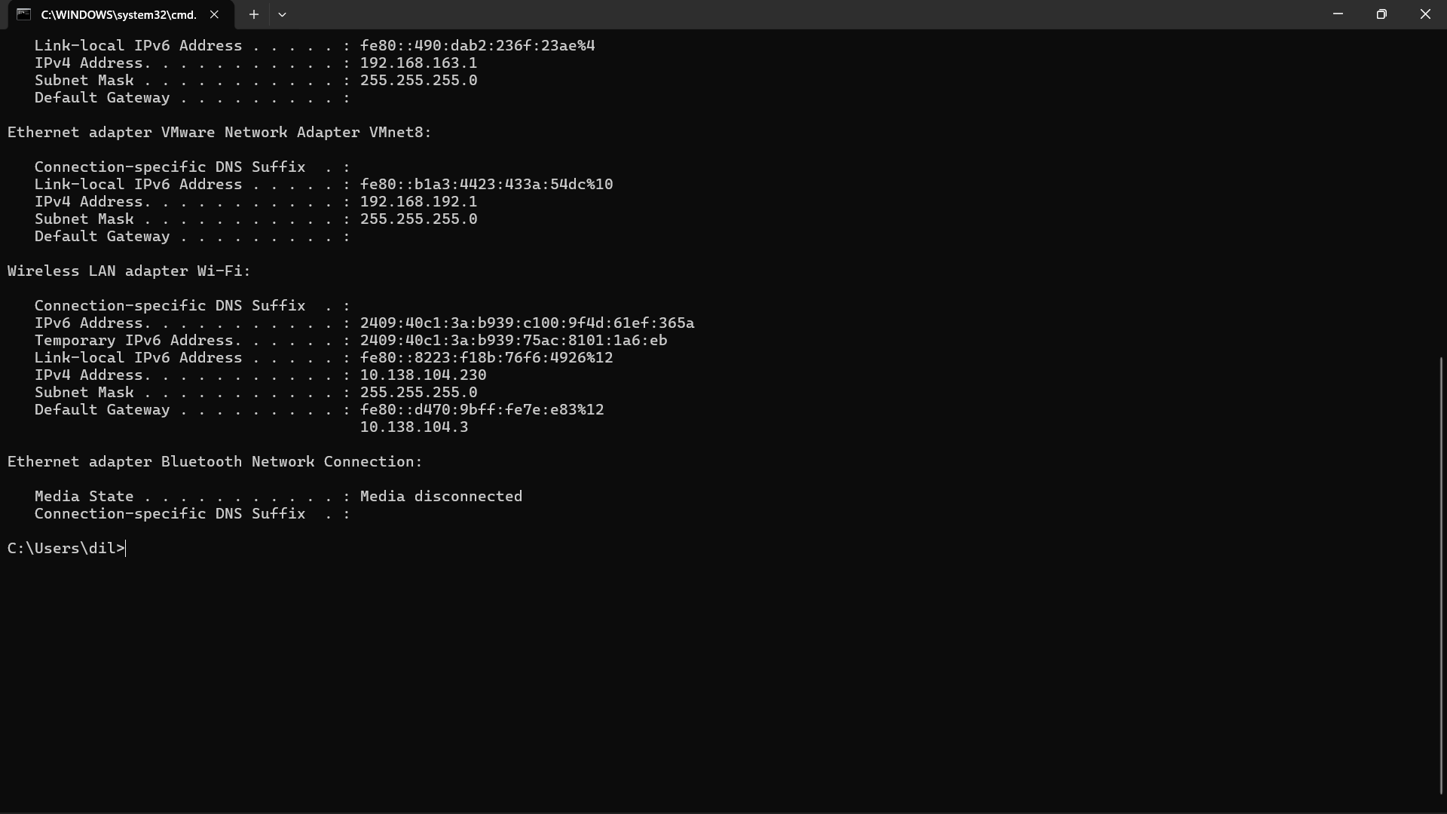
IP Address: 10.138.104.230
Subnet Mask: 255.255.255.0
Default Gateway: 10.138.104.3

Change your device's IP address from 'Obtain IP automatically' (DHCP) to a static IP in the same range as your router (for example, set it to 192.168.1.50 if your router is 192.168.1.1), and test if you still have internet access.
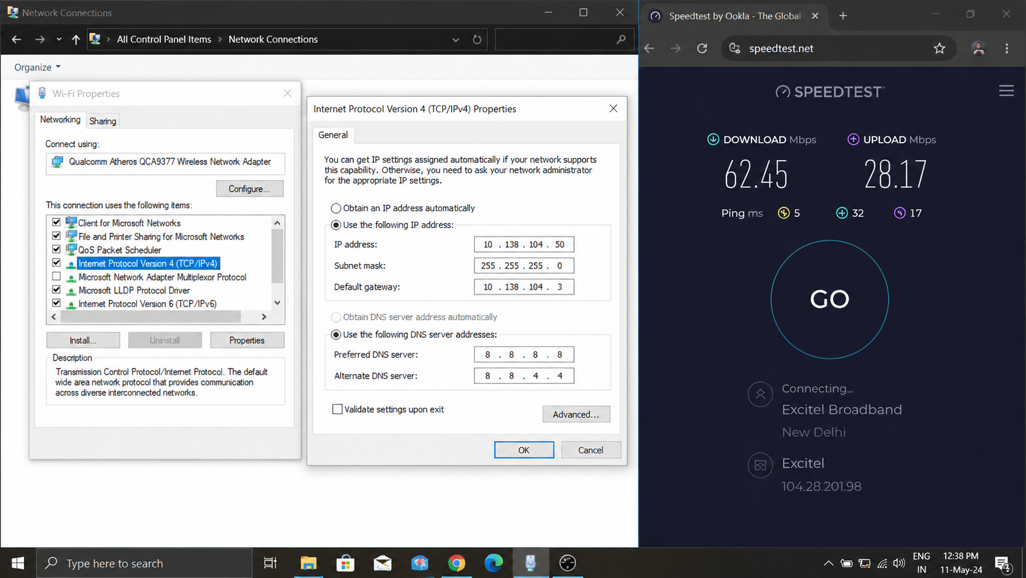

In your router's admin panel, locate the section where you can view or change the DHCP range. Write down the current range, and explain in 2-3 lines what would happen if two devices are assigned the same IP address in this range.
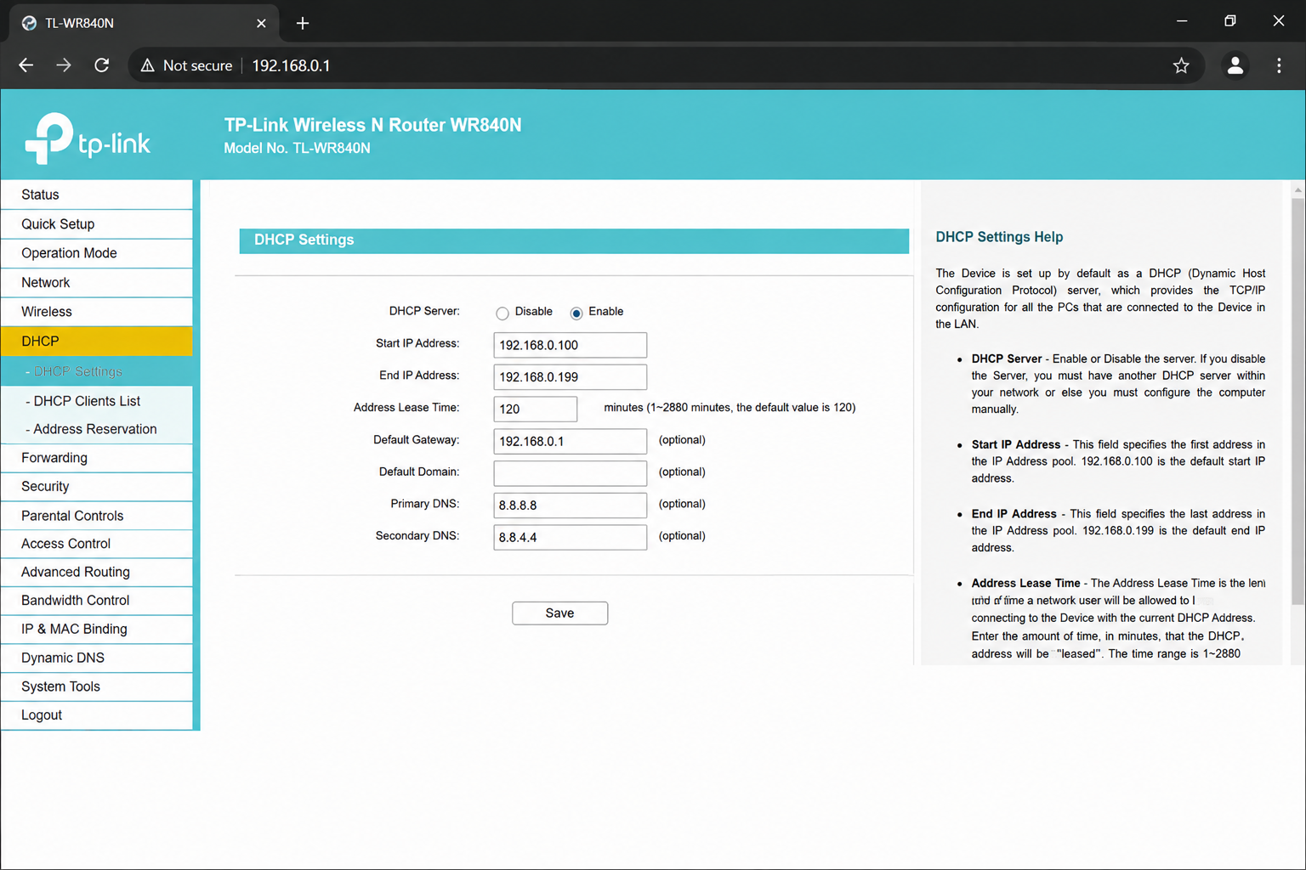
Current DHCP Range:
192.168.0.100 to 192.168.0.199
If two devices are assigned the same IP address, an IP conflict occurs. Both devices may experience network connectivity problems, such as losing internet access or being unable to communicate properly on the network. The router cannot correctly determine which device should receive incoming data, causing unstable network performance.

