Network Cables and RJ45 Connector Assignment

List 3 key differences between Ethernet cables and fiber optic cables, and give one real-world example where each type would be used (for example, home WiFi router, data center, college campus backbone).
Feature | Ethernet Cable | Fiber Optic Cable
Transmission Medium | Uses electrical signals through copper wires | Uses light signals through glass or plastic fibers
Speed & Bandwidth | Good speed for homes and offices | Very high speed and bandwidth
Distance | Effective up to about 100 meters | Can work over several kilometers
Real-World Examples
- Ethernet Cable: Used to connect PCs to a switch in a gaming café or to connect a desktop computer to a home Wi-Fi router.
- Fiber Optic Cable: Used as the backbone network in a college campus or for high-speed connections between servers in a data center.

T568B Straight-Through Ethernet Cable Wiring
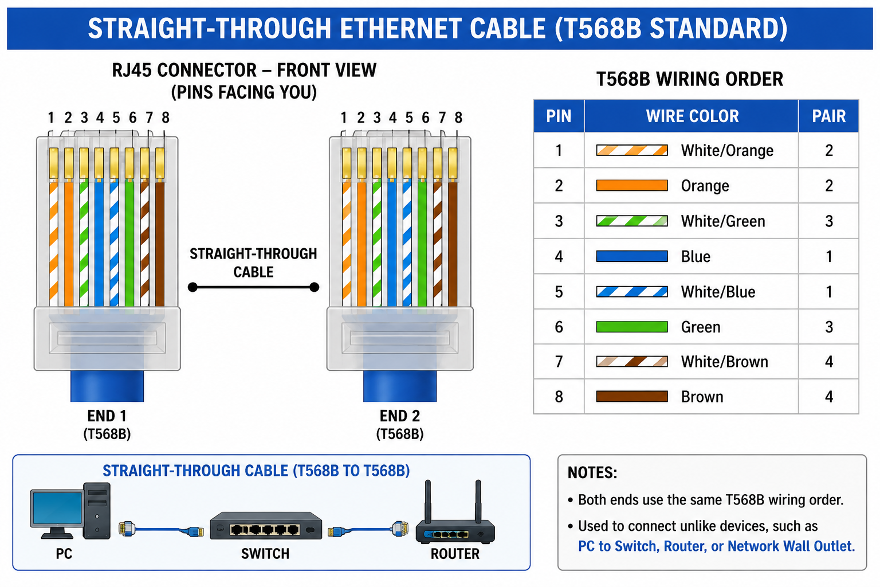

Watch a YouTube video demonstrating how to use an RJ45 crimper, then write a step-by-step guide (in your own words) on how to attach an RJ45 connector to a CAT6 cable.

1. Cut the CAT6 cable to the required length.
2. Strip about 2–3 cm of the outer jacket.
3. Untwist and arrange the wires in T568B order.
4. Straighten the wires and trim them evenly.
5. Insert the wires into the RJ45 connector.
6. Check that every wire reaches the end of the connector.
7. Place the connector into the RJ45 crimper.
8. Press the crimper firmly to secure the connector.
9. Test the cable using a cable tester.

4. Imagine you are setting up a gaming café with 10 PCs for LAN gaming. Decide which cable type (Ethernet or fiber optics) and which tool (RJ45 crimper or fiber cleaver) you would use, and explain your choices in 3-4 sentences.
For a gaming café with 10 PCs, I would use Ethernet (CAT6) cables and an RJ45 crimper. Ethernet cables provide high speed and low delay (latency), which is important for LAN gaming. The distance between PCs and the switch is short, so fiber optic cables are not necessary. Ethernet cables and RJ45 connectors are also cheaper, making them the best choice for a gaming café on a budget.

