- Network Connectivity Assignment

Connect your laptop and a friend's phone to the same Wi-Fi network, then use the ping command to check if both devices can communicate with each other.
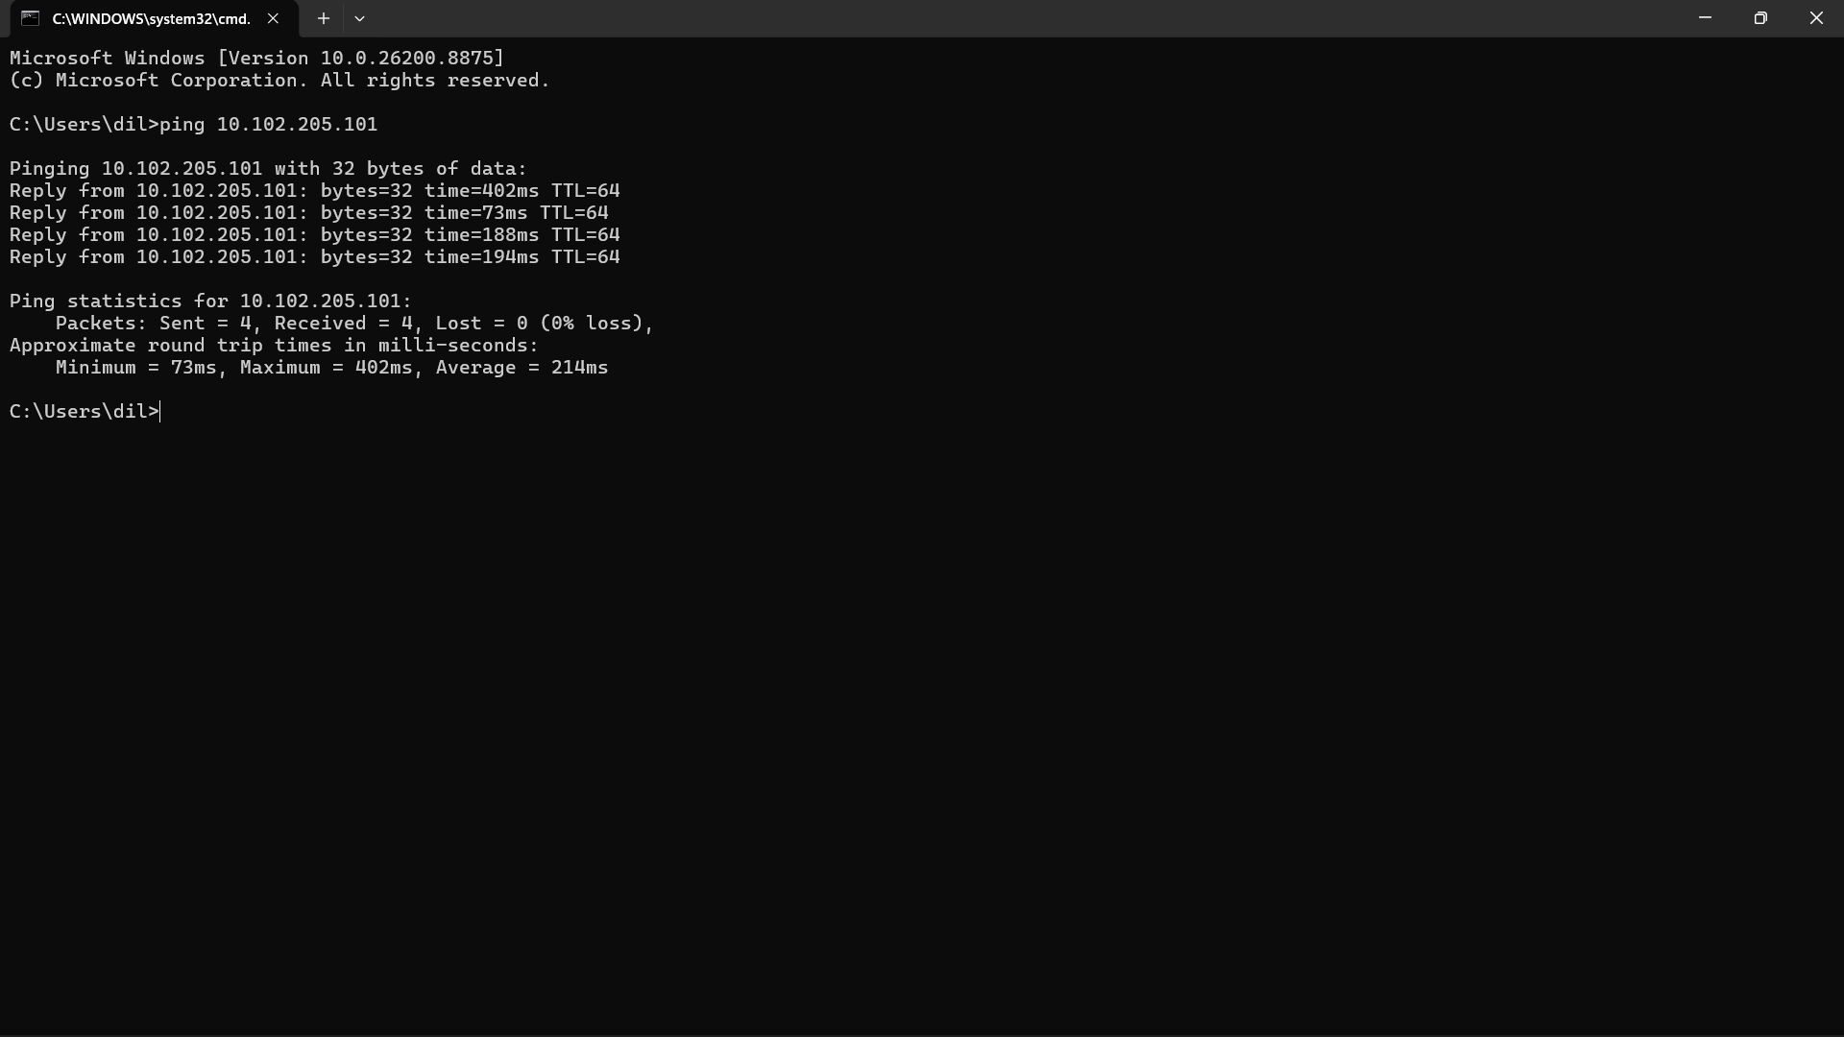

Run the traceroute (tracert on Windows or traceroute on Mac/Linux) command to www.youtube.com from your device and note down the number of hops it takes to reach the destination.how to do it
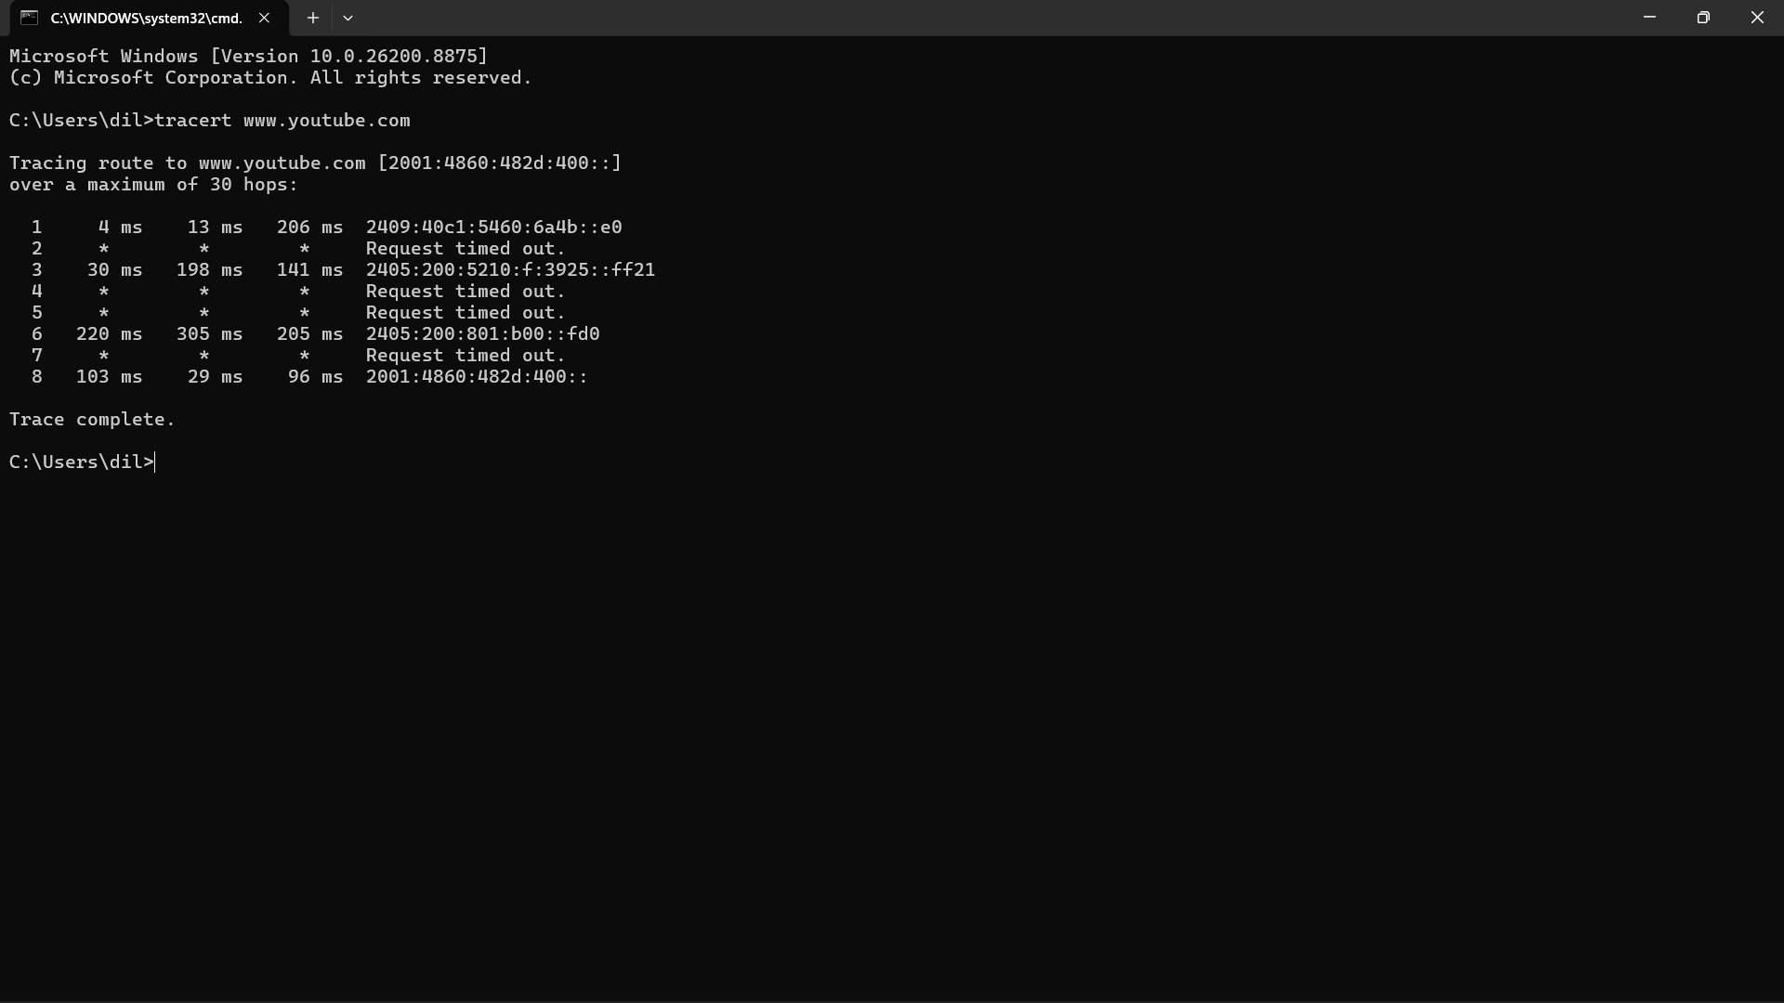

Number of Hops: 8

Disconnect one device from the Wi-Fi, then try pinging it again from your laptop and describe the error message you receive.
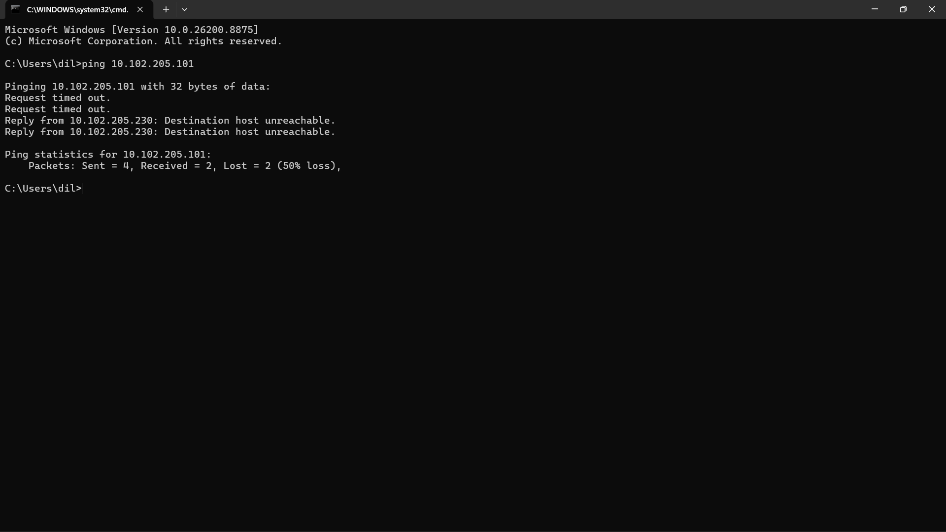
Error Message Received:
- Request timed out.
- Destination host unreachable.

The connectivity test failed after the device was disconnected from Wi-Fi, confirming that devices must be connected to the same network to communicate with each other.

Create a simple table listing the IP addresses of all devices connected to your home Wi-Fi (use 'arp -a' on Windows), and identify which device belongs to which person or gadget.
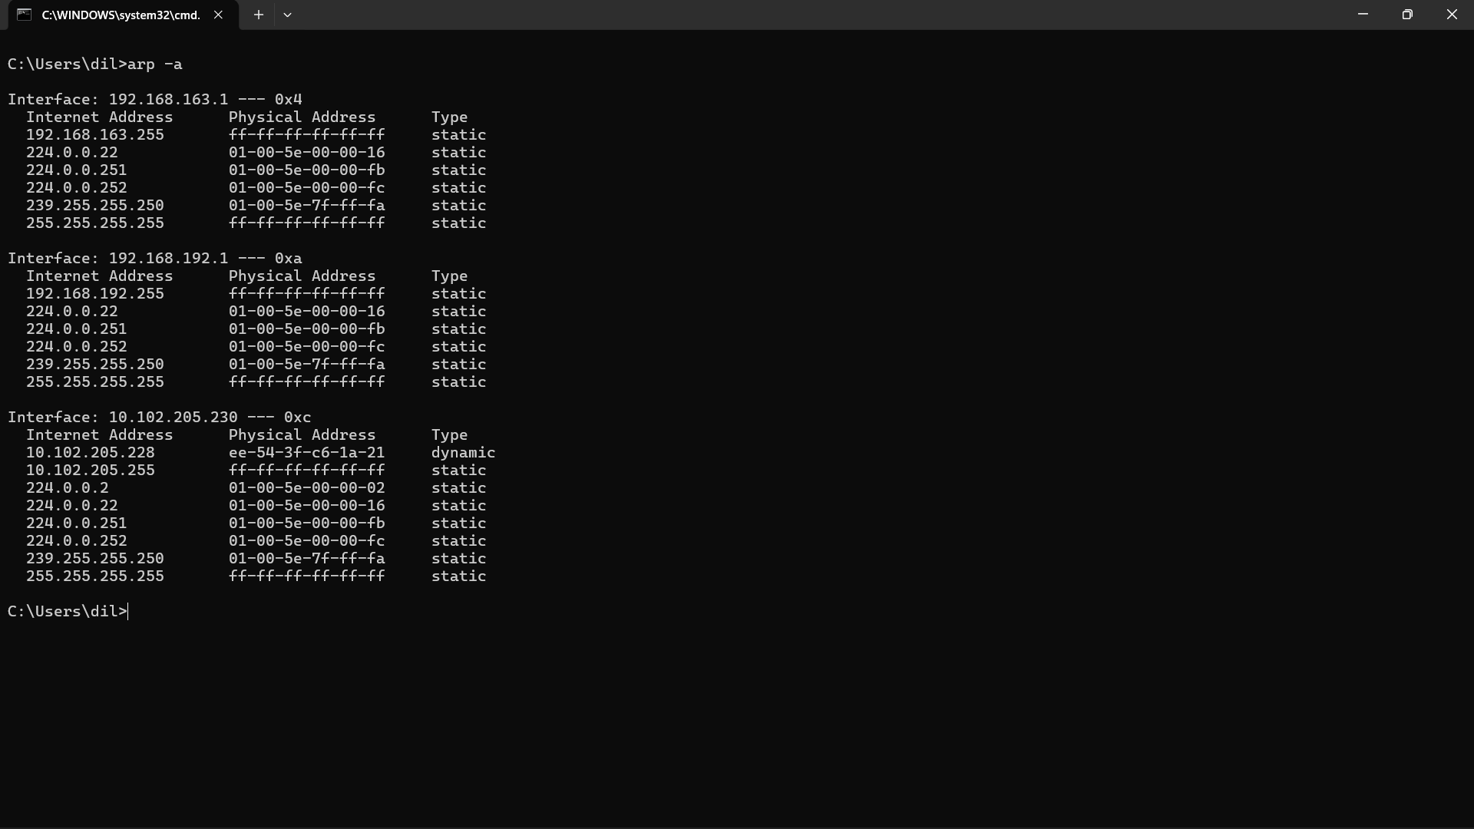
Using the arp -a command, I viewed the devices present on the local network. I identified my laptop (10.102.205.230) and my mobile phone (10.102.205.228) based on their IP addresses. Other entries were broadcast or multicast addresses used by network services and could not be assigned to a specific user.

Write a one-page report explaining step-by-step how you set up the network, tested connectivity using ping and traceroute, and what results or issues you observed.
First, I connected my laptop and mobile phone to the same Wi-Fi network. I checked their IP addresses and used the ping command to test communication between them. The ping test was successful, and both devices were able to communicate with each other.

Next, I used the tracert www.youtube.com command to see the path taken by data packets to reach YouTube. The traceroute reached the destination in 8 hops. Some hops showed "Request timed out", which is normal.

After that, I disconnected the mobile phone from the Wi-Fi network and ran the ping command again. This time, I received "Request timed out" and "Destination host unreachable" messages, showing that the device was no longer connected to the network.

Finally, I used the arp -a command to view devices connected to the network and identified my laptop and mobile phone from their IP addresses.


Conclusion
This activity helped me learn how to test network connectivity using Ping, Traceroute, and ARP commands. I also learned how to identify network problems when a device is disconnected.

