Computer Troubleshooting Tools Assignment

List three real-life scenarios where a multimeter would be used to troubleshoot a computer or smartphone issue, and explain in one line how the multimeter helps in each case.

Scenario | How the Multimeter Helps
Laptop not turning on | Checks if the charger is giving the correct voltage or not.
Smartphone not charging | Measures the battery and charging port voltage to find charging problems.
Desktop computer keeps shutting down | Tests the power supply (SMPS) voltage to see if it is faulty.
Short Answer:
- Laptop not turning on – A multimeter checks whether the charger is supplying power.
- Smartphone not charging – A multimeter checks the battery and charging voltage.
- Desktop shutting down randomly – A multimeter checks if the power supply is working properly.

Watch a short YouTube video demo of a POST card in action (search for 'POST card motherboard test'), then write a brief summary (3-4 lines) describing what the POST card displays and what problem it helped identify in the video
A POST card displays POST (Power-On Self-Test) codes while the computer is starting up. These codes show which hardware component the motherboard is checking. If the computer stops at a particular code, the POST card helps identify the faulty hardware. In the video, the displayed code helped detect a problem with a hardware component such as RAM or the motherboard, making troubleshooting easier. (tomshardware.com)

Download and install any free software diagnostic tool (such as HWMonitor, Speccy, or CrystalDiskInfo), run it on your laptop or desktop, and take a screenshot of the main dashboard showing system health details.
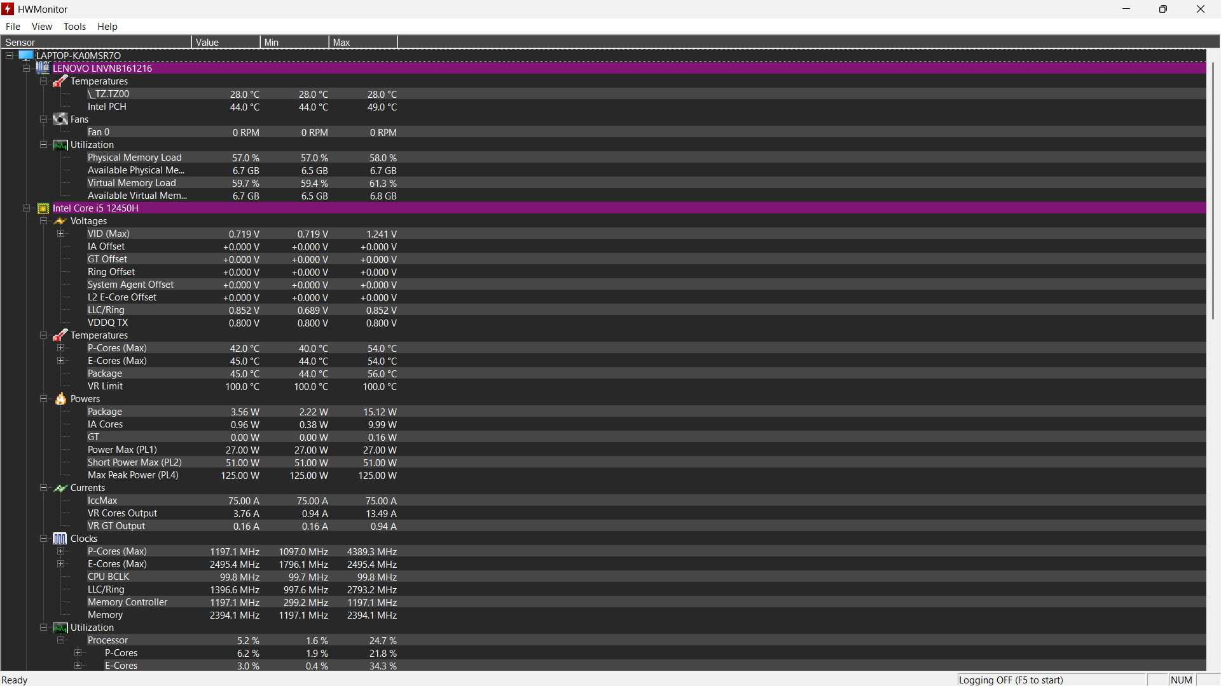

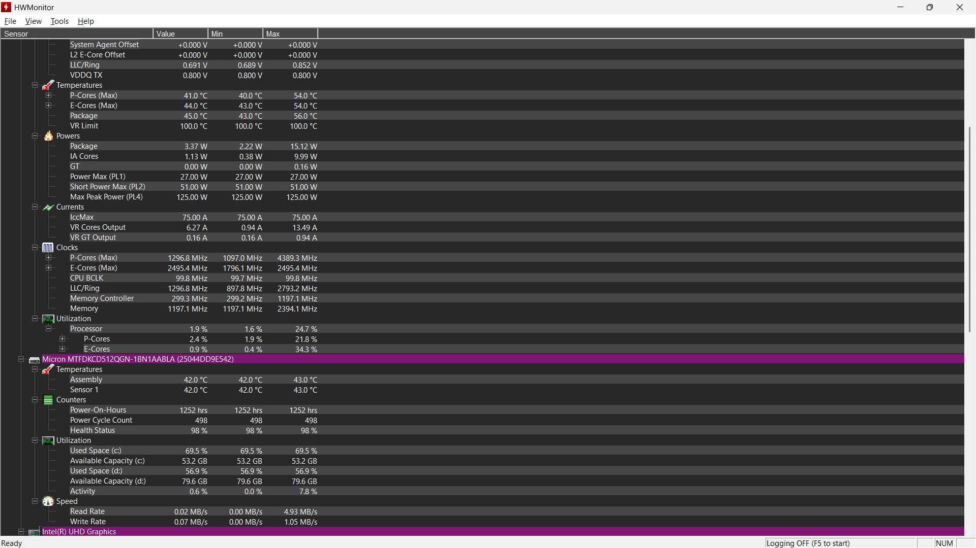

Compare the use of a multimeter, POST card, and software diagnostics by creating a table with three columns (Tool, What it checks, Example Problem Detected) and fill in at least one example for each tool.
Tool | What it Checks | Example Problem Detected
Multimeter | Voltage, current, and continuity in electrical circuits | Faulty laptop charger or dead battery
POST Card | POST (Power-On Self-Test) codes during computer startup | RAM error preventing the computer from booting
Software Diagnostics (HWMonitor/Speccy) | System health, temperature, and hardware status | CPU overheating or hard drive health issue
A multimeter checks electrical problems, a POST card identifies hardware startup errors, and software diagnostics monitor system health and performance.

