BIOS and POST Errors Assignment

List 5 common BIOS or POST error messages you might see when starting a PC and write what hardware or configuration issue each one usually points to.
Error Message | Usually Indicates
CMOS Checksum Error | CMOS battery is weak or BIOS settings were reset
Keyboard Not Detected | Keyboard is disconnected or faulty
No Boot Device Found | Hard drive/SSD not detected or no operating system installed
Memory Error | RAM is loose, faulty, or incompatible
CPU Fan Error | CPU cooling fan is not connected or not working

Given this scenario: On boot, a PC beeps 3 times in a repeating pattern and does not display anything on the screen. Research and write what this POST beep code typically means for an AMI BIOS, and suggest two troubleshooting steps.
If a PC beeps 3 times repeatedly and shows no display, AMI BIOS commonly indicates a memory (RAM) problem. The RAM may be loose, damaged, or not detected by the motherboard.
Troubleshooting Steps:
1. Remove and reseat the RAM modules properly.
2. Test one RAM stick at a time or replace the faulty RAM.

3. Access the BIOS setup utility on any available PC or virtual machine, take a screenshot of the main BIOS screen, and identify the motherboard manufacturer and BIOS version.
Here I had opened my BIOS and you can see motherboard manufacturer and BIOS version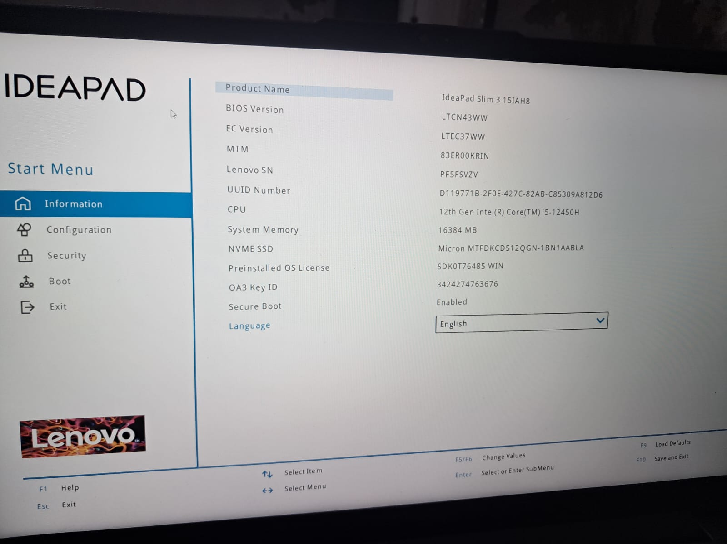

You are given a screenshot of a POST error message that says 'CMOS checksum error – Defaults loaded.' Explain what this means and describe how you would resolve this issue in a real system.
What does it mean?
The message "CMOS Checksum Error – Defaults Loaded" means that the computer found a problem with the BIOS settings stored in CMOS memory. Because the saved settings could not be verified, the BIOS loaded its default settings instead. This usually happens when the CMOS battery is weak or dead, or when the BIOS settings have been reset or corrupted.
How to Fix It
- Enter BIOS Setup
  - Press F2, Delete, or F10during startup.
  - Check the date, time, and BIOS settings
- Load Default Settings
  - Select Load Defaults or Apply Defaults in BIOS.
  - Save and restart the computer.
- Replace the CMOS Battery
  - If the error keeps appearing, replace the small CMOS battery (usually CR2032) on the motherboard.
  - A weak battery cannot save BIOS settings when the PC is turned off.
- Set Date and Time Again
  - After replacing the battery, enter BIOS and set the correct date and time.
  - Save the settings and restart.
Conclusion
CMOS Checksum Error – Defaults Loaded usually indicates a weak CMOS battery or reset BIOS settings. Replacing the CMOS battery and reconfiguring BIOS settings normally fixes the problem.

