- TCP/IP Model and Wireshark Analysis Assignment

- Wireshark Capture and Layer Identification

Objective
To capture network traffic while refreshing the Flipkart homepage and identify packets belonging to different TCP/IP layers.

Procedure
- Opened Wireshark.
- Selected the Wi-Fi interface.
- Started packet capture.
- Opened and refreshed Flipkart homepage.
- Stopped the capture.
- Analyzed packet headers.

Packets Identified
TCP/IP Layer | Protocol Found | Purpose
Application Layer | DNS | Resolves website name into IP address
Transport Layer | TCP | Provides reliable communication
Internet Layer | IP (IPv4/IPv6) | Routes packets between networks
Network Access Layer | Ethernet/Wi-Fi | Transfers data on the local network

Screenshot 1: Wireshark Capture
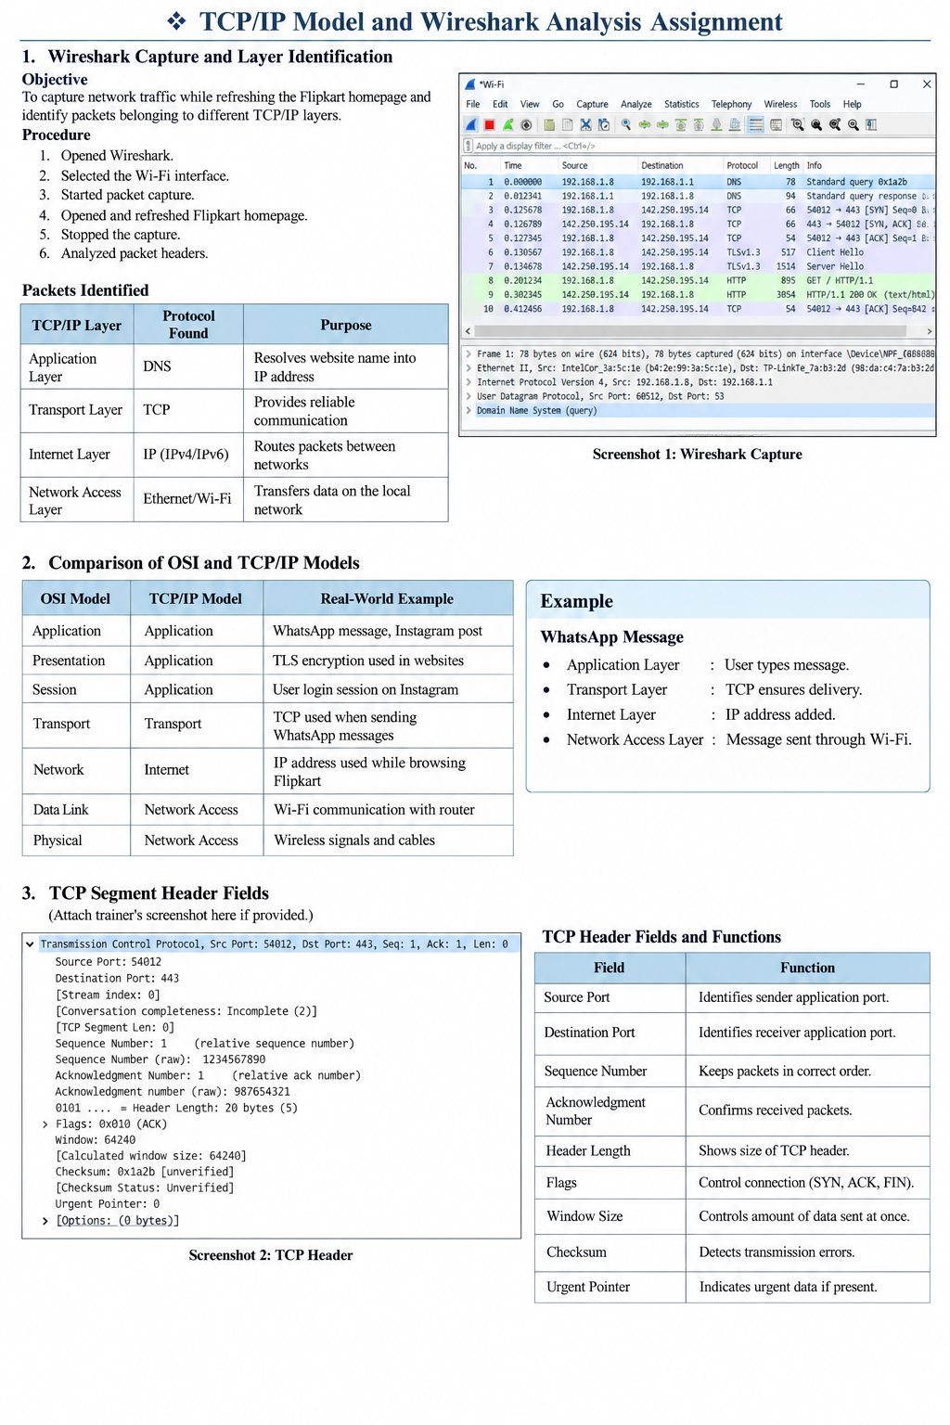

2. Comparison of OSI and TCP/IP Models
OSI Model | TCP/IP Model | Real-World Example
Application | Application | WhatsApp message, Instagram post
Presentation | Application | TLS encryption used in websites
Session | Application | User login session on Instagram
Transport | Transport | TCP used when sending WhatsApp messages
Network | Internet | IP address used while browsing Flipkart
Data Link | Network Access | Wi-Fi communication with router
Physical | Network Access | Wireless signals and cables

Example
WhatsApp Message
- Application Layer → User types message.
- Transport Layer → TCP ensures delivery.
- Internet Layer → IP address added.
- Network Access Layer → Message sent through Wi-Fi.

3. TCP Segment Header Fields
(Attach trainer's screenshot here if provided.)
Screenshot 2: TCP Header


TCP Header Fields and Functions
Field | Function
Source Port | Identifies sender application port.
Destination Port | Identifies receiver application port.
Sequence Number | Keeps packets in correct order.
Acknowledgment Number | Confirms received packets.
Header Length | Shows size of TCP header.
Flags | Control connection (SYN, ACK, FIN).
Window Size | Controls amount of data sent at once.
Checksum | Detects transmission errors.
Urgent Pointer | Indicates urgent data if present.

4. Message Flow Through TCP/IP Layers
Diagram
User Sends Instagram Message
│
▼
+----------------------+
| Application Layer |
| Message Created |
+----------------------+
│
▼
+----------------------+
| Transport Layer |
| TCP Splits Data |
+----------------------+
│
▼
+----------------------+
| Internet Layer |
| IP Address Added |
+----------------------+
│
▼
+----------------------+
| Network Access Layer |
| Sent Through Wi-Fi |
+----------------------+
│
▼
Instagram Server
Explanation
Application Layer
The user types a message on Instagram.
Transport Layer
TCP divides the message into smaller packets and ensures reliable delivery.
Internet Layer
The source and destination IP addresses are added.
Network Access Layer
The packet is transmitted through Wi-Fi or Ethernet.
Instagram Server
The server receives and processes the message.

5. Analysis of One Captured Packet
Selected Packet
Protocol: DNS
TCP/IP Layer
Application Layer
How It Was Identified
The Protocol column in Wireshark showed DNS, and the packet details contained domain name queries and responses.
Real-World Action
When a user opens Flipkart or Instagram, DNS converts:
www.flipkart.com
into an IP address so the browser can connect to the correct server.

Screenshot 3: DNS Packet Analysis
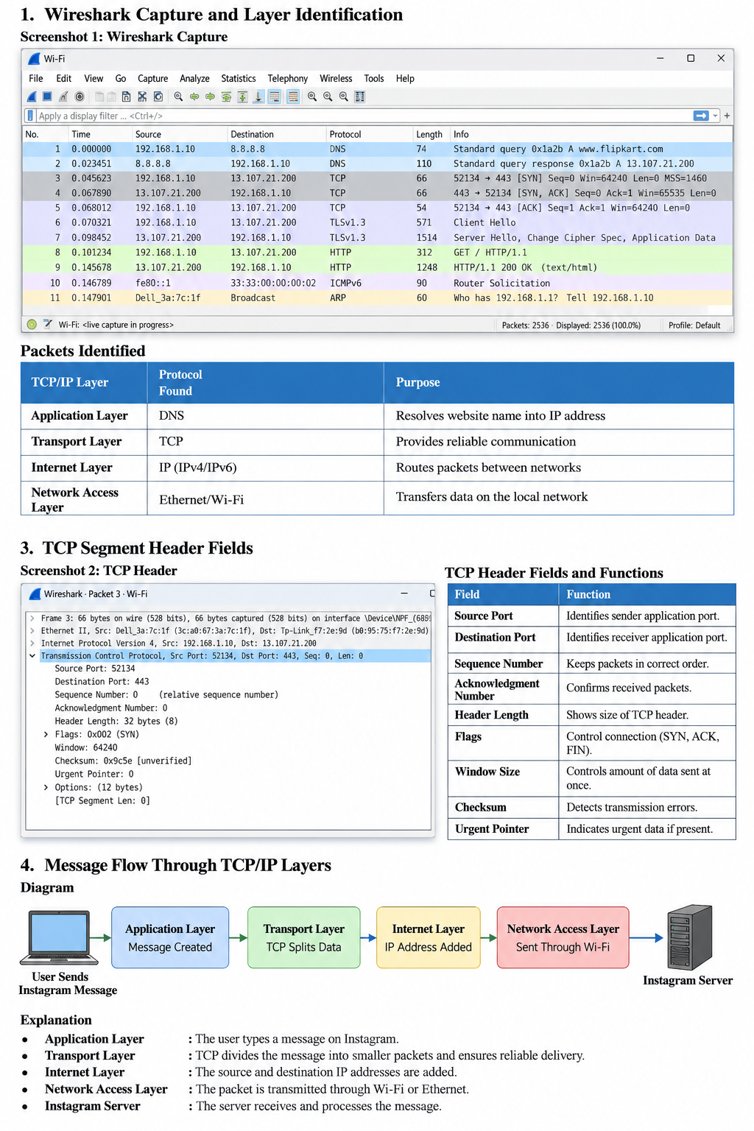

Conclusion
Using Wireshark, network traffic was captured and analyzed. Different TCP/IP layers were identified through protocols such as DNS, TCP, IP, and Ethernet/Wi-Fi. The experiment demonstrated how data travels through multiple layers before reaching a destination server such as Flipkart or Instagram.

