CompTIA N+ - ASSESSMENT
Network Security, Maintenance & Troubleshooting Procedures
Assessment Code: M2-A1

Section A - Concept Application

S1. Selecting CPU, RAM and Storage
For employees using programming software, browsers and video conferencing at the same time, the computer should support multitasking without slowing down.
- CPU: Choose a modern multi-core processor (for example, Core i5/Ryzen 5 class or better) with enough cores/threads for simultaneous applications.
- RAM: 16 GB is a practical starting point for smooth multitasking. Also check DDR generation, speed and motherboard support.
- Storage: Prefer an SSD/NVMe SSD because it gives faster boot, application loading and file access than an HDD.
- Compatibility: CPU socket must match the motherboard; RAM type and maximum capacity must be supported; storage interface such as SATA or M.2/NVMe must be available.
- Also check PSU capacity, cooling, upgrade options and the workload requirements of the software.

S2. Why Antivirus Can Slow a Computer
Antivirus software continuously checks files and running activity for threats. This protection uses system resources.
Component | Effect
CPU | Real-time scanning and threat analysis use processor time, especially during full scans.
RAM | Background antivirus services stay in memory, leaving less RAM for user applications.
Storage | The antivirus reads many files during scans, increasing disk activity. On slower HDDs this can be more noticeable.
The slowdown is usually stronger on systems with low RAM, older CPUs, slow HDDs, or when a full scan runs while employees are working.

S3. USB Keyboard/Printer Driver or OS Troubleshooting
- Test another USB port and reconnect the device.
- Open Device Manager and check for warning symbols or unknown devices.
- Update the keyboard/printer driver from Windows Update or the hardware manufacturer's driver package.
- If a recent driver caused the issue, use Roll Back Driver or uninstall and reinstall the device.
- Check Windows updates and confirm the operating system supports the device.
- For the printer, restart the Print Spooler and reinstall the printer if necessary.
- Test the device again. If it works on another computer but still fails here, the issue is likely with this computer's driver, OS configuration or USB controller.

S4. UPS and Surge Protector
A UPS provides temporary battery power when electricity fails. This gives the user time to save work and shut the computer down safely, reducing sudden data loss and file corruption. A surge protector limits damaging voltage spikes before they reach computer components. Together they help protect the PSU, motherboard, storage and other hardware during power cuts and voltage fluctuations.

S5. DNS and DHCP Working Together
DHCP automatically gives a device its IP address, subnet mask, default gateway and usually the DNS server address. DNS then translates names such as an internal application-server name into an IP address. If a user can reach a server by IP but not by name, DNS configuration or name resolution is likely involved. If devices sometimes fail to obtain a valid IP address, DHCP is also showing a separate problem. Therefore the described symptoms point to checking both services: DNS for the name-resolution failure and DHCP for the address-allocation failure.

S6. Firewall Blocking an Internal Application Server
- Confirm the client has a valid IP configuration and can ping/reach other internal devices.
- Test the application server by IP and test the required application port.
- Review the new firewall's inbound/outbound and inter-network rules for the client subnet, server IP and required port/protocol.
- Check firewall logs for dropped packets matching the client's source IP and server destination.
- Temporarily create a narrowly scoped test allow rule for the required client-to-server traffic rather than disabling the firewall.
- If the test works, correct the rule order, source/destination network, port or protocol and remove the temporary rule.
- Retest access and document the final firewall rule.

Section B - Practical Application
The assessment requires hands-on evidence for these tasks. The following pages give the procedure and leave spaces for your own real screenshots/photos.

Task 1. Workstation Assembly
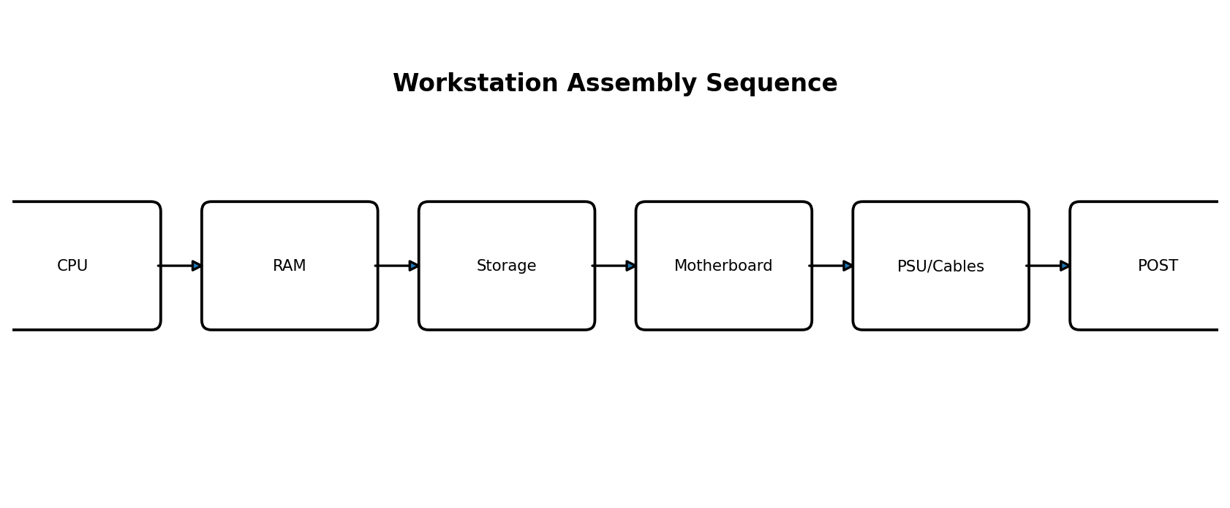
- Wear an anti-static wrist strap and disconnect power.
- Install the CPU into the motherboard socket and lock it correctly.
- Apply/install the CPU cooler as required and connect the CPU fan header.
- Install compatible RAM modules in the recommended slots.
- Install M.2/SATA storage and mount the motherboard in the chassis.
- Install the PSU and any required expansion card such as a GPU.
- Connect 24-pin motherboard power, CPU power, storage/data cables, front-panel connectors and fans.
- Inspect all connections, connect monitor/keyboard and power on.
- Confirm that the system completes POST and enters BIOS/UEFI without hardware errors.
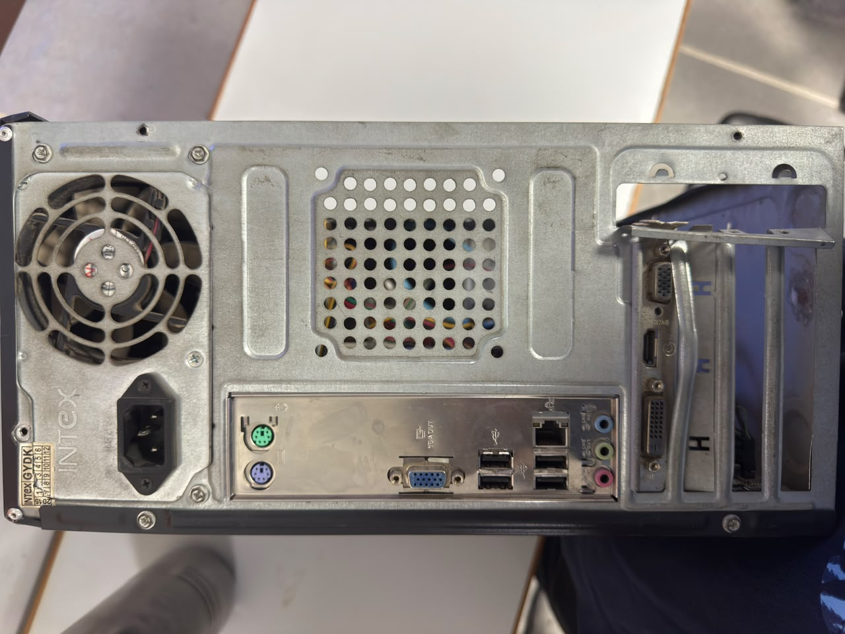
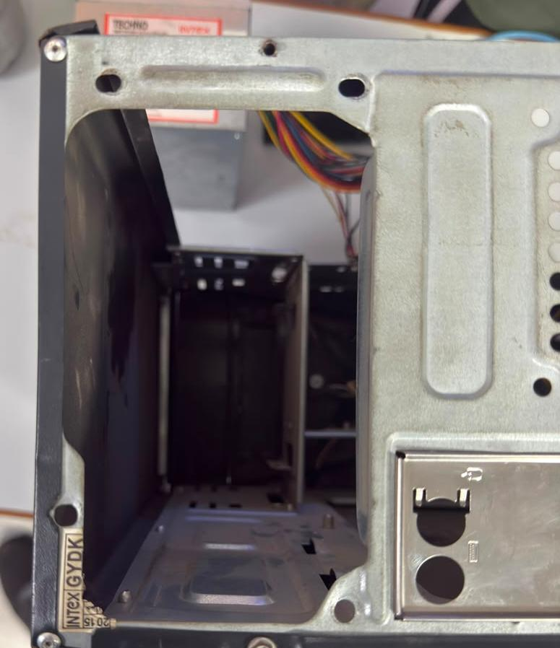
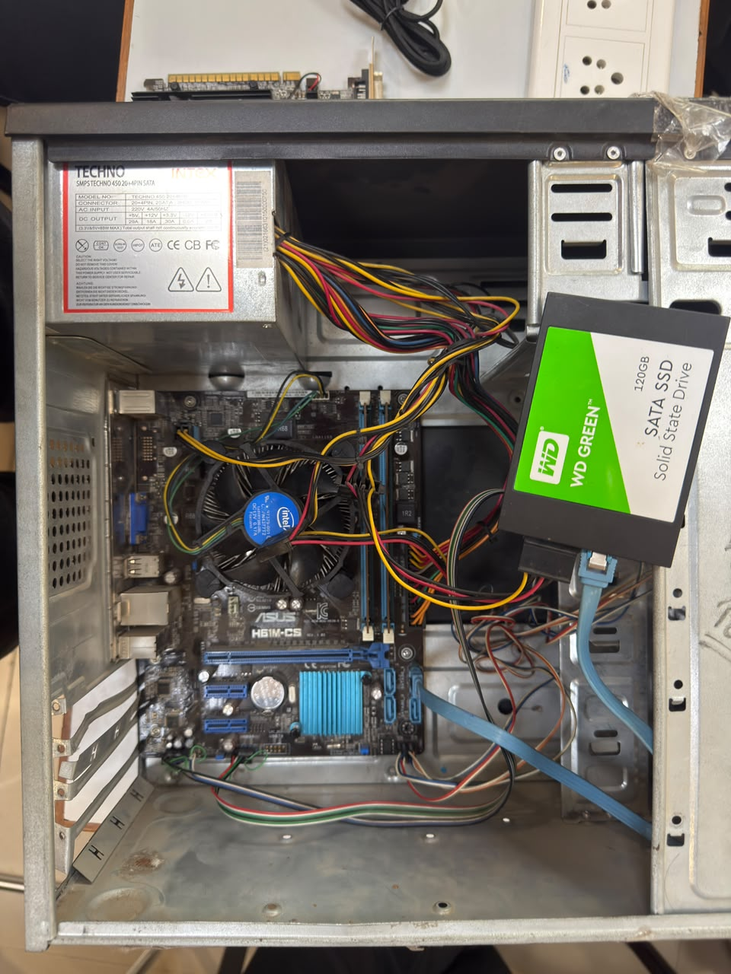
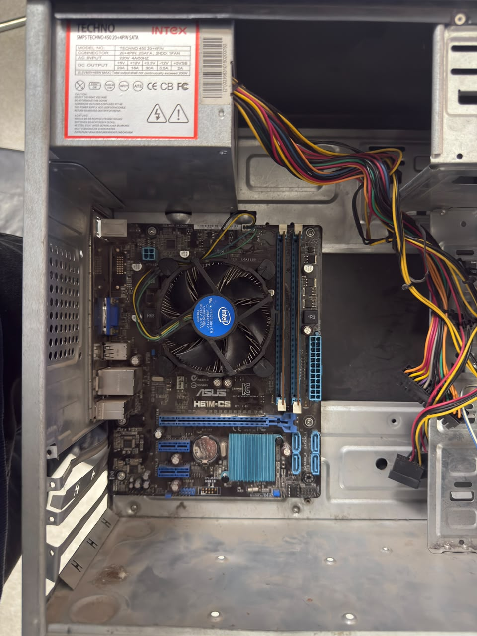
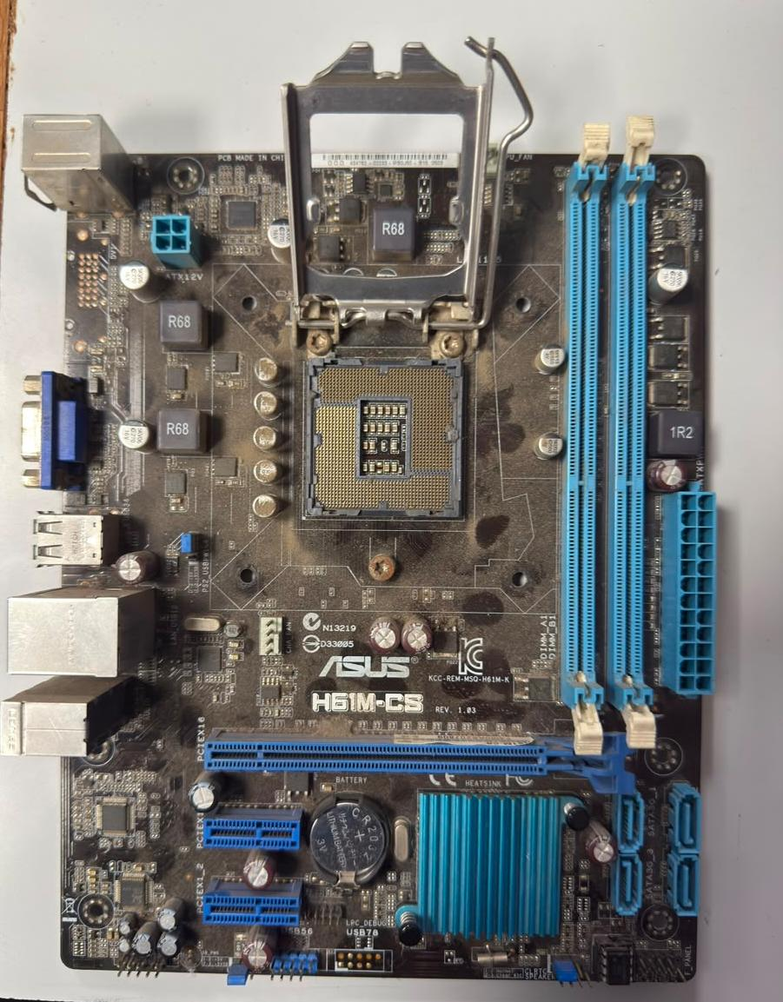
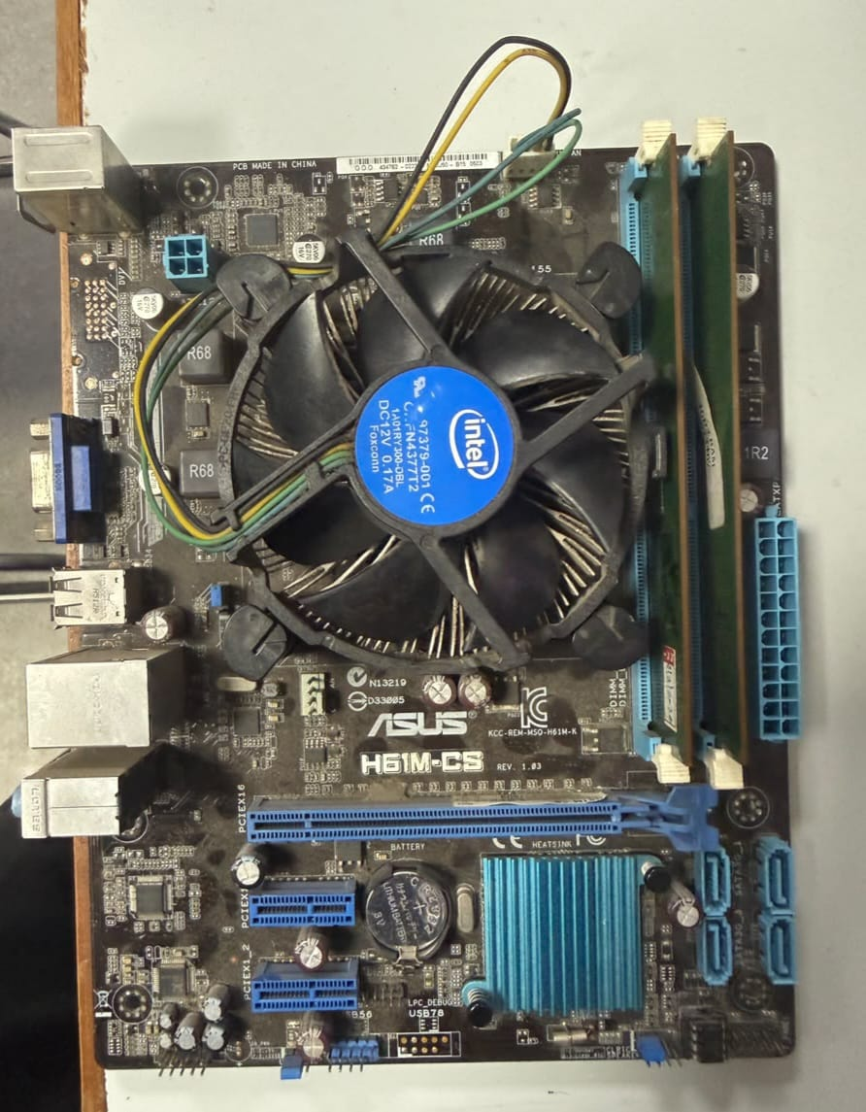
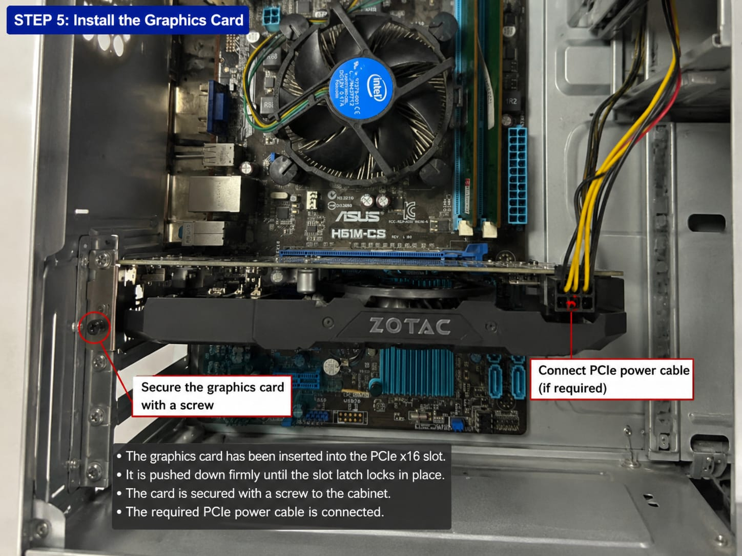
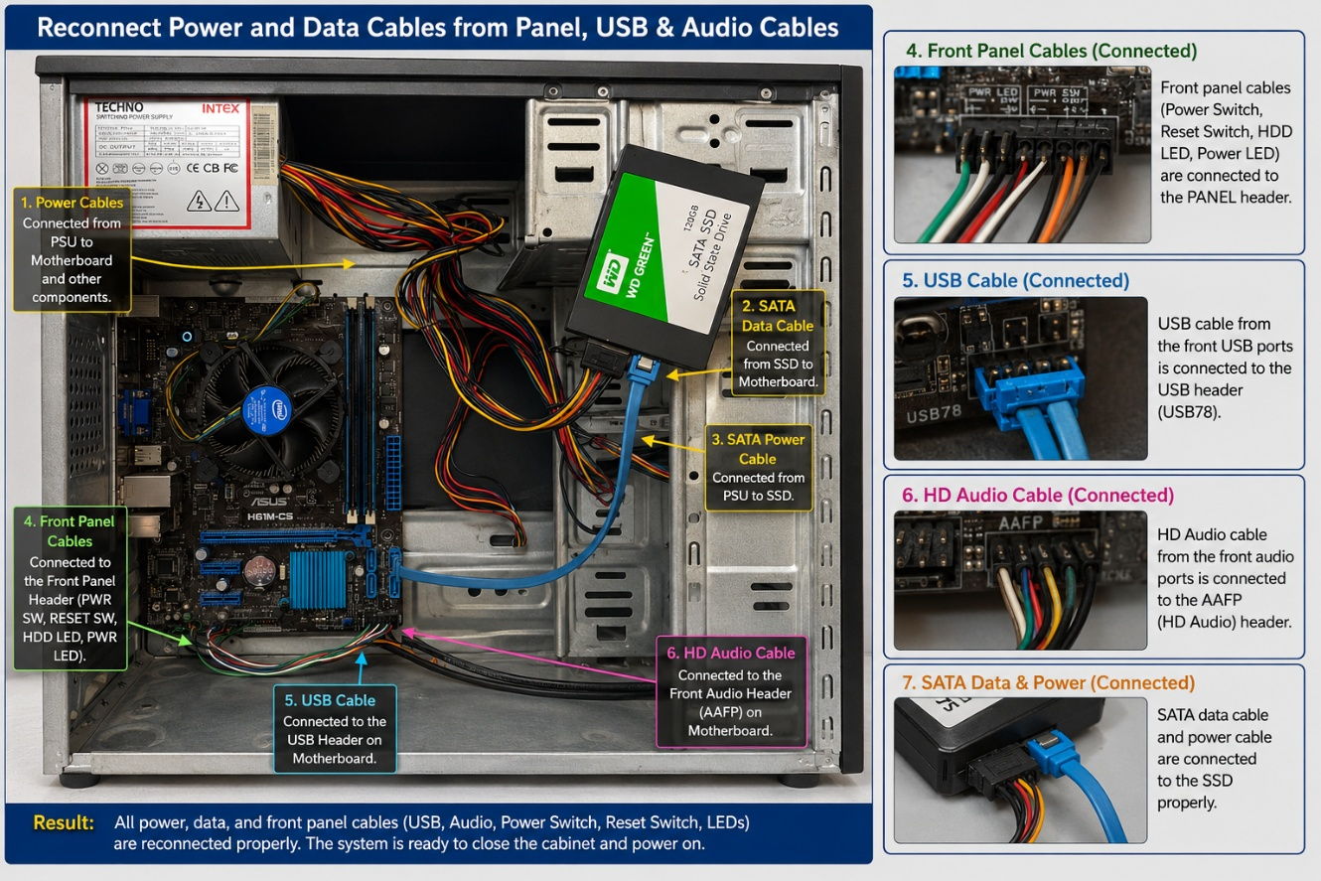
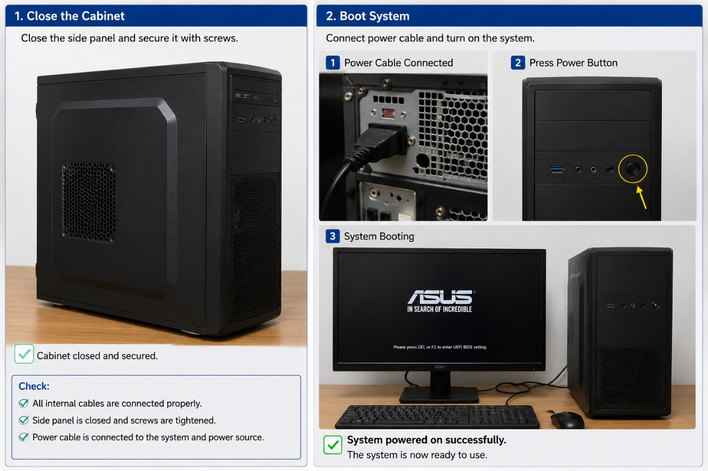

Task 2. RAM Mismatch Troubleshooting
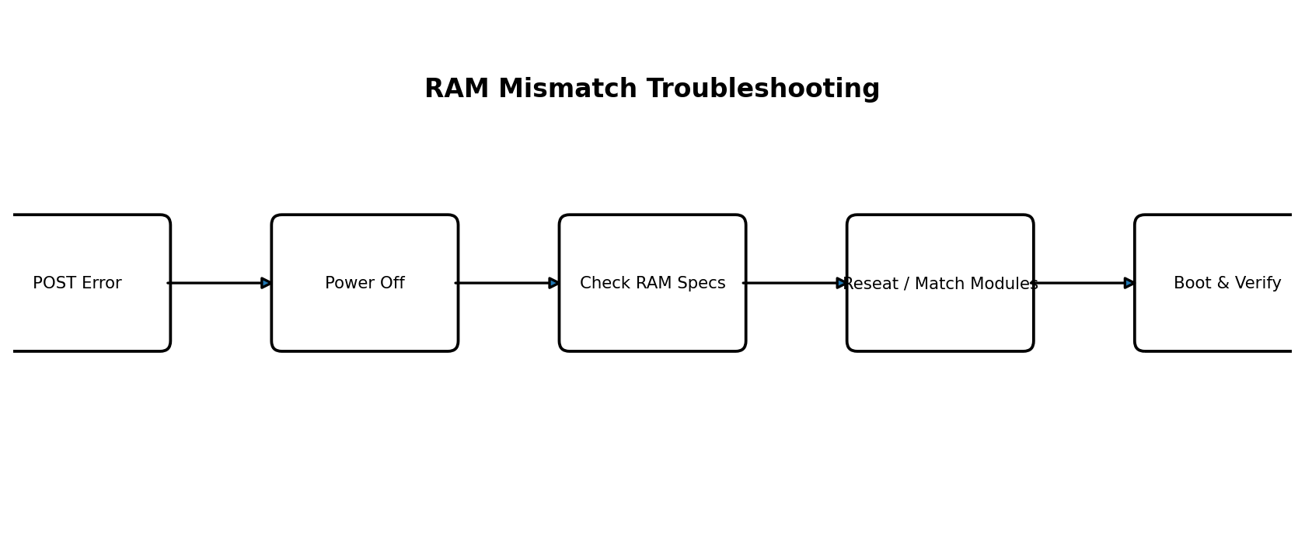
- Enter BIOS/UEFI or observe the POST message and identify the reported memory error.
- Power off the PC, unplug it and use anti-static precautions.
- Check both RAM modules for DDR type, capacity, supported speed and timing.
- Reseat the RAM firmly. If modules are mismatched, use a compatible matched pair or configure a supported memory speed in BIOS.
- Boot again and confirm the correct total memory is detected.
- Save BIOS settings if changed and confirm Windows/Linux boots normally.
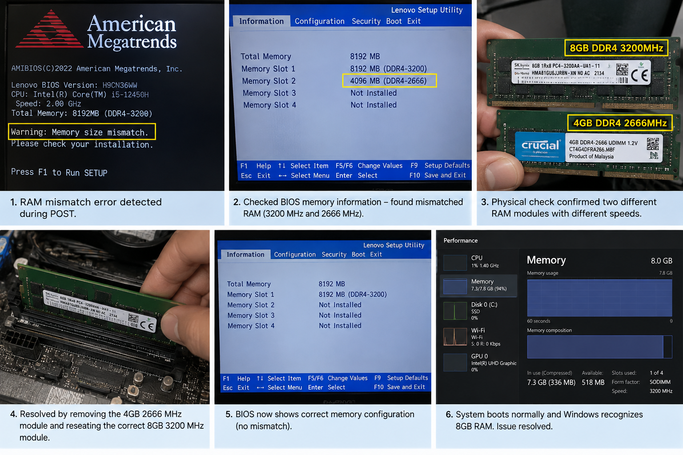

Task 3. LAN Topology Build - 5 Systems and 1 Printer
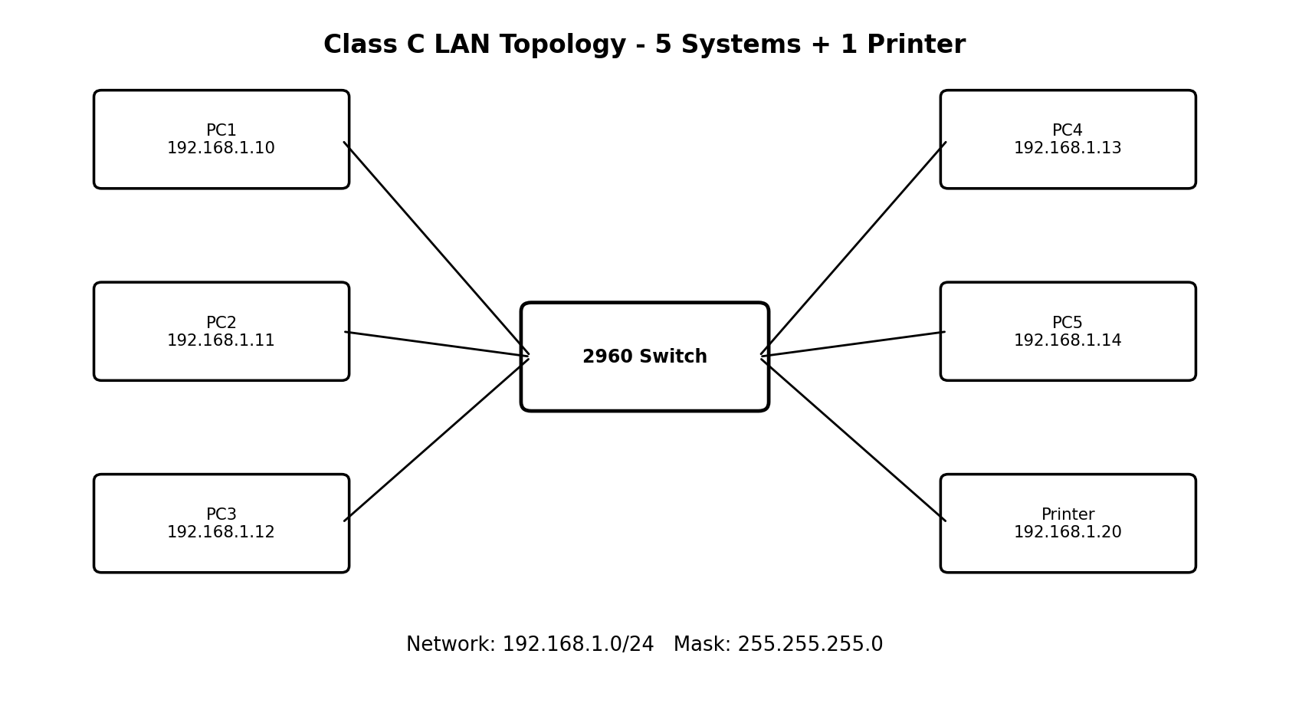
Device | IP Address | Subnet Mask
PC1 | 192.168.1.10 | 255.255.255.0
PC2 | 192.168.1.11 | 255.255.255.0
PC3 | 192.168.1.12 | 255.255.255.0
PC4 | 192.168.1.13 | 255.255.255.0
PC5 | 192.168.1.14 | 255.255.255.0
Printer | 192.168.1.20 | 255.255.255.0
- Open Cisco Packet Tracer and add one 2960 switch, five PCs and one network printer.
- Connect every end device to the switch with Copper Straight-Through cable.
- On each PC open Desktop > IP Configuration and enter the address from the table.
- Configure the printer with 192.168.1.20/24.
- From a PC open Command Prompt and ping the other PCs and the printer. All should reply.
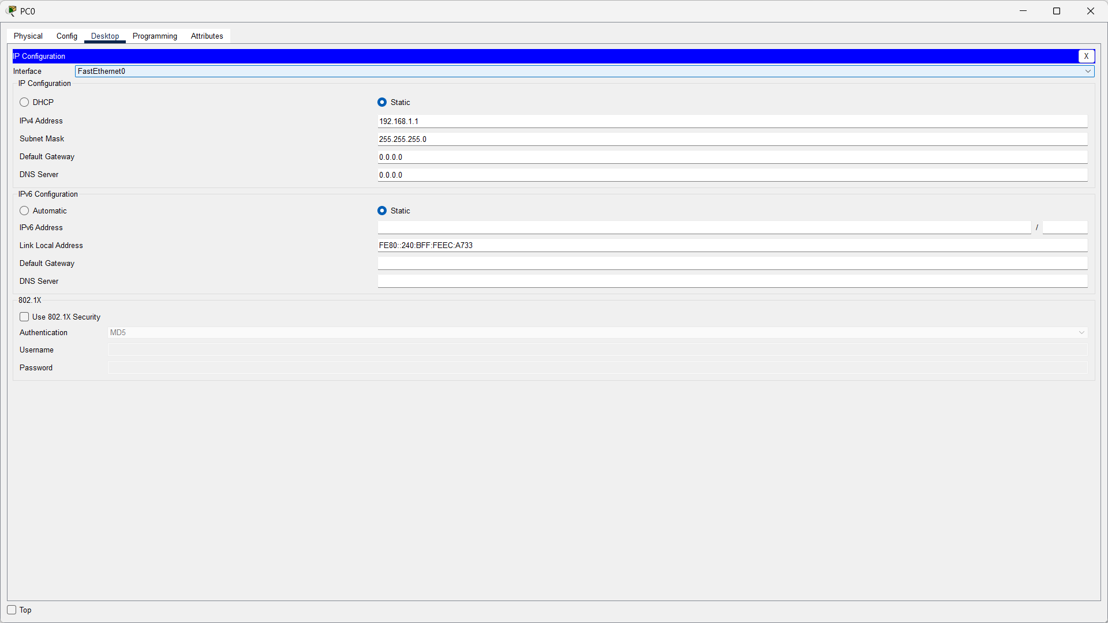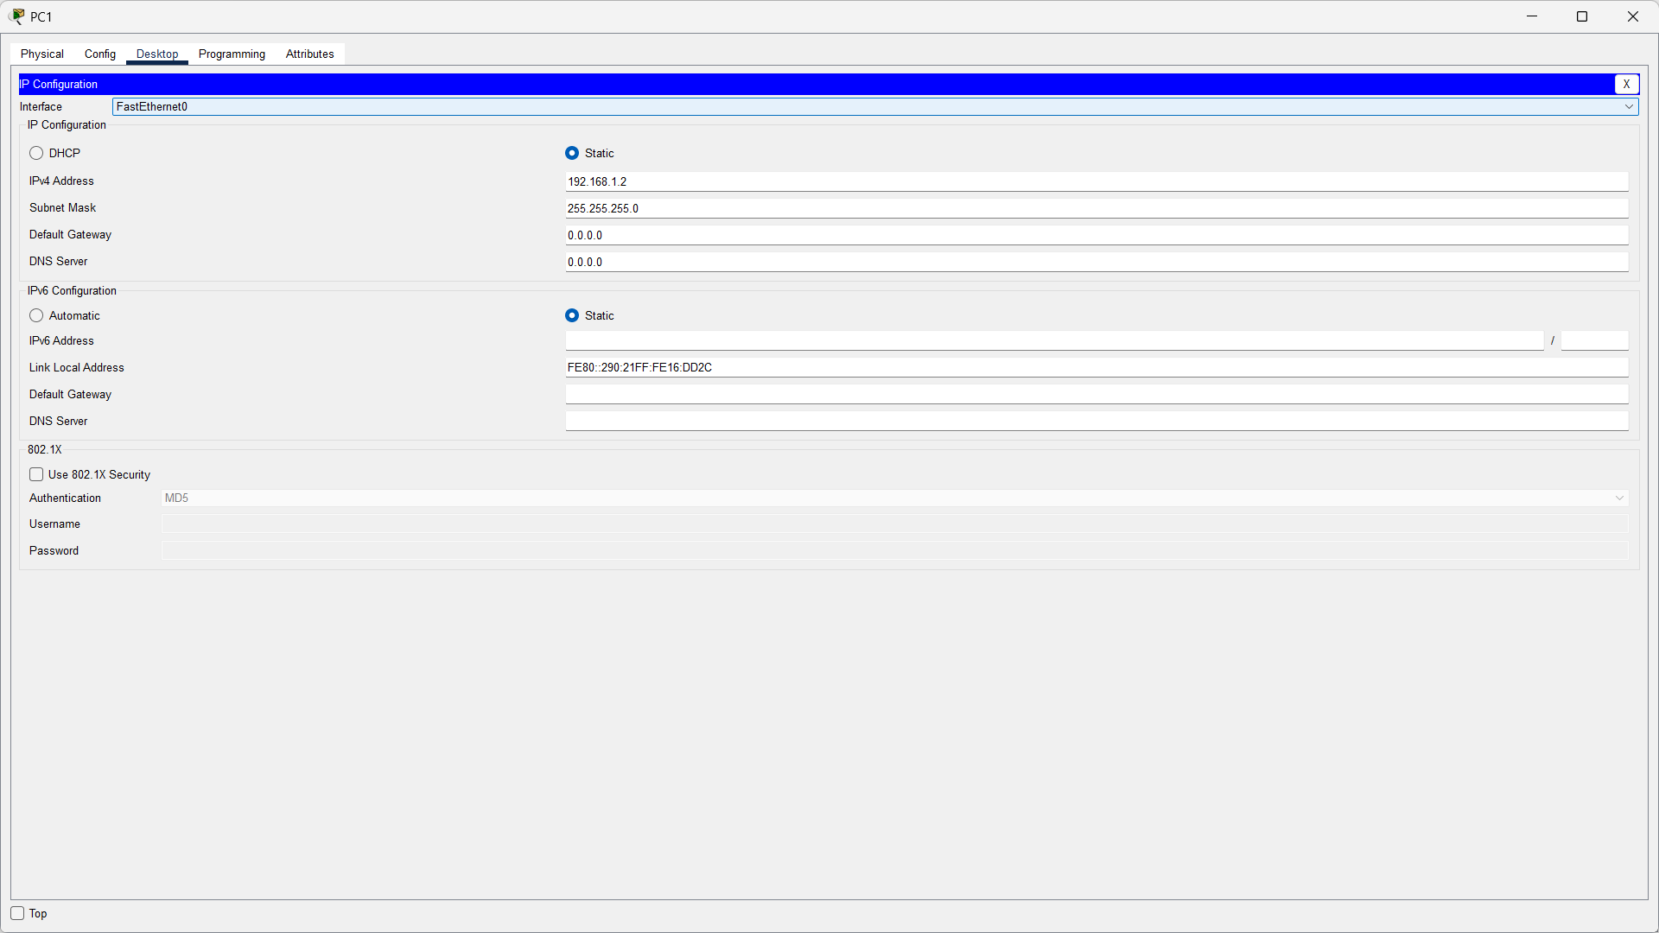
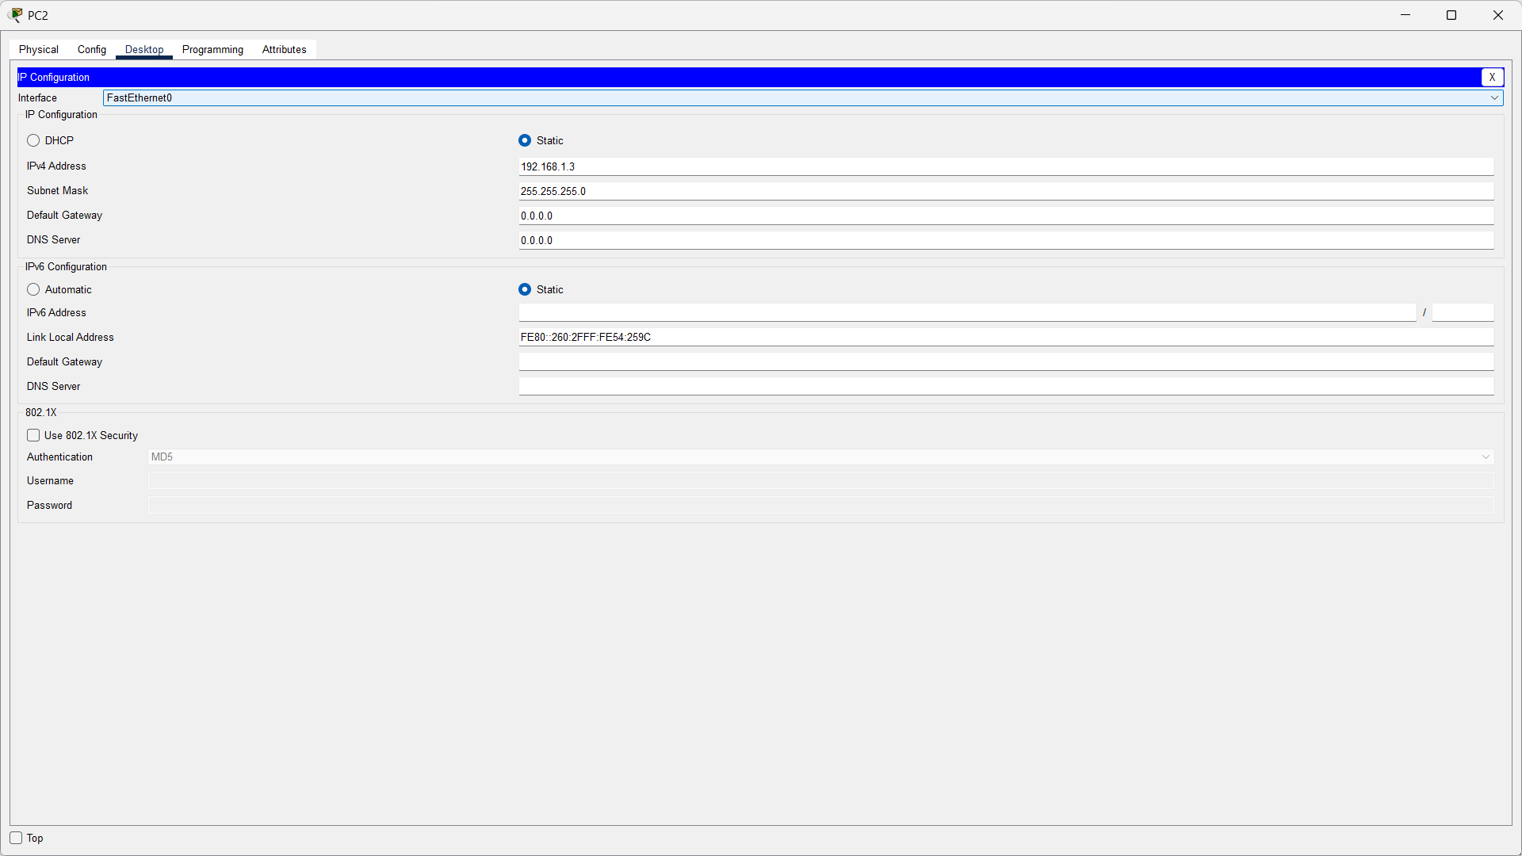
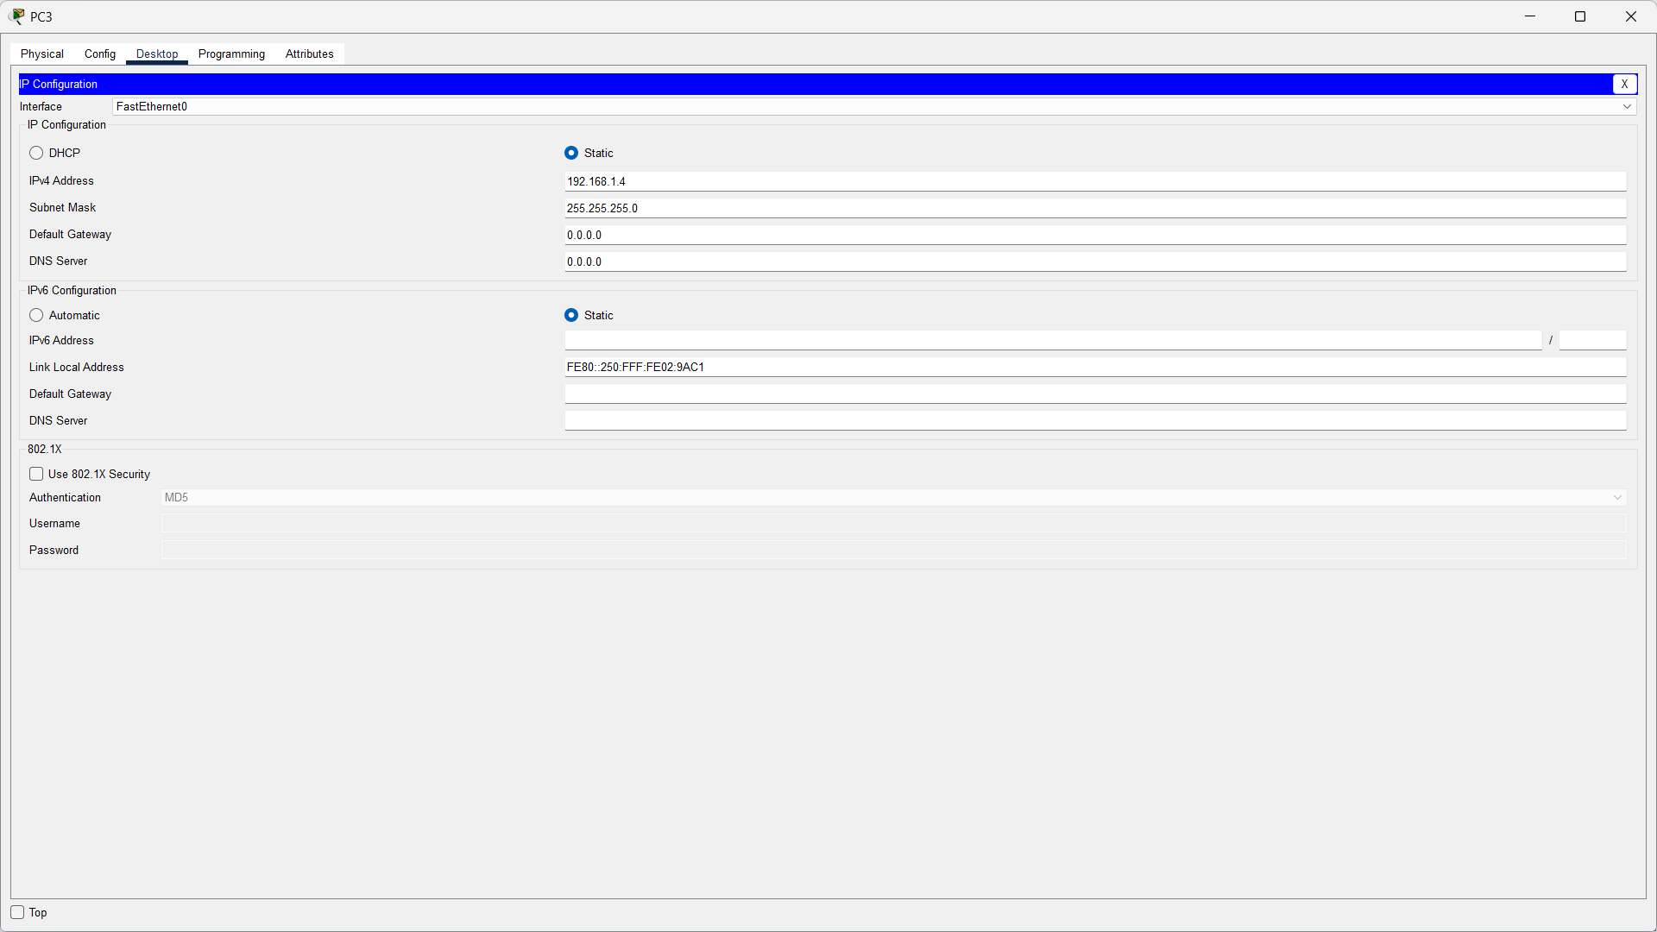

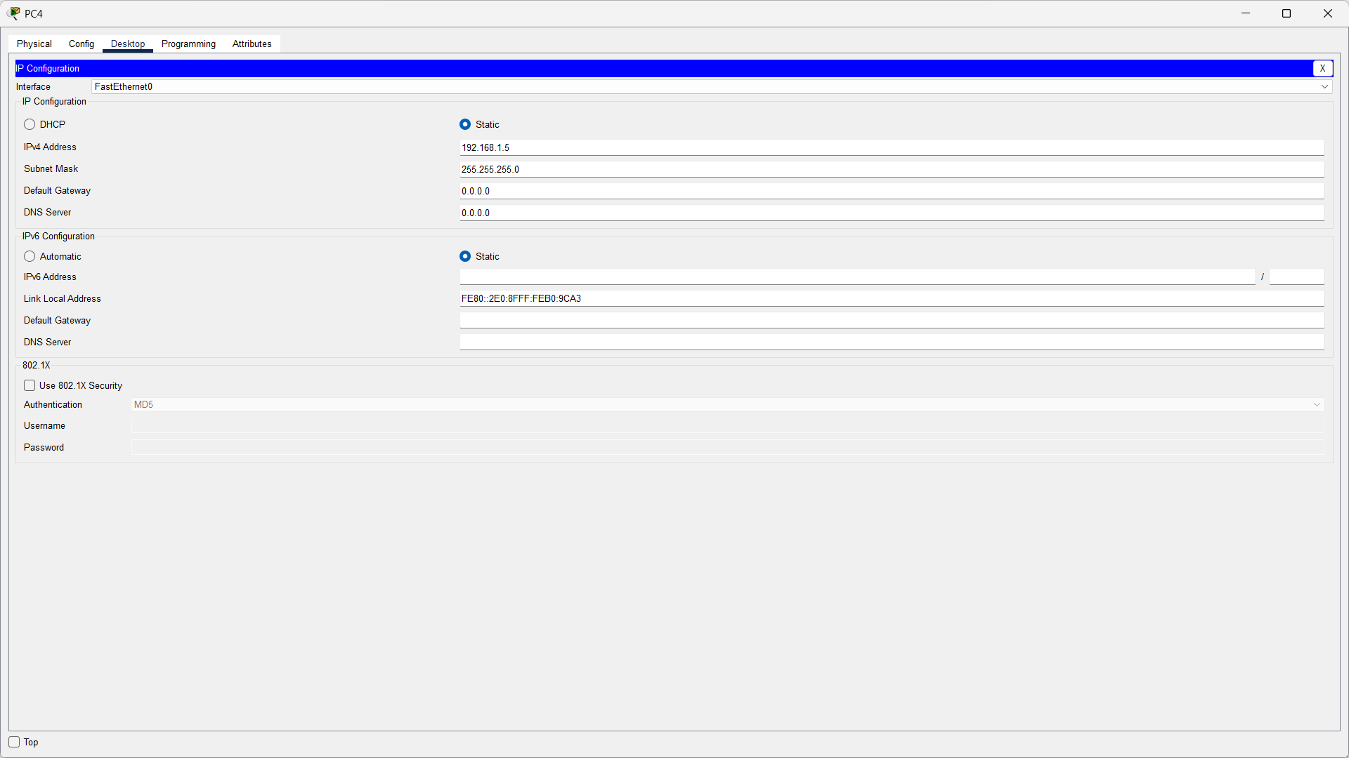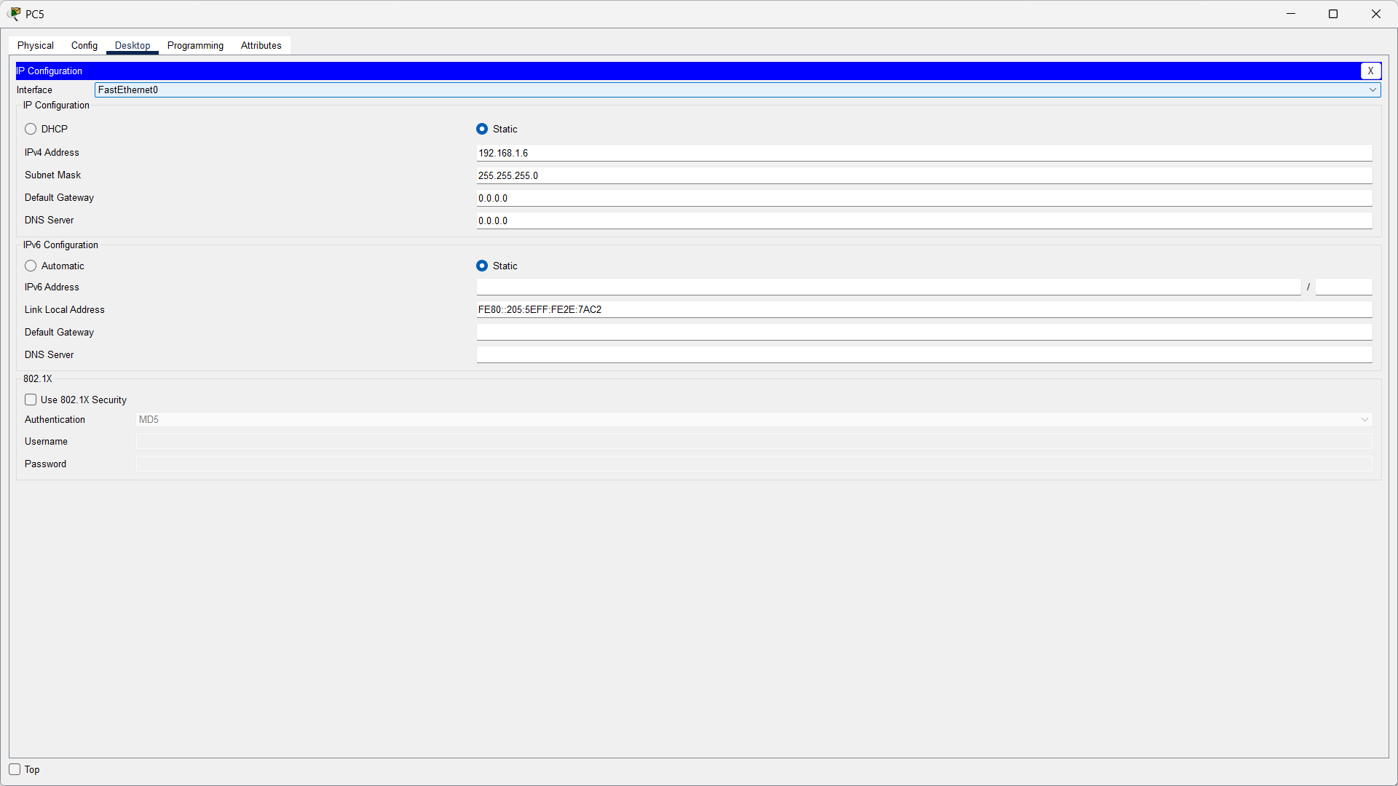
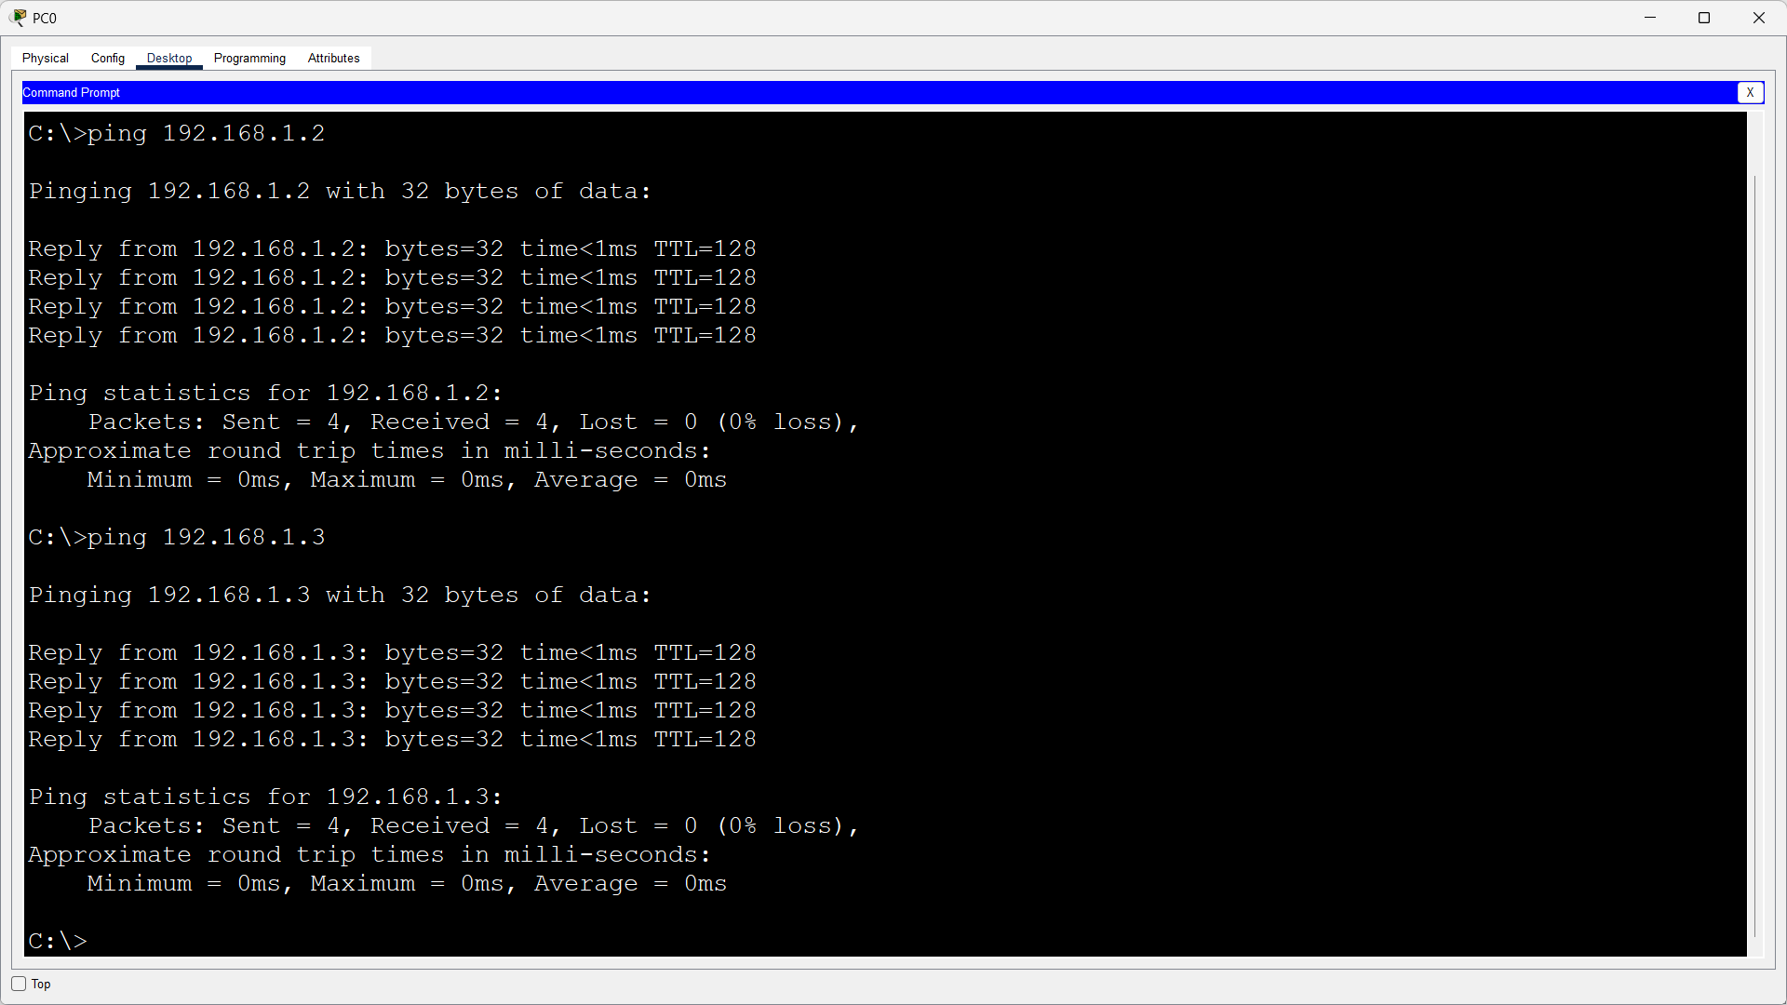
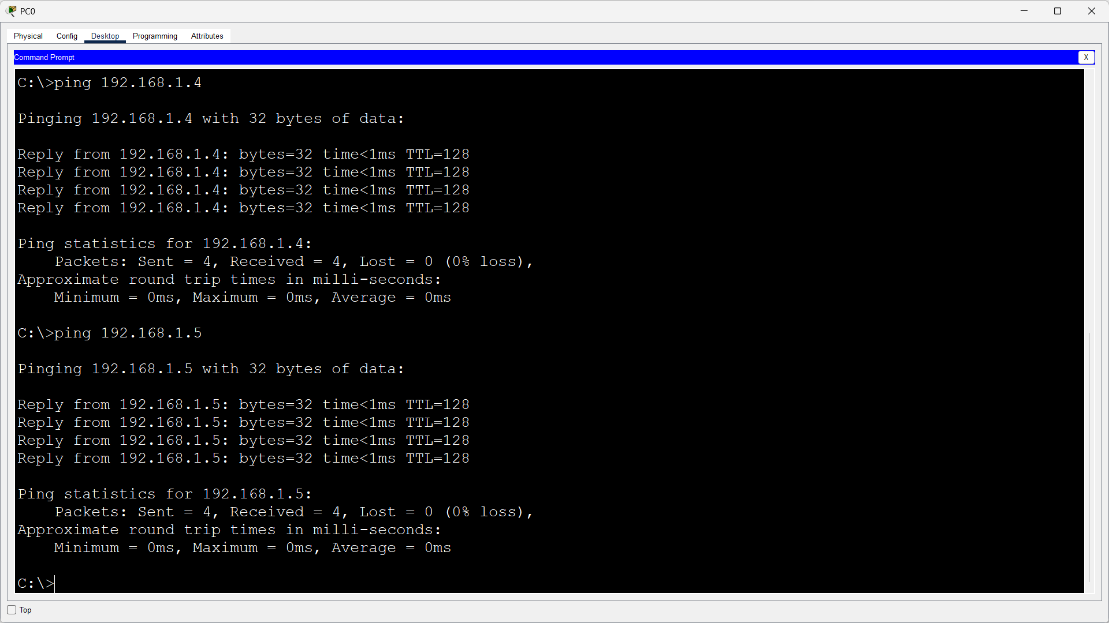
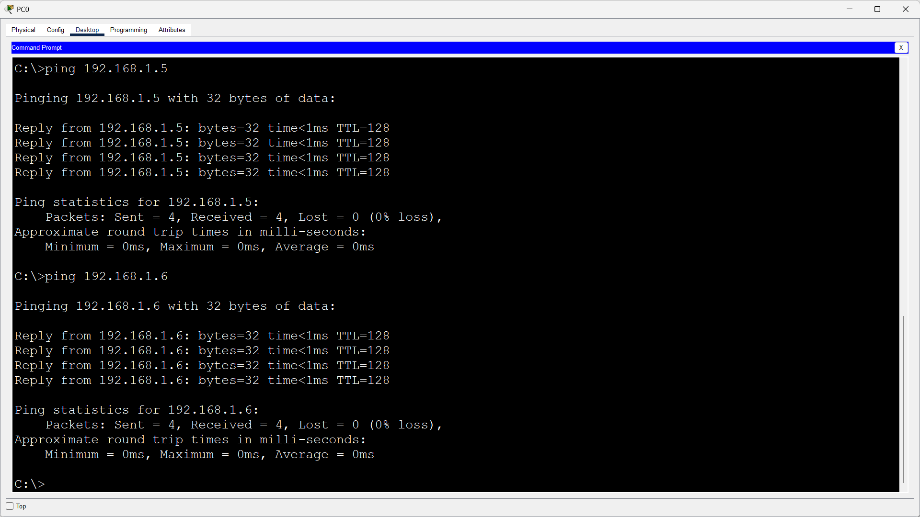
So like this in every pc we can ping any other pc through its ip.

Task 4. Clean OS Installation
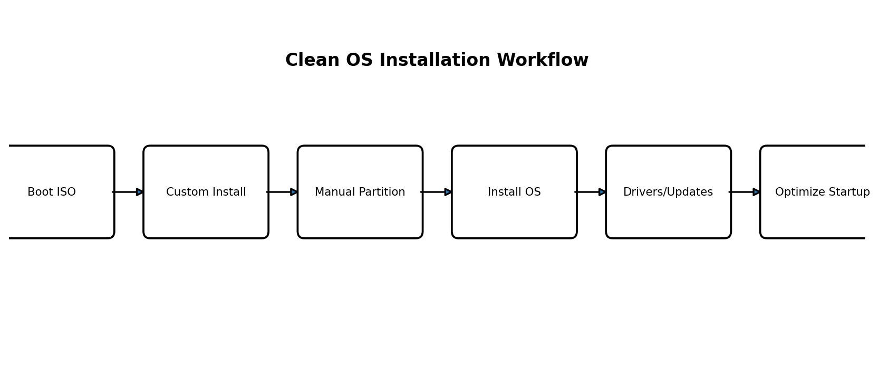
- Create a VirtualBox VM and attach the Windows/Linux ISO.
- Boot from the ISO and start a clean installation.
- Choose the custom/manual installation option instead of automatic guided partitioning.
- Create the required partitions manually, select the OS partition and continue installation.
- After the first boot, install drivers/updates and verify Device Manager or system hardware status.
- Open Startup Apps/services and disable only unnecessary startup items.
- Restart the VM and confirm that the OS boots normally without errors.
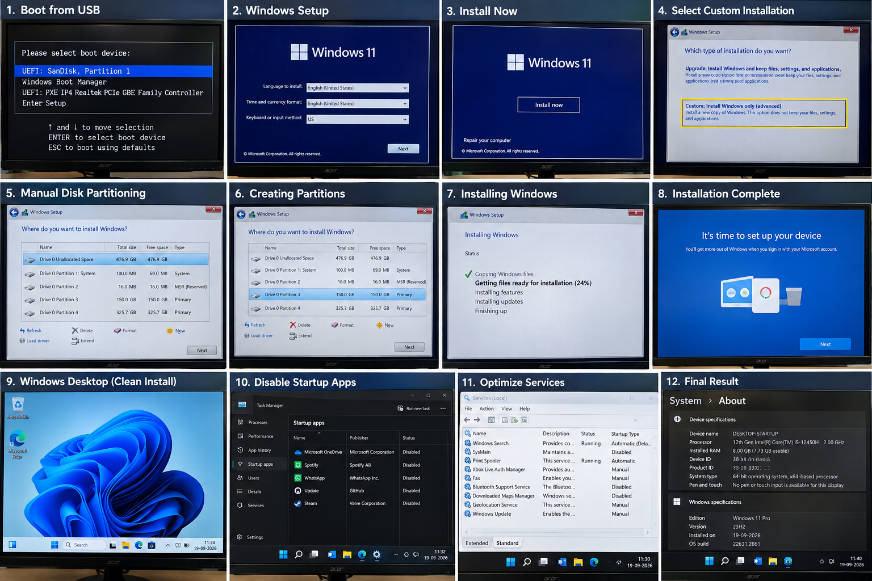

Section C - Mini Capstone Project

Nexus Innovations - Diagnosing Random System Reboots
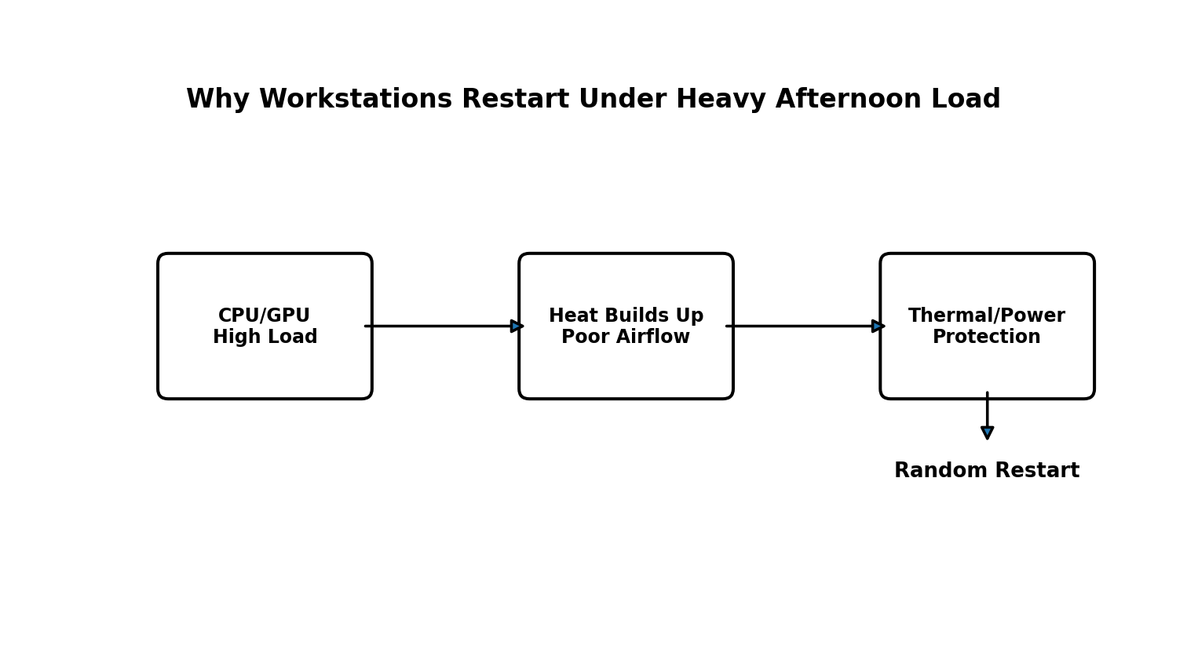

1. Three Most Likely Hardware Components
Component | Why It Can Cause Reboots Under Load
CPU / CPU cooling | Heavy rendering increases CPU temperature. A weak cooler, dried thermal paste or blocked airflow can cause thermal shutdown/restart.
GPU / GPU cooling | Rendering can heavily load the GPU. High GPU temperature or unstable GPU power can cause crashes or reboots.
PSU | A weak, aging or undersized PSU may be stable at light load but fail when CPU and GPU demand more power.

2. Why POST Passes in the Morning but Reboots Occur in the Afternoon
POST is a short hardware check performed when the machine starts and the components are still relatively cool. During long afternoon rendering workloads, the CPU and GPU generate much more heat. Because the computers are inside poorly ventilated desk cabinets, hot air accumulates and cooling becomes less effective. The higher load also increases PSU demand, so a thermal limit or unstable power condition can trigger a restart.

3. Stress-Test Method
- Monitor CPU/GPU temperatures, clock speeds and voltages with a hardware-monitoring tool.
- Run a controlled CPU or GPU stress test while watching temperatures.
- If temperatures rapidly approach the hardware's thermal limit before a restart, cooling/airflow is strongly indicated.
- If temperatures remain acceptable but the PC restarts mainly when CPU and GPU load together, inspect PSU capacity, connectors and power stability.
- Stop the test if temperatures become unsafe; do not repeatedly force uncontrolled shutdowns.

4. Three Remediation Steps
- Move the workstations out of closed desk cabinets or improve cabinet ventilation and cable management.
- Clean dust from heatsinks/fans, confirm all fans work correctly, reseat the cooler if required and replace old thermal paste.
- Inspect PSU wattage, quality and power connectors; replace the PSU only if testing shows inadequate or unstable power.

5. Is a PSU Upgrade Necessary?
A PSU upgrade is justified if the existing unit is undersized for the CPU/GPU load, is failing voltage/load tests, has damaged connectors, or the system becomes stable with a known-good correctly rated PSU. If the PSU is properly rated and stable while temperatures are clearly excessive, improving cooling and airflow should be the priority rather than replacing a good PSU.

Section D - AI-Augmented Learning

Step 1 - Exact Prompt Given to AI
Create an IP addressing and subnetting plan for Nexus Innovations' startup office network. The network has 5 computer systems and 1 network printer. Use a private Class C network. Specify the network/subnet, subnet mask, usable host range and broadcast address. Allocate an IP address to all 5 systems and the printer, and identify addresses that should be reserved for future expansion.

AI's Original Subnetting Plan
The following is the original example AI plan to be checked in Step 2:
Item | Original AI Value
Network | 192.168.1.0/24
Subnet Mask | 255.255.255.0
Usable Range | 192.168.1.1 - 192.168.1.254
Broadcast | 192.168.1.255
PC1 | 192.168.1.10
PC2 | 192.168.1.11
PC3 | 192.168.1.12
PC4 | 192.168.1.13
PC5 | 192.168.1.14
Printer | 192.168.1.255
Future Expansion | 192.168.1.21 - 192.168.1.30
Note: The original plan contains an error intentionally visible during the required manual verification step: 192.168.1.255 is the broadcast address and cannot be assigned to the printer.

Step 2 - Test & Debug Without AI
Manual check: For 192.168.1.0/24, the network address is 192.168.1.0 and the broadcast address is 192.168.1.255. Valid hosts are 192.168.1.1 through 192.168.1.254. Therefore the printer address in the original plan is invalid.

Corrected Plan
Device / Item | Correct Value
Network | 192.168.1.0/24
Subnet Mask | 255.255.255.0
Usable Host Range | 192.168.1.1 - 192.168.1.254
Broadcast Address | 192.168.1.255
PC1 | 192.168.1.10
PC2 | 192.168.1.11
PC3 | 192.168.1.12
PC4 | 192.168.1.13
PC5 | 192.168.1.14
Printer | 192.168.1.20
Reserved for Future Expansion | 192.168.1.21 - 192.168.1.30

3-4 Line Correction Note
I checked the AI-generated plan manually and found that it assigned 192.168.1.255 to the printer. In a /24 network, .255 is the broadcast address, so it cannot be used by an end device. I corrected the printer IP to 192.168.1.20 and kept 192.168.1.21-192.168.1.30 reserved for future devices. The corrected plan has no overlapping addresses and has enough host capacity.

Submission Checklist
- Section A: Answers to all six scenarios.
- Section B: Practical procedures plus your own screenshots/photos in every marked box.
- Section C: Hardware/thermal diagnosis, stress-test method, remediation and PSU justification.
- Section D: Exact AI prompt, original AI plan, corrected plan and correction note.
Important: Replace every empty screenshot/photo box with evidence from your own practical work before submitting.

