1. Thermal velocity, assuming a temperature of T = 300K
Temp = 300;
v_th = sqrt(C.kb * Temp / m_n);
Given a temperature of 300K, the thermal velocity is calculated to be about 1.3224e5 m/s
2. If the mean time between collisions is t_mn = 0.2 ps, what is the mean free path?
t_mn = 0.2e-12;
L_n = v_th*t_mn; %m
The mean free path is taken as the thermal velosity times the mean time between collisions, which gives us a distance of 2.6449e-8 m.
3. Write a program to model the random motion of electrons.
currX = (nomRegionL).*rand(numElec, 1); % set random initial x position
currY = (nomRegionW).*rand(numElec, 1); % set random initial y position
currVel = zeros(numElec,1); % initialize column vector to hold velocity, velocities initialized with zero
currVel(:,1) = v_th; % set all values in the first column as v_th
currDir = (2*pi).*rand(numElec,1); % create column vector with current direction of each electron
currVX = []; % set up x and y velocity vectors as empity column vector
currVY = [];
% Calculate initial vx and vy for each electron given their direction
[currVX, currVY] = XYVelocities(currVel,currDir,numElec);
At this point we should have the initial x and y locations of all electron. The locations should be within the bounded region. All electrons should have their initial velocity set to the thermal velocity, v_th and a random direction between 0 to 2*pi. From the magnitude of the velocity and the direction, the x and y vector components of velocity can be determined. From here, we can now see how the electrons will move about the region. To plot trajectories, we need to save the previous locations of each electrons - i.e need a matrix where rows are individual electrons and columns are different times - these will be saved in a separate matric from the currXXX column vectors.
for n = 0:numTimeStep
currTime(n+1) = n*dt; % determine current time (fs)
% Update according to Newton's laws of motion
% new position = old position + velocity*time
if n > 0 %update position after t=0
currX(:,1) = currX(:,1) + currVX(:,1)*dt; % calculate new X
% if e- crosses right bound, set X=0; if e- crosses left bound, set
% X=upper bound
crossRight = currX > nomRegionL;
currX(crossRight) = 0;
crossLeft = currX < 0;
currX(crossLeft) = nomRegionL;
newY = currY + currVY*dt; % check if new Y crosses boundary
bounce = (newY>nomRegionW) | (newY<0); % bounce electron if it hits bounds
currVY(bounce) = -currVY(bounce);
currY(:,1) = currY(:,1) + currVY(:,1)*dt;
end
% save previous position to plot trajectory
prevX(:,n+1) = currX;
prevY(:,n+1) = currY;
% Calculate average kinetic energy of electrons:
avgE_k = C.m_0*(sum(sqrt(currVX.^2 + currVY.^2).^2)/numElec)/2;
% Calculate temperature of material:
currTemp(n+1) = (2*avgE_k)/(3*C.kb);
end
% make plot
figure(1)
% Colour = hsv(nPlottedElec);
for i = 1:nPlottedElec
plot(prevX(i,:),prevY(i,:))
hold on
end
hold off
axis([0 200e-9 0 100e-9])
figure(2)
plot(currTime,currTemp)
xlabel('Time (fs)')
ylabel('Temperature')
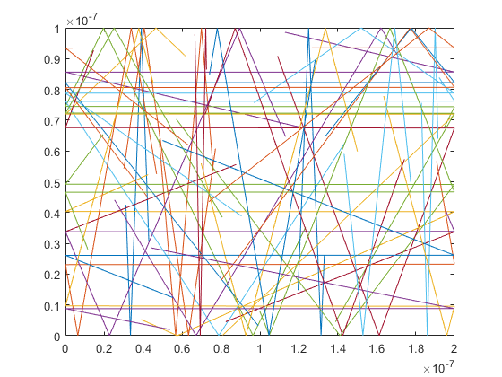
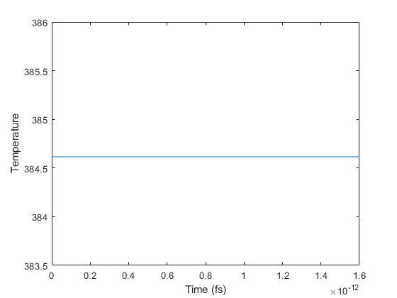
Published with MATLAB® R2021a

