ELEC4700 Assignment 1: Monte-Carlo Modeling of Electron Transport 1
1 ELECTRON MODELING 1
2 Collisions with Mean Free Path (MFP) 3
3 Enhancements 5

ELEC4700 Assignment 1: Monte-Carlo Modeling of Electron Transport
Dilsha Appu-Hennadi 101107857
This assignment will be walking through various exercises to model carriers as a population of electrons in an N-type Si semiconductor crystal. For the purposes of this assignment, electron mass is defined as m_n = 0.26*m_0, and the region will be 200nm X 100nm.
clear all
clearvars
clearvars -GLOBAL
close all
format shorte
% set(0, 'DefaultFigureWindowStyle', 'docked')
global m_n nomRegionL nomRegionW C
global x y Vx Vy nAtoms numElec nPlottedElec numTimeStep dt
C.q_0 = 1.60217653e-19; % Electron charge
C.hb = 1.054571596e-34; % Dirac constant
C.h = C.hb * 2 * pi; % Planck constant
C.m_0 = 9.10938215e-31; % Rest mass of an electron
C.kb = 1.3806504e-23; % Boltzmann constant
C.eps_0 = 8.854187817e-12; % Vacuum permittivity
C.mu_0 = 1.2566370614e-6; % Vacuum permeability
C.c = 299792458; % Speed of light
C.g = 9.80665; % Acceleration due to gravity (m/s^2)
C.am = 1.66053892e-27;
m_n = 0.26*C.m_0; % Effective mass of electrons
nomRegionL = 200e-9; % Nominal region length (nm)
nomRegionW = 100e-9; % Nominal region width (nm)
numElec = 100;
nPlottedElec = 0.3*numElec;
numTimeStep = 1600;
dt = 1e-15;
% newcolours = ['r','g','b','c','m','y','k'];

1 ELECTRON MODELING
ElectronModeling;
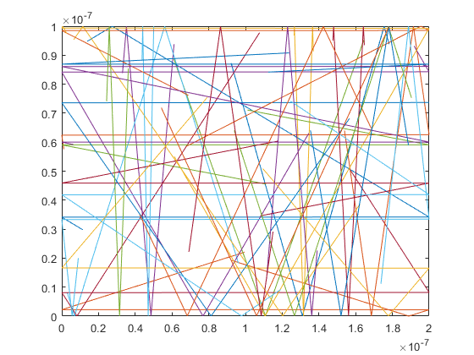
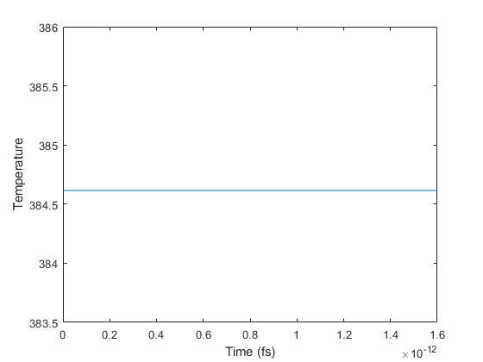

2 Collisions with Mean Free Path (MFP)
CollisionsWithMFP;
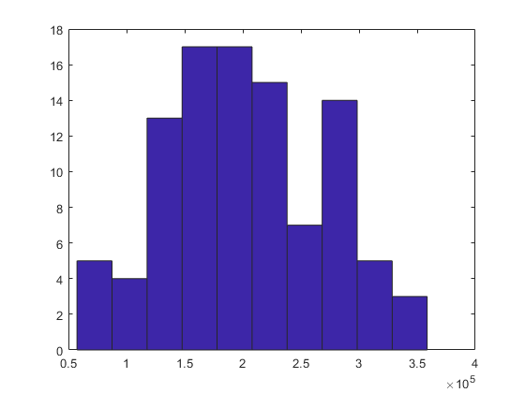
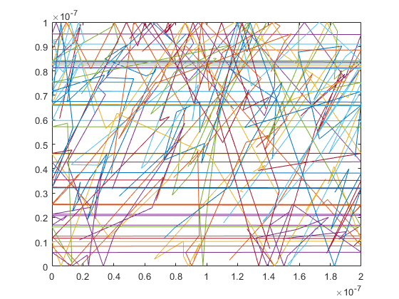
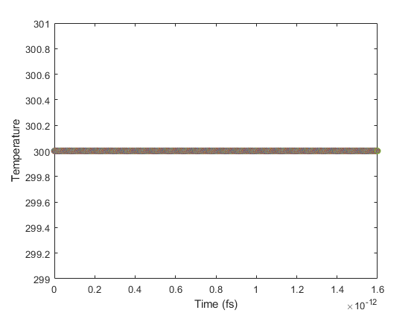

3 Enhancements
Enhancements;
InjectionModel;
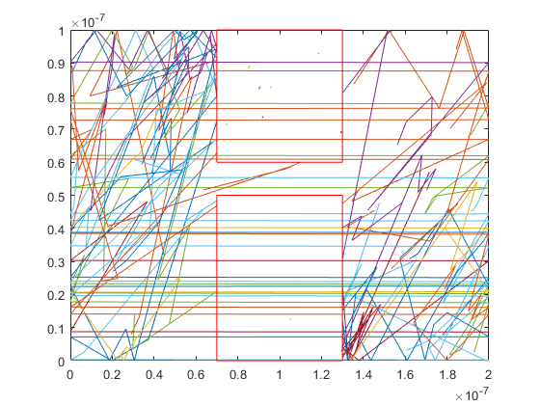
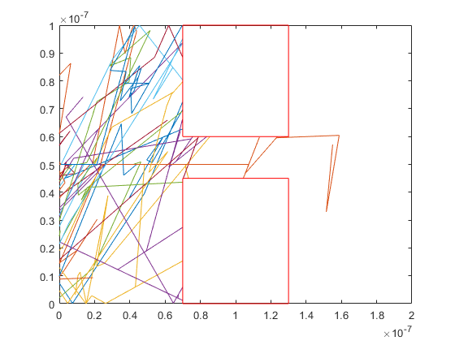
Published with MATLAB® R2021a

