**Reference to source code : https://github.com/DilshaUdayanP/SpringBoot/tree/main/Weekly%20Test**

**Constraints:**  
  Create a student model and an event Model (Id, name, department, branch, location, description, start time, end time, date, image)

Student model will have-

* StudentId first name last name age department

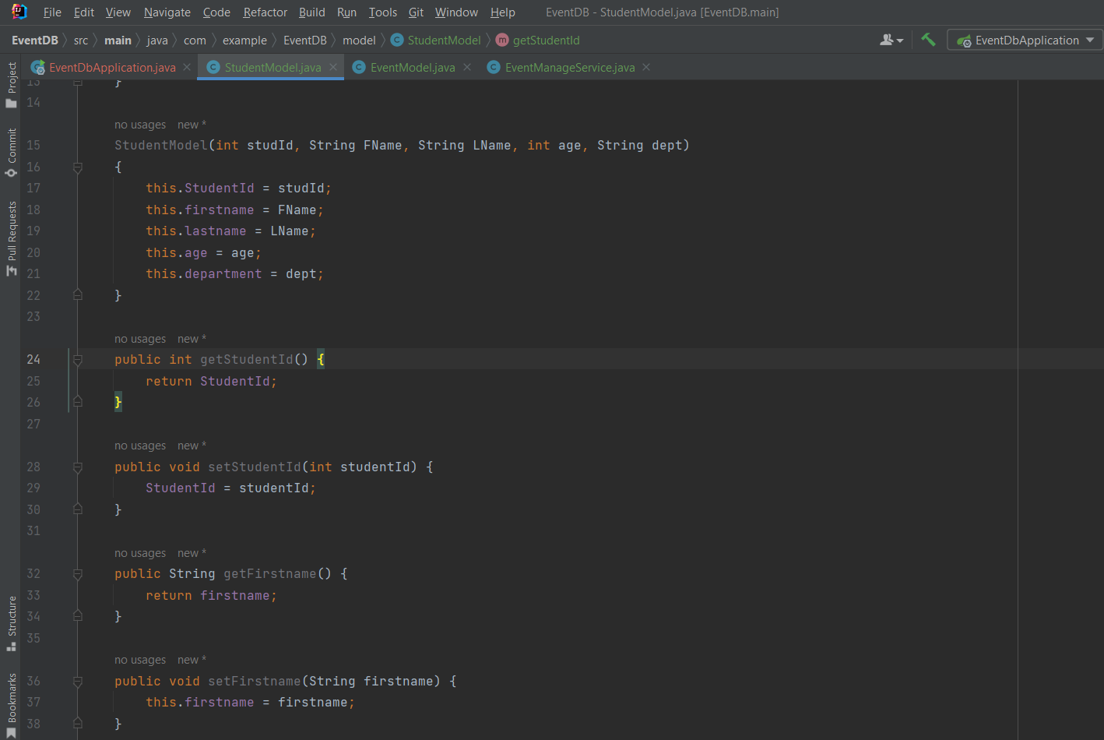

Event Model will have

* eventide eventName locationOfEvent date startTime endTime imageurl

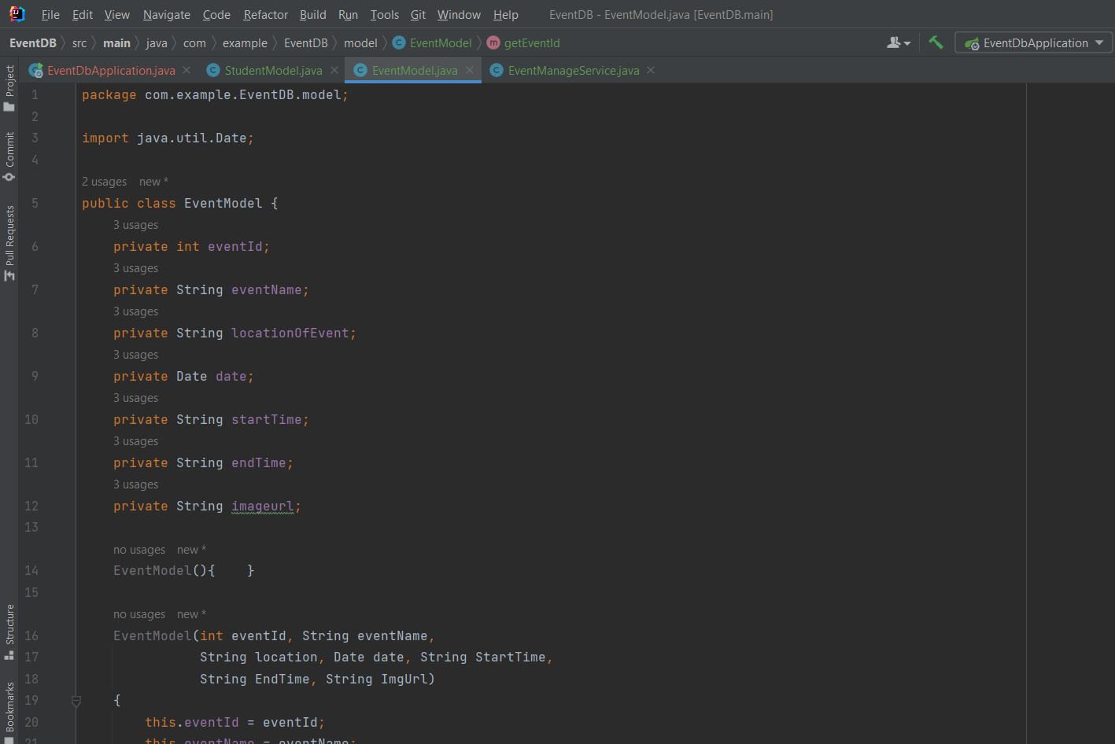

 **Endpoints to provided:-**

* Add student

Before :

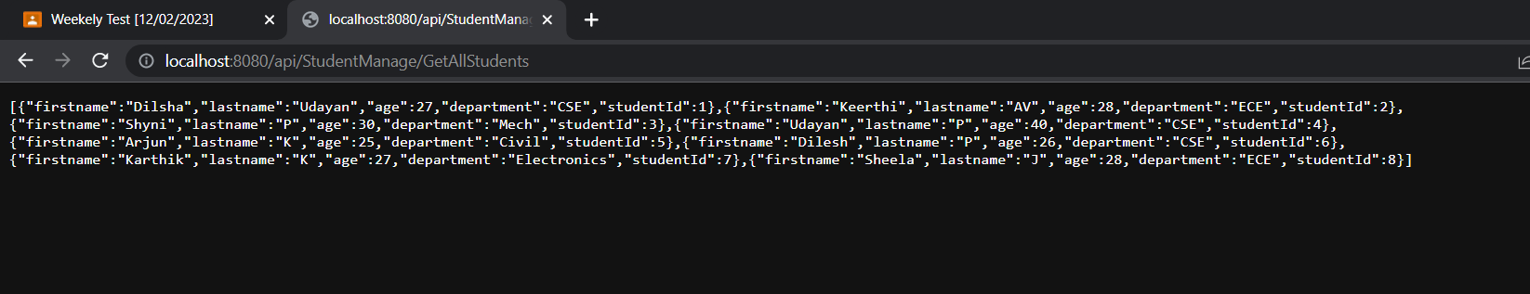

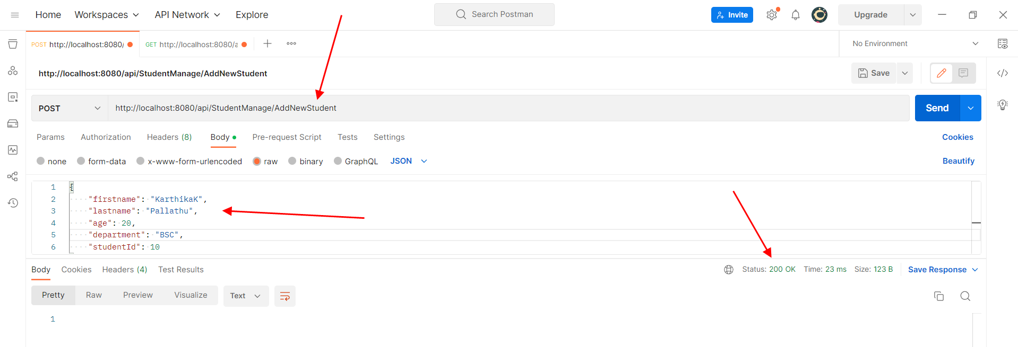

After :

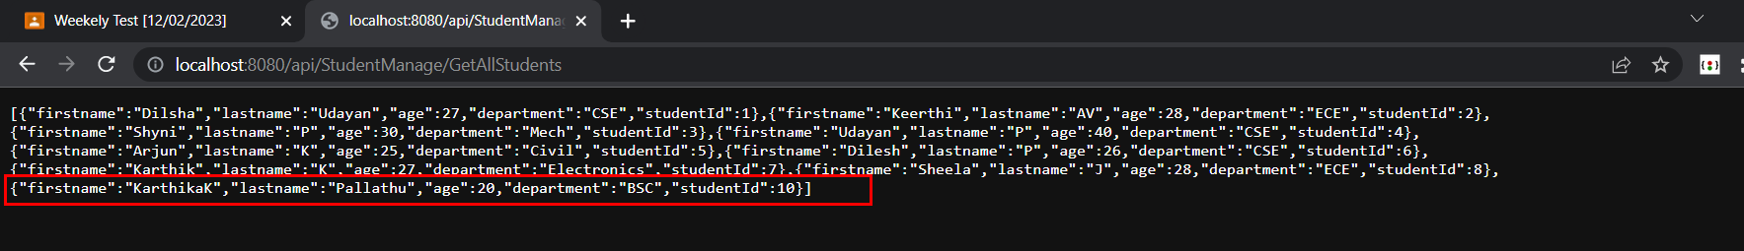

* update student department

Before:

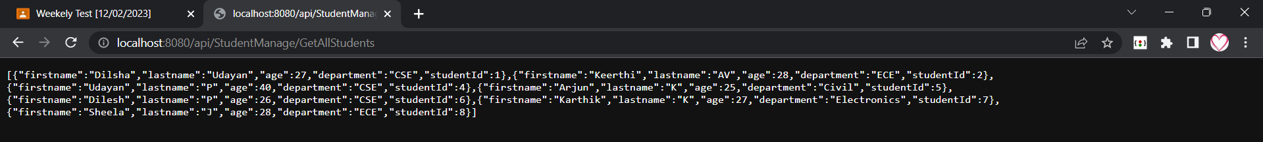

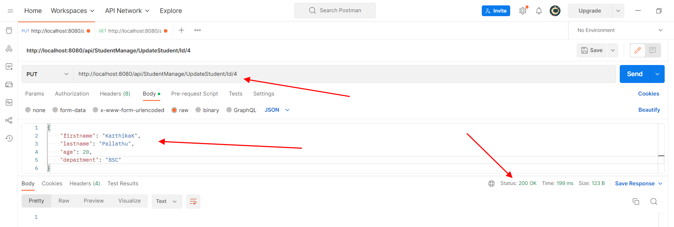

After:

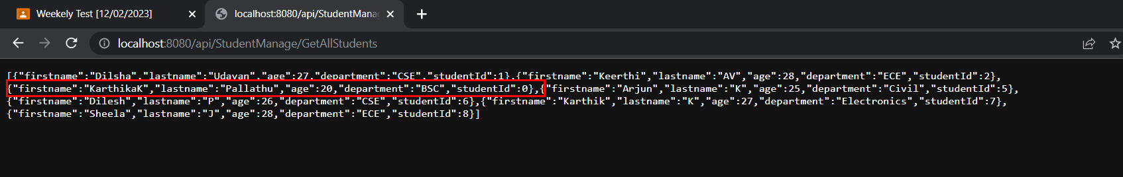

* delete student

Before:

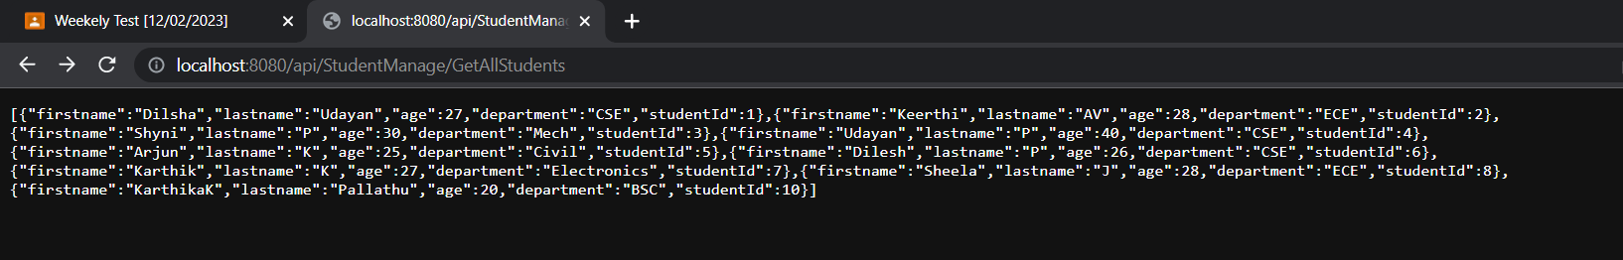

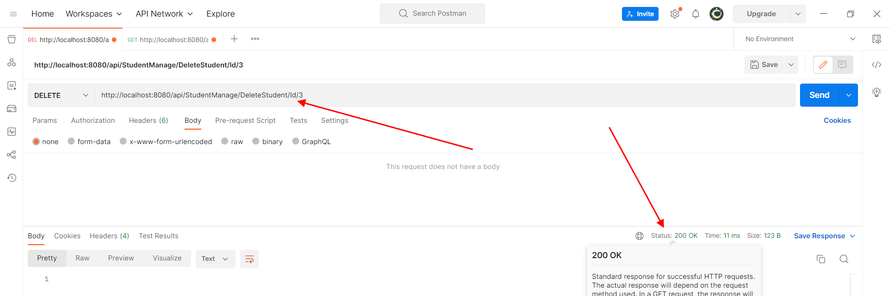

After :



* Get all students



* Get student by Id

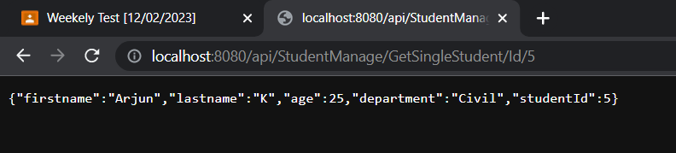

* Add event

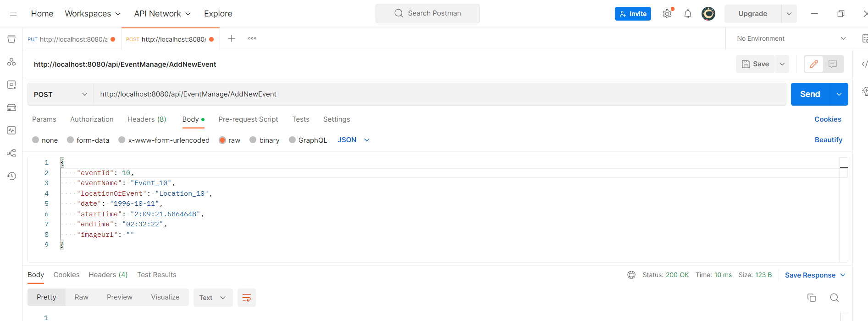

* Update event

Before :

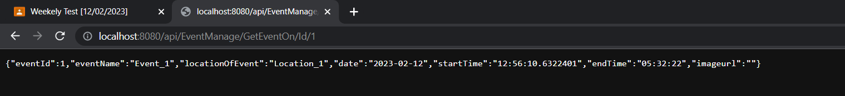

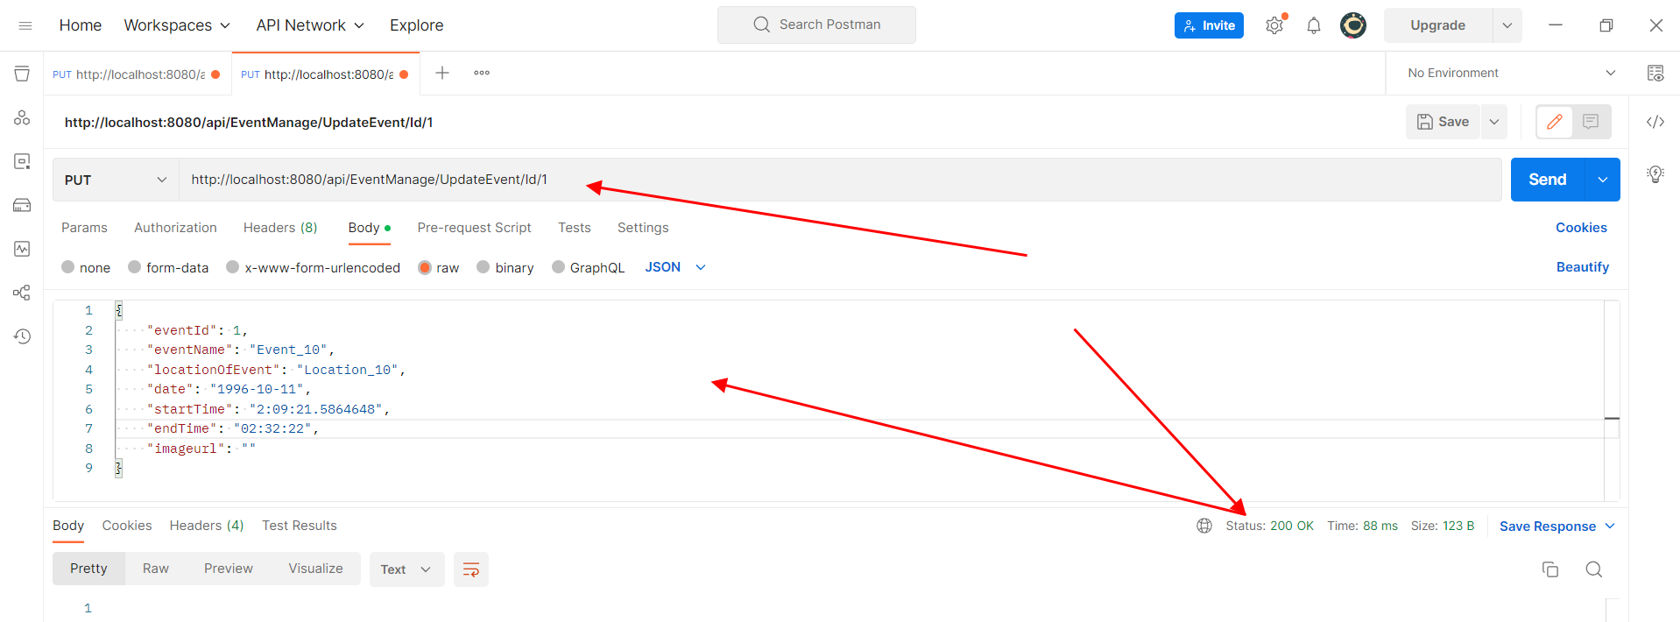

After :

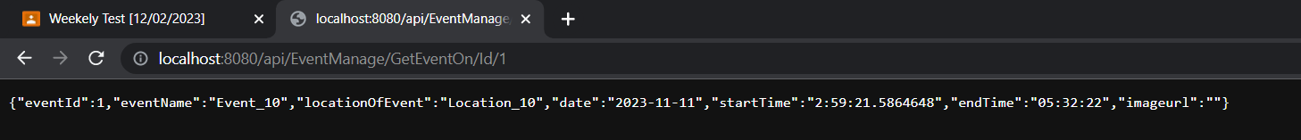

* Delete event

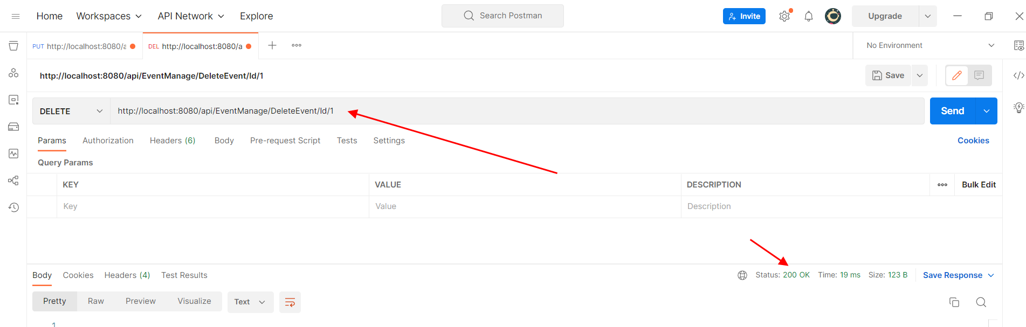

* Get All events by Id //I have issue in reading date so done by Id

